Sunday, June 10, 2012
Stewart Butten, Family Friend
by Bishop Holliman
In reviewing the letters and photographs of the 1930s, I continue to come up on the name of The Rev. Stewart Butten (spelled with an 'e') of Irondale, Alabama. My father, Bishop Holliman, knew 'Butten' in the middle and late 1930s and renewed the relationship in the 1970s. I remember stories about Mr. Butten's liberal views (liberal for the Ulyss Hollimans who were largely Republicans in the 1930s and 40s), and have wondered how he became such a close friend of the family. Here are my father's memories. - GNH
"Mr. Butten was a native of Ireland. I don't know the year he came to the U.S., but he ended up in East Tennessee, attending Maryville College, and eventually becoming pastor of the Presbyterian church in Irondale, Alabama about 1933. He also pastored a church near Trussville and one other out by Lake Purdy. The churches were very small, and he preached at a different one each Sunday.

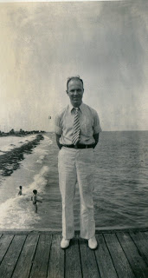
He was about Robert Daly, Sr.'s age (my brother-in-law who had married Vena Holliman in 1928), so they became very close friends. The Dalys, who lived next door to us (the Ulyss and Pearl Caine Holliman house) took Mr. Butten under their wings. He was not married and had no family in the States, so he welcomed their friendship . He went with Vena, Robert and Loudelle (Holliman Ferrell) to the Chicago World's Fair in 1933 and to Florida several summers. He became like one of the family and became sort of a role model for me as I was a young teen-ager, and was always around the Dalys when Mr. Butten was there.
Irondale, of course, had a very conservative Presbyterian church, but I guess it was Mr. B's Irish wit that endeared him to the congregation and community. He seemed to be a good fit, but he was way ahead of the time and place with his social and liberal views about religion, politics and race. He managed to get along well with all the folks.
Above, Mr. Butten in Florida on a Daly trip in the 1930s.
Once, though, he spanked a little boy who had misbehaved at the Bible School. The boy's daddy brought suit against him, and the newspaper picked up the story, and it got all the way to Belfast, Ireland. It was seen by Mr. B's family there, and that's how they learned that he was in the ministry and what he was doing! The law suit was eventually dropped and nothing came of it.
Mr. B drove a motor cycle to his various churches, as an automobile was too expensive. I guess that was also his way of flouting the establishment. He was well-educated, a well-read man. He enjoyed engaging Robert (and me) in heated discussions about current events, FDR, and other issues of the day. He would usually end up every Sunday night at the Dalys, and I would often be there to hear their discussions and engage in arguments with them.

He left Irondale in 1937, taking a church in Knoxville, Tennessee, lived there several years, moving to some job in Ohio, and eventually went into library work. After Mr. B moved to Knoxville, that summer 1937, he returned to Irondale on a visit, and I went back to Knoxville with him and stayed at the home of one of the members. They had a boy my age, and we went up to the Smokies, my first time there and climbed the Chimney Tops. I rode the train back to Birmingham, always a thrill for me.

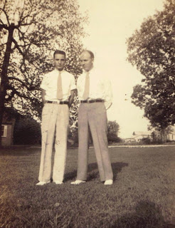
Above, Stewart Butten right with Bishop Holliman left. Note the stylish white shoes in the late 1930s.
More on The Rev. Mr. Butten and his influence on Holliman lives next posting....

Wednesday, June 20, 2012
Stewart Butten, Family Friend, Part II
by Bishop Holliman
"Mr. Butten married in the early 1940s and later moved back to Chattanooga and ended up in Knoxville. In 1975, he attended my younger daughter's wedding in Cookeville, Tennessee. My wife and I visited him in a nursing home once and also in his home. His wife, Hazel, died before he did.
Below, Hazel and Stewart Butten visit with Ralph Holliman in 1975 at the wedding of Alice Holliman and Bill Murphy. At that time, Mr. Butten was retired and Ralph, Bishop Holliman's youngest brother, was a corporate executive in Chicago.
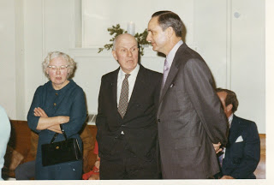
He went back to Ireland once, I'm sure, after Hazel died, and visited his old home place. He is buried near Seymour, Tennessee. Robert Daly, Sr. died in 1959, and Mr. Butten lived on into the 1980s."

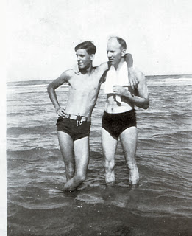
Compare the photo above with the one on the right of the same Ralph Holliman, age perhaps 15, the tallest of the Ulyss and Pearl Caine Holliman children, leaning on Mr. Butten at one of those memorable Florida vacations the Robert Dalys made possible for the family.
Next posting a letter by Mr. Butten on the death of Pearl Caine Holliman....
Posted by Glenn N. Holliman at 2:00 AM

Sunday, July 1, 2012
Stewart Butten, Family Friend, Part III
by Glenn N. Holliman
The beloved mother of seven children, Pearl Caine Holliman, pictured below, died of heart failure on May 5, 1955. This is one of the last photos taken of her, again, on the lawn between her home and the Robert W. Daly's. Born in 1887 in Fayette, Alabama, she married Ulyss S. Holliman in 1906, and with him and their growing family moved in 1917 to Irondale, Alabama, a suburb of the then growing city of Birmingham.
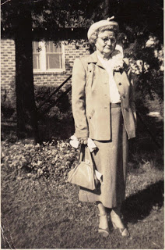
Stewart Butten wrote the following letter to Mary Daly Herrin, the oldest of Grand Mama Holliman's 19 grand children. Sadly, many grand chidlren are too young to have known of her warmth and caring. Her memory lives today for those of us grandchildren who were fortunate enough to have sat around that long and large Holliman table at Christmas, which Mr. B. eludes to in his letter. Click twice to enlarge the letter.
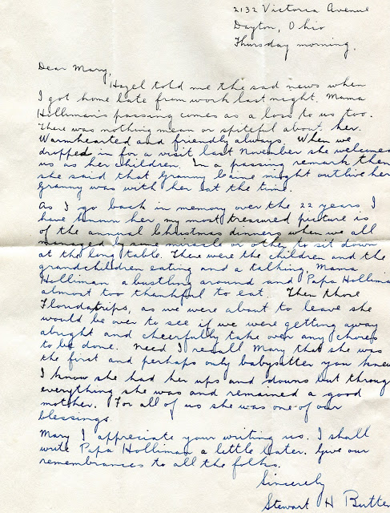
Two good friends, a picture taken in the middle 1930s of Robert W. Daly, Sr. and Stewart Butten, both had an infectious Irish humour.
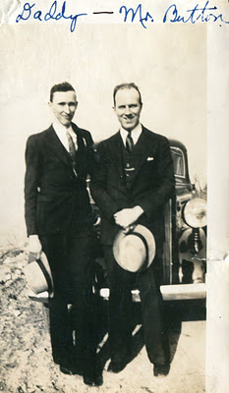
Next, more memories of Irondale, Alabama....in the 1920s

Sunday, July 15, 2012

Memories of Irondale, 1925 to 1942, Part I
by H. Bishop Holliman

In November 2010, also 91 years of age, H. Bishop Holliman (pictured below in the red sweater) who lived his childhood and youth at 2300 3rd Avenue North, Irondale, Alabama, returned to look once more at his home town where he grew up in the 1920s and 1930s. These are his memories and photographs. - Glenn N. Holliman, his son

"Trains, trains, trains…Among my earliest memories of Irondale are the trains that went through the center of town. Four main lines that used five tracks – two for the Alabama Great Southern that ran from Birmingham to Chattanooga on to Washington, DC. One for the Southern that ran from Washington, D.C. to New Orleans and one for the Central of Georgia that connected with the other line that ran from Chicago to Miami. Finally, one for the Seaboard that came from Washington, D.C, through to Birmingham."

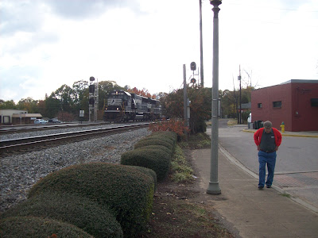
Above the Norfolk Southern freight pulls through Irondale with Bishop Holliman walking beside it in 2010.

"Long before ‘rock and roll’, music came on the scene, Irondale already knew how to shake. It seems that a train was barreling through every few minutes – sometimes four at a time. On summer evenings we would try to sit on the front porch to listen on the radio to Major Bowes or Bob Hope. But about 8 o’clock, the Pelican on its way to New Orleans or the Robert E. Lee from Washington and Atlanta, plus a couple of freights, would create so much noise, we had to go inside.

Each day to and from school, to church on Sunday, to the post office and to the baseball diamond, we had to cross those tracks. There were no warning lights and no guard rails to stop us – we crossed the tracks at our peril. You can imagine the anxiety our parents felt every day that we went to school or to other placers, hoping and praying we would get there and back safety.

Some did not make it. I remember three deaths that occurred. Usually an older student would lead first graders from school across the tracks in the afternoon. About two thirty each afternoon we would hear the toot of the Seaboard train on its way to Atlanta and we would know then school would soon let out."

More in the next post on Irondale, Alabama from 1920s to 1940s.....

Sunday, July 29, 2012
Memories of Irondale, 1925 to 1942, Part II
by H. Bishop Holliman
We continue the memories of my father, Bishop Holliman, of his boyhood home in Irondale, Alabama. The suburb of Birmingham was a rail road center, and it was the Seaborne Rail Line that took Bishop Holliman to the U.S. Navy in 1941. On December 7, 1941, only three weeks into the Navy, he heard the news at the Norfolk Navy Base that Pearl Harbor had been bombed. Almost four years would pass before he could return as a civilian to his Irondale family. - Glenn N. Holliman

"As we got older, one of our fondest dreams was to get on one of those fast passenger trains and ride off to some enchanted places we had heard about. Alas, it did not happen for most of us until World War II. I left Birmingham on Friday, November 13, 1941, on the Seaboard’s Cotton State Special for Norfolk, Virginia to spend nearly four years in the Navy."
Below, Bishop Holliman, left, and his brother, Melton Holliman sans his U. S. Army uniform, both home on leave at their parents, Ulyss and Pearl Caine Holliman at 2300 3rd Avenue N., Irondale, Alabama. It was February 1945, a time when many Irondale men were in service.
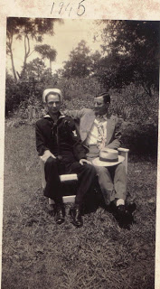
"Incidentally, gates were installed in Irondale after the war to protect against on-coming trains, and thanks to efforts by my Mother, Pearl Caine Holliman, home delivery of mail was begun before the war ended, thus eliminating a daily rail crossing to the post office for all the folks on the north side of town."

Bishop Holliman’s mother, Pearl Caine Holliman of Irondale, wrote this letter to Alabama Congressman Luther Patrick in 1943, describing her efforts to mobilize public opinion. In January 1945, home delivery mail service began Irondale and residents on the hill above the center of town were no longer required to cross the rail road tracks to collect daily mail at the post office.
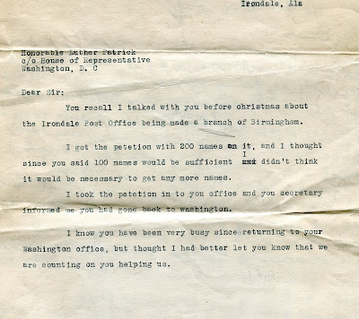
Below, in 1945, to recognize the beginnings of home delivery of the Irondale mail, the Woodlawn, Alabama newspaper ran this photograph of a postman with Pearl Caine Holliman (1887-1955) and her grandson, Robert W. Daly, Jr., son of Robert W. Daly, Sr. and Vena Holliman Daly. The Dalys lived next door to the Hollimans in the 2300 block of 3rd Avenue North.
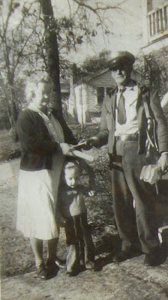
The little boy holding his grandmother's hand would earn a Ph.D. in biology, teach for decades at the University of North Alabama, Florence and become a well-known Alabama naturalist. Dr. Robert W. Daly, Jr. grew up in Irondale and graduated from Shades Valley High School.

Next post, more memories of Irondale, Alabama....

Wednesday, August 8, 2012
Memories of Irondale, 1925 to 1942, Part III
by H. Bishop Holliman
This is the third article of my father’s memories of growing up in the small suburb of Birmingham, Alabama during the 1920s and 1930s, a time of economic deprivation prior to World War II. - Glenn N. Holliman

"Grocery Stores…I remember the two stores that provided food for Irondale folks in the 1920s and early 1930s. We traded with R.H. Davis and Sons, located on 2nd Avenue North and 19th Street. I remember stopping by the store when I was in the first grade and buying a nickel package of juicy fruit chewing gum and trying to chew it all before I reach home. I did not succeed. And I never did that again.
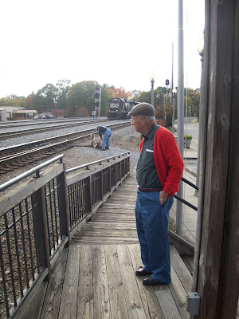
Our groceries were bought on credit and Daddy (Ulyss S. Holliman, 1884 – 1965) would pay the bill every two weeks. Mr. Davis would give him a little sack of candy each time, and my sister Virginia (Holliman Cornelius, 1922 – 2011), brother Ralph (Holliman, 1924) and I looked forward to that treat. Mr. Davis had a small truck he used to deliver groceries, and it could be used for other purposes, such as taking us once to ‘Blue Hole’. "
Above, Bishop Holliman, born 1919, in 2010 standing by the Irondale, Alabama tracks he crossed many times in the 1920s and 1930s.
"This was a small swimming hole created from the artisan well that flowed on the west side of town where 30 to 40 years later the East Side Mall was built. ‘Lokey’ was a black man who worked for Mr. Davis. He would come by the house to take grocery orders then he would deliver them later in the day or the next day. We all learned to love Lokey. He was highly regarded by our family, Grandma Lula Caine and Aunt Maud Cook’s family. He always came into the house through the back door, as was the custom of that era.
The other grocery store was J. T. Ramsey and Son, located on south side of town by the Seaboard tracks in a large brick building that was still standing the last time I looked (2010). We never did trade there. I guess because it was farther away from our house. At one time, I don’t remember the year that it opened or closed, the Jane Griffin family (Eloise, Janie, Joyce and Gerry) operated a store on the corner of 1st Avenue South and 20th Street. I remember buying a cap pistol from Mrs. Griffin when I was about eleven years old, for 25 cents!"
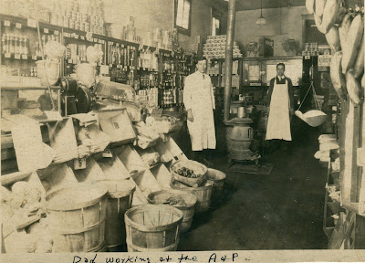
Bishop Holliman’s brother-in-law, above right, Charles T. Ferrell, worked at a Birmingham, Alabama A & P grocery of the late 1920s. Charles would graduate from Birmingham-Southern College and Yale Divinity School, be ordained a Methodist minister and in 1935 marry Loudelle Holliman of Irondale. Photo courtesy of Charles H. Ferrell. This store was similar to the Irondale groceries recorded above.

Next posting, more memories of an earlier Irondale, Alabama....

Saturday, August 18, 2012

Memories of Irondale, 1925 to 1942, Part IV
by H. Bishop Holliman
This is the fourth in a series of reflections on an earlier Irondale, Alabama by my father, Bishop Holliman, born 1919. Below he continues to remember the grocery stores in the small community. - Glenn N. Holliman
"The chain stores eventually came and Mr. Davis could not compete with Hill grocery Company nor with the A & P. J. T. Ramsey stayed in business much longer. Another grocery opened on 1st Avenue, I am not sure of the year, by Ed Fortenberry. We know he was in business when I went off to war, and I don’t know how long he was there. But Hill’s and A & P, I am sure, soon took all the business from local merchants.
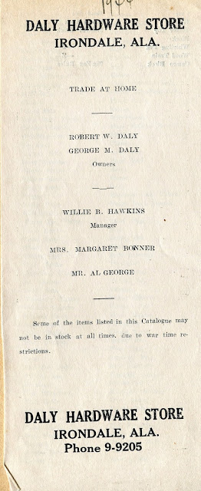

At one time, though, there were two grocery stores there on First Avenue, North. Hill’s was in the same block as the A & P and Fortenberry’s Grocery where the drug store, operated by Dr. Brock and the hardware store owned by Mr. T. C. Burgess. In 1943, Mr. Burgess retired and his store bought by Robert Daly, Sr. (my brother-in-law) and his brother, George Daly.
The announcement of the Daly Hardware opening is on the right. Below is Robert W. Daly, a Woodlawn, Alabama banker. From early 1930s until 1946, he and his wife, Vena Holliman Daly, lived in the 2300 block of 3rd Avenue, North in Irondale. When the war ended they built a larger home on the east side of Irondale adjacent to the current location of the United Methodist Church. The house was demolished in 1969 for a business complex.
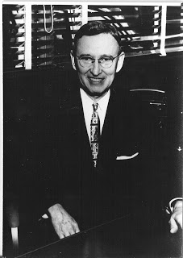
In 1947, the building next to the Robert and George Daly Hardware Store in Irondale collapsed. Below are photos of the event.

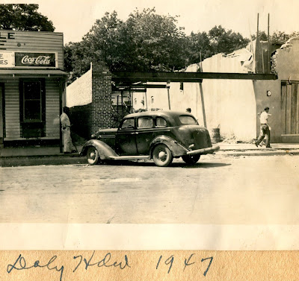

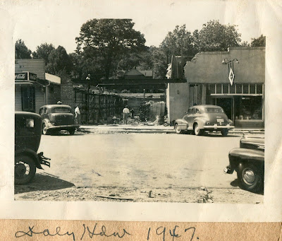
<

Also in the same block was Bess Fortenberry’s hamburger stand that gained fame as the ‘Whistle Stop Café’. We young boys always bought our baseball equipment each spring from the hardware store and Dr. Brock helped us young men fill out the questionnaire we received from the draft board in 1940 and 1941.

Incidentally, the chain grocery stores provided about the only job opportunities available at that time for boys. I worked at Hill’s on Saturdays ‘off and on’ almost to the time I left for the Navy. I was going to Birmingham-Southern at the time and was paid $2.50 for working from seven in the morning until 10 that night. Three cents was withheld for Social Security!"

More memories of Bishop Holliman next posting....

Tuesday, August 28, 2012
Memories of Irondale, 1925 to 1942, Part V
by H. Bishop Holliman
This is the fifth in a series of reflections on an earlier Irondale, Alabama by my father, Bishop Holliman, born 1919. - Glenn N. Holliman
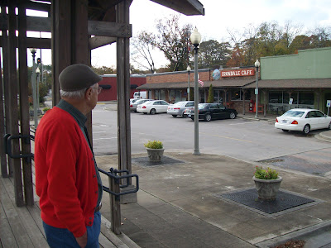
Bishop Holliman surveys 1st Avenue of Irondale, Alabama in November 2010. The café and buildings are still present but with different names and automobiles from the days of his childhood. The Model A Fords are gone. His brother-in-law’s Daly Hardware Store closed in 1960.

The Street Car…I can barely remember riding the street car that came into Irondale on 2nd Avenue North. It ran one block to 20th, went down the short hill…past Ina Powell’s barber shop and Mr. Gaddis’ blacksmith shop, turned right on 1st Avenue North in front of the grocery store, drug store and hardware store. Then back up the slight hill on 19th Street and headed back to town. It must have been 1927 that they replaced the street car with the bus. The fare was seven cents."
Below in 1976 Alvin W. Hudson and Harold E. Cox published a history of street cars in Birmingham, Alabama. In this work they stated that the rail line service extended in April 1913 to 'the newly developed town of Irondale'. In 1927, the cars ceased running and as Bishop Holliman notes, buses replaced them.
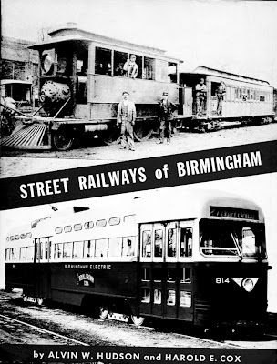
"Riders were given a free transfer from the bus to street cars in Woodlawn for completion of our ride into downtown Birmingham. In Woodlawn we transferred to No. 27 or No. 2 that would take us into town and/or Ensley or West End, all for seven cents!

Most folks rode street cars/busses in the 1920s and up into the 1930s, and again during World War II. Daddy (Ulyss S. Holliman) worked for the street car company (Birmingham Electric Company). The first street car ride I remember was to East Lake Park when I was about six years old."
Below, from the work 'Street Railways of Birmingham', is the route from Birmingham to Irondale. Although undergoing development as a work class suburb in the 1910s and 20s, Irondale as a settlement predates the much larger Birmingham.
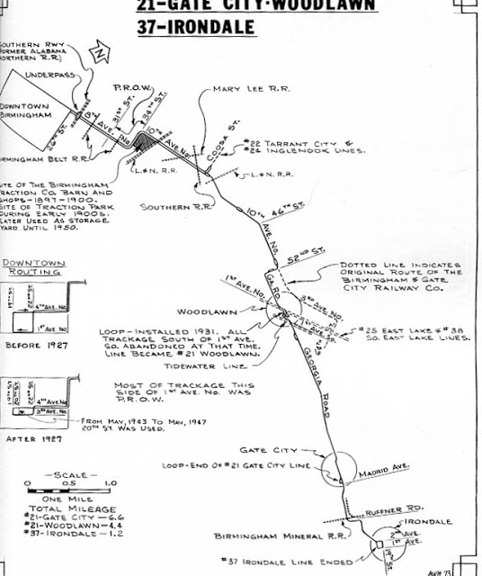

"We transferred to the First Avenue car going to East Lake where there was an amusement park with a merry-go-round, and several other rides. I think we went two summers. I guess it was the Depression beginning in 1929 that brought an end to that entertainment. The street car was a big part of my life until I left in 1941 for the War. I rode it nearly every day to Birmingham Southern College and any time I went to town."
The last street car to run in Birmingham was April 18, 1953 and an era ended.
More Irondale, Alabama memories in next post....

Tuesday, September 11, 2012
Memories of Irondale, 1925 to 1942, Part VI by H. Bishop Holliman
This is the sixth in a series of reflections on an earlier Irondale, Alabama by my father, Bishop Holliman, born 1919. - Glenn N. Holliman
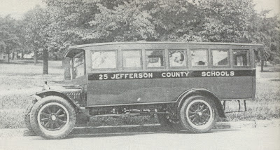
Above, Bishop Holliman rode a bus similar to this one from Irondale to Shades Cahaba School in Homewood leaving at 7:30 am every school morning for a 30 minute, non-stop ride. Photo from the Shades Valley Alumni web site.

"Schools…Irondale schools were among the best in Alabama. I remember all my teachers and events that occurred in each grade. Mr. Houk was principal when I entered in 1927. Later, George S. Millsap was made principal. He was a good teacher but very, very strict, as were all of the teachers. Irondale students competed very well at Shades Cahaba with students from other schools and from families more prosperous than Irondale families. "
Below a page from the 1940 The Owl, the yearbook of Shades Cahaba High School. Far left is Bishop Holliman's sister, Virginia. On the back row, standing behind and right of the student typing, is Walter Cornelius (wearing the tie). Virginia and Walter would marry in 1942. Virginia's brother, Ralph Holliman, was on the staff also. He may be in the photo back row, 2nd from right, next to Walter, his future brother-in-law.
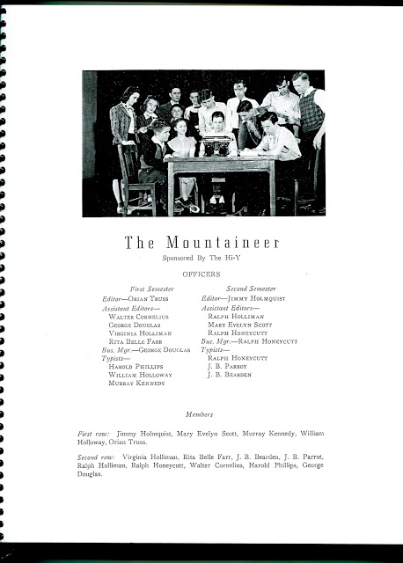

"In 1937, the year of my graduation, I was editor-in-chief of the annual and my closest friend, Charles Pugh, who lived a few doors from us on the hill, was president of the senior class and valedictorian. Some other names that come to mind after all these years are Cecil Giddens, Jean LaFurgy, the two Gaylor boys, the Hurtt girls, Sadie Mae Burgess and Corely Odum.
Irondale students were well-behaved at Shades Cahaba, not entirely due to family upbringing, but also to the strict teachers at Irondale. At the end of the school year in 1933 I was double promoted to the 9th grade, which was the senior year of Junior High.
There were five of us: Clementine Shurbert, George Sorrell, J.H. Ratliff, Oscar Lee Hurt and myself. I am the only one of that circle still living. Our teachers in junior high were Mr. Millsap who taught 9th grade algebra, Miss Margaret Hanes, math and science and Mrs. Joe McClendon English and civics. "
Built in 1920 and renewed several times, Shades Cahaba is now a Homewood, Alabama elementary school. Note the concrete owl on top of the building.
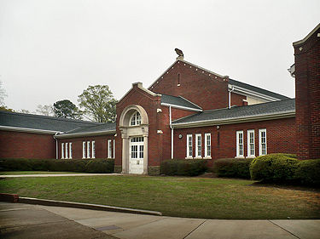
"In retrospect, I think skipping the 8th grade was one of the worst things that could have happened to me. Why? Well, it simply took a year out of my life and it put me in high school and college a year younger than my peers. I don’t think I every caught up, as I always felt insecure when with classmates who were a year older. And also I did not get a good foundation in math by being introduced to 9th grade algebra minus 8th grade math.

In 9th grade civics each Friday we read and discussed the Weekly Reader, a compilation of current events. On this particular Friday one student, Clyde Godwin, was reading from the paper an item about President Roosevelt’s visit somewhere. He meant to read, “The President wore a flower in his button hole.” Instead he read, “The President wore a flower in his bottom hole.” Well, the class exploded!
Even Mrs. Mac (as we were allowed to call her) lost her dignity and laughed along with us. At that age, now soon becoming 15 I was very conscious of how my hair looked, and to make sure it was combed neatly I put a lot of hair oil on it every day. At graduation in May each member of the class was given a gift of dubious value accompanied by some sort of explanation. For me, the gift was a small can of pure lard with the accompanying verse: “To keep your hair down, we know it is hard, so we give to you this compound lard!”

A sad thing happened soon after school opened again in September, principal Mr. Millsap, who was only 31 years old, one morning before 8 o’clock wrapped a towel around his head, put a gun up to it and pulled the trigger. His death was a big blow to all of us and was not easy for his current students and the most recent graduating class to get over.
Glenn Barrow was made principal and remained in that position until death in the Army in 1943. Photo below.

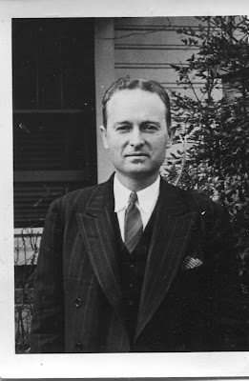
Above, Glenn Barrow died in 1943, much too young. He had a deep influence as a principal and teacher. Bishop Holliman in 1946 would name his only son after him.

Next posting, more memories of pre-war Irondale, Alabama....

Tuesday, September 25, 2012
Memories of Irondale, 1925 to 1942, Part VII by H. Bishop Holliman
This is the seventh in a series of reflections on an earlier Irondale, Alabama by my father, Bishop Holliman, born 1919. - Glenn N. Holliman
The Great Depression…"I was too young to remember the beginning of the Depression and the havoc it wrought to so many. In my young mind, times had always been hard and some people had always been without work. Daddy (Ulyss Holliman) was off from the job just six weeks in the summer of 1933. Many folks we knew were out of work.
It was not uncommon for men to come to the house asking for food and/or other forms of help. Some children went to school bare footed. Loudelle (Holliman Ferrell) and Euhal (Holliman) were still at home. Melton (Holliman) had married in 1932, but he had been living away from home before his marriage and had worked full time. Like us, many folks in Irondale kept chickens or a cow and put in big gardens and managed to get by."

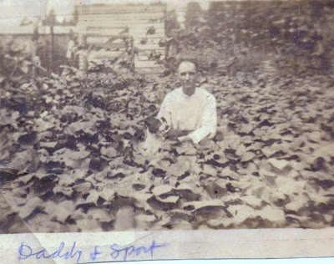

Ulyss S. Holliman of 2300 3rd Avenue, North in Irondale poses in the middle 1920s in his large garden. A native of Fayette, Alabama, Ulyss moved his growing family to this suburb of Birmingham during World War I to take advantage of employment opportunities. During the 1910s, the population of Irondale almost doubled as more and more lots were sold on the hill side overlooking the railroad yard.

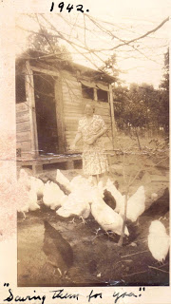During World War II, Pearl Caine Holliman wrote her son, Bishop Holliman, who was in the U.S. Navy, promising to save a Sunday chicken for the day he would return home from the war. As with gardens, many in Irondale raised their own chickens. For several years in the late 1930s, the Ulyss Hollimans even had a milk cow.
"The WPA (Works Progress Administration) and other New Deal projects soon provided menial jobs for the unemployed. In 1936 the sewer systems were installed, and we began to enjoy
indoor plumbing. An early New Deal project was the building of sidewalks through most of the town. Though not a New Deal project (as far as I know) the streets were paved during World War II, and I think Frank Williams was mayor at the time.
I have already alluded to the hobos who rode the freight trains during these years----In my mind, hobos had always ridden them. Central heating had not come into vogue so it was still my job each day to bring in coal and kindling for Daddy to start a fire each morning. We had a heater in the middle bed room and later, one in the living room. After the War, they managed to get central gas heat."
Population statistics reveal the calamity of the Depression. In 1920, by which time the Hollimans had moved to Irondale and were about to construct a home at 2300 N. 3rd Street, the population was 809. As the Montgomery subdivision kept growing, the number of people living in the town almost doubled in ten years to 1,517 in 1930. Irondale must have felt like a thriving and booming place in the "Roaring Twenties".
During the Depression, growth stopped and the population even dropped to 1,486 in 1940. By 1970, the population reached 3,166 but in the four decades since, the numbers living in Irondale have quadrupled to 12,349 in 2012. Source Historical Populations, Wikipedia, Irondale, Alabama

More of Memories of Irondale, Alabama in next post....

Wednesday, October 10, 2012
Memories of Irondale, 1925 to 1942, Part VIII by H. Bishop Holliman
This is the eight in a series of reflections on an earlier Irondale, Alabama by my father, Bishop Holliman, born 1919. - Glenn N. Holliman
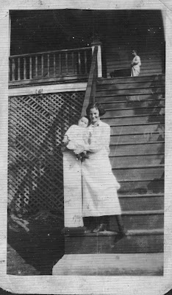
Right, in 1924, Pearl Caine Holliman, age 37, holds her 7th and last child, Ralph Holliman, in her arms at the foot of the tall front stairs of her new home she shared with her husband, Ulyss S. Holliman, and family at 2300 3rd Avenue North. At the top of the stairs is her 6thchild, Virginia Holliman Cornelius.
Below in 2010, Bishop Holliman viewed the steps, now all brick, leading to the front porch and his memories of his beloved ‘Mama’. After his mother died in 1955, his father, Ulyss S. Holliman, sold the home to another son, Euhal Holliman. After Euhal's wife, Edna, died in 1992, the house was sold out of the Holliman family.
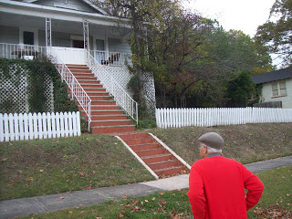

"Each summer Mama would can fruits and vegetables, maybe over 100 jars, as did most housewives. I should note that my sister Vena had married in 1928 and was living next door in the brick house (visible as the white house on the extreme right in the above photo).
Her husband, Robert Daly, was manager of the Woodlawn bank and had a good job throughout the Depression. They were able to take vacations to the beach each summer, a treat denied to most folks in those years."
Below, Ulyss Holliman and his grand daughter, Mary Daly Herrin, who lived next door to her Holliman grandparents from 1932 until 1946. Mary still lives in Irondale with her husband E.C. Herrin whom she married in 1951. Behind the two is the chicken house, typical in the 1940's in small southern towns of families only one generation removed from farming.
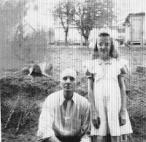
Ulyss is listed in the 1910 U.S. Census as a farmer in Fayette, Alabama. After moving to Irondale in 1917, he is recorded in the 1920 Census as a carpenter (for the Birmingham, Alabama Electric Company working on street cars).
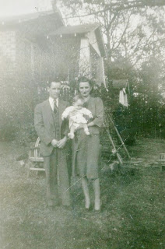
Right, Euhal and Edna Holliman in 1944 hold their fourth child, Jean Holliman, standing in front of the Robert and Vena Holliman Daly house on 3rd Avenue in Irondale.
As noted, Euhal purchased the next door Ulyss Holliman house in 1956. Jean would live with her parents in the Holliman house until her mother's death in 1992 when the house was sold.
Next post, more on living in Irondale, Alabama in the 1930s and 1940s....
Posted by Glenn N. Holliman at 7:49 AM

Wednesday, October 10, 2012
Memories of Irondale, 1925 to 1942, Part VIII by H. Bishop Holliman
This is the eight in a series of reflections on an earlier Irondale, Alabama by my father, Bishop Holliman, born 1919. - Glenn N. Holliman
Right, in 1924, Pearl Caine Holliman, age 37, holds her 7th and last child, Ralph Holliman, in her arms at the foot of the tall front stairs of her new home she shared with her husband, Ulyss S. Holliman, and family at 2300 3rd Avenue North. At the top of the stairs is her 6thchild, Virginia Holliman Cornelius.
Below in 2010, Bishop Holliman viewed the steps, now all brick, leading to the front porch and his memories of his beloved ‘Mama’. After his mother died in 1955, his father, Ulyss S. Holliman, sold the home to another son, Euhal Holliman. After Euhal's wife, Edna, died in 1992, the house was sold out of the Holliman family.

"Each summer Mama would can fruits and vegetables, maybe over 100 jars, as did most housewives. I should note that my sister Vena had married in 1928 and was living next door in the brick house (visible as the white house on the extreme right in the above photo).
Her husband, Robert Daly, was manager of the Woodlawn bank and had a good job throughout the Depression. They were able to take vacations to the beach each summer, a treat denied to most folks in those years."
Below, Ulyss Holliman and his grand daughter, Mary Daly Herrin, who lived next door to her Holliman grandparents from 1932 until 1946. Mary still lives in Irondale with her husband E.C. Herrin whom she married in 1951. Behind the two is the chicken house, typical in the 1940's in small southern towns of families only one generation removed from farming.
Ulyss is listed in the 1910 U.S. Census as a farmer in Fayette, Alabama. After moving to Irondale in 1917, he is recorded in the 1920 Census as a carpenter (for the Birmingham, Alabama Electric Company working on street cars).
Right, Euhal and Edna Holliman in 1944 hold their fourth child, Jean Holliman, standing in front of the Robert and Vena Holliman Daly house on 3rd Avenue in Irondale.
As noted, Euhal purchased the next door Ulyss Holliman house in 1956. Jean would live with her parents in the Holliman house until her mother's death in 1992 when the house was sold.
Next post, more on living in Irondale, Alabama in the 1930s and 1940s....
Posted by Glenn N. Holliman at 7:49 AM

Wednesday, October 24, 2012

Memories of Irondale, 1925 to 1942, Part IX by H. Bishop Holliman

This is the ninth in a series of reflections on an earlier Irondale, Alabama by my father, Bishop Holliman, born 1919. - Glenn N. Holliman

"Beginning in 1937, I was attending Birmingham Southern College, working in the library on a National Youth Administration job, another creation of the New Deal. However, we were still Republican! In 1938, the local GOP sponsored an oratorical contest for “Young Republicans”, and I represented Alabama in the finals in Knoxville, Tennessee and won second prize - $100 – a huge sum – enough to pay a semester at college.

Baseball…During the 1930s amateur baseball was very popular throughout Jefferson County and most of the small towns fielded a team. The baseball diamond in Irondale lay between the Seaboard and Southern tracks, along First Avenue South. It was a Saturday ritual to attend the games that Irondale The whites shared the diamond with blacks. The blacks seldom attended the white games but I often went to see the blacks play.
Some of the players I remember were Hubert Kilgore, Jack Godwin, Jesse Smoke, the two Wilson boys, Alfred McNutt and Click McDanal.
All of these fellows were the age of Loudelle Holliman Ferrell (a sister) and Euhal Holliman (a brother). Baseball was a big part of our lives during the 1930s. The Birmingham Baron games were broadcast over the radio by Bull Connor, and never missed a game if I could help it. I still remember Melton Holliman (the oldest brother) taking me to my first game at Rickwood field July 5, 1931!"
Baseball was not the only recreation for a large family. In the middle 1920s before middle class vacations, a summer treat was to take the family to Grant’s Mill on the east side of Irondale. Here Ulyss Holliman supervises his children in the water, Bishop Holliman front, Euhal Holliman, Loudelle Holliman Ferrell and Vena Holliman Daly, behind the boat.
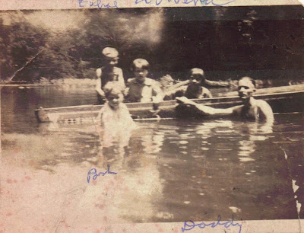

Next Post, more Memories of Irondale, Alabama in the early 20th Century....

Posted

Wednesday, November 7, 2012
Memories of Irondale, 1925 to 1942, Part X by H. Bishop Holliman
This is the tenth in a series of reflections on an earlier Irondale, Alabama by my father, Bishop Holliman, born 1919. - Glenn N. Holliman
Churches…There were three churches in Irondale as far back as I could remember: the Methodist, Baptist and Presbyterian. At Christmas each one staged a Christmas pageant the Sunday night before Christmas. Every summer the Baptist and Methodist Churches held a revival, and that meant for two weeks we had somewhere to go on the warm summer evenings before there were radios, television and air conditioning.

The revival that stands out in my mind was the one in 1936 at the Methodist Church (then located at 2009 South 2nd Avenue) conducted by Fred Brown from Bob Jones College. For two weeks the church was filled each night to hear the Word preached by this dynamic preacher. Even folks from the other two churches came to hear him. At the end of the revival put on a watermelon-picnic feast down at the artesian wells where East Side Mall as later built. I have many good memories of church activity up to the time I left in 1941.

Below an outing in Irondale in the late 1930s. Either church or Shades Cahaba friends (probably both). Virginia Holliman Cornelius is 3rd from left and Bishop Holliman on far right.
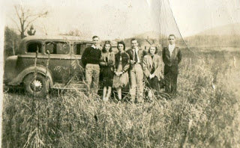

We young people were led by such folks as the Hamiltons, Sherets, Overtons, Grissoms, Glenn Barrow and many others. Most of our social life originated in the church – at Christmas, Halloween, summer outings at Grant’s Mill, where you could go swimming for 20 cents, and cook-outs in the fall at the beacon light on Gate City Mountain.
We also participated in putting on plays at the school, sponsored by the church in support of some project. One time we bought a pulpit bible with money we raised. Some participants I remember now were: Clementine Sherbet, Mary Virginia Hamilton, Frances McNutt, Jo Helen Leath, Charles Pugh and Louis Overton.
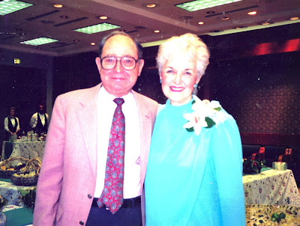
Above Bishop Holliman poses with his sister Virginia Holliman Cornelius (1922 – 2011) at a Birmingham, Alabama reunion in 1985 almost 50 years after the photo by the automobile.
Next Post, more memories and more people of Irondale, Alabama....

Tuesday, November 20, 2012
Memories of Irondale, 1925 to 1942, Part XI by H. Bishop Holliman
This is the eleventh and last in a series of reflections on an earlier Irondale, Alabama by my father, Bishop Holliman, born 1919. - Glenn N. Holliman
"The Blizzard of 1940…It was January or thereabouts that snow began to fall, and before it had ended, 14 inches lay on the ground, a very rare occurrence for our part of the South. It began about midnight and at daylight the radio had already come on with the news that schools would not open, nor would the colleges nor would hardly anything else.

I don’t remember what Daddy (Ulyss S. Holliman, 1884 - 1965) did about going to work. Street cars on some lines had run all night to keep tracks clear. I can’t remember the day of the week it was that all this happened. The hill (the north side of Irondale) was frozen over and I guess nearly impossible for cars to get up it. For two weeks the temperature hardly got above freezing, and it dropped to 10 degrees below on the second day."

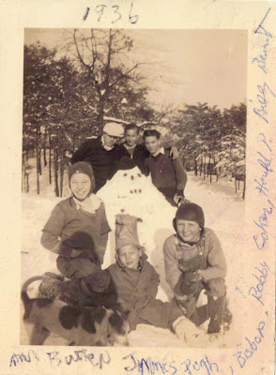
Not the snow of 1940, but above the snow of 1936 on 3rd Avenue, Irondale. Top left to right are The Rev. Stewart Butten, James Pugh, Bishop Holliman. Front row are Bobby Coker, Harold Pugh and Billy Bunt.
"I have forgotten how long it stayed at that mark. Remember, at this time we had no central heat, drinking, cooking, bathing and flushing. Even if they became unthawed, they would refreeze the next night. Each night young folks would gather at the top of the hill above our house, build a fire out of limbs, old tires, etc. and we built sleds out of scrap lumber that somebody furnished and we slide the two blocks downhill. That went on several nights.

It was probably the last night of this merriment that the accident happened. A car parked at the bottom of the hill had not pulled all the way into its driveway, leaving part of it in the road, and a sure target for an unguided sled."

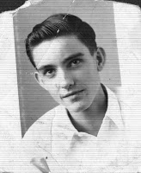
Ralph Holliman (b 1924), right, as a Shade Cahaba High School student ca 1941. Ralph had a highly successful career as a corporate executive in Chicago before retiring back to Alabama.
"My brother Ralph was at the front of the sled, followed by Margaret Overton, Jo Helen Leath and myself. You could not steer the sled. It went wherever the ice allowed it to go, and it went right into the back of the parked car! Ralph, who was at the front bore the brunt of the collision, bringing a gash to his head.

Robert Daly, Sr. was on the scene, having been there just to observe the goings on, rushed Ralph to Dr. Odum’s house on the other side of the town. The doctor patched him and sent him on his way. Probably did not charge more than $2 and did not say come back tomorrow. That experience put an end to our sledding."

Note Ralph Holliman believes the accident was in the great snow of 1936, not 1940. The two brothers have different memories of the date!

"The snow and ice eventually melted, but the blizzard of 1940 stayed with us a long time. That winter as so bad Life magazine ran a cover page in February of the Southern passenger train, The Tennessean, pulling into Washington, D.C., covered with snow and ice, also carrying a story about the frigid winter down south.”

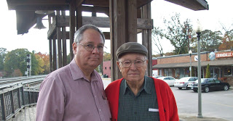Bishop Holliman, 90, returned to Irondale in November 2010 with his 64 year old son, Glenn N. Holliman, to tour the home of his childhood. Bishop named his only son after the Irondale educator, Glenn Barrow, who died during World War II.

Next Post, the Grand Photographic Collage of Grand Mother Holliman (Pearl Caine Holliman)....

Tuesday, December 4, 2012

My Grandmother's Wall of Photographs, Part 1
by Glenn N. Holliman
Is there a grandchild among us who has not stood and stared at family pictures in a grandparent's home? For a nine year old, the question must be always "Who are those old people? Did my aunts and uncles really look like that when they were young?"
Pearl Caine Holliman (1887-1955) had such a wall in her home at 2300 Third Avenue North in Irondale, Alabama. As a youngster, I marveled at the pictures and wondered who were all those people, those relatives of mine? Below are a few pictures and memories of my grandmother's wall of photographs.
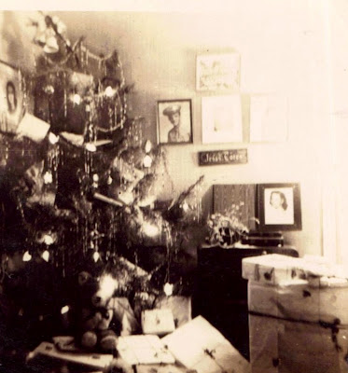

Let me start with an indoor picture, rare for the time, taken of Grandmother Holliman's Christmas tree. It stood in a corner of the living room, a massive tree to my childish eyes. This picture was taken in 1945, the year before I was born but she seemed aways to have a tall tree with electric lights that 'bubbled'. Yes, it is blurry and not the sharpest picture, but let's study it closely.
On the far upper left corner, one sees a photograph of my Aunt Virginia Holliman Cornelius (1922-2011). This may have been her senior picture from Shades Cahaba High School. Today, one of her daughters, Susan Cornelius Wilson of Texas, has possession of it.
Below, embedded in the lower left corner of Virginia's photograph, notice the World War II photograph of Virginia's husband, Walter Cornelius (1922-2006). They married in February 1942, one of the three war time marriages in the Ulyss and Pearl Holliman family. This copy of Virginia and Walter was taken in February 2012 in Trophy Club, Texas.
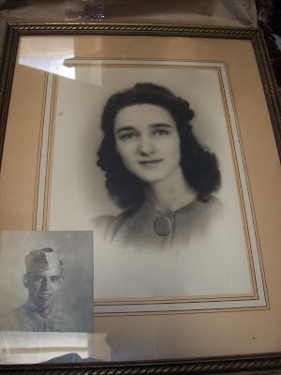

Below Susan Cornelius Williams, one of Walter and Virginia's two daughters, displays this picture seventy years after it first hung in her grandparent's home in Alabama. These pictures were taken at Alice Holliman Murphy's home in Texas. Alice is the daughter of Bishop Holliman (b 1919) and Susan's first cousin.
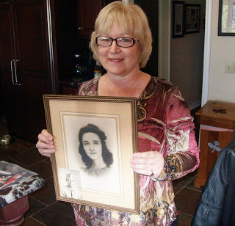
Next posting, more pictures from Grandmother's wall....
Posted by Glenn N. Holliman at 4:30 AM
Email ThisBlogThis!Share to TwitterShare to Facebook

Saturday, December 15, 2012

My Grandmother's Wall of Photographs, Part 2
by Glenn N. Holliman
The year was 1945, and here is another view of my grandmother's Christmas tree that first holiday after the end of World War II. The three sons who went to war of Ulyss and Pearl Caine Holliman of Irondale, Alabama - Melton, Bishop and Ralph - were finally home. A son-in-law, Walter Cornelius, husband of daughter Virginia, still remained in Saipan, a B-29 base in the Pacific. In the corner wall, several difficult-to-discern photographs are hanging. In the last post, we examined the one in the upper left, Virginia Holliman Cornelius.
Now let's look at the one in the upper center, an Army soldier, the youngest son, William Ralph Holliman, born 1924.
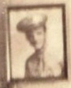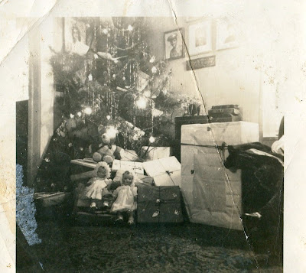
A blurred enlargement. The original was lost in a basement flood years ago.
Ralph went off to the Army in March 1943 and would not return to see his family and new bride, Motie Chisom, for two long years. Ralph would be stationed in England and France with the Army Air Force from late 1943 until the summer of 1945.
Below is a picture taken February 1942, when Ralph, age 18, visited his older brother, Bishop Holliman, age 22, already in the Navy at sonar sound school in Key West, Florida. The war was at its worst for the United States. German U-Boats prowled the East Coast sinking freighters. After the December 1941 attack on Pearl Harbor, the Japanese invaded the Philippines, an American colony at that time. A U.S. and Philippine army was trapped and would be forced to surrender. The days were dark for the American war effort that first winter of the USA involvement in World War II.
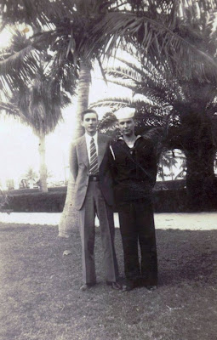

Next, the Photograph of Melton Holliman....
Posted

Tuesday, December 25, 2012

My Grandmother's Wall Photographs, Part 3
by Glenn N. Holliman
We have been examining the pictures that hung in the living room corner of the Ulyss and Pearl Caine Holliman in Irondale, Alabama. Below is another view of the wall at Christmas time 1945.
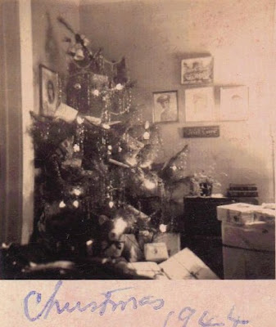
The picture is mislabeled 1944, but it is Christmas 1945. The picture of Virginia Holliman Cornelius is in the left corner, and Ralph Holliman next in line to the right of the tree. Blurred out by the flash bulb are Melton Holliman and Bishop Holliman. The picture displayed of Melton (1908-1958) is probably the one below. Melton's daughter, Pati Holliman Hairston, has kindly shared numerous pictures of her father with me.
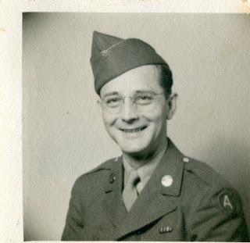
Melton served in France as a medic from July 1944 until high blood pressure sent him to the hospital and eventually home in December 1944. He was discharged in the summer of 1945 after final service at an Army hospital in Jackson, Mississippi. Unfortunately his health remained precarious with a first heart attack in 1955 and a fatal one in 1958 in Mobile, Alabama, much, much too young. He had learned pharmacy from his Uncle Floyd Caine, and became a leading and admired pharmaceutical salesman and Baptist lay leader.
Christmas 1945 would have been special for the three cousins below. Pati, Melton's daughter, is far left. Mary Daly Herrin holds on to her new brother, Robert W. Daly, Jr.
One suspects most of those presents around their grandparents' Christmas Tree were for the grandchildren of which there were 11 by that winter.
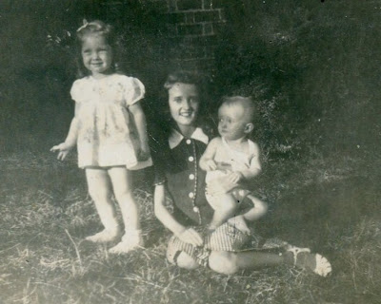
Next the Sailor on the Wall...

Monday, January 7, 2013

My Grandmother's Wall Photographs, Part 4
by Glenn N. Holliman
I have been writing about my Grandmother Pearl Caine Holliman's corner wall at 2300 N. 3rd Avenue, Irondale, Alabama. Informal indoor photography was still expensive in 1945, the year World War II ended. For some reason four photographs were taken of the tree that Christmas, perhaps to capture, at least in part, the photos on the walls. In this picture, one can observe that Grandmother Holliman has placed a new picture against the wall on table. That new photo is of my mother, Geraline Stansbery Holliman, one of the three war brides of the Holliman family, and the only one from out of state - Philadelphia, Pennsylvania.
Here's a close up of that picture. Bishop Holliman met 'Gerry' in 1942 while in Atlantic City, New Jersey, where he was trying to rendezvous with Irondale soldier, Charles Pugh. Bishop never found his boyhood friend, but he did sit behind Gerry and her Mother while at a show on the famed Boardwalk. They exchanged addresses, wrote for several years and lo and behold, the Alabama boy married the Philadelphia girl June 26, 1945. And so Gerry's picture, if not on the wall, was propped up under Bishop's, the Irondale sailor man.
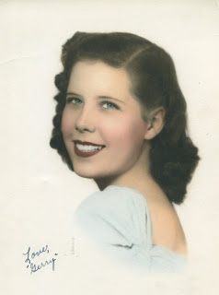
Below is the photo of Bishop, blurred in the top picture, the young sailor in December 1941, the month of Pearl Harbor. He was in boot camp in Norfolk, Virginia when the Japanese attacked. The war was on, and two other Holliman men, Melton and Ralph, also answered the call to service. Euhal Holliman was not called to duty due to being the father of four children by spring 1944.
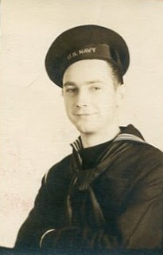
Bishop served as a radioman on two destroyers and saw action at the Invasion of Sicily in 1943 and in the North Atlantic in 1944. The last photo on the wall (top picture) is the one pictured below of Bishop (difficult to see seven rows back, left center, approximately 8 from the left with his hat pushed back or three to the left of the gun barrel nose) on the USS Barker. As a young boy, I would stare at this picture of my father and wonder. It is now in my possession.
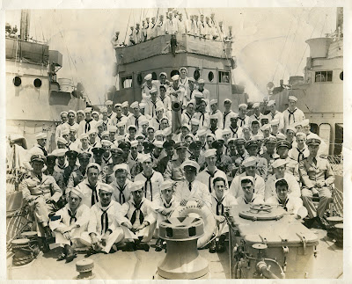
Alas, two of the three Holliman war time marriages ended in divorce. Virginia and Walter Cornelius in 1973 and Bishop and Gerry Holliman in 1988. However, five children emerged from these marriages, and numbers of us would not be in our present DNA composition if not for these young couples falling in love in terrible times.
Next posting, more photos from another wall in the Holliman Irondale home....

Thursday, January 17, 2013

My Grandmother's Wall Photographs, Part 5
by Glenn N. Holliman
In previous posts, I have been expounding on the portraits hung on the wall in my grand mother's home in Irondale, Alabama home in 1945. They remained mounted on the wall until Pearl Caine Holliman's death in 1955.
There was a special collage of photographs in a frame almost a yard wide and 8 inches high. It contained 55 photographs. Every time I visited my grandparents as a young boy, I stared and stared at the pictures of my father's family, when they were all so young.
When Grandmama Holliman died the photographic collage went first to her oldest daughter, Vena Holliman Daly (1909-1990), and while she lived in Irondale, it hung in her home. Later it passed to her older child and first of 19 grandchildren, Mary Daly Herrin. The large collection of Holliman family photos still hangs today over Mary's kitchen table in Irondale. Over 60 years later I still study and ponder the lives of the persons pictured.
Below approximately the first 1/3rd of the collage.

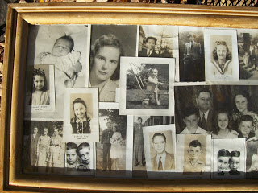

At the Ulyss and Pearl Caine Holliman descendants’ reunion at Al and Linda Herrin Bradley’s house in June 2012, Mary brought the collage for viewing. I took pictures of it, and later scanned them into my computer. With the help of my 93 year old father, Clayton Herrin, Patti Holliman Hairston, Ralph Holliman and others, the persons have been identified and labeled.
It is impossible with my camera to gather the entire collage in a viewable format, so I divide the work into six pieces. The photos are numbered. Click on twice and the picture will enlarge. Here we go to identify the pictures.
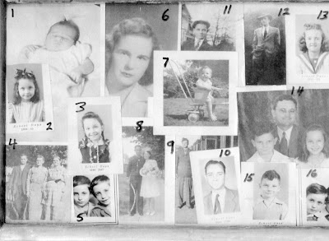

1. Carolyn Ferrell Tatum, daughter of Charles (1907-1999) and
Loudelle Holliman Ferrell (1914-1996). She resides in North Carolina.
2. Carolyn Ferrell Tatum in 1944 in Alabama. Her father was a United Methodist minister and the family moved often during 1940s serving churches in Goodwater, Jacksonville, Huntsville and Ensley, Alabama. Her brothers are Charles Halford and John Melton Ferrell.
3. Carolyn Ferrell Tatum in 1946.
4. William Lee Caine, Lula Hocutt Caine and Martha Jane Walker Holliman (1846-1931 – wife of John Thomas Holliman, and mother of Ulyss Holliman, photo taken in Fayette, Alabama). Left and center are William Caine (1862 - 1938) and Lula Hocutt Caine (1861-1957), the parents of Pearl Caine Holliman (1887-1955).
5. Jerry (1940-2003) and Terry are the twins of Euhal (1912-1989) and Edna Westbrook Holliman (1916–1992). Jerry died of heart failure while salmon fishing near his home in Alaska. Terry resides in Arizona.
6. Motie Chism Holliman (1925-2003) is the first wife of William Ralph Holliman (b 1924) and mother of Pamela Holliman and Kathy Holliman. Rachel Harbour is Kathy’s daughter.
Ralph and Motie married in 1943, a month before Ralph was inducted into the U.S. Army and World War II. He served in England and France and did not return home to see his young bride for over two years until the summer of 1945.
7. Glenn Nelson Holliman (b 1946) in Birmingham, Alabama. This photo was taken in 1947 at the Irondale, Alabama home of his grandparents. The red brick Daly house is just visible in the background. Many pictures were taken on the Holliman lawn with the Daly home in the background due to better afternoon lighting.

8. Bishop and Geraldine Stansbery Holliman in June 1945 outside of Germantown Methodist Church in Philadelphia, Pennsylvania. ‘Gerry’, a native of Bristol, Tennessee, lived in Philadelphia from 1941 to 1944, where she met an Alabama sailor on a three day pass in 1942 in Atlantic City, New Jersey. Three years later they married. They are the parents of Glenn Holliman, picture 7.
9. Melton Pearson Holliman (1908-1958) was inducted into the U.S. Army in August 1943 at the age of 35. This photo of him is at Camp Barkley in Texas where he did a grueling basic training and advanced work as a medic. He served in France with a medical unit from July to November 1944. His health broke, and he was sent home to serve out his duty in Jackson, Mississippi hospital as a pharmacist. He suffered a major heart attack in 1955 and a fatal one in 1958. He may very well have been a casualty of World War II.

10. Bishop Holliman (b 1919) came home to Birmingham in 1945 with his new bride. With the G.I. Bill, he finished Birmingham-Southern College and in 1947 started teaching school at Shades Cahaba Jr. High and later the new Shades Valley High School. This picture is of him as a history and civics teacher. (Do you wonder where his son obtained his interest in family history?)
11. Euhal Holliman looks snazzy in his cap, probably from the 1930s. Euhal had some tough timing in his life as he left high school just as the Great Depression began. He went to work to help pay family bills in the only job he could find at the time - a produce grocer. As his own family grew, he made food sales his career. During his employment at various supermarkets in Gadsden and Birmingham, he was tapped by his co-workers to serve as their labor union representative. His leadership helped to achieve living wages and benefits for Alabama grocery workers.
12. Ralph Holliman (b 1924), looking dapper, poses in front of the Daly house in Irondale, Alabama sometime in the 1940s. Ralph served in World War II as a clerk in an Army Air Corp unit, logging and scheduling air transport flights. He was praised for his administrative abilities during the war by his commanding officer. V-E day found him celebrating in Paris. After time at Birmingham-Southern College, he put his skills to work with a post-war career at American Bakeries retiring as their national vice-president for operations.

13. Mary Daly Herrin is the daughter of Robert W. (1901-1959) and Vena Holliman Daly (1909-1990) and the first born of the 19 Holliman cousins. This photo is of her during school days and before she met the love of her life, Elliott Clayton Herrin, whom she married in 1951.
14. The Charles and Loudell Ferrell family – back Charles Ferrell (1907-1999) and Loudell Holliman (1914-1996), married 1935. Left to right: Charles Halford Ferrell, Carolyn Ferrell Tatum and John Melton Ferrell.
15. Charles H. Ferrrell graduated from Birmingham-Southern College and earned a divinity degree from Emory in Atlanta, Georgia. In 1963 as a United Methodist minister in the North Alabama Conference, he wrote a letter to the then segregationist Governor George C. Wallace decrying his racial policies. The courageous letter, that put Hal's career at risk, was reproduced in a definitive biography of Wallace highlighting that not every white Alabamian supported Wallace’s racial intolerance during those troubled times.
16. Terry and Jerry Holliman, the twins, left Alabama in the early 1960s and located to the far north, Anchorage, Alaska where Terry worked as a fireman for 25 years. Jerry made a career as baggage supervisor for Alaska Airlines. Unfortunately Jerry died in 2003 of a heart attack while engaging in his favorite past time of salmon fishing.

Section 2 of the Collage in the next post!

Friday, February 1, 2013

My Grandmother's Wall Photographs, Part 6
by Glenn N. Holliman
We continue our tour of my grandmother's, Pearl Caine Holliman, collage of photographs in the late 1940s. Until her death in May 1955, this collection hung on her wall in Irondale, Alabama. Today it hangs in the home of Mary and E.C. Herrin. We begin again with #17.
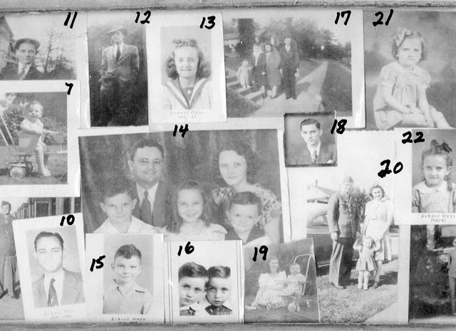
17. In 1944, the family of Robert W. Daly, Sr. posed on the steps of the Ulyss family home at 2300 N. 3rd Street. Left to right, Robert W. Daly, Jr. (b 1943), Mary Daly Herrin (b 1931), Vena and Robert Daly. Their home is in the background. Even before he and Vena married in 1928, Robert Daly, Sr. had become a beloved mentor to the 'second generation' of the children of Ulyss and Pearl Holliman - Bishop, Virginia and Ralph Holliman. His benevolent influence on the whole Holliman family of that generation is incalculable.
18. A snapshot of Ralph Holliman evidently taken while in high school at Shades Cahaba.
As with his sister, Virginia, two years older, Ralph graduated with honors. However,
the lack of family financial resources and the all-consuming World War II delayed his
entry to Birmingham-Southern College until 1945. Ralph went to work, considered
his military options and courted Motie Chisom, his high school sweetheart. They
married in winter 1943, and a month later the draft swept him into the U.S. Army.
19. Glenn Holliman (b 1946) in the stroller with his young mother, Gerry Stansbery Holliman (b 1923) beside him in 1947. This war time marriage resulted in two other children besides Glenn. Rebecca Louise Holliman Payne was born in 1950 and Alice Lynn Holliman Murphy in 1956.
20. Melton, wife Ida Hughes Holliman (1905 – 1995) and Pati, probably taken in February 1944 during a short leave Melton had before being shipped to England and France. Drafted at age 35 into the U.S. Army, the 3rd son of Uylss and Pearl to go to war, Melton already had been married for 12 years. Pati had entered their lives only three months before he put on his uniform in August 1943.
21. Mary Daly Herrin was the first born of the 19 first cousins of this generation. To her aunt and uncles - Virginia, Bishop and Ralph - whom she was close to in age, she was more a kid sister than a niece.
22. Mary Daly Herrin in 1940, Irondale, Alabama, would marry E.C. Herrin in 1951. This generous couple by the late 1960s made their Irondale homes the gathering place for her aunts, uncles, cousins and all their children during the many family gatherings into the early 2000s. Today, their daughter, Linda Herrin Bradley and her husband, Al, continue this tradition by opening their Alabama beach home to family and many cousins.
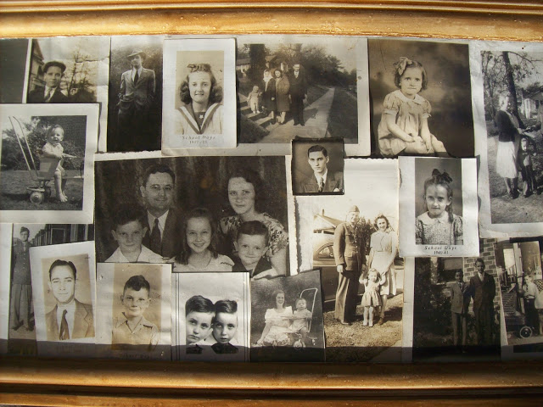
More of the pictures next posting....

Friday, February 15, 2013

My Grandmother's Wall Photographs, Part 7
by Glenn N. Holliman
This posting continues to examine the wall collage of my grandmother, Pearl Caine Holliman of Irondale, Alabama. She and her husband, Ulyss S. Holliman, had seven children and nineteen grandchildren. The collage today is held by the first of the cousins born, Mary Daly Herrin. Previous sections of the collage can be seen in earlier posts.
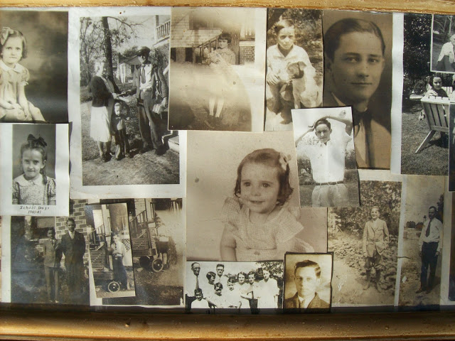

The numbered pictures may be seen in the next photograph below.
23. Pearl Caine Holliman (1887-1955) with Robert W. Daly, Jr. (b 1943) at her feet accepts the first door to door delivery of U.S. Mail at her home at 2300 N. 3rd Street in Irondale, Alabama. Due to her efforts, the post was delivered to Irondale homes, and one no longer had to cross the dangerous and busy railroad tracks to get to the post office. This picture ran in the Woodlawn, Alabama newspaper in 1944. My grandmother was 57 at the time.
24. Dressed in their Sunday best, Ralph and his brother, Bishop, pose by the Daly house, probably around 1937. I suspect Ralph did not enjoy that suit too long. A growth spurt would soon send him towering over all his siblings to 6’4” or more.
25. Bishop holding a football in the 1920s
26. Virginia Holliman Cornelius and a wagon in the 1920s.

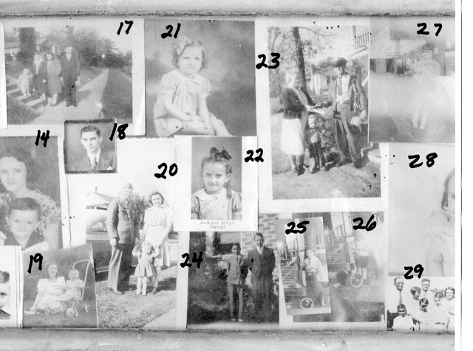
The following are obscured in the numbered copy, but can be seen more clearly in the next post and of course in the clear photo above.
27. Virginia Holliman Cornelius (1922-2011) clutches her doll. Virginia was the sixth child
born to Pearl and Ulyss, and the only daughter born in Irondale. Vena and Loudelle were both natives of Fayette, Alabama, 45 miles to the west near the Mississippi
border.

28. Anne Holliman Phillips was the first daughter born to Euhal and Edna
Westbrook Holliman. This is a beautiful photograph and can be appreciated in the top picture.

29. This photograph of the entire Ulyss and Pearl family must have been made around
1930. Left to right, Ulyss, Ralph, Pearl, Virginia (eye obscured in picture), Melton in
back, Bishop, Vena, Euhal and Loudelle on right. Ulyss moved his family to Irondale from Fayette, Alabama during World War I.
He worked until retirement in 1949 for the Birmingham Electric Company, which ran the street cars in the 'Magic City'. His job was to repair the wooden frames and seats of the trolleys. Four years after he retired, the last street car rolled through Birmingham, all replaced by buses. Below, the full collage.
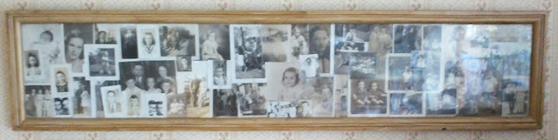
More next post....

Sunday, February 24, 2013

My Grandmother's Wall Photographs, Part 8
by Glenn N. Holliman
We continue our tour of Pearl Caine Holliman's photographic collage which now hangs on the kitchen wall of Mary and E.C. Herrin in Irondale, Alabama. E.C.'s parents, Elliot Clayton Sr. and Pyretta Walker Herrin are bottom left and his aunt and uncle, Ludi and George Herrin bottom right under the collage. In the center are portraits of Mary's parents, Robert and Vena Holliman Daly.
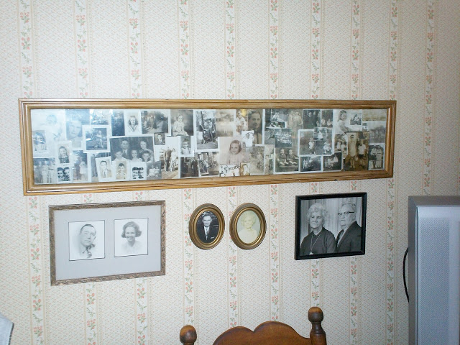

Below, the next section of the collage.

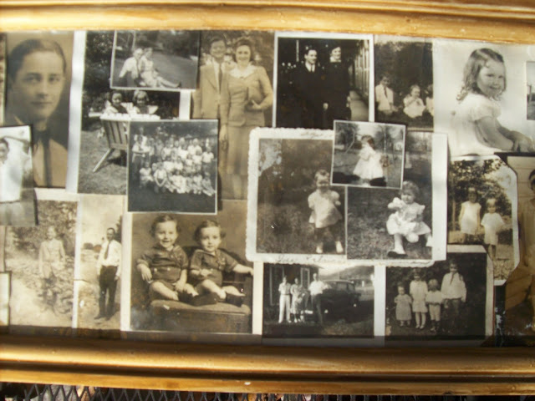
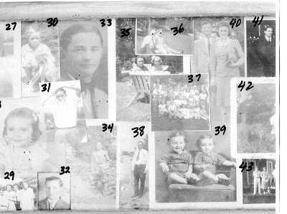
30. Euhal and the family dog, Sport.
31. Ralph, meticulous as always, combs his hair for the photographer.
32. A studious looking Euhal presents a handsome portrait in this picture.
33. Melton was nicknamed ‘Rosie’ by his classmates while in high school. He graduated in 1927, and went to work in his Uncle Floyd Caine’s drug store. There he mastered the pharmaceutical trade and stayed in it all his life. Floyd (1883 – 1966) as Lula Hocutt Caine’s son.
34.Melton Holliman in sporty dress in the 1920s.
35. Vena Holliman Daly and her daughter, Mary Daly Herrin, on the Daly-Holliman lawn.
36. Ulyss and Pearl Caine Holliman on the lawn with grandson Glenn N. Holliman, Bishop’s Son.
37. Far right stands Pearl Caine Holliman who in the 1940s entertained in Irondale her Sunday School class for which she was a teacher. Ulyss and Pearl were very active in the Gospel Tabernacle Church of The Rev. Glenn Tingly of Birmingham. Tingly was controversial, and the first radio preacher in the city from the early 1930s.
While he preached against vice and immorality, Tingly's emotional, end of time theology was not shared by the entire family. The Ferrells in particular, moderate Methodists, were in disagreement with Loudelle’s parents and their financial support of the Tabernacle. Robert Daly, Sr. wrote scathingly during World War II how this ministry was taking resources from Ulyss and Pearl that could have been better used supporting Lula Caine, Pearl’s mother, who lived on a small rail road widow’s pension and who took in boarders to make end's meet.
38. Andrew ‘Eck’ Holliman was one of the six brothers of John Thomas Holliman, and the first to die (1882-1926). Interesting he is the only brother of Ulyss on the picture board. He succumbed to a heart attack and is buried in Anniston, Alabama where he worked for the railroad.
39. Jerry and Terry Holliman.
40. Melton and Ida Hughes Holliman (1905-1995).
More next posting....

Sunday, March 10, 2013

My Grandmother's Wall Photographs, Part 9
by Glenn N. Holliman
The Last Section....
Below is the last portion of my grandmother's, Pearl Caine Holliman, collage of photographs of family she put together in the late 1940s. Grandmother Holliman died in 1955 of heart disease suffered at her home, 2300 3rd Avenue N., Irondale, Alabama.
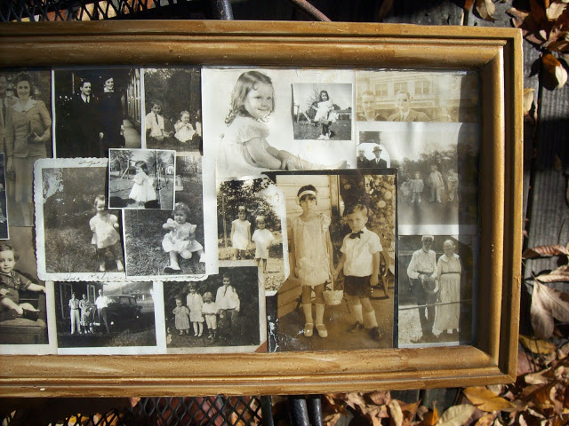

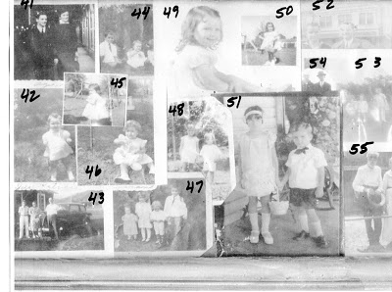
Our identification of the framed photographs continues....

41. Euhal and Edna Holliman. Euhal was the third child born to Ulyss and Pearl in 1912.
42. Patti Holliman Hairston, daughter of Melton and Ida Hughes Holliman.
43. Ralph Holliman and his mother and father, Pearl and Ulyss, on a 1940 trip to western North Carolina. Ralph as the last of seven children, b 1924, to Pearl and Ulyss.
44. Melton and Loudelle Holliman, taken approximately 1915 in Fayette, Alabama. In 1917, Ulyss would move the family to Irondale for economic reasons.
45. Pam Holliman, first born of two daughters born to Ralph and Motie Holliman.
46. Nancy Carol Cornelius Morton, daughter of Virginia and Walter Cornelius (1922-2006)
47. Left to right – Loudelle, Vena, Euhal and Melton Holliman, perhaps 1915.
48. Virginia and Ralph Holliman, sister and brother, perhaps 1926.
49. Patti Holliman Hairston, left, with unknown girl.
50. Pam Holliman, today a professor of religion at a Chicago seminary.
51. Virginia Holliman Cornelius and Ralph Holliman were posed in 1928, dressed up for a traveling photographer, at the time of Vena Holliman and Robert W. Daly, Sr.’s wedding in Irondale, Alabama. Ralph, age 4, perhaps to his chagrin, was the flower boy.
52. Bishop Holliman and his oldest brother Melton met in New Orleans in the winter of 1942. Bishop was in the Navy, the only child yet in service in World War II. Ida and Melton had moved to Mobile, Alabama from Birmingham around 1940.
53. The photo is blurred but left to right are Jean, Anne, Jerry and Terry Holliman with their father, Euhal, behind them. This was made perhaps in 1946.
54. Ulyss and Bishop pose in Key West, Florida in early February 1942. Loudelle, Charles, Ralph, Pearl and Ulyss drove from Irondale to Key West, Florida (a long, long trip in that era) to visit Bishop during this critical time in World War II. They had no idea when (or if) they might see him again.
55. Taken in the late 1920s in Fayette, Alabama are John Thomas (1844-1930) and Martha Jane Walker Holliman (1846-1931). Interesting as the parents of Ulyss Holliman, this photo might be first, but Grandmother Holliman put it last. According to Rhodes Holliman, a Holliman family historian and a great grandson, Martha Jane had personality challenges. John Thomas seems to have suffered Post Traumatic Stress Syndrome from his terrible experiences in the Civil War. He farmed all his life and died in poverty with no savings and before Social Security and Medicare. Their sons had to financially support them in their old age.
Martha Jane’s father, Samuel Walker, went off to fight for the Confederacy in 1862 when she was 16 years old. This great, great grandfather of my generation (we have no picture of him) was at the Battles of Gettysburg, the Crater, Petersburg and Lee’s last retreat. Pearl’s grandmother who is pictured at the beginning of this frame lost her father, Manasses Hocutt, after he died in 1863 from wounds at the Battle of Stone’s River, Murfreesboro, Tennessee.
One can argue that the Holliman family did not recover from the Civil War until the advent of the generation of the children of Ulyss and Pearl Caine Holliman – Melton, Vena, Euhal, Loudelle, Bishop, Virginia and Ralph.
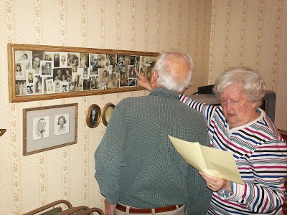

For over 65 years Bishop Holliman (back to camera), son of Ulyss and Pearl Caine Holliman, and his niece, Mary Daly Herrin, have studied and identified their many relatives and loved ones in the collage. Above in January 2013 in Mary's Irondale home, the two did so together one more time.

Sunday, March 24, 2013

Return to Irondale 2013, Part 1
by Glenn N. Holliman
Memories of Irondale, Alabama....
January 29, 2013, H. Bishop Holliman, b. 1919, returned to his boyhood home to share at a meeting of the Irondale Historical Society his memories of the 1920s and 30s. A crowd of 46 turned out to listen and ask questions. Bishop was assisted in his talk by input from his childhood friend, James Pugh, a young 92.
Below, Bishop in the pale blue shirt at the front of the rooms listens to a remark by James Pugh to the back right of this photograph. The meeting was held at the Irondale Public Library community room. The distinguished head of flowing gray hair, back to camera in butter scotch colored sweater, belongs to Bishop's great nephew, Clayton Herrin.
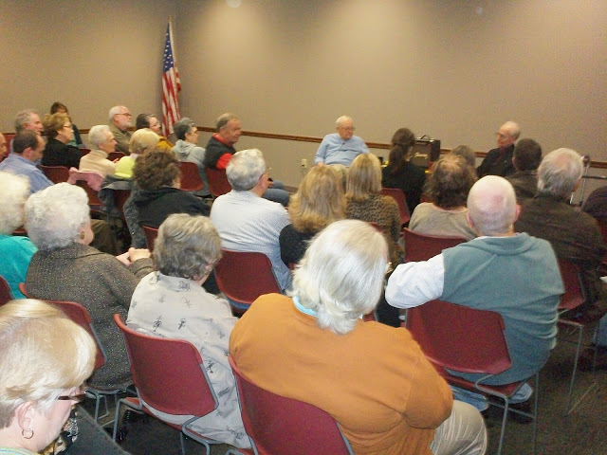
Below, among the many relatives attending were back row - Wally and Tommie Holliman Allen and Jean Holliman, daughters of Euhal and Edna Holliman. Far rear by the camera is Tommie's son, Brian, who videoed the event. Front row is a brand new father, David Herrin, who brought his new daughter briefly to the meeting. Next to him in reddish orange shirt is E.C. Herrin and his wife, Mary Daly Herrin, the first grand child born to Ulyss and Pearl Caine Holliman.
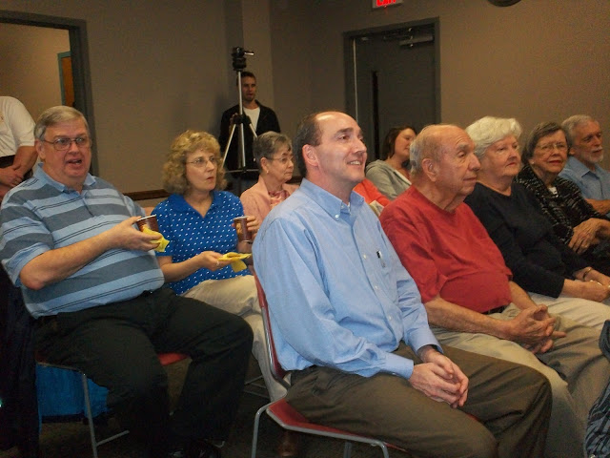
After the speech, Bishop, a young 93, signed copies of his book entitled "Memories of Irondale, Alabama, 1920s and 30s". E.C. Herrin, back row, looks in stunned wonderment that anyone, anywhere possibly would want Bishop's autograph! For a free electronic copy of the booklet, please write glennhistory@email.com.
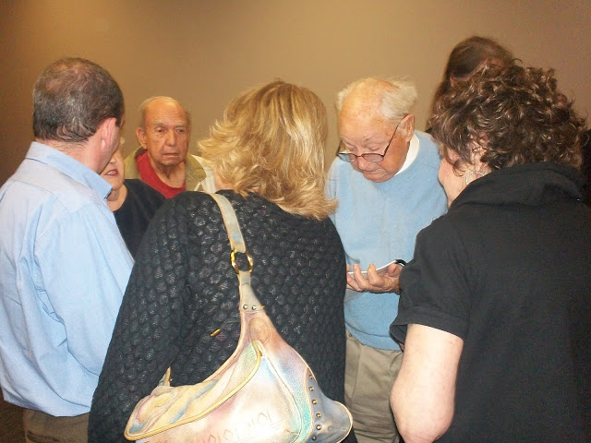
Learn more about the Irondale Historical Society at www.irondalehistory.org . Bishop Holliman is grateful to president Denise Tew Wright for their kind invitation to share a bit of Irondale memories.
Next post, more photographs of family and stories from Uncle Bishop's book!

Tuesday, April 2, 2013

Return to Irondale 2013, Part 2
by Glenn N. Holliman
More Irondale, Alabama Memories....
As written in the last post, Bishop Holliman, b 1919, returned to his home town of Irondale in January 2013 to join boyhood friend James Pugh in a session before the Irondale Historical Society. In the 1930s, Bishop called James 'Huck' and James called Bishop 'Tom'.
Below, Denise Wright, director of the Irondale Historical Society moderates 'Tom' and 'Huck' before a full house of persons interested in life in their small Alabama community during the Depression. Bishop is left in blue and James in dark blue. Against the wall, left of the flag, audio recording the session is accomplished story teller and actress Dolores Hycock of Irondale who interviewed Bishop for two hours earlier that day.
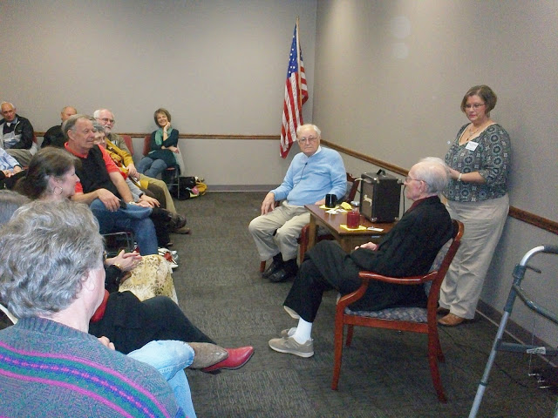
Bishop's take on life in early 20th Century Alabama is written in this manuscript below. Yours truly added some Irondale history and photographs donated by family members. A copy is available by email and also on my Ancestry.com site. Booklets were donated to the Irondale Historical Society and the Public Library.
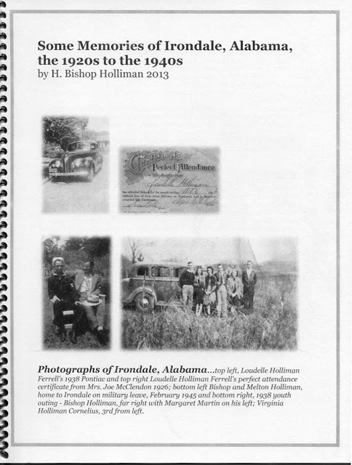

Below, among those attending were Charles H. Ferrell, second row right in pale blue shirt, who is Bishop's nephew. Wife Nancy sits to his left. In the row behind are David, E.C. and Mary Daly Herrin, a niece. Back row, left to right are Wally and Tommie Holliman (niece of Bishop) Allen and Jean Holliman, another niece. Bryan Allen, a great nephew, videos the session. Dolores Hydock, professional story teller, is against the wall, right. James and Bishop are in front.

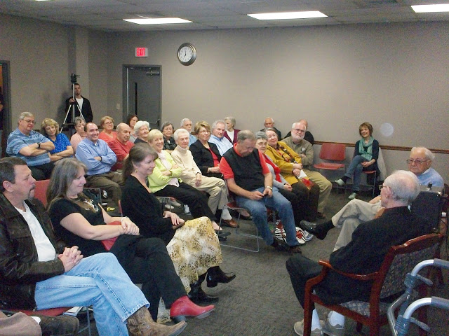
Next posting, more photographs of family and friends at this nostalgic meeting....

Tuesday, April 16, 2013

Return to Irondale 2013, Part 3
by Glenn N. Holliman
Photographs of Family and Friends....
The January 2013 session of the Irondale Historical Society turned into a mini-family reunion for the Holliman family. Below left to right both rows are: Glenn N. Holliman, Tommie Holliman Allen, Walley Allen, Jean Holliman, E.C. Herrin, Clayton Herrin, Elliot Herrin, Glenda Youngblood Norris (grand daughter of Cecil Rhodes Holliman), Mary Daly Herrin, Nancy and Charles Ferrell, Bishop Holliman, David Herrin and Brian Allen.
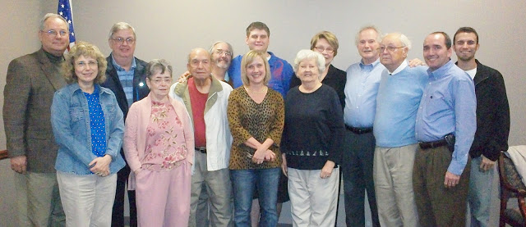

Below Bishop Holliman hugs Jean Bunt Trammel of Irondale, Alabama. The Trammel's were neighbors of Bishop's when growing up in the 1930s on 3rd Avenue North.
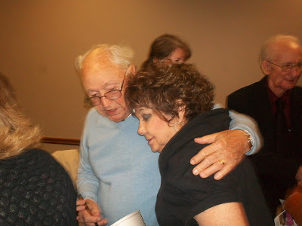
Below, Walley and Tommie Holliman Allen, their son Brian and Jean Holliman. Tommie and Jean are the daughters of Euhal and Edna Westbrook Holliman who raised their family at 2300 3rd Avenue North, Irondale from 1956 to Edna's passing in 1992.
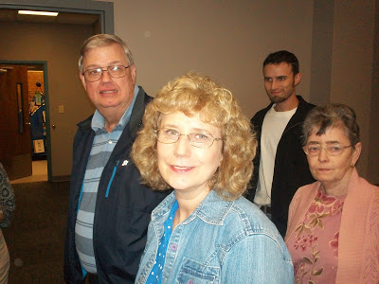
Below - "Her name is Daly Katherine Herrin. She was born December 28. 2012. We are calling her Daly." - reports the proud father, David Herrin standing in the blue shirt. Holding the new grand daughter is Mary Daly Herrin. Tommie and Walley Allen are in the back ground.
Mary is the daughter of Robert W. and Vena Holliman Daly. Mary grew up next door to the Holliman house at 2300 3rd Avenue North. She and E.C. Herrin, a semi-retired lawyer, married in 1951 and raised their family of four children - Clayton, Linda, David and Suzanne - in Irondale. David and Clayton continue to make their homes in Irondale.
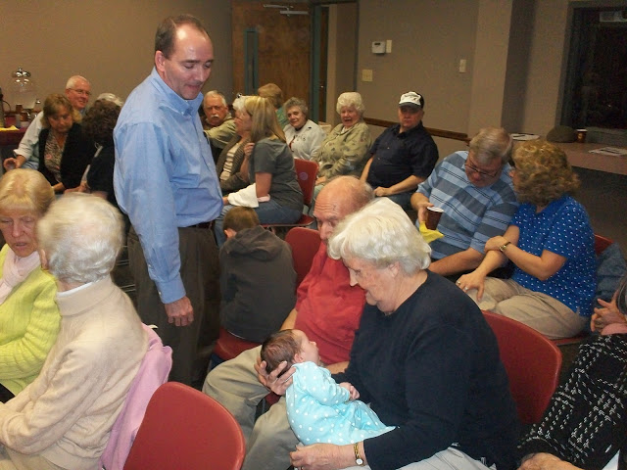

Tuesday, April 30, 2013

Return to Irondale 2013, Part 4
by Glenn N. Holliman
An Oral History of Irondale, Alabama....
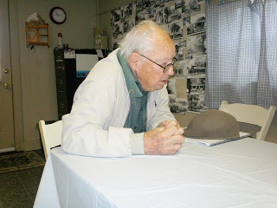
Left, Bishop Holliman, born in the Birmingham suburb of Irondale, Alabama in 1919, returned in late January 2013 for a talk with the Irondale Historical Society. While there he sat for a two hour oral history interview with Dolores Hydock, a professional story teller, who lives only a block from where Bishop grew up 90 years earlier.
Dolores has made an audio CD of the interview which can be ordered at www.storypower.org. Her web site and talents are fascinating. If one is interested in Alabama culture, her work and other CDs are available at her site.
Below, Dolores and Denise Tew Wight, president of the Irondale Historical Society interview Bishop at the society' museum in Irondale. Information on the Society can be found at www.irondalehistory.org.
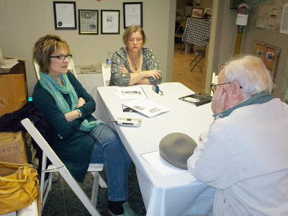
Below, Bishop gives a hug to Delores, a professional actress and Yale University graduate, after the session at the Irondale Historical Society. Denise Tew Wright, director of the Society, who kindly arranged the interview and talk, is on the far right. Denise is the driving force behind the preservation of the local history of the town.
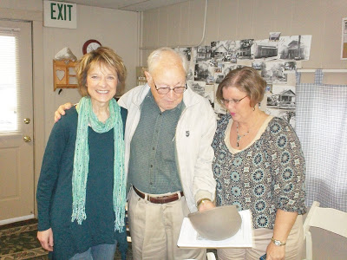
Below, Bishop and Denise stand outside of the Historical Society building. In the background, a modern building has replaced the old grocery store where Bishop worked as a clerk in the late 1930s.
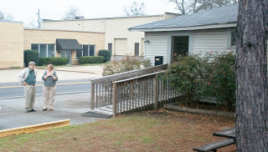
Below, the trains which traversed the town in Bishop's childhood, still move through the center of Irondale, a major switching yard for several railroad lines. This is the view from the Historical Society's back yard looking north.
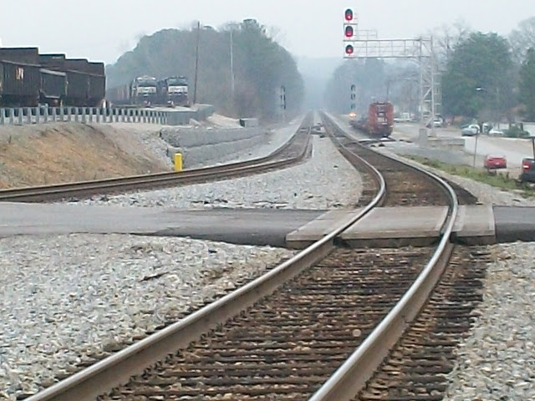
My Father, who now lives in Indiana, is grateful for the opportunity to visit his childhood home and is appreciative that so many nieces and nephews took the time to attend his talk with James Pugh in Irondale in January 2013. GNH

Sunday, May 12, 2013

How a World War changed an Alabama Family, Part 1
by Glenn N. Holliman
War on Two Fronts - World War II at Home and Abroad....
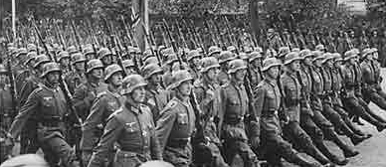
Above the German Army 'goose steps' toward war under Adolph Hitler....

From 1939 until 1945, violence, unprecedented destruction of life and property and mass movements of military, workers and refugees swept Europe, North Africa, the Pacific Islands and Asia. Scarcely an American, civilian or military, was not affected by the investment of the United States in armaments and the training and positioning of 13 million soldiers, sailors and airmen during World War II.
Over 200,000 Americans died among the 50 million or so who perished across the battered planet. Six thousand Alabamians lost their lives among the 250,000 who mobilized.
In the United States, after a decade of the Depression, rearmament, a massive government stimulus plan if you will, led to full employment. Positions went begging as millions of young men were conscripted into the military.
The steel industry in Birmingham added 7,000 jobs in two years. Childersburg, Alabama, population 500, was overwhelmed by 14,000 construction workers to build a DuPont plant. Ship building in Mobile, Alabama increased the city's population from 79,000 to 125,000 between 1940 and 1943. Workers, pulled from economically depressed Alabama farms, literally lived in tents to take advantage of well-paying jobs in the Gulf Coast port.
For the first time in American history, large numbers of women worked outside of the home, filling positions once held exclusively by men. With their own pay checks, women enjoyed increased independence and an enhanced ability to determine their own futures.

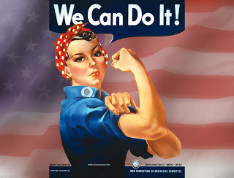

Left, the iconic Rosie the Riveter of World War II fame, illustrated the importance of women in the work force.
Millions of men and women left home and relocated to work in war industries or to serve in the military. Geographical, gender, class and racial divides were crossed. Customs and mores altered under the pressures and stresses of world war and rapid change. There were marriages under war time deadlines, and later John Doe letters and divorces. American families were never the same.
The Ulyss Holliman family of Irondale, Alabama, with seven offspring born between 1908 and 1924, was not immune from these economic, social and military forces. This family saw three sons and a son-in-law go to war and a daughter propelled into the work force which would lead to a career track in banking. Three children would marry during the conflict. After the war, two sons would use the G.I. Bill to further their educations and go on to expanded careers in government and business.
Below on the lawn ca 1938 at 2300 3rd Avenue North, Irondale, between the Ulyss and Pearl Holliman house and the Robert and Vena Holliman Daly house (background), pose numerous members of the family not knowing they would soon be swept into a World War.
Left to right are Ida and Melton Holliman, young Ralph Holliman, his older sister Virginia, Ulyss and his wife Pearl Caine Holliman with her hands on Mary Daly (Herrin). Robert and Vena Holliman Daly are on the far right, the parents of Mary, the first grandchild of Ulyss and Pearl. Both Melton and Ralph would serve in France with the U.S. Army. Virginia would marry in early 1942, work at Robert's bank and discover she enjoyed a business career outside of the home.
Pearl, age 51 in this photo, would age dramatically during the war, consumed by worry for her children and their sacrifices.
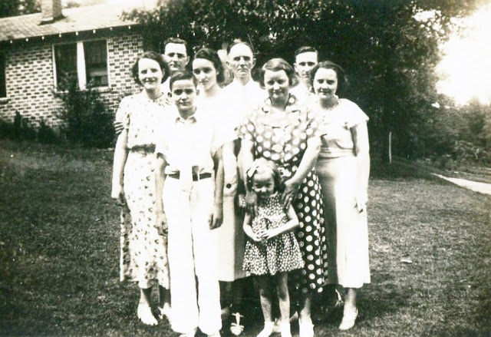

Because this large family saved many of the letters they wrote each other during the conflict, one is able to relive these fateful years and explore the tensions and worries of a family and nation in transition.
Below a 1944 airmail letter from the oldest Holliman son, Melton, age 36, from his Army deployment station in New York, just before shipping overseas to England.
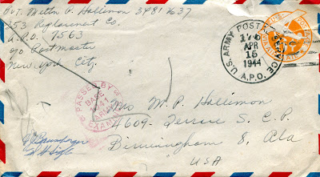

Below, an envelope from Bishop Holliman, age 23, to his sister, Loudelle Holliman Ferrell, age 29, who saved his letters from the War.
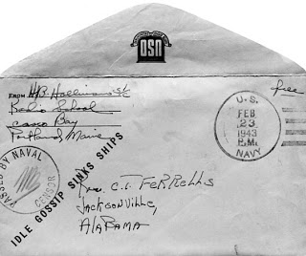
The articles which follow are based on these letters, family interviews and my father, Bishop Holliman's memoirs. I have divided these years into 'The War Front' and "The Home Front', allowing a look into the events, home and broad, that so affected the lives of this extended family
I am grateful to the Ferrell, Daly, Herrin, Cornelius, Hairston and several Holliman families for preserving and sharing these irreplaceable resources on the war.
These articles are written with several audiences in mind:
- One, for the descendants of this family.
- Two, to provide some wartime history of Irondale, Alabama and other families mentioned in the letters.
- Three, to add to the record the story of the World War II generation that saw their world upended and their lives forever changed.
My WWII sources, other than a life time of reading and an M.A. in history, are:
Alabama, The History of a Deep South State by William W. Rogers, Robert D. Ward, Leah Rawls Atkins, and Wayne Flynt (1994)
The Dark Valley, A Panorama of the 1930's by Piers Brendon (2000)
A History of the Second World War by B.H. Liddell Hart (1971)
The Great Crusade by H. P. Willmott (1989)
World War II by C.L. Sulzberger (1969)
A World at Arms, A Global History of World War II by Gerhard L. Weinberg (1994)
Total War by Peter Calvocoressi and Guy Wint (1972)
Blood, Tears and folly, An Objective Look at World War II by Len Deighton (1993)
Eagle Against the Sun, The American War with Japan by Ronald H. Spector (1985)
The Pacific War by John Costello (1981)
Next the Storm Gathers....

Monday, May 27, 2013

How a World War changed an Alabama Family, Part 2
by Glenn N. Holliman
1939 - The Storm Rises....
"It was my lot in life to have been born at a time that propelled me into draft age just at the time WWII broke upon the scene. For several years - since 1937 - we had been hearing about Hitler; we heard his speeches via radio and we read accounts of his threats to absorb all of Europe - 'Today Europe - Tomorrow the world'. - H. Bishop Holliman, unpublished memoirs written 1991
For my father, Bishop Holliman, a college history major, the new war brought energetic campus discussions, theological talks with his Methodist youth friends and friendly arguments with brother-in-law, Robert W. Daly, Sr. My Uncle Robert was famous for 'egging-on' his young in-laws, verbally sparing just for the sake of a good argument and on just about any subject. He helped sharpen their minds and characters during the 1930s.
Bishop was the fifth of seven children, born 1919, and whose life would go in different directions because of the War. Robert was a mentor and 'big brother' figure for the three youngest Hollimans who still lived at home in 1939. In addition to Bishop, Virginia (1922-2011) and Ralph, born 1924, resided at 2300 3rd Avenue North, Irondale, Alabama with their parents, Ulyss (1884-1965) and Pearl Caine Holliman (1887-1955).
Four older children had left the nest earlier. They were Melton (1908-1958), Vena (1909-1990), Euhal (1912-1989) and Loudelle (1914-1998).
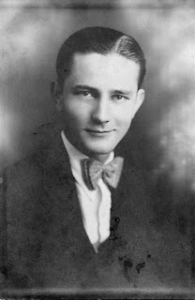Above, Melton Holliman as a Shades Cahaba High School senior in a natty bow tie. After graduating in 1927, he began clerking in his Uncle Floyd Caine's drug store. There he learned the pharmaceutical trade, and made a successful career as a major salesman for Wyeth. His career was interrupted from 1943 to 1945 with service in the Army and medic duty in England, France and Mississippi.
Robert W. Daly, Sr. was a third generation Irishman, his immediate ancestors only six decades in the States by 1940. His grandfather, a civil engineer, had helped construct the Alabama Central Railroad. His father, Karl Daly, had been an Irondale, Alabama farmer. By the 21st Century, the Daly fields had long been subdivided into large housing tracts for suburban commuters, but the highway bears his name. Robert left the farm and become a banker in the early 1920s. 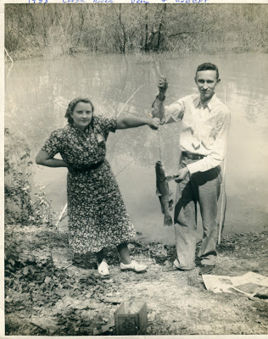
Vena and Robert Daly fishing along the Coosa River in 1938. Although Vena wore a bandana to protect herself from the Deep South sun, Robert fished in a white dress shirt and tie. It was indeed a more formal era in the decade prior to the War.
In 1931 Robert built two brick houses in the 2300 3rd Avenue North block of Irondale, on the steep hill overlooking the railroad switching yard. Vena, his wife, had come of age in the house next door, the home of Ulyss and Pearl Caine Holliman since 1921.
Of the seven children, Vena Vivian Holliman Daly was the first to marry in 1928. Husband Robert, born 1901, wise and full of mischievous good will, managed a bank in Woodlawn, Alabama.
Ulyss moved his growing family from Fayette, Alabama in 1917, seeking employment in the bustling, hard-nosed, blue collar steel city of Birmingham during an earlier World War. He found his carpentry skills in demand by the Birmingham Electric Company that ran the street car line. From that year until his retirement in 1949, he repaired the wooden trolleys. In 1953, the last street car ran in Birmingham and an era closed. But Ulyss had earned enough to support his family during Depression and World Wars.
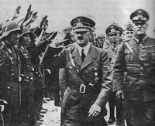
By 1939, a new World War had already engulfed both Asia and Europe. The military government of Japan invaded China in 1937, a snake trying to swallow an elephant. On September 1, 1939, a half-mad, anti-Semitic dictator of a resurgent Germany ordered a Blitzkrieg, a lighting war, on Poland. In the name of reclaiming lands lost by the 1919 Versailles Treaty, Adolph Hitler, (pictured) who came to power in 1933, vigorously pursued his dream of a Greater Germany that would dominate Europe.
In the autumn for 1939, for the second time in a generation, much of the world was at war. What would the United States do? Would it once again come to the rescue of the European democracies? Would the country remain neutral while Japan extended its conquest of China?
And how would it impact the Holliman family of Irondale, Alabama?

Next a County Divided....
Have questions about Holliman family history and associated families? You are invited to join the Hollyman Email List at Hollyman-Subscribe@yahoogroups.com and the Hollyman Family Facebook Page located on Facebook at "Hollyman Family". Post your questions and perhaps one of the dozens Holyman cousins on the list will have an answer. For more information contact Tina Peddie at desabla1@yahoo.com, the list and Facebook manager for Hollyman (and all our various spellings!).
Since early 2010, I have been publishing research and stories on the broad spectrum of Holliman (Holyman) family history at http://hollimanfamilyhistory.blogspot.com/ . For stories on my more immediate family since the early 20th Century, I have been posting articles since early 2011 at http://ulyssholliman.blogspot.com/ .
Let's save the past for the future! If you have photographs, letters, memorabilia or research you wish to share, please contact me directly at glennhistory@gmail.com. Several of us have an on-going program of scanning and preserving Holyman and related family records. Thanks to the Internet, we are able to scan, upload to the web (with your permission) and return the materials to you.
Announcing also a "Seminar and Site" gathering October 18 and 19, 2013 in Fayette, Alabama for Hollimans and associated families whose ancestors are from that area. Space at the Rose House Inn is limited for the occasion due to a football weekend. For information, contact me at the above email. Hope to see some of you there. - GNH
Tuesday, June 11, 2013

How a World War changed an Alabama Family, Part 3
by Glenn N. Holliman
A Humorous Letter that captures the Mood of a Divided America....
"I felt we would not enter World War II. We had learned our lesson, I thought, from the last war. Surely we would get burned again. So I went merrily on my way, doing my thing, and not worrying very much about the ultimate consequences of what was happening in Europe." - H. Bishop Holliman, 1991, a Navy veteran of World War II
Spurred on by lively conversations with brother-in-law Robert W. Daly, Homer Bishop Holliman, born the year of the infamous 1919 Versailles Treaty, a Birmingham-Southern College student, typed the following tongue-in-cheek letter to himself. While meant to be humorous, nineteen year old Bishop, captured the ambiguous feelings of many Americans in the autumn of 1939 as Europe once again plunged itself into an abbess.
Notice in the letter, he refers to the divisive issues of the embargo and neutrality which divided the U.S. Congress. Only with the Japanese attack on Pearl Harbor at the end of 1941 did American public opinion coalesce, and Congress overwhelmingly vote war.
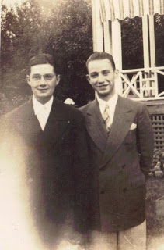
Above Bishop Holliman, right, with his Methodist pastor friend, The Rev. Paul Nelson Propst in 1940 at a Lake Junaluska, North Carolina religious retreat. Note the formal wear. Bishop would give Paul's middle name to his son, Glenn Nelson Holliman, in 1946.
Bishop had been raised in the Irondale, Alabama Methodist Church. Thanks to his sister Loudelle's husband, The Rev. Charles Tigert Ferrell, he would work several years as youth coordinator for the North Alabama Conference of the Methodist Church. This position allowed him to help pay his tuition at Birmingham-Southern College, a Methodist school, from 1937 to 1941.
Below, Bishop's 1939 letter to himself captures his religious and isolationist beliefs as World War II began in Europe. On September 1, 1939, Germany invaded Poland and reluctantly France and Great Britain declared war on expansionist Germany.
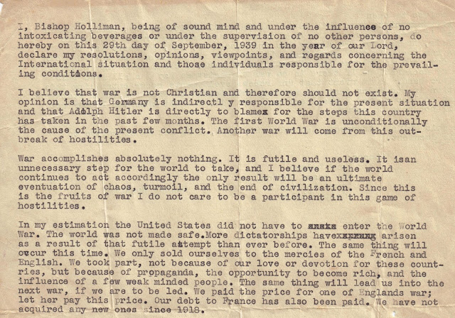

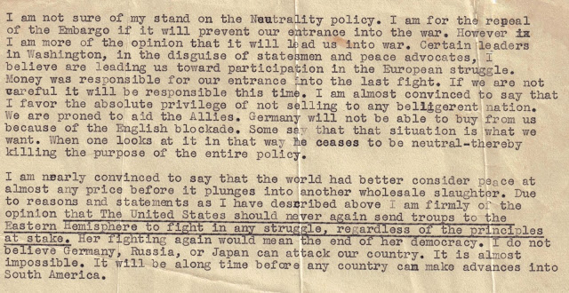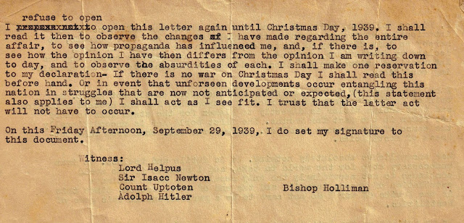
In the late 1930s and early 1940s, thanks to the automobile and paved roads, Bishop and millions of Americans were able to travel and see the United States as previous generations had not been able to do. Below, inn this 1939 photo Charles Pugh (far left) of Irondale and close friend of Bishop's stand with The Rev. Stewart Butten (far right), having just returned from a Methodist retreat in Knoxville, Tennessee.
Notice the street at 2300 3rd Avenue, North, Irondale, Alabama is unpaved. Third Avenue would be paved, ironically, during World War II. The Ulyss Holliman home is in the background. The automobile has a running board. And what natty dressers just returning from a trip, still in white shirts, ties and oh, those white shoes! A month or so later, Bishop would write the above letter to himself.
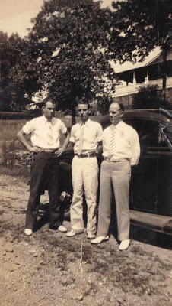
Next posting, the World War and the Changing Mood at Home....

Tuesday, June 25, 2013

How a World War changed an Alabama Family, Part 4
by Glenn N. Holliman
1940...the Storm Grows....
At this time in his life two decades after the Great War, Bishop Holliman was, as were millions of other Americans, an isolationist, one who wanted no involvement in European conflicts. This opinion was shared by many during the late 1930s and early 1940s.
However, by summer 1940 Czechoslovakia, Poland, France, Belgium, the Netherlands, Norway and Denmark had fallen before the Nazi war machine. These frightening events moved more and more Americans to support rearmament and aid to England. Great Britain stood alone against increasing fears of a world dominated by an aggressive government of Germany, a militant Japan and a Mediterranean bully, Benito Mussolini's Italy. Collectively, these were the Axis powers of World War II. Below the two dictators who lost their lives in 1945 in the conflagration they initiated.
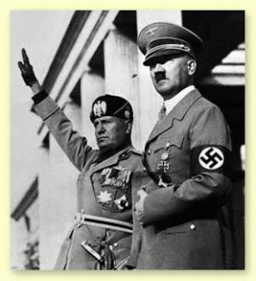
Ulyss and Pearl Holliman of Irondale, Alabama were devout Christians, and had raised their family as Methodists. Their second daughter, Loudelle, married a Methodist minister in 1935, Charles T. Ferrell, born in Mississippi, and educated at Birmingham-Southern College and Yale Divinity School. Loudelle and Charles helped Bishop obtain a part time job as youth director with the North Alabama Methodist Conference in the late 1930s. This work - several summer youth conferences and his own deep commitment to the Christian faith - are evident in Bishop's pacifistic and humane opinions captured in memoirs written in 1991:
"And so it was as the clouds of war loomed ever more ominous on the horizon that I was a student at Birmingham-Southern College, having entered in 1937. During those years I was very active in youth activities in the Methodist Church, and a principle focus in those times was 'world peace'. At all of our youth conferences, programs, and camps, ironically one of the courses would be labeled, with some variations, 'World Peace."- H. Bishop Holliman, 1991
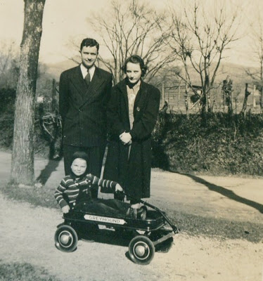

Above, Christmas 1940, young Charles Halford Ferrell tries out his new Greyhound wagon for his parents, The Rev. Charles and Loudelle Holliman Ferrell. Loudelle and Charles would write faithfully to her siblings, while Charles pastored Methodist Churches in North Alabama during the war.

Bishop along with two brothers, Melton and Ralph and a brother-in-law, Walter Cornelius, were soon to be swept into the growing maelstrom. War would come to this Alabama family. Melton (1908-1958) is pictured below with his mother, Pearl Caine Holliman (1887-1955) in the late 1930s in front of the Robert and Vena Daly, Sr. home in the 2300 3rd Avenue North of Irondale, Alabama. Not a young man, Melton served in the U.S. Army in England, France and Mississippi during 1944 and 1945. While overseas, his health broke. He died of a heart attack 13 years after the war at the age of only 49.
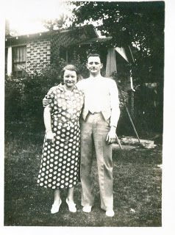
With the fall of World War I ally France in June 1940, the U.S. Congress passed a conscription act to begin the building of an American army which at that time was one of the smallest in the world. Later that year, President Franklin D. Roosevelt asked Congress to pass the Lend-Lease bill that gave assistance to Great Britain, aid short of war.
At the same time, relations between Japan and the U.S. continued to deteriorate. Japan pursued its war in China, and cast covetous eyes on the Dutch, British and French colonies in southeast Asia.
No matter how isolated the U.S. was in the Western Hemisphere, the world had become a dangerous place. Led by FDR, Congress began to appropriate massive funds for naval, air and army armament. However, 'isolationism', remained strong - many Americans did not wish to see the United States once again involved in a European war.
"Remember, we were still living in the shadows of the First World War, and the death and destruction wrought by that conflict were being brought out into the open, and we were able to look back and view the catastrophic horror. Also, we were learning how the profit motive entered into whether we should go to war, and we were taught that greedy munitions manufacturers profited from the deaths of countless millions.
In the late 1930s and early 40s, I struggled to stay in college and worked part time at the Methodist Youth headquarters at 516 N. 22nd Street in Birmingham. I was making maybe 25 or 30 cents and hour to fold letters, run the mimeograph machine and do other such menial chores The job had been designed to aid a ministerial student. I had been given the job my second year in college by Charles Ferrell, my brother-in-law.
He was Conference Youth Director, so through his beneficence I was able to make a little spending money and stay in school. My association with the ministers in and out of the office and my participation in conference youth programs strengthened my faith in the 'rightness' of peace and the evils of militarism and war." - H. Bishop Holliman, 1991.
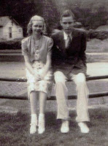
Bishop Holliman, left, sometimes had his mind on items other than religion while attending Methodist youth conferences in Alabama and North Carolina in the early 1940s. Note the cute blond on the far left. Dad is in a coat and tie, and oh, those white shoes and pants.
Next the War moves closer to this Alabama family....

Sunday, July 14, 2013

How a World War changed an Alabama Family, Part 5
by Glenn N. Holliman
Summer 1941
22 June 1941, full of hubris and more than mildly insane, Adolph Hitler launched his war machine east against the Soviet Union. Earlier that spring, his Wehrmacht had swallowed the Balkans, Greece and Crete and joined the Italians in North Africa. German foreign minister Von Ribbentrop wrapped Nazi arms around Hungary, Bulgaria, Romania and Finland. Britain, supported by her dominions Canada, Australia, New Zealand and South Africa, stood on the continental fringes of Europe facing foes Italy and Germany.
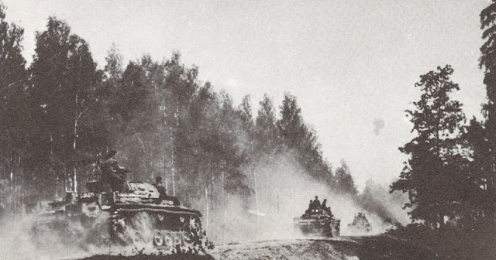
German Panzer IIIs invaded Russian in what most of the world thought would be an easy conquest. It was not to be.
n Panzer III tanks close to a border battle near Brest-Litovsk on June 22
Mad with ambition, a loathing of communism, racial and religious hatred and swollen with excessive confidence in his armies, Hitler hurled over 3 million men against another sadist dictator, Joseph Stalin, the communist autocrat of the largest geographical nation on the planet. The battle of two titans commenced, and the world held its breath.
In the United States the World War would soon reach out and engulf an Alabama family....
The year before, 1940, Walter Cornelius, second row, far left in coat and tie, graduated from Shades Cahaba High School in Homewood, Alabama. His future brother-in-law, Ralph Holliman, Class of 1942, sat near him in the middle of this group picture in the white and black shirt with the collar. In early February 1942, Walter married Virginia Holliman, also Class of 1940. Both Walter and Ralph would serve in the U.S. Army during the war - Walter in Saipan and Ralph in France.
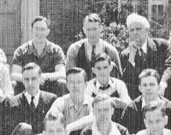
From the memoirs of Bishop Holliman of Irondale, Alabama - "In the summer of 1941, I went back to Lake Junaluska, attended the Methodist Youth Conference at Montevallo College (and was elected president and interesting to note, my opponent was Howell Heflin, later U.S. Senator from Alabama) and worked intermittently at Hill's Grocery in Irondale, Alabama. I am afraid I did not dwell a great deal on the prospects of the U. S. entering the war even that terrible summer in Europe."
Below Bishop Holliman 'concentrating' on his religious duties at the Methodist Conference Center of Lake Junaluska, North Carolina in 1941.
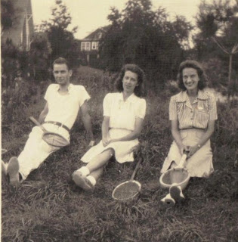In August 1941, a letter from his draft board sent Bishop scurrying back from a vacation in Florida with the Daly and Ferrell families. Checking in, Bishop was told he would be called in the fall. Not anxious to join the U.S. Army, Bishop enlisted in the U.S. Navy, ready to go at a later date.
In the meantime, a girl friend, Gloria Zackey, who was a secretary for Sloss-Sheffield Steel and Iron Company on 1st Avenue in Birmingham, recommended him for a temporary job, filing in chronological order cancelled checks. "I was paid 75 cents an hour and thought a $26 a week pay check was pretty good."

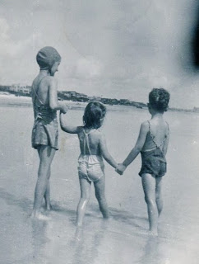
Above, ten year old Mary Daly (Herrin) in a bathing cap suits typical of the period holds hands at Daytona Beach, Florida, August 1941 with her cousins Carolyn (Tatum) and Charles Halford Ferrell. The war would soon bring such vacations to a screening halt for most Americans. Vena Holliman Daly and Loudelle Holliman Ferrell were Bishop, Virginia, Euhal and Ralph Holliman's sisters.
That same August, President Franklin D. Roosevelt rendezvoused in Newfoundland by ship with Prime Minister Winston S. Churchill of the United Kingdom. Their military leaders met, and from the meetings at sea, was issued the Atlantic Charter, a just vision of a post-war world, declared boldly before the U.S. was formally in the war. Below, Roosevelt, Churchill and their staffs on the deck of the HMS Prince of Wales.
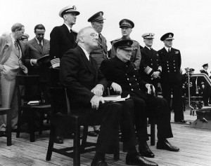
And again that summer of 1941, generally not noticed by many Americans, the State Department, utterly disgusted with Japan's continued war and invasion of China, initiated an embargo of the selling of U. S. petroleum to Japan. For the militaristic government of Japan without oil, the clock began to tick rapidly toward a decision either to seize supplies in the Dutch East Indies or acquiesce to U.S. demands to cease their four year invasion of China.
The government of new Prime Minister Hideki Tojo, a Japanese army general, refused to consider a withdrawal from China, and began plans to confront the U.S. militarily. Japan would decide to secure by violence the resources needed to maintain their military and civilian economy. Time was running out in the Pacific, while most U.S. eyes were focused on the North Atlantic and Europe. Below the Prime Minister of Japan who authorized the attack on Pearl Harbor.
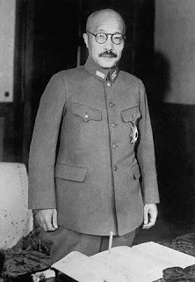
"For ten years, Japan had been front page news, but I was not cognizant of how big a threat she was and I know that in the summer of 1941, I did not view that country as an enemy we would soon fight. I guess all our attention was on Europe and I simply did not foresee future conflict with the 'Rising Sun'. In later years I wondered how I could have been so uninformed - or ignorant - about what was happening in the Pacific." - Bishop Holliman
Next Posting, a Holliman joins the Navy....

Sunday, August 4, 2013

How a World War changed an Alabama Family, Part 6
by Glenn N. Holliman
A Holliman Joins the U.S. Navy....
Autumn 1941
Below, German infantry in the Soviet Union, 1941
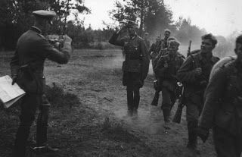
By November 1941, the Soviet armies and cold weather finally slowed the mighty German army in front of Leningrad and Moscow. Casualties were monumental on both sides. By late autumn, Germany, which already occupied with Italy most of Europe, had driven deep into Russia.
In North Africa, the German and Italian Armies threatened the British protectorate of Egypt and the Suez Canal, the life line to the British Empire in Asia.
In the Pacific, a Japanese fleet of aircraft carriers prepared to sail as relations between the Emperor's military government and the Roosevelt administration neared a breaking point. In late November, based on decoded radio intercepts, the War Department issued a 'war warning' to U.S. forces in the Pacific. For the United States, events were moving to a tragic climax.
Rather than take the Army draft, Bishop Holliman of Irondale, Alabama, a student at Birmingham-Southern College, decided to join the U.S. Navy. November 13, 1941, his parents, Ulyss and Pearl, brother Ralph and brother-in-law Robert Daly, Vena Hollman Daly and Mary Daly saw him climb aboard the Seaboard in Birmingham and take the train to Norfolk. Bishop's war began at the Naval Training Station in southeast Virginia. Below, the young Bishop Holliman as a Navy trainee as the nation approached Pearl Harbor.
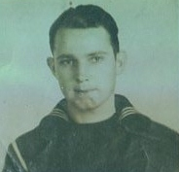

Brother-in-law, Robert W. Daly, Sr., ever the humorist, wrote in his first letter to Bishop, a devout Methodist, at boot camp on November 15, 1941, these words 'quoting' Ulyss S. Holliman, Bishop's father, who accompanied him to the train station.
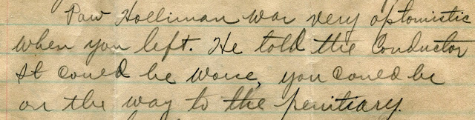

For Bishop's sister, Virginia, who graduated with honors from Shades Cahaba High School the year before, her romance with fellow class mate, Walter Cornelius, was deepening. Below Virginia's attractive photograph from her yearbook and the list of achievements. These leadership positions foreshadowed the successful career she would have in the Alabama banking business from the 1950s to the late 1980s.
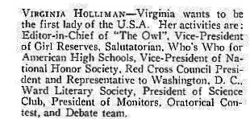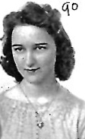

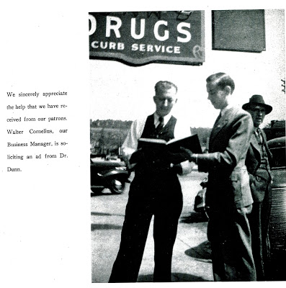
Above right, young Walter Cornelius, business manager of the Shades Cahaba High School annual in 1940, would serve in World War II and go on to a successful career as an attorney in Birmingham, Alabama. He and Virginia, his high school sweet heart, would marry in February 1942. The couple would have two children, Carol and Susan. Their marriage was ill fated; it was one of two Holliman marriages created during World War II that would end in divorce decades later.

Next, with one son in the military, Pearl Harbor and war would blast their way into the lives of an Alabama family.....

Sunday, September 1, 2013

How a World War changed an Alabama Family, Part 7
by Glenn N. Holliman
World War II engulfs America and an Alabama Family!
The day still lives in 'infamy', 7 December 1941. Suddenly, without warning, hundreds of Japanese war planes swarmed over Pearl Harbor, Hawaii and the giant U.S. Navy base. Almost three thousand American service men and women died that day and numerous ships went to the bottom or were damaged for years. Fortunately the U.S. aircraft carriers were at sea and escaped the holocaust. The U.S.A. and the Holliman family of Irondale, Alabama were now, fully, at war.
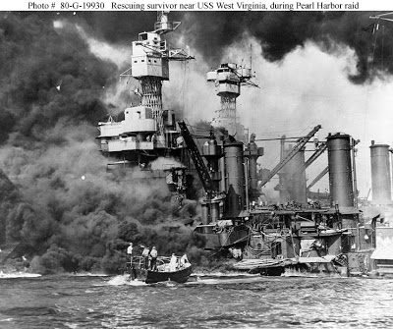
"On Sunday, December 7, 1941 at about 2 pm, I was standing watch in the barracks in the Norfolk, Virginia Navy Training Station when my relief told me he had heard that the 'Japs' had bombed Pearl Harbor. Up to that time, not many of us had heard of Pearl Harbor, most thinking she was a female in one of the dives in Norfolk! Upon receiving word we were at war I felt that at last there was some purpose in having to serve two years or more in the Navy, that finally there was a reason for my being where I was and that my experience would not be completely futile." Bishop Holliman, Memoirs 1991
Below, a training field during World War II at the Norfolk, Virginia Naval Station

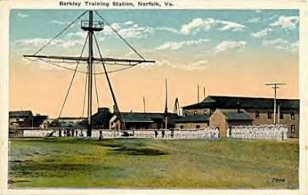

A few days after Pearl Harbor, Loudelle Holliman Ferrell, the 28 year old wife of The Rev. Charles T. Ferrell, expressed her feelings on the national emergency in a letter. She holds her third child, John Melton Ferrell, in 1943.

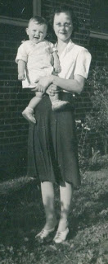
"It was such a shock and such a treacherous act. I hate war, the thought of it tears me up...what the future holds, nobody knows....I feel sorry for my unborn child (John Melton Ferrell, b. 1942) coming into such a world. I am trying to remain calm and control myself. Even thought the world has gone mad and the lights have gone out all over the world, there is one light will never go out...keep your faith and don't lose your grip on God."

Below in 1943 during World War II, Patti Holliman Hairston, daughter of Melton and Ida Holliman, and her cousin, John Melton Ferrell, play in Jacksonville, Alabama where John's father was the United Methodist Church pastor. Patti's father, Melton, would be inducted into the U.S. Army in August 1943 as the War continued to reach out and engulf the Holliman family.
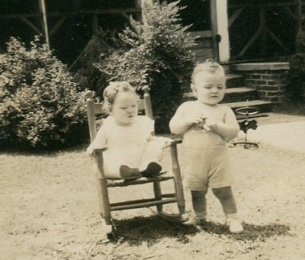

Below in 2012 at the Orange Beach, Florida reunion at the home of Al and Linda Herrin Bradley, the same two cousins looking trim and incredibly youthful, John and Patti, almost 70 years later.
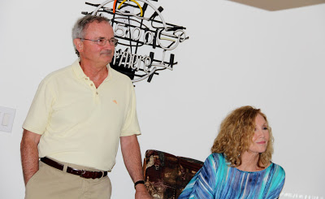

Blessedly, the worst fears of Loudelle Ferrell concerning World War II were not realized for America, but as we all know, the human race continues to produce conflict and challenges.
Next post, the dismal Christmas of 1941....

Tuesday, September 17, 2013

How a World War Changed an Alabama Family, Part 8
by Glenn N. Holliman
Christmas 1941...A Homesick Sailor on Liberty....

In another fit of madness and arrogance and honoring the agreement of the Japanese alliance, Adolf Hitler declared on December 11, 1941 that Germany was at war with the United States. Italy followed suit, and the U.S. Congress quickly replied in kind. The United States now faced global war on numerous fronts after the attack on Pearl Harbor.

Bishop Holliman, b. 1919, of Irondale, Alabama spent his first Christmas away from his large and close-knit family by taking a day's leave from his Navy training station in Norfolk, Virginia to visit the nation's capitol on December 25, 1941. Winston Churchill, then in Washington, D.C. spent Christmas with the Roosevelt's at the White House where planning for a response to the Axis powers - Germany, Italy and Japan - continued for over a month. Their planning would yield rich results in time, but that holiday season, the Allied cause was reeling under the massed forces of Japan, Italy and Germany.
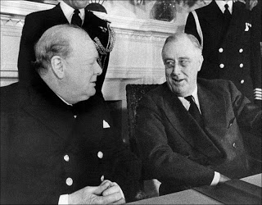
"I had been in boot camp since November 13, 1941. Ordinarily, basic training went on for 6 to 8 weeks but because of the war and, hence, the need to get men to ships and service stations as soon as possible, training was reduced to 4 or 6 weeks. Our platoon (305) disbanded before Christmas and we were assigned to K.P. duty on the base. My first liberty came on Christmas Eve, and I rode to Washington, D.C. I have forgotten how I got there back, but, believe me, for a little more than 24 hours, I forsook the Navy and turned my thoughts to things!
I was due back to the base Christmas night. I knew the family would be gathering on Christmas Day just as they always had, but I would not be there. They would be expecting a telephone call from me, and I fully expected to call home as soon as I could upon reaching D.C.

Washington was indeed a crowded city that first Christmas of the war. Winston Churchill was at the White House. Thousands of service men had crowded into the city as had civilians who were working there, passing through, or visiting. There was hardly a room available to a poor, homesick sailor on his first liberty on the town. finally, I found a room in a boarding house. I don't recall any of the amenities, the cost nor anything about it. My main objective upon depositing my gear was to telephone home to let them know where I was and what I was doing.

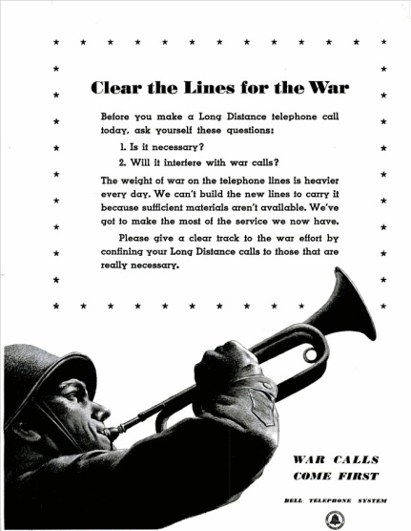

All telephone lines were busy. This was before direct dialing and one had to go through the operator. She would connect you with Charlotte, then Atlanta and finally, Birmingham. Sometimes you might get to Charlotte or Atlanta. At times you would get an immediate response 'all circuits are busy.' So you would try, try again. This contest might go on for hours, which on this Christmas Eve it did. I was never able to get through that night nor the next day." Bishop Holliman, 1991 Memoirs

Immediately after the attack on Hawaii, Japanese forces launched a Pacific-wide offensive of land, sea and air. Hong Kong, Singapore, Guam and Wake Island were quickly conquered and subdued. Only in the Philippines, then a colony of the United States, did the combined forces of the U.S. and the Philippine Army hold off for four months the invasion of Japanese divisions. General Douglas MacArthur, commanding joint colonial and regular U.S. Army troops, stalled the Japanese on the peninsula. of Bataan, north west of the capitol of Manila.

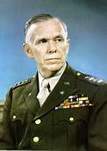

Above, the General of the Army, George C. Marshall, the right man at the right place during the War, reached out and called to Washington, D.C. a former administrative aide to MacArthur, one newly minted one-star General Dwight David Eisenhower. Eisenhower's job that December was to devise a way to get supplies to the Philippines to keep MacArthur's forces fighting. With the Japanese Navy and Air Forces in charge of the South Pacific and with much of the U.S. battle fleet at the bottom in Pearl Harbor, the task was impossible.
Below, one star General Dwight D. Eisenhower, pictured as World War II began.

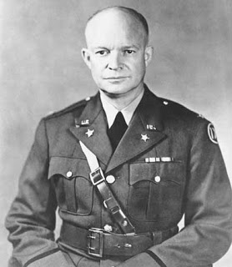

But Eisenhower's work ethic, management skills, organizational talents and cooperative, but firm attitude, caught Marshall's eye. The War would see much of General Eisenhower.
Next, more on that Christmas of 1941 for an Alabama family....

Wednesday, October 2, 2013

How a World War Changed an Alabama Family, Part 9
by Glenn N. Holliman
Christmas 1941...a Sobering time for a Alabama Family and a Nation now at War....
﻿
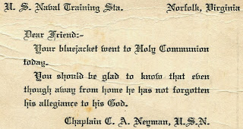
"On Christmas Day 1941, I stood that morning on the Capitol steps in Washington, D.C. on a short liberty from the Navy Training Station in Norfolk, Virginia. Then a civilian drove by, stopped and invited me to his home to partake of Christmas dinner with his family. I was glad to accept his invitation. It became customary at the start of the war to do all you could for the 'boys in the service'. So here was a nice civilian doing what he could to bring a little happiness to a lonely, homesick sailor on Christmas Day.
I can remember anything about the dinner, the house or family. I do recall that before going to his house, he picked up a soldier then drove us all around the city. I had been to Washington only once, the year before on an extended excursion. But this time, I was privileged to see many parts of the city that were new to me, and I was elated that I had fallen upon such good fortune as to taste the first fruits of civilian hospitality that would become a routine action as the war went on.
So what was happening back in Irondale, upon the hill on 3rd Avenue? I wondered throughout the day. I was never able to get in touch with the family until I was back at the base, after Christmas had passed, and the dread of a lonesome Christmas was behind me." H. Bishop Holliman, 1991 Memoirs
Below the Holliman house at 2300 3rd Avenue North, Irondale, Alabama, built in 1921. This photograph was taken in 1955.
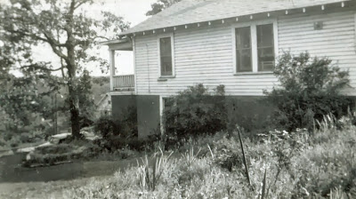

That same Christmas night after the annual Holliman dinner at the home of Ulyss and Pearl Caine Holliman, Bishop's brother-in-law, the humorous Robert Daly, Sr. wrote 'tongue in cheek' from Irondale, Alabama, but he did note the bad news from the Pacific.
"Everyone seemed to be cheerful although the war news from the Philippines kept being pretty bad. The usual gang was present for Christmas dinner at your Mother's - Charles, Loudelle, Hal, Carolyn, Euhal, Edna, Terrible Terry and Jerry, Melton, Ida, Vena, Mary, Robert, Ralph, Virginia, Walter Cornelius, Mom and Pop and Stewart Button. W We missed you at your usual spot, although the food went further."
Terry and Jerry were the twin one year olds of Euhal and Edna Westbrook Holliman pictured below in 1941, who probably behaved at the table like, well, normal one year old boys! Euhal and Edna had married in 1935 and were to have six children - Terry, Jerry, Anne, Jean, Tommie and Bill. Terry and Jerry were the 4th and 5th grandchildren of Ulyss and Pearl Caine Holliman. In 1941, Euhal was a grocer in Gadsden, Alabama. Jerry passed away in 2003 and Terry makes his home in Arizona.

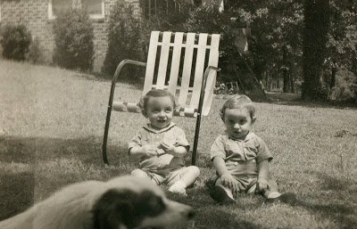
"The Duke from Knoxville (The Rev. Stewart Butten, a family friend) offered a nice blessing and prayer; he mentioned you in his prayer in a way not to draw too much attention to your absence because he did not want to spoil the evening. Your Mom (Pearl) was okay, so was Dad Holliman (Ulyss) although they missed you.
Loudelle (Bishop's sister) answered all phone calls thinking you might call. All calls turned out to be some one else. We did not expect a call due to the Telephone Company asking the public to keep the line open for the War Department."
Melton bought a new Chevrolet yesterday. He took Euhal and family home (Gadsden, Alabama) tonight. I think he got the last car for sale in Birmingham. The Ford dealers won't sell the few they have on board. You can't buy new tires now."
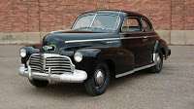

Below, Melton Holliman (1908-1958), a successful pharmaceutical salesman who had South Alabama and Southern Mississippi as his territory. Hence the need for a reliable car such as this black 1942 Chevrolet, right. The public was being admonished with advertising warning about consumption of gasoline and tires.
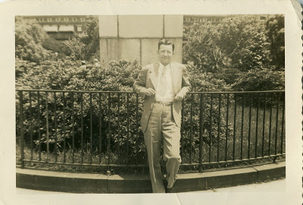

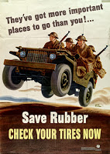
"Virginia got a diamond engagement ring from Walter (Cornelius, her high school flame). They must mean business. I don't know how this will go over."
Below, Walter Cornelius and Virginia Holliman, 1940, from The Owl, the Shades Cahaba High School year book. Virginia was editor and must have placed their pictures side by side on a miscellaneous page in the annual. In February 1942, they would marry. Their rushed wartime marriage created unease in the family.
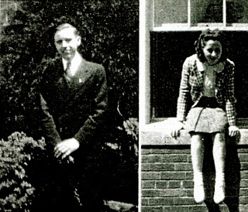

"Hong Kong lost today. Submarine blasted off California coast - that puts one out of action. We are glad you are not on a ship...." Robert W. Daly, Sr., Christmas Night 1941, Irondale, Alabama
Next More War News.....

Monday, October 21, 2013

How a World War Changed an Alabama Family, Part 10
by Glenn N. Holliman
My father, Bishop Holliman, wrote in 1991 in his memoirs of the weeks after the December 7, 1941 attack on Pearl Harbor, Hawaii:
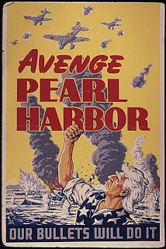

"Thanks to the Japanese, boot camp was cut short, and we apprentice seamen were held to a 'waiting' game at the Norfolk, Virginia Navy base - pending a permanent assignment to a school or ship. We had taken all sorts of tests to determine the fields most suited to our talents. Throughout those few weeks of waiting, we were given KP duty and stood watch.
January 10, 1942 was my father's 58th birthday (Ulyss S. Holliman, 1884-1965), and on that day I was transferred to the Key West, Florida Navy Sound Operator school. With trepidation, I boarded a troop train late at night and headed for this new adventure. The only good thing to come from this was the enjoyable train ride on the way south. We followed a circuitous route, not knowing where we going at first. Another two sailors and I shared a compartment on the train, enabling us to be separated from the throngs of other service men who filled the cars." - Bishop Holliman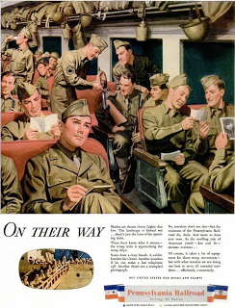
Attitudes within the nation were changing as the reality of war set in. In the letter excerpt below, Bishop's sister, a sensitive Loudelle Holliman Ferrell, laments the fact that her son and daughter have been affected by the global conflict. Her son, Charles Halford Ferrell, had received a toy gun for Christmas. Carolyn Ferrell Tatum is the four year old sister of Hal.
Notice also Loudelle writes of a hasty wartime marriage, marriages which were occurring all over the country as men were called to the armed forces. One such marriage also would occur that same month in the Holliman family. Below in 1943, Charles 'Hal' Ferrell, while not in uniform, seems to have learned to salute the attention of the girls!
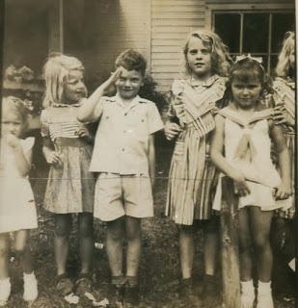
"Everything is a 'mean Jap' and he's mowing them down. I didn't think Charles (The Rev. Charles T. Ferrell) would let Hal keep the gun, but Charles has enjoyed it more than Hal. The other day I heard Carolyn (Carolyn Ferrell Tatum) tell Hal not to do whatever he was doing. She informed him that that was the way the Germans did.
By the way, Margaret Shamburger (a Ferrell relative) ran away about a month ago and married an Army sergeant at Key Field in Meridian, Mississippi. Her mother was in bed for a week afterwards and nearly had a nervous breakdown over it. I think things are going to be all right. He is already calling her 'Mother' and does not think he will have to leave for six months." - Loudelle Holliman Ferrell, January 1942

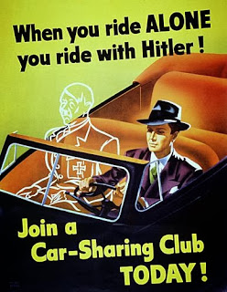
In late 1941, Life Magazine reported that the average subscriber (10 cents a copy) made $2,500 a year. Milk cost 14 cents a quart and eggs 47 cents a dozen. Lamb was 32 cents a pound, coffee 26 cents, bread 9 cents a loaf, tomatoes 10 cents a can, pink salmon 20 cents a can, bananas 7 cents a pound, bacon 37 cents and chuck roast 27 cents a pound. Toilet soap - 7 cents a bar. Gas required 20 cents for a gallon. Medical care for a family was $80 to $100 a year. A movie - 35 cents. Cigarettes were 15 cents a pack.
Inflation normally becomes a factor is a major war as production is moved from civilian to military materials. Rationing of foods as well as automobiles and gasoline soon became an American reality.
Robert Daly, Sr. wrote his brother-in-law, Bishop Holliman, on January 4, 1942:
"It looks like we will be walking soon. Only those that absolutely have to drive a car can get tires. Mine are very thin. I may have to put the old buggy up soon. The Gov. has really put the screws on the banks (Robert was a bank manager) for loans to buy listed articles such as cars, radios, etc. Regulations are plentiful.
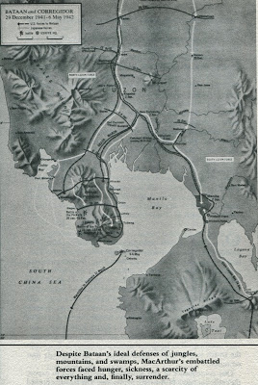
We do not know what Uncle Sam is doing to relieve the Philippines. We don't get much dope the last few days. It looks pretty bad for them." - Robert W. Daly, Sr., January 1942
It was very bad for the American and Filipino troops who were back pedaling from Manila to the Bataan peninsula (see right). With the most of the U.S. Navy's battleships sunk or damaged at Pearl Harbor, there was little the U.S. military could do in early 1942 to come to the aide of this embattled army. The worst defeat in U.S. Army history was unfolding.
And the U-Boat war off the East Coast was a growing reality. The Navy wanted Bishop Holliman to join that part of the world battle with all deliberate speed, and his train was carrying him south to a new training base.
Next posting, more on the Holliman family of Irondale, Alabama going to war....

Thursday, November 7, 2013

How a World War Changed an Alabama Family, Part 11
by Glenn N. Holliman
A Family Member at the U. S. Navy Sonar Training School, Key West, Florida.....1942
"By late January 1942 more than twenty U-boats were operating in American waters. On January 28, a single submarine standing off New York harbor sank eight ships, including three tankers, in just twelve hours." - Williamson Murray and Allan B. Millett, A War to be Won (Cambridge, Mass.: Harvard University Press, 2000)
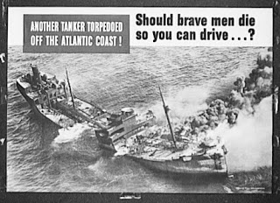

After two months in the U.S. Navy, Bishop Holliman, a 22 year old young man with three years of college, a native of Irondale, Alabama, began training as a sonar operator at the U.S. Naval Base in Florida. His job would be to listen to sound waves bouncing off German submarines which were devastating U.S. shipping in 1942. Through his diary below, we read of his training, homesickness, seasickness, but his pleasure at being stationed at Key West.

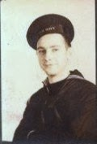

"January 12, 1942 - Started classes on sound operation at Key West, Florida. Not exactly to my liking. Got liberty at 4:30 pm. Went ashore, saw the beach. About 9 p.m. I called the (Holliman) family. Talked to all of them, including the Dalys (Robert W. Daly, Sr. was married to his sister, Vena Holliman).

January 13/14, - Still attending classes, etc. Same routine. Officers are good to us. Climate swell. Tropical atmosphere.

January 15 - Had boat watch. Today was pay day. I might say here that pay day and mail are looked forward to more than any two events. If folks only knew how the boys like to get mail they would write more often. A letter cheers one more than anything else.

January 17 - Had first test today. Make 3.90 out of 4.00.

January 18 - Went to Methodist Church today. Met Mr. and Mrs. L.L. Trent, formerly of Birmingham YMCA. Went to Baptist Church that night. Four of us enjoy going to shows, eating in restaurants, etc. Run together a great deal." - Diary of H. Bishop Holliman, 1942

Information booklet for sailors based in Key West, Florida during World War II

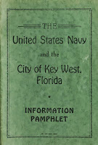

"In January 1942 German U-boats prowling off the East Coast sank 48 ships of 276,795 tons; in February, 73 ships of 429,891 tons, and in March, 95 ships of 534,064 tons. The Navy did not sink its first German submarine until April 1942." - Murray and Millett

So the same week a U.S. sailor from Alabama went to church, in the suburb of Wannsee outside of Berlin, Germany, officers of the German S.S. held a meeting over lunch and brandy to discuss a 'final solution' for the disposition of European Jews. In that bureaucratic atmosphere, as if they were deciding whether to build a new factory or construct a hydroelectric dam, Reinhardt Heydrich (pictured below) and high ranking Nazi fanatics set in motion the process by which six million persons would be murdered by the spring of 1945.

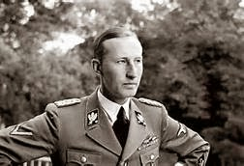

Heydrick assured those present from civil service and security organizations that the plans to eliminate Jews were approved by the Furher. Not until after the War did news of this nefarious Wannsee meeting come to the attention of Allied historians. - Chronicle of the Second World War by Derrik Mercer (Longman, London, 1990).

Meanwhile, the training continued in Key West, the pace increasing, the need great for sonar operators....

"February 2, 1942 - Went out to sea as a sound operator. Really got sea sick.

February 4 - Sea again today; did not get sick.

February 6 - Out to sea again on Saturday.

February 8 - To sea again on through the week, went to sick bay a couple of times during the week.

February 17 - Working five hours a day in buildings on base. Awaiting transfer to ship." - Bishop Holliman, Diary 1942

Next posting, fearing a quick transfer to sea duty, the family visits and a marriage occurs at home....

Friday, November 15, 2013

Visits with Cousins
by Glenn N. Holliman
A Month of Cousins...!
There are 18 living first cousins from the seven children of Ulyss and Pearl Caine Holliman. During the past month, I have had the pleasure of visiting with five of them (not counting my two sisters - Becky and Alice). So let's interrupt our Holliman 'World War II' story and share some photographs and updates on our mutual lives.
Below, Clayton Herrin, the first born great grandchild of Ulyss and Pearl Holliman, waves from his mother's Irondale, Alabama home which we visited in October. His mother, right, is, of course, Mary Daly Herrin, the first born of the grandchildren of Ulyss and Pearl. For over a generation the Herrin family (E.C. Herrin, Mary and now Al and Linda Herrin Bradley) have hosted family gatherings. E.C. is ailing now, and all of us have him and the family in thought and prayer.

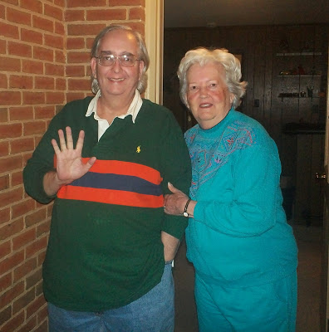

The famous Irondale Café was the location of a meal shared in October with Jean Holliman and Tommie Holliman Allen, two of the six children of Euhal and Edna Westbrook Holliman. Back ground in red, is yours truly, with left to right, Jean, Tommie and my sister, Alice Holliman Murphy. In the café as one consumes fried chicken and fried green tomatoes one can see embedded in the wooden floors the indentions of counters which held merchandise in the former Daly Hardware. The Daly Hardware Store was owned by Robert W. and George Daly during the 1940s and 50s.
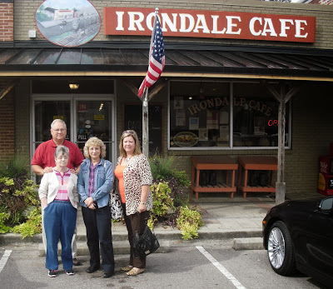

Below, Charles Ferrell, far right, and his wife Nancy, hosted my sister Alice and myself at their home on an October Sunday afternoon in Homewood, Alabama. Charles is the second born grandchild of Ulyss and Pearl Holliman, the first born son of Charles and Loudelle Ferrell Holliman. He kindly shared hundreds of photos of the Ferrell and Holliman families, now scanned, and which we will be posting later in this space and at MyFamily.com.
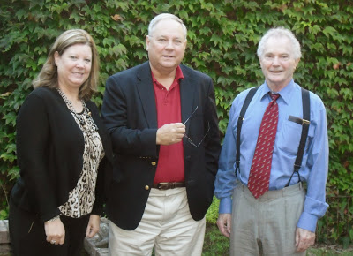
Finally, sharing an evening in my home in Newport, Pennsylvania the past week was Dr. Robert W. Daly, Jr, right. Just retired from his decades long position as a professor of biology from the University of North Alabama, Bob traveled north to visit his son John and his family in southeastern Pennsylvania. While on this excursion north, Bob stopped in for the night our central Pennsylvania farm house.
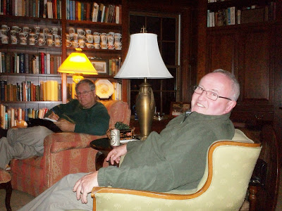

It is a pleasure to reconnect with the cousins of one's youth!
Next posting, back to our story of World War II and the Holliman family....
Join your many cousins at MyFamily.com and view an expanded Holliman family tree

