More on the Blakeneys, a branch of the Alabama Hollimans....

The last two posts, I have been writing of the Blakeney family of Fayette County, Alabama. A distant cousin, Kenneth Bowling of Texas, wrote asking how the Holliman family is related to the Blakeneys. The Hollimans are related in at least two ways (and probably more).

First, the eight child of Thomas Blakeney (1807-1896) the subject of the last article in this space, was Mary 'Polly' Blakeney (1835-1896). In 1853 she married Warren C. Holliman, the son of Charles and Barbara Walters Holliman, also of Newtonville, Alabama as was 'Polly'. This couple had eight children of whom many descendants still reside in the area. Polly is buried in Chapel Hill Cemetery in Fayette County, but unfortunately her married last name is spelled 'Halliman' on her gravestone.

The second Holliman connection is through Thomas Blakeney's first born son, William Blakeney (see below), who died in the Civil War. He was a 3rd Sergeant in the 41st Alabama Infantry, CSA. William came home on furlough in 1862, where, according to family tradition, he was exposed to measles. On his return to his unit, then outside of Chattanooga, Tennessee, he became ill of measles and pneumonia and died in Charleston, Tennessee in 1863.
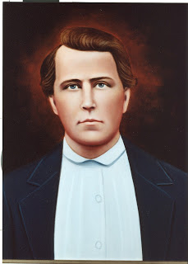
William's widow was Elizabeth Clanton Blakeney who later married Thomas Ashcraft by whom she had another child, Thomas Ashcraft, Jr. William and Elizabeth had given life to one daughter, Belzy Ann Blakeney who married George Washington Baker on November 27, 1878.

In 1879, Belzy Ann gave birth to Elizabeth Baker, who in 1899 married James Monroe Holliman, a great uncle of this writer. James Monroe was the father of the late Cecil Rhodes Holliman and Charles Baker Holliman. Cecil's son is Dr. Rhodes Holliman who has followed in his father's footsteps in cataloguing Holliman and associated family histories. There well be other Holliman-Blakeney connections and this writer would welcome hearing about them.

Below, left to right, ca 1912, Charles and Cecil Rhodes Holliman and their mother, Anne Elizabeth Baker Holliman, grand daughter of William Blakeney, great grand daughter of Thomas Blakeney.
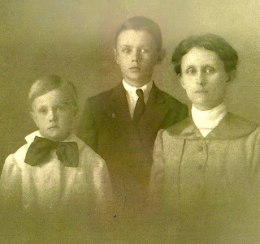
However, let us return to Thomas Blakeney, the great grandfather of Reed Blakeney, who wrote the book, Sipsey. Sipsey is the thinly disguised story of Thomas' passionate relationship with his housekeeper slave after the death of his first wife. The unnamed person was an alluring woman of Cherokee and African-American heritage. The couple had two children, a boy Jerry, and a girl named Sarah.

In time, Thomas married another white woman, who quickly sent the mixed race woman packing, perhaps to an Indian reservation. The children remained, and after the Civil War, Thomas had them apprenticed to him so he look after their welfare.

The late Walt O. Holliman has written in a Blakeney history that Tom, realizing his sons and particularly his step-sons, would make it untenable for the mulatto children after his death, is said to have given Jerry and Sarah a measure of gold he had buried during the Civil War. With this generous legacy he also provided them with a horse and wagon and as much farm equipment as it would carry and sent them 'off into the sunset'. In later life, Jerry Blakeney often looked after his father, Thomas, supportive of him in his old age.

Author and family historian Reed Blakeney has established that Jerry settled in North River, Tuscaloosa County. Reed made contact with three of Gerry's children - Walter and Willie, who lived in Birmingham and Evalina Blakeney Green, who lived in Tuscaloosa. The three adult children were aware of their Blakeney heritage and bore the name proudly.

Out of the cultural confusion and ethnic chaos of the near frontier of the Ante-bellum South, emerged a compassionate person whose DNA can only be called American - a combination Cherokee, African, Irish and English. Below a stately and imposing photograph of Thomas Blakeney's son, Jerry Blakeney (1857-1955).
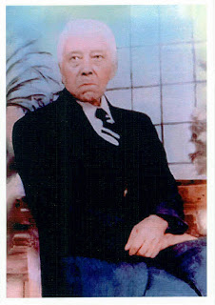

My thanks to the late Walt O. Holliman, Dr. Rhodes Holliman and Reed Blakeney for a reading of their research and photographs on this American family.

