Hello Barbara,

Yes there was litigation. A Judgment from Circuit Court was Ordered November 04, 1929 (see enclosed copy of Judgment). And, the was a Decree in Probate Court April 7, 1931 (See enclosed copy of Decree. I went to the Library and there was an article of Rosalie's death and funeral at our house. But, we could not find anything related to the Circuit Court Action in 1929. But, then again I went to the library first before going to the Register of Deeds Office, and I did not have the exact dates of the Judgment or Decree at that time.

These questions were raised. 1. Where did you find the newspaper clipping? 2. I who's Things - files, etc.? and 3. Can you scan it and send it to me, and the librarian? You have my e-mail address. Her name is Marly. Her e-mail address is: mhanson@tadl.tcnet.org . She may be able to identify it, and tell you weather it came from the TC Record Eagle. Maybe it came from another paper. ???? Are you sure it came from TCRE? Anyway attached are what I found today.

I hope this puts your mind to rest regarding the family accusations.

See ya Barbara, Have a good weekend.
Ric Zehner
RIC ZEHNER REAL ESTATE
516 SIXTH STREET
TRAVERSE CITY, MI 49684-2418
231-947-8038
Web: http://www.netonecom.net/~riczre
E-mail: riczre@netonecom.net
ps No offers yet. The Brick house next door came on the market today for $329,900. It'll sell sooner than this house. Price.
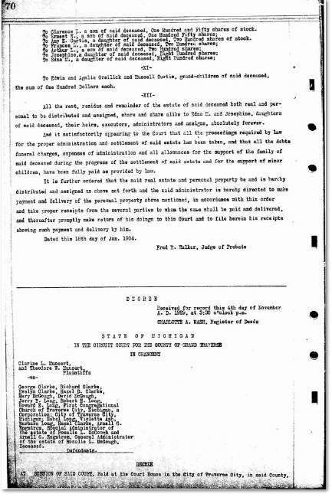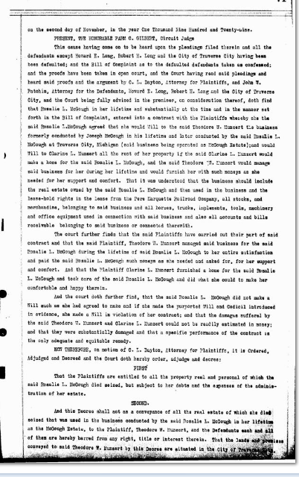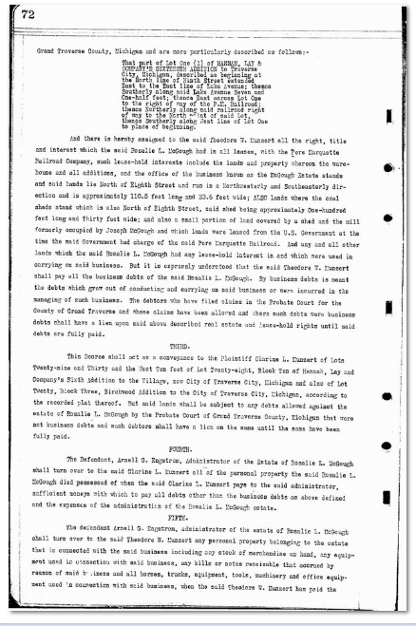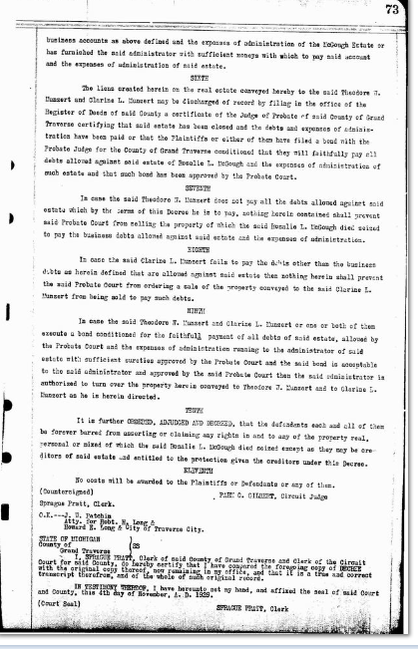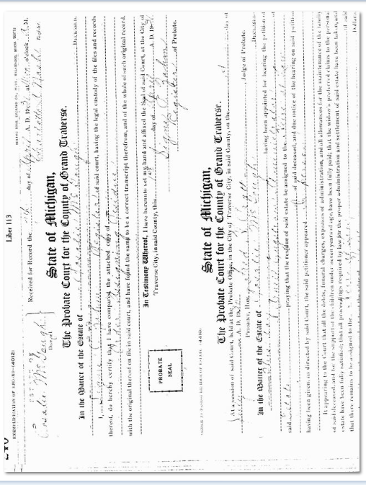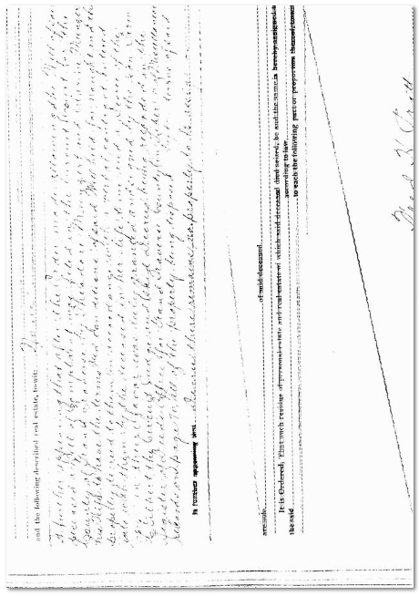 Hi Barb,

Rose. Is she Rosalie Maria Long McGough? And, is she your Great Aunt, and a sister of your Great Aunt Clarine Long Munzert? And both of them are daughters of Barbara Beiter Long. Do I have this correct?

YES!

Barbara and Charles married 10 November 1860. Rosalia was born 18 August 1861, the day before her mom’s 20th birthday! The first of 5 children. Clarine was born in 1879.

And, I believe you said that your Great Grand Mother, Barbara Beiter Long came to live with her daughter Rosalie in 1903. I think it was about 1905, but after Charles died in 03.

Great Uncle Joseph H. McGough was killed in an auto accident in 1910. 1915 See photo of grave attached

His wife, Rosalie asks her sister Clarine, and husband Theodore Munzert to come and run the McGough business, McGough’s Feed, Seed, & Coal. They all four live at 516 Sixth St; Barbara Beiter Long, Rosalie Maria Long McGough, and Clarine A Long Munzert and Theodore Munzert. YES

Charles Long, husband of Barbara Beiter Long dies in 1903 of “Brights Disease” (Kidney). And, Barbara comes to TVC to live with her daughter and husband, Joe & Rose McGough. YES

Joe dies in an auto accident in 1915

So, Rose invites Clarine and Theodore Munzert to come to TVC and take over the McGough business. YES

Rosalie McGough dies of Colon Cancer in 1928. (age 67…just) In her Will she leaves her home to her nephew, Robert Howard Long (my father, age 13, living in Lockport, NY).

Munzert’s who have been living in the 516 Sixth Street McGough home since 1915 with Rose McGough, and their Mother Barbara Long contest the Will, and apparently win litigation, and settlement in this property. See article in Traverse City Record Eagle about 1928 or 29.

They sue Rose’s brother, Howard Evans Long, (son of Charles Evans Long and Barbara Beiter Long), on behalf of my father, Robert Howard Long.)

My father, Robert Howard Long, to whom the property was Willed, after a period of time, (1947…Dad was 32 and I was 2) makes up with his Aunt Clarine A. Long Munzert. But, she and her brother, Howard Long, never settled their differences. (Howard died 1942.)

In her Will, she Will’s the 516 Sixth property and all of her possessions to Robert Long (her nephew and my dad). My dad gives me the house and possessions in a Quick Claim Deed.) My name was Barbara Long Tilmann at that time, and I was living in Kalamazoo, MI.

My Grand Father, Howard Evans Long dies of lung and brain cancer in November of 1947 in Lockport, NY. He was Born: 25 September 1881.

Clarine A. Munzert was named after Clarine Deveraux, a friend of Barbara and Charles who lived in Lockport, NY. The street they lived on when the first married (1860) was Deveraux Court. The apt house still exists. Photo being sent. (Listed as 133 Washburn St. REAR in census data)

Barbara Beiter came to the U.S. from the Stuttgart, Germany on the ship, THE Hope, in 1852; arriving in New York. She marries Charles Long in 1860. (She was born in 1841, died in the TVM house in 1935 age 94).

1861 is also the year Rose was born isn’t that coincidental. (Got the date wrong, 10 Nov 1860 was the marriage date).

STATE OF MICHIGAN—In tlTCircuit Courl for the County of,
Grand Traverse—in Chancery.
Clarine L. Munzerl and Theodore
W. M u n z e r t, Plaintiffs,
vs.
George Clarke, Richard Clarke,
Evelyn Clarke, Haze! D. Clarke.
Mary McGough, David McGough.
Jerry B. Long, Robert. H. Lonp.
Howard E. Long. First Congregationa l Church of Traverse City.
Michigan, a corporation: City of
Traverse City. Michigan, Mabel
Long. Violettc Ash. Barbara
Long. Hazel Clarke aud Arnell G.
Engslrom, Special Administrator
ot tbe estate of Rosalie L. McGough. Defendants.
Suit pending in the Circuit court
for the County ot Grand Traverse,
in chancery, at Traverse City.
Michigan, on tbe 29th day of January, A. D. 1.929.
In this cause it appearing from t h«
a f f i d a v it of Theodore W. M u n z e rt
on file, that the defendants George
Clarke. Richard Clarke. Evelyn
Clarke. Hazel D. Clarke, Mary MeGough. David McGough. Jerry B.
Long, Robert H. Long. Howard E.
Long. Mabel Long. Violette Ash
and Hazel Clarke do not reside in
this state, but that George Clarke.
Richard Clarke. Hazel D. Clarke,
Evelyn Clarke. Hazel Clarke, Mary
McGough. Robert H. Long
Howard E. Long, all live in tlie
State of New York. And that
defendanls Jerry B. Long and Violetto Ash reside in the State of
Massachusetts, and the defendant
David McGough resides in the
Stale of Ohio. And that it cannot
he ascertained after diligent search
! and inquiry in what, state or country the d e f e n d a n t, Mabel Long resides.
Therefore, on motion of C. L.
Dayton, attorney for the plaintiffs,
it is ordered that the defendants,
George Clarke. Richard Clarke,
Evelyn Clarke. Hazel D. Clarke,
Mary McGough, David McGough,
Jerry B. Long, Hobert H. Long,
Howard E. Long. Mabel Long. Violette Ash, Barbara Long and Hazel
Clarke, cause their appearance to
be entered in said cause within
three months from the date of this
order.
It is further ordered, that within
forty days tbe plaintiff cause a notice of this order to be published
in the Record-Eagle, a newspaper
printed and published in. the City
of Traverse City, Michigan, and
circulating in said county: and
that such publication be continued
therein .at least once in each week
for six weeks in succession, or that,
the plaintiffs cause a. copy of this
order to he personally served on.
' said, non-resident defendants at
least twenty days before the time
above described for their appearance.
FARM C. GILBERT,
• Circuit Judge.
Filed and entered this 31st day
oi January, A. D. 1929.
SPRAGUB PRATT.
Clerk.

