My Grandmother's Wall of Photographs, Part 1
by Glenn N. Holliman
Is there a grandchild among us who has not stood and stared at family pictures in a grandparent's home? For a nine year old, the question must be always "Who are those old people? Did my aunts and uncles really look like that when they were young?"
Pearl Caine Holliman (1887-1955) had such a wall in her home at 2300 Third Avenue North in Irondale, Alabama. As a youngster, I marveled at the pictures and wondered who were all those people, those relatives of mine? Below are a few pictures and memories of my grandmother's wall of photographs.
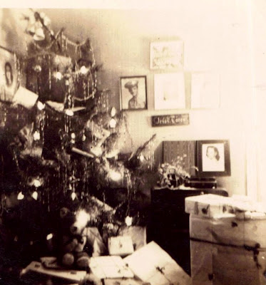
Let me start with an indoor picture, rare for the time, taken of Grandmother Holliman's Christmas tree. It stood in a corner of the living room, a massive tree to my childish eyes. This picture was taken in 1945, the year before I was born but she seemed aways to have a tall tree with electric lights that 'bubbled'. Yes, it is blurry and not the sharpest picture, but let's study it closely.
On the far upper left corner, one sees a photograph of my Aunt Virginia Holliman Cornelius (1922-2011). This may have been her senior picture from Shades Cahaba High School. Today, one of her daughters, Susan Cornelius Wilson of Texas, has possession of it.
Below, embedded in the lower left corner of Virginia's photograph, notice the World War II photograph of Virginia's husband, Walter Cornelius (1922-2006). They married in February 1942, one of the three war time marriages in the Ulyss and Pearl Holliman family. This copy of Virginia and Walter was taken in February 2012 in Trophy Club, Texas.
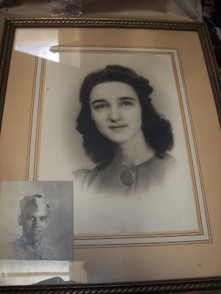
Below Susan Cornelius Williams, one of Walter and Virginia's two daughters, displays this picture seventy years after it first hung in her grandparent's home in Alabama. These pictures were taken at Alice Holliman Murphy's home in Texas. Alice is the daughter of Bishop Holliman (b 1919) and Susan's first cousin.
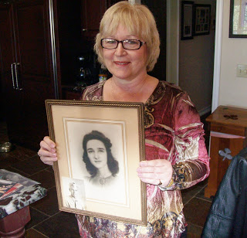
Next posting, more pictures from Grandmother's wall....

My Grandmother's Wall of Photographs, Part 2
by Glenn N. Holliman
The year was 1945, and here is another view of my grandmother's Christmas tree that first holiday after the end of World War II. The three sons who went to war of Ulyss and Pearl Caine Holliman of Irondale, Alabama - Melton, Bishop and Ralph - were finally home. A son-in-law, Walter Cornelius, husband of daughter Virginia, still remained in Saipan, a B-29 base in the Pacific. In the corner wall, several difficult-to-discern photographs are hanging. In the last post, we examined the one in the upper left, Virginia Holliman Cornelius.
Now let's look at the one in the upper center, an Army soldier, the youngest son, William Ralph Holliman, born 1924.
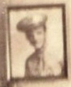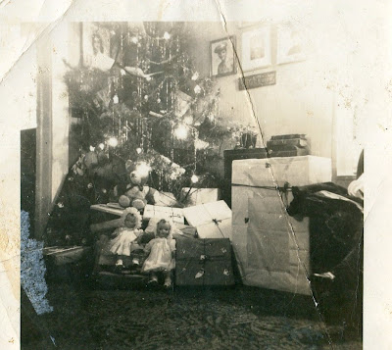
A blurred enlargement. The original was lost in a basement flood years ago.
Ralph went off to the Army in March 1943 and would not return to see his family and new bride, Motie Chisom, for two long years. Ralph would be stationed in England and France with the Army Air Force from late 1943 until the summer of 1945.
Below is a picture taken February 1942, when Ralph, age 18, visited his older brother, Bishop Holliman, age 22, already in the Navy at sonar sound school in Key West, Florida. The war was at its worst for the United States. German U-Boats prowled the East Coast sinking freighters. After the December 1941 attack on Pearl Harbor, the Japanese invaded the Philippines, an American colony at that time. A U.S. and Philippine army was trapped and would be forced to surrender. The days were dark for the American war effort that first winter of the USA involvement in World War II.
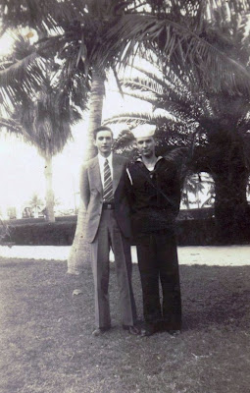
Next, the Photograph of Melton Holliman....

My Grandmother's Wall Photographs, Part 3
by Glenn N. Holliman
We have been examining the pictures that hung in the living room corner of the Ulyss and Pearl Caine Holliman in Irondale, Alabama. Below is another view of the wall at Christmas time 1945.
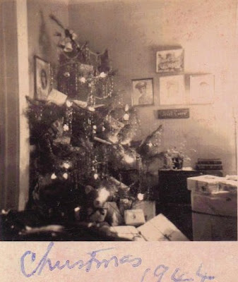
The picture is mislabeled 1944, but it is Christmas 1945. The picture of Virginia Holliman Cornelius is in the left corner, and Ralph Holliman next in line to the right of the tree. Blurred out by the flash bulb are Melton Holliman and Bishop Holliman. The picture displayed of Melton (1908-1958) is probably the one below. Melton's daughter, Pati Holliman Hairston, has kindly shared numerous pictures of her father with me.
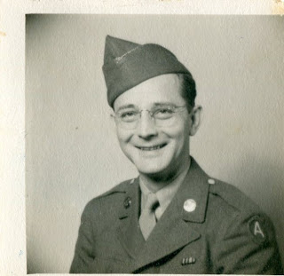
Melton served in France as a medic from July 1944 until high blood pressure sent him to the hospital and eventually home in December 1944. He was discharged in the summer of 1945 after final service at an Army hospital in Jackson, Mississippi. Unfortunately his health remained precarious with a first heart attack in 1955 and a fatal one in 1958 in Mobile, Alabama, much, much too young. He had learned pharmacy from his Uncle Floyd Caine, and became a leading and admired pharmaceutical salesman and Baptist lay leader.
Christmas 1945 would have been special for the three cousins below. Pati, Melton's daughter, is far left. Mary Daly Herrin holds on to her new brother, Robert W. Daly, Jr.
One suspects most of those presents around their grandparents' Christmas Tree were for the grandchildren of which there were 11 by that winter.
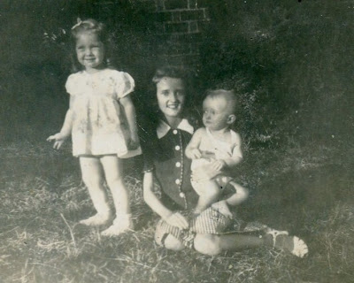
Next the Sailor on the Wall...

My Grandmother's Wall Photographs, Part 4
by Glenn N. Holliman
I have been writing about my Grandmother Pearl Caine Holliman's corner wall at 2300 N. 3rd Avenue, Irondale, Alabama. Informal indoor photography was still expensive in 1945, the year World War II ended. For some reason four photographs were taken of the tree that Christmas, perhaps to capture, at least in part, the photos on the walls. In this picture, one can observe that Grandmother Holliman has placed a new picture against the wall on table. That new photo is of my mother, Geraline Stansbery Holliman, one of the three war brides of the Holliman family, and the only one from out of state - Philadelphia, Pennsylvania.
Here's a close up of that picture. Bishop Holliman met 'Gerry' in 1942 while in Atlantic City, New Jersey, where he was trying to rendezvous with Irondale soldier, Charles Pugh. Bishop never found his boyhood friend, but he did sit behind Gerry and her Mother while at a show on the famed Boardwalk. They exchanged addresses, wrote for several years and lo and behold, the Alabama boy married the Philadelphia girl June 26, 1945. And so Gerry's picture, if not on the wall, was propped up under Bishop's, the Irondale sailor man.
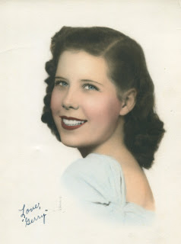
Below is the photo of Bishop, blurred in the top picture, the young sailor in December 1941, the month of Pearl Harbor. He was in boot camp in Norfolk, Virginia when the Japanese attacked. The war was on, and two other Holliman men, Melton and Ralph, also answered the call to service. Euhal Holliman was not called to duty due to being the father of four children by spring 1944.
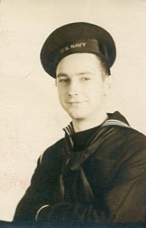
Bishop served as a radioman on two destroyers and saw action at the Invasion of Sicily in 1943 and in the North Atlantic in 1944. The last photo on the wall (top picture) is the one pictured below of Bishop (difficult to see seven rows back, left center, approximately 8 from the left with his hat pushed back or three to the left of the gun barrel nose) on the USS Barker. As a young boy, I would stare at this picture of my father and wonder. It is now in my possession.
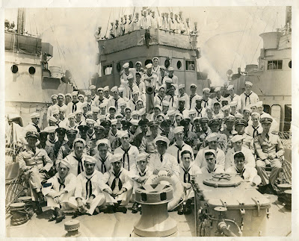
Alas, two of the three Holliman war time marriages ended in divorce. Virginia and Walter Cornelius in 1973 and Bishop and Gerry Holliman in 1988. However, five children emerged from these marriages, and numbers of us would not be in our present DNA composition if not for these young couples falling in love in terrible times.
Next posting, more photos from another wall in the Holliman Irondale home....

Thursday, January 17, 2013

My Grandmother's Wall Photographs, Part 5
by Glenn N. Holliman
In previous posts, I have been expounding on the portraits hung on the wall in my grand mother's home in Irondale, Alabama home in 1945. They remained mounted on the wall until Pearl Caine Holliman's death in 1955.
There was a special collage of photographs in a frame almost a yard wide and 8 inches high. It contained 55 photographs. Every time I visited my grandparents as a young boy, I stared and stared at the pictures of my father's family, when they were all so young.
When Grandmama Holliman died the photographic collage went first to her oldest daughter, Vena Holliman Daly (1909-1990), and while she lived in Irondale, it hung in her home. Later it passed to her older child and first of 19 grandchildren, Mary Daly Herrin. The large collection of Holliman family photos still hangs today over Mary's kitchen table in Irondale. Over 60 years later I still study and ponder the lives of the persons pictured.
Below approximately the first 1/3rd of the collage.

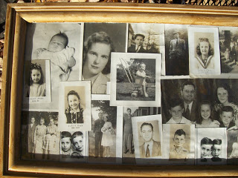

At the Ulyss and Pearl Caine Holliman descendants’ reunion at Al and Linda Herrin Bradley’s house in June 2012, Mary brought the collage for viewing. I took pictures of it, and later scanned them into my computer. With the help of my 93 year old father, Clayton Herrin, Patti Holliman Hairston, Ralph Holliman and others, the persons have been identified and labeled.
It is impossible with my camera to gather the entire collage in a viewable format, so I divide the work into six pieces. The photos are numbered. Click on twice and the picture will enlarge. Here we go to identify the pictures.
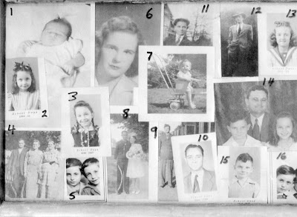

1. Carolyn Ferrell Tatum, daughter of Charles (1907-1999) and
Loudelle Holliman Ferrell (1914-1996). She resides in North Carolina.
2. Carolyn Ferrell Tatum in 1944 in Alabama. Her father was a United Methodist minister and the family moved often during 1940s serving churches in Goodwater, Jacksonville, Huntsville and Ensley, Alabama. Her brothers are Charles Halford and John Melton Ferrell.
3. Carolyn Ferrell Tatum in 1946.
4. William Lee Caine, Lula Hocutt Caine and Martha Jane Walker Holliman (1846-1931 – wife of John Thomas Holliman, and mother of Ulyss Holliman, photo taken in Fayette, Alabama). Left and center are William Caine (1862 - 1938) and Lula Hocutt Caine (1861-1957), the parents of Pearl Caine Holliman (1887-1955).
5. Jerry (1940-2003) and Terry are the twins of Euhal (1912-1989) and Edna Westbrook Holliman (1916–1992). Jerry died of heart failure while salmon fishing near his home in Alaska. Terry resides in Arizona.
6. Motie Chism Holliman (1925-2003) is the first wife of William Ralph Holliman (b 1924) and mother of Pamela Holliman and Kathy Holliman. Rachel Harbour is Kathy’s daughter.
Ralph and Motie married in 1943, a month before Ralph was inducted into the U.S. Army and World War II. He served in England and France and did not return home to see his young bride for over two years until the summer of 1945.
7. Glenn Nelson Holliman (b 1946) in Birmingham, Alabama. This photo was taken in 1947 at the Irondale, Alabama home of his grandparents. The red brick Daly house is just visible in the background. Many pictures were taken on the Holliman lawn with the Daly home in the background due to better afternoon lighting.
8. Bishop and Geraldine Stansbery Holliman in June 1945 outside of Germantown Methodist Church in Philadelphia, Pennsylvania. ‘Gerry’, a native of Bristol, Tennessee, lived in Philadelphia from 1941 to 1944, where she met an Alabama sailor on a three day pass in 1942 in Atlantic City, New Jersey. Three years later they married. They are the parents of Glenn Holliman, picture 7.
9. Melton Pearson Holliman (1908-1958) was inducted into the U.S. Army in August 1943 at the age of 35. This photo of him is at Camp Barkley in Texas where he did a grueling basic training and advanced work as a medic. He served in France with a medical unit from July to November 1944. His health broke, and he was sent home to serve out his duty in Jackson, Mississippi hospital as a pharmacist. He suffered a major heart attack in 1955 and a fatal one in 1958. He may very well have been a casualty of World War II.

10. Bishop Holliman (b 1919) came home to Birmingham in 1945 with his new bride. With the G.I. Bill, he finished Birmingham-Southern College and in 1947 started teaching school at Shades Cahaba Jr. High and later the new Shades Valley High School. This picture is of him as a history and civics teacher. (Do you wonder where his son obtained his interest in family history?)
11. Euhal Holliman looks snazzy in his cap, probably from the 1930s. Euhal had some tough timing in his life as he left high school just as the Great Depression began. He went to work to help pay family bills in the only job he could find at the time - a produce grocer. As his own family grew, he made food sales his career. During his employment at various supermarkets in Gadsden and Birmingham, he was tapped by his co-workers to serve as their labor union representative. His leadership helped to achieve living wages and benefits for Alabama grocery workers.
12. Ralph Holliman (b 1924), looking dapper, poses in front of the Daly house in Irondale, Alabama sometime in the 1940s. Ralph served in World War II as a clerk in an Army Air Corp unit, logging and scheduling air transport flights. He was praised for his administrative abilities during the war by his commanding officer. V-E day found him celebrating in Paris. After time at Birmingham-Southern College, he put his skills to work with a post-war career at American Bakeries retiring as their national vice-president for operations.

13. Mary Daly Herrin is the daughter of Robert W. (1901-1959) and Vena Holliman Daly (1909-1990) and the first born of the 19 Holliman cousins. This photo is of her during school days and before she met the love of her life, Elliott Clayton Herrin, whom she married in 1951.
14. The Charles and Loudell Ferrell family – back Charles Ferrell (1907-1999) and Loudell Holliman (1914-1996), married 1935. Left to right: Charles Halford Ferrell, Carolyn Ferrell Tatum and John Melton Ferrell.
15. Charles H. Ferrrell graduated from Birmingham-Southern College and earned a divinity degree from Emory in Atlanta, Georgia. In 1963 as a United Methodist minister in the North Alabama Conference, he wrote a letter to the then segregationist Governor George C. Wallace decrying his racial policies. The courageous letter, that put Hal's career at risk, was reproduced in a definitive biography of Wallace highlighting that not every white Alabamian supported Wallace’s racial intolerance during those troubled times.
16. Terry and Jerry Holliman, the twins, left Alabama in the early 1960s and located to the far north, Anchorage, Alaska where Terry worked as a fireman for 25 years. Jerry made a career as baggage supervisor for Alaska Airlines. Unfortunately Jerry died in 2003 of a heart attack while engaging in his favorite past time of salmon fishing.
Section 2 of the Collage in the next post!

