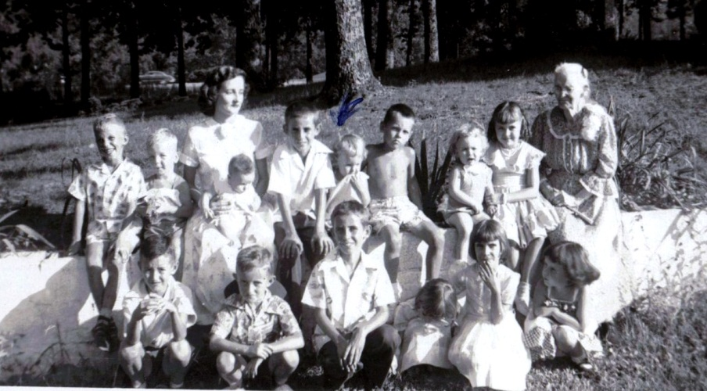

Photograph made 1953 when Lula Hocutt Caine as 92 years old at the Robert Daly, Sr. house in Irondale, Alabama. Front row as identified by Mary Daly Herrin (back row, 3rd from left):
- Jerry Brasher, son of Juanita, daughter of Dorothy Prince, daughter of Vista Caine, sister of Pearl Caine Holliman
- Robert Daily, Jr., son of Vena Holliman Daly
- Jerry or Terry Holliman, twin son of Euhal and Edna Holliman
- Jean Holliman, 4th child of Euhal and Edna Holliman
- Anne Holliman Phillips, daughter of Euhal and Edna
- Pam Holliman, daughter of Ralph and Motie Holliman
Back or second row:
- Unnamed sons of B.J. and Alta Cook and grandsons of Maude Caine Cook, sister of Pearl Caine Holliman
- Mary Daly Herrin, daughter of Robert W. Daly, Sr. and Vena Holliman Daly
- Clayton Herrin, baby on Mary’s lap, her first borne
- Jerry or Terry Holliman
- Becky and Glenn Holliman, children of Bishop and Gerry Stansbery Holliman
- Susan and Carol Cornelius, daughters of Walter and Virginia Holliman Cornelius
Lula Hocutt Caine had four children: Floyd, Pearl, Maude and Vista. Floyd had three children: Floyd Jr. Annie Lue and Mildred.

My thanks to Clayton and Mary Herrin for the identifications.

