We continue our series of articles on the historic 1830 Holleman House which rests in Isle of Wight County, Virginia on part of the original plantation of Christopher Holyman (1618-1691), the founder of most Hollimans (and many spellings) living in the United States today. My continued thanks to Sarah Barlow Wright, Janet Wright Moore and Susan Holleman Brewer for their sharing of information and critique of these articles. This series could not have been done without their generous participation. GNH
From the memorabilia of Gladys Holleman Barlow, courtesy of her daughter, Sarah Barlow Wright, are some additional photographs. Below, is the extended family of Josiah James (1851-1937) and Augusta Hannah Holleman (1859-1941) gathered for a picture in 1921. They are sitting on the front steps of the house. Wilson Holleman (1803-1873), builder of the house, had given it the name of 'Mayfield' and for a number of years the post office in the vicinity was called Mayfield.

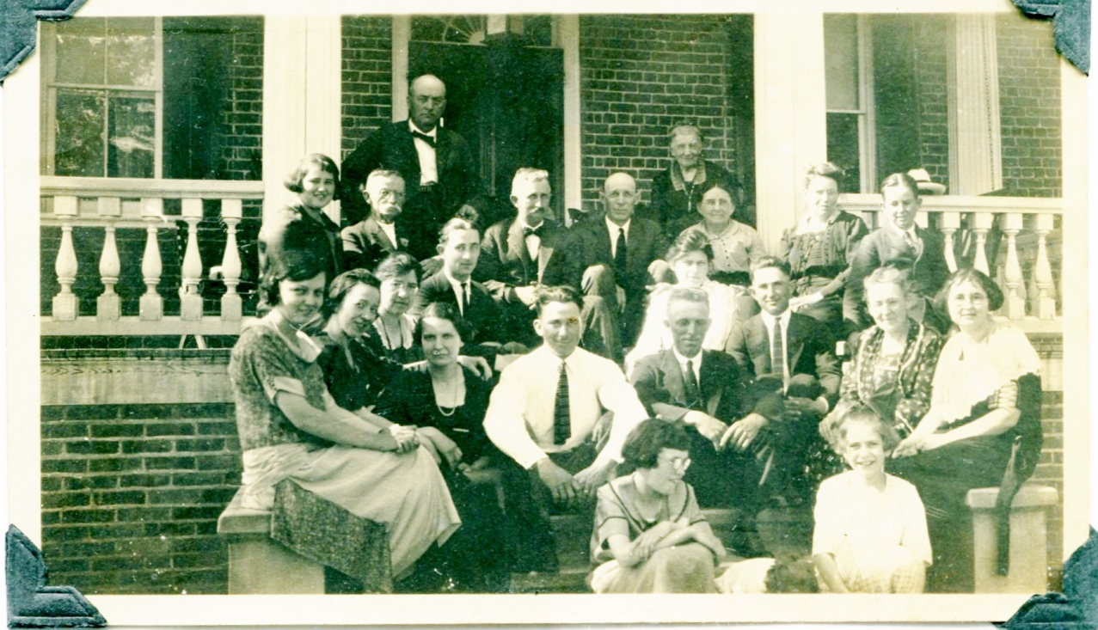
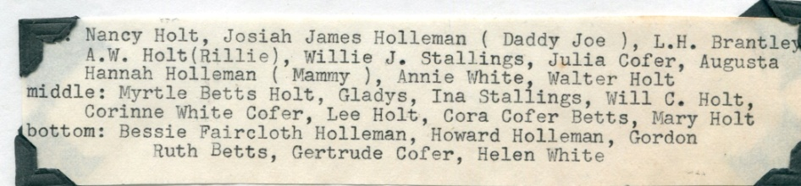
Fifty-four years later another family gathering was photographed on the same site on a cold day in February 1975. As with all families new generations are born as the old depart. This was a celebration of Gladys Holleman Barlow's 80th birthday. She is on the far right with the purple corsage. Of interest to the historian, the names of Cofer and Gwaltney, families who lived in the Mill Swamp area in the 1600s with the original founder, Christopher Holyman, still are living in the vicinity and marrying 20th Century Hollemans.
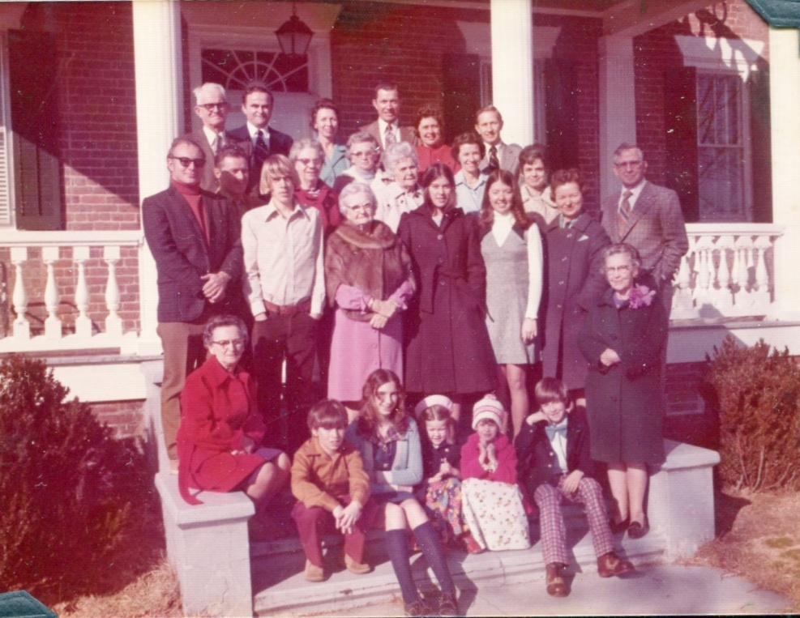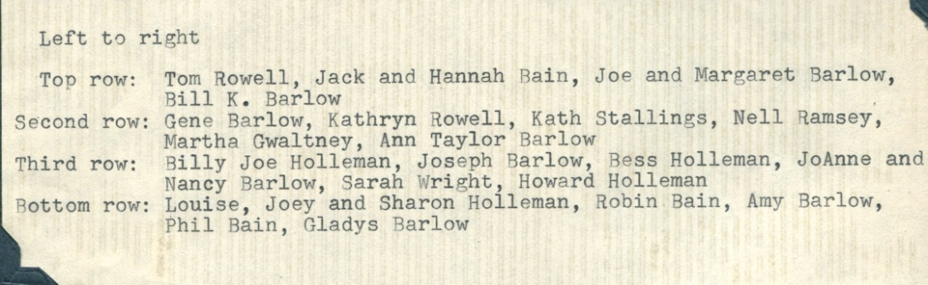
Right, present in 1975, just as they were on a summer day in 1921, were brother and sister, Joseph Howard Holleman (1897-1979), about whom we have written previously, and Gladys. Howard, a long serving member of the Virginia House of Delegates from neighboring Surry County, also is pictured as a young man on the left, below. Gladys, Howard and their brother, Algernon Holleman ((1902-1963) were born at the Holleman House.
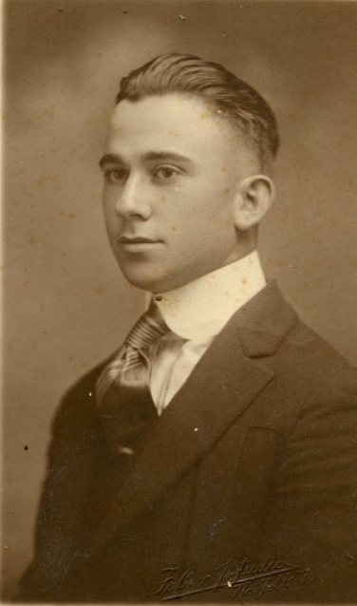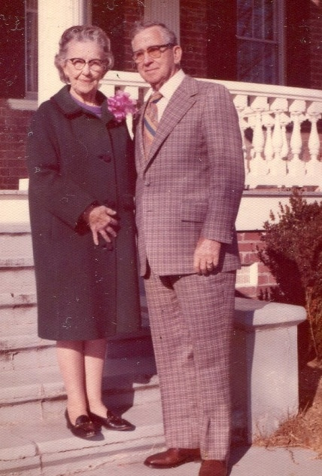
Gladys Hortense Holleman Barlow (1895-1996), lived a long and generous life in Isle of Wight County serving, among other activities, as a teacher, school principal, active leader in her Baptist Church and numerous civic organizations. In 1921, she married Gordon Eugene Barlow, a member of another prominent and early family of the County, and they had five children - Gordon Eugene Barlow, Jr., Hannah Barlow Bain, Joseph Holleman Barlow, Sarah Barlow Wright and William Kyle Barlow. At the time of her passing there were eight grandchildren and seven great grandchildren.
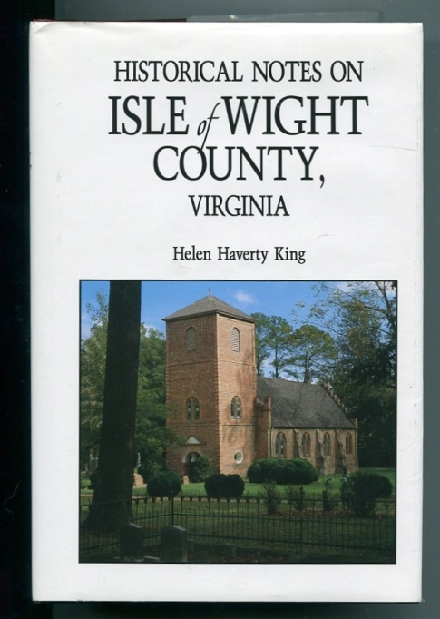

Both the Barlow and Holleman family contributions to the community are recorded in Helen Haverty King's 1986 work, Historical Notes on Isle of Wight County, Virginia, a must read for the serious student of James River history.

Next posting, using Ms. King's historical writings and the Federal Censuses of the middle 1800s, we shall learn more about the Hollemans who remained in Virginia....

