A Life in Appalachia,
The Diary of Frances Wilson Osborne
1851-1940
by a Great Grandson, Glenn N. Holliman
(Last updated 2016, transcripted in 2011)

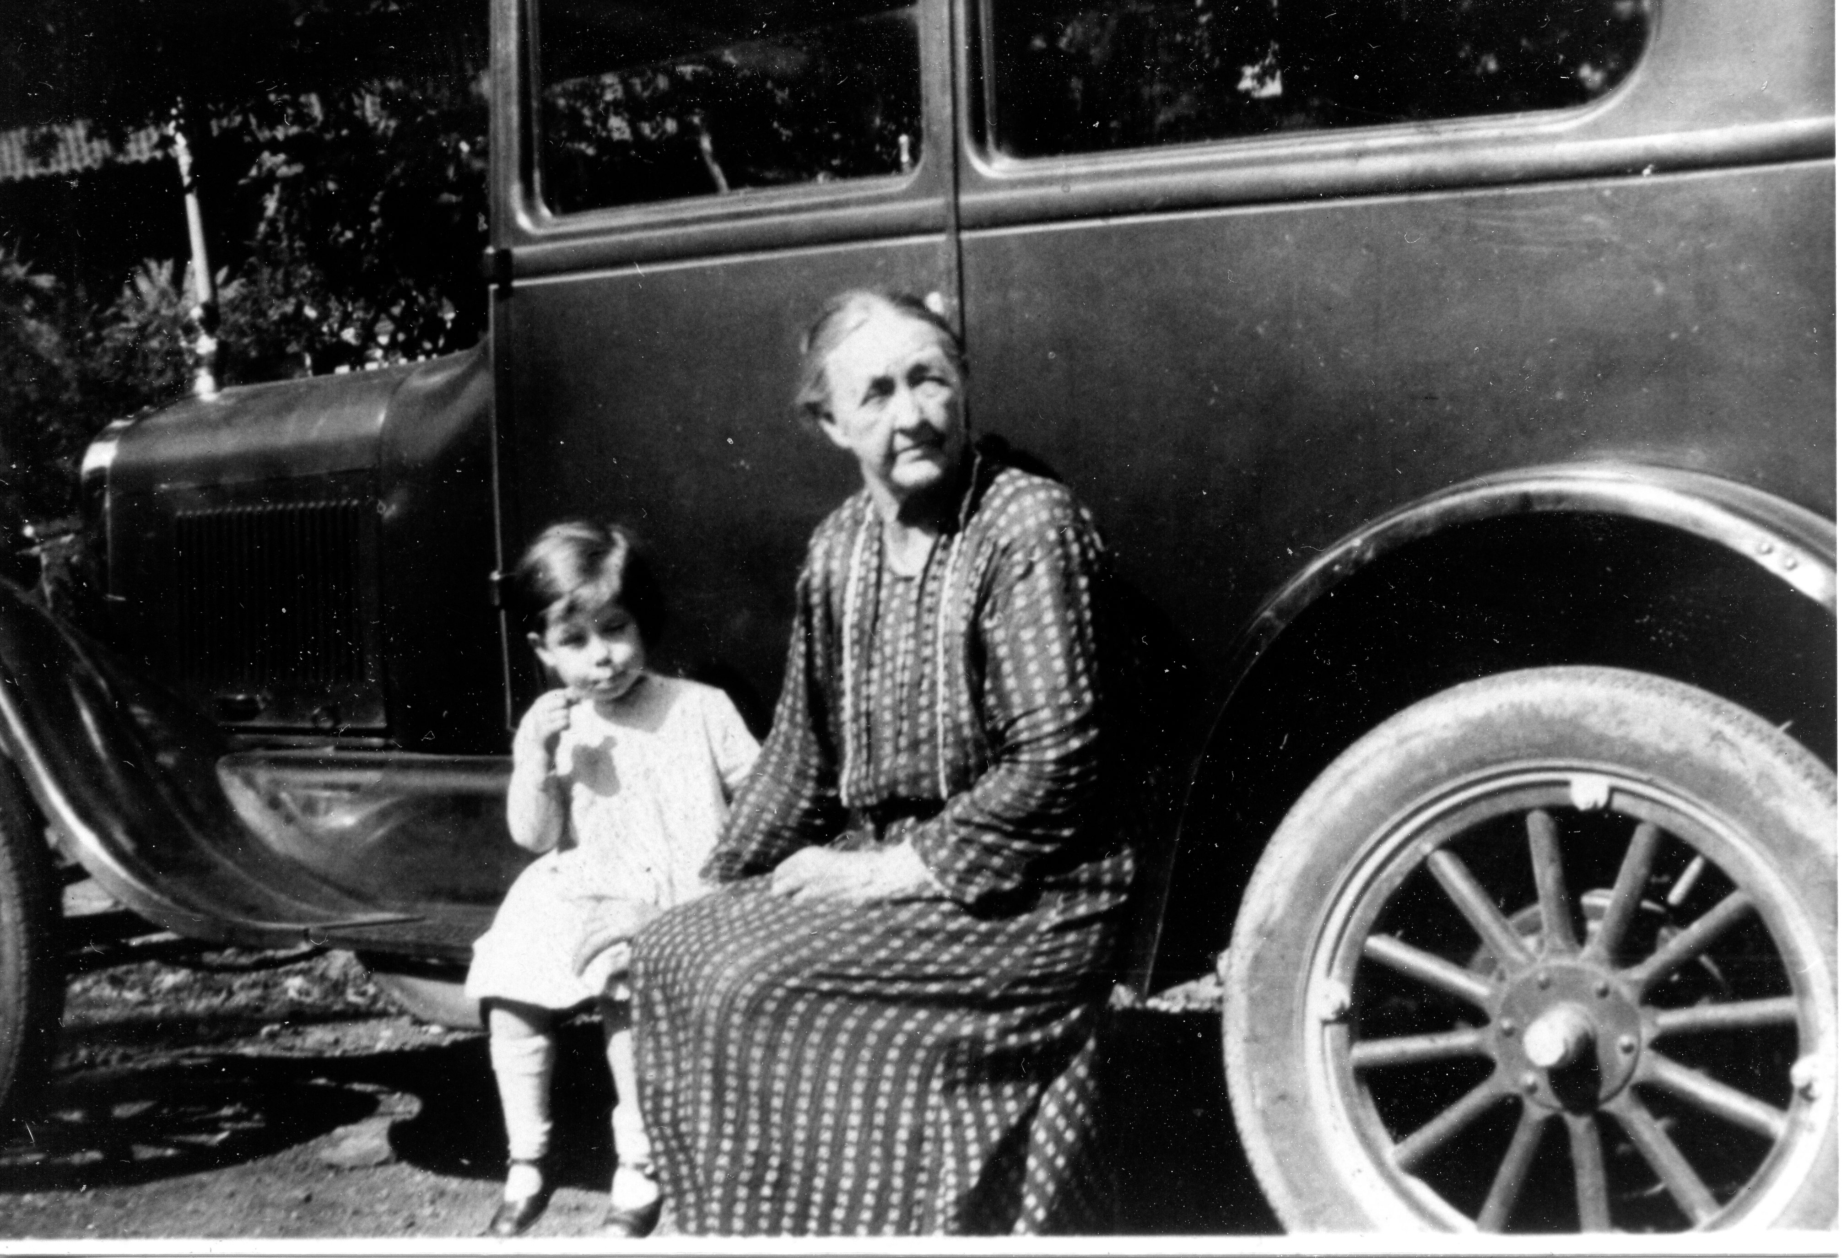
Above, Geraldine Stansbery Holliman Feick, this writer’s mother, sits on the running board of a family automobile in Damascus, Virginia with her grandmother, Frances Wilson Osborne, circa 1928. Photo courtesy of Clinton W. Getziner and Lois Ann Howard Adams, fellow descendants of Issac and Caroline Greer Wilson of Ashe County, North Carolina.

Introduction

An old adage states that to understand the present, one must understand the past. We understand our current time and ourselves better if we know from whence we have come and how time became, well, our time.

Of course, our ancestors were born into a culture, a place and a set of social, religious and political conventions that differ, perhaps little or much, from current mores and economic conditions. Of our birth, this emergence into Creation, we have no control. Here we are and here we shall be, until the inevitable departure of this life. What we make of our time and place depends much on family of origin, personal characteristics, circumstances, health and good fortune.

Studying history has been both an occupation and an avocation for me. It was an occupation from college through 1976, when I left teaching to raise funds for schools and Episcopal churches. My career in capital campaigns and financial development has closed, and now I return to my first love, a discovery of the past.

Family history exploration and interpretation is fraught with pitfalls. Parents and ancestors are revealed too often as the flawed human beings of whom we all are. One might ask why did this ancestor do this or not do that. Of course, by asking that of a predecessor, one also is asking the same of oneself. Hence to this writer, discovery of someone else’s yesterday causes me to ask the same of my yesterdays and how this might apply to my more limited tomorrows. Perhaps it will for you, the reader, especially my children’s children and all other relatives who have ancestors recorded in this reflection.

How did one cope in a world of differing morals, transitional technologies, societal expectations, racial and gender relations, and the wars that ancestors had which to contend? Would I have behaved any differently given their levels of education, their more limited world views, and their hopes and dreams for themselves and their children? Like me they had various ambitions, character issues, passions, appetites, greed, and made both poor and excellent decisions. Many also made daring decisions, braved the oceans, fought wars, made the land abundant with food, loved, married, raised children, exercised generosity, and grew feeble with age, if blessed to make it that far. Eventually they crossed the River as we all must do.

All my direct ancestors were fortunate enough to make it to sexual maturity, or neither you nor I would not be here in our present DNA form. Generation to generation, since the dawn of cell life, this process has occurred.

To look into the life of an ancestor is to see someone at birth, midpassage and death. What we can learn about their lives and times presents a panorama of one moving through history.

My first cousin, Dr. Vance Sherwood, a talented and published clinical psychologist in Knoxville, Tennessee asked, when inspecting a photograph of a great- great-grandmother, if I felt anything of and for that person, i.e. any relevance to my life? As one who ponders history, my answer is yes, I do. It is fascinating to try and crawl into their time and culture, and see the world through their heads and hearts. I know from where they came, and unlike them, I know the future of their lives and world. I can see what is coming - they could not.

One of my great-great-grandparents on my father’s side, an ambitious farmer in Alabama made sizeable purchases of land in 1857 and 1859. Uriah Holliman was not a slaveholder, but with the coming of war, he enlisted as a private in the Confederate Army in 1861. A year later after the Battles of Shiloh and Corinth, he and one of his sons, Charles Daniel Holliman, both died of measles, not wounds. The farm in Alabama languished and many family opportunities died with them. The trauma of that war reverberates in the Holliman family tree since.

In most ancestral cases, their daily perseverance, the raising of their children, and in some cases putting and losing their lives on the line for their beliefs, is both inspiring and sobering. The woodland philosopher, Henry D. Thoreau, wrote that most men live lives of quiet desperation. In this early part of the 21st century most of us do live from paycheck to paycheck, whereas our fore parents lived from harvest to harvest. Frances Caroline Wilson Osborne, in her early years, lived to take food from the land every summer and fall. In her final years, she lived from a meager pension check to pension check.

Many of my ancestors lived to old age, and some died in their middle years before their allotted seven decades or so. Here then is one story of a lady, Frances Caroline Wilson Osborne, who carried her burdens and joys to old age exercising a positive and generous nature. To put this story together, I have had the benefit of diaries, correspondence, memories from my mother, Patricia Geraldine Stansbery Holliman Feick (Gerry) and information from other cousins and relatives, including Phyllis Mink of Virginia, who have given life to this family tree and branches.

Since the summer of 2011, I have been receiving additional information on the Wilson and Osborne families from distant cousins Clinton Getzinger (look for the initials CWG), Jeanie Bond and Sara Porter. I have adjusted information, added their research and corrected statements. My thanks to them and their continuing input. This Diary has become a skeleton on which to hang a larger story. In particular I appreciate the photographs provided by these three generous family historians.

For those relatives who have information to add to this narrative or to carry the story forward to other peoples and times, please contact me at the below address. In the hours yet before me, I hope to continue to record and consider the lives of this extended American family.

Glenn N. Holliman
P.O. Box 240
Newport, PA 17074
Glennhistory@gmail.com

Chapter I - Before the Diaries

Frances, “Frankie”, was born in 1851 in Ashe County, North Carolina to Isaac and Caroline Greer Wilson on their farm near the Watauga County border. Both parents descended from American Revolutionary war officers and veterans, persons who had arrived on the North Carolina and Virginia frontiers in the 1750s and 1760s. One of Isaac’s great grandfathers, Benjamin Wilson died serving with General Nathanial Green at the Battle of Guilford Courthouse, NC during the American Revolution.

Benjamin Greer, one of Caroline great grandfathers, fought at the Battle of King’s Mountain. According to one historian, he helped dispatch to eternity the British commander Major Patrick Fergueson. Caroline’s third great uncle was none other than Daniel Boone, whose sister, Sara Boone Wilcoxson, was Caroline’s 3rd great grandmother. Daniel, Sara and Sara’s husband, John Wilcoxson, have their names inscribed on the historical monument at Ft. Boonesboro, Kentucky. The wording honors their settlement and defense of the new commonwealth from British and Shawnee warriors.

This military tradition continued when the Civil War broke out. Isaac Wilson, born
1822 in Ashe County, NC, managed a successful farm, planting and harvesting his corn and tobacco in a cove nestled in the high mountains against the Tennessee state line. Spring came late and winter came early at that elevation, and the mountains often blotted the sunshine.

However, Isaac prospered and even engaged in trade. In the small communities of Creston and Sutherland, not far from Boone, NC, Isaac developed leadership skills. When the war erupted, the community elected him a lieutenant in a local Confederate regiment.
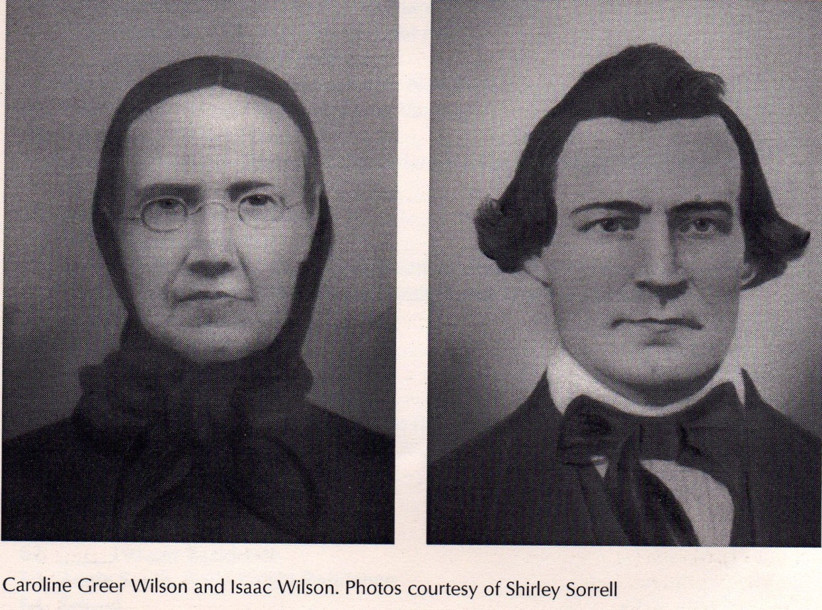
Isaac had been fortunate in marrying Caroline Greer Wilson, born 1828. From their marriage in 1849 came seven children, one being Frances Caroline Wilson (Osborne), born 1851, a second child. From her parents, especially her mother, Frankie learned the farming, gardening and homemaking skills necessary for survival in her time.

Tragedy stuck this family on June 17, 1864. While home on leave, Isaac was plowing his corn, and several children followed behind helping with the weeding, one being Frankie. From ambush shots rang out from Union sympathesizers. Two bullets struck Isaac in the back. Within a few hours he died in his home, and the next day was buried in what has become the Wilson Cemetery. (In a printed remembrance decades later, Frankie wrote: “Isaac Wilson, died June 17, 1864: Aged 41 y., 5 m., 25 d.”)

The murder set off a spree of violent revenge, and before many days passed, six men died, and more women widowed in this mountain backwater of the War. This ‘bushwhacking” and subsequent turmoil is well told by one of the children, The Rev. William A. Wilson, Frankie’s younger sibling, in his memoirs. These can be found along with additional family and local history in the work Neighbor to Neighbor published in 2007 by Appalachia State University Press. Copies are available through the college book store in Boone, NC.
Caroline, age 36, was left a widow with seven children, all 14 years of age and younger. Using her wits, talents and courage, she survived, raised the children, bore another out of wedlock in 1866 and lived to the age of 83, dying on the same farm in the same cove in 1911.

Just getting through 1864 challenged the family. Union sympathizers twice invaded their home, and both Caroline and her mother, Frances Brown Wilson, had confrontations with Union soldiers seeking horses and food.

Perhaps because of these frightening episodes, Caroline did not turn away two young men who sought hospitality and healing at her farm that summer of heartache and fear. Young residents of Ashe County, Richard Franklin Osborne and a relative, George Washington Osborne, had been in an altercation with local Union supporters. G.W. (as he is known) suffered a knife wound to his side, and for various reasons found the Wilson farm a safe haven for recuperation.

While there Frank fell in love with Emaline, Frankie’s older sister, and G.W. was smitten by young Frankie, then all of 13 years of age. In January 1867, then 15 ½ years old, Frankie married George Washington Osborne, Jr., age 21. G. W. had served in the war as a young officer with the 13th NC Cavalry CSA and suffered wounds at the Battle of Shiloh. He was described by his brother in-law, William A. Wilson, as a giant in size, strong and with a friendly disposition.

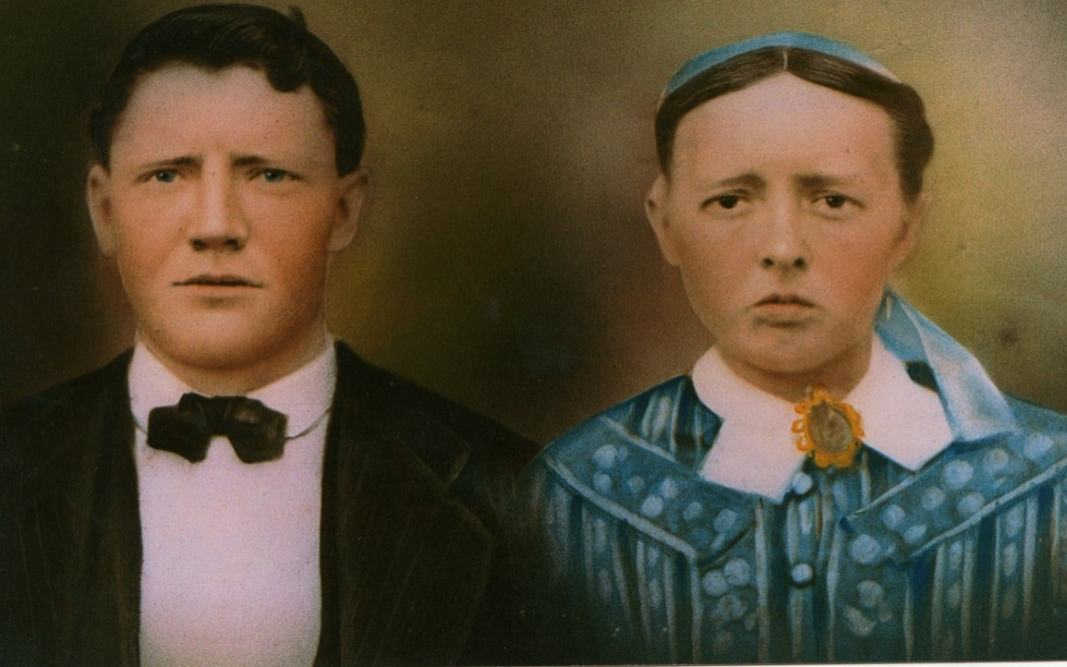
G.W. and Frances Wilson Osborne taken 1874
Like the Wilsons, Greers, Boones and Wilcoxsons, the Osborne family had had its share of frontier fighters. Settling in what is now Grayson County, Virginia in the 1760s, G.W.’s 3rd great grandfather Ephraim Osborne, Sr. sired numerous children. One son, Enoch, Sr. served with Daniel Boone and later as a captain of militia fought both Cherokee and Tories in the Revolution. A great, great grandfather, Jonathon Osborne, is reported by one genealogist to have fought in Lord Dunsmore’s War and at the Battle of Point Pleasant in 1774 against the Shawnee. These Osbornes have their names listed on a Revolutionary War monument that stands on the grounds of the Grayson County old courthouse, Independence, Virginia.

The descendants moved across the Virginia border to Ashe County, NC, and there G.W. grew up to be a farmer and cattle and horse trader. There were seven children who lived to maturity of the marriage of Frankie and G.W. In 1897, G.W. sought to better the economic condition of the family by moving to Blountville, Tennessee from Mast, North Carolina and running a mercantile store near the center of town. One of his daughters, Pearl Osborne Wright, in 1970 wrote of this adventure of moving their furniture with a wagon, her brothers walking, and she riding in a surrey with her mother Frankie and a relative. Alta Osborne, who was married to Pearl’s brother, Toby Osborne. (See below Pearl Osborne Wright in the wagon with black hat, probably 20 years after the family treck to Tennessee.)

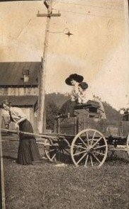
Pearl Osborne Wright, 1890 – 1980 in large hat with friends in Damascus, Virginia in undated photograph.
From the on-line New River Notes is this story by Pearl Osborne Wright, when as a girl she traveled with her parents and siblings from Watagua County, North Carolina to their new home in Blountville, Tennessee. Note the mode and challenge of travel by horse and wagon compared to the 1920s and 1930s when Frankie would visit relatives by bus and car. Interestingly, Pearl omitted her baby sister, Mamye Osborne Stansbery (1896 –1943) completely from this narrative probably written in the 1970s when memory may have been slipping.

Damascus Stories
The House That Played
“The year was 1897. I was seven years old when my parents, George and Frances Osborne, left Boone, North Carolina to make their home on a farm near Blountville, Tennessee.
Our furniture was packed in wagons. Father, Mother, Aunt Alta Osborne and baby son, Lawrence, and I rode in a beautiful black surrey, one of those that inspired the song, "Surrey With the Fringe On Top". The trip was a lark for my five older brothers as they walked, ran along beside, or sometimes rode the furniture-bearing wagons. I helped care for Baby Lawrence. He wore long white dresses and petticoats, all tucked and lace-trimmed. It kept us all busy keeping him happy on such a long trip. We traveled along with other wagons until we reached Damascus. Here our trail turned westward. My father was very impressed with the Damascus Community, and I think he secretly planned to return there to live.
One of the highlights of our journey happened just north of Damascus. The Beaver Creek had to be forded at what was later known as Vail's Mill. The furniture laden wagons had gone ahead and were across the creek. Our horses had entered the water, slowly pulling the surrey. As we reached the half-way mark in the river, one of the wheels hit a large rock, and we could not move. After much splashing, wading, pulling, and pushing, we reached the bank. The wheel was repaired and we were on our way again. The rest of the journey was uneventful.
After we had settled on the farm and had things going smoothly, my father bought and successfully operated a large mercantile store in Blountville.
The depression had ended and news of the rapidly developing town of Damascus reached us. In 1908 my family left Blountville and returned to Damascus. My father bought and operated a mercantile store near the center of town. He also bought a big white house near the store and Mother rented rooms to some of the many people moving into town. Damascus had really grown since our first trip. There were several stores, a bank, two churches, and numerous lovely houses between the two rivers. Before there had been only three houses and a store. By 1910 the first train came to Damascus. The main street was a wide smoothly scraped road with board sidewalks on each side. The Damascus Light and Power Company supplied the town with electricity. R. Dave Wright, who would later be my husband, was an employee of this company.
After living in Damascus for two years, my parents moved again. This time we moved to Afton, Tennessee; there my father owned and operated a larger store. In 1911 Dave Wright came to Afton to ask me to be his wife. We were married in Greenville, Tennessee and came back to Damascus to live.
Our first home was a small upstairs apartment in the telephone office building. Dave continued to work for the Damascus Light and Power Company. Later we bought and moved into the house now owned by Ollie Weaver.
The Damascus Light and Power Company were bought by the Appalachian Power Company, and Dave became manager of the Damascus Branch. We bought and moved into the house presently owned by Harold "Joe" Lamb.
Dave was always interested in anything involving electricity. He operated the moving picture machines for years. When radio came into being, he built a miniature house containing a speaker and hung it on a wire over the street in front of our house. Music could be heard on the street in the lower end of town.
At the death of my sister-in-law, her three children came to live with Dave and me. The two girls, Doris (Mrs. E. F. Akers) and Gladys (Mrs. Howard Adama), lived with us until they married and moved into their own homes. Their brother, Bascome, entered the navy, when he became of age.
Due to illness, Dave retired from Appalachian Power Company in 1952. We built more rooms to the radio shop. Hazel and Wayne McConnell lived there until they built their own home below Damascus in 1965. When Dave passed away, I sold the big house and moved into the smaller one. It is my home today.”

In 1908 and again in 1910, G. W. Osborne searching for an economic edge relocated his store to first Damascus, Virginia and then Afton, Tennessee. In 1915, he sold his farm and property in Greene County, Tennessee, and at age of 70, he and Frankie moved to Bristol, Tennessee, perhaps to be closer to the children who had settled there.

In 1925, G.W. suffered a brain hemorrhage followed in 1926 by a stroke. Bedridden for the rest of his life, he died in 1927 and is buried at the East Hill Cemetery next to Frances, who would die in 1940 at age 89.

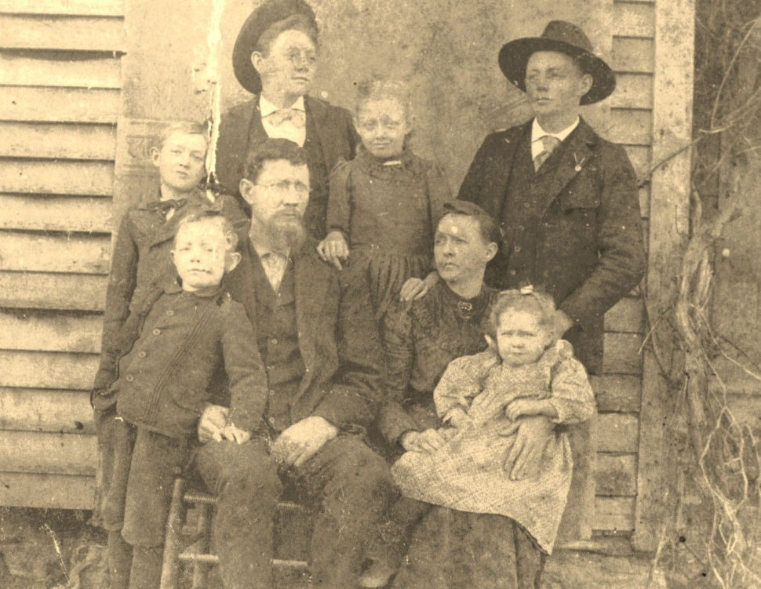
Taken circa 1899, front row – Bill Osborne, George Washington Osborne, Frances Wilson Osborne and on lap, Mayme Osborne Stansbery. Second row – Toby Osborne, Bishop L. Osborne, Pearl Osborne Wright and Leroy Osborne. G.W. was wearing glasses and a beard in this photo, probably taken in Bountville, Tennessee.

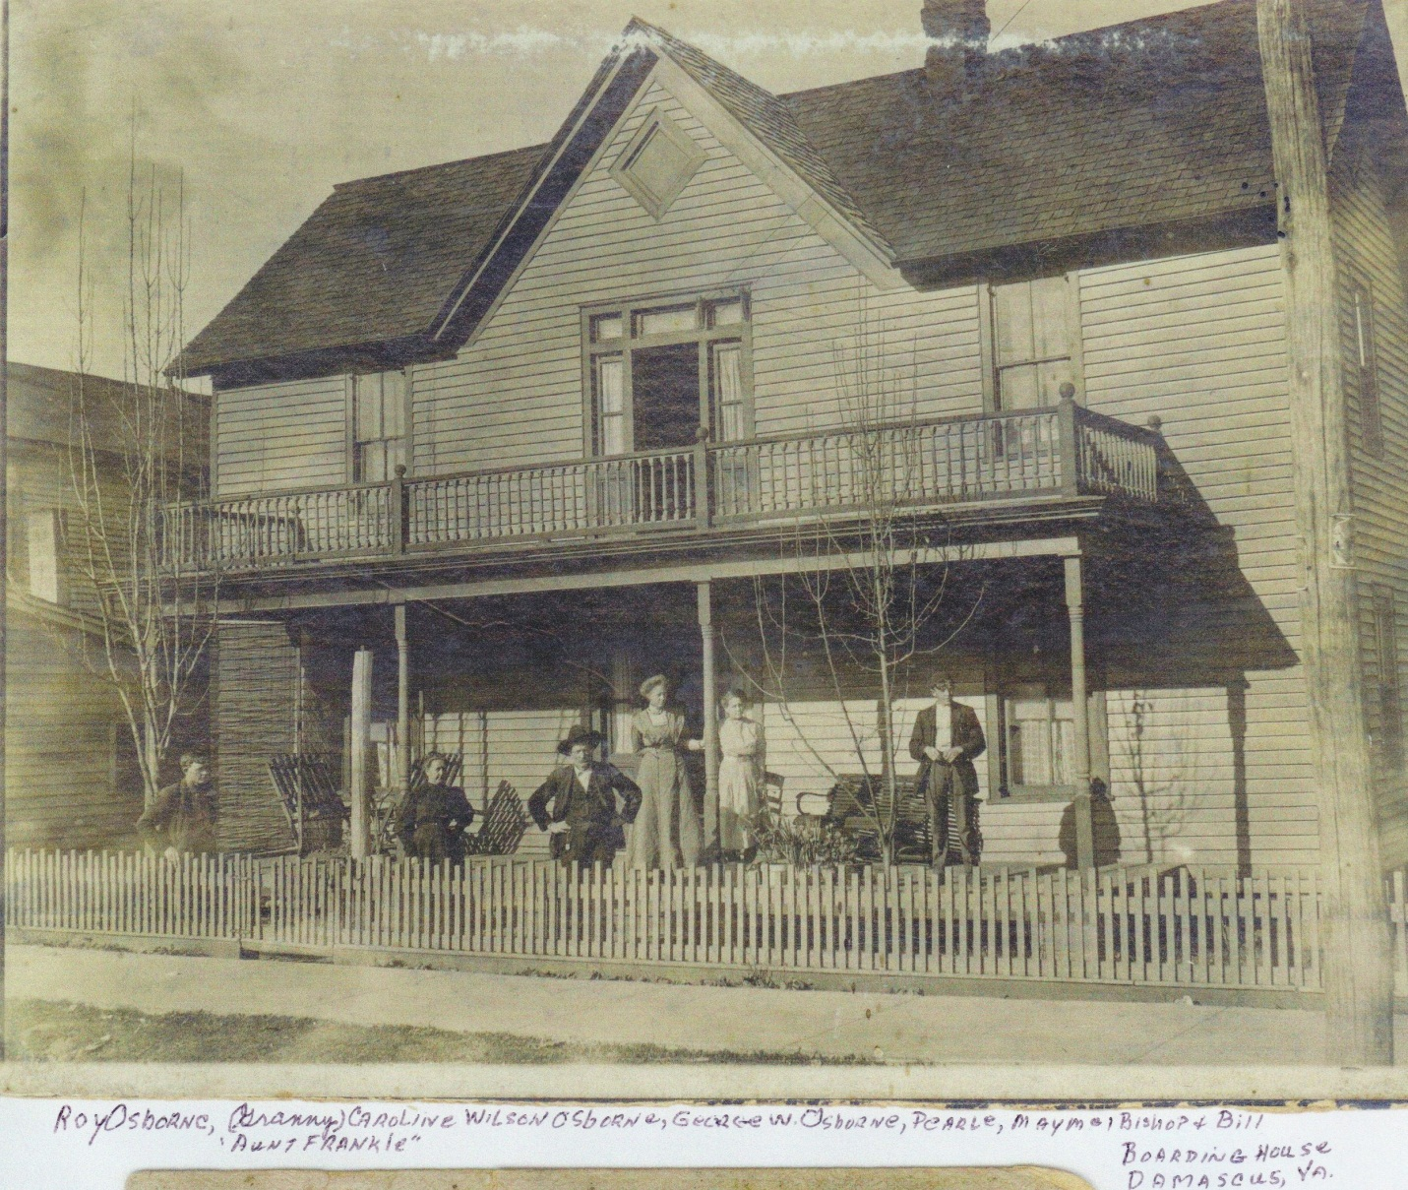

Above identified by Geraldine Stansbery Holliman Feick is the Osborne boarding house in Damascus, Virginia some time between 1908 – 1910 are left to right – Leroy Osborne, Frances Wilson Osborrn, G.W. Osborne, Pearl Osborne Wright, Mayme Osborne Stansbery and Bill Osborne.

Hard Times Come Again No More

The inside page 2 of the diary states: “Bank of Bristal when it closed in april 1932… approximatley $1,400 at the time of closing the Bank.”

This widow, my great grandmother Frankie, lost her life’s savings during the Great Depression with only a small Confederate pensiont. Social Security, Medicare, FDIC, food stamps and public welfare were not yet part of the U.S. social fabric. The economic safety net consisted of growing your own food, of family, neighbors, church and charity. In the midst of her own economic adversity, Frankie shared with others.
Her youngest daughter, my grandmother, Mayme Osborne Stansbery, who suffered from ill health (migraine headaches three days out of seven according to Geraldine Stansbery Holliman Feick, my mother) and could not work, faced the Depression with her own troubles, three children and a physically handicapped husband. Charles Stansbery Sr. in 1930 during Prohibition consumed toxic Jamaica Ginger and paralysis of a leg followed. The marriage, evidently on rocky ground already, collapsed. Charles Sr. went home to Afton to be nursed by his parents and to rebuild his life. His children from his first marriage stayed with Mayme in Bristol, Tennessee.

The 1930s would be a time of severe economic stress for this fractured family. Only when the oldest child, Louise Stansbery Sherwood, went to work at Kress’s Five and Ten Store in Bristol, Tennessee August 1933, would there be regular, if severely limited, income for the family. Charles Stansbery, Jr., after joining the Army Air Corps in the later 1930s, would send money home monthly to help support his mother and sisters.

What Charles Stansbery Sr. provided the family after he removed to Afton is not known. We do have Geraldine Stansbery’s statement in 2009 that Charles, her father, ran a store in Afton with his new wife, Lucy Lee Barkley, who always gave her step daughters groceries from the shelves when they visited their father. A statement in the diary indicates in 1933 Mayme filed papers seeking divorce and child support. Charles Sr. remarried in 1934 and produced a second family, of whom one child, Nancy Stansbery Higgenbotham (born 1940) of Afton, Tennessee survives.

Here then is one family’s struggle, and especially that of Frankie’s. Her perseverance, hard work, generosity of spirit and good nature in time of ‘quiet desperation’ has something to teach her descendants.

Chapter II – In Context, Diaries, Documents, People, Locations and Commentary
What follows are the transcribed diaries of Frankie W. Osborne that I have discovered to this point, saved by my Aunt Louise Stansbery Sherwood and my mother, Geraldine Stansbery Holliman Feick. I also include in this transcription letters, photographs, post cards and newspaper articles.

My original intent was to record only relevant information, but I decided to include ALL Frankie’s entries. Why? I came to believe even repetitious entries (such as weather and visits by relatives and friends) added tone and texture to who she was as a person and how she viewed and lived the days of her life. Yes, there is much about house cleaning and writing letters to children, but I came to see these recordings as a reflection of what and who were important to her life. And through her life, we see better her times and social conventions.

Grannie, as she was known to her grandchildren, begins her most complete diary (she had several journals) with the following note inside the front cover, a sad one reflecting the horror of the Civil War and its impact on her life. She says this about her parents:

“Isaac Wilson (&) Caroline Greer was married the 25th day of march 1849. Isaac Wilson was kild on the 17 day of June 1864 time of civil Ware. Caroline Wilson fell broke her hip June 8 1907 (&) died Sept 1911.”

Her diaries are written in both pencil and ink. I have used her spelling and punctuation which reflects the mountain dialect of the time. The main diary jumps back and forth in years beginning in 1912 and ending in 1934. Other smaller diaries carry the story to a few weeks before her death in 1940. I have tried to reproduce the words as written, although in many cases, especially with names, the writing is not decipherable. She would capitalize some names and not others.

The Main Diary
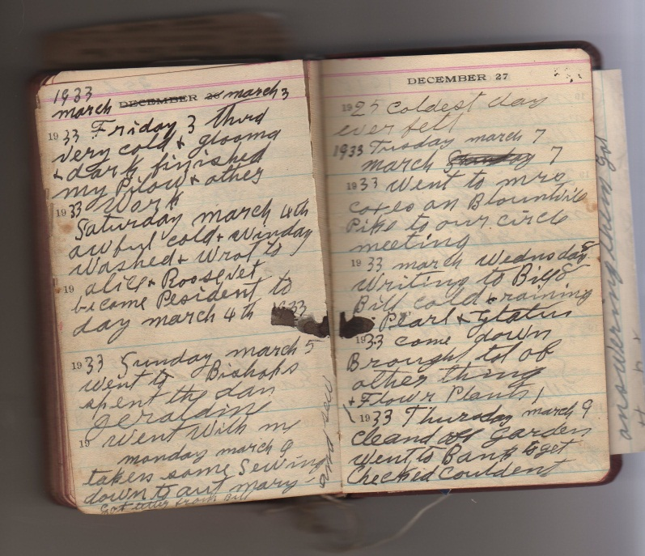

The commentaries are strictly my interpretation of the times and the peoples. Family members may have, of course, differing views of the past and persons. The orginal diaries were given to the Appalachian State University Historical Archives in Boone, North Carolina in January 2010 and are available to be read and pondered by family and scholars.

What to Look for in these Diaries?

In this look back in Appalachian and U.S. history, I try to notice trends and specific events in Frankie’s life that reflect a mindset, a social convention now obscure or a technological advance that altered how people lived.

Anderson Street Methodist Church – The faith and community anchor for Frankie. Her parents ‘converted’ to Methodism during a camp meeting in Sutherland community, Ashe County in the 1850s. Frankie was raised a member of the Sutherland Methodist Church, which exists to this day although most of the structures in the 19th century town are now gone. Frankie’s many rental homes in Bristol in the 1920s and 1930s were all within two to three blocks of the Anderson Street Church.

Automobiles – Frankie and G.W. evidently never owned a car. In 1912 she took her first car ride with a son-in-law, David Wright of Damascus who ran a car service! Her husband, G.W. bought, fed, raised and sold horses for a living in the 1870s and 1880s. By the 1920s, as part of the second transportation revolution (if we consider the rail road the first), two of his sons and one son-in-law would buy, sell or repair automobiles for a living. Prior to the automobile Frankie could visit rarely her many brothers and sisters in Western North Carolina. Compare Pearl Osborne Wright’s 1897 description of a family move by horse, buggy and wagon (appendix) to Frankie’s movements in the same region by bus and car in the 1920s.

Observe how often family members travel by car to visit or take short vacations. Taken for granted in a later generation, until the early 1920s, such travel was virtually impossible.

Bank Holidays – The Bank of Bristol took a ‘holiday’ before President Franklin D. Roosevelt shut the nation’s banks in March 1933. Frankie lost her life savings in the Great Depression.

Canning – Frankie saved food for the winter by ‘canning’, a process of preparing vegetables and fruits under heat and pressure, and then ‘canning’ or sealing them for later in the year when fresh foods are not available from her garden. My mother canned in the 1950s, but today it is almost a lost kitchen art.

Coal – Although she had a gas stove, she heated with coal, perhaps an open grate or stove. Today almost no one in the United States heats with coal.

Curtains – She washed her curtains and stretched them often. Why? Dust from the coal fire.

Family – If there be anything to learn from Frankie’s life, it was her love of family and friends how she worked at relationships. She had many relatives – seven brothers and sisters grew to maturity, and she had seven children, who also grew to adulthood. Note that in the generation of her children, no more than three children were born to a family.

Health – Her health had ups and downs, and only for a major accident or problem did she seek out a physician. It is amazing she did not lose her eye sight in the 1915s when exposed to x rays to destroy a cancer. When reviewing the problems Frankie and her youngest daughter, Mayme, had with their teeth, I can only be grateful for fluoride toothpaste! In that generation, it was not the norm to have health insurance. Few Americans did.

Holidays – Armistice Day began on November 11, 1918, and by the 1930s this date was firmly embedded in Frankie’s mind. Mother’s Day did not begin until the early 1910s, but Frankie obviously enjoyed it, and from the cards she saved, her children remembered her. Notice in the diary how often she referred to public or folk holidays.

Labor Saving Devices – Frankie recorded the gift of an electric iron and oil or gas stove purchases and problems. Later she would acquire an ‘ice box’. Yet, she continued to wash with a bucket and wash board all her life.

Language and Dialect - Frankie’s formal education was limited by lack of opportunity, geography and Civil War. As my mother states, “Grannie wrote like she talked!”
A partial Grannie Frankie Glossary reads as follows and reflects the dialect of the Appalachian region of the time.

Aut - aunt
Tha – the or they
Nic - nice
Chool – school
Houc – house
Hospitle – hospital
Irond – ironed
Cleand – cleaned
Mopt – mopped
Hoewd – hoed
drug – dragged, dug or dig
yar - yard
Buss – bus
Set – sit
Sed - said
Sudent - suddenly
Deceast – deceased
Buriel - burial
Moterd - motored
Solger – soldier
Preacht – preached
Stopt - stopped
Winsor – Windsor Avenue
Hom – home
Gon - gone
Coff – cove as in Cove Creek, NC, homeplace of Hiram Wilson, Sr.
Been – bean
Letus – lettus
Cince – since
Watter - water
Par – pair
Helt - held
Survis – service
Sarf – scarf
Choe - shoe
Started – mailed
Glooma – gloom or gloomy
Stayd - stayed
Motered – motored, trip by automobile
Comenst – began
Rot - Wrote
Evning – evening
Chopping – shopping
Peced – pieced or put patches on a quilt
Helpt - helpedMaild - mailed

Exms - Christmas
Wensday – Wednesday
Tusday – Tusday

Cleavland – Cleveland, Tennessee, approximately 20 miles northeast of Chattanooga
and home of Roy Osborne
Chatanuga – Chattanooga, Tennessee, approximately 200 miles southwest of Bristol on the Georgia border
Oragan – Oregon
Abinton – Abington, Virginia, approximately 15 miles north east of Bristol
Baltamor – Baltimore, Maryland

Stansbury is spelled Stansbery, Stansberry or Stansbury. Osborne is with or without an e.
Gladys is spelled many different ways and Mayme, her daughter, is spelled maym, maymie or rarely Mayme. In general, Frankie often dropped the last ‘e’, especially silent ‘e’s at the end of words.

Radio – On a trip to Sumner, Washington in 1928 she listened to a local worship service over the radio and marveled at the novelty of it.

The State Penitentiary – In 1921, she noted the sending of persons to the State Penitentiary, one assumes in Nashville. What is all this about? It remains a mystery. She wrote that she ‘started’ them to prison. She probably meant she ‘started a letter’ or wrote them.

Time – Frankie remembered many anniversaries concerning health and birthdays. With her appreciation of time, she might have been a historian in a different age.

Train Travel – Today few take the train. Notice how often this mode of transportation occurred in her life. Yet, when traveling to relatives in rugged Western North Carolina, only the bus was available in the 1920s and 1930s. Imagine how remote these communities with elevations of 3,000 to 5,500 feet were prior to the automobile.

Weather - Frankie often (as do many diarists) referred to the weather. Remember she was a farmer’s daughter and farmer’s wife. Good weather and appropriate rain were important to her even into old age. Of course, as she gets older, she felt the cold more. Most of the diary was written in Bristol, Tennessee with an elevation of over 1,600 feet. When she returned home to the Boone, NC area to visit, the elevation was higher and the weather often more severe.

The Cast of Characters and their Locations

The Family of Frances Caroline Wilson Osborne

Parents: Isaac Wilson, 12/16/1822 – 17/6/1864; Caroline Greer Wilson, 12/10/1828 - 1911. Married March 25, 1849 in Ashe County, North Carolina.

The Brothers and Sisters of Frances Caroline Wilson Osborne

Mrs. Nancy Emaline Osborne (1850 – 1919): Married Richard Franklin Osborne (1846 – 1897). Frank’s mother was Sarah Thomas Osborne (1829 – 1903), who according to Johnson County (TN) Photographs on-line was married first to Alvin Osborne, then to Alexander Osborne. Sarah was the daughter of William and Mary Sutherland Thomas of Ashe Co., NC. Mary Sutherland was the daughter of Alexander Sutherland of Grayson Co., Virginia. Alexander’s son Thomas Houston Sutherland, born 1785, was the founder of Sutherland, NC.

Mrs. James Harvey Proffit ( Polly Jane) (1852 - January 24, 1937): Married James Harvey Proffit.

John Wilson (1855 – 1928): Married Rebecca Wilson (1862 – 1952).

Mrs. Martha Evaline Forrester (1857 – 1904): Married Andrew Johnson Forrester and have five children. Family historians Jeannie Bond and Clinton Getziner report Martha Evaline Wilson Forrester also had five children by her brother-in-law, Frank Osborne while he was married to her sister, Ema.

Robert Boyd Wilson (Bob Boyd) (1860 – 1949): Married Sara Ellen Wilson (1866 – 1952).
The Rev. William Albert Wilson (1861 – 1951): Married Mary Amelia McClellan. Youngest son of Caroline and Isaac Wilson, he obtained an education, attended Trinity College (Duke), was ordained a Southern Methodist minister and became a missionary to Japan. One of his ministries in Japan was Hiroshima. He retired in 1931 after 41 years in Asia.

Mrs. Sara Marilla Osborn (1866 – 1882): Married William Osborne. Sara was born out of wedlock to Caroline Greer Wilson. The father was a neighbor, Tom Sutherland according to Clinton Getziner.

The Brothers and Sisters of George Washington Osborne, Jr.
Information courtesy of Jeanie Bond, great, great granddaughter of Isaac and Caroline Wilson Greer

Father: George Osborne (1803 – 1882)
Mother: Mary Baldwin Osborne

Siblings
Alexander C. Osborne (1827 – 1862)
Clemons W. Osborn (1834 – 1902)
Jonathan Osborn (1836 - )
Noah Osborn (1838 - )
Tabitha Osborn (1840 - )
Andrew Osborn (1842 - _
George W. Osborn (1846 – 1927)

The Children of George Washington and Frankie Osborne

Marion Lee Osborn (8/31/1874, age 6 days): Taken from a printed remembrance by Frankie.

Toby Miles Osborne (1/26/1876 - 1951): Lived in Sumner, Washington beginning in 1920s. His children were Eddie Lawrence, Russell Miller and Pauline Osborne Smith. Pauline married a Bennett Winston Smith. They had a son ‘Bennie” and a daughter, Melinda. Toby’s first wife, Alta Holsclaw, died 8/18/1933. Toby remarried. Unfortunately his life ended tragically, having been incarcerated in five prisons for mail fraud and counterfeit checks. He died penniless in 1951 in Seattle, WA according to his great grand daughter, Sara Porter.

Leroy Milburn Osborne (2/17/1879 – 1948) Roy lived at 1016 16th Street, Cleveland TN in 1936. His wife was named Lena Holsclaw (9/17/1879), had children: Ralph Summers Osborne, Albert Leslie Osborne, Robert Lafayette Osborne and Lucille Osborne. He listed his occupation in 1918 as a farmer when he signed up for the draft.

Bishop L. Osborne (12/13/1881 – 6/1965): Wrote poetry and articles for the Bristol, Tennessee paper. Employed at King’s Department Store as an accountant. King’s Department Store, a major establishment in Bristol and Johnson City was owned by the Frazier family. Bishop’s wife’s name was Cora E. Broyles Osborne. Due to a cleft foot, she always wore long dresses. Bishop’s poetry was occasionally published. I have in my procession a collection of his poems given to me by my mother, which reflect his patriotic and religious beliefs. Son’s name was Vivian Randall Osborne.

Eddie C. Osborn (Died 8/29/1886, age 1 year, 4 m., 4 d.): Taken from a printed remembrance: “Eddie Carlock Osborne – Born April 25 1885”.

Bascom Wilson Osborne (7/ 5/1887 – 9/1970): Lived in Baltimore and after death of first wife, Dora Catherine Kruger (age 33, buried Woodlawn Cemetery, Baltimore, MD), relocated to Louisville, KY and then to Owensboro, KY and worked for Brodie Motor Company, a Dodge dealership. His second wife’s name was Ada. They lived in 1936 at 730 Walnut St, Owensboro, KY.

William (Bill) Vestal Osborne (7/22/1892 – 11/20/1968): Lived at 1634 7th Avenue, Los Angeles California in 1938. He was used car manager of Ford dealership, Pico Motors in Los Angeles. Wife (married 1920) was Katherine Rader. One daughter, Margaret Shields was their only child. “Willy”, according to my mother, was Frankie’s favorite child.

Pearl Osborne Wright (3/1/1890 – 8/20/1980): She was born in Mast, North Carolina and died in Damascus, Virginia. Husband Robert David Wright, married 12/20/1911.

With no children of their own, beginning in 1922, they raised the three children of Bascom Osborne and his deceased wife Catherine Kruger Osborne (1889 – 1922) of Baltimore, MD. The three children are recorded below:

Bascom Kruger Osborne (referred to incorrectly in the diary as Junior): Bascom K. would join the U.S. Navy in 1927 at age 17 and serve on the USS Marblehead in 1930s. In 1938, he was stationed in Manila, the Philippines billeted to the USS Black Hawk as a Chief Electrician’s Mate. One undated Christmas card has Bascom K. (that is the way he signs himself) on the USS Long. He was born 1910 and died 1977, a retired officer.

Doris Ethel Osborne Akers: Husband Elmer was nick named Flea. Their daughter (born 1940) is Phyllis Akers Mink, a contributor to this document.

Gladys Pearl Osborne Adema: In the late 1930s lived in Buffalo, NY at 39 W. Balcom St. Her husband’s name was Howard, and the 15th month old baby named Peggy (letter dated June 20 1938) now lives in Florida.

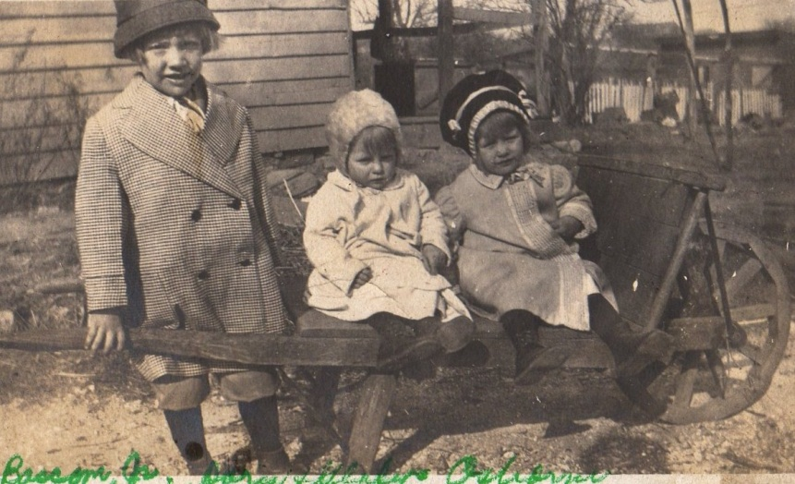
Bascom, Gladys and Doris Osborne as children

Mayme Tarrence Osborne Stansbery (1/16/1893 – 12/3/1943): She married Charles S. Stansbery on April 29, 1914. She is this writer’s grandmother. Below when she was young.

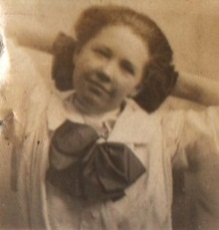
The Children of Charles Skelton Stansbery Sr. (12/5/1893 – 11/19/1957) and Mayme Osborne Stansbery (1/16/1896 – 12/3/1943)

Frances Louise Stansbery (Sherwood) (1/27/1915 – 6/20/2006): Born in Afton, Tennessee, she married Vance R. Sherwood in 1941.

Charles S. Stansbery, Jr. (nicknamed Red due to his hair color) (6/15/1918 – 2006): He married in 1943 Anne Duthil Smith of Philadelphia, PA who passed away in 2002.

Patricia Geraldine Stansbery (b. November 16, 1923): Born in Bristol, TN, she married Homer Bishop Holliman in 1945 and Donald Feick in 1989.

The Children of Charles Skelton Stansbery Sr. and Lucy Lee Barkley (11/11/1912 – 6/25/1978)

Anne Stansbery (1935 – 1936): A twin sister died at birth.

Nancy Stansbery Higginbotham (11/3/1940): Married Daniel G. Higginbotham 1/15/1962. He died in a car accident in 1984 after retiring from the U.S. Army. Two children from this marriage: Charles Webster Higginbotham (1962) and Sharon Higginbotham Potter (1966). Nancy thoughtfully contributed this paper.

Jean Stansbery Dobbs (3/1944 – 9/9/1999): Married four times and died of diabetes and kidney failure. Daughter, Donna Lee Campbell, from first marriage lives in Florida. Buried in Afton, Tennessee in Methodist Church cemetery on Stone Dam Road.

The Parents, Brothers and Sisters of Charles Skelton Stansbery Sr.

Parents: William Luther Stansbery (4/29/1861 at Hopewell, Knox Co., Tennessee – 4/9/1943). Annie Eliza McCray Stansbery (December 20, 1863 at Jonesboro, TN – 1/11/1936). Married January 1, 1884. William’s father was Pryor Lee Stansbery, an Union Civil War veteran. An earlier grandfather was a N.C. Revolutionary War veteran, Luke Stansbery, incarcerated by the British in Charleston, SC in 1780. The Stansberys immigrated to Maryland in the 1660s after several generations in the Netherlands. Originally from England, probably Devonshire.

Their children:
Margaret Edith Stansbery (10/15/1884 – 10/26/1954 in Bristol, VA): Married Roe Williams on May 19, 1907. One son – J.C. Williams.

George Lee Stansbery (November 14, 1886 - September 25, 1965 in Jefferson City, TN): Married Annie Lee Stansbery December 20, 1906, one son and two girls.

James Arthur Stansbery (December 19, 1888 - June 14, 1969 in Virginia): Married Nellie Homes March 4, 1914.

Fred Walker Stansbery (May 9, 1891 – May 27, 1968 in Greenville, TN): Married Flora Eunice Dennis, born December 11, 1891 in Bristol, VA. Married September 10, 1913.

Charles Skelt Stansbery, Sr. (December 5, 1893 - November 19, 1957): Married Mayme Tarrence Oborne April 29, 1914 and who died December 3, 1943 in Philadelphia, PA and buried at East Hill Cemetery, Bristol, VA. Mayme Osborne was born January 16, 1896. He is buried in Afton, TN next to his second wife, Lucy Lee Barkley in the Stone Dam Road Methodist Church cemetery.

William Cecil Stansbery (December 15, 1896): A doctor in Cleveland, TN, he married Etta Mayers Henley, September 20, 1925. They had one son, a dentist, and one daughter.

Harry Price Stansbery (December 14, 1899 and lived in Georgia as of 1981): Married Zola Rymer June 18, 1924.

Selma R. Stansbery (April 10, 1902 and died two days later).

Eva Kate Stansbery (September 10, 1903 and died in 1979 or 1980 in Afton, TN): Married Guy Williamson December 14, 1922, one son Guy, Jr.

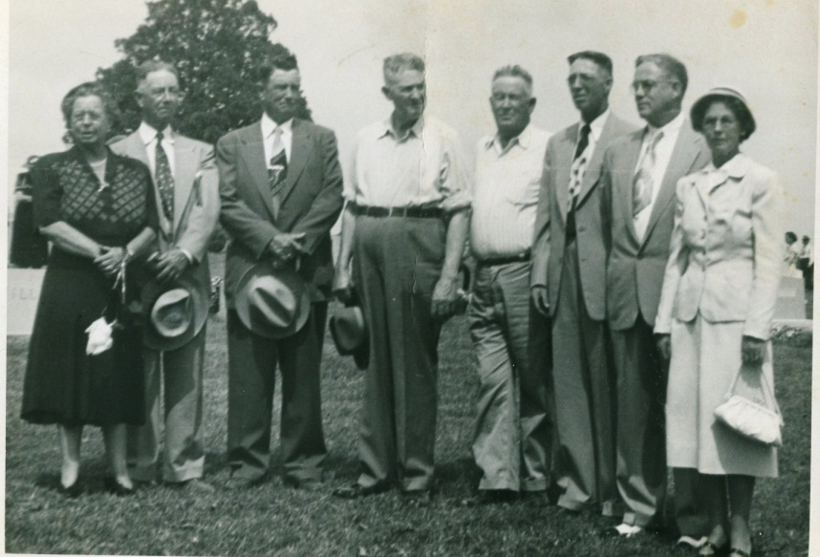
Left to right in this 1953 photograph are: Margaret Edith Stansbery Williams, George Lee Stansbery, James Arthur Stansbery, Fred Walker Stansbery, Charles Stansbery, Sr., William Cecil Stansbery, Harry Price Stansbery and Eva Kate Stansbery Williamson.
Descendents Who Came Later

The Child of Louise Stansbery Sherwood
Vance R. Sherwood, Jr (12/7/1946)

The Child of Dr. Vance R. Sherwood, Jr. and Dr. Donna Sherwood
Katherin ‘Kate’ Sherwood

The Child of Charles S. Stansbery, Jr.
Susan Stansbery MacKenzie (11/18/1946)

The Children of Susan Stansbery MacKenzie
Roxanne Hayes
Gavin Stansbery

The Children of Patricia Geraldine Stansbery Holliman Feick
Glenn N. Holliman (9/28/1946)
Rebecca Louise Holliman Payne (3/15/1950)
Alice Lynn Holliman Murphy (4/13/1956)

The Children of Glenn Nelson Holliman and Lynn Draper Holliman Armstrong
Grace A. Holliman 1974
Christopher Stansbery Holliman 1978

The Children of Rebecca Louise Holliman Payne and Paul Daniel Payne
Bryan Parker Payne 1977
Allison Elizabeth Payne 1980

The Children of Alice Lynn Holliman Murphy and William Murphy
Erin Lee Murphy Hensley 1977
Jonathan William Murphy 1979
Patrick Glenn Murphy 1985
Sean Daniel Murphy 1988

Persons Recorded in Frances Wilson Osborne’s Diaries whose identies were obscured.

Who are Earl and Maymie, Boone, NC 1938? Shirley Sorrell states: “My grandmother Mayme Wilson Donnelly, daughter of John Wilson and Rebecca and neice to Frankie Wilson Osborne, was married to Earl Donnelly. They were born in 1892. They lived in Creston in the house that I have inherited.”

Who is Alice Snyder in Mountain City? Her daughter Lois Ann wrote a letter to Frankie in 1938 and addressed her as Aunt Frankie. Who is Mrs. Jacob Snyder (Jake) from Shouns, Tennessee. Alice identifies herself as a niece. Who are her mother and father?

From cousin Jeanie Bond these questions are answered: Maud Alice Osborne Snyder is the daughter of Richard Franklin and Emma Wilson Osborne. Alice Snyder (1878 – 1938) is the niece of Frances Osborne. Lois Ann Howard Adams is the granddaughter of Alice Osborne Snyder, and daughter of Roby and Hallie Snyder Howard. One of the 11 siblings of Alice Osborne is William I. Osborne (1869 – 1953).

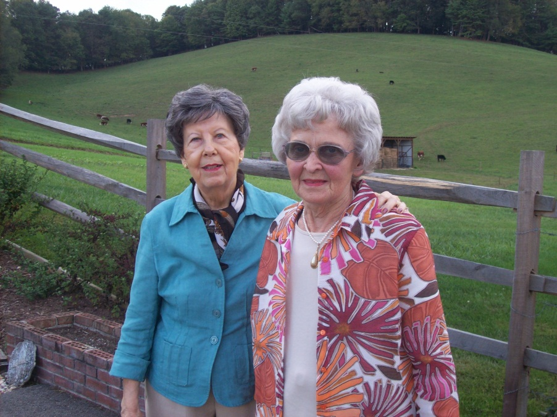

Above, Geraldine Stansbery Holliman Feick (left) and cousin Lois Ann Howard Adams at her home in Mountain City, Tennessee September 2011.

Who is George Stewart, 1805 S 12th Street, Salem, Oregon 1938?

Who is Bruce Torrence of Mountain City? Mayme Osborne Stansbery’s middle name was Torrence or Tarrence. Who is Bruce Torrence of Mountain City? Shirley Sorrell writes: “I think this is Torrence Wilson Donnelly who married Bruce Donnelly. I need to check the spelling of her name. Torrence was the daughter of Robert and Ellen, neice to Frankie.”

The Locations

Ashe County, North Carolina – The northwestern most county in North Carolina, snuggled against the Tennessee and Virginia lines. In these mountains and valleys still live the Wilson, Greer and Osborne clans, the relatives of this writer.

Damascus, Virginia – G.W. Osborne ran a mercantile store from 1908 – 1910 and Frankie took in boarders. While living there Pearl Osborne met and later married David Wright who worked for the local electric company. In the early 1900s, the easiest way from Bristol, Tennessee to get to Ashe County, NC, the Sutherland area, was through Damascus.

Afton, Tennessee – A rural hamlet in Greene County, Tennessee where the Stansberys lived and grew tobacco, now a suburb of Greenville. From 1910 – 1915, the G.W. Osborne’s lived there and ran a store and farm. During that time young Mayme Osborne (1896 - 1943) met and married Charles S. Stansbery (1893 – 1957).

Bristol, Tennessee – A small city located half in Tennessee and half in Virginia. The Osbornes and Stansberys lived on the Tennessee side. Approximately 20,000 persons lived in the twin cities in the 1920s. Most of the diary concerns events and people of Bristol, Tennessee.

Cleveland, Tennessee – Home of Lawrence (Roy) Osborne. Grannie wrote his name as ‘roy’ and spelled Cleveland as ‘Cleavland” throughout the diary.

Boone, Banner Elk, Blowing Rock, Cove Creek and Vilus - Communities in Watauga County, NC adjacent to Ashe County. Osbornes, Wilsons, Greers and extended families lived and still live in both counties.

Mountain City, Tennessee – Home of the Snyders, nieces and nephews of Frankie. Mountain City is located in Johnson County, and also the location of Trade, Tennessee. The Johnson County Historical web site has numerous photos and pictures of the Greers and Wilsons. Photos of Frankie and G.W. are on the web site along with the story of the 1864 bushwhacking.

Sumner, Washington - The town where Toby Osborne and his family moved in the 1920s. Family lore has it Toby had bounced too many checks in Bristol and Damascus, Virginia and needed to start over in life. So he went west. His daughter Pauline appears to be one of several favorite granddaughters of Frankie’s. In 1927, Frankie made a memorable trip to the west by train to visit her sons Toby and Bill Osborne.

Los Angeles, California – The emerging city where son Bill Osborne moved in the 1930s, after a sojourn in Vancouver, British Columbia. As one of a new generation, he also entered the automobile business, a car salesman.

Mast, North Carolina – According to the 1890 census, the home of G.W. and Frances Osborne. Pauline and Bill were born there, and maybe more children. Several Wilsons married Masts. Today there is an inn in the old Mast place in Valle Cruces, North Carolina.

Chapter III – From the Diaries and Papers of Frances Wilson Osborne, 1912 – 1925: The Arrival of the Automobile Age, Retirement, Health, a Family Reunion and the Move to an Urban Environment.

(Frankie’s writings and other documents will appear in print of this size. Comments by this writer and other cousins will be italicized in this style. There are missing years and months. I have placed in bold the names of relatives when they first appear in her diary.) Note, Frankie’s diary has huge gaps!

1912

June 20 – “I am 62 today. For the first time I ever rode in a car. Went from Damascus to Glade Spring (a town in southwest Virginia). Dave Wright drove. He is my son in law.” David Wright married Pearl Osborne, born 1890. They met when the Osbornes briefly lived in Damascus, Virginia. In 1911 they married in Afton, Tennessee and lived the rest of their lives in Damascus. This kind couple took in Bascom Osborne’s children after the sudden death of their mother, and raised them beginning in 1922.

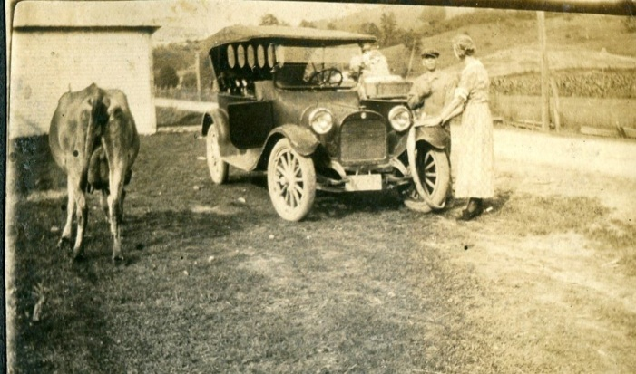
Above, not only a car but a cow in this picture of David Wright. His wife, Pearl Osborne, may be next to him with her back to the camera. David Wright descended from founders of Damascus, Virginia.

1915 -As 1915 opens Frankie, G.W. and at least Roy Osborne, a son, lived in Afton, Tennessee. During the year they sold their farm and moved to Windsor Avenue in Bristol, Tennessee.

April 9 – “had all of my children with me for diner except roy & Pearl.” Pearl would be Pearl Osborne Wright, born in Mast, North Carolina 1890. She died in 1980 in Damascus, VA.

May 13 – “roys cow left…haven’t herd from her.” Herd is not meant as a pun! Evidently Roy was a farmer. His 1918 draft registration lists him as a farmer in Cleveland, Tennessee.

May 17 – “Lena & Robert come Back from NC…Jane Proffitt come with them. Jane Wilson Proffitt was Frankie’s sister, b 1852 – d 1937, who lived in Western North Carolina.

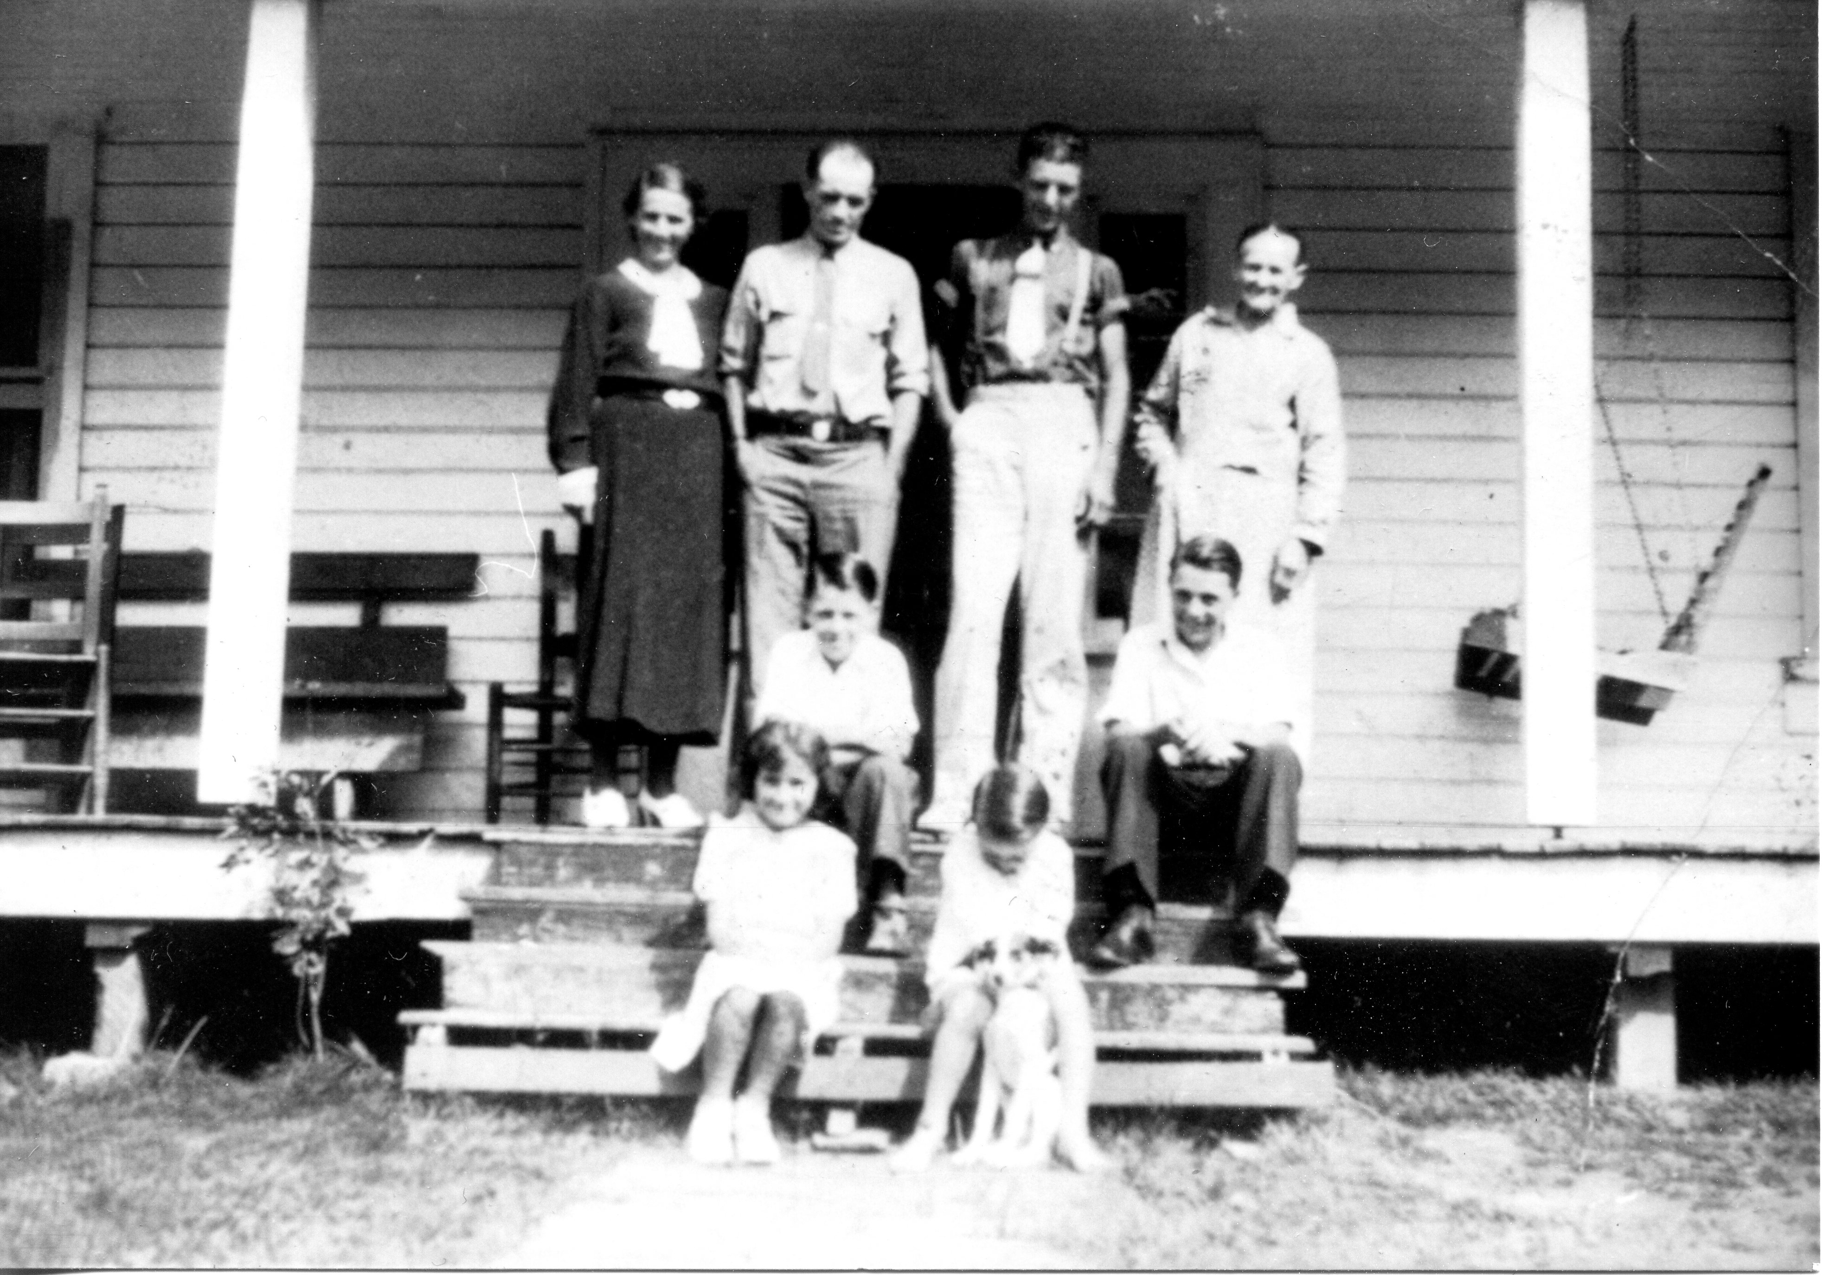

Above in their North Carolina home in the 1910s are: front row left to right: Mary and Tom Proffitt; middle row: Lee and Jack Proffitt; back row: Wilma Lawrence Proffitt, Jim Proffitt, Fred Proffitt and Jane Wilson Proffitt. This photograph from the extensive collection of cousin Clinton W. Getzinger to whom we are indebted for numerous pictures in this document. Clinton runs a blog on the Osborne family which may be Googled.

July 20 – “Dr Peters and Dr Pewler cut growth from my eye…sewd it up.”
Frankie had a growth on her eye. One wonders after all this radiation that she had any eyesight left! Evidently this work was done in Greenville, Tennessee, a few miles from Afton.

July 21 – “Dr. Peters used xray, Friday 21.”

July 22 – “Taken stitches out of my eye.”

July 24 – “Monday, used Exray.”

August 2 – “Wednsay 2…used exray.”

July 26 – “Wednsday 26…used exray.”

July 29 – “Saturday 29…used exray.”

August 7 – “turnd exray on my eye.”

August 14 – “Went to Dr Peavlers to have eye treated.”

August 17 – “Went Thursday to have eye treated.”

August 19 – “saturday 1915…to have eye treated.”

August 21 – “have eye treated.”

August 23 – “Wednsday 23…Went to Dr office…have eye treated.”

August 25 – “went Dr office Fridy 25 1915 to have eye treated.”

August 30 – “Wednsday 30…had eye treated.”

September 20 – “sold our farm.” Here is the move from Afton to Bristol, Tennessee. She did not record why, but G.W. at age 70 was probably too old to work.

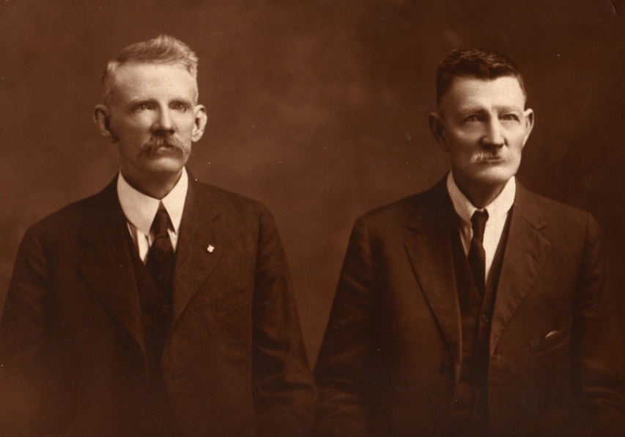
G.W. Osborne on right; a relative on the left, unknown, perhaps an older brother.

September 21 – “1915…roy moved to Prices Dery (diary) farm.”

September 25 – “1915…Bought us a houce and lot on 960 Winsor Avenue from mrs Martha grose close. Paid 960 winsor av Bristol Tenn.”

September 30 – “1915…Went to Dr office Wednsday 30 to hav eye treated.”

December 28 – “moved to our new hom 960 Winsor av.”

1917

January 18 – “taken me to St. Luke’s Hospital.”

January 19 – “tha operated on me tha 19.” Tha is used as ‘they’ or ‘the’.
We do not know the nature of Frankie’s illness. Notice the relatively low cost of the medical care. Perhaps the eye problem reoccurred.

Marh 1 – “march 1 1917…Paid Dr Cowin ten dollars.” Frankie recorded paying the doctor $5 or $10 a month into December, a total of $170 “that is all we owe him.”

August 3 – “Curten Boy got kild with live Electricl Wire.” Electricity was new and dangerous.

September 18 – “1917…Tm & Lawrence came to Bristol after Pauline…car.” Toby Miles Osborne and his son, Lawrence, came to pick up Pauline, Toby’s daughter. Pauline would write often to Grannie. Lawrence was born 1897, and his first name was Eddie or Edward. His great niece, Sara Porter, reports he died without issue and an alcoholic.

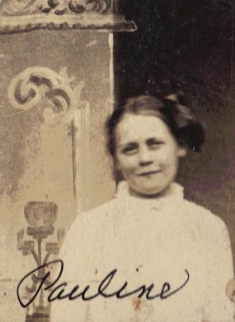
1918 - The Charles Stansbery’s moved September 8, 1918 from Afton, Tennessee to Bristol. Why? One imagines Charles Sr. had employment. A daughter, Geraldine, states he worked at the Ford dealership as a service supervisor during his twelve years in Bristol. Perhaps the entry of the U.S. into World War I spurred economic opportunities that led Charles from the life of a tobacco farmer to the city and a mechanical job. Records indicate the population of Bristol grew rapidly in the early 1900s.

The Ulyss Holliman (my grandfather on my father’s side) family made a similar odyssey in 1918, leaving the small town of Fayetteville, Alabama and a saw mill for regular work for Ulyss at the Birmingham Electric Company as a carpenter.

The census of 1920 reported for the first time less than 50% of Americans lived on a farm. Here are two American families that demonstrate the reality of that figure.
Frankie makes no notice of U.S. entry into World War I.

February 7 – “Preston Devalt died…Bill go me a Electrict iron insured 5 years.” A neighbor died. Frankie recorded often the passing of church members and neighbors. Frankie’s house keeping was eased by her first electric iron with a five year warranty. Bill was son Bill Osborne (who moved to Vancouver, B.C. and later to Los Angeles where he died in 1968).

March 5 – “Bo Wiliams moved in the Pearler house.”

June 2 – “W. A. Wilson’s family came from Derum (Durham, NC), stop over for a day & night.” William A. Wilson was home from Japan on leave. He is the youngest of Frankie’s brothers, a Southern Methodist missionary to Japan. His memoirs record the life of the family from the Civil War into the Twentieth Century. See appendix for one of his letters and the sacrifices he and his family made for his ministry. It is through the memoirs of Will Wilson that so much of the family history from the turbulent 1860s has been preserved.

June 11 – “1918, Went to afton to be with maym a while.” This is Mayme Osborne Stansbery, her youngest child. Frankie rarely spelled Mayme’s name correctly.

June 15 – “maym baby bornd.” This is Charles Skelt Stansbery Jr. Frankie would record his birthdays in 1920, 21, 22, 23, 24, 25, 26 and 1927. Charles joined the Army Air Corp in the late 1930 as a mechanic working on B-10 bombers. Later he was stationed in England in World War II repairing B-24s. In the 1950s, he would service B-36 and B-52 bombers. As a civilian in the 1960s, he would build silos for Minute Men nuclear missiles in South Dakota. In one career, an American serviceman went from the tiny B-10 bomber to hydrogen bombs.

August 4 – “1918…maym & children and my self all went to NC.”

August 18 – “We had a reunion at Brother John Wilson all the living brothers and sisters was ther.”

- Mrs. N E Osborne
- Mrs. F C Osborne
- Mrs. P J Proffet
- Mr. John Wilson
- Mr. Robert Wilson
- Mr. William Wilson

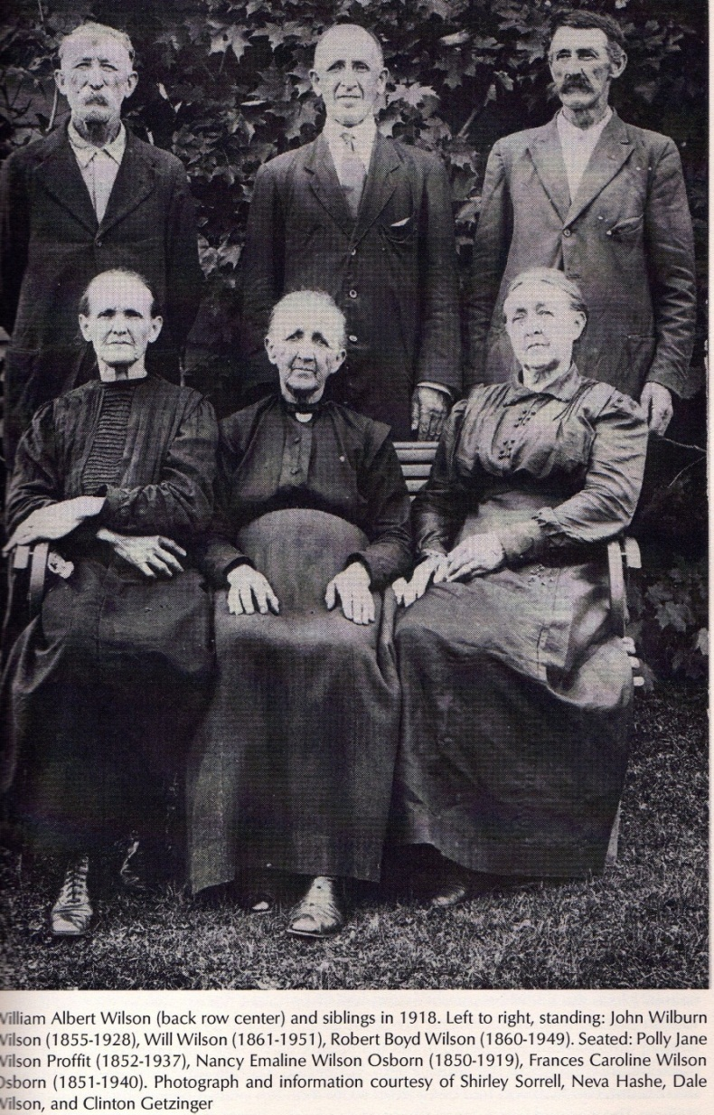

How surprised Grannie Frankie and all the rest of the family would be to know in 2007 Appalachian State University would take the memoirs of The Rev. William A. Wilson and print the same and photographs of this reunion in the book by Sandra Ballard entitled Neighbor to Neighbor. This reunion took place in Ashe County on the farm where Isaac Wilson was murdered and buried. Today, this cove is on Oscar Wilson Road, just north east of Trade, Tennessee. The Donnelly store is at the entrance to the cove. The Donnellys are descendants of the Bob Boyd Wilsons, a brother of Frankie’s who is back row, far right.

Frankie would write in another diary this similar report; in fact she wrote it twice:

August 18 1918 – “having Reunion at John Wilsons, Ashe Co NC…the children of Isaac Wilson, deceast and Caroline Wilson, deceast.”

Mrs. N. E. Osborne (Nancy)
Mrs. F. E. Osborne (Frankie)
Mrs. J. P. Proffit ( Polly Jane)
Mr. John W. Wilson
Mr Robert B. Wilson (Bob Boyd)
Mr. William A. Wilson (Methodist missionary to Japan)

“All living the ones that has past away are Mrs. Martha E Forster and Mrs Sara mariler Osborn.” Martha died in 1904 due to cancer. Sara, not a daughter of Issac Wilson, died in 1888. Below Andrew Johnson and Martha E. Forster in the 1880s. Photo courtesy of Clinton W. Getzinger.

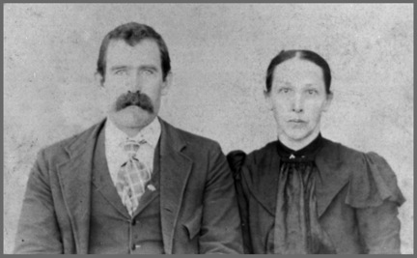

The following is written on the same page but may be a different date. John Wilson was living in 1918, but not in this later entry.

Deceased: Mrs M E Forester
Mrs S M Osborne
Mr J. W Wilson

September 8 – “Charles and maym moved to Bristol.”

October 9 – “Wednsday mayme moved on Anderson Street.” The Charles Stansbery Sr. family moved into the same two square block area as Frankie and G.W. For most of the next 22 years, Frankie would live with or within a few blocks of daughter Mayme.

October 12 – “1918…first killing frost this night of the 12.”

October 30 – “1918…October 30…Lawernc inlisted in the navy Tusday.” And the war ended November 11, 1918. Frankie made no mention of the end of the war, but did record Armistice Days in future years. This was grandson Lawrence Osborne, Toby’s son. Frankie’s sons were too old to enlist or be drafted but they had to register for the draft.

December 5 – “Charles and Louise come…Went back same day….maym gon to Knoxville.” These are the children of Mayme and Charles Sr. Stansbery. Louise is Louise Stansbery Sherwood and Charles is Charles S. Stansbery, Jr. or ‘Red’ as he was known due to his hair color.

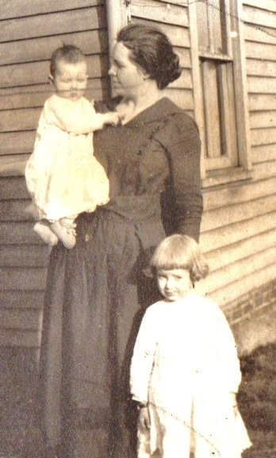
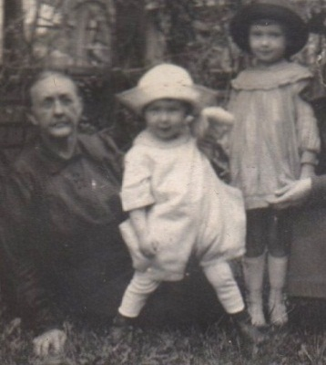
Above, Frankie Osborne, Charles Stansbery Jr. and Louise Stansbery Sherwood; left photo Charles Jr., Mayme Osborne Stansbery and Louise ca 1919 and 1920.
1919

January 3 – “Our tax was $32.80 for 1919.”

January 23 – “Roy and Ralph started to cleavland Tenn with tha thing tha ar moving.”
This was the move of Lawrence (Roy) and his son to Cleveland, Tennessee.

January 24 – “Willie goon to work for Hamer tha se can (second) time.” This is son Bill who was employed in the automobile business.

January 26 – “Lard Albert & Robert have gon to Join roy and Ralph in Tenn., ther new home.” The names are difficult to read, and the persons unknown.

February 1 – “Brought me home to day from Hospitle.” Again we do not know the nature of the illness.

February 2 – “was the most awfulst snow storm I ever seen.”

February 3 – “Was the worst day I ever saw, the day after they Brought me from Hospitle 6 years.”

February 19 – “Charles (Stansbery Sr) commenced working at the garage for Rendls.”
Here Charles Sr. began working for the automobile industry.

March 4 – “Ralph Osborne is 18 years old today.” She would repeat this entry through 1924. Ralph is the son of Roy Osborne, one of Frankie’s sons.

March 14 – “I went to Damascus. Tom is sick. Lawrence home on furlough.”

March 18 – “got a seting of eggs from John Ramsey’s set hen.” Frankie raised her own chickens for eggs and food, common enough in the 1920s, almost forgotten in the 21st Century.

March 26 – “Charles Osborn & wife minie ate diner hear on ther way to oragan.”
This may have been the son-in-law of Robert Boyd Wilson (1860 – 1949), one of Frankie’s brothers. However, the book Neighbor to Neighbor lists this supposed Charles’ wife as Edna Wilson. Perhaps this Charles Osborne is more closely related to G.W. The Wilsons and Osborns were marrying kin with considerable frequency.

Did this Osborne family relocate permanently to Oregon, and is this why Toby Osborne would select the state in the 1920s as his new home?

Shirley Sorrell writes: “This is Chall and Minnie Wilson Osborne (Minnie daughter to John and Rebecca Wilson and neice to Frankie). His name may have been Charles. Chall and Minnie did live in Oregon.They moved back to NC and lived in Sutherland. The house is just down the road from Wison cemetery. They are both buried in Wilson cemetery.”

March 30 – “Johnathan Osborn died today.” A relative, relationship unknown. The great grandfather of G.W.’s was named Jonathon Osborne, veteran of the American Revolution and resident of Grayson County, Virginia.

April 8 – “Bill got 2 drug it.” Evidently Frankie was planting her garden. Drug means either dragged, dug or dig. Bill is her son Bill Osborne, soon to relocate in British Columbia and later California.
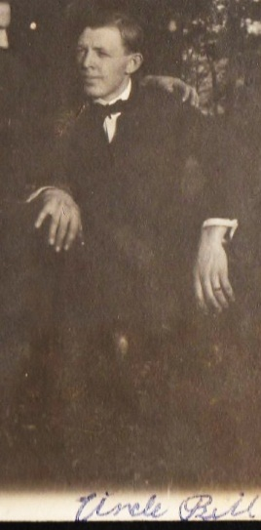
Bill Osborne (1892 – 1968)

April 28 – “April 28 – Bill gon to Work for mr Hill.” Later note: “quit Decemb 11.”

May 18 – “33 years this month (1886) had my Teeth Put in …haven’t got any of them Broke out yet. Dr grant made them.” Frankie made this interesting health observation again on this date in 1923, 24 and 25. I imagine most of us today would remember this important quality of life occasion also!

June 21 – “Bitha grabeal died.” Unknown person Graybeal perhaps?

June 29 – “Went to Cleavland Tenn to visit roy at his new home.”

July 5 – “Bascom is 32 today (1919).” Frankie repeated this birthday through 1926. At the time, Bascom, a son, lived in Baltimore, Maryland. After the early death of his wife, he gave up his children to his sister Pearl, and moved to Owensboro, Kentucky. His grand daughter, Phyllis Mink, and niece Geraldine Stansbery Feick, said in 2009 they were not certain why Bascom made this drastic decision, but speculated on some kind of nervous breakdown. Bascom would remarry, and work as a car mechanic the rest of his life.

July 12 – “Came back from Roy’s”

August 4 – “Planted Beens…mont guymery warden co…check for $1.61.” The famous Montgomery Ward catalogue!

August 28 – “mayme and my self went to Damascus.” This is the home of Pearl and Dave Wright.

September 8 – “Willie went to mt city to fair.”

September 12 – “GW got one par of shoes, got 2 par of sock…got 1 hat, one par of pants…4 shirts and one coat in this month.”

September 30 – “Bill quit Working for Hammer…gon to work for Avery Osborne & Tompson.”

October 6 – “GW gon to Atlanta ga to a reunion.” A Confederate soldiers’ reunion. G.W. had been in the Battle of Shiloh. The local Daughters of the Confederacy would continue to send Christmas cards to Frankie until her death.

November 4 – “Went to Baltimore to visit Bascom.” Probably took Train 42 of the Southern Railroad.

Date uncertain but just below the above, also in pencil: “Brought James Mock home dead.”

November 6 – “Went to Baltamore to visit my son Bascom Osborne.”

November 16 – “Come back from Baltamore from Bascombs.”

December 3 – “1919 Toby Bought houc and lot from Mr Cole on Winsor Ave.”

December 4 – “1919…my sister mrs N E Osborne died this 4. ms sister Nancy E Osborne Died…was Buried the 5th, 2 clock, Friday Dec 5…colde.” This is Frankie’s sister Emaline, who nursed her husband- to-be during the Civil War and worked in the corn field with Frankie when their father was killed in 1864. Nancy Emaline Wilson Osborne 1850 – 1919, married to Richard Franklin Osborne (Frank). They lived in either Watauga or Ashe County, NC at her death. Emma was long suffering. While Frank was married to her, he fathered five children with Martha, Emma’s younger sister.

December 10 – “GW come back from NC…Brother Bob (Wilson) come with him…He had all of his teeth puld.”

December 12 – “Bill went to work for mr Bob Hammer. TM moved the 12 of December 1919.” Hammer was a local garage. Rather than horses, this generation repaired automobiles. Bill seemed to have trouble holding a job, and within a few years would move west eventually settling in Los Angeles.

December 14 – “Our first snow…the morning of the 14th.”

December 18 – “Mr Will Wood died this morning.” Frankie would continue to note when friends and church members pass away.

1920

January 3 – “Taxes this year of 1920 is $44.” The Federal Income Tax began in the 1910s. Until World War II, most Americans paid this tax once a year. Later generations would become used to a payroll deduction.

February 1 – “3 years to day cince they Brought me from Hospitle.”

February 15 – “got sick.”

March 22 – “Billie Sunday first Sunday in Bristol.” Billy Sunday was the most famous evangelical preacher of his day. A local lumberman built a special tabernacle for him for his 37 days in Bristol. According to an on- line biography, his evangelical fame was fading by the 1920s, and he would die in 1937. Often Sunday and his team had a wooden frame meeting house constructed for his revivals.

April 1 – “We bought house lot from T.M. Osborne, the Henry coal home at 1020 Winsor Avenue (Bristol, TN).” A number of pages over, Frankie repeated this note as follows: “Moved in houce we Bought from TM, 1020 Winsor Av.” TM is Toby Osborne, a son. One wonders how G.W. and Frankie could afford to bail out Toby, a favorite son who spent twenty years of his life in prisons. Toby’s 1918 draft registration lists him as living in Damascus, Virginia and a hotel proprietor. I believe the ‘proprietor’ title is exaggerated, and he probably assisted his sister, Pearl, in running the Damascus Inn.

April 4 – “Easter Sunday, 1920…got diner for Pearl, Dave, Donly & Wife Beckey Wilson, mayme & children.” Pearl and Dave were the Wrights from Damascus, Virginia. The Wilsons married into the Donnelly family (the general store at the entrance to the old homestead on Oscar Wilson Road is today owned by the Donnellys). This couple could be cousins of Pearl Osborne Wright. The Wilsons may have motored over the mountains, probably driving through Damascus.

April 13 – “had hot watter… Put in our stove today.” This may have been the oil or gas stove Frankie mentioned later. One can easily envision her cooking on a wood stove most of her life. Even in the 1950s, I remember our neighbors, the Coxes, in Johnson City, Tennessee, 25 miles south of Bristol, cooking on a wood stove. Just as I remember all too well that my first grade experience at Bernard Elementary School on the old Jonesborough Highway (now West Walnut Street) in Johnson City included a pot-bellied stove in the middle of the classroom and a multi seater outhouse for toilet facilities. One house for the boys and one house for the girls. Heaven knows what facilities the faculty utilized.

April 25 – “Billie Sunday left to night…he Preached 5 weeks.”

April 28 – “mr warmne died today.”

May 16 – “John grabeal died this morning.” Graybeal? The Graybeals were relatives.

May 17 – “Elise Osborne died today.”

June 16 – “had a diner for Russel, Charles Jr and myself. Russel 19 years, Jr , 2 years and I am 69 years.” Roy’s son, Russell and Mayme’s young son, Charles.

June 20 – “I am 69 years old to day. Pulled Louise’s first tooth today.” Louise Stansbery, Mayme’s oldest child.

July 12 – “GW 75 today.” b 1845 – d 1927

July 13 – “Lawrence 27 years old today.” Frankie repeated this entry for the next 5 years concerning Toby Osborne’s son.

July 25 – “Wednsday July 25 – Went to Anderson st church to a childrens Play.” This was the local Methodist Church where Frankie found friends and faith.

August 4 – “Tm Osborne & family moved back to Damascus VA…they lived in Bristol most 7 months.” My mother reports Toby Osborne had financial troubles, and had to leave Bristol due to bad debts. When Toby came back to visit Bristol on one occasion, my mother remembers her Uncle Bishop Osborne was anxious that Toby leave town again quickly. She believes her Uncle Bishop was concerned about the family’s reputation. Is this why Toby relocated to Washington State, far away from creditors and the law? Perhaps.
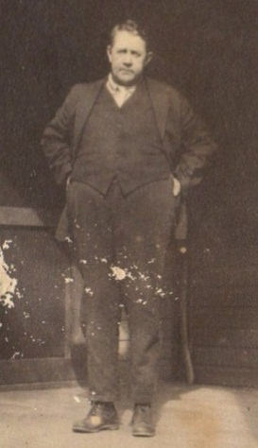
Toby Osborne (1876 – 1951)

August 7 – “Tusday August 7…got $7.00, seven dollars from Bank of Damascus.”

August 17 – “1920, Went to NC August 17 – come back Sep first.”

August 22 – “Wednsday 22 August…gave check to Bank of Baner Elk for $5.00, five dollars.”

September 16 – “Went to Damascus the 16th…came back the 18th.”

October 18 – “1920…Bill maried miss Kathern Rader.” Son Bill Osborne married and soon he too would be moving west, one assumes for employment opportunities.

December 25 – “1920…EXMs came on Saturday…nic day…no snow.” Frankie used shorthand for Christmas.

December 29 – “Charles & maym moved in with us. TM left hear for home. Bill moved in they houc Wher mayme moved from.” This move signals the beginning of years and years of moving from one house to another, sometimes Frankie living with the Stansberys and sometimes not. Frankie and G.W. do not appear to have purchased a home in Bristol but only rent a house or part of one. All of these homes were within a few blocks of each other. When I visited Bristol, Tennessee with my mother in 2009, I was astounded by all the houses she pointed out in which she and her family had lived, suggesting severe economic stress.

1921

January 1 – “TM went to Radford to the sanatorium for treatment. Came home February 5th from Radford.” Radford is about 100 miles north east of Bristol. Toby would soon relocate his family to Washington state. His great grand daughter, Sara Porter, believes he may have had mental problems and this entry would support that. He was incarcerated in a western mental institution in the early 1930s.

January 26 – “Toby M Osborne is 45 today.” Toby had 30 years left to live, 20 of them in prisons.

January 27 – “Louise Stansbery is 6 years old.” Louise Stansbery Sherwood would marry three times, the last to Vance R. Sherwood in 1941, a marriage that lasted until his death in 1990. Louise died of dementia in 2006.

January 28 – “9 years cine got arm broken.” This must have been a serious injury; Frankie recorded this anniversary from 1921 to 1925.

February 1 –“4 years to day cince they Brough me from hospital.”

February 17 – “Roy Osborn 42.”

March 25 – “come back from Damascus Friday befor Easter.”

March 26 – “Russel got discharge from navy, come home.” Russell, born 1903, is a son of Toby Osborne. Pauline is his sister.

March 28 – “Easter come, nice warm day.”

April 10 – “had a freese, killd fruit.”

April 15 – “Simp Osborne spent the night.” Another relative, exact relationship unknown.

April 16 – “Louise Stansbery got measles. Had a little snow.”

April 17 – “helt service in Anderson St Church for a solger boy name Carnahan.”

April 30 – “Charles Stansbery Jr got measul.” Evidently Louise gave the then common childhood disease of measles to her brother.

May 15 – ‘Charles mayme children & myself moterd to Damascus.”

May 29 – “Came back from Damascus. TM & family brought me to abinton in car. Charles & mayme met me there.”

This photo is of Frankie, Alta, Toby Osborne and young Louise Stansbery around 1919, probably in Damascus, Virginia where Toby worked as a hotelier with his sister Pearl Osborne Wright.

June 16 – “had our first mess of beens.”

June 23 – “GW sold is first beens.”

June 27 – “Mrs John, Dave & little george have gon to spend a month at moorisburg springs.” Evidently friends to a vacation spa of some type.

July 8 – “Pauline Osborne from Damascus came to visit relatives.” Pauline is Toby’s only daughter, and the grandmother of Sara Porter. Pauline wrote Frankie faithfully throughout the
1930s. I met Pauline one time as a small boy in the 1950s. Below circa 1920, Charles Stansbery, Jr., Pauline in the center and Louise Stansbery right.

. 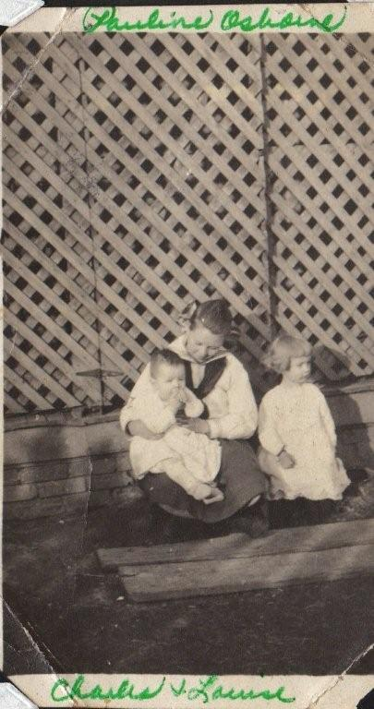
July 31 – “Thursday, mayme had her front teeth pulled.” This is the first statement concerning Mayme’s health. She would die young in 1943, at the age of only 47 in Philadelphia, PA, only three years after her 89 year old mother.

August 13 – “Callie Wilson & Ruth came…callie on her way to Durn (Durham, NC).”
Callie Wilson (1898 – 1999) was a niece of Frankie’s and a daughter of John Wilburn and Becky Wilson of Ashe County. Callie would marry her first cousin William A. Wilson, Jr, son of the missionary to Japan. William A. Wilson Jr. was born and raised in Japan. He and his cousin Callie married June 19, 1926 at Duke Memorial Church, Durham, NC.

Ruth is Ruth Wilson 1903-1999, another daughter of John and Becky Wilson. She was born 1903 and would marry Shirley (male name) Hurt.

August 16 – Newspaper article: “Miss Oleano Gilpin and Mr. Austin Elrod motored to Bristol and were quietly married at the home of the Lutheran minister, Rev. J. L. Smith. They were accompanied by the bride’s parents, Mr. and Mrs. J. L. Gilpin.” Friends or acquaintances.

August 20 – “Hagen Bently died to day…he died at heartsville Tenn…his body will arrive on train no 26.”

August 21 – “maym and children come back from greenvill to day.”

August 26 – “Bornd to mr and mrs W V Osborne, a girl name margret shields.” Newspaper note: “Born to Mr. and Mrs. W.V. Osborne on Shelby Street, a daughter.”
Bill’s family later moved to Vancouver, BC and Los Angles, California and had only this one child, Margaret.

September 9 – “Thursday started to NC on 8th…Went by they way of Damascus then to mt city then to NC…got ther Saturday, the 10…stopt at TM over night.”

October 5 – “1921…come back Wednsday From NC… gone a month.”

October 11 – “1921…Tusday…Went to Damascus to see TM.”

Novemnber 6 – “1921…came back from Damascus … gon most 4 weeks.”

November 11 – “first little snow…mr and mrs mcdonel baby died…taken it to marine to bury.”

November 12 – “mr Jackson Wilson from NC died at St luk Hospitle.” Andrew Jackson Wilson 1858-1921 is a 2nd-cousin of Frankie's. (CWG)

November 18 – “at YMCA missionary ladys…had a turkey diner.”

November 19 – “Friday…I went to Damascus.”

November 20 – “1921, Tusday…”I came back from Damascus.”
1922

January 6 – “Went to Damascus in car with Toby and family. Came back the 10th.”

February 1 – “5 years to day cince they brought me home from Hospitle.”

And now the tragic death of Bascom’s wife, Dora Kruger Osborne, which would so affect the three children of the marriage:

February 24 – “Dora Osborn Died this evening at seven 7 died sudent (suddenly) Friday evening…sent telagram…maym children & my self started Saturday evening at 8 eight on 42 to Baltimore for Funeral to be Monday 27…got the suday at 10 clock. Maym, Louise, Jr. (Charles, Jr.) and myself started to Baltamor on 42 train to be at the Buriel.”

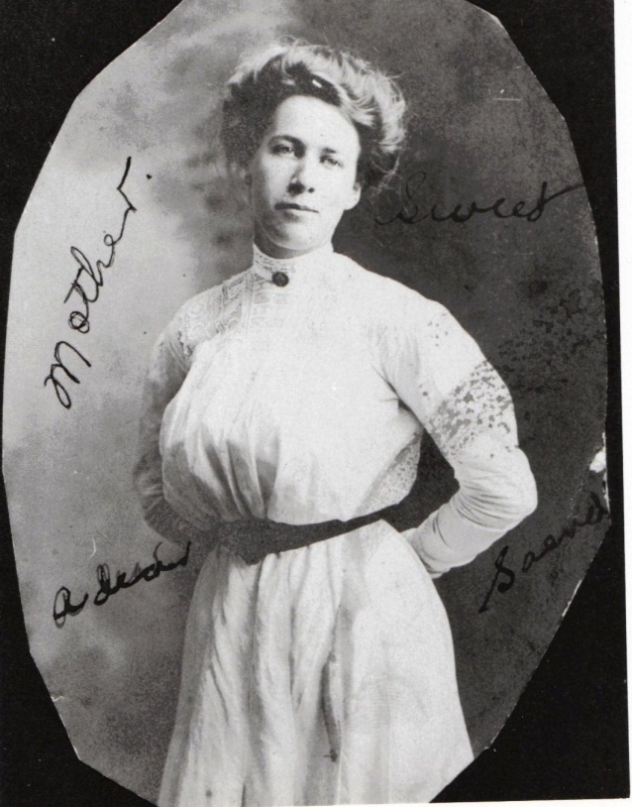
Doris Kruger Osborne, first wife of Bascom Osborne

February 26 “We arrived at 10 clock at Bascom in Baltamore, Sunday.”

February 27 – “Buried Dora this evening at 3:30 Monday.”

February 27 – “Bascom Osborne children – bascom Jr, Doris and glatis come to stay with ther aut Pearl Wright this summer. This is Doris Birthday. (Date of this writing is uncertain; perhaps the three children did not move to Damascus, VA until a few months after their mother died.)
March 4 – “Saturday, got back from Baltamo to day, stated from Baltam at 1:30 at night, got to Bristol at 4:30 in the evening.”

March 20 – “Sunday, Taken Toby to marion to day.” Marion, Virginia?

March 21 – “Went to Bills to stay a few dayes.”

April 14 – “Bascom Eakers sentenst to day to go for five years to the penitentiary for embeselment.” Here Frankie recorded a crime conviction. How did she know this person? Why did she record this comment? Is this person a friend of her son Toby who by the 1930s was incarcerated himself for mail fraud.

April 17 – “easter Sunday, nic warm day.”

April 25 – “Bill moved on Sixth st in the slack property.”

May 3 – “Ash C. NC…W A Wilson was Bornd Dec 20 1860 and started for Japan May 25 1890. Married to miss mary Mccleton. This photo (not in diary) was taken at Kob Japan september 27 1890 from home to it is 28 days journey…this may 3 the 25 of this month may, it will be 32 year cine he left for Japan, this may 3, 1922.” W. A. Wilson’s wife was Mary Amelia McClellan, b. 1868.

May 4 – “W.A. Wilson started for Japan May 25, 1890. Before leaving his home on Cove Creek, he read the 12th chaper of Romans and had prayer with the family.”

May 14 – “Mothers day…Bishop conducted the survis.”

May 31 – “Came back from Damascus. Dave Pearl & Pauline come with me. I gave Pearl my chiney clausil (obscure – China?). She taken it home with her.”

June 3 – “Saturday went to Damascus to keep house for TM while
TM, atta & Russel went to a trip up North.” Alta Holtzclaw (or Holtsclaw) was Toby’s wife. Frankie constantly mis-spells it.

June 16 – “Came back from Damascus…alta, Russel and Pauline come with me. Russel is 20 years old.” As she did with other children or grandchildren, Frankie recorded Russell’s birthday in 1923 and 1924. His great niece, Sara Porter, reports Russell had a career with Washington Public Power in Wenatchee, WA, and later moved to Scottsdale, AZ where he owned a parking garage and several houses. He died in 1998 at the age of 96.

June 29 – “Charles, mayme and children motered to Greenville & afton.”

July 4 – “Wet and raind most all day…TM, Atla, Russel and Pauline came…they ate supper with us Mrs. Tilly died at St. Lukes Hospitle…she lived one week after they taken her there… buried today, the 4th.”

July 10 “TM left Damascus.”

July 25 – “Pauline went home Tusday, the 22. Mayme and children went to afton for a rest, camping.” My mother told me that she remembers camping along the creek in Afton, just off what is now Highway 11. I have wondered why they did not stay with Stansbery relatives. I suspect there was no spare room.

July 18 – “made krought.”

July 26 – “1922, July 26…Put in gas range stove today.” Later she wrote for July 26: “Went to Damascus, VA”

July 28 – “Alta and Russel went to Blowing Rock.”

August 29 – “Tm had sail (sale) Monday…they saile amounted to about nine hundrd.”

August 31 – “TM Osborne and family all left for some Part in West…Went in car.”
Toby had sold his house and moved his family to Sumner, Oregon. Imagine driving west in 1921 with few paved roads in the vehicles of that day. A record of this journey would be invaluable to day. One suspects they had to camp out as they drove on a many days journey.

September 19 – “coloroda.” This was a one word entry; do not know what it means. Perhaps Frankie received a post card from Toby in Colorado?

September 22 – “Roberson sho. Come to Bristol.” A vaudeville show? Frankie mentioned very little about entertainment other than family or church socials.

September 29 – “started to NC…Went by the way of Damascus…stayd ther till Sunday oct 1…I was gon till novembs 21…gon 8 weeks.”

December 11 – “Monday charles made his first payment on place $30 dolers.” Charles Stansbery Sr rented from his in-laws.

December 13 – “Bishop 41 years old…We moved to they faucet houce…Paid 17 ½.” The game of musical ‘homes’ continued. Did people keep raising the rent, or even more worrying, was the family delinquent in rental payments? Bishop Osborne was another son, an accountant at King’s Department Store and often a writer for the local paper.

Frankie repeated Bishop’s birthday in 1923, 24 and 26.

She also recorded on this page that on June 8 1907, her mother, Caroline Greer Wilson, fell and broke her hip. Her mother, a courageous woman who endured much suffering during the Civil War, lived until September 1911. Frankie’s death would be also the complications from a broken hip.

1923

January 13 – “moved in Mr. Fancet house on 6th Street and pay 17 ½ dollars per month.” This was like paying $221.61 in 2010. CWG

January 24 – “Came back from ?Darna s end.”?

January 30 – “Charles mad second payment – 30 dollar” $379.91 in 2010 - CWG

February 1 – “6 years today….”

March 2 – “G W set out cabage Plants nice warm spring day.”

April 1 – “nice day…Dave, Pearl & Bascom Jr, Dois & glatius Osborn Bascom’s childen, they all moterd from Damascus to Bristol to spend Easter suday with us & take diner with us.” This would Dave and Pearl Osborne Wright and the three children of Bascom Osborne that they raised.

May 3 – “1923…Charles changed his insurance with another company.”

May 6 – “had a awful rain storm then sleet & snow & freese then frost.”

May 10 – “first Ball game for the season…Pearl come down.” A minor league game at Bristol? Was Frankie a baseball fan? This is the only comment on sports in her diaries. This could be a reflection of what Charles Stansbery Sr. may have done that day – he was a rabid baseball fan. I remember as a young boy when visiting him in Afton, he showed me a baseball signed by Mickey Mantle of the New York Yankees, his favorite team.

His daughter by his second marriage, Nancy Stansbery Higginbotham, born November 3, 1940, reported to me in July 2009 that she remembers her father sitting by the radio and later watching television every time he could receive a baseball game over the air. An early photo of Charles shows him wearing a baseball uniform and swinging a bat during a game for Tusculum College in Afton.

May 11 – “comenst to knit maym a.”

May 12 – “Mr Ervin & Ervin and Mrs. Sparger were married today.”

May 13 – “mothers day…mr Kebler conducted the servis. J. Osborne ate diner with us today.”

May 26 – “Bascom Osborn from Baltimore came to Damascus…his sister, mrs David Wright, come to see his children…Pearl is keeping them…they ar going to chool.”

June 1 – “Friday, 1923…Bascom Osborne & children came to spend a few days with Father & mother, Brothers and sister.”

June 3 – “Bascom left on 42 for Baltimore Sunday nitht.”

June 17 – “Charles, maym & children all went to Greenville and afton to spend a few days. They went in car.” As opposed to the train. The automobile was fast replacing trains as the main means of transportation in America.

July 16 - The newspaper reported: “Mrs. Charles Stanbury and children, Lousie and Charles Jr have returned to their home on Windsor Avenue after spending three weeks with relatives in Greeneville.” The relatives were Charles’ parents, William Luther and Annie McCray Stansbery of Afton, TN. Why was Charles Sr. not mentioned? Perhaps he had returned earlier to work. Below, Louise, Mayme Osborne and Charles Stansbery, Jr. circa 1925.

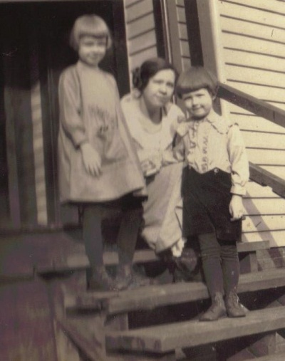

June 20 – “FC Osborne. I am 72 years old to day.”

July 12 – “GW 78 years old today.”

July 23 – “mayme and children came home today…they spent 2 week in Greenville and afton…mr & mrs Fred stansbery & children came home with them…spent a few days.”
Fred was Charles’ brother.

August 18 – “Went to Boby Howards…came back to Damascus, stayd over night.” There is confusion about this name. Frankie wrote it as Boby, Roby and Ruby. Boby and Alice Howard are the parents of Lois Ann Howard Adams, still living in Mountain City, Tennessee at this writing. It could just be the way she wrote her R's as his name was Roby Howard. CWG

August 19 – “Bascom childen come, stayed till Wednsday.”

August 25 – “Lawernc came back from the west…he was gon most a year.” This is Toby’s son, Lawrence, who later worked in the insurance business, became extremely obese and alcoholic, reports Sara Porter.

October 25 – “had a big snow…ever thing looking green…no frost to kill anything.”

October 29 – “GW started to NC this evning…Went by the way of Damascus.”

November 11 – A newspaper article recorded the death of an infant child of Mr. and Mrs. James D Faucette, Jr. To my knowledge this is not a relative, but probably an acquaintance of Frankie’s.

November 16 – A newpaper article records: “Geraldine is the name given to the little daughter born to Mr. and Mrs. C. S. Stansberry, 1020 Windsor Avenue, November the sixteenth.” Frankie writes: “Bornd to mr & mrs stansbery a girl name Geraldine. Witht 8 lbs.” This is my mother, Patricia Geraldine Holliman Feick. Her nick name is Gerry. She is the last of three children by Charles and Mayme Stansbery.

A President of the U.S. died in office this month, Warren G. Harding. Frankie made no mention of this important event. Throughout the diaries she seldom related national or international news. Nor does she ever mention reading a newspaper or book. Given her sparse education, perhaps this is not surprising. With the exception of her youngest brother, William A. Wilson, no sibling of her generation seems to have received much schooling.

December 2 – “2 Dec Tusday…maym and family ate diner with us today.”

December 3 – “had big snow.”

December 21 – “Lawerce come to Bord dec 21 1923…Lawerence left for home the June 3 1924…been hear 5 months 13 d.”

December 26 – “Tusday 26…Warm, Black EXm…Bascom Children come day after Exm…spent severl dayes.”

1924

January 3 – “Son Bishop went to Boone, NC and ordered the Watauga Democrat sent to his father (G.W. Osborne) as a present.” The Osbornes were from Watauga and Ashe Counties, NC originally.

January 6, Sunday – “Was the coldest time I ever felt. Mr T.P. Snider had a stroke of paraleses had it about 1 clock…lived 26 days without moving or speaking.” This is the mother of Alice Snyder of Mountain City. Frankie kept a regular correspondence with Alice Snyder of the Tennessee hamlet not far from Ashe County, NC. Alice Osborne Snyder was daughter of her sister Emaline Wilson Osborne. Mr. T.P. Snyder MIGHT be Alice's father-in-law or brother-in-law. CWG

January 9 –“Lawrence Osborne (a grandson) went to work at the Shelby garage.” Again, an offspring taking a job in the new world of automobiles. Later Lawrence moved back to Washington State and tried his hand at insurance. According to Sara Porter, his great niece, his wife was the worker in the family.

March 22 – “Charles & Charles Jr went to afton, spent the night & one day.”

March 23 – “A Pratracled meeting that has been going on for two weeks closed today.” Perhaps this was a ‘protracted’ meeting or what is called a Methodist revival, a week of evening preaching to seek Christian conversion. Revivals were common in the South in the 19th and 20th centuries, generally in more biblically fundamentalist churches that believed strongly in an emotional commitment to Christ as a personal savior.

March 31 – “the last day of march was a warm nic day.”

April 1 – “aprile the first…Was the Worst day I most ever seen…it snowd, raind most all kind.”

April 20 – “Easter Sunday…Dave, Pearl & Bascoms children all motered from Damascus, pent the day.”

April 24 – “mayme rented her rooms up stars to Earl Hift.” Frankie had written 1919 in pencil beside this comment. Was this written then in 1919 although 1924? It is in ink. At what date did the Stansberys begin renting homes to increase income? Throughout this diary are references to renting rooms to boarders or doing the same from others. Evidently it was a much more common occurrence to rent out a room prior to World War II. I can remember in the 1950s, my Holliman grandparents renting rooms to railroad workers in Irondale, Alabama, something almost unheard of as housing became more available in this country in the last half of the 20th Century.

April 29 – “Started Pauline her music. Postige cost sixty fore cts.” (Started must mean ‘mailed.’)

May 4 – “Friday, may the 4th washed and went to the church to the Funeral of mrs. Owens.”

May 14 – “may 14…the operated on atta Osborne to day for gall stone …taken 43 out of her…gall sise of bean to chestnut.” Below, Alta is Toby’s wife and Pauline Osborne Smith’s mother. Alta is cousin Sara Porter’s great grandmother.

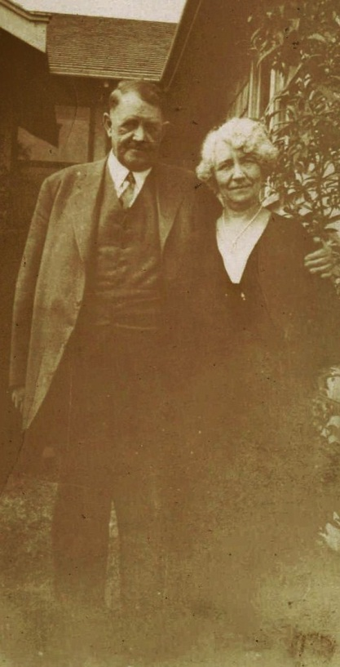

May 18 – “alta is getting along fine in Hospitle …Atta Osborn at Hospitle at Puallu KY (Paducah?)” This is strange; perhaps Frankie means Washington, not Kentucky. There is a Puyallup, WA very close to Sumner, WA. CWG

June 2 – “Bascoms children came to spend a few days before leaving for Baltimore. They have spent most two years with their Aunt Mrs D.R. Wright at Damascus, VA. They have been in chool.”

June 3 – “Lawrence left this evening on 26, Memphis Special for home…came her the 21^{st Dec}…been hear 5 months, 14 days.”

June 12 – “got girl to stay with mayme for a while. Name myrtle Johnson from Bluefield, West VA.” This is disturbing evidence that Mayme suffered chronic health problems. Her poor health complicated her marriage.

June 15 – “Bascom Osborne borrowed one hundred and fifty dollers…going to pay 5 dollars a week till paid.” Frankie noted he paid on July 9, July 22 and August 26. Was Bascom having financial problems? Was this why his sister Pearl raised his three children? Bascom gave up his children to his sister Pearl to raise. There is family tradition that alcohol played a part in Bascom’s ‘break down’ after the death of his wife.

June 20 – “I am 73 years old today.”

July 7 – “Bascom Osborns children – Bascom Jr, Doris & glatus left on 42 (train) for Baltimore to be with their father. They have been staying with their aunt for most 2 years, lacked 1 ½ months be there 2 years (since) 1922. They left Baltimore September 12, 1922, got to Bristol the 13th, stayed there 4 days, then the 8th we went to Damascus…remaind there til July the 7th…went back to Baltimore, there stayd with their aunt Pearl, lacked 1 /12 months being the 2 years.”

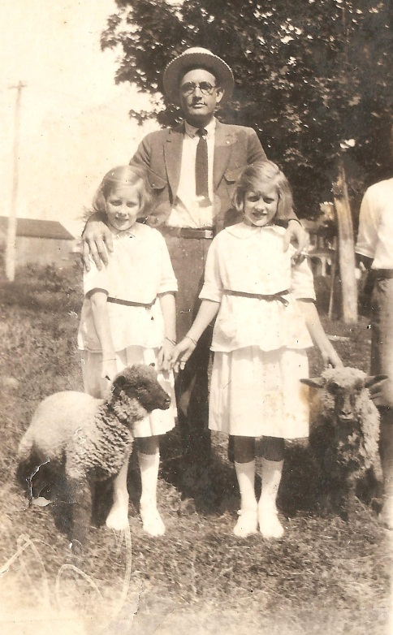 Bascom Osborne with his two daughters, Doria and Gladys Osborne, photo probably taken in Damascus, Virginia.

July 24 – “charles, maym, Louise, Charles Jr, Geraldine and myself all motered to afton and Greenville, spent a week.” One crowded 1920s automobile! Charles Stansbery, Jr and Sr. below.

July 31 – “Thursday 31…maym had her front teeth puld.”

August 24 – “Mrs charles Stansberey, Louise and Charles jr, Geraldien and my self all went to NC by the way of Damascus…spent Friday night with Mrs D. R. Write…then to NC…stayd 23 week…went Friday 22, came back sept Sunday 7.” Mrs. Wright is her daughter Pearl. It is an interesting convention of the time that Frankie often referred to her children and herself by married title.

September 15 – “Miss Elen Snider from NC came to stay with maym this Monday 15th.” She may have meant to write ‘Alice’ but the name Ellen shows up several times.

September 21 – “1924…started W A Wilson a letter today.” Her youngest brother in Japan.

September 25 – “old solgers had a reunion at VA cort houc…servd diner. Becke Wilson and Ruth Hurt From NC come…spent the night.” This is her sister- in- law, John Wilson’s wife, Becky (1862-1952) who is featured in photographs prominently in Neighbor to Neighbor. John and Becky’s daughter, Ruth (1903 - 1999), married Shirley (male name) Hurt. John lived from 1855 to 1928. The family resided at Caroline Wilson’s old home place, now on Oscar Wilson Road which begins at Donnelly Store in Ashe County, NC.

September 30 – “the last night in sept…it turned very cold and had a big Frost.”

October 23 – “1924…Oct 23…Amra grotto organized in Bristol…had big Parade…GW joined…had to Pay $37 dolers fee.” This must be a fraternal organization, the Masons? His tombstone bears a Masonic emblem.

October 25 – “1924…Charles-mayme and chidlen and Elen snider all moterd to greenville.” Again, we see the name Snider or Snyder, descendants of Ema Wilson Osborne.

October 26 – “mrs green Buried to day halt seric in church…m rely and mr woolsis conducted the servis in Anderson street church.”

November 6 – “Nov 6 Thursday…roy Paid GW five dolers on what he owd.”

November 27 – “1924 thanksgivn is a dark cold and glooma day…dark all day at night raind and snowd and tund very cold.”

December 3 – “1924…Dec Wednsday 3…GW Paid 3 dolers for grottoes.”

Loose paper: Cover envelope from W.A. Wilson, 113 Kunitomi, Okayama, Japan to Mrs. G.W. Osborne, 1016 Anderson Str., Bristol, Tennessee U.S.A. Letter below. 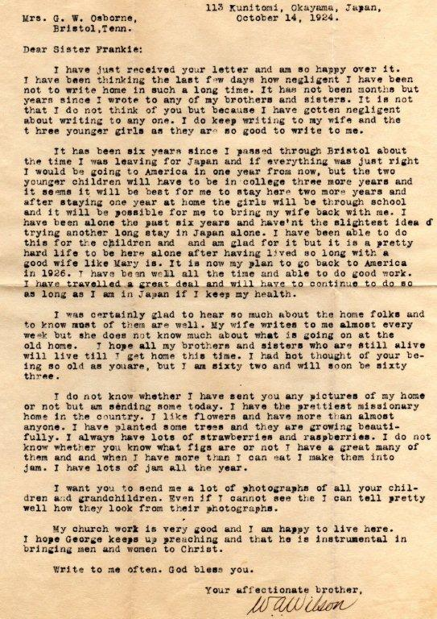

1925

January 7 – “GW goes to work to sell fruits for a Mr. Crawfurd and a Mr. Gilmer this Jan 6.” Bishop Bascom wrote in G.W.’s obituary that G.W. was a Methodist minister. A history of Ashe County, NC states G.W. was ordained at at Sutherland United Methodist Church, evidently in the 1870s. Geraldine Stansbery states (2009) that relatives said there was hair stain on the side of the nave wall where he rested his head during services at the Anderson Street Methodist Church in Bristol. Evidently G.W. worked to supplement retirement. A 1914 marriage license does show he presided at Mayme Osborne’s marriage to Charles Stansbery, Sr.

January 13 – “Bill started off today.” “Burreh field elecuted today for the murdering of five people and seting fire to the house his wife stepson and mr and mrs smith and little daughter.” Local crime? Bill Osborne, below, moved to the west, following in the footsteps of his brother Toby.

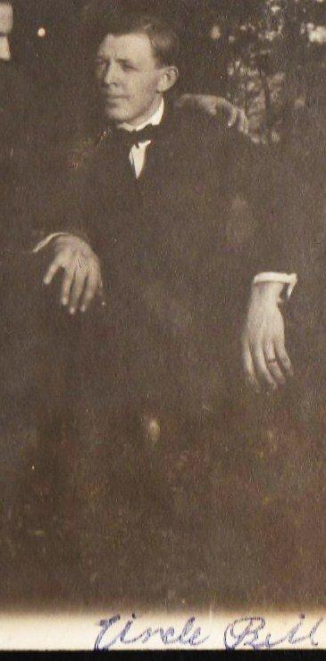

February 23 – “Paid $5.50 dolers insurance to grottoes.”

February 27 – “Wilburn greer died 27th of Feb age 91 years old. Press Greer died april 29…1885…Wilburn Greer’s son.” Frankie’s mother was Caroline Greer Wilson, and her grandfather was Jesse Greer, Jr., both of Ashe and Watauga Co., NC. In another diary, Frankie recorded: “February 27 1925…Wilburn greer died age 91 year old.” Wilburn was a brother of Caroline Greer Wilson and an uncle of Frankie’s.

On line in Johnson County (TN) Photographs, there is a biography and photo of Wilburn (Wib) and his wife Annie Reece Greer. Wilburn was born October 10, 1833; married January 17, 1858 in John County, TN to Annie Reece, born Nov. 24, 1839, daughter of Hugh Reece and Mary Reece. She died February 6, 1920 and is buried Banner Elk, Avery Co. NC. Wilburn died Feb. 27, 1925 and is buried in Banner Elk. During the Civil War he served in the 6th NC Cavalry, CSA.

Interesting Frankie mentioned her cousin, John Preston Greer, b June 30, 1861 who did pass away in 1885 at Cove Creek, Watauga Co. NC.

March 1 – “Pearl Birth day she is 35 years today this Sunday march 1st 1925, raining and cold.” Frankie repeated this information in 1922, 23, 24, 26, 28, 29, and 1930, Pearl Osborne Wright’s 40th birthday.

March 25 – “super tanated ministers, Wives & widows of the Methodist church intertained by circle no 1 of State Street Church. Mrs. J.B. Drinkerd is President.”

March 29 – “Charles, Maym, Louise, charles jr, Geraldine, Ellen snider and myself all moterd to Damascus, spent the day.”

April 14 – “Went on the North Fork of New River to Uncle albert Wilsons to selabrate is 100th birthday.” The local newspaper reported at Albert Wilson’s death in 1928 that he was the oldest Confederate veteran in North Carolina (1825 – 1928). He died three miles east of Boone, NC, blind, deaf and palsied. His mind remained active until death in February, two months short of his 103rd birthday. His brother was Isaac Wilson, Frankie’s father. In the Civil War he served as a Confederate with Company E, 37th North Carolina Infantry. As a first sergeant, he was in battles at New Bern, Hanover Courthouse with General Thomas “Stonewall” Jackson followed closely by Mechanicsville, Gaines’ Mill and Frazier’s Farm. Malvern Hill and Cedar Run followed. A member of Jackson’s ‘foot cavalry’, he charged a New Jersey brigade at Manassas.

At Chancellorsville while lying wounded, he heard the shot that killed General Jackson. There followed Gettysburg, Petersburg and finally the surrender with Lee at Appomattox. When he returned home he had ‘to deal with the bushwhackers’. The funeral was at Three Forks Baptist Church, Boone, NC.

The clippings on the next page were found in Frankie Osborne’s papers.
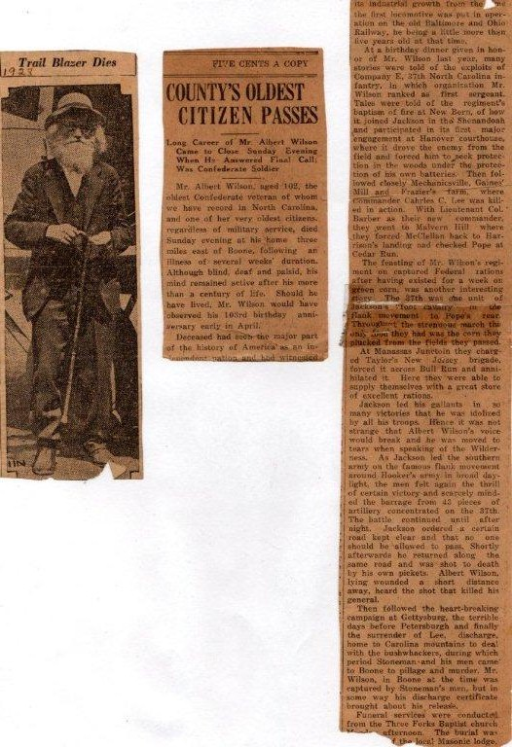

April 16 – “Paid $5.50 dolers insurenc.”

May 11 – “may 11, 1925…charles sold his house and lot to a man by the name of Hubble from marian, VA.” (Marion, Virginia) Charles Stansbery Sr seemed to be doing well economically by selling one house and building another one, a larger structure according to my mother. A descendant of Martha Wilson Forrester married into the Hubble family of Smyth County, VA. I wonder if there was a connection? CWG

May 18 – “Charles and Mayme moved to 12 street in Dr Dykes house till they get ther house built.”

June 4 – “Charles & maym and Louise & Jr & Geraldine Stansbery & Kathern & Margaret Osborne and myself all motered to Island Park on a Pick nick. The K K Klansmen had a big Perade. Pearl, Dave & Bascoms children all down from Damascus. Bascom Jr, Doris & Glatis.” This was obviously a large family picnic.

What to make of the Ku Klux Klan parade? In 1915, the ‘modern’ day KKK was reborn at Stone Mountain, Georgia. The on line Tennessee Encyclopedia of History and Culture in an article on the Klan in Tennessee states that by the early 1920s many Klan cells (clubs) had been created in East Tennessee with more in Chattanooga than Knoxville or the Tri-cities (Bristol, Johnson City and Kingsport). The Klan, with 2,000 members in Knoxville where a major race riot occurred in 1919, was so prevalent in Tennessee that for several years in the early 1920s their influence elected a governor and U.S. Senator.

This was the aftermath of World War I, the Red Scare and bombs on Wall Street and in Washington, DC, the local Scopes trial and the rise of immigration from Eastern Europe and the Mediterranean areas, many Roman Catholics. These events plus the revolution in transportation and occupations resulted in increased social and economic fears and dislocation. There was a resurgence of ethnic hostility, not just in the southeast U.S, but also in the Midwest. What was semi-respectable in one generation may be the next generation’s abomination.

The Stansberys and Osbornes were like hundreds of thousands of Americans in the 1920s, moving from an agriculture economy to a new urban environment of automobiles, electric lights, street cars and the need for technical and new occupational skills to survive. Charles Stansbery, Sr. grew up on a tobacco farm and had his early training in managing horses and suckering a farm plant. By the time he married in 1914, horse power was moving under the hood of a car, and new employment skills were necessary.

In 1918, age 25, and with no known trade or advanced education, he moved his growing family from a farming hamlet to an expanding town. He found employment and monetary success as a Ford mechanical repair supervisor. As with many who tried to find their way in changing times, Charles Stansbery had challenges and fears. When he consumed the adulterated alcohol in 1930, his world came crashing down. Later in an attempt to earn a living, he turned, not to automobile servicing, but rather running a small country store back in his native Greene County. By the 1940’s, he had returned to hog and tobacco farming, keeping up his brother’s farm in Afton. Bristol and its urban pace environment were part of his personal history. He had gone home and started a new family and life.

June 16 – “1925 June 16…GW Paid $5.50 insurance to grats.”

July 6 – Post card from Bill Osborne, Vancouver, BC: “Wonder country…we should of com here years ago. Opportunity still (for?) working.” His wife, Katherin, and daughter Margaret had been at the family picnic the month before. Perhaps it was a goodbye party for the Bill Osborne family. Bill found work in Canada before locating to Los Angeles. Again, the new automobile industry.

July 12 – “Charles, mayme and Louise, Charles Jr and Geraldine all moterd to Greenville.”

July 13 – “GW Paid $5.50 insurance to grato insurance.” Frankie recorded this same statement on September 18, October 30, November 9, December 9 1925 and January 30 1926.” Was this life insurance?

July 21 – “Maym, Louise, Charles Jr, Geraldine and myself went to roy Osbone at Cleavland, spent 2 weeks. Charles came after us. We came back in car. We Went July 21, came back August 4.” Family visits in that generation were much longer than one would dare stay with relatives today!

Newspaper article recorded: Mrs. G.W. Osborne, Mr. and Mrs. Charles C. Stansbury and children motored from Cleveland, Tenn, Tuesday wher

Chapter IV – 1925 – 1931: Death of her Husband, Family Travel, Economic Challenges and a National Scandal Strikes Home Collapsing a Marriage

August 8 – “1925…Mr GW Osborne had a hemorge of Brain…taken very sudent.” This tragic illness would put my great grandfather to bed for two years until his death in 1927. My mother, Geraldine, believed he had Alzheimer’s, when it appears a stroke might be the proper diagnosis. Notice Frankie always addressed her husband as either Mr. Osborne or GW.

August 18 – “Bascom Osborne Jr came to spend a week while Pearl and Doris and glatus gon on a campin trip.” This was the teenage Bascom Kruger Osborne, not really a junior. Perhaps he helped nurse his ailing grandfather.

August 25 – “Friday, August 21 1925…Mr and Mrs Stansbery moved in the new home on holston ave this Saturday 22, 1925.” This may have been the high point of the Charles and Mayme Stansbery’s marriage and economic prosperity. Their daughter Geraldine remembers this as a large home, evidently located in an attractive part of Bristol, and that her father managed the service department of the Ford agency. Charles evidently had excellent mechanical skills prior to his disability in 1930.

October 9 – Newspaper article: “Charles Stansbery Jr had his tonsils and adenoids removed Friday at the Staley Infirmary. He is getting along nicely at his home on Holston Avenue.”

October 28 – “1925…Kathern and margret went to roy to day.” Bill Osborne and his family must be visiting from Washington State.

October 30 – “1925…first snow cold.”

December 2 – “Put $50 dollars in Bank. Had had $50.89 in Bank…this make $100.89 the Bank of Bristol Tenn.”

December 25 – “Exm come on Friday…cold… gw still sick.”

December 27 – “1925…coldest day ever felt.”

1926

January 13 – “Rented 2 rooms from C S Stansbury. Pay 15 dollar per month. On Holston Avenue.” Frankie must have moved her sick husband, G.W., in with Mayme’s family. Again these two families seemed to move back and forth with each other or sometimes without. Puzzling behavior. Due to health and economic conditions I suspect.

January 26 – “mr Billie White died at 1 clock this morning the 25.” “Toby Osborn is fifty years old today.” A number of pages later, Frankie wrote: “Nancy Osborne, wife of Jonathan Osborne, died at her home.” Nancy Brown Osborne 1844-1925 was Frankie's sister-in-law. She married GW's brother Jonathan 1836-1919, and was herself an Osborne descendant. CWG

January 28 – “Mr Floid Ford died this morning at 8 o’clock to(ok) him to Sutherland NC to bury.” This is a new Ashe County name – Ford?

January 29 – “Friday eve at 7 clock miss Edna may Tomas nineteen years old committed suaside while seting in her car shot her self.” By the 1920s cars became locations for suicides. It is interesting that Frankie recorded three suicides in Bristol in her diaries

February 1 – “9 years to day cince the Brought me home from Hospitle.” These dates are confusing. Evidently Frankie was hospitalized in 1917 for a serious illness and again in 1919 for a broken arm.

February 4 – “1926…Feb 4…Friday the forth…Paid Grotoes $5 dollars duse for exspences.” This continues to perplex. Was this a fraternal organization that G.W. belonged to and purchased life or health insurance? Frankie spelled this organizations name many different ways heightening the confusion.

February 28 – “Sunday, Feb 28 1926…GW had a stroke of paralysis in his tong and Face.” G.W.’s illness worsened. No assisted living; one stayed at home in that generation.

March 14 – “1926…Sunday mar 14 1926…Paid grottoes $5.50 five dolers and 50 cts to grottoes insurance.” And again on April 27 and May 7, 1926.

March 14 – “march 14 1926…mr Sam Anard hanged him self to a Rafter in garage about 7 oclock today.” Another suicide!

April 14 – “started with mr Dikison to the Penatentiaory for one year one month for exbeselment.” Does this mean Frankie ‘wrote’ to Mr. Dickson, or went with him to the state prison or the police ‘started’ or took him there? This is the second person she mentioned going to prison for embezzlement. These entries have puzzled me, and make me wonder if they might be related to Toby Osborne’s situation which deteriorates throughout the 1920s resulting in mail fraud and check embezzlements in the 1930s.

April 18 – “Started with mr Dixson to the Penatentiay for one year, one day.” Frankie repeated this episode.

May 8 – “saturday…Bascom came from Baltimrore…comenst to work at gargaqe for mr Walker on VA side of Bristol.” Before moving on to Louisville and Owensboro, Kentucky, Bascom evidently worked in Bristol for an automobile garage.

June 14 – “paid grottoes $5.50 one five dolers fity cts to grotoe to day. Mr GW Osborne.” Repeated on August 26, October 4, November 29, 1926 and January 3, 31, March 31 and May 31 1927.

June 20 – “I am 74 years old today.”

July 17 – “Mrs Stansbery, Louise, Charles Jr and Geraldine all left for NC on a visit. Came back August the 2nd on Monday.” Whatever the economic challenges of this marriage, they took numerous trips. One imagines they stayed with relatives. The photo below was probably taken on this trip to Ashe County, NC. Frankie Wilson Osborne holds her granddaughter Geraldine Stansbery with Louise and Charles Stansbery, Jr. on the horse.

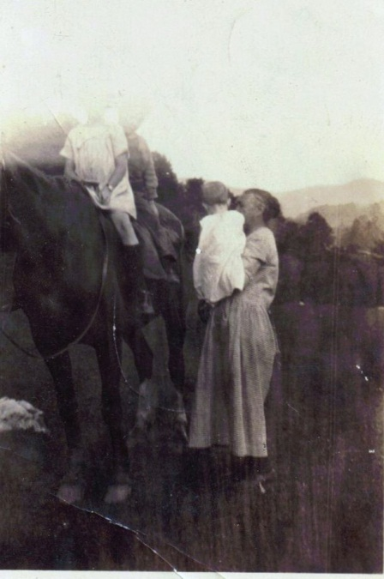

August 8 – “August 8, 1926…GW has been sick one year today.” A melancholy anniversary, no doubt, for Frankie.

August 12 – “August 12, 1926…got crate of Peaches from cleavland, roy sent them.”

October 23 – “Kathern started west today Saturday by the way of Knoxville.” Kathern went west to join Bill Osborne.

October 25 – “October 25…first snow, very cold.”

November 2 – “Bascom left for KY going to work in a garage…he came to Bristol may the 8th…left today nov 2 1926.” Here was Bascom’s move to Kentucky. He lived there the rest of his life.

November 24 – “Wednesday Nov 24…mr & mrs Stansbery and children Louise Charles Jr and geraldine all moterd to Greenville. Mr Stansbery went bird hunting… they come back Sunday the 28th.”

My mother remarked in 2009 that her father and his brothers would go bird hunting with politicians. One imagines that consumption of illegal whiskey would be part of the late autumn bird hunt, an activity that irritated my grandmother, Mayme. She and most of the Methodist Osbornes were greatly opposed to consumption of alcoholic beverages. Prohibition had been the law of the land since 1919. Stansberys were more ‘party’ people, the Osbornes more ‘church’ people. According to my mother, this was a major reason for the incompatibility of her parents, Charles and Mayme. At marriage, Mayme taught her husband The Lord’s Prayer.

Charles S. Stansbery, Sr. 1920s

November 26 – “1926…November 13, Charles sold his houc and lot on Holsto Ave to a mr Reigh.”
December 1 – “Dec 1…we all moved to Broad st in mr Woods house…Paying him 40 dolers rent.” Earlier in the diary, Grannie Frankie wrote: December 1 – “moved to mr Woodes House on Broad st. Pay 15 dollars. House no 1116.” This has an ominous ring to it. Perhaps the Stansbery paid $25 monthly and GW and Frankie $15. A little more than a year after Charles had built a large house, he sold it and moved his family, including father and mother-in-law into a rental house in a less expensive neighborhood.

This event must have made an impression on Frankie who had to move her bed ridden husband for a second time. She records the same event a number of pages further in her diary.

December 1 – “Wednesday the 1…We moved to mr Wood houce on Broad st…no of houce 1116.”

December 2 – “1926…Wednsday…started with L P summer to the Penatentary to serve 15 years.” Here again is the mysterious statement about persons she seemed to know going to state prison.
December 5 – “sunday 1926 Dec 5…Charles Stansbery Birthday 33 years old.” This is the grandfather of Glenn Holliman, Becky Payne and Alice Muphy, Vance Sherwood, Jr. and Susan Stansbery Mackenzie.

December 25 – Saturday 25 1926…just Poord the rain all day Xms…gw is no beter in a serious condition.” A sad Christmas for Frankie in a new rental house, rotten weather and a very sick husband.

1927

January – “Bascom will be 17 in march.” Bascom, as one recalls, was raised by Pearl Osborne Wright of Damascus, VA. Bascom, Sr’s. wife had died in 1922, and his sister Pearl, who had no children of her own, raised the three children along with her husband, Dave Wright.

January 27 – “Louise is 12 years old today.” In the diary is a cut-out of an angel, colored solid red. On one side, Frankie has written: “Jan 27 1927 Louise Stansbery 12 year old today at 1116 Broad st.”

February 3 – “Roy Osborne from cleavland Tenn came up …spent a few days.”

Mr. Roy Osborne of Cleveland, Tennessee, has returned home after spending a few days with his parents Mr. and Mrs. G. W. Osborne on Broad Street. From the local newspaper we have this article above and below, a telling report on G.W. Osborne and his health.

Mrs. Osborne is just recovering from flu and throat trouble and Mr. Osborne who has been confined to his room for nineteen months does not improve. His condition is unchanged. Feb. 3, 1927

March 18 – “march 18 – Bascom Osborn Jr is 17 year old to day, he is in the Navy.” As soon as he was legally able, Bascom K. joined the U.S. Navy and would go on to a successful career as an officer.
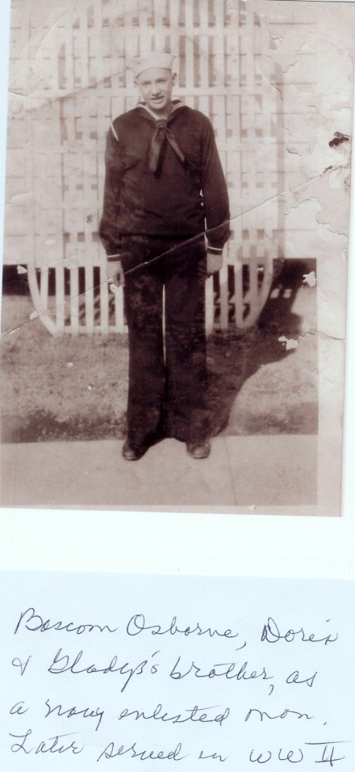

May 2 – “mrs John Wilson & Shirly Hurt – wife – baby …all come spent the night and a day with us from NC.” This was Frankie’s sister- in-law, Becky from the Wilson farm in Ashe Country. Shirley is Becky’s son-in-law and the wife, Ruth, is the mother of the new baby.

May 8 – “Sunday 8…this is mother day…got telegram from Bascom, … from Louisville, Roy. …got telegram from Bishop…he is in Harling Ky (?)… mother greeting.”

May 12 – “mr – mrs E D Tucet…Baby girl name ann…Thursday may 12.”

June 10 – “Doris & glatus Osborne spending a week with thir grand parents in Bristo. Glatus birthday the 10th…she is 13 years old today.” The grandparents were, of course, Frankie and G.W. G.W. was nearing the end of his life.

June 17 – “June 17, 1927…Friday at half past 6 they started to Knoxville with mr gw Osborne to Hospitle in a serious condition.” Even now with G.W. in extremis, she addressed him as Mr. Osborne.

June 20 – “I am 75 years old.”

June 30 – “Rev GW Osborne died in the Hospitle at Knoxville at 6 clock Thursday morning. Mr McNeal, the undertaker, went for him. He was buried Friday evening at 4 clock with Masonic order in Bristol, TN.” G .W. b 1845 in Ashe County, NC, was buried at East Hill Cemetery. Frankie was placed beside him thirteen years later.

G.W. Osborne, 1920s

July 12 – “GW Osborn would have been 82 years old today…died June 30.”

While Frankie was mourning the death of her husband of 60 years, a major cultural and business event occurred quietly in Bristol that July 1927. Mr. Ralph Peer of the R. C. Victor Record Company came to East Tennessee and Virginia searching for the local sound of traditional ‘folk’ music of the region. While in Bristol he recorded for the first time the A. P. Carter Family of Maces Spring, Virginia and one Jimmy Rogers. They were paid $50 a record. Because of this event, Bristol claims today the title of the Birthplace of Country Music and celebrates each year with a festival.

July 22 – “Left Bristol July 22…went to Damascus. Went to NC to Bob Wilsons.” No longer caring for a bed ridden husband, Frankie took a long trip, perhaps delayed the past two years, to visit family members in Ashe and Watauga Counties.

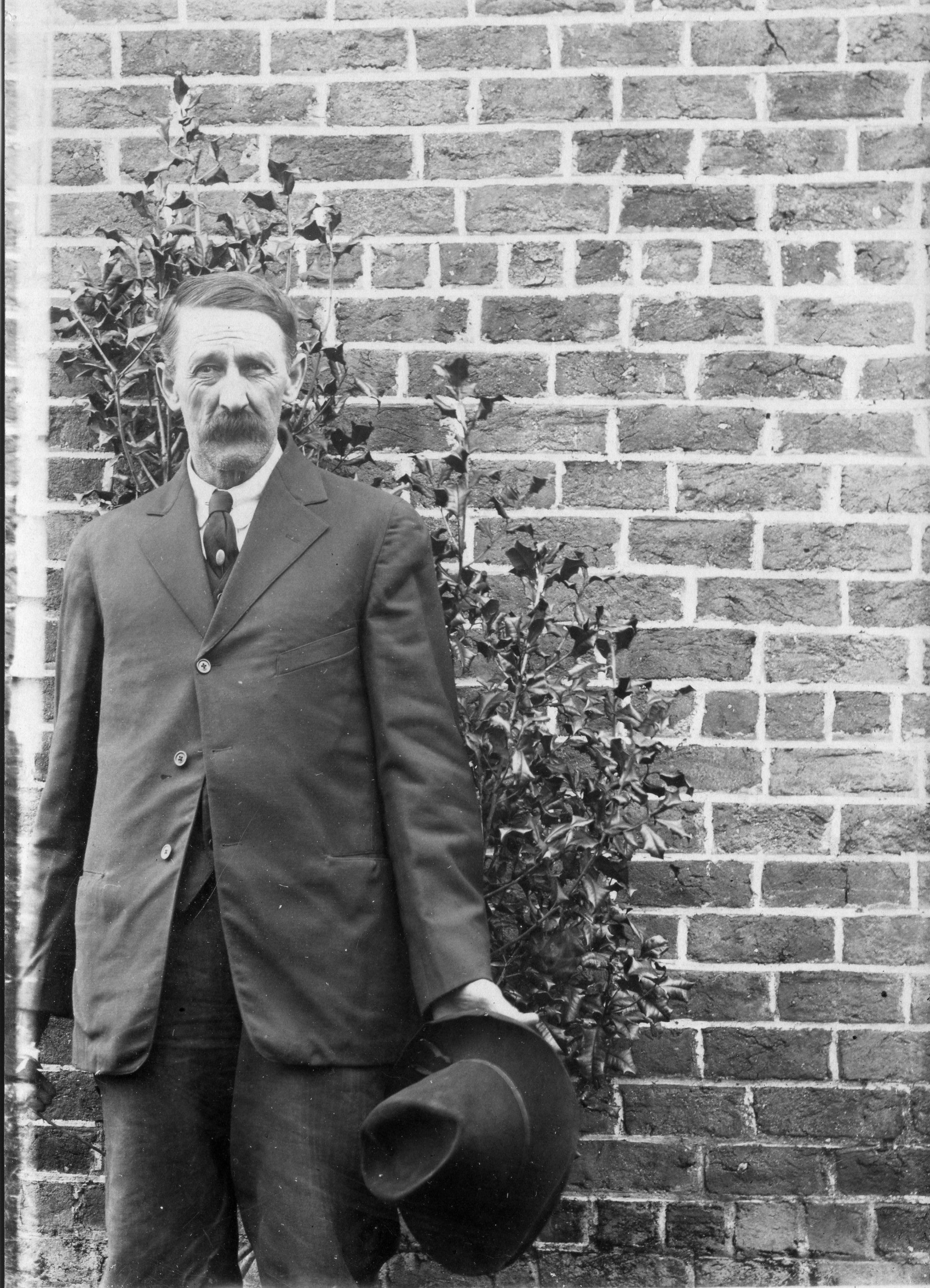
July 20 – “Went to Damascus, then from Damascus. Sunday to Brother Bob Wilson.” This was her brother, Robert Boyd Wilson of Ashe County, NC. Photo above is of Bob Wilson provided by Clinton W. Getzinger.

July 22 – “1927…Went to dr Peters office…had a another treatment for cancer…radium treatment…that makes two treatment. Paid him $10 doler, ten dolers.” Did she have her treatment in Damascus? Geraldine Stansbery has no knowledge of this illness which does not reappear in her life. Was this a misdiagnosis?

July 30 – “Left NC, went back to Damascus , stayd there till the forth of August. Went to roy Osborne at cleavland Tenn…stayd there till August. 17. Went from Cleavland to Elk Park to Dr. Proffits, stayd till the 18th. Went to Niles (?) to Emer Hensons th 19th. Went from there to NL mast the 20th. Then to Jane Proffit. Stayd there til 26th…Went stayed at Charles profit one night, then back to Jane’s…left Jane’s the 27th, went to arlas Wilsons…stayd there til 31 of August, then came home. Pearl went to Cleavland August 4, left for home to Damascus the 8th.” One of Aunt Jane Wilson Proffitt's daughters married into the Henson family of Cove Creek, Watauga County, NC. CWG

August 28 – “1927… Mrs. Broites fell Broke her hip and arm…she is in bad shape.”

September 10 –“Went to Dr Peaters office…had the third treatment of cancer.”

The Great Train Trip!

Beginning October 4, 1927, Frankie embarked on the longest trip of her life, both in duration and distance. She left home on the above date and did not return until February 1928. She visited first her son Roy in Cleveland, Tennessee and then embarked on a trans-continental train excursion to see sons Toby and Bill Osborne.

She recorded aspects of the trip in various parts of her diary, some redundant, perhaps reflecting her joy at the experience. While her entries are jumbled, we can catch the pleasure of this marvelous excursion.

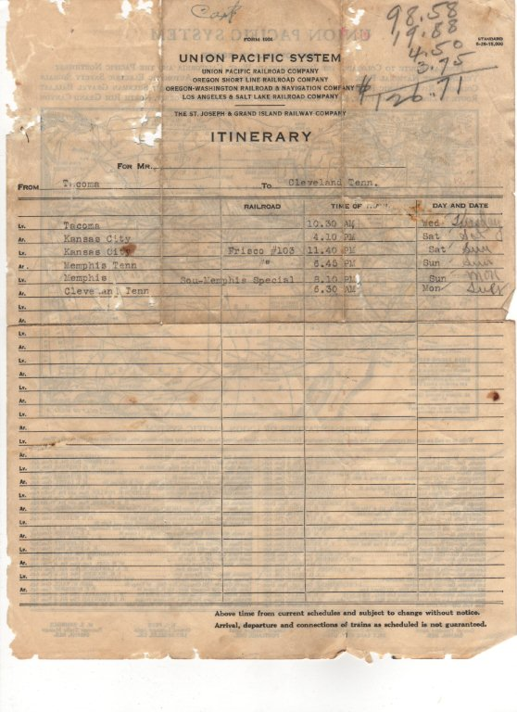
October 4 – “Tusday 4…Bristol Tenn…I left hom the 4th Oct…Went to roy at cleavland…stay ther till the thirteenth…got ticket to chatanuga…changed train…got a sleeper to Chigio…got there Friday morn at seven…lay over 3 hours…changed train for Tocama Washington…got in Tacome at 10 Monday morning…from ther to sumner Wash to TM. Trip to Wash cost (coast?) out of Rock (ies) at Drum and Abedeen….Sunday morning got in to the rockies at 12…got out at noon…at Breakfast on train…cost 55cts. Ate at 8 clock.”

“Round trip from sumner to Victory British Columbia…seven dolers and 53 cts be sides Lunch.”

October 13 – “Leav cleavland 9:50 Thurs a.m.

Ariv chattanuga 11 am Thursday am.

Leav chattanug 11:35 am.

Arrive Chicago 7:05 Friday a.m.

Leav 10:30 am lay over 3 hours

Ariv Tocoma 9:10 am Monday the 17th.

Fare $98.58. Pullman $29.000 (total) $127.58. From Bristol to cleavland - $6.79.”

Later Frankie wrote more: “Leav cleavland 9:50 Thursday 17…chattnuga…got Birth and Ticket…ariveded Chicago at 7:05 Friday morning at 7…Lay over 3 hours…changed from aberdean…In the Rockeys at 12 at night…out of Rockeys at Sun up in the morning….Sunday morning…Drumond Aberdeen …past Through Walla Walla Wash…Penatentery…it’s a fine looking Place, such a Big Building…I ate Breakfast on train…cost 55 cents …ate at 8…arivd at Tocome Washing at 10 Monday morning…Then to Sumner Washing…visited many places.”

There is a sad irony in Frankie noticing the prison building at Walla Walla, Washington as her son, Toby Osborne, would spend part of his life incarcerated in this facility.

Here she gave a synopsis of her trip.

“I visited the museum…Seen many thing the most interesting thing was a yoke of Big Red oxen Hitched to a coverd wagon…the name of oxens wer Dave and Dan, a Par of Boats tied to the Back of the wagon…the man tha a ownd the oxen and wagon was a man name exery meker, first man ever Drov a Wagon to tha state of Washington…he Blasede tha way to Washington and drove the agon…many other thing while ther…I went to Canidy (Canada)…taken Boat at Seattle October 29…Taken Boat to port owned Wash…arrived at 8 washing…then Taken Train to Fort angeles Monday morning taken Boat to canady…we ate diner on Boat under watter (I think she means ‘over’)…We got in Canidy…We Drove a round…Wrot som cards…Sent out tht evening as we come Back…ther was a heavy …gave the Boat quit a Shaking up…dident do much Sleeping…We Puld in at Seattle at 11 at night…Got off of Boat…spent a whil at a lunch…got on Boat…Went to Tocamie…got off Boat…got on Buss…went to Sumner Washington…Had a fine trip…Mrs G W Osborne.”

October 29 – “1927…Saturday Oct 29…left sumner Wash at 2 clock…went to seatle…taken Boat to Port Townson…then got off of Boat …taken trains to Port angeles…then Monday Oct 31…taken Boat to Victoria British Columbia. Monday 31…Halowene at Birdie October 31.”

Nov 6 – “1927…Went to John Harbins…spent the day… in the evening Bill came…taken me down ther…spent the week with them.”

November 24 – “1927…sumner Wash…this is thanksgiving day. I am at TM Osborn…ate diner with them…had goose and Duck for dinner. I am 35 hundred miles from hom…I am 76 year old fiv month and four day along was from home.”

December 1 – “1927 Thurd this day Russel, TM, alta and my self went driving. Went to Aubern…then Friday second…we drov to Puyalluv (?)…seen the statue of a man the name of meakner, Ezry meakern, the first man that came to Washington…come in a ox wagon…then Saturday the 3 Russel, Alta and myself went to Tacoma…Got back, ate super.”

December 3 – “Russel, TM, alta and my self all drov to aubern…got back at 10 that night.”

December 4 – “Sunday the 4th…Went to church…then that evning went to Tacoma for a rid…then Monday the fifth went a fine show…then Friday 6…Went up to town.”

December 7 – “Wednsday the 7…started BL a Birth day card…Went window shoping…Went to lunch room…got ice cream and Pop…had 2 frost and a little flury of snow.”

December 8 – “Wrot to Brother W A Wilson Japan…Went to a show.”

December 9 – “don som window shoping Friday…Went to town…went to Bank of sumner…don som shoping…maild W A Wilsons letter to Japan.”

December 10 “Saturday the 10th 1927…Washed, started mayme and kids a Box…had a little snow yesterday the 9.”

December 11 – “Sunday 11 1927…Went to church…Wrote some letter then Pauline and myself went to Tocama…Went to a show, ate supper, come back to TM in sumner.”

December 12 – “Monday 12 1927…helpt alta Wash…Went to Town tht night…went to show…Wrot to B.L osb.”

December 13 – “Tusday 13 1927…Went to town…maild letter to BL…got lettr from Louise, Jr and Geraldine.” BL is Bishop Lafayette Osborne, her son who lived in Bristol.

December 14 – “Wednsday 14…Went to town…don some shoping…wrot some letter.”

December 15 – “Thursday 15…started Pearl-mayme ex mas Boxes that night…Went to show…then went to the Bery land, got lunch.”

December 16 – “Friday 16 1927…Went to Town…traded some…maild letters.”

December 17 – “Saturday 17 1927…Washed…Went to Tacoma…Bought Pauline a seder Chest…Went to show then to a choe shop..gat lunch.” Pauline Osborne Smith is a favorite of Frankie’s. Pauline is Sara Porter’s grandmother.

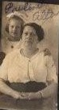

Above, Pauline Osborne and her mother, Alta, who died in 1933. Photo circa late 1920s.

December 18 – “Sunday 18 1927…Went to Tacoma to Brills to stay few days…that night Bill Kathern, margrt and myself went to Pantage show.”

December 19 – “Monday 19 1927…Wrot some card…set round fire at Bill.”

December 20 – “Tusday 20 1927…Washed som …went to stor made some Jellie for Kathern…went to John Harbins for a little while.”

December 21 – “Wednsday 21 1927…”kathern and my self went to town…done some choping.”

December 24 – “Saturday 24…come from Bills to TM in Sumner. Mad some apple butter for Katherine…Bill brought me to sumner.”

December 25 – “Sunday 25 exm day…got a lot of exm present…Went to church in the morning and at night.”

December 26 – “Monday 26…Washed & Wrot to mayme children…fix a little box for the children.”

December 27 – “tusday 27…started little Will Oborne a letter…went to post office…sent packig to children.” Unknown Osborne relative. He is probably a grandson or great-grandson of one of her in-laws. CWG

December 28 – “Wendsday 28…Went for a little ride…Wrot to Louise…got some mail.”

December 29 – “Thursday 29…a great surprise to sumner people…last evning nic suny ev(ening)…got up this morning…the ground whit with snow.”

December 30 – “Friday 30 1927…stayd in most all day…don some writing.”

December 31 – “Saturday 31 1927…Washed…don some sewing for Pauline. Went to store.”

1928

January 1 – “Sunday Jan 1 1928…dident go to church…seting by fire hearing songs Prayers and sermon over Radio…something grand…hop to live a more humber Christian than I ever have this new year 1928…god help me.” Here is Frankie’s first mention of a radio. This gentle person wrote of her desire to live a more humble Christian life. Sadly, Pauline’s father, Toby, will soon face difficulties with the law and soon will be sent to prison.

January 2 – “Monday 2 stay in doors…cold…don som sewing…Went to Post office, maild letter.”

January 3 – “Thursday 3…irond some and sewd som…wrot to Pearl and glatus.”

January 4 – “Wednsday 4…Washed…went to Bills in Tacoma…don som shoping.”

January 5 – “thurd…drov 38 miles after supper. Sewd som…Bill, K, margaret and my self went driving over Tacoma. Went to camp Lewis wher taken solgers for training…Hubert Reigh went ther for training from Damascus VA.”

January 6 – “Friday…Went out driving…went about 12 miles to Wards seatle…went over the new Brige.”

January 7 – “Saturday 7…Kathern, myself have been fixing some thing to take out for diner tomorrow. We all went out driving…drove about 30 miles…then wrote pearl and mayme at Bills in Tacoma.”

January 8 – “Sunday Jan 1928…Bill, Kathern, margret and myself drov to olimpia to the capital of Washington…drov around the Building…then drove a way the other sid the (then) came back this side…ate our lunch…come to Navaco…Watch the ar plain leaving the land. Then came back to Tacoma….drov round the sound…then to the museum…seen many wonderful things. The most of all was yoke oxans and coverd wagon, one owned by the name of Ezery meaker…the was the first wagon that was drivin through Washington trail…his statue is in Puyollap…he is still living…he is 97 years old.. his boots is tied to the back of wagon. Maild letter to maym and Pearl then come to Bill…We all went to the Baptist church.”

Below, by 1930 Bill Osborne moved his wife Kathlen and daughter Margaret Shields to Los Angeles. Notice the hat styles of the era.
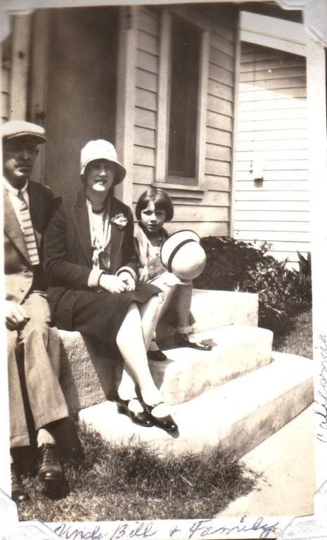

January 9 – “Monday 9…Went to Town…done som shoping…started maym and children a box…com back…drove to town.”

January 10 – “Tusday 10…Wrot a letter to Louise…Went with mrs crankel to calver Presbyterian church to a missionary meeting.”

January 11 – “Wednesday…rainy bad day…irond and stayed in door. I am in Tacoma at Bills.”

January 12 – “Jan Thursday…I sewed a little and help in houc…work wrot to Doris.”

January 16 – “Mayme Stansbery – 32 1928 Jan 26. Toby is 52 years old 1928. Roy is 48 years old.”

January 19 – “January 19 1928 – Come Back

Leav Tacoma Thursday…Portland oregan at 12:30 …a snow storm…cross Portland River, changed Train at Portland Oregon…columbia River…its dark…I am in origan…just ate my lunch…state of Idaho crossing Idaho river about sun up…Big snow now…seen thousand of cattle and sheep and horses.

Just in Idaho at 1:37 at night Jan 20…Friday…Just Past the Idaho tourist camp Glen Fery King Hill…

Saturday morning Jan 21…got in wyoma at 6:45 am Idaho out. Jan 21 1928…Saturday morning, out of Idaho at 6:45 in the to Wyoma…going Through snow till Station…many change at Denver…4:35 Saturday evening 21…then to Portland to Denver to canssity (Kansas City) to Memphis…Snow storms all the away from Tocom to Cansis City…first tim sen the ground…could see thousen of cows, horses and sheep pawing the ground….Then to Chatnuga…Then to Cleavland Tenn…Then Left Cleavland to Bristol Monday morning Jan 23 Monday…had a wonderful trip throu…mrs G W Osborne.”

February 19 – “Left Tacome Washington Through Omaha Nebraska…then to Portland oregon Then Aberdeen Washington…then to Bois Idaho then to sheyinne Wyoma then to Denver Colorado then to Kansas Cith then Memphis Tenn then Chatanooga Tenn then to cleavland (she never could spell this word, Cleveland) then to Bristol. Left Tacoma Thursday the 19, got to Bristol 26 of Feb.” Frankie recorded this trip twice in her diary.

May 4 – “May 4 1928…Got my first Pension, got twelve dollar & half…mr GW Osborn died 1927, June the 30...head been 10 months and 4 days befor I go any pension. June 7 got second pension.” Later wrote more: may 4…got my first widow pension, got twelve dollars.”

Frankie repeated this entry on the same page for June, July, August and September. She recorded on September 6 “got interest today on money…Deposit this sept the 5th.” One can easily recognize what a life-line this small retirement payment was to her. Almost as in celebration, she embarked on an extended visit to family in SW Virginia and Northwestern North Carolina.

On a scrap of paper inserted in her diary is the statement she and Geo. W. Osborn and Frances C. Wilson were married January 6, 1867. This is recorded on the same sheet that contains another statement about receiving her first pension check of $12.35.

Below this statement and continuing on the back are addresses of two of her children and a friend Mrs. Hoover. This may or may not have been their addresses in 1928. The ink and pencil writing are different, and in 1928 W.V. (Bill) Osborne did not live in Los Angeles. Perhaps these addresses were added through the years as children moved.

Mr W.D. Hoover, Houce No 944, Hill st…Phone no 1625 L, Bristol, TN.

Mr B. W. Osborne, 200 E Gray St, Louisville, Ky.

Mr W.V. Osborne , 1817 Seventh Ave, Los Angeles, Cal.

May 6 – “On Sunday from Bristol to Damascus on Bus for $1.25 from Damascus Saturday to Trade 75 cts from Trade to Sutherland 50 cents from Walter to Brother Bobs 50cts from Sutherland to Trade 50 cts.” Many pages later, Frankie re-recorded the visit with more details: “may 6 1928…Went to Damascus, stayd a Week…Went to NC to mrs J W Wilsons at sutherland the 12. I wast church for mother day the 13…nice day…ate diner with Oscar Wilson.” A nephew of Frankie. The road to the old Wilson place is named after him.

May 19 – “may the 19 saturday…Went to Bob Wilsons at sutherland.” This is one of Frankie’s brothers.

May 25 – “Friday 25…Went to Walter Osborne, spent 2 night…Sunday 27, came back to Bobs Wednsday 30…come to Earl Donnelly Sunday 3…left Earl Donnely ..come to church the…went up to Becky Wilson.” Walter Raleigh Osborne 1867-1933 was Frankie's nephew. His father was Clemons Osborne 1835-1902, a brother of GW. Earl Donnelly is a son-in-law of Uncle John & Aunt Rebecca Wilson. He married their daughter Mamie Edna Wilson. CWG

Below in 2009, the Donnelly family general store located at the entrance to the former Issac and Caroline Wilson farm. The family cemetery is just a half mile into the cove off the road known as Oscar Wilson Road.
“Started (mailed) check to Bob matern to put in Bristol Bank. Went to store & started (mailed) children a little box of candy.”

June 8 – “Becky & my self went to Brushe at dinner at mr Billie Barlow.”

June 10 – “went to Preaching & Sunday chool. Come back to Bruce Donnelly for diner.” Bruce Donnelly married Uncle Bob Wilson's daughter Lillian Torrence Wilson. CWG

June 15 – “Friday 15…Went to Conby, spent the night. Bought 1 galon of strawberry, paid 50cts. Got half dosen pint cans, paid 45 cts…got 4 lbs sugar, paid 36 cts…cost of all $1.31.”

June 16 – “Saturday…Went to Bobs, spent the night, came Back to Beckys Sunday. Spent the night Sunday 17.”

June 18 – “Monday 18 …came to Henson chapple to be at the Buril of Little Luceil Proffitt, Daughter of mr and mrs James Proffit, then went to Jane Proffit, my sister.”
Jane Wilson Proffit was the wife of James Harvery Proffit. This James Proffit would be a nephew of Frankie’s and a son of Jane’s. The Hensons are relatives. Jane Wilson Proffitt's daughter Marilla Proffitt married Benjamin Henson. CWG

June 20 – “June 20…I am 77 year old to day…been helping Billie Henson cap strawberrys. Started som letters …am at Jane Proffit on Cove creek…had a bad wind & rain storm…77 year old.”

June 20 – “I Francis C Osborn 77 years old to day.”

June 21 – “got letter from mayme & a Doller in money for a birth day Present.”

June 23 – “June 23…got letter from Pearl & Box of candy…started Pearl letter.”

June 25 – “Sunday June 25…taken a birth day diner at Ben & susan Riller…gave it for Ben my self.”

June 26 – “Went to Wats Henson, ate diner…then went to Enoch Swift, spent the nigh.” Enoch Swift COULD be a relative of Frankie's descended from her Cousin Lemuel Wilson, her 1st cousin once removed. Lemuel's granddaughter Mary married a Swift. CWG

June 27 – “Wednsday, taken diner with Dr. Bingham widow…then in the evening, went to Will Hensons…spent the nigh…then Thursdy 28th…came to John Smith, stayd a While then went Harve Deals, ate diner with them…then from there I went to Charles Hensons…Spent the night, then Friday morning I went up to sister Janes…had a awful rain storm.” Harvey Deal was related to Frankie's Uncle John Wilson, brother to Isaac. He was Frankie's 1st cousin once removed. CWG

June 30 – “Went to Charles Proffitt, Saturday 30.”

July 3 – “Came back from Charles Proffitt, stayt with Maggie and mary Harbin at diner, then come up to sis Jane Proffitt.”

July 8 – “Sunday July 8…went to Hensons Chaple to Preachin then sister & my self went to N L mast for diner then up to sister Jane’s.”

July 12 – “Left sister Janes, went to N L mast, the civic club met ther for a diner…ther was 63 ate supper that paid 75 cts a Plate, nic crowd. I spent the night ther Friday 13, went to arla Wilson.”

July 13 – “Sunday, July 1st…Went to Blowing rock with arta Wilson & family and Mr. John Greer family. Take diner at (obscure) an lot of Blowing rock.” The only John Greer I know of closely related to Frankie was her 1st cousin John Preston Greer. She DID say John Greer Family, so she likely meant his widow and or their children. CWG

July 15 – “this is Sunday July the 15th. I have some verses in different chapters in Bible that Brother John Wilson marked for all of us to read before he died…he died march the 4th of march. Numbers, chapters 23, v 10; Judges chapter 6, 10; Psalms chapters 24, v. 7, chapter 25, v 18-19; chapter 37, v 35; chapter 55, v 6; chapter 71, v 9, chapter 144, v 4. Rev W a Tomus helt servis …subject was a great, good man has fallen.” This was Frankie’s brother. The following was found many pages over.

July 15 – “Went to Mrs John Johnson, spent the day.”

July 18 – “Went to mr clide Ruse, ate diner and spent the night…Thursday 19, came back to mrs Johnson …widow ate diner, then went up to arle Wilson.” Frankie had a distant cousin named Clyde Reece on her Greer side. CWG

July 20 – “Went to Bishop’s…spent the night.”

July 22 – “Sunday, went to church at mable…herd Rev Taler.”

July 23 – “Monday July 23…come to Bristol with mr Greer in Truck.” Thus Frankie’s six week long journey to visit relatives and the mountains of her youth and family ended. Frankie’s mother, Caroline Wilson, was a Greer. This Mr. Greer, is perhaps a cousin.

Frankie recorded the following in fine black ink several pages further. Note the incorrect Mayflower note. This comment inspired no doubt by her visit to the valley of her birth.

“Hiram Wilson was a son of John Wilson and John was a son of Charles, he come over in Mayflower from Irland. My father was Isaac, the Son of Hiram.” For those interested in the Wilson family tree, these notes are important. Research indicates yes, Isaac was the son of Hiram, who was the son of John. This statement that Charles was the father of John agrees with John Preston Arthur’s A History of Watauga County, NC, published 1916. Arthur states Charles Wilson came to NC from Pennsylvania about the time of the Revolutionary War. His wife is said to have been a sister of Gen. Nathaniel Greene of Rhode Island. Charles was in General Greene’s army and died at the Guilford Court House, NC battle. My research does not reveal that General Greene had a sister, so I am dubious of this possible relationship.

July 29 – “C S Stansbery & family, Tom malcom & family, sparger girl and Allen girl all went to the Holston River for a week.” The family liked to go camping and would even camp along Sinking Creek, next to the William Stansbery’s in Afton, TN.

July 30 – “Went to mr Balls to a circle meeting.”

August 8 – “1928…Charles Jr Stansbery and my self left Bristol Sunday morning …went to Damascus…stayd there till Wednsday the 8th. I put him on Buss, sent him back to Bristol…I went to Cove Creek to sister Jane Proffit…stayd there till the 13th …went to NL Mast for diner, then went to Will Hensons at Vilus.…spent the night…I went with Hensons family to Boon to a show…then from ther came to Baner Elk to Lee greer from home to ?”

August 14 – “Tusday 14…left Vilus from Will Hensons. Went to Lee greer, Wednsday 15…had the worst east storm of rain and wind that ever visited Baners Elk…torn down crops of all kind…Blown down trees.”

August 17 – “Friday 17…Went down to mrs Annie Shoemakers.”

August 19 – “Sunday…went from Mr Jo Shoemaker to Isaac greer at Banners elk…stayd ther till Wednsday the 22…Went to James Shells, ate diner. Callie and my self went to sematary and other fine building…then came up to Joseph Shoemaker”

August 23 – “Stay the till the 24th…Went to Lee greer, spent the night, then went to Jim Mikels the 25th Saturday…this is Sunday 25th…spent the day.”

August 27 – “Went to Tom Romneger(?).” This is likely Tom Rominger. Frankie's Aunt Emeline Greer 1827-1859 married Nathaniel Rominger 1822-1908. Emeline was the eldest child of Jesse Greer, Jr and Frances Brown Greer. CWG

August 28 – Tusday august 28…Went back to James Mikels.”

August 29 – “Wednsday august 29 …Went to Jo Shoemakers…spent the night there.”

August 30 – “Thursday…left for Elk Park.”

August 31 – “Friday august 31…left Elk Park for Bristol on Buss…cost $1.65.”

“Buss station 25 cts…from Buss station to Damascus $1.25, from Damascus to Mast at Cove Creek $1.50 from Vilus to Baners Elk - $1.00.”

“Friday, from Elk Park to Bristol, car fair $1.65”

September 7 – “Friday…moved on Hill st…got 2 rooms from W D Mrs hoover Houc, no 944 …Phone No 1625L…Paid Houce rent $8 dollars…eight dollers.”

September 28 – “moved to my W D Hoovers on Hill st house no 944 Phone 1625 rent 8 dollars.” Yet another move.

November 2 – “Friday Went to Jo Anderson…came back the 3th Saturd.” This person is unknown. She stayed several weeks.

November 6 – “Election.” Frankie made no mention of voting or whom she supported. This was the election between Republican Herbert Hoover and Democrat Al Smith of New York. Wall Street would collapse in ten months but at that time the economy remained strong or seemed that way.

November 7 – “Wednsday 7 –Went to Larence Osborne.”

November 9 – “Virginia Avenue Exstencion came back.” Bristol had a street car line in the 1920s.

November 11 – “Sunday 11 armisted day…Went to ?uston Proffitt.” This might be Austin Proffitt, a son of Andrew and Isabella Greer Proffitt, and a grandson of Frankie's Uncle Wilburn Harding Greer 1833-1925. Andrew Proffitt was a brother of Uncle Harve Proffitt who married Frankie's sister Jane 1852-1937. CWG

November 12 – “Monday 12…Went to his home at childers. Came back home Friday 16.”

November 16 – “Geraldine five years old to day…she had a Birth day Party this Nov 16 1928.”

December 13 - Frankie recorded on his day all of her children’s latest age and birthday.
All ages as of month in 1928

Bishop Osborn is 48 years old, Dec. 13.
Maym Stansbery 32 years old, Jan 16.
Toby Osborn 52 year old aprile.
Roy Osborne 48 years old march.
Pearl Wright 38 years old July .
Bascom Osborn 41 years old July 23.
Bill Osborn is 36 year old.

1929

June 5 – “Went to Damascus Wednsday 5, stayd there till Sunday 9…went to mt city, stayd till Friday. I came back to Damascus 14, Saturday. Came home 15th.”

March 16 – “started Pauline the Hearel Courier to sumner Wash…Paid for it for six months.”

Many pages on, Frankie wrote on this date: “mrs John Denny died this evening at 5:30 at her home on 955 Hills St. she leav a Husbnd and fore children, 3 girls and 1 boy….miss maud Denny of Bristol, mrs Clren Baswel of Greenville Tenn, mrs Hamer McCorkel of Bristol, mr Rudolph jr Denny of Bristol…Funeral at 2:30 sunday evening conducted by Rev Paxton.”
April 9 – “april 9…Went to Damascus to be at the burial of Bliss Keys, whom got burned to death.”

Apr 22 – “started Pauline a quilt.”

May 4 – “may 4 moved to mrs Chandlers 1016 Anderson st. moved from mr hoovers on Hill St.” Yet another move.

May 12 – “mothers day…Went to Anderson st to church…Rev Charles Williams Preached four hundred seventy fiv at Sunday chool.”

June 20 – “I am 78 to day.”

June 22 – “planted som corn…got dinner for maym & children & Joe Osborne.”

July 1 – “July 1…had a awful rain storm.”
From a newspaper dated September 28, 1929: “Mr. and Mrs. L. M. Osborne of Cleveland, Tennessee, motored to Bristol and were guests over the week-end of Mr. Osborne’s mother.”

July 2 – “BL Osborne, coari, Hatty and Harve Hages and myself all went to Blountville.”
Cora is Bishop Osborne’s wife. The Hages are unknown. In Grayson and Smyth Counties in VA the name is spelled Haga or Hagy. CWG

July 23 – “Bill is 36 years old today.” Frankie again repeated this entry in 1927, 1924 and 1925.

September 3 – “Elk Park, Avery Co, NC…Went to Elk Park to Dr Tom Proffitt…spent most three weeks with sister…came back on Thursday 19th to Cleavland Tenn.” Tom Proffitt is a nephew of Frankie’s, a son of Jane Wilson Proffit. Tom will die in a tragic automobile accident. According to a granddaughter of Uncle Wilburn Greer, brother of Caroline Greer Wilson, Dr. Tom Proffitt inherited from the Greers two large portraits of Isaac and Caroline Wilson belonging to Jesse and Frankie Greer. CWG

September 28 – “Roy and Lena came Saturday 28…Went back Monday 30 to cleavland to ther home.” This is her son Roy and Lena Holtsclaw who live in Cleveland, Tennessee.

September 29 – “Sunday 29…Pearl and Dave come down…spent Sunday with roy and lena and my self.”

September 22 – “Sunday spet 22…Dave & Pearl taken Doris to Roanoke to put here in Business chool…take a business career.”

October 1 – Post card from Lena, Cleveland, TN: “Dear Mother, We got home all O.K….found everything alright. It sure is cool down here this morning…Hope you are feeling better by now, write soon, as ever, Lena.” It was addressed to Mrs. G.W. Osborne, 1016 Anderson St., Bristol, TN.

The Stock Market on Wall Street crashed. She made no note of such a faraway event, an event which would make her life more difficult.

October 31 – “Thursday Oct 31 1929…Taken mrs green to Knoxville to hospital…she has lost her mind.”

November 2 – “1929 nov 2…had supper…circle no 1 had a supper at Anderson st church…got seventy two dollars…goes on new church.”

November 13 – “1929 Nov 13…started my Brother W A Wilson in Japan a letter.”

November 22 – “1929…moved to miss marten 965 Winsor av, Bristol Tenn. Pay 12 dollars houce…today our first snow.” Yet another move!

November 28 – “1929 taken thanksgiving diner with B (Bishop) L Osborn. Turned very cold…charles Stansbery, mayme and children all moterd to afton…spent the day.”

November 30 – “Saturday…the all moterd to Knoxville don som shoping.”

December 9 – “started Pauline a rug.” Her grand daughter in Sumner, Washington.

December 25 – “1929…Went to Damascus…Went to Damascus Tusday 20…came back Sunday 25…While up ther spent Thursday with the cornet girls.”

December 30 – “Ginda mast from NC spent the day with mrs gw Osborne Tusday.”

1930

January 26 – “TM (Toby?) Osborne 54 years old today.”

January 27 – “Started W A Wilson letter.” The Rev. William A. Wilson left North Carolina in 1890 to become a Methodist missionary to Japan. He returned home for retirement in 1931, and later wrote of growing up in Ashe Co., NC. From this highly educated man, Frankie’s youngest brother, we have a good record of the family and the Civil War. It is sad to note the difference in literacy between Frankie and William. Frankie had little schooling and married at 15. William was a graduate of Trinity College, now known as Duke.

January 27 - “Louise Stansbery birthday 15 years old.”

March 12 – “Wednsday 12…I Went to Boby Howard at Mt city spent the night. Thursday morning got a wire message that Bishop Osborne had a car reck between Baners Elk and Heatn’s store…he went over a Bank of a but 60 feet…he was badly cut and brused and cut. His car was torn all to peace, couldent get it out. The(y) Taken him to Dr Tom Proffitt’s Hospitle. I remainded with him till Wednesday, the 19th. We Brought him hom. I was real sick when got home. I had a beald throat for several days.”

This was a serious accident in which my mother’s Uncle Bishop almost died. Ironically Dr. Proffitt would himself die in a car accident later that year.

March 23 – “Sunday, 23..mr Jo Tevas died at 4:30 this evening at his home on Hill st. Cathern Fugit died at Abingdon in Hospitl.”

March 25 – “march 25…1930…Held Funerl servis at Anderson st church at 1:30 for mis cathern Furgit, 15 year of colige girl.. Held Funeral servis at Anderson st church for mr Jo Fevis servis at 3:30, he was 44 years old, left wife.”

April 11 – “moved up on Winsor av, house no 1233…let maym have 740.” Is this a house number or an amount of money? Again, Frankie relocated and again in the same neighborhood.

April 18 – “held Servis in Anderson st church for mrs claman to day.”

April 20 – “April 20 1930…Nic war day, went to Sunday chool. Adly Loudy wife san…went to preaching…Rev martin presiding Elde Preached…he babtised some children. To day is the last Sunday that ther will be any preacher in the old Anderson st church going to tar down, build 1233 Winsor on Bristol, Tenn. The Rev Frank Jackson preached the last sermon in Anderson st church at night with a packed house.”

April 26 – “maym – children went to afton.”

April 27 – “Sunday 27…Rev Williams Preached first sermon in tent apr 27 1930.” Several pages later, Frankie wrote: “Went to Sunday chool held at mr Keblers…then Went in Tent for Prachin. Rev Charles Williams our pastor Preacht…Wil Preach ther til get church Built.”

May 13 – “Got half ton coal…Went to Damascus”

May 15 – “Spent the day with Cornet girls.”

May 17 – “Went to Ruby Howards.” Roby or Boby? Roby Howard, son-in-law of Alice Osborne Snyder 1878-1938. CWG

May 20 – “Went to Jake Synder.” This was the husband of Alice Osborne Snyder and son-in-law of Emmaline Wilson Osborne, Frankie's sister. CWG

May 25 – “Sunday 25 went to Brother Bob Wilsons then come back to Roby Howard. Stayed ther till Thursday, the 29th.”

May 29 – “Come to Damascus…Stayd ther till June the 1, came home.”

July 7 – “Monday 7…went to Jake Snyder…went from Bristol to mt city on bus…from mt city to Jake Snyder’s, Roby Howards taken me.”

July 8 – “Tusday…Peced quilt…wrote to Maym.” Do you know which descendants have quilts made by Frankie? CWG

July 14 – “Monday, 14…had a wonderful rain…broke up a bad drought…cand me some apples.”

July 15 – “Tusday 15…cool and winday…Picked berys.”

July 18 – “Friday, alice went to mt city.”

July 20 – “Sunday…Boby Howard & family all come, ate diner.” Roby Howard

July 22 – “finished canning burys. Alice, my self got hens.”

July 25 – “1930…Friday came home from Jake Snyder…been gone for 3 week …canning burys and apples.”

September 9 - “1930…Tuesday 9…Pauline and my self went to Damascus to spend a few days.”

September 14 – “Sunday…went to NC with Oscar Wilson…at diner with them…then went down to Brother Bob Wilson…Went to Oscar Wilson…Wednsday 17…spent the night then Thursday 18…ate diner at Brother Donley…supper at Canly Wilson…then back to brother Bob.” Oscar Wilson is Uncle Bob Wilson's son. Thomas Conley Wilson is Uncle John's son. CWG

September 19 – “Went to Charles Osborne…spent the night…Saturday 20…back to Brother Bobs then Sunday morning 21…went to Sunday morning went to sunday chool then up to Becky Wilson…spent the night…then back to Brother Bobs…then Wednsday 24…came hom for few minutes…then got train out of Bristol to Johnson City…got bus went to Elk Park to Dr. Tom Proffitts to be at his funeral and buried…he was layd to rest by the side of wife, Thursday 25th.”

September 22 – Frankie gives additional comment on the accident several pages further in the diary. “Dr Tom Proffit kild in car accident. I left for Elk Park Wednesday from NC to Damascus …$2.00 doller from Damascus to Bristol. $1.25 from Bristol to Jon city…90 cts… from Jon city to Eld Park - $1.10.”

September 23 – “Dr Tom Proffitt got kild in car reck.” This physician and Frankie’s nephew had treated Bishop Osborne, her son, earlier in the year after his car wreck. Tom is Jane Wilson Proffitt’s son.

September 24 – “Wednsday 24…From Bob Wilson to Damascus $2.00…then train far to Bristol $1.25…then Train far from Bristol to Joh City – 9 cts…then from John City Buss far to Elk Park $1.10. Taxie too and from depot 50 Ct. Dr. Tom Proffitt got kild in a auto accident Tusday 23…Buried Thursday 25 at Elk Park…came hom Sunday 28…Mrs. G W Osborne.”

September 25 – “Thursday the 25…the laid him to rest by the side of his Wife that Past a Way To year a go.”

Newspaper paragraph: “Mrs. G.W. Osborne has returned from Elk Park, North Carolina, where she was called on account of the death of her nephew, Dr. Tom Proffitt. Dr. Proffitt died in Baner Elk Hospital after a car accident.”

October 11 – “Saturday 11 1930…mayme children…all went to afton.”

October 12 – “Sunday october 12…the(y) lay the corner ston at Anderson st church. Pauline myself wen to BL for supper.”

October 13 – “I move to mrs Buchcanon on Shelby st 926.” The moving from house to house continued. Frankie must have lived out of a suitcase with all her traveling and moving. The lady had a lot of energy.

October 13 – Much earlier in the diary as Frankie skiped around, she wrote: “moved to mrs Buchcanons on Shelby st 920.”

October 18 – “Saturday oct 18 1930…Pauline my self went to roy Osborne at cleavland Tenn.”

October 19 – “Sunday 19…roy-Lema-Pauline and my self all motered to Chattanna. We visited Fort Oglethorpe, missionary Ridge at Chattanooga Tenn. All so went to se the Doller Pan.” What is the ‘Doller Pan’?
Pauline Osborne, Toby’sDaughter, probably boating in Damascus, Virginia, home of her Aunt Pearl Osborne Wright.
October 22 – “Wednsday oct 22…Pauline started for hom state of Wash at Sumnere Washing.” Pauline must have been visiting her relatives.
October 26 – “Sunday Oct 26…Abert-wife-children, Ralph-wife children-roy-Lena myself all…went out for long drive.” Hope they rented a bus!

October 31 – “1930 Oct Friday 31…our first snow.”

November 1 – “Saturday Nov 1…roy-Lena Osborne myself moterd from clavland Tenn to Bristol Tenn.”

November 4 – “Tusday Nov 4 1930…today was Election day…raind-snowd all day.” These were local and state elections.

November 11 – “Twelv years Armistes…the ladys circuit met with mrs Frank.” Then Frankie repeats herself: “12 years today cinc Armistes…it’s a day to be remembered.”

November 27 – “1930…this is Thanksgiv…very cold…I taken diner with Bishop to day.”

December 2 – “1930…Dec Second…Had a all day meeting missionary had quite a lot of business to tent to. Elected officers. Brother W A Wilson from Japan, a missionary, came spent 2 days with me. Brother Shuler, the Preacher, spent the day…had lunch with Brother and my self. W A Wilson left this morning the 4th for Durn to his home.” The Rev. W. A. Wilson arrived home from Japan, this time to stay. Aged 70 years old, he lived in Durham, NC until his death in 1951.

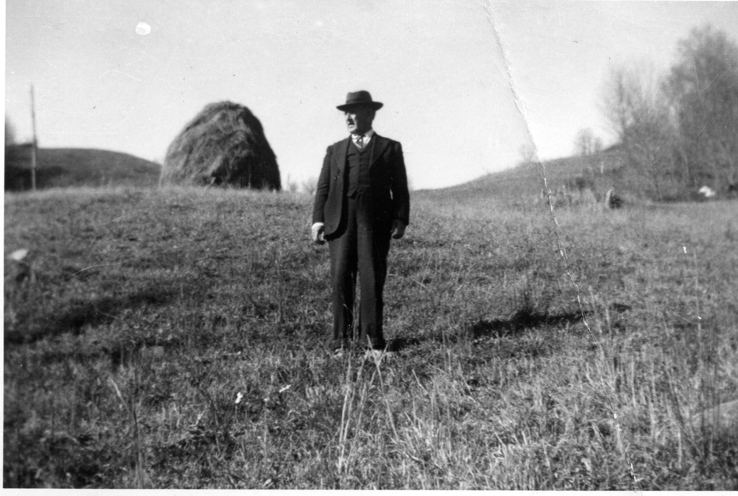
Above Frankie Osborne’s youngest brother, William A. Wilson, inspects the site where his father was ‘bushwacked’ and murdered on June 17, 1864. This photo courtesy of Clinton Getzinger was taken circa 1938. It is William’s memoirs that became the basis of the book Neighbor to Neighbor published by Appalachian State Unversity Press in 2007.
December 8 – “Monday December 8…Went to NC to see my Sister…she is sick.”

December 9 – “Tusday went up on the mountain to her hom.”

December – “11 Thursday at diner with Kiler Henson.”

December 16 – “Tusday…Went down to Jame proffitt…that night come one of the Bigest snow I most ever seen.” I wonder if she meant James Proffitt, her nephew or Jane Proffitt, her sister? CWG

December 18 – “BL com back for me. We started home…car wouldnent run…had to take to garage…dident get to start hom till Friday morning 19…awful day …com by the way of Damascus…coulden cross the mountain.”

December 20 – “Saturday…started some card …BL had me som coal hauld.”

Here Frankie inserted a historical reflection, perhaps inspired by her time in North Carolina. The exact date is unknown. It reads: “the year 1896, November 24(?)…We left Coff (Cove) Watauga creek for Tenn.” This was the move to Blountville, Tennessee described and recorded now on line under New River Notes by Pearl Osborne Wright. See the appendix this writing.

December 20 – “Dec Sunday 20…mrs Swan died …Buried Wednsday the 23rd.. Started Pauline a Pilow to Sumner Washington.”

December 22 – “Dec Tusday 22 (perhaps error on date)…mrs J B marten died at 12:15 at night.”

December 25 – “Thursday Dec 25…Exm …cold, gad day…stayd hom all day. No body cam…the post man dident cary any mail, the first time that we mist having any mail on Holly day.” Hummmm…was the U.S. Mail carried on Christmas in the 1930s?

December 26 – “Friday Dec 26…Went to stay with Miss Ida marten…she was by her self.”

December 27 – “Saturday dec 27…Went to spend the night with Miss Lida marten…she by self.”

December 28 – “Sunday Dec 28…Cold, Bad day so much ice…cant go to church…dark and gluma”

1931

January 16 – “Mr and Mrs GW Osborne has been married 64 years today married the year 1867.” Frankie’s husband, G.W. Osborne, b 1845 – d 1927.

Feb. 10 – “moved to Mrs. D (T?) ishners house, Hill st. Pay 10 dollars. …the 10 House no 1017 in mrs Dishner house pay 10 for 3 roams Phone 1037R.” This is becoming unbelievable….the poor woman moved yet again!

March 15 – “march 15…raind & snowd.”

March 22 – “Sunday 22…awful snow at Boon NC, 12 inch deep.”

April 5 – “Easter Sunday, spent the day with B L.”

April 6 – “Monday the 6th…got diner for maym & children.”

April 7 – “Washed Tusday, Wednsday 8th cleand yar, set out flowers…In the evening mrs Greer came after me to stay with her for a while.” (A relative, which one? Her mother was Caroline Greer Wilson, daughter of Jesse Greer, Jr. It was likely someone related to her Uncle Wilburn Harding Greer 1833-1925. CWG

April 8 – “Thursday 9, Planted Potaotes…went out in country after Pigs.”

April 10 – “Friday 10 come Back to Bristol, got man to spaid garden.”

April 11 – “Saturday in the evening we went to post office, then up to mr greer (grav) at Emery.” April 11 (believe this to be 1931) “moved on Winsor Aven house no 1233. Let mayme have half I pay 7.40 per month each.” This must be the time Charles Stansbery, Sr. left the family in Bristol and moved back to Afton, Tennessee. The separation led to a divorce. Incompatibility, economic stress and the illness brought on by consuming toxic Jamaica Ginger are the believed reasons.

The Jamaica Ginger poisoning effected anywhere from 30,000 to 50,000 people in East Tennessee and parts of the mid west in 1930. Distributed by a Newark, New Jersey company owned by two men in Boston, one of whom went to jail, an adulterated recipe was marketed as a way around prohibition regulations. The ginger was 70 % to 90% alcohol. In East Tennessee, hundreds were struck lame by the poison within six to fourteen days after consumption.

Preachers, including the pastor of Muncy Memorial Methodist Church in Johnson City, thundered that “God is handing out a red flag as a danger sign to those who violate His Law.” In 2003 the New Yorker magazine carried a long article by Dan Baum about this episode. On line information can be found at “Paralysis in a Bottle, the Jake Walk Story” by Cecil Munsey.

The consequences of consumption were life altering. Charles Stansbery, Sr. would be crippled for the rest of his life, moving slowly with a cane and dragging his left leg forward. I remember him in the 1950s, either visiting our house in Johnson City, Tennessee or we in his home in Afton. A friendly grandfather, a fanatic on the New York Yankees, and pleasant, he must have suffered terribly from his ‘Jake Leg’ and the consequences of Jamaica Ginger poisoning.

His daughter, Nancy Higgenbotham in 2009, described him as good hearted but ‘bossy’, a tobacco chewer who drank moonshine, not a church goer, and who sold milk from cows. My father, Bishop Holliman, remembers Charles as ‘affable’ and quick to pull some meat out of the smoke house in the 1950s to send home to Bishop and Geraldine’s young family. I remember him giving us a smoked ham from his smoke house.

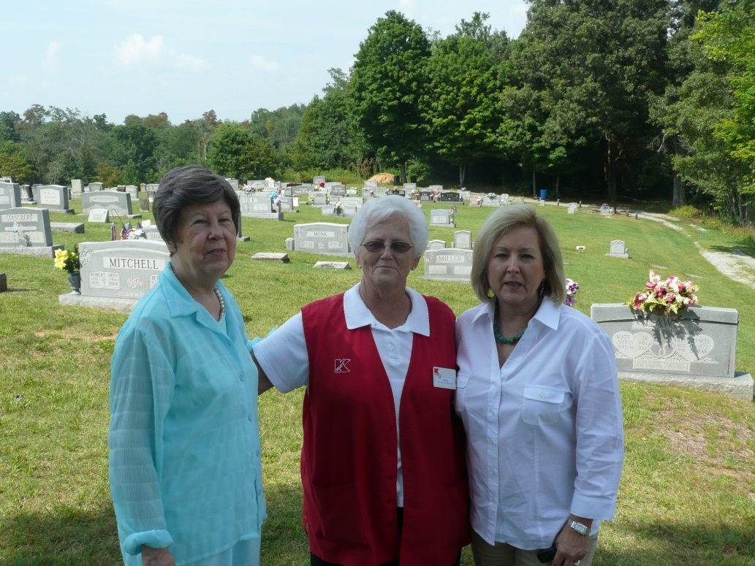

Above, two daughters and a granddaugher of Charles S. Stansbery, Sr. at his grave site in Afton, Tennessee in 2009. Left to right – Geraldine Stansbery Holliman Feick, Nancy Stansbery Higgenbotham and Rebecca Holliman Payne.

As an aside, our next door neighbor in Johnson City in the 1950s was one Mr. Cox. He too was believed to have consumed the ginger, and until his death in 1956, he hobbled in his back yard, disabled and not capable of supporting his family. This was a terrible poisoning and in a day before class action consumer lawsuits, the culprits never paid a dime in recompense to the damaged lives of tens of thousands of persons. In the Stansbery family, this illness pushed the fragile marriage into collapse. Charles Sr. would die of complications of diabetes and pneumonia in 1957.

April 12 – “Sunday We went to Brother Bob’s NC, spent the day.”

April 13 – “Monday 13…we washed.”

April 19 – “Sunday 19, we went to church at meadow view.”

April 21 – “Tusday 21 went to Roby Howards, stayed ther till Saturday 25, came to Damascus, VA.”

April 22 – “Wednsday 22, had a snow storm then turnd cold.”

April 26 – “mrs greer com to Damascus after me…We Went to meadow view.”

April 27 – “Monday 27 went to Posoff NC, got Jr. Watch out aff (obscure) __ow.”

April 30 – “Thursday 30 came hom to stay, made som garden”

May 1 – “Friday may 1 1931…mad garden.”

May 2 – “Saturday 2…raind, went to town to Band.” Later wrote these puzzling words: “Saturday eve, Turned on Lights 1931.”

May 3 – “Sunday 3…stayd hom, not well.”

July 1 – “Planted some corn…mr carel moved in corner Houce.”

July 3 – “Bishop & Cora Osborn, Hary Hogh (Hawn)and Hattie gone to Roanoke. Picked and sold 2 gallons of beens.”

July 4 – “Hot and had a hard rain in the evning…I washed…Charles Jr gone to afton.”

July 8 – “July 8…left home…Went to mrs J W Wilson in NC…stayd there til the Wednsday the 15th…Went to Brother bobs Wilson.”

July 19 – “Sunday 19…spent the day with Maggie Elet.”

July 20 – “Monday 20 went to Walter Osborne, spent the day.”

July 22 – “Wednsday 22…went back up to Beckys. Stayd there til Sunday, the 23rd.”

August 2 – “Sunday…stayd till the 2nd, then came to Damascus to Dave Wright…stayd there till Tusday, the 4th…come home…gone 4 weeks.”

August 8 – “Went to church.”

August 11 – “Found Bob Teaster dead on the rail road track Sunday morning…the 9th Held his funeral at Anderson st church the 11th. Quilting at church…Saturday…cold.”

August 14 – “had ice cream super at church, August 14.”

August 26 – “Geraldine Stansbery had her toncil and adnois taken out August 26.”

August 31 – “martens moved in mrs Dishners houc.”

September 2 – “George Dave is leaving today…cleavland ohio…wher he will enter Western Reserve University.”

September 13 – “it is Home coming day at the church…Rev Wolf Preach at 11 clock…Rev Pearl Preach at 7:30 at night. The ar our former Preachers 30 years a goe.”

September 25 – “Friday 25…raind at night…drough brok up…turn cold.”

September 26 – “Saturday 26…had a cold hard rain.”

September 27 – “Sunday…dark cold day.”

November 26 – “1931…Cold, gluma day thankgiving day…helpt maym pack to move Friday. Pearl came just a little while in the evening.”

November 26 – “Maym moved to mrs Grham houc on Winsor av. Pay 25 doller per month.” This must be a reflection of economic distress.

December 8 – “Went with B L to Brother Bob…stayd ther 2 night…Went to Becky…Thursday the 10…stayed ther till Wednsday 16…came to Pearl…spent one night then home.”

December 21 – “she died Tusday evening at the Hospitle.”

December 24 – “Thursday 24…mrs John marten Buried.”

Chapter V – 1932 – 1934: Economic Hard Times bring False Hopes and Determination

1932

January 10 – “Mrs. Henry Coal died Sunday eve.”

January 16 – “Mrs C Stansbery birthday she is 36 years old.” Frankie’s daughter, Mayme, my grandmother.

January 23 – “got Sick”

February 11 – “Thursday 11…warm..Sun shing…see men today, out on street with out raps.”

February 15 – “Feb Saturday 15…taken the Flue. I in for 5 weeks.”

February 17 – “Roy will be 53 in 1932.” Frankie recorded his birthday in 1921, 1922, 1925, 1926 and 1929, as she often did her children. This is Roy Osborne.

February 20 – “1932…mr J B marten and wife Lois been married 6 six year today Saturday.”

February 25 – “got a Bucket of honny from Sumner, Wash(ington) Pauline Osborne. Sent it postage 85 cts.”

February 26 –“Mr Flanagin moved in mrs Dishner House in a part (pay)ment Where I live.”

February 27 – “Feb 27 came a hard rain at night…it stormed and coad.”

February 28 – “Wrot to Bascom jr.”

March 1 – “First came in warm an nic come like a lamb going out lik a lion.” Tuesday, march 1st…Charles Lindburg jr was kin napt, found dead may the 12th some 72 day found within five miles of his father home in a patch of wood (co)voered with diret & leave, the body all most uncoverd…Part gon, the Father could reconise it by the parts toes & Teeth.” Evidently Frankie added this dramatic national news report later at the end of this March 1st entry.

March 5 – “Saturday march 5, nice warm day at night it began to rain and blow, then turnd cold & snow. It has been the coldest spell We have had cince Feb. 2.”

March 1932 – The Wendel Millions. This is a puzzling episode in the life of the Stansberys in the Depression, one of false hopes. I remember my mother referring to this story many times in my growing up years.

One Miss Ella Wendel died March 13, 1931, age 75, at 39th and 5th Avenue in New York City, the last survivor of numerous sisters who never married.. She was worth at death close to $100,000,000. She was a descendent of John Gottlieb Matthias Wendel, who in late 1700s became associated with John Jacob Astor. John Wendel in 1799 married Miss Elisabeth Astor, a sister of John Jacob Astor. This couple had a child, John Daniel Wendel, b. 1800.

At age 34, John D. Wendel married Mary Ann Dew, ‘the amiable’ as she was called. Mary Ann Dew was the grand daughter of General Tobias Emerson Stansbury of Maryland. This may have been Tobias Stansbury, who died in 1709 in Maryland, a 7th great grandfather of this writer, or a great uncle decended from this line. We know our Stansbery line left Maryland and moved to the Carolinas by the middle 1750s, and later to Tennessee by the Civil War.

John D. Wendel showed an amazing ability to buy and sell real estate, and accumulated a fortune before his death in 1876. He built a maison at 444 Fifth Avenue, finally demolished a century later from its construction in the 1830s.

The reclusive Miss Ella lived with the curtains drawn and the shutters closed. There was no telephone until her final illness, and until 1930, gas lit the house. When she died, she left her tens of millions to charity! (This information from A Memorial Address by Dr. Ezra S. Tipple, President Emeritus of Drew Theological Seminary, delivered 1935. Copy in Frankie’s papers.)

A March 1932 newspaper clipping saved by Frankie contains a photograph entitled: “Represent 2,000 seeking Wendel Millions – Lawyers representing 2,000 would-be heirs to the estate of the late Ella E. Van E. Wendel of New are seen presenting claims in surrogates’ court. More than $100,000,000 is at stake.”

Other newspaper clippings state a Rosa Drew Stansbury of Vicksburg, Mississippi attempted to establish a case for her relationship to the late Ella Wendel. Another clipping reports the vacant mansion worth $2 million and in late 1931 only inhabited by her dog, Tobey, an aristocratic poodle continuing to live as he had become accustomed! The mansion, by the way, went to Drew Seminary, and the fortune to other religious institutions.

My mother, Geraldine Stansbery, remembers this episode, and that the Stansbery brothers helped pay for lawyers to go to New York to contest the will. To the disappointment of the family (mother reports her mother Mayme was already designing a new house!), the inheritance went mainly to charity.

The October 16, 1933 edition of Time magazine announced the death of the lawyer, Charles G. Koss, 78, longtime legal adviser of the Wendel family. He fought so ably in court that the claims of 2,295 heirs were disallowed (DARN!), nine distant relatives were paid to drop contest proceedings, and a dull witted housepainter sent to prison for posing as Ella Wendel’s nephew. Tobey, age 8, the last of the poodles, died the same week as the attorney.

April 8 – “Friday, went to Damascus to Pearls.”

April 13 – “Wednsay 13 Went to (Ruby?) Howards.”

April 16 – “Saturday 16 alice Snyer come to Rabys (Ruby?).”

April 22 – “Friday 22…alice went home, I went home with her. Hallie made som Picturs.”

April 23 – “Saturday night had awful storm.”

April 30 – “Saturday 30 …Last day of April 1932.”

May 3 – “may 3 1932…Jr Stansbery taken mumps.” A later note: “may the 3…Went from Jake to Roby (Boby?) Howards.”

May 4 – “Went to Damascus to Pearl.”

May 5 – “Thursday 5 came home to Bristol. Pearl Brought me.”

May 6 – “Friday …Went to Town…done some shoping.”

May 8 – “Mothers day…Went to church & Sunday chool.”

May 9 – “Started (mailed) alice Snider a Packige Monday…it cost 13 cts. Awful storm.”

May 13 – “may 13th 1932…Friday…started alice Synder…a morning paper tell about finding the Lindburg baby”

May 15 – “Sunday may 15…nic warm day…Went to Sunday chool, got diner for maym & children.”

May 22 – “Went to Sunday chool, come home, ate diner…Went to mr Emmert to see mrs Probbit. Mrs Emert mother came back…Wrot to TM Osborn in the west in Sumner, Washington.”

May 31 – “cleand off garden, washed, drug it my self.”

June 1 – “Cleand off garden & chicken lot…set out flowrs. Wrot to alice Snyder.”

June 2 – “Been working in garden.”

June 3 – “Washed & helpt maym pack to move.”

July 5 – “Sunday, went to Sunday Chool.”

July 6 – “Monday, went to town and cleand off garden… Went to missionary meeting in Edward’s home.”

July 8 – “Wednsay, moved.” Earlier Frankie had written: July 8 – “Moved on Hill St in the Edward’s house. Pay 19 dollars let mame have half.” Another move!

July 9 – “Thursday July 9…mayme moved with me in the mrs Edward house.”

Undated month – “Moved in house with six martin girls on Winsor. Pay 12 dollars.”

July 10 – “mowd yard, set out tomatoes.”

July 10 – “Taken Buss (Friday 10)…to Damascus…tock a taxis…15 cts…Bus - $1.50.”

July 11 – “From Damascus to Trade - $1.50. From Trade to Becky’s – 80 cts.”

July 12 – “Sunday 12…From Becky’s to Cob (Cove?) Creek to Jane Proffitts.”

July 13 – “Monday 13 at Sister Jones.”

July 14 – “Tuesday, 14 – done some mending.”

July 15 – “Wednsay 15 – washed.”

July 16 – “Thursday 16…went down to Rillies Henson, Jr and James boy.” Evidently Charles Stansbery Jr was on the trip with her.

July 17 – “Went fishing. Got mud turtle.”

July 18 – “Saturday 18…Boy sawd wood, had awful stom.”

July 19 – “Sunday 19…Sister Jane James and wife and children, Charles Jr Stansbery and myself all moterd to Baners Elk. Take diner with Clint Greer.”

July 20 – “my birth day 81 years old. I Washed.”

July 21 – “Tusday 21…ate diner with Riber Henson.”

July 22 – “Wednsday 22, James and family and Jr all went to pick cherrys.”

July 23 – “Thursday 23 at Jane’s.”

July 24 – “helpt sister get diner.”

July 25 – No entry, just date.

July 26 – “Sunday 26…from Ian Proffitts to Oscars for diner…then up to Becky’s. James Proffitt and his mother came over…then went back. Jane is my sister.”

July 27 – “Monday 27…Washed and made a little coal fire.”

July 28 – “Tusda 28…raind all day…wrot Alic.”

July 29 – “Wednseday 29 – irond.”

July 30 – “Thursday 30…not well.”

August 2 – “Cold, got diner for Becky.”

August 28 – “Protracted meeting comenst at Anderson st.”

September 5 – “Rv Ralph Johnson Sept the 5 he preached a sermon for mothers…the oldest mother got a bunch of flowrs…mrs GW Osborn got the flowrs., 81 yars old…the was Presented to her by the Rev. Johnson for being the oldest lady Present.”

September 11 – “Went to Sunday chool and church.”

September 12 – “Monday 12…washed.”

September 13 – “Tusday 13…maym and Louise, Charles Jr, Geraldine and my self all Taken our supper and went to the Knobs and ate.”

September 14 – “Sept 14…Wednsday…taken Buss to Damascus…stayd with Pearl Wright, my Daughter till fiv clock…then taken Buss to Roby Howard…stayd ther till Sunday 18…Went to Jake Synders.”

September 19 – “Monday 19…gatherd apples and Beets.”

September 20 – Cand beets and made perservs.”

September 21 – “Wednsday the 21 fixt apples to dry and wrot to Pearl.”

September 22 – “Thursd 22 cand apples.”

September 23 – “Made jellie.”

September 24 – “gatherd apples.”

September 25 – “got diner…Bettie Wilson’s baby bornd at 8 oclock, alice’s girl.”

September 26 – “Monday 26…gather apples and peald to today…it raining.”

September 23 – “1932 Sept Tusday 27…cand apples …had hard rain.”

September 28 – “Wednsday 28…Peald apples to dry and washed.”

September 29 – “Thursday 29…cand apples…got some cans from Pearl.”

September 30 – “Friday Peald apples…mad apple Butter, the last day of month.”

October 1 – “Saturday October 1…I am at Jake Snyders…Alice gon to her daughter Bettys to spend the day. I have been very busy…churned and got diner and many other things. It’s a Brite Suny day and warm.”

October 2 – “Sunday 2 at Jakes…helpt get diner for had quit few hear for diner… after diner Boby and Hattie, my self went to see Betty Wilson, hatties sister.”

October 3 – “Monday 3…alic myself dug som potatoes.”

October 4 – “Tusday 4…sheld been (shelled beans), got pension…writing to maym.”

October 5 – “Wednsday 5…Washed, cold day.”

October 6 – “help alic Hull ground cherry.”

October 7 - “Friday 7 …Wrot to Bill and Pauline and mayme…alice got to see Betie, her daughter.”

October 8 – “Saturday 8…Put Fowrs in pit in the evning. Went out calling on Florine Price and other neighbors.”

October 9 – “Sunday 9 …alic my self stay at her home all day. Jake went to church.”

October 10 – “Monday 10…cleaning yard and seting out flowr plants.”

October 12 – “Wednsay 12…helpt Pick up apples the gathered at apple fixt some to dry.”

October 13 – “Thursday 13…started maym a letter.”

October 14 – “Friday 14…mr Price and Alice Snyder and myself Went on the mountain to gather Fall grapses.”

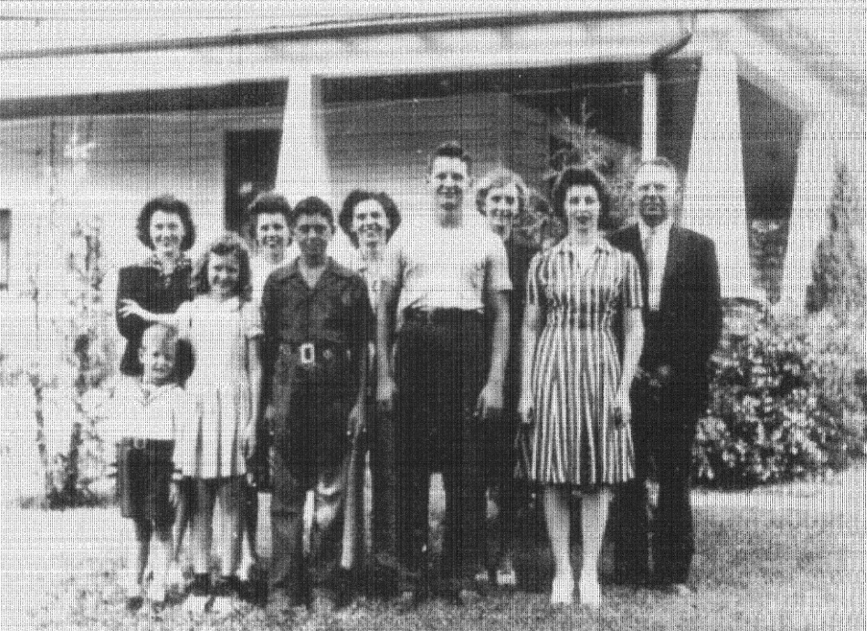

Around 1940 this picture was taken in Mountain City, Tennessee of the Howard family of whom Frankie Osborne often visited. Left to right: Malcolm Howard, Eula Adams, Lois Ann Howard Adams (who loaned me the photo), Hester Howard Williams, Earl Butler Howard, Hazel Howard Congdon, Roby Howard, Jr., Hallie Synder, Trula Howard Muse and Roby Howard.

October 15 – “Saturday 15…Went from jakes Snyders to Boby Howards….goat letter From Pauline.”
October 20 - “Thursday 20…Boby Brought me to Damascus to Pearls.”

October 21 – “Friday…Pearl Brought me home to Bristol”

October 22 – “Saturday 1932…October 22…Went Town…Paid Houce rent and got grociery.”

October 23 – “Sunday 23…stayd home…Wrot to TM and Pauline…helpt get diner.”

October 24 – “Monday 24…Planted onions.”

October 25 – “Tusday 25…Washed.”

October 26 – “Wednsday 26…trimd som bushes…Planted som flowr seed…raind.”

October 26 – “Wednsday Oct 26…had hedge cut…mr Boyd died at Hospitle.”

October 30 – “Sunday October 30…went to church.”

October 31 – “Monday 31…Washed & irond.”

November 1 – “Tusday 1 November first…the Buried mr Boyd…Plumer came to some Pluming work.”

November 2 – “Wednsday 2…I went to Town to get pension check.”

November 3 – “Went down to aunt marys to seam up a quilt top…fixt till Lois ann Howard a doll.”

November 4 – “Friday Nov 4th…Taken up canied and Spaded up Flowr Beds.”

November 5 – “Saturday 5…Set out Hysons bulbs nd Tulips.”

November 6 – “Sunday 6…Went to Sunday chool and church.”

November 7 – “Monday…Washed.”

November 8 – “Tusday 8…irond…got diner…planted som Flowers…Election…Went to BL for a few minutes.” Interesting that Frankie mentioned little about national events such as the Depression by which she was certainly affected. The 1932 Presidential election between Herbert Hoover and Franklin D. Roosevelt noted only in passing.

November 9 – “Wednsday 9…Washed then it raind, turnd coal…Went to church at night.”

November 10 – “Thursday 10…Nic sun a daky. Went to mr Mortens funderal.”

November 11 – “Friday 11 armistus day…cold & raining. Bob Rutherford and Louise and mayme all moterd to Knoxville. Mr Vance and myself taken up flowrs and set out some.” Bob Rutherford was a friend of Louise Stansbery’s.

November 12 – “Saturday 12…cold…first little snow.”

November 13 – “1932 Nov 13 Sunday…cold, dident go to Sunday chool or church…Wrot to TM & Pauline.”

November 14 – “Monday 14…Washed.” Of course, it’s Monday. - GNH

November 15 – “Tuesday 15…irond & sewd som on quilts.”

November 16 – “Wednsday 16…Anderson st church lady had a Turkey diner at the UMCA. I helpt.”

November 17 – “Thursday 17…cold, raind last evning and turnd cold. Washed I tile not well…Wrote to alice Snyder.”

November 18 – “Friday 18…got letter from Bill…he is in calaforna…I answered it and done some sewing.”

November 19 – “Saturday 19 …Washed some, kild chicken…don som Baking for Sunday.”

November 20 – “Sunday 20 dident go to church…not well…stayd in all day.”

November 21 – “Nov Monday 21…it has cleard off…nic suny day…got letter from mrs. Raby Howard…I answered.”

November 22 – “sew and washed.”

November 23 – “Pearl sent nic box for Thanksgivn.”

November 24 – “had nice good diner…Pearl sent so many good things for thasgivin.”

November 25 – “Friday after thanksgiving…nic and warm…went to BL – Geraldine and my self. Cleand yard.”

November 26 – “Saturday 26…Washed and cleand Houce… cold and raind.”

November 27 – “Sunday 27…Very cold…wrot to TM and Pauline and roy…dident go to church.”

November 28 – ‘Monday 28…awful cold…was X eramd…got letter from Alice.”

November 29 – “Tusday very cold…wrotin to alice…started alice letter.”

November 30 – “Wednsday 30…the last day of Nov…Started alice a box of quilt craps (scraps) to peac (piece) her and my self a quilt.”

December 1 – “thusday s first…Washed and went down to see aunt mary Sheets. She is sick.”

December 2 – “Friday 2 got pension…went to town…Payd hose rent.”

December 3 – “Saturday 3th…Workd on quilt…went down see aunt mary…Payd her doller.”

December 4 – “Sunday 4…Stayd home all day…not well…raind gloama day.”

December 5 – “Monday Dec 5…Washed, cleand house.”

December 6 – “Tusday 6…had all day meeting at church missionary meeting. Mrs Berd made a nice talk on Indian.”

December 7 – “Wednsday 7…Worked on quilt…got letter from Alice.”

December 8 – “Thursday 8 …helpt maym sew.”

December 9 – “Friday 9…Worked on quilt and sew som…Wrot to roy.”

December 10 – “Saturday 10…Washed & mopt and in the evening went to Town don som Shoping.”

December 11 – “Sunday 11…Raining and cold…stayd home…dident go to church.”

December 12 – “made me a kinder ward robe to put my dresses in. Went to see aut mary…writing to alice.”

December 13 – “Washed and mopt rooms.”

December 14 “ Wednsday 14…Sick…set around.”

December 15 – “Helpt mayme and peaced an quilt and som sauck.”

December 16 – “Friday 16…Washed 2 quilts, clead home…Went to see aut mary…better. Got letter from Bill.”

December 17 – “Saturday 17…writing to Bill…got EXM card from Bascom…Very Bad day…ice coverd ground.”

December 18 – “Ground covered with snow and ice and very cold.”

December 19 – “Monday December 19…Very cold…Washed…got letter from Pauline…going to answer.”

December 20 - “Tusday 20…got card and letter from alice…Writing to her, sending card and letter. Washed nice sunshining , cold.”

December 21 – “Wednsay Dec 21…Peaced an quilt…irond the days ar the shortest to day.”

December 22 – “Thursday 22…got card from Roby Howard and wife and children…got one from BL and Cora and Vivin.” Vivian is the son of Bishop and Cora Osborne.

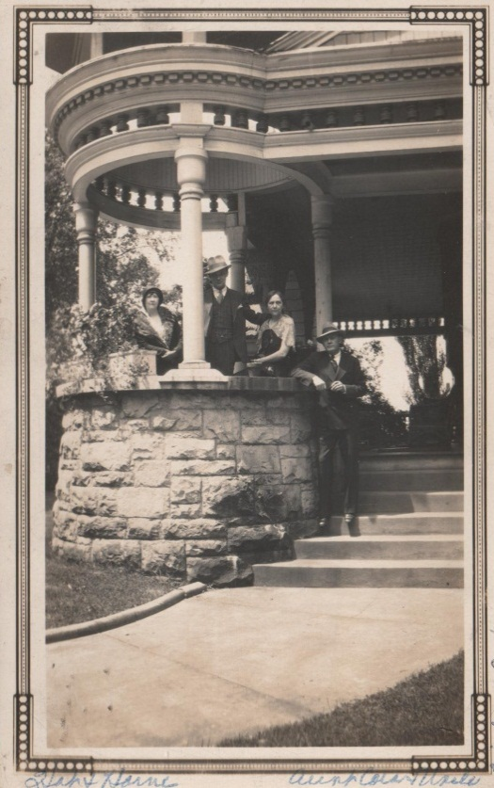
Far right, Bishop and Cora Osborne, Bristol, Tennessee

December 23 – “Friday 23…Washed and worked on quilt…got a nice box of Presents from Pearl for EXM….nic and warm to day…got half bushel of corn…got card from Kathern and five dollars…got check from Doris and Glatus for five dollars.”

December 24 – “Saturday 24…nice and warm…fixing for EXm…Got lot of nice good things for EXM from Pearl…from Damascus.”

December 25 – “Sunday 1932 the 25…Exmas day…Warm rainy day.”

December 26 – “Washed, irond, taken curtens, clead windows.”

December 27 – “Tusday 27…Been washing curtens…moping and done some baking.”

December 28 – “Wedsday Dec 28…Stretch curtens. Pearl-Glatus come down …spent the day…The Brough all of our diners…dident half to cook any only cabbage.”

December 29 – “Thursday 29 …Put up curtens, clead houce…taken a Packige to Post office for alice Snyder.”

December 30 – “Friday Dec 30…fixt stove wood and went down to see Aunt mary Sheets…done som Sewing…nice – warm.”

December 31 – “Saturday Dec 31…Washed and irond…it rains and sletd and snowd…awful day the last day of Dec 1932.”

1933

January 1 – “Today got first cold and nic sun day…clare and I ate the first egg for diner this year.”

January 2 – “Monday January 2…awful cold nice 0 clear morning.”

January 3 – “Tusday January 3…Went to Bank…got Check cashed…Went Paid Houce rent 17 dollares. Came Back…Went to the church to missionary society.”

January 4 – “Wednsday…Planted out som bulb for flowrs…cloudy and coal…got grocierys – Bag flowr and other things. Worked on quilt.”

January 5 – “Thursday 5 – nothing.”

January 6 – “Friday January 6 houce cleaning…got letter from alice…Writing to alice…Went to church to a missionary meeting.”

January 7 – “Washed and irond…raind…Turnd cold.”

January 8 – “Sunday Jan 8…Went to church. Went down to see mrs Walker…very sick…not expected to live.”

January 9 – “Monday January 9…awful rain and cold…worked on quilt…mrs Walker died at 4:10.”

January 10 – “awful rain…wash and mopt…finished quilt”.

January 11 – “Wednsday Jan 11…cold and rain…Worked on quilt.”

January 12 – “Thursday Jan 12…went to town… done som Shoping.”

January 13 – “Friday jan 13 1933…worked quilt.”

January 14 – “Saturday 14…washed…Robert and wife stopt over a few minutes as the(y) was on ther way home from Roanok.”

January 15 – “Sunday 15…Went to church at 11 anderson st… at night went to presbyterg Church… at 2:30 went to mr grub Bural.”

January 16 – “Monday 16…Went to mrs Evert…cut out some quit peaces.”

January 17 – “Tusday 17…Went to mr pennys…got som magasense.”

January 18 – “Wednsday 18…Went to Town…Washed, sewd on quilt.”

January 19 – “Thursday 1933…Washed…Went to mrs Evert after Patern to se Walter girl.”

January 20 – “Friday 20…Went to church to intertamman and worked on quilt. Went to aunt mary…got her to help me sew som.”

January 21 – “Saturday 21…Washed, done som Baking…worked on a quilt for the ladies circle…the Duck girl quit for the church…got quilt from alice she Peast.”

January 22 – “Sunday 22…Went to church…Wrot alic – TM…Went to Presbyteryan church at night.”

January 23 – “Monday 23 nice sun shining morning…mr J C Lenard died this morning at 12:24.”

January 24 – “Tusday …Went to mr Lenards Funerl.”

January 25 – “Wednsday 25…Went to Prayer meeting …awful Bad day.”

January 26 – “Thursday 26…nice Bright morning…Writing to Bill.”

January 27 – “Friday Jan 27…awful bad day…got letter from Alic…Washed.”

January 28 – “Washed and cleand houc…Worked on quilt.”

January 29 – “Sunday January 29…Went to church…herd very good serman from Dr Wile, our Presider Elder.”

January 30 – “Monday Jan 30…Went to Post office to mail a letter to alice Snyder. Pearl – Glatus came down for a few minutes.”

January 31 – “Tusday Circle 3 got diner at the church for 86 preachers and women and delegates.”

February 1 – “1933…Wednsday Feb 1…first cut the old pensions and widows pensioners from $30 to $11 ½. Dark raining morning…first day of Feb.” The Great Depression reached its depth as the State of North Carolina could no longer afford to make promised payments to Confederate widows. As little as Frankie was receiving, this was a devastating reduction.

The week before Adolph Hitler came to power in Germany.

February 2 – “Went to Prayer meeting…got my pension $11.50 draft from $30 dollars to 11.50.” A day later and Frankie still bemoaned the hard reality of her reduced check. Yes, perhaps this was a day to go to prayer meeting! Went to Bank…got pension check cashed. Went up to Fred Newland office…maild letter to roy and to Bascom…maild letter to Brother W A Wilson…Ground Hog day.” Frankie kept up with all folk and official holidays.

February 3 – “Friay Feb 3…Went to Anderson st church quilting a Circle 3 quilted it to Pay on our new church.”

February 4 – “Saturday 4th…irond, workd on quilt…it snowd most all day and melted off. Got letter from roy.”

February 5 – “Sunday 5th…awful cold and a big snow…got up this morning, found a big snow and very cold…couldent go to church so cold an snowing…Wrot to roy.”

February 6 – “Monday 6th Went to Town…maild letter to roy..com by coal yard…got half ton of coal.”

February 7 – “Tusday 7th…Went to missionary cociety…work day quilt.”

February 8 – “Wednsday 8th…Very coald..snow and wind all most fosse to death.”

February 9 – “Thursday 9th…still cold…cant get out …Got letter from alice Snyder…se mrs Howard died Saturday 4th.”

February 10 – “Friday Feb 10…Still Snowing and cold…very cold…working on rug.”

February 11 – “1933 Saturday 11…Washed, finished plating for rug.”

February 12 – “1932 Sunday 12…Went to church…the ladys circle 4 served Big crowd...had goo tim…had som nic talks and diner.”

February 13 – “Monday Feb 13…Went to Post office, maild letter to Roby and hattie and alice and Pearl then com back…Went to aunt mary Sheets.”

February 14 – “Tusday Feb 14…Valentine…Went to Mrs Lindamer to Circle 4…Awful frigid and rainy day…got a large fine cake from valentine…got letter from hattie Howard…got cake from Pearl.”

February 19 – “Sunday Feb 19…went to church…then at 4 clock went to mrs Dixsons Funerl on Winsor Av.”

February 20 – “monday Feb 20…worked on quilt…got letter from Pauline.”

February 21 – “Tusday Feb 21…Washed. Went down to aunt mary to get here to help on quilt. Wrot to Pauline. Pearl came down for a few minutes.”

February 22 – “Wednes 22…Went to Town…Went to Prayer meeting…come back… to Pearl.”

February 23 – “Thursday 23…sick…finished mrs allins quilt…Sears…started fuller mop back to the company…its broken…send a new one in the plac of it.”

February 24 – “Friday 1933 the 24th…finsht a quilt…??? of it is going a round the world.”

February 25 – “Saturday 25…Washed, irond, cleand houce…Bob went to Roanoke.”

February 26 – “Sunday the 26th…cold, dident go to church….mrs Charle vans sent me a waiter of the nicest diner that was so sweet of her.”

February 27 – “Monday Feb 27…nice day…Put out som flowrs. Went to mrs Everts.”

February 28 – “Tuesday Feb 28…racked yard and some in the garden…last day of February.”

March 1 – “Wndsday march 1…very Windy and cold…mr Woods on Broad street died last night. Cut pension…I got thirty…get $11 ½ cinc February first.”

March 2 – “Thursday march 2…very warm day…went to Town to the Bank to get check cashed…couldent…its national (bank) holiday. Went to mr Kebler to our clas meeting…very cold.”

March 3 – “Friday 3 third…very cold and glooma and dark…finished my pillow and other work.”

March 4 – “Saturday march 4th…awful cold and windy…Wshed and wrote to Alice. Roosevelt became President today march 4th 1933.”

March 5 – “Sunday march 5…Went to Bishops, spent the day. Geraldine went with me.”

March 6 – “Monday march 6…taken some sewing down to aut mary…and sew…got letter from Bill.”

March 7 – “Went to mrs coxes on Bountville Pike to our circle meeting.”

March 8 – “march Wednsday 8…Writing to Bill…cold and raining. Pearl and Glatus came downt. Brought lot of other things and Flowr Plants.”

March 9 – “Thursday march 9…cleand off garden…Went to Bank to get checked…Couldent.” FDR‘s Bank Holiday was in force until Congress could pass stabilizing legislation to ensure solvency and halt the nation-wide run on banks. In Frankie’s bank book is a $61.50 certificate issued by the State of Tennessee Bank Superintendent at the failure of the Bank of Bristol. Stamped on the back are the words: February 21, 1934, Credit by 20% of face of Certificate.” As with many, many Americans, the collapse of the banking system destroyed the savings of Frankie in both 1932 and 1934, such as they were.

March 10 – “Friday march 10…went to Town to mr Fred Newlands office to Pay Houce rent.”

March 11 – “Saturday march 11…washed, went to Town to Pay for coal.”

March 12 – “Sunday march 12…Went to Sunday chool then went to m randy Hoover for diner…Went to Preaching at night.”

March 13 – “Monday march 13…got my garden Spaded, nic and warm. Went down to aunt mary Sheets for a few minutes.”

March 14 – “Went to missionary meeting at church. Had one of the worst rain and Hail storms I ever herd…several kild at Kingsport…the los of lives and damage of houses.”

March 15 – “Wednsdy marc 15 – “got letter from alic Snyder…had awful storm last night…Washed off Porch this morning. Wrot to alice.”

March 16 – “Thursday…Went to mr Linda mood to help quilt a quilt for our circle no 3…went in mrs Fords car.”

March 17 – “Friday march 17…been cleaning the yard…taken goods up to mrs Richerds to make me a dress.”

March 18 – “Washed, went to Town for Grociery.”

March 19 – “Sunday march 19…Rainy day…dident go to church or Sunday chool.”

March 20 – “Monday march 20…tied up grape vines…got letter From Pauline…wrot to Pauline… awful windy…had rain storm.”

March 21 – “Tusday march 21…had hard rain and snow and wind storm…turnd very coald.”

March 22 – “march 22…coal day…awful coal…Went to Prayer meeting.
March 23 – “Thursday march 23…Went to mrs Evert to a quilting…making quilt to sell for the church…turned very cold and windy.”

March 24 – “Went back to mrs Everts for a While…Work on quilt…came back…Planted Potatoes…they sold the Bank of Bristol Bank.” The local bank had collapsed.

March 25 – “Saturday march 25…Saturday Very cold…Washed…Went to stor…got grociery…Got letter from Bill.”

March 26 – “Sunday march 26…Went to Sunday chool…very cold…Writing to Bill.”

March 27 – “Monday march 27…Worked in garden…Planted Beets, carots, peper, letus, radish.”

March 28 – “Tusday march 28…set out Flowrs Plants…Planted some mor Potatoes and a lot of flowrs…set out a rose Bush…mrs Sheets gave me…got letter from Alice…nic day.”

March 29 – “Wednsday, march 29…Workd in garden, not well.”

March 30 – “Thursday march 30…Went to church to help With a diner service for the church.”

March 31 – “Friday march 31 …The last day of March been seting out flowr Plants.”

April 1 – “Saturday the first day of April…washed, irond, went to store. Pearl came.”

April 2 – “Sunday, April 2, Went to Sunday chool & stayd for preaching . Our Preacher Rv Charles William & his class of boy had a Free will offering diner had a large crowd and a fine diner.”

April 3 – “Monday, apr 3…Went to Town, Went to Bank, got check cashed…Paid Phones, rent, paid five dollars on house rent, don’t get only eleven dollars per month, been getting 30 dollars up till Feb.”

April 4 – “Tusday april 4th, cleand one room, worked in hard.”

April 5 – “Wednesday 5…Roby Howard & family all came for a While, gave Larce ann a till by chair.”

April 6 – “Thurday apr 6…Washed rond, S…com a awful wind & rain, A crowd of boy & girls from Tenn Hy Chool went to Johnson City to Put on a Play. The(y) have Louise is int it…she went with them.”

April 7 – “Friday, April 7…cleand one room…set out some flowers ordered on march 8.”

April 8 – “Saturday april 8..washed, rond, worked on yard.”

April 9 – “Sunday, april 9…Went to church, came back got diner for maym & children. Mr-Mrs malcome & children, mayme & childr all motered to afton.”

April 10 – “Monday, worked in garden, planted so corn.”

April 11 – “Tusday , set put som flowr …Went to missionary meeting…went to mrs Richerson to have dress Fited.” One of the few times Frankie talked about new clothes.

April 12 – “Wednesday april 12…Went to Prayer meeting, set out flowrs.”

April 13 – “Thursday april 13…Planted Beens & sowd flwr seed. Went to church…colored Easter eggs.”

April 14 – “april Friday 14 1933…in the evening went to the Ball Park to a Easter Egg Hunt. Geraldine went with me.”

April 15 – “Saturday apr 15, washed & napt…Sowd some flowr seeds…Went Store.”

April 16 – “Sunday apr 16…went to Sunday chool…Bob Rutherford & Louise taken their diner & motered some wher to Blowing Rock. Charles Jr went out to the airplace landing the or pulling of some Big Stunts out ther.” My mother remembers Charles Jr. going every weekend to the airport to look at airplanes. A few years later he would fulfill his childhood dream and work on airplanes as a member of the U.S. Army Air Corps.

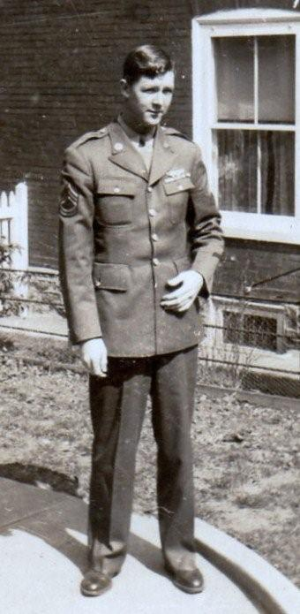
Above, Charles Stansbery, Jr. during World War II in his U.S. Army Air Corp uniform.

April 17 – “Monday apr 17 1933…Worked in garden…Went up to mrs Bieherson after my dress in the evening…Went to store, raind hard.”

April 18 – “Tusday apr 18…Went to mrs Tranums after glatolia buls & set them out.”

April 19 – “Wednsday apr 19, Went to Town, done som Shoping…Went to Prayer meeting.”

April 21 – “Friday apr 21…Planted beens, went to aunt mary, then to store for grocierys.”

April 22 – “Washed, mopt, riond…Went to stor for grocierys and (k)nobs for kindling.”

April 23 – “Sunday april 23…Went to Bristol, spent the day…Went to Preaching at night, herd a indian mak a talk.”

April 24 – “Wokd in garden, put down Tomatoes stick…howd potatoes.”

April 25 – “Tuesday apr 25, cleand yard & worked in Garden.”

April 26 – “Wdnsday apr 26…Went to Town got garden seeds & som onions slips, set out & bed seeds.”

April 27 – “Thursday 27…Went to Town, got som mor garden sees & Planted them.”

April 28 – “Saturday apri 29…Sowd cucumber seds, cleand yard, washed.”

April 30 – “Sunday apr 30…the last day of April 1933, Went to Sunday chool & church…mr (obscured) Preached.”

May 1 – “Monday may 1st…Got Pension check…Went to Town, Paid Phone, rent…got som Tomatoes Plant, set out som…went to Blountville to Temperence Rallie…herd som good speakin.” A temperance rally proclaimed the evils of alcoholic beverages. In 1933, the United States repealed the prohibition of alcoholic beverages (the 1919 Volstead Act) and persons could purchase wine and spirits legally again. The Methodist Church at this time heartedly distained alcoholic beverages. Most sadly alcoholism seems to have affected the lives of two of Frankie’s sons and several grandchildren.

May 2 – “Tusday may 2…worked in garden, Went to mr Smith, got som Flowr Plants, set out, went to Circle 3.”

May 3 – “wednsd may 3th…Cleand houce, Planted Raishes Seeds. Went to Prayer meeting, started alice Snyder a letter.”

May 4 – “Thursday may 4…Went to store after grociery…Put down tomatoes sticks…Went to mr Kebler to a class meeting.”

May 5 – “Friday may 5…Wrot to Pauline, raining & cool.”

May 6 – “Saturday may 6…Pearl com…I Went to Town with her…she helpt me get grociery.”

May 7 – “Sunday may the 7th…Went to Sunday Chool & church…mr Wright Preached.”

May 8 – “Monday may the 8…Went to Town to Balls…got a stove kettle…then in the evening visited som familys.”

May 9 – “Tusday may th 9…howd out my garden & set out Tomatoe plants…Bob Ruherford toke maym & children to afton.”

May 10 – “Wednsady may 10 …Washed curtens and irond.”

May 11 – “Thursday may 11…”Went to mr Hary mcdonel after Tomatoes sticks & stuck Tomatoes.”

May 12 – “Friday may 12…Went to town going to go to church…going to hae a supper at church.”

May 13 – “Saturday may 13…washed went to Town…Set out some flowrs…Pearl come.”

May 14 – “Sunday may 14…Went to Sunday chool & church…at night went with Rv Shuler & wife to is church…he preached aother semond. BL came, brothout me a nice Bunch of flowrs.”

May 15 – “Monday got card & Ten dollaers in money for mothers day….Got nic card from Bill & family. Got too doller from Pauline.”

May 16 – “Tusday may 16 Went to Mrs Evert, her Birthday, her circle met …they making a quilt for the church.”

May 17 – “Wedn may 17 …went to aunt mary, finished my pillow & work in garden.”

May 18 – “Thurday may 18…Went back to mr Everts to finish up so quilts.”

May 19 – “Friday may 19 …writing to Browth W A Wilson at Durham. I got letter fro Pauline & answerd.”

May 20 – “Saturday may 20…washed, rond, washed off proch…Went on knobs after wood.”

May 21 – “Sunday may 21…went to Sunday chool.”

May 22 – “Monday may 22…mowd yar …weed, put flowrs…went to mr owins afte milk.”

May 23 – “Tuesday may 23…Howd out my garden, stuck beans. Cleand out garden, planted cucumbers, washed off porch.”

May 24 – “Wednsday, Went after milk, helpt aunt mary carry a crate of strawbury. Went to mrs Linday , made tack a quilt.”

May 26? “ Friday, May 24…Went after kindling…Washed off Porch.”

May 27 – “Saturday may 25 …Washed & mopts…Went to Town go grocery.”

May 28 – “Sunday may 28…Went to Sunday chool, went down in Baracker class to a memorial service. Went to Tenn High Chool, Barcerly service.”

May 29 – “Monday may 29…Howd out my garden, mowd your.”

May 30 – “Tusday, may 30…Went over to mr Fords, help quilt a quilt for our circle.”

May 31 – “Wendsay may 31…the last day of may 1933…Howd out garden…Ted Vane fixt Mayme stove. Charles Jr mowd Mrs Malence yard.”

June 1 – “Thursday, June the first cold and winday…went to the clas of chool Tenn Hye.”

June 2 – “Planted onions, planed cucumber seeds…Cold had to have fire…went to the clase of school Tenn Hye choll. Louise graguated to night.”

June 3 – “Saturday June 3…Washed, went after milkd. Payd for coat, mopt, irond…Set out Tomatoe plants.”

June 4 – “Sunday June 4…Went to church…Went hom with mrs Kevler for diner… after dine We went for a driv up on the Abingdon Pike. Mrs. Backet taken us.”

June 5 – “Monday June 5…Mr vane fix’t mayme Stove…I half to Pay him…paid one dollar.”

June 5, July 3, November 2 and Feb. 1934, paid Charles Vane, a neighbor, one dollar each time to fix Mayme’s stove. This indicated the lack of funds in the Mayme Stansbery’s house.

June 6 – Tusday June 6 today is election day & circle no 3 meets at mrs. Sherwood’s.”

June 7 – “Wednsday June 7 …Payd 5.00 dollars mor on Houce rent…got letter from roy…sent me Five dollars…Went to Prayer meeting.”

June 8 – “Thursday June 8 …wrot to roy & Bill…benn watering yard.”

June 9 – “Friday June 9…Worked in garden…Planted some corn.”

June 10 – “Saturday June 10 – Washed, mopt, went to store.”

June 11 – Sunday June 11 – “Went to Sunday chool & church.”

June 12 – “Monday June 12…Pauline sent maym a Box of cloths…I set out Plantes…it raind most all day & Turned cold. Bible chool comenst at Anderson st church.” Later Frankie wrote more about this day: “Bible chool comenst at Anderson church today.”

June 13 – “Tuesday, June 13 – very cold & clar. I went to Bishops…stayd while.”

June 14 – “Wednsday, June 14…worked in garden & mowd yard…its very cold, had to make fire. Mayme Finished houce cleaning. Sowd some Letus seeds.”

June 15 – “Thursday June 15…howd out Tomatoe…mr Johny Glover got drowned in Watauga River…lay in watter 18 hours.”

June 16 – “Friday, June 16…Went to mr glovers to see the corps of Johny…ther son that drowneded.”

June 17 – “Saturday June 17 …Washed, mopt…Went after milk, irond, Went afer grociery.”

June 18 – “Sunday, June 18…went to Sunday chool & church. Wrot to Charles.”

June 19 – “Monday June 19…worked in garden…Went to Town to see B L…went on Knobs for Wood. Wrot to alice.”

June 20 – “Tusday June 20…my birth day – 82…Pearl com Brought me a nic cake & the grociery and gave a dollar. Went with aut mary Sheets to town. Pearl came in the evening…Brought a nice cake for my birthday cake and many more things to eat and a doller in money.”

June 21 – “Wednsday June 22…the longest dayes in the year….mrs Longe & my self went to mr Blevins to see mrs Blevins…she is Sick. Went to Prayer meeting.”

June 23 – “Thursday Jun 23…Went to Mr Owins for milk…Worked in garden and yard. Washed off Porch.” Below, the small home where Frances Wilson Osborne lived in Bristol, Tennessee when she wrote some of her Diary. This photo was taken in 2011 by a great grandson, Glenn N. Holliman.

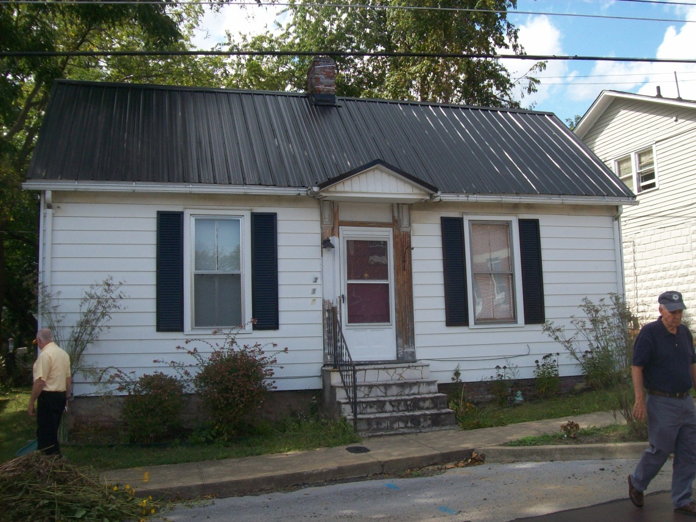
June 24 – “Saturday June 24…Washed, set out some Tomatoes Plants…Worked in garden…went after milk.” Again she wrote more later in the diary: “Saturday, June 24…Bible chool closed at Anderson st to night with a with a little play. Little girls made a little pillow apiece…they put ____ doll on thems…Geraldine made one…they are all nice.”

Below in 2011 Geraldine Stansbery Holliman Feick (1923) stands with her son Glenn N. Holliman (1946), September 2011 at the Anderson Street United Methodist Church, Bristol, Tennessee where her family worshipped in the 1920s and 1930s.

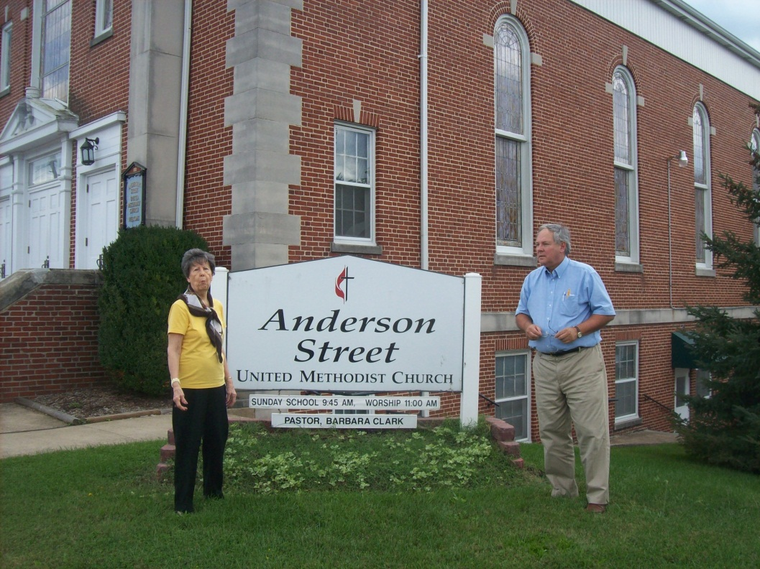
June 25 – “Sunday June 25..went to Sunday chool & church.”

June 26 – “Monday June 26…Worked in garden…Planted som corn and cucumbers.”

June 27 – “Tusday June 27 …Went to Bow Wiliams to spend the evening. Geraldine went with me…raind.”

June 28 – “Wednsday June 28 – very to…mowd yar…Went to Prayer meetin.”

June 29 – “Thursday June 29…Worked in garden, set out som flowrs. Went to se aut mary.”

June 30 – “Friday June 30…the last day of June…went to BL Osborne the last of June 1933. Mr Swan died at five this evening at is home on Broad st., age 82.”

July 1 – “Saturday July 1…washed went up to mr Swans old home…he died yesterday the last day of June 30 1933.”

July 2 – “Sunday July 2…Went to Sunday chool… in the evening went to mr Swans funeral.”

July 3 – “Monday July 3…Went to Bank…Paid five doler on house rent. Very cold & Windy. Paid mr Charle Vane one doller for stove fixture … this makes 2 dollars.”

July 5 – “Wednsday, Went to Town for Butter & Soap, then com back. Went to mr Balls to circle number 3 anderson st then went to Prayer meeting.”

July 6 – “Thursday July 6 worked in garden.”

July 7 – “Friday July 7, went to mrs owins…taken bath…went to mr denys.”

July 8 – “Saturday July, washed & irond and other things.”

July 9 – “Sunday, July 9…Went Sunday chool & preachin.”

July 10 – “Monday July 10, Went to bank, got a certificate for my deposit $61.50 in the Bank of Bristol. Won’t get any thing till may 1934, 61 doller 50 ct.”

July 11 – “Tusday July 11, Worked in garden, went see a houce.”

July 12 – “Wednsday July 12…Went to see mrs Jenkins…She is very sick…Went to Prayer meeting.”

July 13 – “Thusday July 13 – Went to Town to set some paint for to paint cheirs.”

July 14 – “Friday July 14 – “Went after milk & painted chars and Shelf after come back. Got letter from Pearl, sent me a Doller. Got letter from Bill. Sowd letus seeds.”

July 15 – “Washed, irond…went to town, got paint and varnish…had a hard rain.”

July 16 – “Sunday July 16…Went to Sunday chool, wrot to Bill and alice Snyder. Went to Hospitle to see Rev. Shuler.”

July 17 – “Monday…Washed rugs and finished painting.”

July 18 – “Tusday, July 18…Went over on Twelve st…cleand up a Houce I am going to move in…belongs to mrs. Evert.

July 19 – “Wednsday, worked washed, went to Prayer meeting this nite. Went out to WCTU…herd them broadcast on Temperence.”

July 20 - “Got diner at church, Thursday, July 20…Went up to chool, voted we feed (muddled) the Election People.”

July 21 – “Friday, Went over to the house where I will move. Cleand out coal house, put up chicken wire.”

July 22 – “Saturday, July 22…Washed, mopt, done som packing…went after some milk overt mr owins & to see her little Baby bornd Thursday 22.”

July 23 – “Sunday, Went to Sunday chool and church. Very Hot.”

July 24 – “Monday to mrs Erwins house one 12 st…had lites turned on. I pay 10 dollars a month for house and she payes watter.. its very Hot.” Earlier in the diary, Frankie wrote: July 24 – “Move to Mrs. Ever’s house at 304 12 Street, and pay 10 dollars rent. Roy Osborne and wife (Roy is a son) move to Bristol from Cleveland, TN to France’s house.” What happened to the garden she planted?

July 25 – “Tusday…been starten in up houce, weeding yard & flowrs…its very hot & dry…Went to Post office, maild card to Pearl and roy.”

July 26 – “wednsday 26…Went to mrs Evert helpt Peel peaches & weed out garden.”

July 27 – “Over to mayme…getherd some corn for her diner…its raining very hard…going to can peaches…to bushel. Pearl & Glatus corn.”

July 28 – “Friday, made jelly, tied up tomatoes & pulled some weeds out of garden and yard.”

July 29 – “Saturday, July 29 – Washed & irond, worked in yard & garden.”

July 30 – “Sunday, Went to Sunday Chool & church.”

July 31 – “Monday, the last day of the month, very hot.”

August 1 – “Worked in yard…went to mrs Evert to circle 3, got my pension – 19 dollars.”

August 2 – “Wednsday August the 2 – Went to town, got check, cashed, paid some bills. Coffee man came, got a box of chrisco.”

August 3 – “Thursday, August 3, Cleand garden …howd out my little patch of corn…went down to aunt mary sheets.”

August 4 – “Friday, August 4 – “cleand out flowrs & yard, fixt chicken wire.”

August 5 – “Saturday august 5th…Washed and mopt…Went after milk, then went over to my garden, got potatoes & tomatoes. Went to mrs Ervins after flowers. Pear and Doris and Glatus came.”

August 6 – “Sunday August 6…Went to church & Sunday chool, met mrs St John…she gave her had as shaking. Put 2 dolles in my hand…Wrote Pauline and Albert Osborne and alice Snyder”

August 7 – “Monday August 7 – Went to Town, got me a par of Shoes. Paid $1.49.”

August 8 – “Washed, irond, got card from Roy & lina…they are at White Sulpher Springs, W VA. They gone thre from Cleavland Tenn hist health, sed he is feeling better…had a nervous Breakdown and other Trouble. Got check from Tom malcom to pay lites. Missinary meeting today. I wan’t well, didin go.”

August 9 – “nic brite morning. Yesterday was Election day to Elect magistrate. Mr John Fair was elected. I made some grape juice. We went up to mrs Everts to help pix some grapes. Cut off mayme’s lites to day.” The economic woes of the Stansbery house climaxed the summer of 1933. Mayme’s family, minus Charles Sr., had no electricity.

August 10 – “Thursday August 10, Cand apples & mad grap juice.”

August 11 – “got letter from alice Synder…Wrot that Raby Howards house got fire last Friday. Burnd up ever thing.” This was a wretched year for Frankie’s relatives.

August 12 – “Saturday, August 12…washed & mopt, made some grape juice.”

August 13 – “Sunday, went to church. Mr Charley Swan died last evening. Will be buried to morrow.”

August 14 – “Monday, August 14…gathered grapes, made grape juice and marmalay. Took magie Williams 2 gallons for mayme. Went to church to mr Swans funeral.”

August 15 – “tusday…Went to Circle 3…had a linen shower at mr Evert for Mrs Dye…she will be leavin for merlan VA soon to make their home. She belongs to our circle no 3…sory to give her up. Servd refreshments.”

August 16 – “Wednsday, Washed & went to mr owins for milk…raind very hard this morning…its nice & warm now, clear, Went to the church to little play.”

August 17 – “Thursday August 17 …raining, irond…Went to mrs Solomans to if she want Charles jr mow her yard…He is mowing it.”

August 17 – “Thursday august 17…Louise Stansbery commest working in Kressess Store. Mrs Soloman moved in mr Rogers houce on the corner of 11 and Anderson st.”

Frankie makes this entry in another diary.
August 17 – “Thursday august 17 1933…Louise Stansbery comenst working J M Kresses store.” This employment by Louise was critical to the economic survival of the Mayme Stansbery family.

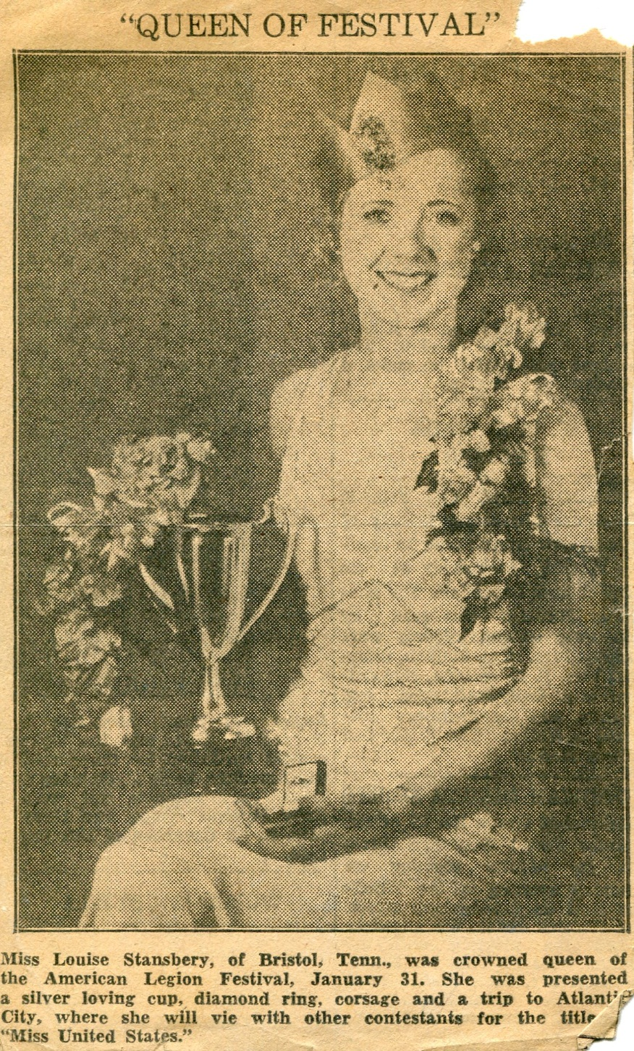

Louise Stansbery went to work in the summer of 1933 to support her mother, Mayme Osborne Stansbery and two siblings. She found time to compete in a local beauty contest which propelled her into the Miss Tennessee contest, which she won. In 1941, she married Vance Sherwood. He died in 1990 and she in 2006 in Knoxville, Tennessee.

August 18 – “Washed, went to see aut mary sheets…she isn’t. got letter from Pauline, tell me her mother very sick. We had a ice cream and cake supper at Anderson st church.”

August 19 – “Saturday, washed, irond, got a telegram from Sumner Washington tell me that mrs. TM Osborne died Friday 18th, my daughter in law.” Alta passed away.

August 20 – “Sunday, went to Sunday chool – preaching…Wrote to Pauline, her mother buried today.”

August 21 – “Went to mr Denny, got some grapes. Made grape juice. Pearl came. Brought some melons and apples. Bishop came.”
August 22 – “Tusday, Went to Bishops for a little while. Cand some apples. Went to Anderson st church to ice cream supper.”

August 23 - “Rev Shuler operated on at Norwill today. Cand some tomatoes. Raby Howard – family came…taken lunch with me. I kept Louise ann while they went to town today. House shopping. Roy – Lena came…they have been to White Sulpher Spring for a reast…his health bad. Mrs Baugh mom died to day the 23…Roy gone home today. Vivins wife came overnite.” I believe Vivian is Vivian Osborne, Bishop’s son.

August 24 – “1933…Roy left today. I went to town, done a till shoping…started Pearl Wright a card. Started alice Snyder a carde. Grandmother Baughman buried this evening.”

August 25 – “Friday…cleand house and yard. Mrs Ervin came. Mayme come over…Mrs Hoover-daugher com. Gave Geraldine dog Pegie.” This was my mother’s beloved childhood dog, Peggy. My mother, Charles Jr, Louise and Mayme were living in a house without electricity at this time due to the bill not being paid.
August 26 – “Washed, irond, many other things.”

August 27 – “Sunday, Brite, lovely morning…went to Sunday chool – Preaching. Nell Stansbery and Charles Stansbery came in for a few minutes.” Nell was Charles Stansbery Sr.’s sister-in-law.

August 28 – “Monday, gatherd tomatoes and cand some. Went to mr Owins for milk. Went to church to Preaching.”

August 29 – “Tusday, went over to mayme to see Geraldine…she is sick…turnd very cold.”

August 30 – “Very cold…went to prayer meeting.”

August 31 – “Thursday, the last day of August…nic day…Went to Aunt mary Sheets to take her some letus for her Birds…came back by mrs Tompsons…then came by the Rev. Sullers to ask how he is…he in Hopspitle at Knoxville. They went up on Anderson St. to see Mrs Ward…she is very sick…got a man to cut my hedge in front of house.”

September 1 – “Friday…got letter from Bill and Pauline…clean huce & Porch.” Pauline’s mother had just died.

September 2 – “Washed, taken pension to Bank…got cashed, payd lites, paid house rent…paid clid crawl grociery…Payed cawood grocery.”
September 3 – “Went to Sunday chool…come back…Wrot Pauline – rot Bill rot roy rot Bob.”

September 4 – “Monday…Went to Pay a coal Bill…Went after milk.”

September 5 – “Our Circle No 3 met with mrs Gobble, mrs GW one of Hostesse. We had a nic crowd…after meeting over, Servd a nic lunch.”

September 6 – “Wednsday, Phoned to mr warn for aunt mary Sheets. Bought some apples. Cand some made som apple butter…didn’t go to Prayer meeting.”

September 7 – “Thursday…nic Brite morning…Went up to mr Everts to Phone to mr Warn.” Frankie did not have a telephone. To this point, she made no mention of a radio. Of course, television, computers and the internet were decades away from this portrait of the first third of the 20th century. This was before supermarkets, and Frankie had to go to town often to purchase groceries.

September 8 – “Friday…Went after milk, cleand house and yard.”

September 9 – “Saturday, Washed, went to town for grociary. Mrs Blevin and a miss Doad rogers.”

September 10 – “Sunday…Went to Sunday chool, stayed for Preaching…mrs Fagan come visiting. Mrs Mater came for a little while…had nice till rain…Went to church.”

September 11 – “Monday…Went to Mr Bill Blevins to mrs Doad Rogers. Blevins funeal and then went to Blountville to her…burial at Blountville Semitary.”

September 12 – “cand apples for mayme in the evening…went to the church to a missionary meeting…had a hard rain.”

September 13 – “Went after milk and irond…got letter from alice Synder. Very hot…didn’t go to prayer meeting...come a shor of rain.”

September 14 – “Thursday, Sept 14…wrot to alice …made me apron…got diner for mayme & Louise and Geraldine.”

September 15 – “Friday, Sept. 15…Cleand house…went to cort Houce with Mayme…she lay in for divorc…went in town, done some shoping…got card from Bill.”
The marriage was ending. Mayme filed for divorce.

September 16 – “Washed, irond…Went after milk…mayme came over irond. Very hot.”

September 17 – “Went to Sunday chool & Preaching…Went down to see aunt mary Sheets.”

September 18 – “done some work outdoors…went to see mr. Shuler – sick.”

September 19 – “Went to Anderson st church to a all day meeting…had some fine talks on farm mission field….servd diner for a large crowd…the Rev mulens and wife made fine talk on the foren missionarys.”

September 20 – “Wednsday…Got supper for Maym & children….Went to prayer meeting…mrs Joe Tevis conducted it. The Sterci Compnay (a furniture company in East Tennessee) came taken mayme furniture from her for an old debt Charles made.” My mother remembers this episode with dismay at what the neighbors must have thought. No electricity and now no furniture.

September 21 – “Thursday , went down to mr Dennys. Borowd a cot for Charles Jr to sleep on…the maid let me have it…they taken the last bed she had in house.”

September 22 – “Friday, Sept 22…clean house. Went over to mayme…Bishop come for a few minutes this morning. Very cold; there was a little front.”

September 23 – “Saturday Sept 23 …washed – irond…went down to mr Dennys after chicken feed…to see Aunt mary Sheets…met mrs Barr from Bountville.”

September 24 – “Sunday, Sept 24…went to Sunday chool & preaching. Bob Rutherford and Louise took maym & Charles Jr and Geraldine to Greenville.” I suspect that an important meeting took place and a demand for financial assistance occurred. By this time, Charles may have been running a small grocery store either by himself or with his brother, Fred Stansbery. His daughter, Nancy Stansbery Higgenbotham, believes he worked for the WPA in Kingsport, Tennessee sometime during the Depression.

September 25 – “Monday Sept 25…I went to town to see if she couldn’t get lites in house… got letter from Pauline…wrote to Roy.”

September 26 – “Tusday Sept 26…made chow chow and cand some apples…wrot to Pauline.”

September 27 – “Went to Prayer meeting…Rev. Graham Preached, got letter from roy.”

September 28 – “maym & Louise went to town to have lites turned on. Louise got dress. Mayme & Geraldine ate diner with me.” The meeting in Afton must have been successful. Enough money was found to turn on the electricity.

September 29 – “Pearl came for a few minutes. Brought some apples, potatoes, a mess of pork. Mr Shirler gave me vegetables. Making chow chow…cleand house.”

September 30 – “the last day of Sept…very hot and dry…washed. Cand apple, made more chow chow.”

October 1 – “Went to church and Sunday chool… Rev McDowell preached.”

October 2 – “Mrs. Poor and myself went to East Hill Semitary to clean off mr Osborns and mr Poors graves.”

October 3 – “Tusday…Got pension …went to town…got pension check cashed. Payed lits and house. Went to missionary.”

October 4 – “Wednsday…Went to mrs Ervin …don some sewing. Set out som flowrs. Plant. Mayme made first five dollars on the living room suit.”

October 5 – “Thursday, Octob 5…very fogie and cold…went to mrs Emert to see mrs Bell Proffitt…went to mr Keble to class meeting.”

October 6 – “Friday…Washed, cleand, have went to the store…got grociery…very cold, had ome frost...got letter from Toby. He has got hom from Hospitle. Mr Bery & family moved on corner of 12 and Winsor…moved the 5th (to) mr Balls house…once mrs Hill’s houc.” Toby was probably being circumspect to save his mother grief. The hospital was a mental institution where he has been incarcerated after a term in prison for mail fraud.

October 7 – “Saturday, Oct 7…irond, don so mending…went down to Aunt mary Sheets…made fire in grate, very cold.”

October 8 – “Went to Sunday chool & preaching. Rev. Simmeran preached…very cold…some frost…Wrot to Toby yesterday…very cold.”

October 9 – “Went after milk…mayme came over and made two pies and sold them.”

October 10 – “Tusday, Oct 10…Went to mrs Everts…went to church to missionary meeting.”

October 11 – “Wednsday…Got some rumige…washed, went to mr Evert…Phone to mrs Wislon and Evers Pike…went to Prayer meeting.”

October 12 – “Thursday…irond…went to mr Erwins…Phone in a half ton of coal…I carried all of it from yard. Put in coal house…have a nic bunch…then went down to mr Shulers…sorted apples.”

October 13 – “Cleand house, cand some paars…Went to Town to get me som Butter…got me a little shovel.”

October 14 – “Saturday October 14 …washed, went to Tow…taken shoe to get mendid...com back irond.”

October 15 – “Sunday, Oct 15…Went to sunday chool and to Preaching. Rev Charles Williams Preched his Farwel serman leavin this week for his new field of labor.”

October 16 – “Monday, Oct 16…Washed and Streched curens…went over to mayme…taken up my gltiolus…Got letter from Pauline.”

October 17 – “Tusday…We had White Elefant sail at mrs Berry…had Big Croud, nic Time.” A yard sale.

October 18 – “Wednsday Oct 18…Cleand house…Roy (and) Lena came the Live in Cleavland Tenn. Got Supper for Mayme & family.”

October 19 – “Thursday Oct 19 – Roy & Lean hear…the Went out Driving this Evning.”

October 20 – “Witl Wilson and his siter nova from NC com for a few minutes.”

October 21 – “Roy Osborne and Wife & roy mother all moterd to Damascus, ate diner…they then moterd to Sutherland NC to Brother Bob Wilsons…spent the night.”

October 22 – “Saturday Oct 22…We left Bob Wilsons, drov to Trade Tenn, then down Cof (Cove) Creek a peace, then Back to Damascus, ate diner…then drove Back to Bristol…then roy & Lena spent the nit…then Sunday started home.”

Below Leroy Osborne, a farmer in Cleveland, Tennessee where many of his descendants live today.
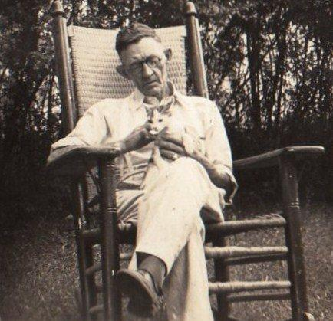

October 23 – “Roy Osborn and wife lena left this morning for home, Cleavland Tenn. Roy gave me money to get my winter coal. I went to church to hear our new Preacher, his fir sermon…like him fine…first sermon at Anderson st…. Mr Bennets little boy buried today, Sunday.”

October 24 – “Monday…oct 24…Went to Town…got me a Par of Shoes and a Parr of Houce Slipers. Got a Ton of Coal…Git it in coal houce.”

October 25 – “Tusday Oct 25…Washed, cleand hosue…started Tm a letter.”

October 26 – Wednsday Oct 26 – “Taken up some flowrs…cleand garden…went after chicken feed.”

October 27 – “Went after milk…Went to mayme after flowrs…Went to Fords and aunt mary.” In the same neighborhood lived a family named the Fords on Anderson Street. Their son Ernest sang in the Anderson Street Methodist Church choir with Charles Jr. Later Ernest would pick up the nickname Tennessee Ernie Ford and go on to a successful career as a singer and comedian.

October 28 – “Friday…Oct 28…Set out a lot of Bulbs…Hysons, Tulips, narsises and other flowrs.”

October 29 – “Saturday Oct 29…Got letter from Toby from Sumner, Wash…got card from Roy…he is sick, not able to be out…his trip up hear last week has layed him up again.”

October 29 – “Sunday Oct 29…Went to church and Sunday chool…Wrot to TM Osborne at Sumner Wash…rot to roy at Cleavland Tenn.”

October 30 – “Monday oct 30…Went to town…Got load of kindling, cost 75 cts…Our church members gave our preacher a pounding.” A pounding was a welcome for the new pastor. Often this include cash gifts.

October 31 – “Tusday Oct 31…the last day of Oct, nice and warm…looks like summer cut down that bush in garden”

November 1 – “Wednsday Nov 1st…nice and warm…Pearl and Glatus came for a few minutes. Brought apples…gone to prayer meeting.”

November 2 – “Thursday, Nov 2…went to church, had a reseption for Preacher.”

November 3 – “Caning apples…making jelly…Went to Town yesterday…got check cashed. Payd Houce rent and other things.”

November 4 – “Saturday Nov 4…Went after milk…Washed…been sick…my iron blew out all the lites. Man came fixt them.”

November 5 – “Sunday…raining and cold…dident go to Sunday Chool or church…not well…wrote to T.M. Osborne in Sumner Washington…wrot a card to Roy at cleavand.”

November 6 – “Monday, Nove 6th…very cold…ben making me a Pufft Guicidis. Went to Town to Pay a man for fix my (lites?)” The word looks like ‘shads’ – shades?

November 7 – “Tusday Nov 7…Went to town…went over to maym…went up to mrs Burry to our circle.”

November 8 – “Wednsday Nov 8…Very cold…been doing some writing…Wrot to Pauline. Mrs Boy came in for a while. Mrs Evern came in for a while. Mrs Poor came in for a while.”

November 9 – “Thursday Nov 9…Went over to mayme…Went after milk…Workd on pillow.”

November 10 – “Friday, Nov 10…made 2 pyes for mrs davis, one for mrs Evert…Went to town to mr Cated…got 3 old burners…got some grocierys. Got a dosen paper plates. Got letter from Bill, one from Toby too.”

November 11 – “Saturday Nov 11…today is armistest day…15 years to day cinc pease made World War.”

November 12 – “Sunday Nov 12…Went to Sunday Chool and Church…herd a good sermon…Mayme came over…dident go to church….Mrs. Poor came, stayd a while.”

November 13 – “Monday Nov 13…fixt over a old quilt for mrs Dais….been very sick this evning…Had very hard rain turned cold.”

November 14 – “Tusday Nov 14…Very cold and a Terable wind …been in all day…been very sick. Got letter from alice.”

November 15 – “Wednsday No 15 …very cold…I am very sick…mrs Bader come to see if she could (rent) a room and live with me…Wrote Alice.”

November 16 – “Very cold…Working on a pillow. Geraldine Birthday 10 years old. Bob Rutherfod gave her a rist watch. Very cold…I have been making me a pillow. I am feeling better today is Geraldine’s Birthday…she is 10 years old…Bob Rutherford gave her a rist watch nice.” Geraldine in 2009 remembered the watch as a ‘Mickey Mouse”, a cartoon character just introduced by an up and coming Hollywood cartoonist named Walt Disney. Frankie repeated her entry here.

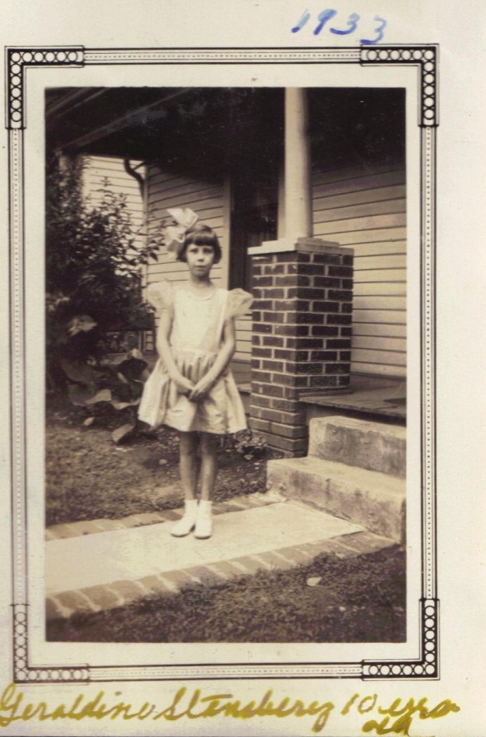

November 19 – “Sunday Nov 19…dident go to church…Sick. Albert Osborne came up from Cleavland…got supper for mayme and children and Albert…had chicken for supper.”

November 20 – “Tusday Nov 21…Wrot to Pauline…Went to Mrs Evert to Phone to mrs Whiker.”

November 21 – “Tusday Nov 21…Cleand off Garden…raind this evning…mrs Ervin com commenced burning on that tun of coal.”

November 22 – “Wednsay Nov 22…Anderson St Church ladys had a Turkey dinere at the YWYMCA…had a very large crowd…got a letter from TM Osborn.”

November 23 – “Thursday, Nov 23…Washed up every thing that was dirty…had a hard rain and Hail storm…turnd coal..Got letter from Bill.”

November 24 – “Friday Nov 24…irond cleand house…went to Town...Got Charles Jr short Jacket (paid $2.95)…Got some grociery…worked on Pilow Top.”

November 25 – “Saturday Nov 25…Lisend to Hams Sermon on radio this morning after noon visted the sick…went to see mrs Wadkins and then to see Rev Shuler, then mrs. Sheets.” For the first time Frankie mentioned having or at least listening to a radio in Bristol. Geraldine remembers her family had one as a child and listened to Amos and Andy. Earlier Frankie had written: “Saturday Nov 25…mr John Denny Birth day 75 yers old to day.”

November 26 – “Sunday Nov 26…Went to Sunday chool & Preachin…it was very cold…dident go out at night.”

November 27 – “Monday Nov 27…very cold…had a little Snow flying last night. Baked a pye for mrs Evert.”

November 28 – “Tuesday Nov 28…very cold…the Rev Ham Preached at Anderson st church. I went to hear him…got letter from Alice Snyder.”

November 29 – “Wednsday Nov 29…nice day…been baking pies…mad 4 for mrs Davis, 2 for mrs Evert, some for mayme and myself…Baked a cake…Got a Box from Pearl at Damascus…she sent a Dresst chicken, large upside down cake and mayonies Bread and letus for Thanksgiving tomorrow.”

November 30 – “Thursday Nov 30…thanks giving…the last day of November…very gluma day…I have been Sick all day…Bishop com over Brought my lunch…haven’t been out…hom all day…Louise came over brought me a lunch.”

December 1 – “Friday Dec 1st…nic warm day the first day of Dec…got my pension…went to Bank…got cashed…Paid Houce rent and so other bills…Going to Write to Toby…Washed and done som moping.”

December 2 – “Saturday Dec 2…Nice and warm…went to Town …started Toby a letter…got one from Toby…couldn’t wait for me as I had waited a few days over my usual time, poor boy.”

December 3 – “Sunday Dec 3…raining and cold…not well…cant go to Sunday chool or church.”

December 4 – “Monday Dec 4…Work on quilt…went to mr Owens to see if he coud get me a load of wood…started TM and alice Snyder a letter.”

December 5 – “not well.”
December 6 – “Wednsday Dec 6…went to church to help quilt …had diner…dident get done.”

December 7 – “Thursday Dec 7…Worked at quilt after diner…Went to mrs Erwin to a quilting. Pearl, Doris and Glatus cam down from Damascus…Brought me som apples and oranges. I am going to mr Kebler to a class meeting.”

December 8 – “Friday Dec 8…Went to mr Erwin to help finish a quilt…got done all except the binding.”

December 9 – “Saturday Dec 9…very cold…washed and mopt…dident do any thing after noon…sick.”

December 10 – “Sunday Dec 10…dident go to Sunday chool or Preaching…not well and too cold…Wrot to TM Osborne.”

December 11 – “Monday…Dec 11…Sick…BL came over for a while.”

December 12 – “Tusday Dec 12…the (y) ar (e) having a missionary meeting at church serving diner…Mrs Marten going to giv them a talk on farenfied…I was sick…couldent go.”

December 13 – “”Wednsday Dec 13…sick…mrs Erwin Brought me som meat…Got letter from Pauline.”

December 14 – “Thursd Dec 14…Mrs Evert Brought me a nic lunch for diner.”

December 15 – “Friday Dec 15…Wrot to Pauline…Wet (obscure).” Pauline no longer seems to be living in the same domicile as her father. Toby may be in prison.

December 16 – “Saturday Dec 16…Wet and raining…got letter from Sister Jane…Got letter from Toby.”

December 17 – “Sunday Dec 17…been in all day…sic …wrot TM Osborne a letter…sent him a card…Wrot W V Osborne a letter and sent him a card. Wrot Mrs J. H Proffitt a letter and sent her a card. Wrot alice snyder a letter and sent her a card….Sent Pauline Osborne a card…this finish the day.”

December 18 – “Monday Dec 18…Ironing, turning cold…Started lettere and card to TM, Bill, Pauline, Jane Proffitt, alice Snyder.”

December 19 – “Tuesday Dec 19…Washed…Got a roll of papers from the West From TM showing of the awful flood.”

December 20 – “Wednsday Dec 20 1933…irond…BL brought me severl Christm card & stamps to sen out. Our Pearl & I addresst…redy to start (mail).”

December 21 – “Thursday Dec 21…maild out 7 card. Pearl and Doris and Glatus all came for a While. Brought me a Big up side down cake and a chicken, orenges and grapes…Cross Whites…mailed from Hoover house next door from me.”

December 22 – “Friday Dec 22…Washed, cooked hog head and liver…making sraple…cleaned all the dishes.”

December 23 – “Saturday Dec 23…been getting severl Exm cards…som money and got Glatus Pictur…Got letter from Bill and Margret Bills girl.”

December 24 – “Sunday Dec 24…Roby Howard and daughter and Alice Snyder from mt city came taken diner with me.”

December 25 – “Monday Dec 25…Xms day been in all day…read the Book of Job all through…Pearl com for a few minues.” After the year the Osbornes, the Stansberys and the nation had had, I too might read the Book of Job on Christmas day!

December 26 – “Tusday Dec 26…was started Bill a letter…got lettr from TM and a card. Writing to TM…Got card and a doller from TM and Pauline…Very cold.”

December 27 – “Wednesday Dec 27…Very cold…Got Ton of coal started TM a letter…Went to Town…don som…Shoping…Got me a wash bord, burner for oil stove…its very cold and freesing.”

December 28 – “Thursday Dec 28…Very cold. I washed. I am sick…Phoed for som kindling for Maym.”

December 29 – “Friday Dec 29…went to get chick feed.”

December 30 _ “Saturday Dec 30…the last Saturday.”

December 31 – “Sunday Dec 31…to day is the last day of Dec 1933…Gon start an another year.”

1934

January 1 – “Monday January 1…started on a new year 1934…Got letter From TM…Got pension…had a very hard rain storm and heavy thunder.”

January 2 – “Tusday Jan 2…Very nic day…went to Town…Got pension check…cashed and payd grocer bill, home rent.”

January 3 – “Wednesday Jan 3…Washed…Got som thing from Juel tea man.”

January 4 – “Thursday Jan 4…Cold & windy…Went after milk…Went to mayme…Got a new years card from Bascom Jr Osborne…he is in Calaforna…he belongs to the Nava.”

A return address, date unknown, reported B.K. Osborne on the USS Marblehead c/o PM San Francisco, California.

January 5 – “Friday Jan 5…been nic warm like spring…cleand houce.”

January 6 –“Saturday Jan 6…Went to Town…Got grocierys…in the evning raind…warm…Got shoes half solded, cost 75 cts.”

January 7 – “Sunday Jan 7…raind very hard this morning then cleard up. Had the Preacher and wife…Rev Kelly our paster, mrs Evert & mayme and childern – Louise, Charles Jr and Geraldine…all for diner.”

January 8 – “Monday Jan 8…Washed…Went to mr Lillies to see Mrs Lillie…he is sick…then went to see mrs Owens…she is sick…its turnd very cold…mrs Thorn Williams dyed yesterday, Sunday.”

January 9 – “Tusday Jan 9…cold, irond…went to church to misnary meeting.”

January 10 – “Wednsdy jan 10 _ Cold…went to Prayer meeting.”

January 11 – “Thursday Jan 11…went to mrs erwins…helpt Lora Pick some chickens. Going to have a chicken diner tomorrow night. We had one of the Bigest Frosts this morning.”

January 12 – “Friday Jan 12…Snowd then turnd to rain and Sleet…Very cold. Flora Stansbery ate diner with me. A mr Weaver moved in mr Hoovers Houce next door to me. Missionary ladies had a Chicken diner at the church…had a big crowd.”

January 13 – “I am mending …stayed in all day.”

January 14 - “Went to church today and then at night and had a very fine serman.”

January 15 – “Washed and went to Mrs. Owens for milk. Very cold….today is mayme Birthday… she is thirty eight 38 today Tusday Jan 15 1934.”

January 16 – “Very coald I got load of kindling. Wet to mrs mary Sheets spent part of evening at Supper with her lat mayme had some kindling Aunt mary Sheets birthday 76 today.”

January 17 – “Iron curtens for door.”

January 18 – “Circle 3 (a Methodist church organization for women) had a supper at church, good crowd. Got letter from TM (Toby).”

January 20 – “Saturday – Very cold. Went over to mayme for a few minuts. Mrs Poor came spent a wile with me tonight.”

January 21 – “Went to Sunday School and Preaching.”

January 22 – “Monday – Washed got very Sick cold Got letter from Bascom Jr.”

January 23 – “I have been in all day very bad cold. Got package from Pauline sweater and other thing.”

January 24 – “Sick. B L Carn brought some medison. Got letter from TM started Pauline letter.”

January 25 – “Nine days been in doors & days been sick got Flue.”

January 26 – “been misting rain all day. I have been sick ever since Sunday night hav Flue… mrs Berry just left …she Brought ma a nice fried Pye. …Toby Osborne is 58 years old to day.”

January 27 – “Sick dident get out … Got letter from Bill.”

January 28 – “Very cold and windy. Wrot to TM Osborne. Wrot to Bill Osborn. Wrot to Pauline Osborne.”

January 29 – “Wrot to Pearl its very cold. Sit of Watter Pipes Burste.”

January 30 – ‘it’s the coldest time I beleav I ever felt Got letter from Glatus.”

January 31 – “the last day Very cold so many pipes bursted caring watter from her.”

February 1 – “Got up this morning found ground white with snow. It snow very hard till after noon it was about 4 inches deep. Got letter from TM Osborne. Got letter from Pauline Osborne… answered tonight.” Pauline was Geraldine’s first cousin, Toby’s only daughter. Below, right to left, 1954 in Johnson City, Tennessee, Pearl Osborne Wright, Pauline Osborne Smith, Geraldine Stansbery Holliman, David Wright, Bennie Smith, Van Sherwood (standing), Glenn Holliman with dog, Pauline's daughter, Becky Holliman Payne and Louise Stansbery Sherwood.

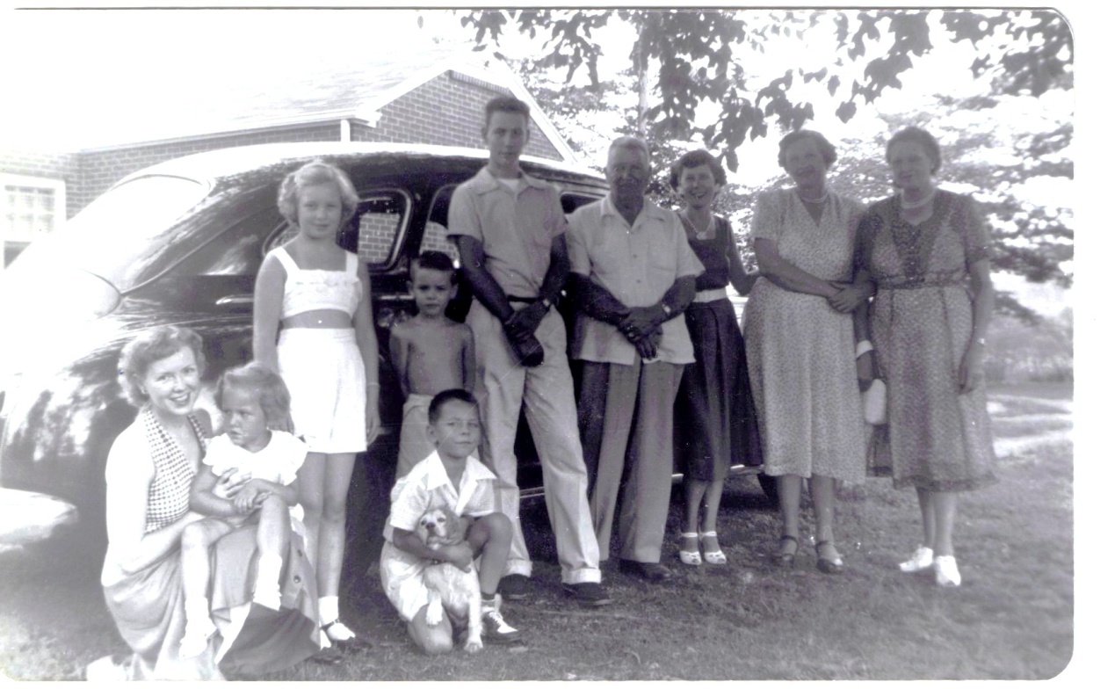

February 2 – “nice Brite morning…ground Hog seen its shadow. Went to bank….payd lite (bill)….had my lite Stove fix’t…cost 50 cents.”

February 3 – “washed went to Scates(?) to correct a mistake…mrs. Carmack Buried to day.”

February 4 – “Sunday, mayme and children ate diner with me…nice day…been in all day…not well.”

February 5 – “Monday Feb 5…Paid mr Vane one doller, irond, Worked on quilt …nice day.”

February 6 – “Tuesday…Feb 6th…Worked on erah(?) Book…Got letter from TM.”

February 7 – “Wednsday Feb 7th…Washed, wrot to Toby…the Jewel Tea man cam….Paid him a Doller. Got coffee and chips(?) soap? For washing….mr Dyer move yesterday.”

February 8 – “Thursday Feb 8…worked on bufft Pilow…Went to aunt mary sheets after noon.”

February 9 – “Friday Feb 9th…Very cold…work’d on Pillow, irond. Just freezing cold…man came fi’t camode frose up…”

February 10 – “Saturday Feb 10th…Very cold, watter pipes Frose up last night…finished Pilow…orderd Mayme a Half Ton of coal. Mr John B Redford died Early this morning…”

February 11 – “Sunday Feb 11…Very cold dident go out to day not well.”

February 12 – “Monday Feb 12…Very cold Snow’d last night…2 of John Grabeats boys stop’t in the a.m. GW Osborne neffues (nephews), his Sister boys, Tabnithe Osborn Grabealy. (Graybeal) BL came for a few minutes…Pearl came for a few minutes…She Sed mr Tise wicox died this morning at Damascus VA.”

February 13 – “Very cold…don’t get out in cold…got letter from alice & ?Hallie.”

February 14 – “Wednsday Feb 14 …nice day Valentine to day…mr matern went to knxoville to day…Linkerns Birth day yesterday.”

February 15 – “Thursday Feb 15…nice warm day…Washed mrs Poor – myself…Went up to mr. Matern to her a semon from mr dosey over Radio.”

February 16 – “Friday Feb 16…Went to mrs Harkroden after milk.”

February 17 – “Saturday Feb 17…irnd…went to mrs ervins (?) after Paper.”

February 18 - “Sunday Feb 18…stayed home all day not Wel…Got supper for mayme & children…Mrs Lindamood came in fro While till time for preaching.”

February 19 – “Monday Feb 19…Very bad day raind and turned cold…couldent go out..not Well.”

February 20 – “Tusday Feb 20…very cold ever thing freesing up…got letter from Bill & anwerd writing to TM.”

February 21 – “Wednsday Feb 21…started TM a letter went to Bank of Bristol drawd 12 ½ dollars y Deposit money I had in Bank…Got Charles Jr a par of Shoes.” The only son of Charles Stansbery, Sr., Geraldine believed Charles Jr. harbored a life long animosity toward his father due to the divorce and financial stress of the family. However, in a visit in July 2009, Geraldine’s half sister, Nancy Stansbery Higginbotham reported Charles had sent a Christmas card annually to his father. Charles Sr. had lived with his new family of wife Lee and two daughters, Nancy and Jean (1944-1999) on his brother Cecil’s farm in Afton, TN. A former store owner, tobacco and hog farmer, the last years of his life he worked at Magnovox, a 1950s television plant in Greenville, TN. “Got some Groceieys …Got 12 lbs Bag of floer, cost 50 cents.”

February 22 –“Thursday Feb 22…today is Washington’s Birthday …awful Bad day…rain a while…then snow. Rutheford Hall’d me a half Ton of Coal.”

February 23 - “Friday Feb 23…Cold. I washed ..got letter from TM…Charles Jr com put coal in coal house.”

February 24 – “Saturday Feb 24…irond Very cold is Snowina…Charles Jr went to Bank…Geraldine and his money (obsure) in ghbal money.”

February 25 – “Sunday Feb 25 it’s a bad cold time…got up tis morning the 25 of Feb with a big snow on the ground.”

February 26 – “Monday Feb 26…awful cold and bad time…got letters from Pauline and an card…ever thing freesing.”

February 27 – “Tuesday Feb 27…very cold…got letter from Calie? Snyder…answered it.”

February 28 – “Wednsday Feb 28 to day the last day of Feb 1934…very cold ground white with Snow. Mr John Berry died yesterday at 10 clock at the Hospitle.”

March 1 – “march Thursday…march 1st…kinder warmd up thawd up today if Pearl writes…birth day…she is nice and warm… all most gon.”

March 2 – “Friday march 2…raind all day…I went to Bank got check cashed paid som Bills. Buried mr John Berry…bad rain day…got teller (telegraph?) from TM.”

March 3 – “Saturday march 3…raing and col. Washed. A Mr Colins & family moved in the Dyer house.”

March 4 – “Sunday march 4th…still raining Got diner for mayme & family…Mr matern & mrs nighterfer came for a while. Writing to TM.”

March 5 – “Monday march the 5th…nice day until about 3 came up with rain and wind lik march. Went to see aunt mary Sheets...she is Sick. Payd off the coffee and Tea Co. man and quit getting thing. Started TM letter, started roy letter, all so the old lady Pencion Papper (obscure).”

March 6 – “tusday mrch 6…bad day in all day not well…got letter from Alice Snyder.”

March 7 – “Wednesday march 7…this morn nice then it clouded came awful rain…Roby Howard and Wife and children came(?) Writing to me (?).”

March 8 – “Thursday march 8…Wet & cold rains most ever day.”

March 9 – “Friday march 9 …nice day, got letter from TM. Pearl com(e) dow(n) this evening.”

March 10 – “Saturday march 10…nic (she spelled nice ‘nic’ throughout her diary) this morning then got cloudy and just peppered the snow and very cold…Charles jr and Geraldine ate Supper with me. Maym went to mr Wosley offices to sine (send) papers to have Charles to help Support the children.” The inability of Charles Sr. to support Mayme and the children is recorded here, and corresponds to my mother’s memories. I remember her tears at his death in 1957. But in the 1930s, well, times were tough everywhere. Charle Sr.’s disability could not have come at a worse time.

March 11 – “Sunday march 11…Very cold stayed in all day growing White with Snow.”

March 12 – “Monday march the 12…nic sunny day but cold. I went to see aunt mary Sheets…she is very low exspecting her to die any time.”

March 13 – “Tusday march 13…very nice & warm…went to see mrs Mary Sheets…she is very bad…had several visitors today.”

March 14 – “Wensday march 14…very bad day it has raind & snowed all day turned very cold….I gave Geraldine a Doller to her a Par (pair) of shoes.”

March 15 – “Thursday march 15…nice day day went to see aunt mary sheets. Pearl & Doris & Pear (?) for a while. Pearl Brought me a dress… they was going to a Show.”

March 16 – “Friday march 19 nice day wash…went to mr owins for milk.”

March 17 – “Saturday march 17…Went to Town for grociery, irond, went for milk.”

March 18 – “Sunday march 18, nice warm day….Went to Sunday Shool & Preaching…dident go at night its raining. Writing to TM Osborne…writing to alice Snyder.”

March 19 – “Monday march 19…raind all day & cold, started TM letter, started alice snyder letter…stayd in all day.”

March 20 – “Tusday march 20…Went to Town, don som shoping, went to church, herd a very good sermon.”

March 21 – “TM married to day in Seattle. Went to church, herd a fine sermon by rev Kelly and a mr – mrs________ to conduct services.” Her son Toby remarried after the death of his first wife, Alta.

March 22 – “Thursday march 22…nice warm day …went to See mrs Sheets…she is very Sick…went to church…got a Protracted meeting.”

March 23 – “Friday, march 23, very bad day, raind most all day & turnd coald…went to church. Got letter from TM, got letter from Bill…washed today.”

March 24 – “Saturday march 24…awful cold, rind all day. Went to Church at night.”

March 25 – “Sunday march 25, last Sunday in march…cold & raining…wet to church and Sunday School…went to see mrs Sheets…she is very low. BL Brought me a nice lunch for diner.”

March 26 –“Monday march 26 – nice & warm , went to church, mailed TM Osborn and W N? Osborne som letter…went to See mrs Owen…she is sick.”

March 27 – “Tusday march 27 …very bad day, raind all day, turnd cold…Went to mrs vires)?) to a cotige Prayer servis…Went to church at night, finish my quilt.”

March 28 – “Wednesday marc 28…Very cold Thursday, nice and warm. Went to mrs Whites to cotige Prayer meeting, got letter from Tm.”

March 29 – “Thursday march 29…had cotige Prayer meeting with me…got letters from alice. Washed.”

March 30 – “Friday march 30…Went to church, went mr Charley Rittie for Prayer servis. Servis for old ladys.”

March 31 – “Saturday mar c 31…went to Town for grociery…Went to church. Sold 2 my Hens, killed one. Glatus Osborne from Damascus hear for a few minutes.”

April 1 – “Sunday, 1st…Went to Sunday chool & Preaching to day is Easter Sunday…this revival that been going on for 2 weeks closed to night…the Singer mr & mrs Walls Will leave in the morning…had a wonderful meeting…the received 42 in the church.”

April 2 – “Monday april 2…Wrot 4 letters, one to TM Osborne, 1 to roy Osborn, 1 to Bill Osborne, 1 to alice snyder. Got pension today.” As a Confederate widow Frankie received a small pension from the State of North Carolina. Remember, life savings lost in bank failure, no Medicare and no Social Security, no welfare or food stamps. Survival depended upon family, church and neighbors, not the government.

April 3 – “Tusday, april 3d…Mr – mrs Wilson come in (which family members?). Went to Bank to get check cashed. Payd some Bills.”

April 4 – “Wednsday april 4th, very Wrm had my (obscure) garden patch spaded & planted …Sun flower seed & som gladales & Potatoes. Got a packed from Alice Snyder of onions.”

April 5 – “Thursday april 5…went down to see aunt mary. Started alice Snyder a Packed of Flower plant.”

April 6 – “Friday apr 6 – wshed, went down to stay with aunt mary till mrs Lamberth went Dr Boors Bisriek(?).”

April 7 – “Saturday april 7, Went dow to the Polls voted, got diner for maym & children. Wrot TM Osorne, wrot alice Snyder, wrot Hallie Hower.” Howard

April 8 – “Sunday april 8 – didn’t go to church, sick, wrote 3 letters. Raining turned cool, cant go to church, wrote 4 lettrs to day. TM, alice sister & Hallie. Got card from Virlin Friday in new york.”

April 9 – “Monday apr 9…raind all day & turned cool, been tacking carpet strips, fixed finding.”

April 10 – “nice and warm, turned cool this evening, raining…wrote to Bill from 10 to 11 a.m.”

April 11 – “Wednsday april 11 (1934)…raining & Windy…ow cold it got in the evening.”

April 12 – “Thursday 12…got up this morning found the ground white with snow. Snowd most all day, looks life Winter, very cold & Blustery.”

April 13 – “Friday, apr 13…Washed, Streched curtins…mrs Frank Devenhort died last night at Hospilte…Went up to ther Home to see her to night…Mrs Poor and mrs masters went with me”

April 14 – “Saturday…come to Damascus to Pearls to spend 2 weeks to re up. Mr. Keys died this evening.” Later she wrote further: “Went to Anderson st church to mrs Devenport funeral then they taken her to Pine Flats for Burial…I went with them.”

April 15 – “Sunday apr 15…Went to church at 2 clock…Went to East Hill (cemetery) to Mrs Mcdowell burial.”

April 16 – “Monday apr 16…fixt carpet string…went to see aunt mary …Started TM Osborn a letter. Bill a letter…Pauline and one to California to the Dymen Co.”

April 17 – “Tusday apr 17 – “raind most all day, then clard of, went after milk.”

April 18 – “Wedns, apr 18 1934…Went to Town, got some onion Plants…set out som…Got mayme some cabig Plant & seed Peas.” Much later in the diary: “Went to see aunt mary.”

April 19 – “Thursday apr 19…cleand, howd, very cold and raind and stormd all day.”

April 20 – “Friday apr 20 1934…Washed, went to a Supper at the church.”

April 21 – “Saturday apr 21…haven’t done very till been sick…ordered (obscure) coal…been very cold. Charles Jr planted peas and set out cabage plants. I planted a few hills of potatoes.”

April 22 – Sunday apr 22…went to Sunday chool and church.”

April 23 – “Finish pillow. BL came over. Phoned for some tomatoes stick. Got letter from TM. Very cold. Put in coal…had to get more coal Saturday”

April 24 – “Tusday apr 24…set out cannies…come a very hard hail storm…Wrot to TM and wife, to Pauline, to alice Snyder. Helpt Jr plant his corn.”

April 25 – “Wednsay apr went to see mrs Sheets…went to prayer meetin.” Many pages later Frankie added: “mrs Poor was called to Mr Nutty to nurce mrs Nutty. Her baby died at 7 clock.”

April 26 – “Thursday apr 26…Set out Flowrs…worked in yard…nic & warm in the morning then turned cold.”

April 27 – “Friday, washed…cold and raining…went up to mrs. Materns…got me a jar gear of apple butter.”

April 29 – “Sunday apr 29, 1934…Went to sunday chool and Preaching in the evning 2:30 Went to Mr Jak Harkroad Funerl and to church at night.”

April 30 – “Monday, the last day of apr the 30 1934…nic day… Charles Jr sick…got pension. Howd my potatoes.”

May 1 – “Tusday may the first day went to Bank…got check cashed…Paid Bills nic warm day.”

May 2 – “Wednsday may 2…nice and warm…went over to Charles Jr…he is sick…Mrs Owens died at 8:30 tonight.”

May 3 – “Mrs. Owens buried today. Held her funeral at Anderson Street Methodist Church by Kelly the paster.”

May 5 – “Saturday – Set out tomato plants.”

May 10 – “Thursday may 10…very hot and dry. Workd in garden and yard. Went after milk…got letter from tm and wife…may they sent me a doller for mothers day. Will be Sunday may the 13…it all most dark...it has turnd a little coolder and has commenced to rain every thing is very dry.”

May 11 – “Friday may 11…Washed…Went after butter. Got letter TM, and mailed a doller. Pearl and girls came down.”
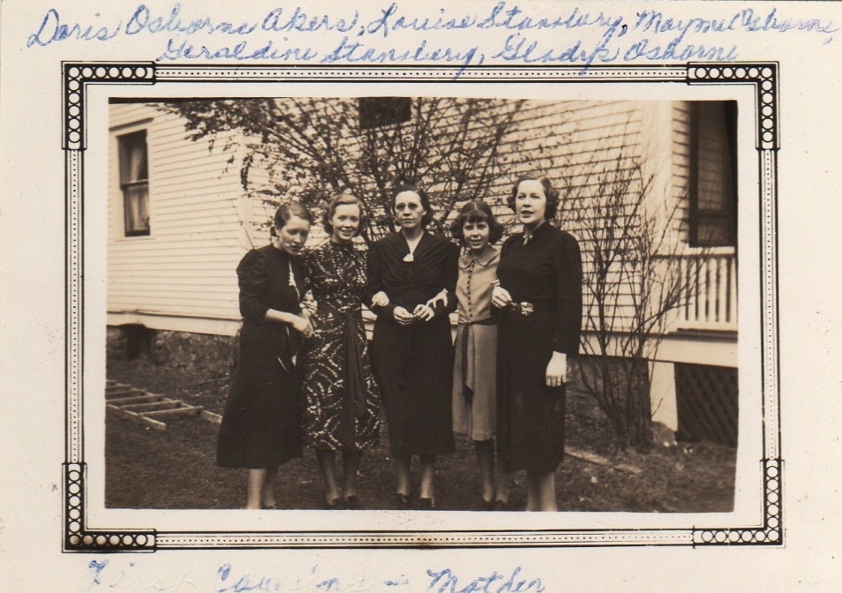Taken at the Dave and Pearl Osborne Wright home in Damascus, Virginia are Doris Osborne Akers, Louise Stansbery Sherwood, Mayme Osborne Stansbery, Geraldine Stansbery Holliman Feick and Gladys Osborne c. 1937.

May 12 – “Saturday may 12…BL com then roy and Lena com from cleavland Tenn. Spent the night… Mayme worked in the Elections…they all at diner.” These elections were local and state primaries.

May 13 – “Sunday…roy lena Went hom …I went to BL for diner from church.
Year uncertain - November 8 – “Saturday…Wash

Chapter VI – 1937 – 1940: Final Travel, a Marriage, Great Grandchildren, a Broken Hip, a Humble Will and Slow Decline as a World War Began

1937

January 25 - Telegram from Jim Proffitt, Boone, NC to Mrs. GW Osborne, Windsor Ave. “Mother died last night at one o’clock…Funeral tomorrow at 2 o’clock.” Mother was Jane Wilson Proffitt, Frankie’s sister.

April 16 – Fred Proffitt, Jane Wilson Proffitt’s grandson, graduates from Cove Creek High School, Ashe Co., NC.

1938

July 1 – “July the Firs …Leaving Bristol, moterd to Louisville Ky…Then from ther to Ill…We got Touris camp next morning.” Frankie described a trip to visit Charles Jr., then in the Army Air Corp, with Mayme and Geraldine. This was a long trip to Chicago, but notice even in 1938 how much time one could make even on single lane highways that went through towns.

July 2 – “the 2 at Breakfast, moterd til wer joind by Charles Stansbery Jr Chanuta…We Picked him up at Chanuta Field, Rintond Wher he tending the air corps technical chool…We visit many interesting places and Sunday 3 went to church…tendid church at the Methodist…after church we moterd back to Chanut Field. Dropt Charles Jr off…came back to Louisville Ky …spent the night.”

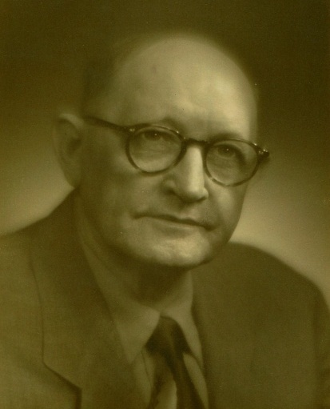
July 3 – “Left Chicago and left com to Louisville, KY. Back to Louisville Ky July 3…spent the night… Monday morning July the Forth taken Buss for owensborow to my Son B W Osborn at eleve Monday… stayd there about 2 week, then moterd back to Louisvil Ky…taken Train to Knoxville there my Boy roy Osborn met me…taken me to His home in clevland Tenn…I spent most 2 week…com back to Bristol my hom….” Right, Bascom Osborne, father of Doris Osborne Akers and Gladys Osborne Adema.

October 16 – “Sunda Octob 16…Went to Ruby Howard…Stade ther til Saturday October 24…to Pearl at Damascus…Stade ther till Monday October 31.” Due to her fall, this would be Frankie’s last trip.

November 17 – “November 17 1938…Friday the 17 fell, Broke my hip…fell Dow Basment Steps…Sending B W pic…I had a Peace a bout the Date… Doris and Baby came to stay with me till Bascom com Back from the Standing arma(?).”

According to Geraldine, Frankie tripped on the last basement step at the Morton House where she, Mayme Stansbery and Geraldine were living. Frankie wrote more later: “November 17 Friday…Fell down Basement step…Brok my hip all off.”

Newspaper account: “Mrs. G.W. Osborne of 930 Windsor Avenue, received a painful injury at 4:30 o’clock yesterday afternoon when she fell and broke her hip as she was going down the stairs into the basement of her home.

She was rushed to King’s Mountain Memorial Hospital and admitted under the care of Dr. Harry Bachman and Dr. W.R. Rogers.

Mrs. Osborne, 87 years of age and well known in Bristol, has been noted for her excellent health. At the age of 80 years she made a long trip alone through Canada and Alaska and down the Pacific Coast.

During the past July she went to Chicago with friends and on the return journey she left them at Louisville and went on along to visit a son in Owensboro, KY. From there she went to Cleveland and returned to Bristol.”

Geraldine has stated that her Uncle Bishop Osborne, who worked for King’s Department Store but also wrote for the newspaper and composed poetry, always exaggerated. He certainly did with G.W. Osborne’s obituary in 1927, and, if he wrote the above piece, he lengthened Frankie’s trip to Washington State to include Alaska which she did not visit.

Below is an article written not by Bishop Osborne but someone of a more feminine nature. This describes the activities before the ill-fated marriage of Louise Stansbery, later Sherwood to Frazier King, the son of the King’s Department store owner, a wealthy family in a small community. Complicating this marriage, which lasted two years, was the reality that Mayme and Geraldine moved with the young couple into a new, large home in a more fashionable part of town. So two young people, from different backgrounds, set up home with the mother- in- law and daughter- in- law present! No date is given on this article.

Newspaper account: “MISS STANSBERRY, MR KING FETED…Miss Cooper, Mr. Hammer Give Buffet Supper for Bride and Groom-elect…Thursday evening at Mrs. Thomas W. Bradley’s, Euclid avenue, Miss Douglas Cooper and Tom Hammer, Jr, were hosts at a buffet supper of especially beautiful appointments, honoring Miss Louise Stansbery and her fiancé, Frazier King, whose wedding on Tuesday evening is of especial interest to a large circle of friends.”

The guests were the members of the bridal party. The lovely blonde bride-elect was especially lovely in black velvet and corsage of rosebuds.

The lace covered table had for the central adornment a charming wedding scene, with the daintily dressed bride and hand some groom standing at the flower-bedecked altar, the giureines being about six inches in height. Surrounding the lovely scene were white pon pons, maiden hair fern and white asters. At each end of the table, dainty white vases held bouquets of palest pink chrysanthemums.

Today Misses Julis Johns and Julia Warren are entertaining with a luncheon for Miss Stansbery at the home of Miss Warren, Solar street, and tonight Turner Morison is giving a dinner party for the bridal party at his home in Fairmount.”

Undated News Article: “Frazier King and Bride-elect are Being Feted: Their Wedding Tuesday – “Frazier King, and his lovely bride-elect Louise Stansbery are being feted this week with lovely parties. Wednesday evening Miss Douglas Cooper and Tom Hammer Jr., were hosts at bridge honoring the couple. Saturday at noon Misses Julia Johns and Julia Warren are giving a luncheon at the home the latter on Solar Street for Miss Stansbery. Saturday evening Turner Morison will be host at dinner party of the bridal party at this home on Maryland Avenue. On Monday evening, following the church rehearsal, the groom’s parents Mr. and Mrs. Armin King will give a buffet supper for the bridal party at their home on Lee Heights. The wedding takes place Tuesday evening at 8 o’clock at Anderson Street Methodist Church.”

October 12 – Postcard from Louise Stansbery King, evidently from her honeymoon with Frazier King. “Dear Grannie, Hope your cold is all gone and you’re feeling swell…this sea air surely would help...everything is fine…see you soon…Love, Louise and “Sonny” Addressed to 933 Windsor Avenue.

December 6 – A letter from Hallie Howard of Mountain City states that Mayme is living with Frankie, taking care of her.

1939

June 19 - Newspaper account: “TO CELEBRATE HER 88 BIRTHDAY TUESDAY – Mrs. G.W. Osborne will celebrate her 88th birthday Tuesday, June 20…Open house will be held on Tuesday afternoon, from 3 to 5 o’clock at her home at 1100 Hill Street. Mrs. Osborne is very much improved in health and will be very glad to greet her friends.”

August 15 – “Maymie, Louise and Geraldine all left this morning. For chimna Rock NC to spend 2 or 3 week.”

August 22 – “”Kebler class Wher I Belong had our class to meet with mrs G.W. Osborne as she cant go …got her Hip Borken…the ten did to the Business of Circle and Had a Pick nic. Good time those present of our circle (Frankie then listed 19 individuals).”

August 23 – “Mayme and Louise and Geraldine Returd From chimna Rock NC…Sed they had a good time.”

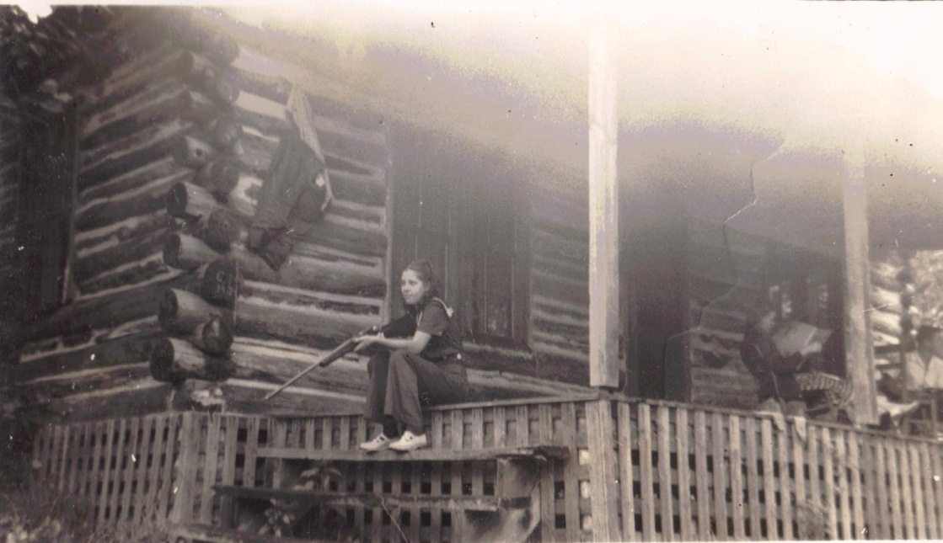
Geraldine Stansbery practices her shooting in North Carolina. Louis Stansbery and Vance Sherwood read the paper in far right.

1940

January 3 – “1940…Receive a packig from mrs B K Osborne From USS marblehead TPM San Francisco, Cal. Maymie and mr Evert at Supper with me to night.”

January 16 – “mayme Birthday Tusday Jan 16 1940…Louise and mayme ate diner with me. Mr marion glover Buried to Day…Good man. Roby Howerd and wife come for a While…a boy came with the…he is Mr Will Osborn boy from Walla Walla Washington, cousin of mrs. Roby Howard, mountain city Tenn.”

January 17 – “Had a big snow last night…got letter from BW Osborne…mrs Evert come in for a few minutes. BL dog named Trixa Died, a valuble dog.” Mrs Berry sick, critically sick.”

January 18 – “Wrot mrs Bettie Wilson, Shouns Tenn. Wrot mrs Howard at mountatin city Tenn – 18”

January 19 – “Friday 19…Wrot Pauline sumner Washington. Mr W B Cash to Hospitle at Abington VA.”

January 20 – “Saturday Jan 20…wrot Charles Jr. Coldest day…Frazer King other partys went to Washington to spend week. Mayme and the girls com over Sunday night for a while, very cold.”

January 22 – “nic sun shing brite…B L Osborne came in for a little whil this morning. Got letter from mrs Bettie Wilson…Shouns Tenn. Pearl come from Damascus…stayd a little While…mrs cross com …lives on winsor avenue…Brought me a nic dish of krout.”

January 23 – “Mrs Tevis…Buried to day…awful Bad day…Big snow.”

January 25 – “mrs mayme Stansbery spent the day…Taken diner with me. Mr Charley Jones came…fixt my wheal char…paid 25 cts. Skating on street with ther skates..it an ice… mirtle crussel Went to Town…Went on Buss…sed it very cold out…big snow. Had a Bad Fire on Hill st…upper rooms of mr Beross Burd all the roof off and other damage.” Mr Chale Jones got him a new car.”

January 26 – “Mr TM osborn bornd Jan 26 18(7)86.”

January 27 – “got letter from Roy Osborne and a check From cleavland Tenn…got letter from Mrs BW Osborne, owensborough ky with a packig with pretty camanio gust lock.”

January 29 – “got letter from B W Osborne…from ownsborow Ky with money in it. Myrtle went to Town…get check cashed….Got letter from Rile Hensom from Vilus NC, Box 117 R 76.” January 30 - “Paid clide crowee one month grocery bill 9.82…mrs Bery sick…sent her diner to Her.” This is Rile Hensom, Jane Profffitt’s daughter, Marilla ‘Rilla’ Proffitt Henson. Mary Proffitt Wilson states that her Aunt Rilla Henson talked like a sailor. - CWG

February 2 – “had a awful snow storm this morning…this Evning nic and then sunshining…the old Ground Hog seen Himself.”

February 4 – “maymie and Louise came in for a few minutes as the came from the church.”

February 5 – “got letter from Doris with 2 Doller in it…sweet of Her. Leroy m Osborne was Bornd February 17, 1879.”

February 7 – “Pearl as in for a little while today…Brought me some milk.”

February 9 – “mrs Dove come in For a Whil to day.”

February 12 – “Bishop com in for a Whil…He isn’t wel.” Wrot to Glatis addressed 39 West Balcom st, Buffalo, NY. Got card from Pega Jo...Got Letter from Charles Stansbery jr….Started valentine cards out to Geraldine, Lois anne to Little Bennie and Pega Jo.”

Below is a 1954 photograph in Johnson City, Tennessee at the home of Geraldine Stansbery Holliman Feick. Left to right, Louise Stansbery Sherwood, Becky Holliman Payne, Melinda Winston, Glenn Holliman, kneeling, Vance Sherwood, Jr., Bennie Winston, Dave Wright, Geraldine, Pauline Osborne Smith and Pearl Wright.

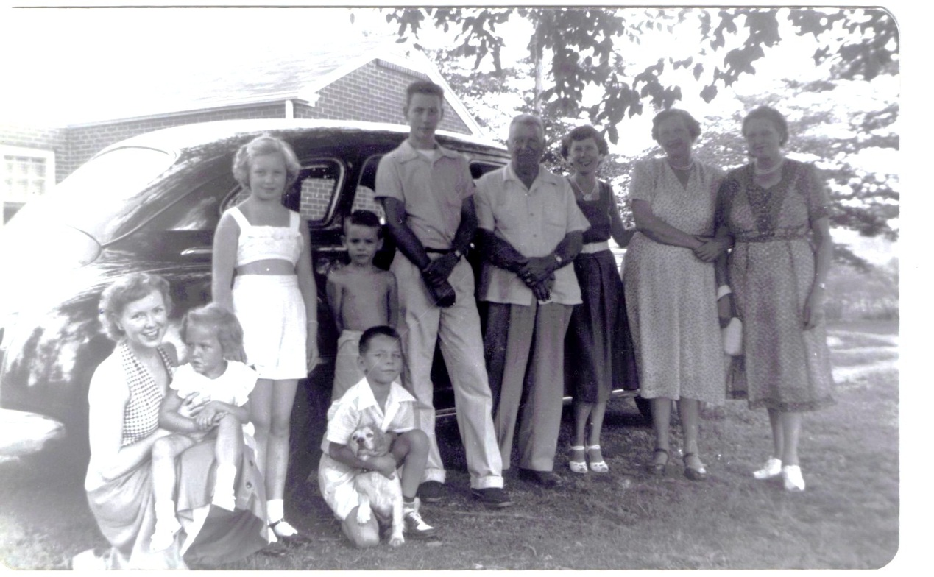

February 14 – “Got card from Pegie Joe adams…Finished stretching curtens. Tund cold last night…raind then snow this morning ..a awful snow storm…got Valentine card from maymie, lovely one. Mrs george Ste sent me a lovely bunch of fine rosies from valentine.” Peggie is Margaret Adema, sister of Bob Adema, and aunt of Philyss Mink.

February 15 – “maymie ate diner with me…Louise ate diner with me. BL came today for a few minutes. Mrs Kebler come today for a little while. Got letter from BW and Adie today. Sed this got the packig with shoes.”

February 17 – “Started Mrs. B.W. Osborne a packig…ther was Shoes in it.” Later she wrote: “February 17 1879, Leroy M. Osborne Bornd.”

Below Bascomb Osborne and second wife, Ada.
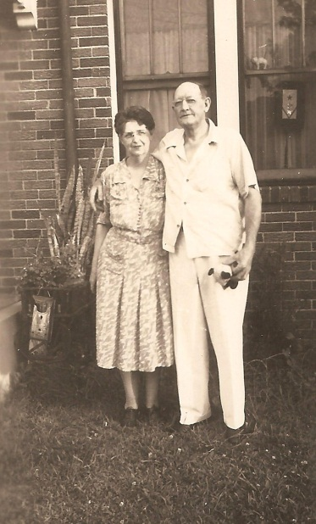
February 18 – “Sunday the 18…maymie and Louise Brough my diner to me, a nic good diner.”

February 20 – “B L came yesterday…Brought me several nice things for my supper. Mayme-Louise-Geraldine…for a while last night.”

February 21 – “Pearl Wright and Doris Akers came this evin for a few minutes. Myrtle Crussel girl Lives with me…been washing curtens.” Doris was Doris Osborne, the niece that Pearl raised as a daughter.

February 22 – “Washington Birthday…Had maymie Stansbery and Louise to take diner with me.”

February 23 – “Receivd Letter from Sumner Washington telling me that Pauline Osborn Smith was in Hospitle…Been operated on for pendicks.”

February 26 – “Sunday, Bishop Bought me a nice Lunch for my diner. Maymie and the girls come for a few minutes. Pearl com for a little While…got letter from roy and check…maymie spent the evning with me.”

March 1 – “This march first, Thursday 1940…Pearl Write, Damascus VA, Bornd march 1 1890…Pearl Wright Birth day to day…Got leter from BW – Ada Osborne Owensborough, Ky and money….wrot Launie Milum…Paid mrs Kayler houce rent – 26 dollars.” This is ‘Lunie’ Wilson Milam, daughter of Richard Franklin Osborne and Martha W. Forrester. CWG

March 5 – “Pearl come sed she as going with the Wind, som kind of a Show.” This was, of course, the first run showing of what is now a much viewed classic of the Civil War, “Gone with the Wind.”
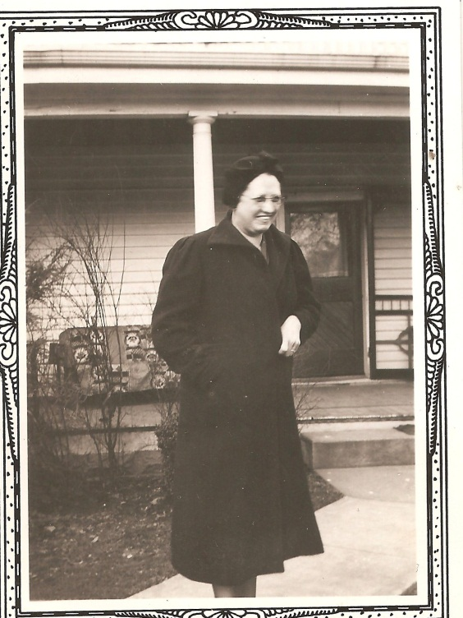

Pearl Wright, resembling very much her younger sister, Mayme Osborne Stansbery, in this photo.

March 6 – “maymie come…Spent the evning with me.”

March 9 - - “mrs maymy Donly and daught com…argues, Wilson and wife com. Sunday, maymie and Louise com for little while.”

March 13 – “mrs E Trainham died this moring, age 56. Pearl come today for a while…maymie come evening.”

March 19 – “mr Gellacores moved from Kaylor partment Tusday, March 19 1940.”

March 22 – “Got letter and Easter card and a Doller From Pauline, Sumner Washington.”

March 23 – “Pearl Wright come…Brought me a Big fat hen and a lot of grociery for Easter…myrtle Crussel Went to Town…got her a coat and Dress and hat. Louise gave her a Pickbook and glover. BL came Brought me some Fish….Core and BL came for a few minutes. Mayme and Louise and Geraldine all ate Easter diner with me., Sunday march 24 1940.”

March 24 – “Easter…Snowd all day and very cold.”

March 26 – “Mrs Feigan varnished my Davenett…Got a cheq from mrs Dunan with a large peac of country Ham.”

March 27 – “myrtle went to Bluff City to Her Sister to see a sick boy and mrs. Feigan Spent the Evning with me. Mrs Shutter com.”

April 1 – “moved from Mrs Kaylors apartment on Winsore Ave 1131 winsor ave Bristol Tenn to mrs Heniger 900 Hill st, corner of 9 and Hill street.” The last move!

April 5 – “maymie came over this evning…put up curtens. Mrs Barr com in this evning for a While.”

April 6 – “Saturday 6 april…mr kenkad died. Got ton of coal…mrs Belia Osborn of Hemlock ??...Lacked less than three moths of Being a Hundred years old…Died at her Home last Saturday evning…Mrs Osborn was the wife of the late Noah Osborne.” Frankie mentions the death of her sister-in-law ‘Belia’ Celia Graybeal Osborne 1840 – 1940, wife of Noah Osborne 1838 – 1916. CWG

April 10 – “Louise got mump this april 10…got Letter From Bob Wilsons…mr Dally combs, Buried today, april 5.”

April 8 – “Monday 8…mr Kinkaid Funderl at Anderson st…Rev Kreger held.”

April 10 – “We ha had a very cold spell…Snowd april the 12 Friday 1940.”

Frankie throughout the spring of 1940 recorded the birthdays of her children, and not on the anniversary they were born. Perhaps reflecting on each one of them gave her pleasure in the last spring of her life.

“Bascom W Osborn Bornd July 5 1887.”

“July 22 1892 William V Osborne Bornd.”

“December 13 1881, Bishop L Osborne Bornd”

“Maymie T Osborne Bornd January 16 1896.”

“January 26 1876, Toby M. Osborne Bornd”

Below Toby Osborne when incarcerated in a Wyoming prison.
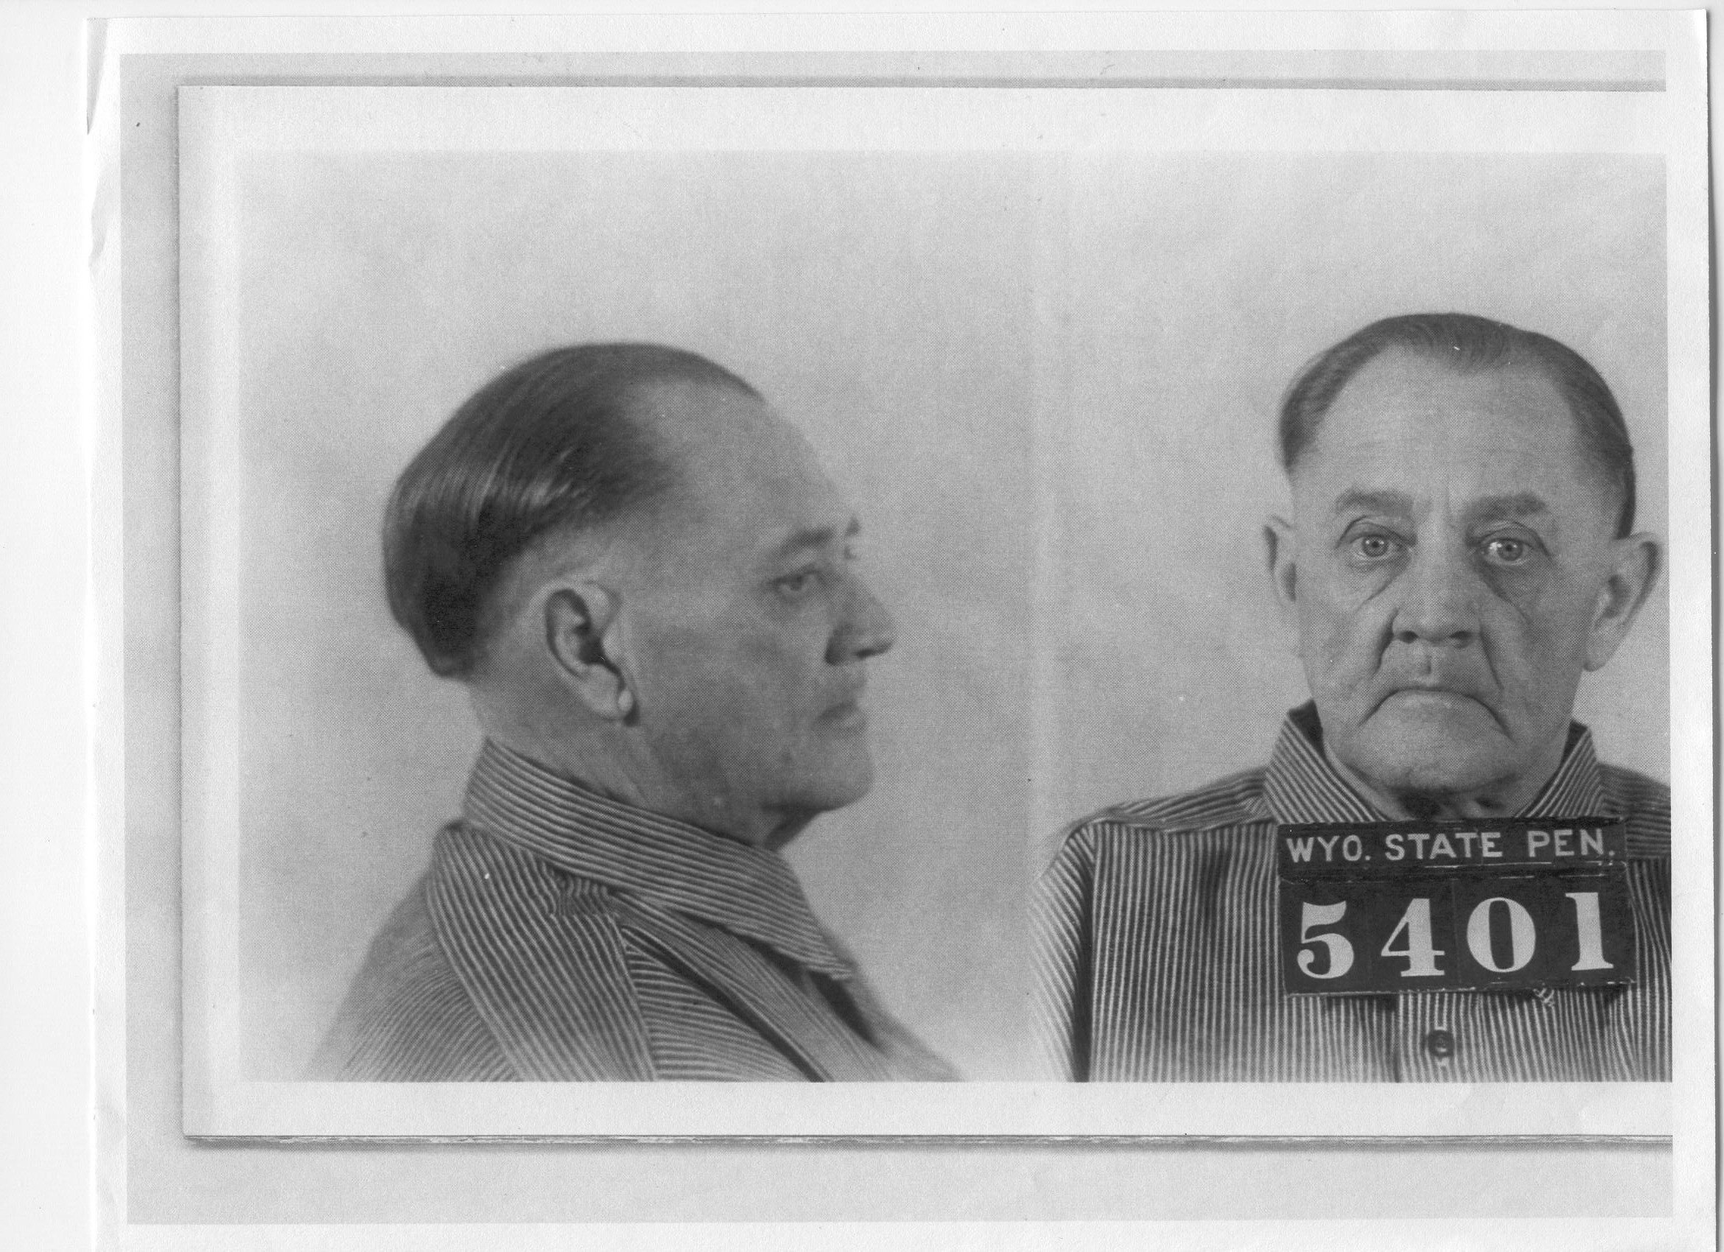

April 13 – “Saturday april 13, 1940…Geraldine Stansbery were selected from the Home economic Department of Tennessee High chool to go to Knoxvill to model at UT dresses that had made.”

April 18 – “Thurday April 18 1940…mr Colwell Buried to day.”

April 22 – “Tusday Albert Franklin Seymour Buried today…Kiled him self … evidently shot himself Sunday.”

April 27 – “April 27…Roy and Lena came…Spent the nig Sunday…then left for hom…cleavland Tenn.”

April 28 – “maymie and girls ate diner with me…spent the eving…fist time cinc Louise been out cinc had measel 4 weeks…maymie been cen Sicke…Got roys check chased to day – twelve 12 doller…pearl write From Damascus…came in a few minutes.”

May 2- “Jak Synder and Hallie came in for a few mitues…Got letter from jr…Wrot Brother W A Wilson.” This is Jake Synder and Hallie Howard. By this time, Alice Osborne Synder, Jacob’s wife, had died. CWG

May 12 – “Sunday may 12 1940…This is mother day…maymie, Louise Brought my diner…it sur was nice and so many good things…that evning about 3 Pearl from Damascus came in with a nic Basket of many good thing to eat. We had a feits (feast?) then a famon com…We surrenround it…Doris – Her Husband com…from Damascus…Doris gav me a doller…Had several vaster mother Day…Pearl gave me 2 doller…Pauline From Sumner was Sent me 1 doller.”

Doris Osborne Akers and her husband, Elmer ‘Flea’ below in a charming photograph. He met Doris while working for the Civilian Conservation Corp in Damascus, Virginia in the 1930s.
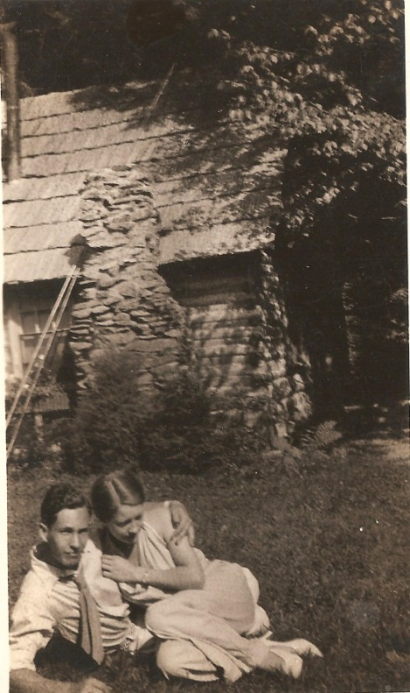

Frankie added another May 12 entry several pages on. This one gave a hint of Louise Stansbery King’s future.

May 12 – “Sunday may the 12..mothers day…maym and the Girls moterd to Chilhowie to a Friend, Mrs. Sherwood.” The next year Louise, now divorced from an unhappy marriage with Frazier King, would marry Vance Sherwood of Chilhowie, a successful marriage that would
last until Vance’s death in 1990.
. 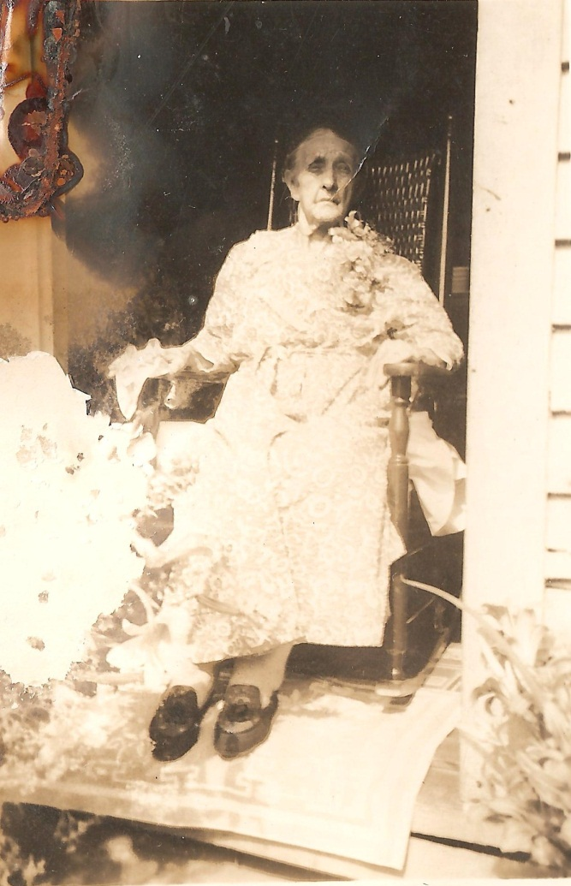
Probably the last photograph of Frances Wilson Osborne taken on Mother’s Day 1940.

May 14 - “Mrs Lenard married today May 14 1940.”

May 15 – “Mrs Lenard Died…mrs Bill Sruvivied today….Died to Saturday may the 18 1940.”

May 18 – “Pearl Wright of Damascus Bought me a ice Box…sent me…first time had ice was Tusday the 21st.”

May 22 – “Wednsday, may commenced 22…getting milk from mr Miler.”

Frankie’s sentences, never very grammatically correct (as are most diaries) began slipping on this date. The words were more out of order and/or more of them were missing. Take for example, this emotional evening:

May 26 – “Sunday may 26…anderson street church member came …Had old Time singing and Prayer at mrs G.W. Osborne came all enjoyed it so nice it was a Pleasant evning and a Happy one to me seting her in my invaled char was 20 of them come.”

May 30 – “Thursday may 30…Mr Howard with wife and children come for a Whil…Jake Synder and Mrs wagner from Kingsport came.”

May 31 – “Friday may the last day…mayme is going to start having Her Teeth puld then have her a plat made. The last day of may cold…had to hav a Fire…Maymie came, Spent the evning…Had a Hard Rain.”

Frankie in another diary recorded what must have been a horrible ordeal for Mayme.

May 21 – “may 31 1940…Friday last day…Mayme Started to Have all her Teeth Puld…Had 4 puled.”

June 5 – “Pearl came Wednsy.”

June 8 – “Saturday…Doris and Earl came…Brought me some grociery.”

June 8 – “Mayme had 4 more teeth Pulld.”

June 17 – “Got letter from W A Wilson, my Brother from durm NC and a doller for Birthday.”

June 17 – “Monday…Frazer King left at 7 clock for Washinton.”

June 17 – “Maymi had 3 mor teeth Pulld.”

June 20 – “Thurdsday Jun 20 my Birthday..got many nic Presents. And cards and money in the evning at 3:30 Keblers Class wher I belong met to have our circle meeting…the were 13 her…we servd cake and punch…tha wer another present mrs Write rom Damascus, me maymie Stansbery Geraldine and Louise.”

June 23 – “Mayme had 3 more Teeth Puld.”

June 26 – “Having my kitchen cabnet painted.”

June 30 – “Sunday June Last day…mayme and the girls come over for a few minutes.”

July 4 – “B.W. Osborne from onwssboro came spent the day and night with His mother mrs GW Osborne…He left for Home this morning…maymie and Louise and Geraldine taken diner with her mother mrs GW Osborn that 4 of July.”

July 5 – “4 more teeth puled.”

July 9 – “maymie and the girl Louis and geraldine left this morning to maron VA to spend a few days in a cabin at the river.”

July 13 – “Saurday July 13…maymie and the girls came back from the cabin in VA on a vacation of a week.”

July 14 – “Sunday 14…maymi Louise Geraldine at dine with”

July 16 – “Wrot Bascom to day, Wrot Betty to day, Wrot Bill today.” What else she wrote that day was her will, written by her on lined note paper, unwitnessed and merely signed ‘mother’.

“Tusday July 16 1940…Thing after I Pass…thing When I am gon…to be divid and som to sell.

2 Big Bed steid, matres and spring
1 Foding cots and springs and matris
1 Devnet, 1 ward robe, 2 Rocking chars, 1 kitchen cabnet, 1 Gass stove, 1 Little Shelf for dishes, 4 chars, 1 stool, 1 little cook Table, Some Pictus and ice box…

1 the Dresser belong to Pal.

1 the Fallen Leaf tables is maymie.

That larg Pictur Hanger on the wall… that Flowr Stall is all so maymie.

The End Table the what not and the Footstool and thoses large Pilow & slips ar Geraldien…

The larg Picture Wher Christ naild to the cross, thes Picturs of Papa and mother, the charm string and Donut Jar ar Louises.

I want Pearl and maymi to devide all my things between them…devia dishes and beding if I have any little thing you all want ther is a few things her that I give to each one …you Will don’t want any hardness when you Both get what you wan of my thing of any kind. Put in that round Top trunk…sent to Better…ther is a few little thing…I have give when I get don with them…the water Jar, Jugs Pitcher that Kregr gav mamyme, that Donut Jar Louis thoses little thing as clock, bed lamp and soap dish and other…all the Pilos are mayme except that one frund Bed…thse larg one ar Geradins and 4 par of slips for them…- mother”

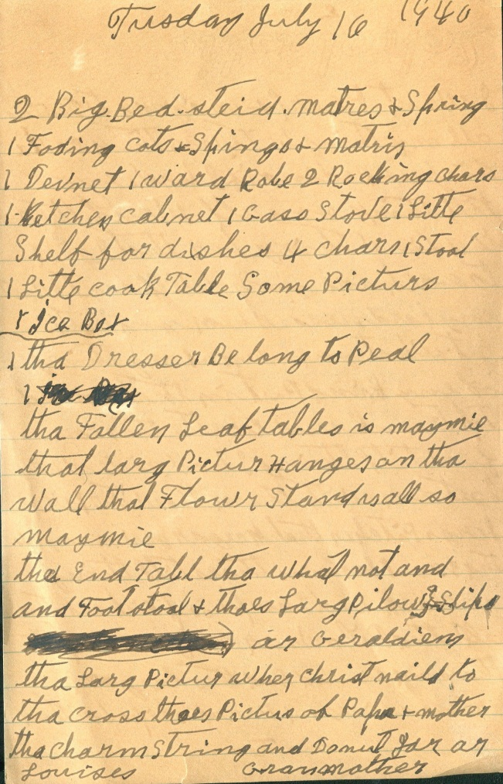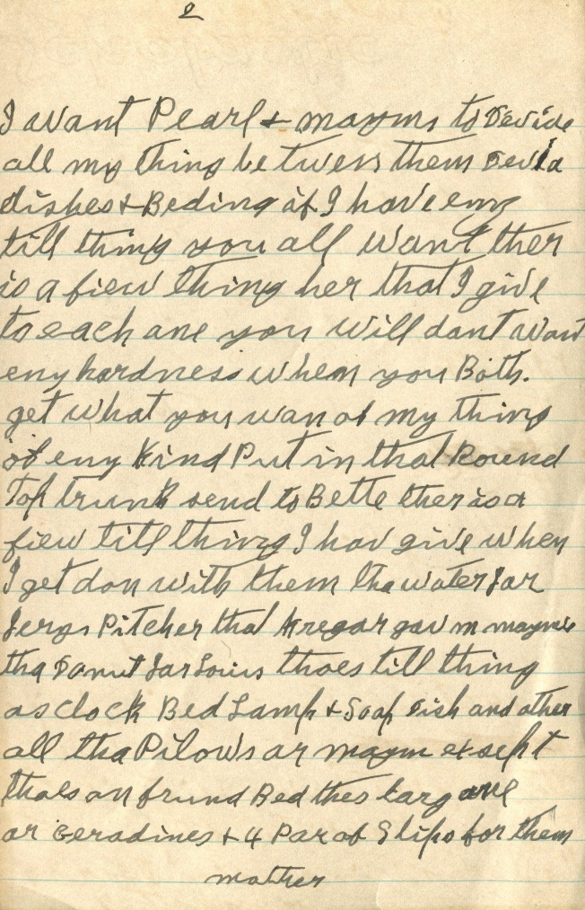
And these were all her worldly goods….

July 18 – “mr Rile Stone, Buried monda July 15…Pearl in for a few minutes…came to Bring Dave to Doctor.”

July 20 – “Saturday July 20…Doris Baby Bornd at one clock.” This baby was Phyllis
Acker Mink, Radford, VA, a cousin who helped proof this transcription. On the next page Frankie wrote on this date: “Pearl and Dave came…I got real Sick…had the Dr.”

July 21 – “Sunday July 21…mayme and Louise at diner with me.”

July 22 – “Monday July 22 mr Buck evert died.”

July 23 – “Dr Dulang died.”

July 26 – “Friday July 26…maymie had 2 teeth puld the last one.”

August 10 – “Friday 10…Bob Wilson came for a few minutes.”
This would be a last visit from her brother. Below Bob and Ellen Wilson Wilson.

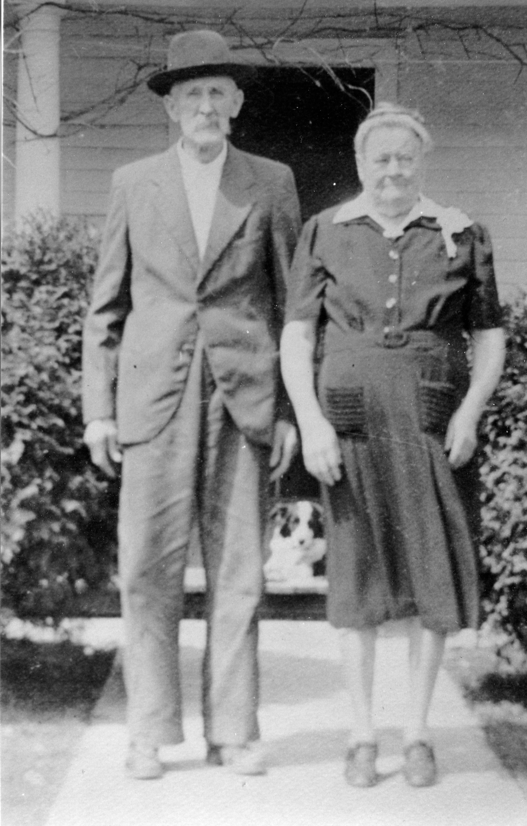
August 11 – “Saturday mayme Donly com… Mrs Margret Danken in Hospitle King memorial.”

August 24 – “Roy Osborne and Lena spent lat nigh with me on ther way back from Maralin to cleavland Tenn their hom…mrs GW Osborn….”

August 30 – “august Friday 30…Pearl com got my Wheal char this evning.”
Frankie’s handwriting became shakier at this point.

August 30 – “Got my wheal char augst 30 got Wheal char…Pay 1.30 doller a month until payd for.”

As if recording for family history or perhaps just reflecting, Frankie wrote this of her husband of 60 years.

“G.W. Osborne Had a hemerg of the Brain August the 8 year of 1925 and Died June 30 at 6 clock Thursday morning at –Here Frankie trailed off, but we know G.W. died 1927 in Knoxville at a hospital.

September 2 – “Laber day, Monday Sept 2 1940…mr Price and Florine his wfe and Ekee Florence mother com….Roby Howard and Hallie and Bettie Wilson all came.”

September 9 – “Rev Bashmand in for little While…Had Prayer with me.” The Methodist ministers were now visiting suggesting that her health had deteriorated.

September 17- “mrs Stanfred and Her Boy ate diner with me.”

September 20 – “Rev Walter Fagan com in for a little whil…Had Prayer.”

September 22 – “maymie and Louis at diner with me.”

September 23 – “Monday Sept 23 1940 – 76 inlisted Bristol Boys left this evning for Fort Jackson, 3 pulman cars of boy for training for a year. This was the 1940 peacetime draft, and yes, these boys served more than one year! World War II was drawing closer to the Osborne family. Mr Sam Odel Died at 9:45 Wilson st, Bristol Tenn.

Rev Walter Fagan left this morning for home in Florida…been her on a visit to see his mother and other friends.”

September 25 – “maymi and Louise Brought milk and my diner.”

September 27 – “Friday…mrs Effel Biebe com all so mr & mrs Price…daughter of mrs Biebe. Mrs Gerett Harman spent the day here…her Home in akron ohio. Pauline Osborne Smith Birthday…Here Home in State of washington, Sumner.”

October 2 – “Pearl come in for a few minutes. Mrs Will Ensor com today and got one dollars worth of coal to. Paid 3 doller on Wheal char.”
October 3 – “Got letter from Charles Jr Stansbery today.”
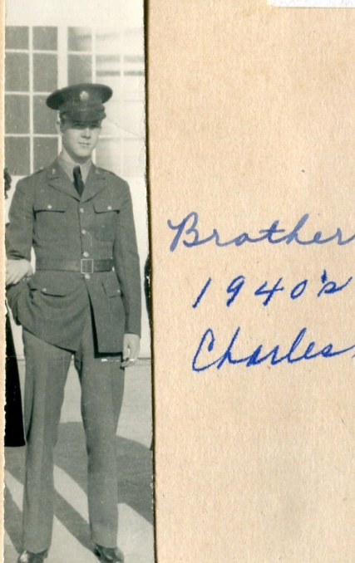

October 8 – “Tusday oct 8 1940…Doris Aker from Damascus and Baby and her Sister mrs Glatus Adams (Adema) from new Jersy (Buffalo, NY).”

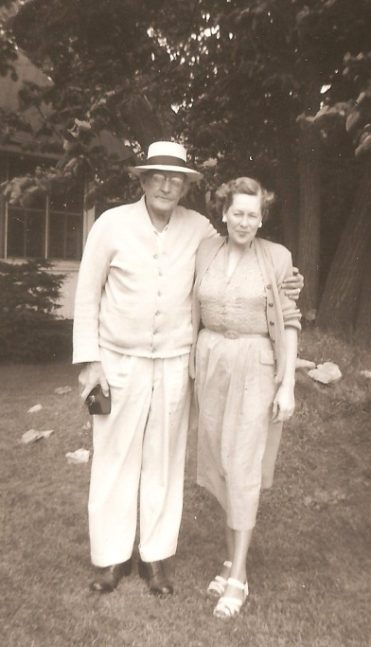 Bascom Osborne and his daughter, Gladys Osborne Adema

October 9 – “maymie and Louise had a ton of coal put in my coal house barn the 9 of oct.”

Ironically Frankie’s last written entry refered to her son-in-law who in the first entry of this diary in 1912 gave her that first automobile ride. Frankie never learned to spell Cleveland, Tennessee or to capitalize her son Roy’s name.

October 10 – “Dave Wright and Pearl Stopt in today as they was on ther way to roy Osborne cleavland Tenn oct 10 for a week vacation.”

Below Pearl and Dave Wright and Doris Osborne Aker’s son, David at Damascus, Virginia in late 1940s.
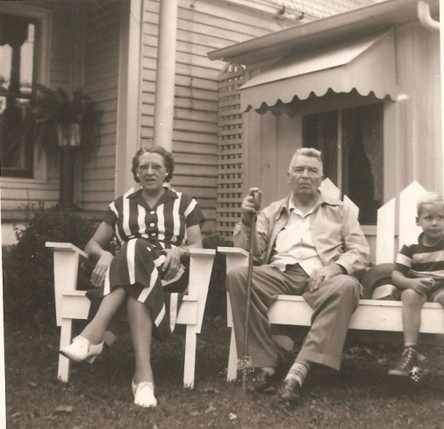

This last diary was a pad of 2 ½ inch by 3 ½ inch note paper with the words 1940 in large letters separately attached as a monthly calendar. “Holding” this paper and calendar is an ante-bellum young girl, looking a lot like a character from “Gone with the Wind”.

On November 9, 1940, Frankie died and was buried beside her husband, George Washington Osborne at East Hill Cemetery, Bristol, Virginia. They had first met in the furnace of the Civil War as very young people, summer 1864 and married January 7, 1867

November 9 - In writing on the back of a miniature Confederate flag: “From DCV (Daughters of Confederate Veterans), Galax (VA)…wreath to Grannie, November 9, 1940”

Her earliest memories were of the Civil War and the violence it inflicted on her family. At her death, another World War was raging in Europe as England fought off German air forces. By 1944, her beloved grandson Charles Stansbery, Jr. would be stationed in eastern England keeping B-24s in the air against Fortress Germany. Another grandson, Bascom K. Osborne, would serve in the Navy in the Pacific.

Frankie’s death would enable Mayme Osborne to move with (see below) Louise and her new husband, Vance Sherwood, to Philadelphia, Pennsylvania in the summer of 1941. Geraldine Stansbery would go also, and graduate from high school in Philadelphia. Vance would serve briefly in the U.S. Army before a discharge to take care of his wife, sister-in-law and mother-in-law before moving in 1944 with Louise to Knoxville, Tennessee. Vance and Louise gave life to Vance Sherwood, Jr., December 7, 1946, their only child.

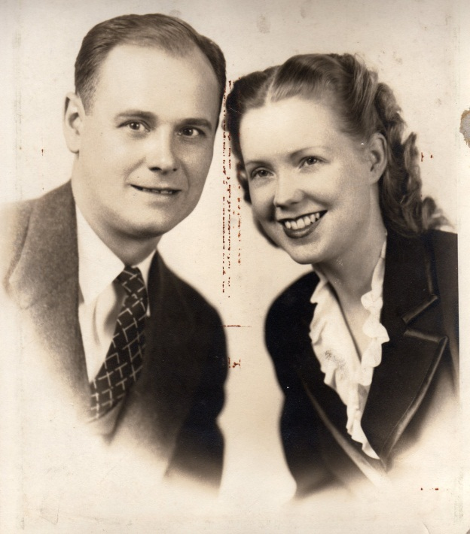

The summer of 1942 at Atlantic City, New Jersey, Geraldine Stansbery, accompanied by her mother, Mayme Osborne Stansbery, would meet a young sailor from Alabama, one H. Bishop Holliman. Mayme would die young in December of 1943 of internal infection. Geraldine and Bishop would marry in Germantown, PA on June 26, 1945. After three children, that war time marriage would dissolve in 1988.

After a whirlwind, five week courtship, Charles Stansbery, Jr. married Anne Dulith Smith of Philadelphia, the girl he met in 1943 at the local Stage Door Canteen. Charles Jr., stayed in the Air Force and fathered Susan Stansbery MacKenzie, now of Boulder, Colorado. The marriage of Charles and Anne lasted until her death, 2002. Charles died in 2006, a few months after his sister, Louise Stansbery Sherwood (pictured previously with her husband Vance who died in 1990).

All of the above families would economically prosper and take part in the expanding abundance of the post World War II decades. The memory of the daily financial struggles of Frankie Osborne, Charles Stasnbery, Sr. and Mamye Osborne Stansbery would live on in the attitudes of their children. Later generations, benefiting from the prosperity of the late 20th and early 21st centuries, might well reflect on the incredible changes that took place in the lifetime of the Frances Wilson Osborne and how this good woman coped with adversity.

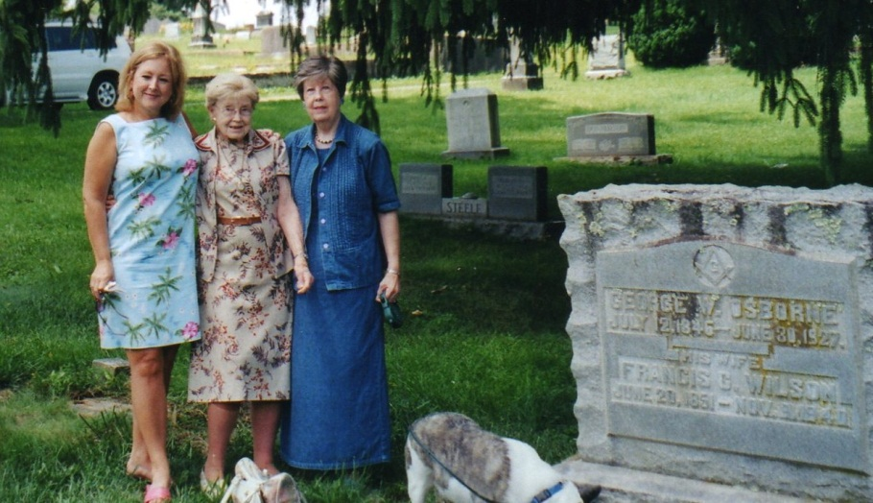
L to R, in 2005, Rebecca Holliman Payne (Geraldine’s daughter), Louise Stansbery Sherwood (age 90) and Geraldine Stansbery Feick (age 81), year 2005 at East Hill Cemetary, Bistol, TN. Gravestone is G.W. and Frances (Frankie) Wilson Osborne, natives of Ashe County, North Carolina and ‘veterans’ of the American Civil War. Louise died in 2006 and Geraldine in 2015.

Below email comments by Shirley Sorrell who read this manuscript in 2012.

1919 Reunion photo in Wilson Cove, Sutherland, NC: The guys on the ground are not Bishop. If Bishop is in the pic he must be one of the two on the roof.
William, the missionary son of John is man on ground on left with his three daughters. Yhe other man on ground is Arliebeside his wife Bessie and three sons. Son Ernest on porch below Rebecca and sons Boyd and Clyde in front of them. Bessie is oldest daughter of John.

I just found baby Charles....do you see him in Frankie"s lap???? Tthese are all the same 12 kids in the pic I sent you. I have looked at this too long tonight. How old was bishop in 1918? I think the darker man on roof closest to the two women in the window is William(1861), the missionary's son, William who married my great Aunt Callie in the window. (They were 1st cousins). I emalied a cousin Dale Wilson to see if he had this picture with names as his dad Argus was great for writing names on his pics. He was only 9 in this pic so I can't hold him accountable. Cousin Dale says he does not have this picture.
On Fri, Jul 6, 2012 at 1:04 PM, Glenn Holliman <glennhistory@gmail.com> wrote:
Shirley,

I think Mayme Osborne (1896-1943) is on the roof, in the middle, furthest back with my Aunt Louise Stansbery Sherwood (1915-2006) beside her. Standing on the ground with a hat on and his neck tie askew must be Bishop L. Osborne (d 1965), who wrote the goopy pages about the reunion. He wrote poetry and a column for the Bristol newspaper. I suspect his wife Cora is standing beside him. Has anyone every identified every one present that August day 1918?

Issac and caroline
John Wilborn Wilson (1855) and Rebecca Wilson Wilson(1862)
Mayme(spelled Mamie in some places)(1892)and Thomas Earl Donnelly
Deronda Wilson Donnely(1918) and Barbara McCall Donnelly
Shirley Donnelly Sorrell(1946)

Shirley Sorrell sdsorrell@gmail.com | 4:47 PM (5 hours ago)
to me

sept 25 is fine but that would be too late for clinton as he will be back in school.
Back to pic: Look at roof, the boy laying back on his arm is my great uncle Robert. no one could identify the one on left or the one on the right ( 3rd from the window). I think that is your Aunt Mayme holding Louise on the roof.The two guys on roof and the older lady to the left of column beside Aunt Emaline are the only ones not identified..See all those kids on bottom front are the ones in that group pic except for your aunt loise on the roof with her mom.
i really enjoyed reading the paper by your uncle bishop....so it is up to you to say which one he is. i have a cousin Dale who's dad was great about labeling everything. i am going to check with him...

August 4 – “1918…maym & children and my self all went to NC.” So the baby in my picture of cousins must be Charles. One of William Wilson’s girls is holding him next to Louise.

August 18 – “We had a reunion at Brother John Wilson all the living brothers and sisters was ther.” So Frankie has to be in that group pic where people are on the roof and porch. Someone recognized Em, so we need to look at pic again for baby Charles, Mayme, Louise and Frankie.
. - Mrs. N E Osborne
- Mrs. F C Osborne
- Mrs. P J Proffet
- Mr. John Wilson
- Mr. Robert Wilson
- Mr. William Wilson
Am thinking that the group pic of the 6 above siblings was taken at same time as the reunion and the cousin’s children picture I showed you Tuesday? And the group pic of all the family at John on the porch and roof that I gave you both copies on wedneday.

Shirley Sorrell sdsorrell@gmail.com | 11:37 AM (2 hours ago)
to me

i have looked at the three photos that i think were taken at the same time. the john wilson house with everyone on front porch and roof, the 6 issac wilson children and the picture of just the children. i have found your grandmother Mayme and aunt louise on the roof. no one had been able to identify them. you remember the copy i had written on identifying others. i have found my original of that picture on the back i had a sticky note that Jane profilt, and Aunt Frankie were sitting beside my great grand parents and emaline osborne was standing behind them. i am scanning for you just so you know what i am talking about.i can not get scanner to work today..my son is coming tonight, i will see if he can fix for me.
got to get ready for the beach with my kids and grand kids tomorrow. i will try to send it to you. sds

March 26 – “Charles Osborn & wife minie ate diner hear on ther way to oragan.”
This may have been the son-in-law of Robert Boyd Wilson (1860 – 1949), one of Frankie’s brothers. However, the book Neighbor to Neighbor lists this supposec Charles’ wife as Edna Wilson. Perhaps this Charles Osborne is more closely related to G.W. The Wilsons and Osborns were marrying kin with considerable frequency.

Did this Osborne family relocate permanently to Oregon, and is this why Toby Osborne would select the state in the 1920s as his new home?

This is Chall and Minnie Wilson Osborne(Minnie daughter to John and Rebecca Wilson)(neice to Frankie) His name may have been Charles. I have his obituary and will look at it. Chall and Minnie did live in Oregon. I have some pics of them there. They moved back to NC and lived in Sutherland. The house is just down the road from Wison cemetery. They are both buried in Wilson cemetery.

