Monday, May 16, 2011
The Hollimans of Alabama by Glenn N. Holliman
Alabamians Crossing Paths
During my recent sojourns to my native state of Alabama, I have been staying with my first cousin Mary and her husband Elliot Clayton (E.C.) Herrin. I have known E.C. since his marriage to Mary Daly in 1951. As am I, Mary is a 3 great grandchild of Cornelius Holliman (1792 - 1862) who immigrated to Fayette County, Alabama as a pioneer family from South Carolina in 1836.
Mary and E.C. have raised a family of four and now have six grandchildren. After service in the U.S. Navy and graduating from Howard College (now Samford University), E.C. in the 1950s worked as an accountant in the Birmingham steel industry. However, he had an ambition to be an attorney.
Below, the lovely Mary Daly Herrin, the year before her marriage to E.C. Herrin in Irondale, Alabama. Her parents are the late Robert W. Daly, Sr. and Vena Holliman Daly. Mary is the granddaughter of Ulyss and Pearl Caine Holliman, Irondale, Alabama and great granddaughter of John Thomas and Martha Walker Holliman, Fayette, Alabama. Her 7th great grandfather is Christopher Holyman, Sr. (1618 - 1691), the founder of the Holliman families of Virginia and America. On the Daly side of her family are Irish ancestors who engineered railroads in 19th Century Alabama.
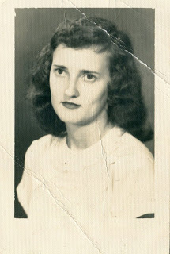
In a punishing schedule, strongly supported by Mary and the family, E.C. Herrin went to law school for years, sometimes three to five nights a week. In 1964, he passed the Alabama Bar and in 1967 became the municipal judge for the city of Helena, Alabama. In 2011, now 81 years old, he continues to hold court for the city twice a month. He is the longest serving municipal judge currently on the bench in Alabama, a distinguished record of service. He may be the longest serving municipal judge in Alabama history!
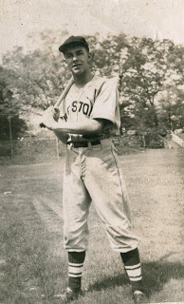
E.C. Herrin has loved sports all his life and played sandlot ball many afternoons as a youngster. Above he is in his high school baseball uniform in the 1940s.

A favorite childhood companion was John Thomas Vaughan, another youngster growing up in the Depression in a small town in east central Alabama. Born in 1932, Dr. Tom Vaughan became a outstanding veterinarian and served for 18 years as the 6th Dean of the College of Veterinary Medicine at Auburn. Today, the large animal hospital at the University of Auburn is named after the well-respected and well-known Dr. Vaughan.
These Alabamians Crossed Paths!
While these two children played their sandlot games prior to World War II, an old dignified Black man used to stop and watch. After a time, he came to know the boys by name. "Hello, Mr. E.C., Hello, Mr. Tom", he would say in the parlance of the pre-Civil Rights era. And in the societal manner of a different age, the two boys, eight or nine years of age, would respond to the ancient figure, "Hello, George, how are you today?" This happened on numerous occasions.
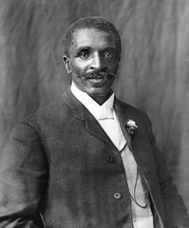
E.C. has never forgotten the kind, older African-American gentleman who died in 1943. Who was the man who befriended these two children? He was the distinguished Alabamian, a former slave who did his scientific work at Tuskegee Institute - none other than the legendary George Washington Carver, who revolutionized agriculture in the South! The above photo of Dr. Carver was taken in 1906.
More in the next post on the Hollimans and Associated families of Alabama....and paths that crossed....

