This photographic and copy tribute was prepared in part by Susan Anderson, the oldest grandchild of Helen Maude Osborne Anderson (1912-2004) who died earlier this month . The following foreword is provided by Jeanie Bond, a niece of Helen's.

Helen was born in Home Place, Skagit, Washington, the daughter of William Isaac (1869-1953) and Waneta Dreyer Osborne (1879-1923). Her paternal grandparents were Richard Franklin (1846-1897) and Nancy Emmaline Wilson Osborne (1850-1919) of Ashe County, North Carolina. It was Nancy's father, Isaac Wilson (1822-1864) who was shot from ambush during the Civil War while plowing his corn field. - Glenn N. Holliman, a great, great grandson of Isaac and Caroline Greer Wilson, 3/2014.

"Helen has two surviving brothers, Derward, mentioned by Susan, is 98 years old and C. Mark who lives in Texarkana is 95. My mother, her sister, died in 2009 at age 93.

The following photos are all that I have of Helen in my electronic photo database, and there are several supplied by Susan. I've included Susan's captions when I have them and the others are my description.

Here are a couple of things you should know about Helen's early life:

When she was 9 or 10 her mother gave Helen cooking instructions from the adjacent bedroom because Waneta knew that she was dying of kidney failure due to diabetes. Helen was 11 when her mother died in January of 1923. And the following September, Helen's older sister died of tuberculosis shortly after giving birth. Not long after that, the family was eating dinner when a bolt of lightning struck the pole near the house, traveled down the wire to the light hanging above the dining room table and caused the bulb to explode. Helen's response was, "God must really hate us."

Helen cooked and cared for her father and siblings from 1923 until she married Vernon Anderson in 1929. Her younger brothers and sisters, not wanting her to leave them, would throw stuff at her boyfriends from the upstairs bedroom windows. At my mom's (Juanita) insistence, Derward and Verner hid her make-up... the idea being that if the boyfriends saw how she REALLY looked, the wouldn't marry her. My point: she was a really caring person who was essentially tortured by her younger siblings.

Okay, now on to the photos" - Jeanie Bond

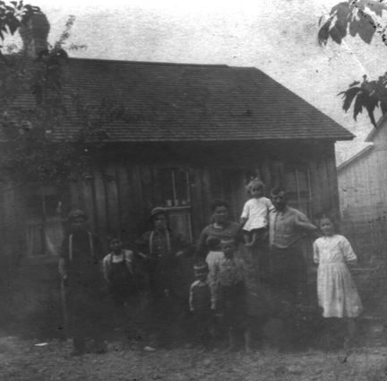

1914. The is the earliest photo of Helen. She is sitting on her father's arm. Left to Right: Sam Osborne (brother of "Papa."); Frank (B), Harry (A), Verner (H), Chet (E), Mother (behind Chet), Helen (G), Papa, Hattie (D). This is the original building that the two-storey was added to. For those of you who remember the house as it was in 1950, the window on the far right was the 'dining room' window. The window in the middle, to the left of the front door, became the doorway for the house into the addition and the window on the far right became the door to a closet in Grandpa's bedroom.

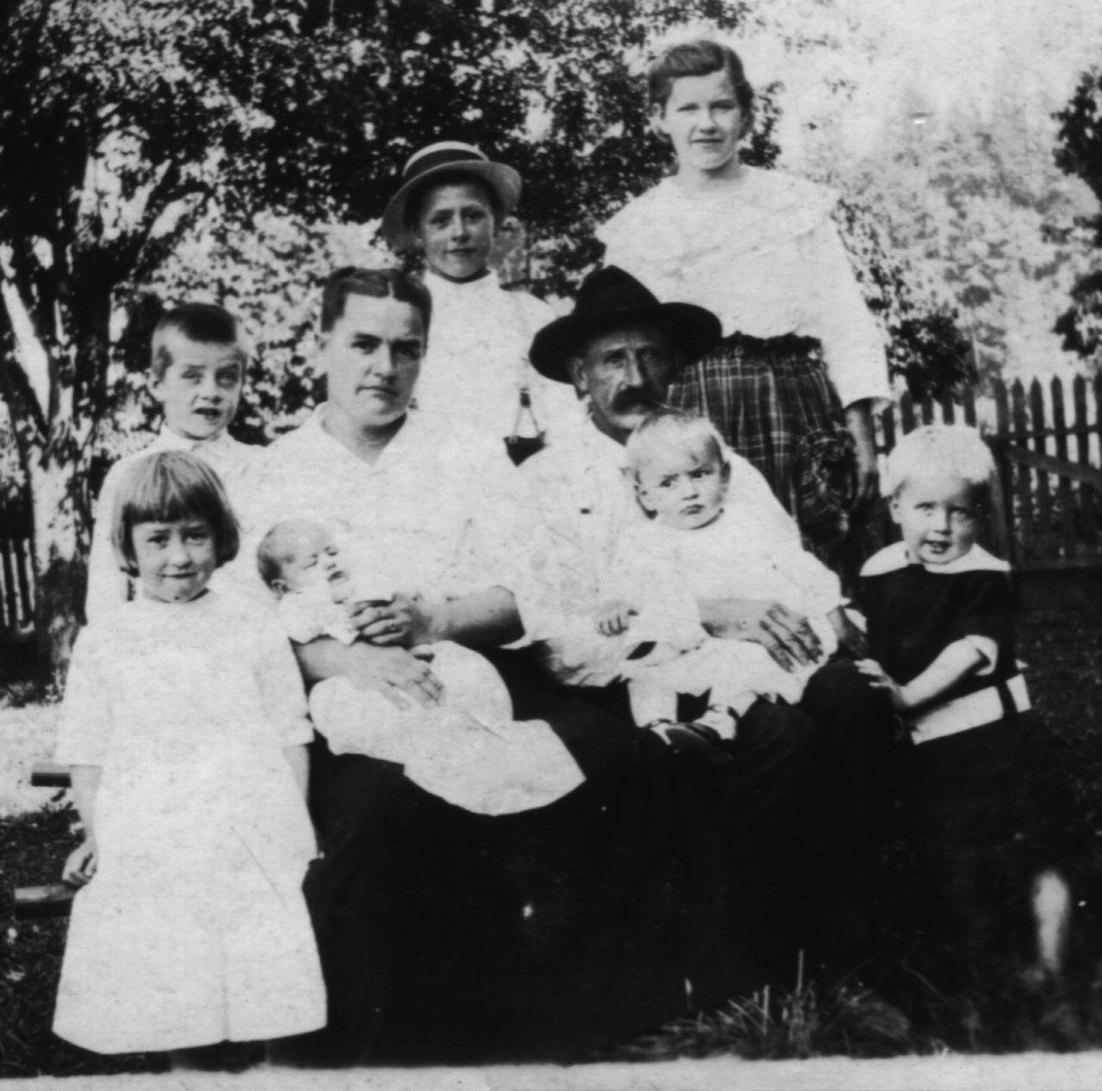
1917. Left to right: Helen (G), Lawrence (F), Juanita (J) on her mother's lap, Chet (E) behind his mother, Derward (I) on his father's lap, Hattie (D), and Verner (H) is, on close examination, pinching Derward's fingers. This was taken in the side yard of the Dreyers, parents of Waneta.

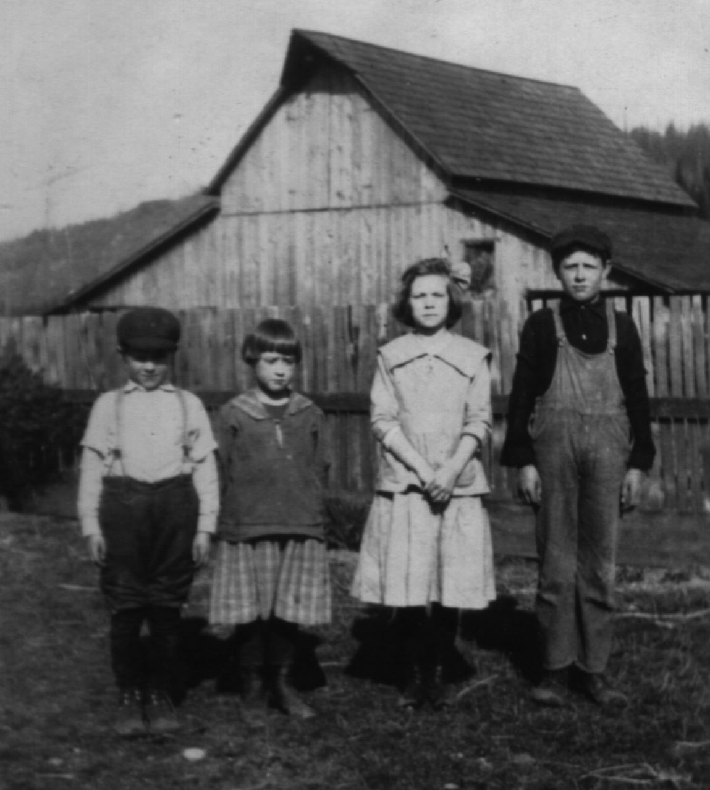
1919. L to R: Lawrence (F), Helen (G), Unknown, Chet (E). Helen is 7 in this photo. In a couple of years, she will become responsible for feeding the family. The fence behind them divides the Home Place side yard from the garden. This was a favorite spot for taking photos and we can watch the little tree on the far left grow.

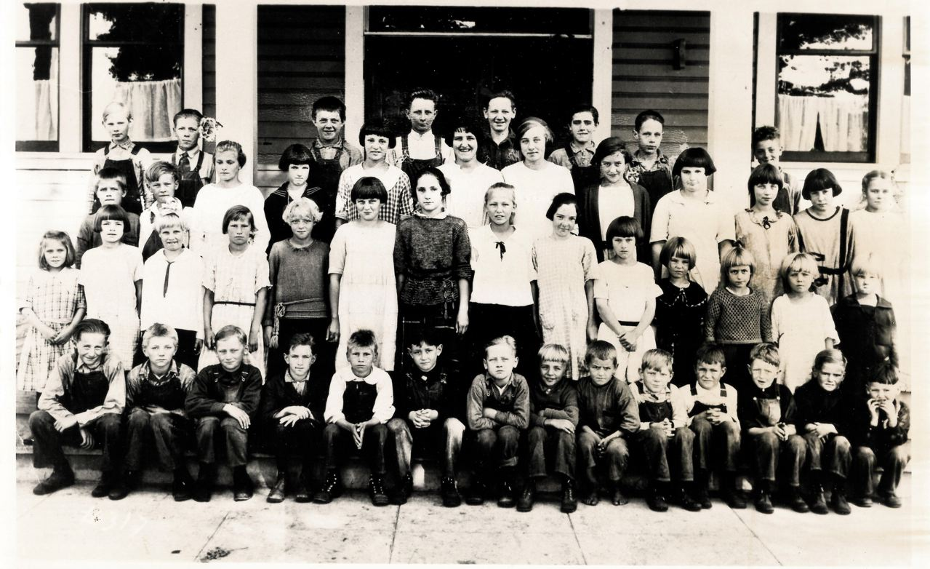
1923.McRaeSchool. This photo was taken in September following the January death of Waneta. In the back row, 3rd from left is Lawrence (F). On the far left the 3rd row from the front is Verner (H). In that same row, 5th from the right, is Helen (G). In the second row from the front, 3rd in from the right, is Juanita (J), in the front row, 6th from the right, and not wearing shoes, is Derward (I). The children had to walk to school, a distance of about 1.5 miles.

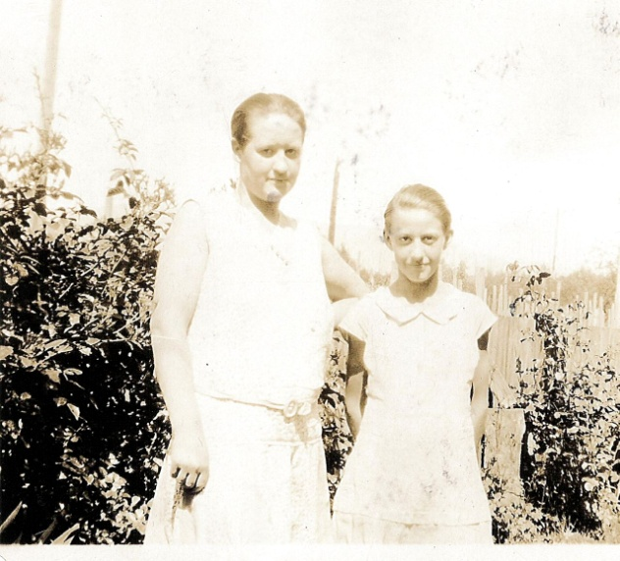
1927. Helen and Juanita in The Home Place side yard.

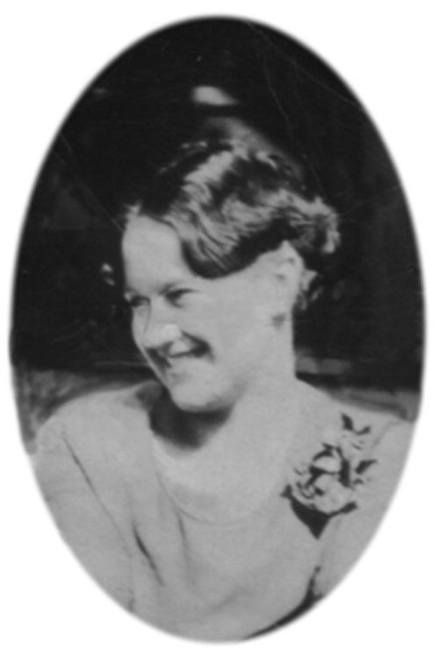
1929. A 'clipping' of a larger photo that includes her first husband, Vernon Anderson. I'm pretty sure this was taken on or near the date she was married.

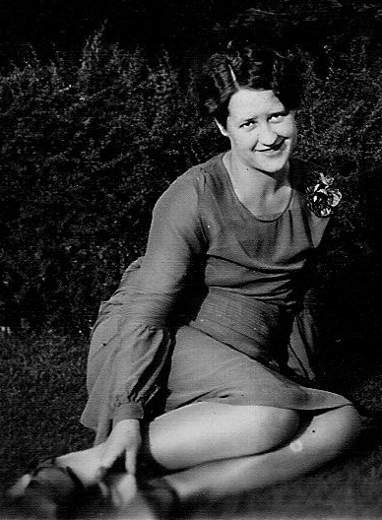
1929b. I think this photo was taken on the same occasion the one of her and Vernon.

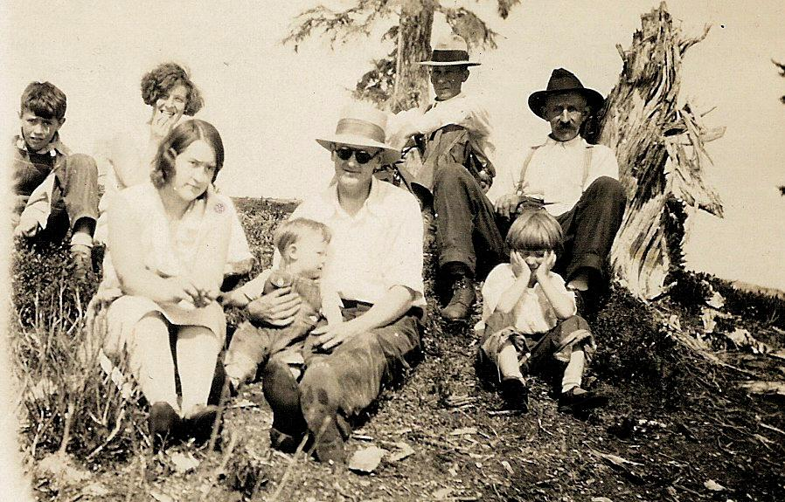
1930.Skagit Co. Left to Right: C. Mark (K), Yetive Hamilton, Helen, V. Duane "Junion" (G1), Vernon Anderson (Gs), Charlie Martin, Juanita (J) and WIO. This could have been taken any number of places in Skagit County area.

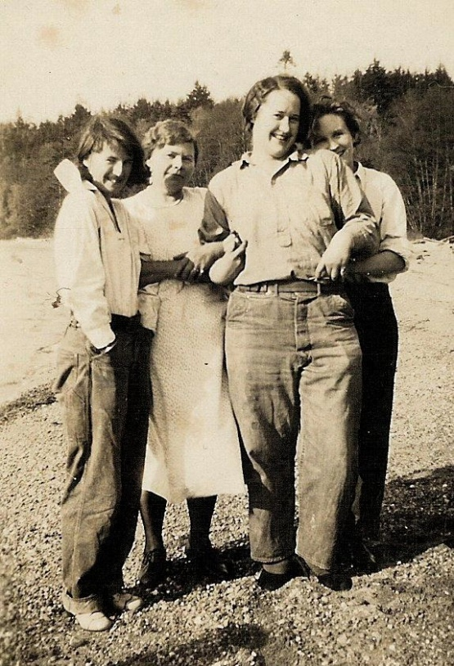
1935. Helen and her Gal Pals. Notice that Helen is wearing high heels. I'm pretty sure the pants are borrowed

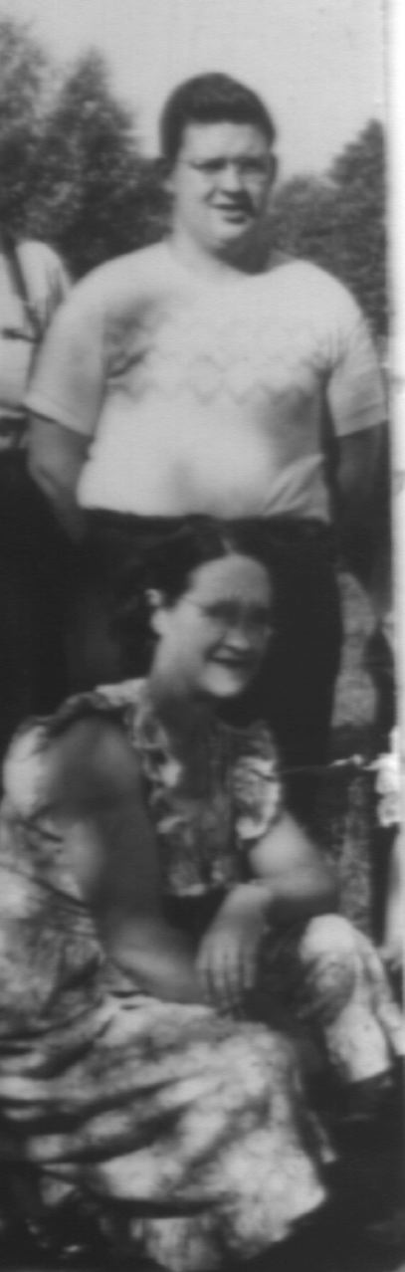
1945. Helen kneeling in front of Duane "Junion" (G1)

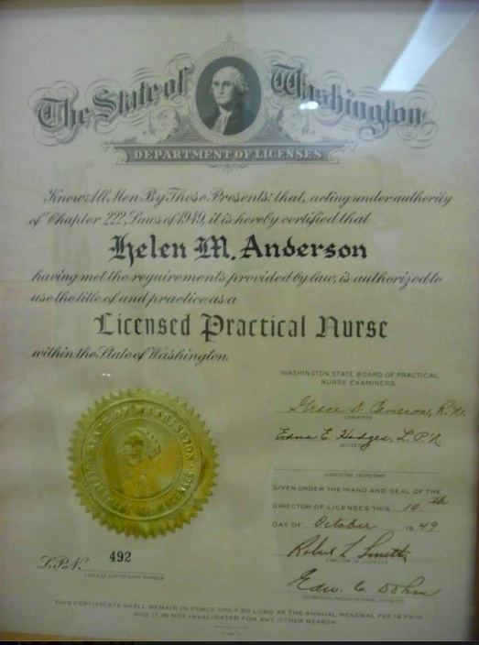
1949.LPNCert

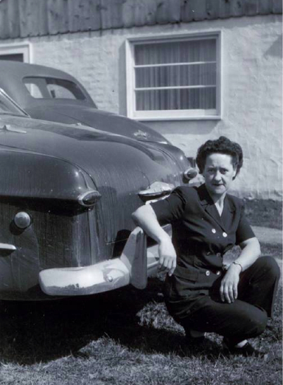
1951.Sedro Woolley. Susan: "Grandma and "the Ford", her pride and joy."

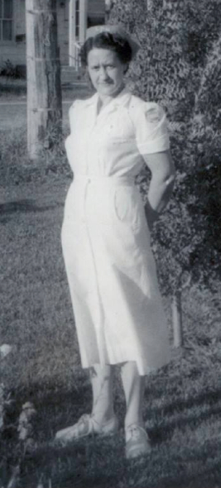
1957.Burlington, where the Cocusa Motel is now located. Susan: "In her nursing uniform in 1957. This photo was taken in the front of the house on Rio Vista street in Burlington."

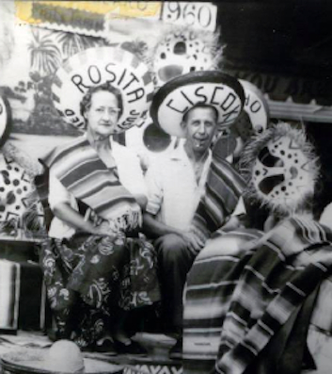
1959.Mexico. Susan: "Gramps looks like he's having a great time."

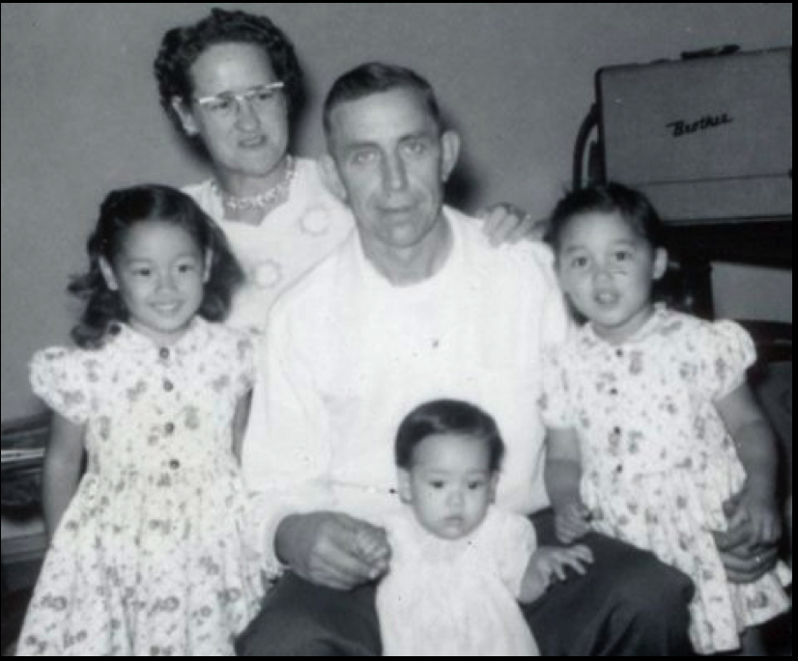
1960

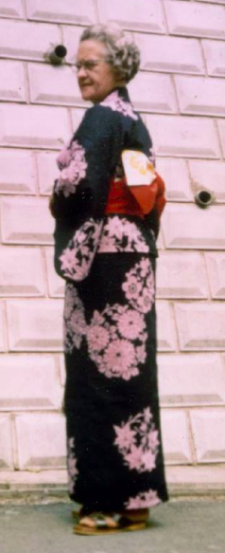
1987.Japan. Susan: "In Yokosuka, Japan visiting daughter-in-law Iku's family."
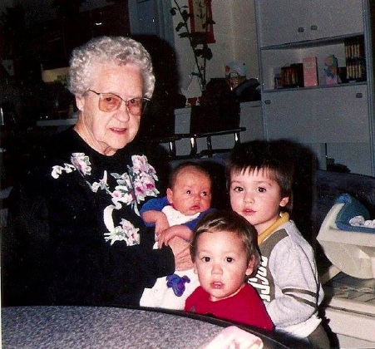
1992.Netherlands. Susan: "Grandma Helen with grandsons Nico, Casey and Andy in the Netherlands, 1992."

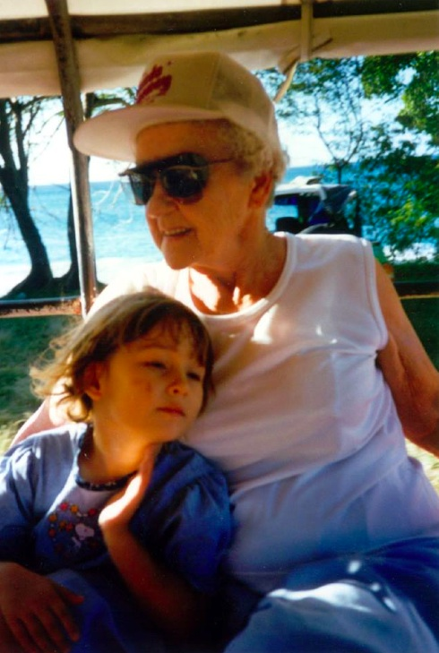
1997.Caribbean. Susan: "Riding in the back of a pickup truck with grand-daughter Mitsu in Bequia, an island in the Caribbean. For a Skagit County gal, Gramma sure did see the world!"
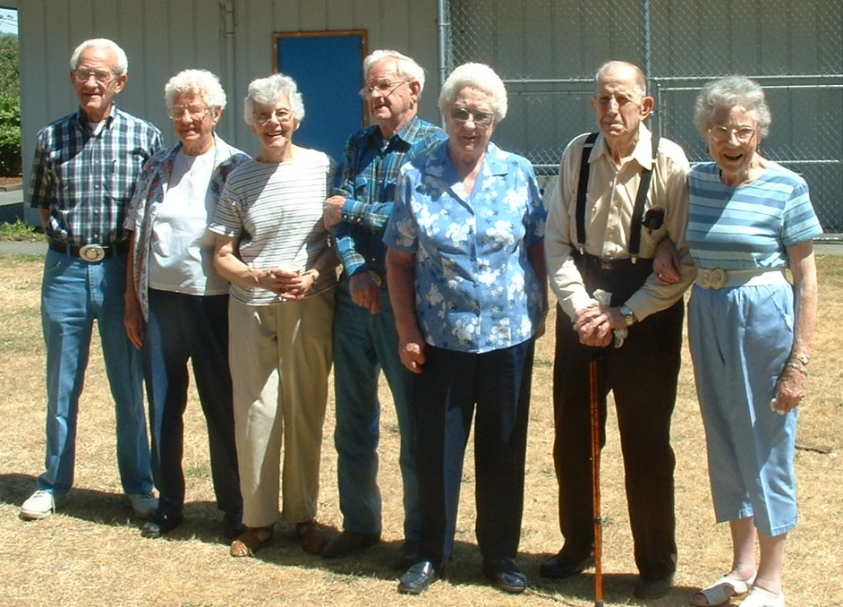
2003.SedroWoolley. L to R: C. M., Juanita, Betty (Is), Derward, Helen, Claud, Clara (Es)

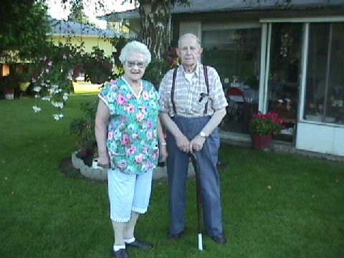

2007.Burlington. Helen in her beloved garden. Claude's grandson, Carl Wiles who, along with his sister Kathy, lived for several years with Claud and Helen posted several photos of Helen in her garden. She over-wintered fuschias in the sun room and when they were not quite ready to bloom she would squeeze the buds so that she could get an early glimpse of what they would look like when they finally bloomed.

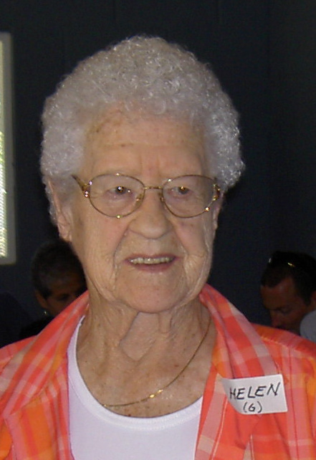
2009.SedroWoolley - Family Reunion

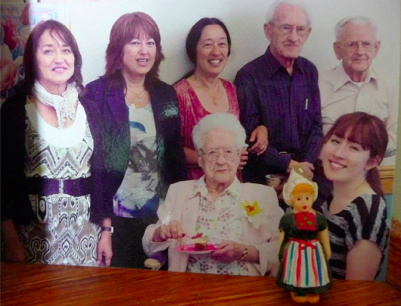
2012.Burlington. Helen's 100th birthday celebration L to R, standing: Terri (G12), Toni (G13), Susan (G11), C. Mark (K), Derward (I). Seated: Helen at 100. Kneeling: Mitsu (G111)

