Stewart Butten, Family Friend
by Bishop Holliman
In reviewing the letters and photographs of the 1930s, I continue to come up on the name of The Rev. Stewart Butten (spelled with an 'e') of Irondale, Alabama. My father, Bishop Holliman, knew 'Butten' in the middle and late 1930s and renewed the relationship in the 1970s. I remember stories about Mr. Butten's liberal views (liberal for the Ulyss Hollimans who were largely Republicans in the 1930s and 40s), and have wondered how he became such a close friend of the family. Here are my father's memories. - GNH
"Mr. Butten was a native of Ireland. I don't know the year he came to the U.S., but he ended up in East Tennessee, attending Maryville College, and eventually becoming pastor of the Presbyterian church in Irondale, Alabama about 1933. He also pastored a church near Trussville and one other out by Lake Purdy. The churches were very small, and he preached at a different one each Sunday.

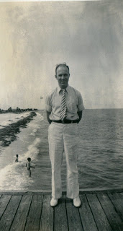
He was about Robert Daly, Sr.'s age (my brother-in-law who had married Vena Holliman in 1928), so they became very close friends. The Dalys, who lived next door to us (the Ulyss and Pearl Caine Holliman house) took Mr. Butten under their wings. He was not married and had no family in the States, so he welcomed their friendship . He went with Vena, Robert and Loudelle (Holliman Ferrell) to the Chicago World's Fair in 1933 and to Florida several summers. He became like one of the family and became sort of a role model for me as I was a young teen-ager, and was always around the Dalys when Mr. Butten was there.
Irondale, of course, had a very conservative Presbyterian church, but I guess it was Mr. B's Irish wit that endeared him to the congregation and community. He seemed to be a good fit, but he was way ahead of the time and place with his social and liberal views about religion, politics and race. He managed to get along well with all the folks.
Above, Mr. Butten in Florida on a Daly trip in the 1930s.
Once, though, he spanked a little boy who had misbehaved at the Bible School. The boy's daddy brought suit against him, and the newspaper picked up the story, and it got all the way to Belfast, Ireland. It was seen by Mr. B's family there, and that's how they learned that he was in the ministry and what he was doing! The law suit was eventually dropped and nothing came of it.
Mr. B drove a motor cycle to his various churches, as an automobile was too expensive. I guess that was also his way of flouting the establishment. He was well-educated, a well-read man. He enjoyed engaging Robert (and me) in heated discussions about current events, FDR, and other issues of the day. He would usually end up every Sunday night at the Dalys, and I would often be there to hear their discussions and engage in arguments with them.

He left Irondale in 1937, taking a church in Knoxville, Tennessee, lived there several years, moving to some job in Ohio, and eventually went into library work. After Mr. B moved to Knoxville, that summer 1937, he returned to Irondale on a visit, and I went back to Knoxville with him and stayed at the home of one of the members. They had a boy my age, and we went up to the Smokies, my first time there and climbed the Chimney Tops. I rode the train back to Birmingham, always a thrill for me.

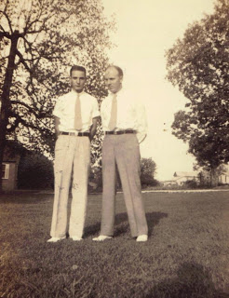
Above, Stewart Butten right with Bishop Holliman left. Note the stylish white shoes in the late 1930s.
More on The Rev. Mr. Butten and his influence on Holliman lives next posting....

Stewart Butten, Family Friend, Part II
by Bishop Holliman
"Mr. Butten married in the early 1940s and later moved back to Chattanooga and ended up in Knoxville. In 1975, he attended my younger daughter's wedding in Cookeville, Tennessee. My wife and I visited him in a nursing home once and also in his home. His wife, Hazel, died before he did.
Below, Hazel and Stewart Butten visit with Ralph Holliman in 1975 at the wedding of Alice Holliman and Bill Murphy. At that time, Mr. Butten was retired and Ralph, Bishop Holliman's youngest brother, was a corporate executive in Chicago.
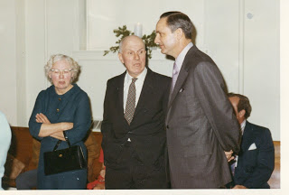
He went back to Ireland once, I'm sure, after Hazel died, and visited his old home place. He is buried near Seymour, Tennessee. Robert Daly, Sr. died in 1959, and Mr. Butten lived on into the 1980s."

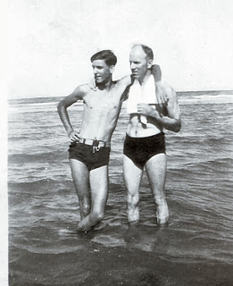
Compare the photo above with the one on the right of the same Ralph Holliman, age perhaps 15, the tallest of the Ulyss and Pearl Caine Holliman children, leaning on Mr. Butten at one of those memorable Florida vacations the Robert Dalys made possible for the family.
Next posting a letter by Mr. Butten on the death of Pearl Caine Holliman....

Stewart Butten, Family Friend, Part III
by Glenn N. Holliman
The beloved mother of seven children, Pearl Caine Holliman, pictured below, died of heart failure on May 5, 1955. This is one of the last photos taken of her, again, on the lawn between her home and the Robert W. Daly's. Born in 1887 in Fayette, Alabama, she married Ulyss S. Holliman in 1906, and with him and their growing family moved in 1917 to Irondale, Alabama, a suburb of the then growing city of Birmingham.
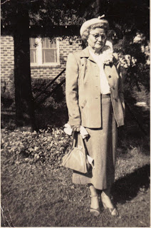
Stewart Butten wrote the following letter to Mary Daly Herrin, the oldest of Grand Mama Holliman's 19 grand children. Sadly, many grand chidlren are too young to have known of her warmth and caring. Her memory lives today for those of us grandchildren who were fortunate enough to have sat around that long and large Holliman table at Christmas, which Mr. B. eludes to in his letter. Click twice to enlarge the letter.
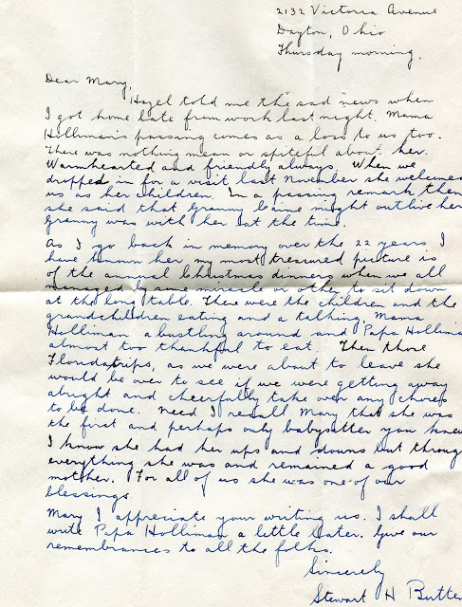
Two good friends, a picture taken in the middle 1930s of Robert W. Daly, Sr. and Stewart Butten, both had an infectious Irish humour.
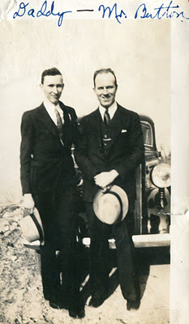
Next, more memories of Irondale, Alabama....in the 1920s and 30s.

