Dear Glenn, I am also a decendant of James Grantson Holliman. I found the Holliman family history site last Sept. while trying to do some family history. I was tremendously excited at what I found. Your blog in May showed the picture of Warren Holliman who is the brother to my gggrandfather Elijah. Warren, Elijah, and Cornealus who were all brothers all served in the 41st Ala. Warren was shot in the arm at Petersburg, Cornealus was killed and Elijah was shot in the back all at Petersburg. It is my understanding that John Thomas Holliman and other relatives and friends pulled Cornealus off of the battlefield under snipper fire. These boys were all sons of Charles Holliman. Charles and Cornealus were brothers and I understand that they settled in Newtonville, Al. Much of this I have discovered since last year. It's been coming together like a puzzle and your blogs have helped alot. This is my lineage, James Grantson Holliman, Charles Holliman, Elijah Holliman, Peter Aaron Holliman, Lewis Pinkney Holliman, Faye Holliman Brandon. We are the lost sheep from the Holliman family. I say this because this group lives around the Memphis, Tn area. This is a large group because most of them had large families. One of these relatives moved to Tate, Co. Ms just south of Memphis. He married four times and each wife died before him with exception to the last. This union produced a lot of girls who married in the community. If you look at the family names of the men they married it makes up probably a third of the families in that end of the county even today. I visited the gravesite of Elijah Holliman who is buried in Springhill cemetary between Columbus, Ms.and Millport, Al. Once I started sharing who I was I was introduced to so many realitives in the area that were either kin folk or had married into the family or knew the family that I was totally taken back. I felt that I had come home. This was a wonderful experience for me. My name is Raiford Brandon and I would like to attend the Holliman roundtable in Oct. Please send me the info. and I will share this with others of the family who I think would like to attend as well. Thanks for everything and keep up the blog. We are reading it. Raiford Brandon

Glenn I found another photo you may or may not be aware of. I thought I would send it to you just in case. It's another pretty neat piece of history. The flag in the center is the actual flag of the 41st. From what I understand this flag was captured at the battle of Petersburg. This William Blakeney was Warrens brother in law. I think the Blakeneys were a pretty famous Revolutionary war family. This also has a picture of John Thomas. I may have a few other things I can send later. See you.
Elijah Holliman
- Memorial
- Photos
- Flowers
- Edit
[Add A Photo]
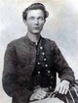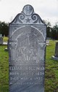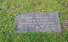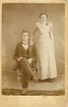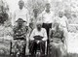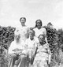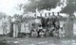
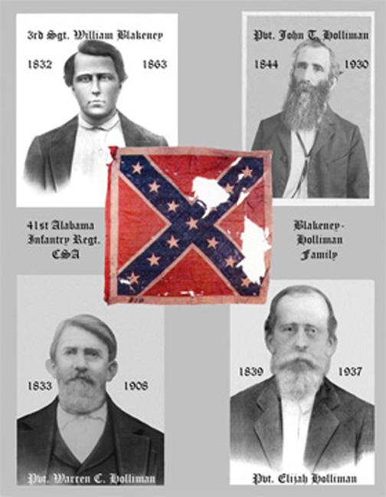
The 41st Alabama Infantry Regiment, CSA. William Blakeney died of disease in TN. John Thomas Holliman. Brothers, Warren C. and Elijah Holliman. There was a third brother, Cornelius who was KIA at Petersburg.

Glenn this is my gggrandfather. I don't know if your have seen this photo or not, but he is buried in Springhill Cemetery between Columbus, Ms. and Millport, Al. just down the road from our roundtable will be held. This a real neat picture dressed in his uniform. He was in the 41st Ala. along with his brothers Cornelius, and Warren. The local paper had a write up when he died stating that he was the oldest confederate veteran to die in Lamar County, Ala. Also another one of our cousins wives who lives near Columbus, Ms. was telling me that her father who was a Sproles walked home from the war together with gggranddad Elijah. So many of the people in that area are kin folks, and went through the trails of war together. Elijahs father Charles (brother to your gggrandfather Cornelius) had twelve children. Six boys fought in the civil war. Two of them died. We could write a novel about the Holliman family. |  | Elijah Holliman
- Memorial
- Photos
- Flowers
- Edit
Birth: Jul. 12, 1839 Newtonville Fayette County Alabama, USA  Death: May 11, 1937 Lowndes County Mississippi, USA  Married Mary Elizabeth Shaw about 1858; Permelia Gibson, November 18, 1869 in Alabama; and Melinda Elmina Levisa Jane Johnson about 1873  Son of Charles Holliman and Barbara (Barbary) Walters  Last Confederate Veteran to die in Lamar County, Alabama. He was 98.  Elijah and his third wife, Melinda, are buried beside each other.  Family links:  Children:  John W Holliman (1885 - 1985)*  *Point here for explanation  Burial:  Spring Hill Cemetery  Lamar County  Alabama, USA  Created by: JKB  Record added: Nov 01, 2006  Find A Grave Memorial# 16414441 | Added by: JKB  Added by: JKB  Added by: JKB  There are 7 more photos not showing...  Click here to view all images...  Photos may be scaled.  Click on image for full size.  - Algal  Added: Jul. 8, 2011  RIP Elijah. Doing a lot of research on you. Very thankful for the wonderful photo's that my Rhodes B. Holliman has contributed to this website.  - Glenda Norris  Added: Apr. 5, 2011  Rest in Peace, Elijah. See you in Heaven.  - Mary  Added: May. 30, 2010  There are 3 more notes not showing...  Click here to view all notes...

---------- Forwarded message ----------
From: Glenda Norris <gnorris@bcbsal.org>
Date: Tue, Aug 2, 2011 at 12:25 PM
Subject: RE: Elijah Holliman in the blog of July 25, 2011
To: Glenn Holliman <glennhistory@gmail.com>, sheila brandon <sheilabrandon15@gmail.com>
I have been so busy and haven’t had a chance to go back into my emails and check. Glenn, these are the markers that were put up by a distant cousin – a good bit of the info on them is incorrect. I know that there are several Elijah’s in our line – which makes it confusing. I know that the Elijah who is the son of Charles lived to be an old man…he was injured in the war……he is buried in Millport, Alabama….
The Elijah that was killed…well I’m not sure who he belonged to…I believe this is a brother of JT Holliman…but will need to check my notes to verify….
From: Glenn Holliman [mailto:glennhistory@gmail.com]
Sent: Tuesday, August 02, 2011 12:15 PM
To: sheila brandon
Cc: Glenda Norris
Subject: Re: Elijah Holliman in the blog of July 25, 2011
Raiford, I continue to look up the Elijah who died at Petersburg, VA. There it is on this ‘memorial’ stone which has his name on it with the 41st which was at Petersburg. The death date of John Thomas Holliman next to this stone is incorrect. He died in 1930, not 1903. So is this Elijah incorrect.
Yes, Cornelius died at Petersburg.
John Thomas Holliman, my great grandfather, had a brother named Elijah who died of disease in Georgia in 1864 and is buried there. Glenda, can you help us out? Thanks, Glenn

From: sheila brandon
Sent: Sunday, July 31, 2011 11:11 PM
To: Glenn Holliman
Subject: Elijah Holliman in the blog of July 25, 2011
Who is this Elijah that died at Petersburg. Who was his father. I also have another Holliman cousin that can be added to that list that died at Petersburg. Cornelius, son of Charles, son of James Grantson H. My great great granddad Elijah was wounded at Petersburg. His brother Warren was shot in the arm, and Cornelius was killed there. I know there are several Elijahs out there and I was just wondering who this one was. Thanks, Raiford

***CONFIDENTIALITY NOTICE***
This e-mail is intended for the sole use of the individual(s) to whom it is addressed, and may contain information that is privileged, confidential and exempt from disclosure under applicable law. You are hereby notified that any dissemination, duplication, or distribution of this transmission by someone other than the intended addressee or its designated agent is strictly prohibited. If you receive this e-mail in error, please notify me immediately by replying to this e-mail.

Hi Glenn,
That sounds great . I really get excited when I am able to connect a new family member. I am doing a lot of work on my dads side of the family, and they are in many of the same areas of the country as the Hollimans at about the same time. The James Grantson hollimans were in Anson, N.C. and the Brandons were in York, Co. S.C. which are neighboring counties to each other. Much of what you wrote about the Holymans in Eng. coinsided with the Brandons. The Brandon line I have been able to trace from the area of Suffolk, Eng. into Ireland and into Pa. and Halifax, Va. This Brandon was Charles Brandon who was raised with Henry the VIII and married his youngest sister. His father was the standard bearer and knight for Henry the VII. You wrote about the religious unrest of that period with the Right Reverend John Holyman and all of a sudden I realized that I probably had family on both sides of the issue. Charles Brandons father was William Brandon who was the knight and standard bearer for Henry VII. He was killed at the battle of Bosworth field during the War Of The Roses. Richard III was the King who the Tudors were at war with. King Richard ran William Brandon through with a lance and killed him. King Richard was a Plantagenet. One of my lines on my fathers side joins into the Plantagenet lineage and back to King Richard. This is two sides of the family fighting one another in the same battle, and killing one another. This is not all. John Howard Ist Duke of Norfold was also killed in the same battle. This John Howard was a distant relative through my mothers lineage. This line comes together in 1555 joining the Holliman line and the Brandon line together as it dates back to me. This was not a direct line of the Holliman name or the Brandon name but of the families they married into. The more you write in you blog, the more I am able to connect the dots. I would like to know more where the Hollimans came from before they arrived in Eng. I know you get excited when you stand in Eng. and all of a sudden you discover factual information about an ancestor, because it seems as if you were living life through this ancestor. I would like to think this is inspired work, because I feel inspired when I work on it. I look forward to the meeting in Oct. I will make arrangements accordingly. My inlaws live just across the Ms. line outside Columbus; so I will have a place to stay. I look forward to meeting you and all the others. Keep up the good work.
On Sun, Jul 3, 2011 at 3:59 PM, Glenn Holliman <glennhistory@gmail.com> wrote:
Raiford,

