The Seventh Child of Ulyss and Pearl Caine Holliman
William Ralph Holliman, 1924, Part I
At the Ulyss and Pearl Caine home at 2300 3rd Avenue in Irondale, Alabama on July 3, 1924, William Ralph Holliman was born. He was the last of seven children of the couple who had moved to the Birmingham suburb from the small town of Fayette in west Alabama in 1918. His oldest brother, Melton, had been born in 1908, making a spread of 16 years between the first and last child.
In essence, the Holliman children could be divided into an older and younger generation. Melton, 1908, Vena, 1910, Euhal, 1912 and Loudelle, 1914 were all born in Fayette. Bishop, 1919, Virginia, 1922 and Ralph 1924 were born in Irondale. Because Vena and Loudelle married exceptional men in 1928 and 1935, the last three children experienced mentoring and were offered opportunities the first four children did not experience.
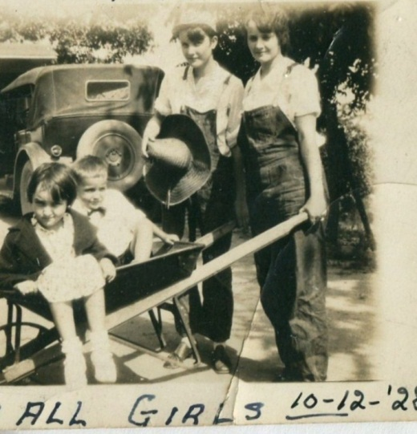
When four years old, Ralph and Virginia, six, in the wheel barrel had their picture taken with Vena and Loudelle Holliman, their older sisters who were dressed in bib overalls, probably for the only times in their lives.
One of these brothers-in-law was Robert Daly, Sr., a banker and second generation Irishman with a wry sense of humor, a generous nature and desire to travel and take family members with him. The second was The Rev. Charles Ferrell, a Birmingham-Southern College and Yale Divinity School graduate who became a Methodist minister and quietly encouraged his younger in-laws to pursue higher education.
Because the Dalys built a home next to the Ulyss and Pearl house in Irondale, Robert Daly became a very strong influence on the family, all for the good. Ulyss, by nature an taciturn and quiet man, worked long hours for the Birmingham Electric Company, up early to build a fire to warm the house in the winter and back after dark, tired from his commute and a 10 hour day, 5 ½ days a week of repairing street cars. He did this from 1918 until retirement in 1949, although thanks to the New Deal he began to experience the 40 hour work week and paid vacation in the middle 1930s.
Into this semi-void stepped Robert Daly who took the children places, gave them odd jobs and spending money, gently teased them and challenged them to think. As Ralph has said, “Robert Daly was my father!”
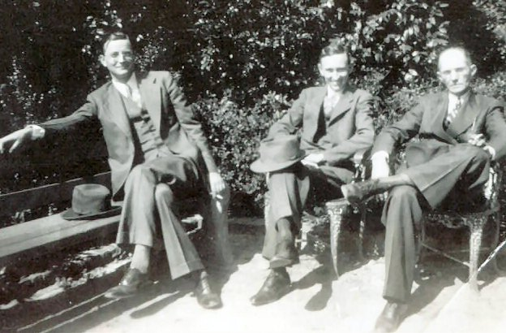
Left to right, Melton Holliman (1908 – 1958), Robert Daly, Sr. (1901 – 1959) and Ulyss S. Holliman (1884 – 1965).

Next posting, Growing up in the Shadow of Coming World War….

The Seventh Child of Ulyss and Pearl Caine Holliman
William Ralph Holliman, 1924, Part II
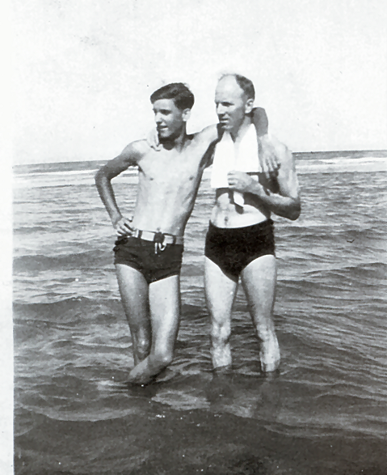Above at Ft. Walton Beach, Florida in 1939, a tall, lanky 15 year old Ralph Holliman, leans on Stewart Button, a great friend of the Dalys and Hollimans. Of the four brothers, the youngest, Ralph, would be the tallest.
Ralph proved a good student and as with Bishop and Virginia developed into a public speaker. In 1938 Ralph from Irondale Junior High and Virginia from Shades Cahaba High School found themselves in the finals of a city speech contest pitched against each other! The Birmingham News carried the following article about the contest. Note the sub headline.

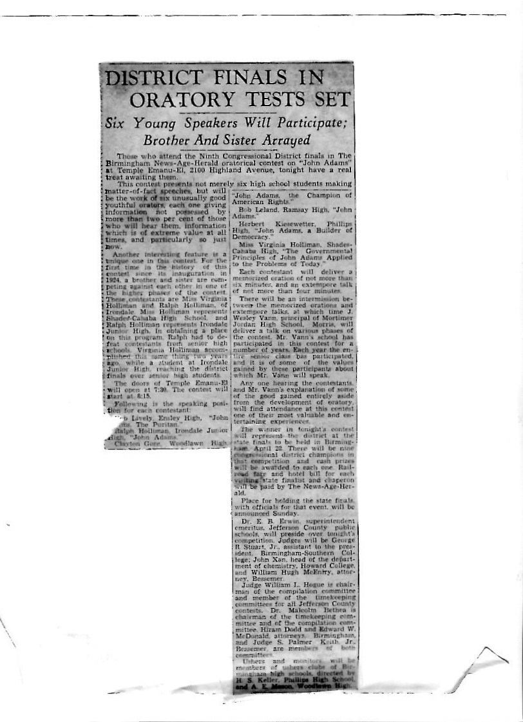
In 1941, Ralph and Virginia were both in the Shades Cahaba Honor Society as the page from The Owl displays. Note Virginia’s future husband, Walter Cornelius, was not present for the photograph
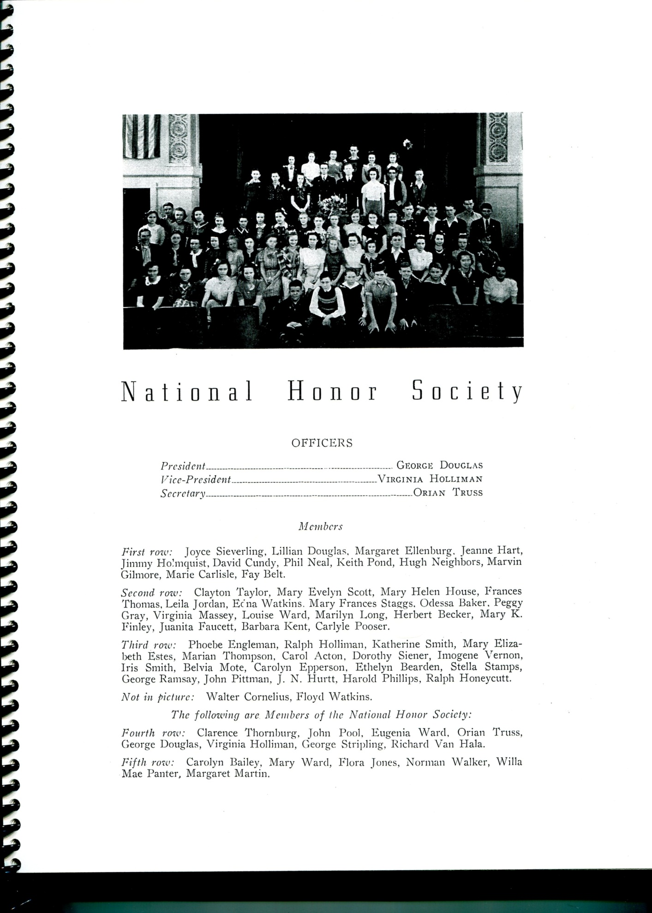
.
The successful days of high school closed for Ralph in 1942. When a sophomore, Germany had invaded Poland, and before his junior year, France had fallen to the Nazis. The British were fighting for their existence in the skies over London. After Pearl Harbor his senior year, the young Alabamian knew he would soon be joining his brother, Bishop, and millions of other Americas in the War.
Above, William Ralph Holliman, age 17, a senior at Shades Cahaba High School in Irondale, Alabama.
Next the War Sweeps over the Holliman Family….

The Seventh Child of Ulyss and Pearl Caine Holliman
William Ralph Holliman, 1924, Part III
In February 1942, Ralph took a week off from his senior year to travel by car with his parents, Ulyss and Pearl Holliman, and his brother-in-law and sister, Charles and Loudelle Ferrell to visit his older brother in Key West, Florida. Bishop Holliman had joined the Navy in November 1941, and a few months later Americans were worried sick by the Japanese advance in the Pacific and German U-Boats in the Atlantic.
To this point only one of the four Holliman brothers was in the fight. This would soon change. Below Ralph and Bishop in Key West, Florida, both facing an uncertain and dangerous future, and their Mother knew it.
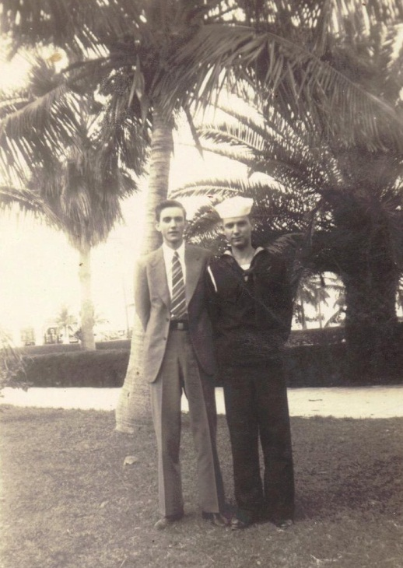
Below Motie and Ralph, newly weds, pose outside of the Daly home in Irondale, Alabama, 1943.
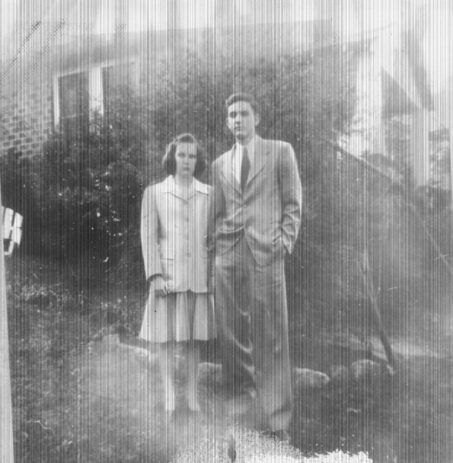 The War and his coming induction into the Army led to the marriage in the late winter of 1943 of Ralph and Motie Chisem, a high school sweetheart. After a honeymoon in Atlanta (an airplane flight no less!), Ralph in March of that year found himself in basic training in Miami, Florida. Assigned to the U. S. Army Air Corp, he traveled by troop train to his next base in Stapleton, Denver, Colorado. Although the train stopped in Birmingham, he was not able to get off to telephone Motie, his young bride.
Later the Army instructed Ralph in the Army Functional File System (his nephew, Glenn, learned the same system 25 years later) in Sacramento, California. By October 1943, he has in a crowded troop ship sailing from Newark, New Jersey to the Firth of Clyde, Scotland.

Below, Christmas 1943 Ralph sent a V-Mail Christmas card to the Daly family in Irondale. V Mail was a micro-photographed single sheet of paper that allowed a soldier to send home a note. Vital shipping space was saved with the reduced paper size.
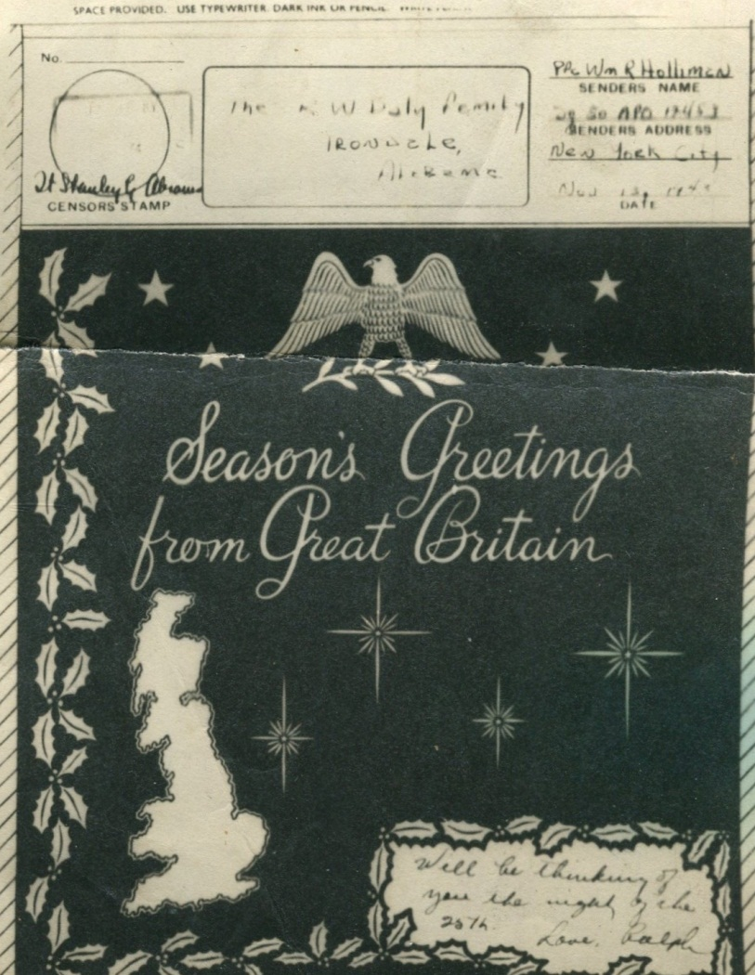

For 11 months, he was stationed in England at Bournemouth and Oxford. As a clerk for the 326 Ferry Squadron, 9th Air Force, he filed flight plans. On June 6, 1944, he noticed a sudden increase in air traffic; three months later he was in France, following his brother, Melton, an Army medic who had arrived in a hospital receiving station in July 1944.
On his destroyer, Bishop had been passing through the Straits of Gibraltar on D-Day. One can only imagine the thoughts and prayers of Pearl Holliman that spring and summer of 1944. Except for Euhal, who was excused from the draft due to age and the father of four children, her sons were in the European Theater
Below, Ralph Holliman left outside his air base control facility in Bournemouth, southern England.
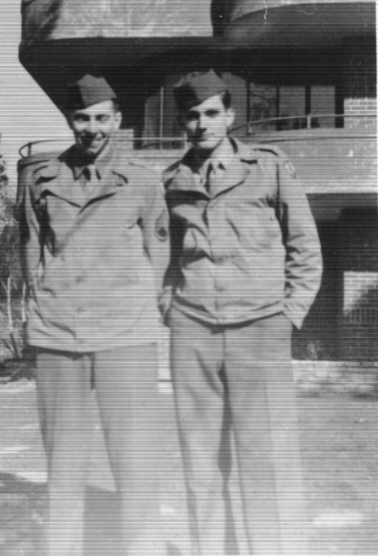His duty station was Criel in a suburb of Paris. He made sergeant, rank which allowed him to miss the draft for infantry during the Battle of Bulge in January 1945. V-E Day he joined thousands in Paris to celebrate the conclusion of the conflict in Europe.
In August 1945, Ralph was about to leave on a troop ship through the Suez Canal from Marsaille, France when the Atomic Bomb was dropped. The ship, the Dorothy L. Dix, never left for the Phillippines but instead turned to the USA. As with millions, the Holliman brothers came home, along a new brother-in-law, Walter Cornelius, Virginia’s husband.
Ralph also came home with enhanced organizational and management skills. As the document below attests, the young man had sharpened some talents which he would soon put to use in civilian life.
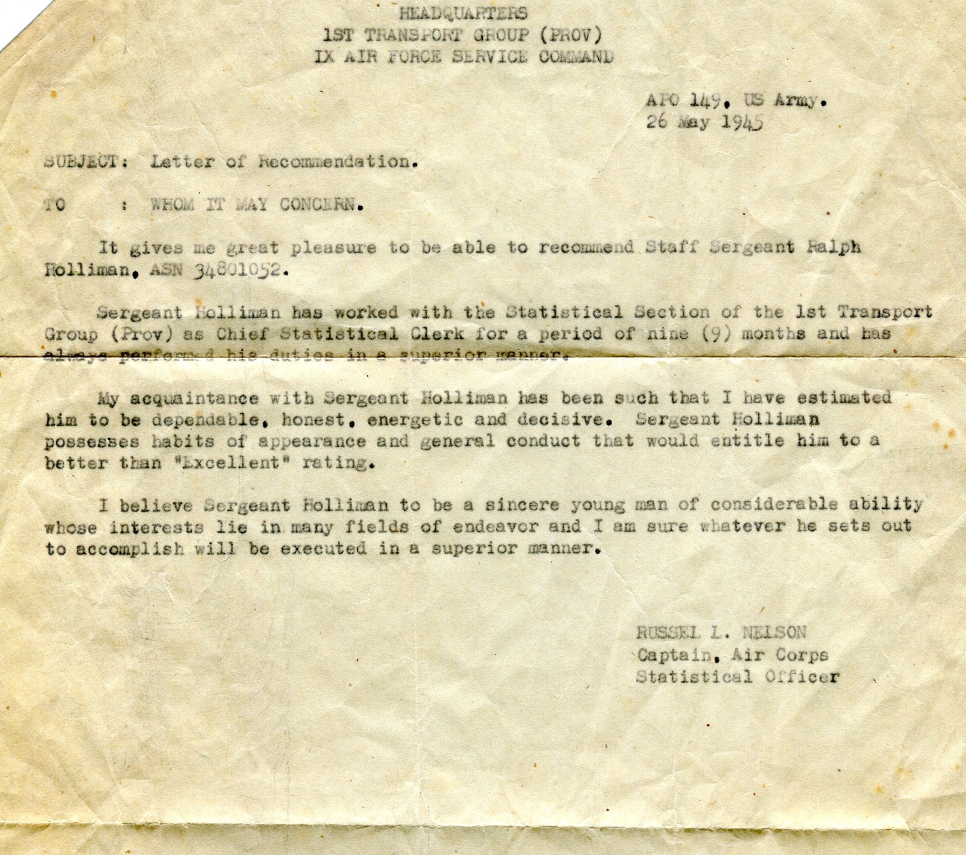

Next Ralph Holliman enters the world of corporate America….

The Seventh Child of Ulyss and Pearl Caine Holliman
William Ralph Holliman, 1924, Part IV
There had been three war time marriages in the Ulyss and Pearl Holliman family – Virginia and Walter Cornelius in February 1942, Ralph and Motie Chisem February 1943 and Bishop and Geraldine Stansbery in June 1945.
Below, two new sister-in-laws, Motie and Gerry Holliman, Bishop’s wife, in Irondale, Alabama in front of the Holliman home at 2300 3rd Avenue, 1945.
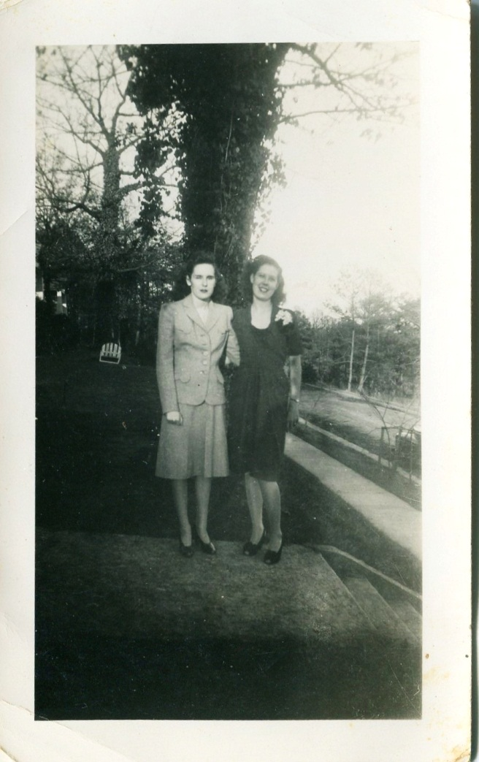
With the war over, Ralph took the G.I. Bill and returned to Birmingham-Southern College. However, Motie and Ralph joined the production of Baby Boomers when in 1947, their first child, Pamela Holliman was born. Katherine, a second daughter, entered the world in 1951. With his family growing, Ralph took a job as a clerk with the local branch of the American Bakery Company in Birmingham. It was a fateful choice as Ralph’s skills were appreciated, and he began a career of 37 years with the same company.
It is tempting to see something of Ralph’s career in White’s book The Organizational Man, a late 1950s treatise on corporate America and the men (yes, mainly men at that time although his sister, Virginia Holliman Cornelius was a pioneering exception) who ran America’s businesses. With each promotion and increase in responsibilities, heads of households had to move their families from branch office to branch plant and so forth.
During their marriage Motie and Ralph moved 17 times, and Pam attended seven schools by the 7th grade! The cities tumbled by: New Orleans, Jacksonville, Birmingham, Rocky Mount, North Carolina, Atlanta, Dallas and finally Chicago which became their home for 22 years. In 1993, Motie and Ralph moved to their retirement home in Gulf Shores, Alabama, where Ralph lives to this day.

The U.S. economy was rapidly expanding, along with a population demanding televisions, appliances, air conditioning, bigger and newer automobiles and houses. The consumer age was born, and the GDP of America kept going up, up and up.

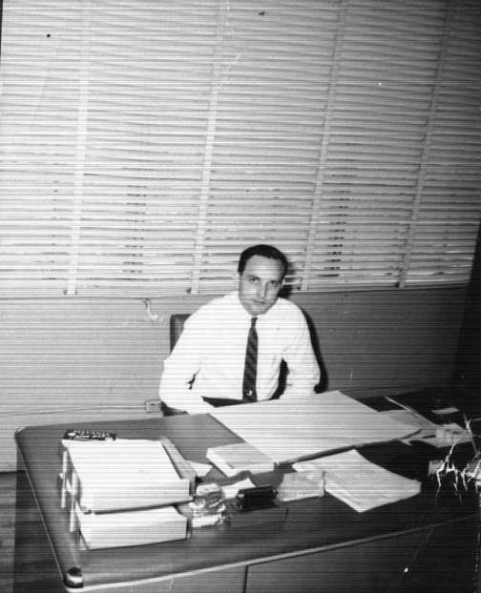
Ralph Holliman in the company attire of his generation – white shirt and tie. No computer on his desk in this early 1950s photograph. Letters were done by dictation, generally to the female secretary. Direct dial telephones spread rapidly in the 1950s, and one no longer had to wait for an operator. Hard to believe in the 21st Century, but families and businesses often had to share a party-line, that is one could pick up the telephone and hear a conversation of others on the ‘line’. And the phone would not be available until that person had finished their call!
The affluence that Ralph’s generation was creating and enjoying was almost unimaginable to his parent’s generation. It is startling to recall that the Ulyss Holliman home did not have an indoor bathroom or running water until 1938. Pearl Holliman was still churning butter in her kitchen and killing and defeathering her own chickens until her death in 1955.
The 17 grandchildren of Ulyss and Pearl were to live in the greatest economic expansion in the history of the planet and have enjoyed a standard of living far richer than any king or baron of industry born before the mid-20th Century.
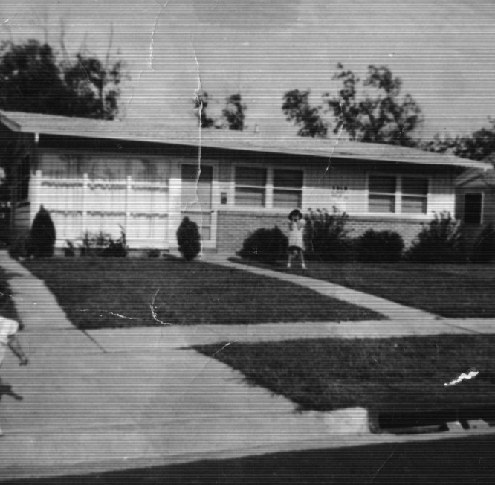
This is one of the numerous suburban homes Pam and Kathy Holliman would know in their growing up years. In the 1950s and 1960s millions of American acres were being converted into subdivisions, ranch style homes with air conditioning, concrete driveways, car ports, large picture windows (as above) and sans front porches (not needed if a house was air conditioned).
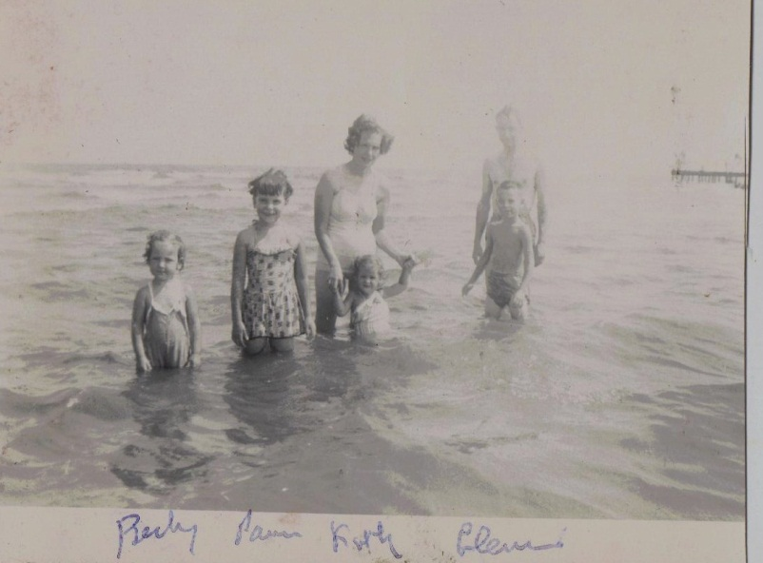 The expanding economy allowed middle class families to travel and visit relatives. In this 1953 photograph taken at Lake Ponchatrain in New Orleans, Louisiana are from left to right – Becky Holliman Payne, Pam Holliman, Motie and Kathy Holliman, Bishop Holliman and a young Glenn Holliman in front.

