Ralph Holliman and Family

Ulyss and Pearl Caine Holliman and their Descendants
The Seventh Child of Ulyss and Pearl Caine Holliman:
William Ralph Holliman, 1924, Part 1
by Glenn N. Holliman, his nephew
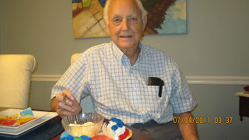
Above, Ralph Holliman in 2011.
At the Ulyss and Pearl Caine home at 2300 3rd Avenue in Irondale, Alabama on July 3, 1924, William Ralph Holliman was born. He was the last of seven children of the couple who had moved in 1918 to the working class Birmingham suburb from the small town of Fayette in west Alabama. His oldest brother, Melton, had been born in 1908, making a spread of 16 years between the first and last child.

In essence, the Holliman children could be divided into an older and younger generation. Melton -1908, Vena -1909, Euhal -1912 and Loudelle -1914 were all born in Fayette. Bishop, 1919, Virginia, 1922 and Ralph 1924 entered life in Irondale. Because Vena and Loudelle married exceptional men in 1928 and 1935, the last three children experienced mentoring and were offered many opportunities the first four children did not receive.
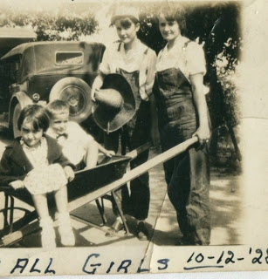
When four years old, Ralph and Virginia, age six, in the wheel barrel, had their picture taken with Vena and Loudelle Holliman, their older sisters dressed in bib overalls, probably for the only times in their lives.

One of these brothers-in-law was Vena's husband, Robert Daly, Sr., a banker and second generation Irishman with a wry sense of humor, a generous nature and desire to travel and take family members with him. The second was The Rev. Charles Ferrell, a Birmingham-Southern College and Yale Divinity School graduate who became a Methodist minister and quietly encouraged his younger in-laws to pursue higher education. He married Loudelle in 1935.
Because the Dalys built a home next to the Ulyss and Pearl house in Irondale, Robert Daly became a very strong influence on the family, all for the good. Ulyss, by nature a taciturn and quiet man, worked long hours for the Birmingham Electric Company, up early to build a fire to warm the house in the winter and back after dark, tired from his long commute and a 10 hour day, 5 ½ days a week of repairing street cars. He did this from 1918 until retirement in 1949, although thanks to the New Deal he began to experience the 40 hour work week and time off in the middle 1930s.
Into this semi-void stepped Robert Daly who took the children places, gave them odd jobs to earn spending money, gently teased them and challenged them to think. As Ralph exclaimed in 2011, “Robert Daly was my father!”
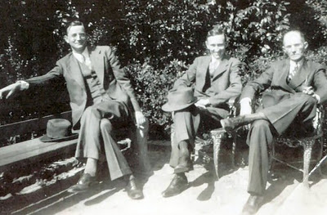
Above, sometime in the early 1940s are left to right, Melton Holliman (1908 - 1958), Robert W. Daly, Sr. (1901 - 1959) and Ulyss S. Holliman (1884 - 1965).
Next Part 2 of the biography of W. Ralph Holliman

Ulyss and Pearl Caine Holliman and their Descendants
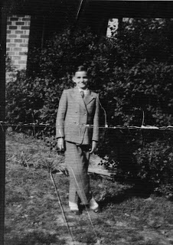
The Seventh Child of Ulyss and Pearl Caine Holliman
Ralph Holliman, Growing up, Part II
by Glenn N. Holliman, nephew
This is the second of a series on the seventh child of Ulyss and Pearl Caine Holliman. Left, young well-dressed Ralph Holliman, around age 11 and growing fast, had his photo taken at the side of the Robert W. Daly, Sr. home, just across the lawn from his own house.
Ralph proved a good student and as with his siblings, Bishop and Virginia, developed into a public speaker. In 1938 Ralph from Irondale Junior High and Virginia from Shades Cahaba High School found themselves in the finals of a Birmingham speech contest pitched against each other!
The Birmingham News carried the following article about the contest. Note the sub headline from the scrapbook of his sister, Virginia Holliman Cornelius.
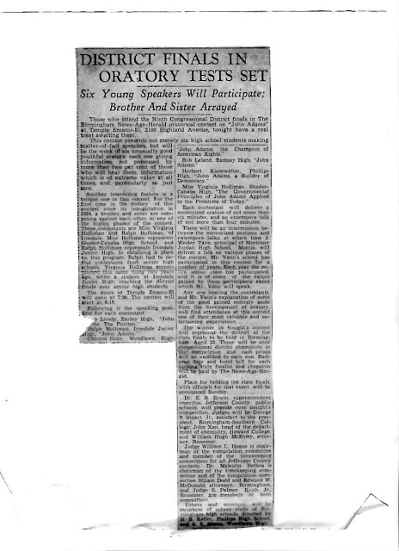
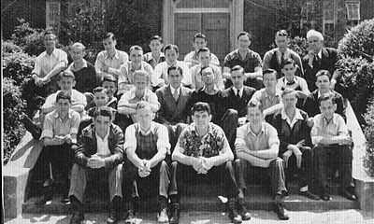
Ralph and his sister, Virginia Holliman Cornelius, were at Shades Cahaba High School in Birmingham at the same time, she two years ahead of him. In this photo, Ralph sits on the right side on the next to the back row, just right from his future brother-in-law, Walter Cornelius. The year is 1939. Virginia and Walter graduated in 1940 and married in 1942. Ralph would marry his high school sweetheart, Motie Chism in 1943 as the U.S. Army beckoned.
Next posting, the World War comes....

Ulyss and Pearl Caine Holliman and their Descendants
Ralph Holliman, the War Sweeps over the Holliman Family… Part III
by Glenn N. Holliman
The successful days of high school closed for Ralph in 1942. When a sophomore at Shades Cahaba in Birmingham, Alabama, Germany invaded Poland, and before his junior year, France fell to the Nazis. The British fought for their existence in the skies over London. After Pearl Harbour during his senior year, the young Alabamian knew he would soon be joining his brother, Bishop, and millions of other Americas in the War.
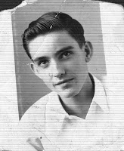

Right, William Ralph Holliman, age 17, a senior at Shades Cahaba High School in Irondale, Alabama.

In February 1942, Ralph took a week off from his senior year to travel by car with his parents, Ulyss and Pearl Holliman, and his brother-in-law and sister, Charles and Loudelle Ferrell to visit his older brother in Key West, Florida. Bishop Holliman had joined the Navy in November 1941, and a few months later Americans were worried sick by the Japanese advance in the Pacific and German U-Boats in the Atlantic.
To this point only one of the four Holliman brothers was in the fight. This would soon change.
Below Ralph and Bishop in Key West, Florida, both facing an uncertain and dangerous future, and their Mother knew it.
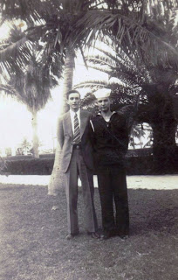
Life speeds up during war time.
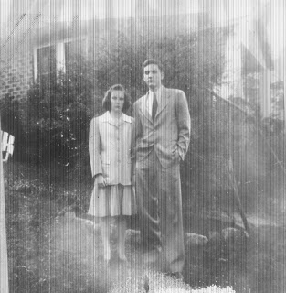

The War and his coming induction into the Army led to the marriage in the late winter of 1943 of Ralph and Motie Chism, high school sweethearts. After a honeymoon in Atlanta (an airplane flight no less!), Ralph in March of that year found himself in basic training in Miami, Florida. Assigned to the U. S. Army Air Corp, he traveled by troop train to his next base in Stapleton, Denver, Colorado. Although the train stopped in Birmingham, he was not able to get off to telephone Motie, his young bride.

Once again with the Robert W. Daly, Sr. house as a back drop, Ralph and his new bride, Motie, pose for the camera. Soon Ralph would leave his new wife for Army service, not to return for almost two years. The marriage would last until Motie's death in 2003.
Ralph Holliman at War....Part IV
by Glenn N. Holliman
Below, Ralph Holliman right with an Army buddy, unidentified, at the Bournemouth, England air base.
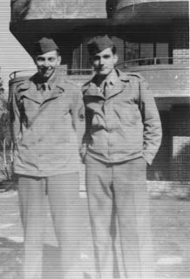
The Army instructed Ralph in the Army Functional File System (his nephew, Glenn, learned the same system 25 years later) in Sacramento, California. By October 1943, he has in a wretchedly crowded troop ship, the Dorthea Dix, sailing from Newark, New Jersey to the Firth of Clyde, Scotland.

Below, Christmas 1943 Ralph sent a V-Mail Christmas card to the his parents in Irondale, Alabama. V Mail was a micro-photographed single sheet of paper that allowed a soldier to send home a note. Vital shipping space was saved with the reduced paper size. Ralph was not allowed to tell his family where he was stationed in the United Kingdom. All mail was censored by the military.
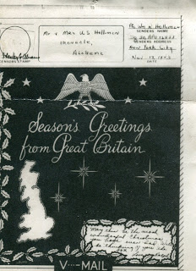
For 11 months, he lived in England at Bournemouth and Oxford. As a clerk for the 326 Ferry Squadron, 9th Air Force, he filed flight plans. On June 6, 1944, he noticed a sudden increase in air traffic; three months later he was in France, following his brother, Melton, an Army medic who had arrived at a French-based hospital receiving station in July 1944. On his destroyer, his other brother, Bishop had been passing through the Straits of Gibraltar on D-Day.
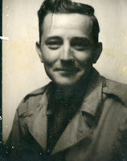
Right, Melton Holliman, arrived in England in May of 1944, and by July was in France where he served until disabled in November of that year.
One can only imagine the thoughts and prayers of their mother, Pearl Holliman, that year 1944. Except for son Euhal, who was excused from the draft due to age and being the father of four children, her sons were in the European Theater and she knew not where.
Next, the War ends and a career begins....
The War Ends and a Career Begins....Ralph
Holliman, Part V
by his nephew, Glenn N. Holliman
We continue our story of William Ralph Holliman, b. 1924, the seventh child of Ulyss and Pearl Caine Holliman.
By September 1944, Ralph Holliman, an enlisted man in the U.S. Army Air Corp, was stationed in Creil, thirty miles north of Paris and headquarters of the 9th Air Force. He made sergeant, a rank which allowed him to miss the draft for infantry during the Battle of Bulge in January 1945. On V-E Day he joined thousands in Paris to celebrate the conclusion of the conflict in Europe.
Ralph mailed this Mother's Day message to his mother, Pearl Caine Holliman, who saw three of her four sons serve in Europe.
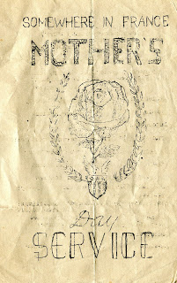
In August 1945, Ralph was about to leave on a troop ship in Marsaille, France for Asia via the Suez Canal, when the Atomic Bomb was dropped. The ship never left for the Phillippines, but instead turned to the USA. As with millions, the Holliman brothers came home, along a new brother-in-law, Walter Cornelius, Virginia’s husband.
Ralph survived the war, fortunately missing combat and Nazi bombs at his air bases. His administrative talents were honed in the Army as the letter below suggests. These abilities would serve him well in his civilian career.
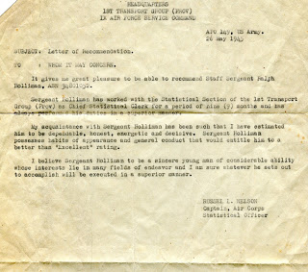

Now home to resume education, career and family.... The Seventh Child of Ulyss and Pearl Caine Holliman
William Ralph Holliman, 1924, Part VI
by Glenn N. Holliman
Success in Corporate America
There were three war time marriages in the Ulyss and Pearl Holliman family – Virginia and Walter Cornelius in January 1942, Ralph and Motie Chism in February 1943 and Bishop and Geraldine Stansbery in June 1945.

Below, two new sister-in-laws, Motie and Gerry Holliman, Bishop’s wife, in Irondale, Alabama in front of the Holliman home at 2300 3rd Avenue, February 1945.
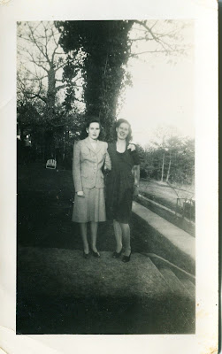

With the war over, Ralph took the G.I. Bill and returned to Birmingham-Southern College. Motie and Ralph joined in the production of Baby Boomers when in 1947, their first child, Pamela Holliman was born. Katherine, a second daughter, entered the world in 1951. With his family growing, Ralph took a job as a clerk with the local branch of the American Bakery Company in Birmingham. It was a fateful choice as Ralph’s skills were appreciated, and he began a career of 37 years with the same company.
It is tempting to see something of Ralph’s career in William H. Whyte’s best selling book The Organizational Man, a 1950s treatise on corporate America and the men (yes, mainly men at that time although his sister, Virginia Holliman Cornelius, was a pioneering exception) who ran America’s businesses. With each promotion and increase in responsibilities, heads of households had to move their families from branch office to branch plant and so forth.
During their marriage Motie and Ralph moved 17 times, and Pam attended seven schools by the 7th grade! The cities tumbled by: New Orleans, Jacksonville, Birmingham, Rocky Mount, North Carolina, Atlanta, Dallas and finally Chicago which became their home for 22 years. In 1993, Motie and Ralph moved to their retirement home in Gulf Shores, Alabama, where Ralph lives to this day.

The U.S. economy was rapidly expanding, along with a population demanding televisions, appliances, air conditioning, bigger and newer automobiles and houses. The consumer age was born, and the GDP of America kept going up, up and up.
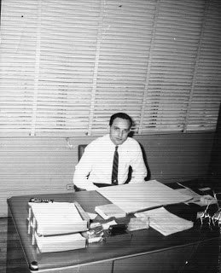
Ralph Holliman in the company attire of his generation – white shirt and tie. No computer on his desk in this early 1950s photograph. Letters were done by dictation, generally to the female secretary. Direct dial telephones spread rapidly in the 1950s, and one no longer had to wait for an operator. Hard to believe in the 21st Century, but families and businesses often had to share a party-line, that is one could pick up the telephone and hear a conversation of others on the ‘line’. And the phone would not be available until that person had finished their call!

Next - the 1950s....
The Seventh Child of Ulyss and Pearl Caine Holliman,
William Ralph Holliman, Part VII
by Glenn N. Holliman, a nephew

The affluence that Ralph’s generation was creating and enjoying was almost unimaginable to his parent’s generation. It is startling to recall that the Ulyss Holliman home did not have an indoor bathroom or running water until 1936. Pearl Holliman was still churning butter in her kitchen, and killing and defeathering her own chickens until her death in 1955.

The 19 grandchildren of Ulyss and Pearl were to live in the greatest economic expansion in the history of the planet and have enjoyed a standard of living far richer than any king or baron of industry born before the 20th Century.

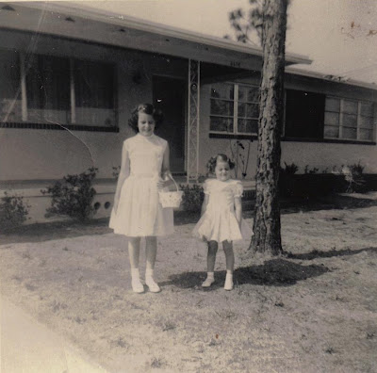

This is one of the numerous suburban homes Pam and Kathy Holliman would know in their growing up years. In the 1950s and 1960s millions of American acres were being converted into subdivisions, ranch style homes with air conditioning, concrete driveways, car ports, large picture windows (as above) and sans front porches (not needed if a house was air conditioned).

The expanding economy allowed middle class families to travel and visit relatives. In this 1953 photograph taken at Lake Ponchatrain in New Orleans, Louisiana are from left to right – Becky Holliman Payne, Pam Holliman, Motie and Kathy Holliman, Bishop Holliman and a young Glenn Holliman in front.
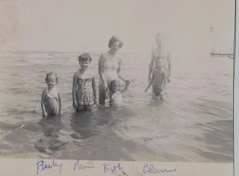

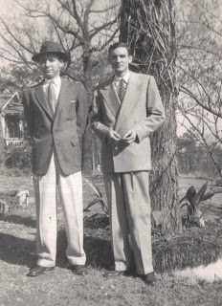
Right, two young, up and coming executives, Bishop Holliman with the hat and his younger brother, Ralph Holliman, pose in the front lawn of their childhood home in Irondale, Alabama, Christmas 1954. Both are formally dressed and attired as if for the office. In the decade after World War II, men wore fedoras and business suits even when on vacation.
Next, Siblings and Children....
Posted by Glenn N. Holliman at 2:20 PM No comments:
The Seventh Child of Ulyss and Pearl Caine Holliman,
William Ralph Holliman, Part VIII
by Glenn N. Holliman
The years slipped by for Ralph and Motie. From a clerk at American Bakeries in Birmingham, Alabama, he climbed the corporate ladder to office manager and plant manager, regional, divisional and finally national vice president of operations in Chicago. At one time the company had sixty-two plants and 10,000 employees. Those were busy years, but he never lost his Alabama roots.
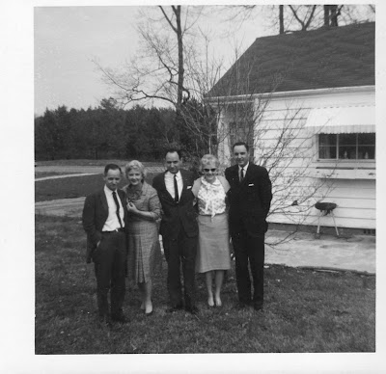
Right, in 1965 at the Robert and Vena Daly home in Irondale, Alabama, five of the six surviving siblings of Ulyss and Pearl Caine Holliman gathered for a group picture. Left to right are Euhal, Vena Daly, Bishop, Loudelle Ferrell and Ralph. Notice the three men are in suits and ties.
In 1978 Vena, Ralph, Virginia and Bishop took time to gather in Birmingham.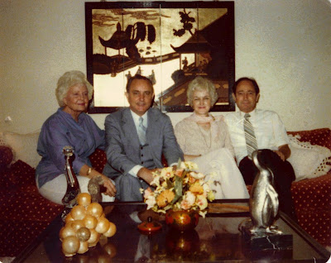

In 1984, Motie, Ralph, Mary Daly Herrin and Bishop Holliman met in Irondale, Alabama, Mary's home.
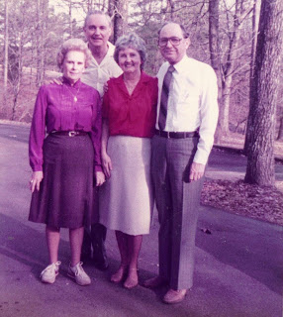

Below, Ralph, Gerry Holliman, Motie and Bishop Holliman, 1987.
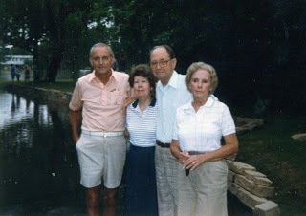

Next, the Children of Ralph and Motie Holliman....
The Seventh Child of Ulyss and Pearl Caine Holliman,
William Ralph Holliman, Part IX
by Glenn N. Holliman
Ralph and Motie Holliman were blessed with two talented and gifted daughters. Pam has a doctorate in religious studies and today teaches at a seminary in Chicago. Her career track has included professional counseling and director of not-for-profits. Below in the 1990s, Ralph, Motie and Virginia Holliman Cornelius.
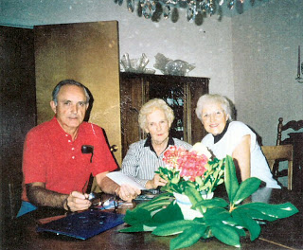

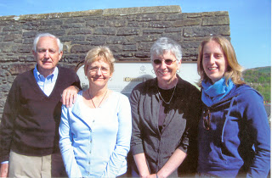
Left in the middle 2000s, Ralph, Kathy, Pam and Kathy's daughter, Rachel Harbour.
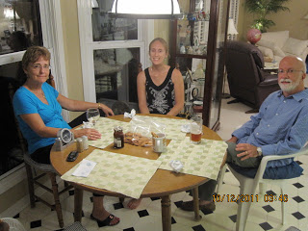
To the right are Kathy, Rachel and Kathy's husband, Tim Donald. Rachel and Tim live in Philadelphia where both are writers and publishers for medical and scientific publications. Earlier in her career, Kathy taught school and wrote for the Bangor, Maine Daily News.
Below, Ralph visits with Pam in her Chicago seminary office in 2010.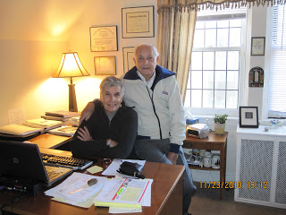

Motie passed away in 2003 after 60 years of marriage. In 2007, Ralph was fortunate to meet a widow, Laura Stanley, who has brightened his life in countless ways.
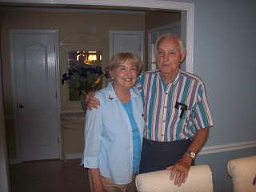

This ends our biographies of the seven children of Ulyss and Pearl Caine Holliman. In future postings, we shall dig deeper into the history and culture in which the family lived.

