DRAFT

by Glenn N. Holliman

In this post, more photographs from the family of John (1855-1928) and Rebecca Wilson (1862-1954) who raised ten children to adulthood in their farm cove in Sutherland, North Carolina, where John's father, Isaac, had been bushwhacked in the Civil War.

Four children Nora (1881-1887), Edgar (1883-1885), Boyd (1885) and Nancy (1912) died in infancy or early childhood. Front row left to right is John holding Preston (1900-1989), his wife Rebecca, holding Ruth (Hurt, 1903-1999). Far right is Conley (1882-1957).

Back row with her hand on her father is Mayme (Donnelly, Shirley Sorrell's grandmother) (1892-1975), William Donnelly (1890-1975), Bessie (1887-1976), Maggie (1894 -1992), Minnie (1896-1987) and Callie Frances (1898-1999). Robert Earl Wilson is not present, being born in 1906, died in 1987.

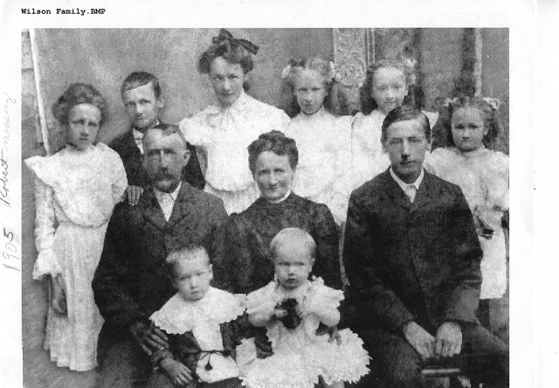

A few years later in their finest white dresses, the girls gathered around their mother, Rebecca, for a formal photograph. Front row left to right would be Minnie, Rebecca, Ruth and Callie. Back row are Bessie, Mayme and Maggi.
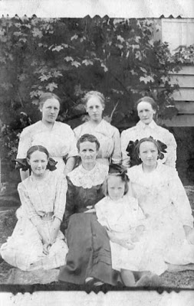
From 1881 until 1912, a period of 31 years from ages 18 to 49, Rebecca Wilson Wilson gave birth to 14 children of whom only 10 lived to adulthood. Despite the many pregnancies and the labor of the farm, Rebecca lived to be 92 years old!

If a child of John and Rebecca's made it to adulthood, they lived a long life. The four sons averaged 82.5 years at death. The daughters averaged a staggering 93 years at passing!

Below Rebecca in 1951 in Wilson Cove.

