Sorry guys, this isn't it. I think the same info came across to us a few years ago.

According to "Burke's Irish Family Records," Robert and Sarah Ormsby Blakeney did indeed have a son John. But this son is "Col. John Blakeney, of Abbert, co Galway (bought 14 May 1734), JP (1727), High Sheriff 1727 and 1738, Galway Drags, MP for Athenry from 1727, married Grace, dau of Henry Persse, of Roxborough, co Galway, and DIED 21 July 1747, leaving issue"
(Robert, John, Theophilus, William, Sarah, and Mary).

All these stayed in Ireland, and this John died before ours showed up in NC.

Sarah Ormsby married Robert B. in 1702. She couldn't have been born in 1715.
Also, Robert Blakeney died in 1733. Their first son was John, followed by George Augustus, Gilbert, Robert, Margaret, Dorothy and Lettice. If this John was born in 1732, then Robert couldn't have sired 6 more kids before dying the following year.

Further, Childers lists this Robert as the son of William Blakeney & Eliz.
Bowerman. Not correct. His parents were John Blakeney, born 1649, and Sarah Persse; they were married in 1671.

Childers may have gotten these names and dates from the Mormon IGI. I had gotten all excited at one point when I found all kinds of info there, but
then found almost all of it to be wrong. :-( Not all IGI listings were
documented or checked, and a lot of it comes from research done when it was harder to find sources and keep the lines straight. (Don't know how any of you ever worked on this before there was software to help!)

Burke's lists the Baron's brothers but except for Robert, no marriage or further lineage is listed for them. Doesn't mean they didn't have any, just that Burke had no info for them. I still think that's where our problem lies -- finding marriage and parenting documents for any one of them.
Robert's info is full on his line of children, and our John isn't among them.

Let's keep looking, though!

Love,

Rhonda

----- Original Message -----

From: <JimBlake@aol.com>
To: <RLBJ1161@bellsouth.net>
Sent: Monday, January 26, 2004 8:46 PM
Subject: Fwd: Fw: Source of John Blakeney info

>
>
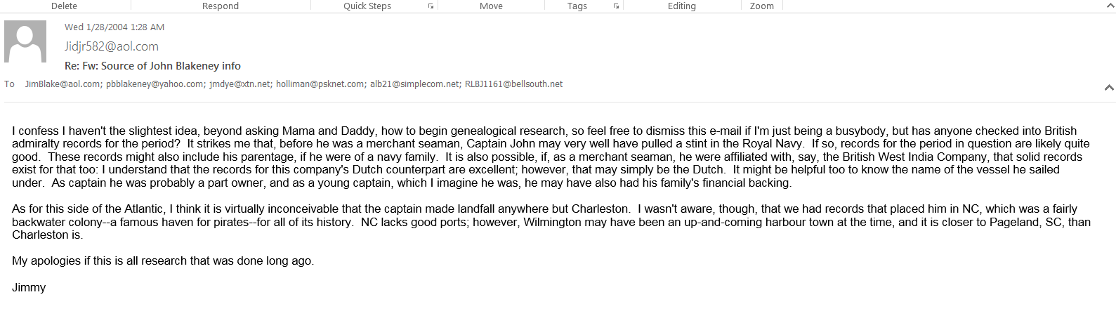Hey Jim! And everybody else, too...

In the past I have come across a couple of old library books about the Royal Navy back in that time frame, but I didn't find any leads. Can't remember now but doubt they were comprehensive as to lists of sailors or years we needed. The pickings are slim so far as published works. You're right about extant records, though; they probably exist within England's Public Records Office. The problem is money and access, I'm afraid. The PRO has a great web site and searchable catalog from which photocopies of documents can be ordered. However, you don't know ahead of time what exactly might be included in the records or how brief or long any one section might be. I have a list of about 300 documents I'd like to look at, but I for sure couldn't afford to order them. The thing to do would be to just go over there and pore over documents oneself; boy, would I love to do that! But the problems of time and money to finance the travel have pushed that option far in the future.

I do think it likely that John came over with a branch of the military, even though he didn't earn his title until much later, as a Revolutionary. He would have been practically a boy -- and I know for a fact that Irish regiments of the time, including the Baron's own, were padded out with boys. And the Baron visited most of the coastal states with his own regiment on recruiting ventures. Furthermore, there were always one or two Blakeneys in his and neighboring regiments. I'd like to find records that show whether any of them retired from the military while over here. I even have kept an eye out for deserters. These records also are possibly to be found in the PRO.

However, we don't know that he came directly to the southern coast. He may very well have come to the northeastern shores and worked his way down, as multitudes of Irish Protestants did at that very time. There are records of Blakeneys in PA and NJ just a few years before John showed up in the Carolinas. Going by the rarity of the name, there's no reason not to wonder if they might have been relatives. John may have gone to them first -- perhaps even belonged to one of the family units.

Speaking of boy sailors and Blakeneys, has any of you seen "Master and Commander" yet? I've been meaning to but haven't yet. I understand one of the main characters is a preteen sailor named Lord Blakeney. Ha!

Let's keep theorizing...

Love,
Rhonda

----- Original Message -----

From: JimBlake@aol.com
To: Jidjr582@aol.com ; RLBJ1161@bellsouth.net ; holliman@psknet.com
Sent: Wednesday, January 28, 2004 6:19 PM
Subject: Re: Fw: Source of John Blakeney info

Actually, Captain John was first associated with a residence in Anson County, N.C. and worked with a land survey team. Anson was absorbed into South Carolina. His title of Captain, I believe, came about when he raised a company of infantry volunteers to join Col Lemuel Benton's Regiment. He had at that time settled on Lynches River, in S.C. and in time came to own much of what is now Chesterfield county. His plantation was known as Blakeney's Crossing. After the Civil War, it became Pageland, in honor of a Yankee carpetbagger named Page. He was later run out of the county by the Ku Klux Klan. A Civil War skirmish took place at Blakeney's Crossing. Don't know who won.

