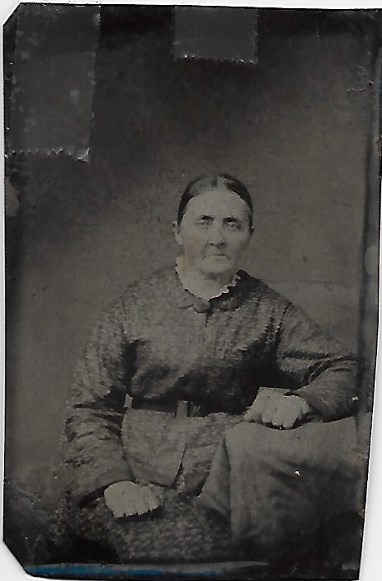
Sally Holleman (1823-1909)

Tintype, unknown date, of Sally Holleman Faison (1823-1909). Sally looks like a petite lady, and isn’t smiling for us. Not many people did when the photography process was somewhat tedious. Family called her “Mama Sal.” She married Josiah W. Faison, who was from Sussex County, Virginia. She went to school in Smithfield, Virginia, at Oak Grove Academy. She is my third great grandmother.

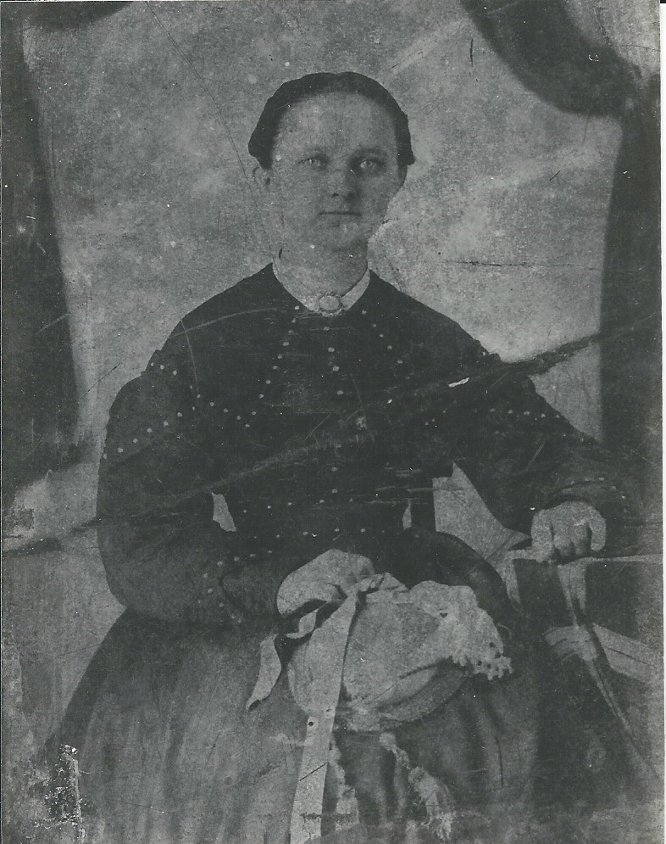

Tintype of Elizabeth Faison (1842-1898), daughter of Sally Holleman Faison. She looks to be in her early twenties, so this picture was made in about 1860. I know nothing of her education. She was born in Sussex County, VA. She and her sister married brothers, Jacob and James Heath, who were from Duplin County, NC. All 4 moved to Duplin County, and lived there all their lives. My mother once told me that this picture was made at her wedding. I don’t know how she knew that.
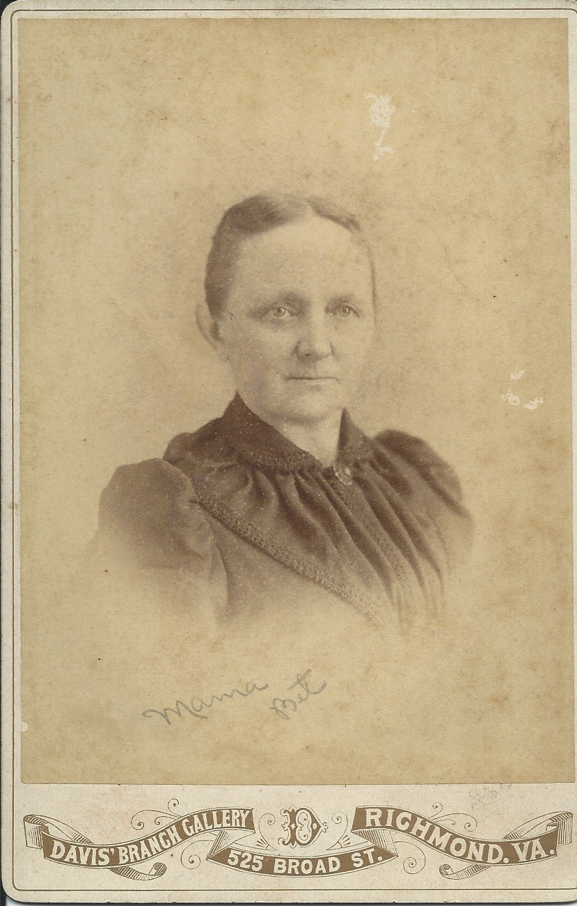
Photography of Elizabeth Faison Heath, perhaps in her forties. Note picture taken at studio in Richmond, VA. My family called her “Mama Bet.” She had 3 children, two daughters, Bettie Florence and Sally. She had one son, Perry. She was my second great grandmother. I have a letter written to her by a friend, expressing how glad she was that her daughters were “studying music.” Mama Bet died before her mother Sally did.
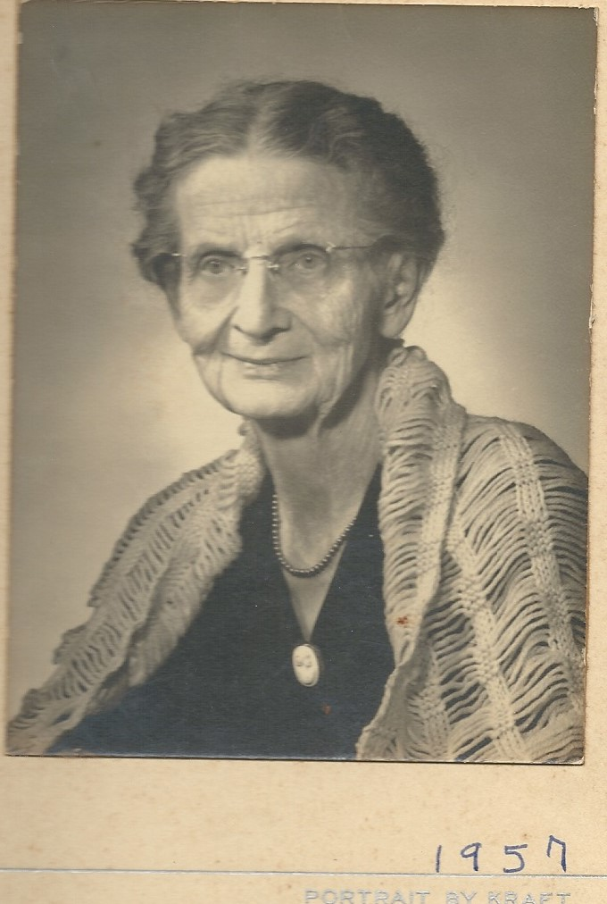
Bettie Florence Heath (1871 -1959) daughter of Elizabeth Faison Heath, my great grandmother. She married Jordan Horne, and they had 4 living children, 3 sons and one daughter. The family lived in the town of Magnolia, Duplin County, NC. One son, Ralph, went to jewelers school in Philadelphia, PA. Another, Herbert, graduated from Blackstone Military Academy in Blackstone, VA. Her daughter, Bettie Florence, graduated from Stuart Hall Girls School in Virginia, and then from East Carolina Teachers College.

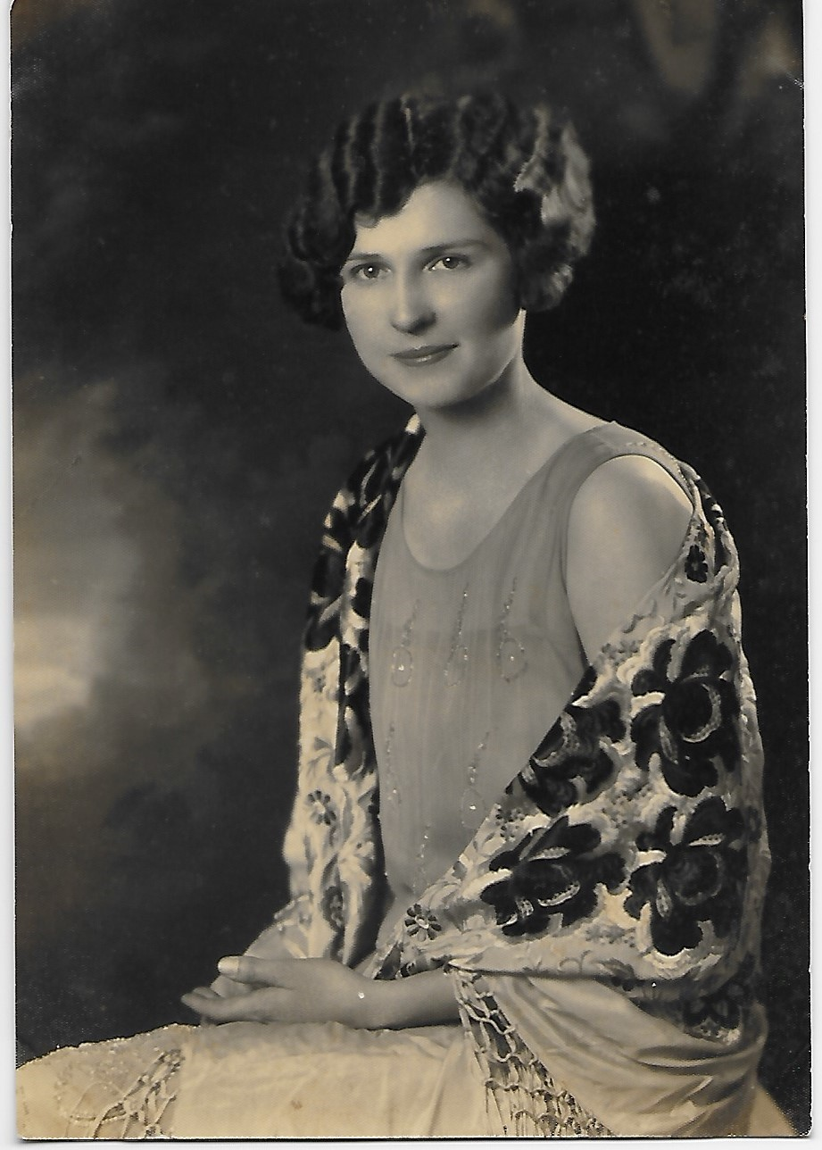

Bettie Florence Horne (1903-1980), daughter of Bettie Florence and Jacob Horne. This may have been taken in high school, about 1920. This is my great aunt “Bet.” She was the only daughter of Bettie Florence and Jacob. She earned a college degree from East Carolina Teachers College. She never married.
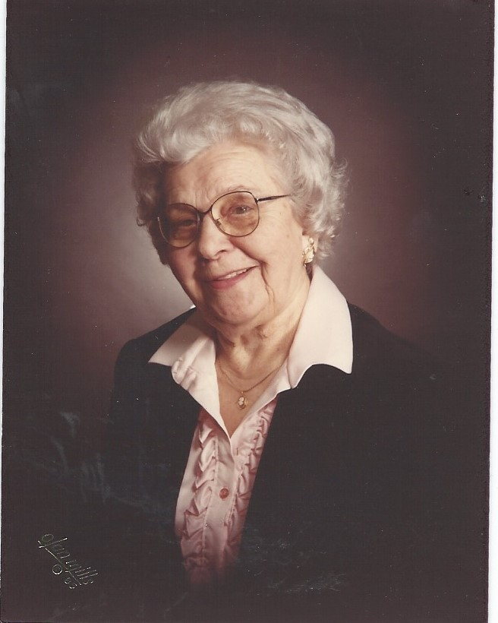

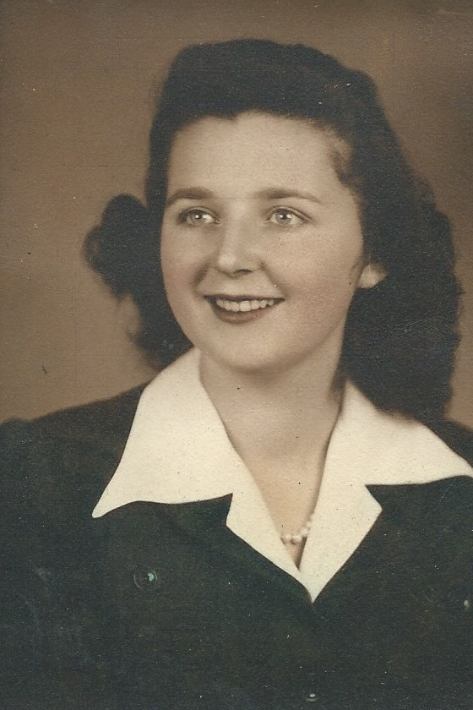

Here is Florence Elizabeth Horne (1925-1993), my mother. She married Neil Edward Gallier, and they had 3 children, my two brothers Neil Edward, Jr., Frank Wilson II, and me. She attended East Carolina Teachers College, now known as East Carolina University, for two years.

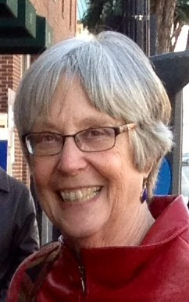
Yours truly, Susan Carol Gallier White (1946-present).

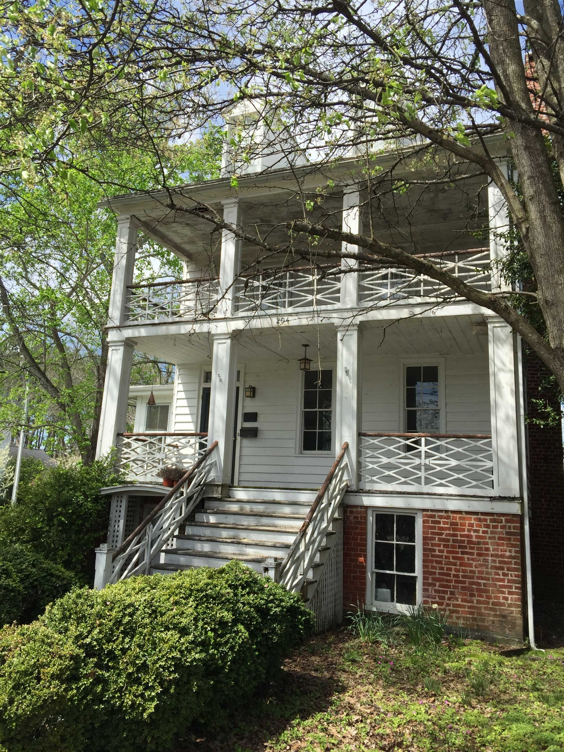
This is the old Oak Grove Academy, on Grace Street in Smithfield, Virginia.

