by Glenn N. Holliman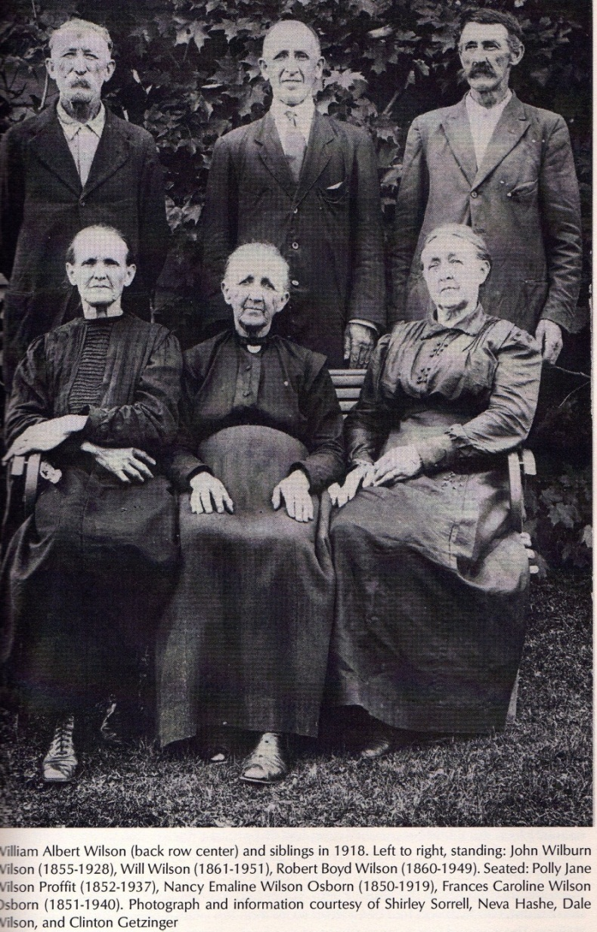
The Family of Frances Caroline Wilson Osborne

Parents: Isaac Wilson, 12/16/1822 – 17/6/1864; Caroline Greer Wilson, 12/10/1828 - 1911. Married March 25, 1849 in Ashe County, North Carolina.

The Brothers and Sisters of Frances Caroline Wilson Osborne

Mrs. Nancy Emaline Osborne (1850 – 1919): Married Richard Franklin Osborne (1846 – 1897). Frank’s mother was Sarah Thomas Osborne (1829 – 1903), who according to Johnson County (TN) Photographs on-line was married first to Alvin Osborne, then to Alexander Osborne. Sarah was the daughter of William and Mary Sutherland Thomas of Ashe Co., NC. Mary Sutherland was the daughter of Alexander Sutherland of Grayson Co., Virginia. Alexander’s son Thomas Houston Sutherland, born 1785, was the founder of Sutherland, NC.

Mrs. James Harvey Proffit ( Polly Jane) (1852 - January 24, 1937): Married James Harvey Proffit.

John Wilson (1855 – 1928): Married Rebecca Wilson (1862 – 1952).

Mrs. Martha Evaline Forrester (1857 – 1904): Married Andrew Johnson Forrester and have five children. Family historians Jeannie Bond and Clinton Getziner report Martha Evaline Wilson Forrester also had five children by her brother-in-law, Frank Osborne while he was married to her sister, Ema.

Robert Boyd Wilson (Bob Boyd) (1860 – 1949): Married Sara Ellen Wilson (1866 – 1952).
The Rev. William Albert Wilson (1861 – 1951): Married Mary Amelia McClellan. Youngest son of Caroline and Isaac Wilson, he obtained an education, attended Trinity College (Duke), was ordained a Southern Methodist minister and became a missionary to Japan. One of his ministries in Japan was Hiroshima. He retired in 1931 after 41 years in Asia.

Mrs. Sara Marilla Osborn (1866 – 1882): Married William Osborne. Sara was born out of wedlock to Caroline Greer Wilson. The father was a neighbor, Tom Sutherland according to Clinton Getziner.

December 4 – “1919…my sister mrs N E Osborne died this 4. ms sister Nancy E Osborne Died…was Buried the 5th, 2 clock, Friday Dec 5…colde.” This is Frankie’s sister Emaline, who nursed her husband- to-be during the Civil War and worked in the corn field with Frankie when their father was killed in 1864. Nancy Emaline Wilson Osborne 1850 – 1919, married to Richard Franklin Osborne (Frank). They lived in either Watauga or Ashe County, NC at her death. Emma was long suffering. While Frank was married to her, he fathered five children with Martha, Emma’s younger sister.

December 10 – “GW come back from NC…Brother Bob (Wilson) come with him…He had all of his teeth puld.” April 4 – “Easter Sunday, 1920…got diner for Pearl, Dave, Donly & Wife Beckey Wilson, mayme & children.” Pearl and Dave were the Wrights from Damascus, Virginia. The Wilsons married into the Donnelly family (the general store at the entrance to the old homestead on Oscar Wilson Road is today owned by the Donnellys). This couple could be cousins of Pearl Osborne Wright. The Wilsons may have motored over the mountains, probably driving through Damascus.

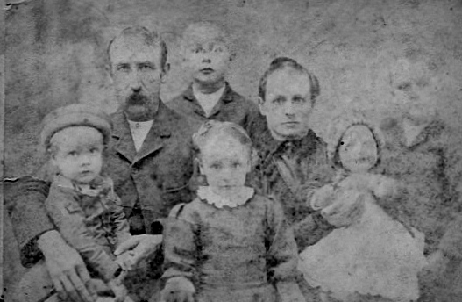

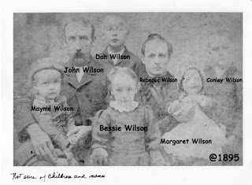

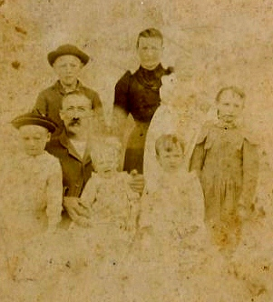

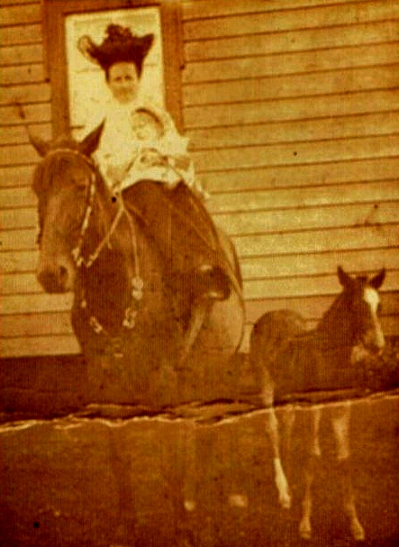

by Glenn N. Holliman

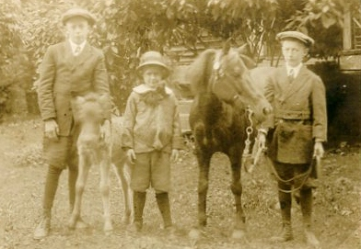
Left to right are Boyd Wilson, Clyde Wilson and Ernest Wilson
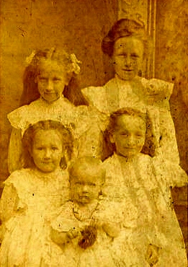

1905 Margaret, Mayme, Cal, Minni and Ruth

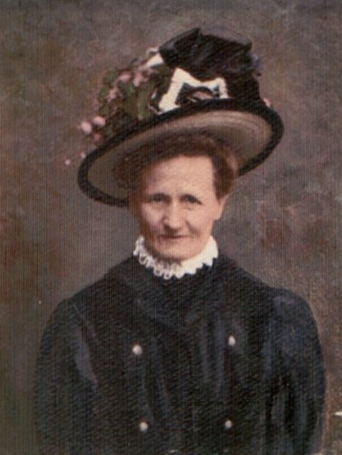
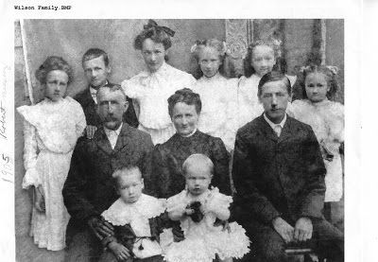
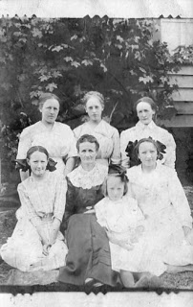

1919 March 26 – “Charles Osborn & wife minie ate diner hear on ther way to oragan.”
This may have been the son-in-law of Robert Boyd Wilson (1860 – 1949), one of Frankie’s brothers. However, the book Neighbor to Neighbor lists this suppose Charles’ wife as Edna Wilson. Perhaps this Charles Osborne is more closely related to G.W. The Wilsons and Osborns were marrying kin with considerable frequency. Charles Osborne is the grandson of Clemons Osborne and therefore a great-nephew of GW Osborne. Minnie is a daughter of John & Rebecca Wilson Wilson. (CWG)

1921 August 13 – “Callie Wilson & Ruth came…callie on her way to Durn (Durham, NC).”
Callie Wilson (1898 – 1999) was a niece of Frankie’s and a daughter of John Wilburn and Becky Wilson of Ashe County. Callie would marry her first cousin William A. Wilson, Jr, son of the missionary to Japan. William A. Wilson Jr. was born and raised in Japan. He and his cousin Callie married June 19, 1926 at Duke Memorial Church, Durham, NC.

Ruth is Ruth Wilson 1903-1999, another daughter of John and Becky Wilson. She was born 1903 and would marry Shirley (male name) Hurt.
1924 September 25 – “old solgers had a reunion at VA cort houc…servd diner. Becke Wilson and Ruth Hurt From NC come…spent the night.” This is her sister- in- law, John Wilson’s wife, Becky (1862-1952) who is featured in photographs prominently in Neighbor to Neighbor. John and Becky’s daughter, Ruth (1903 - ?), married Shirley (male name) Hurt. John lived from 1855 to 1928. The family resided at Caroline Wilson’s old home place, now on Oscar Wilson Road which begins at Donnelly Store in Ashe County, NC.

1927 May 2 – “mrs John Wilson & Shirly Hurt – wife – baby …all come spent the night and a day with us from NC.” This was Frankie’s sister- in-law, Becky from the Wilson farm in Ashe Country. Shirley is Becky’s son-in-law and the wife, Ruth, is the mother of the new baby.

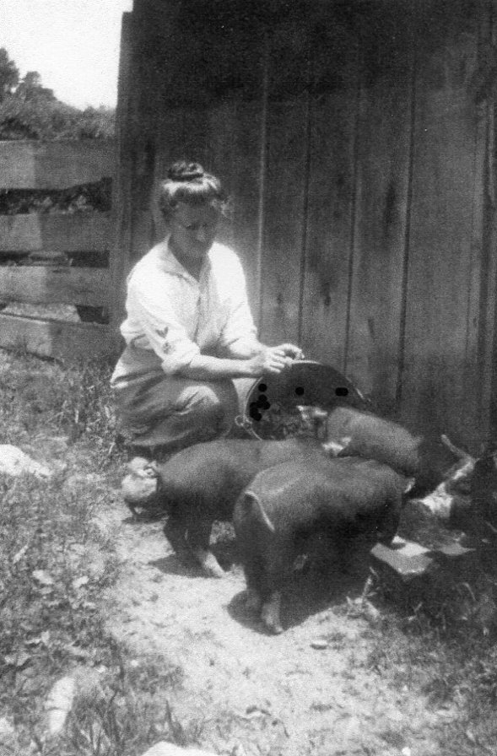

by Glenn N. Holliman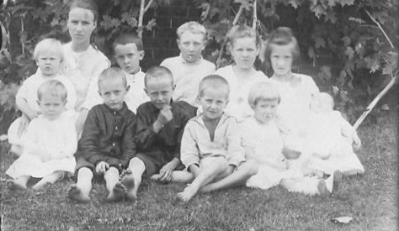

1918 Front row: Ernest, Boyd, Clyde, Louise Stansbery Sherwood and Charles Stansbery (baby)
Back row: Earl, Verde, Frances, Argus, Robert and Marie
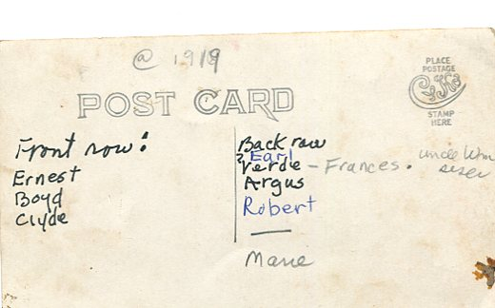

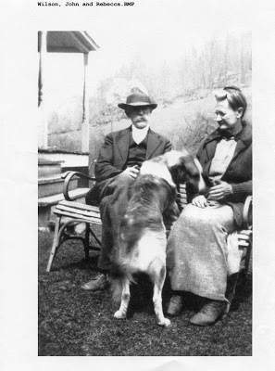
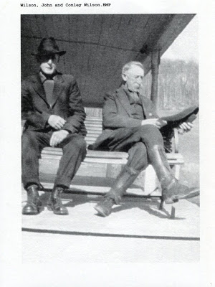
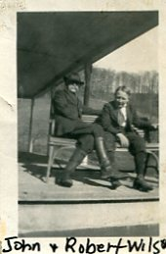
by Glenn N. Holliman

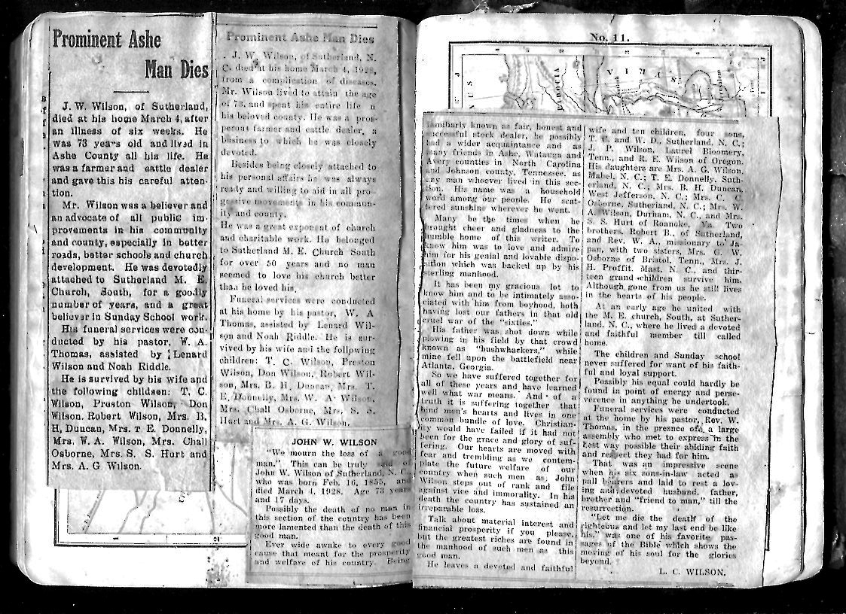

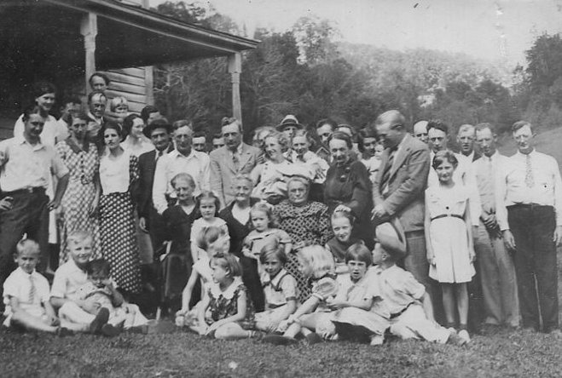

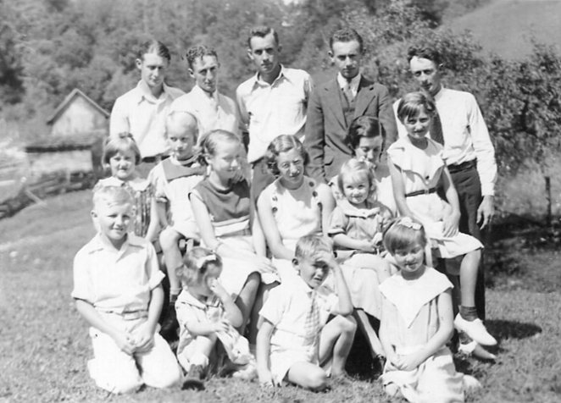

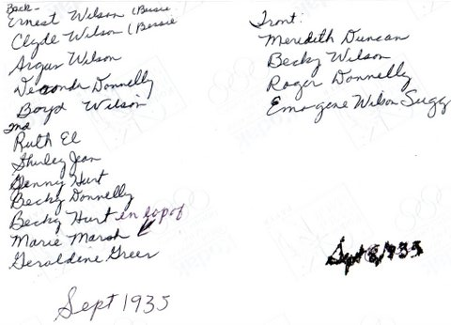

Shirley Sorrell, great great grandaughter of Isaac and Caroline Greer Wilson continues to share photographs she has collected of her parents, grandparents, aunts and uncles and cousins.
Below, pictures in the 1940s of Roger Donnelly, left, followed to the right by Mayme Donnelly. Next moving right is John T. Sutherland and his wife, Mayme's daughter, Rebekah Donnelly Sutherland. The picture was taken at the Mayme Donnelly home in Sutherland, North Carolina.
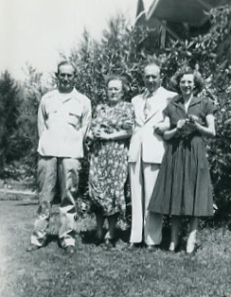
In 1937, in Sutherland, a picture was taken of the oldest children of Bessie and Conley Wilson, who are also the grandchildren of John (1855-1928) and Rebecca (1862-1952) who is sitting center on the front row.
Back row, left to right are: Bessy's oldest son, Boyd Wilson and his wife, Lexie holding the baby named Gloria. Then Coney's oldest son, Argus and his wife, Grace Wilson holding baby Betty. Finally on the back row is Conley's daughter Marie and husband Don Marsh with baby Shirley Marsh.
In the front, left is Bessie Wilson Wilson holding Boyd's son, Robert. Then Rebecca Wilson Wilson and finally Conley Wilson.
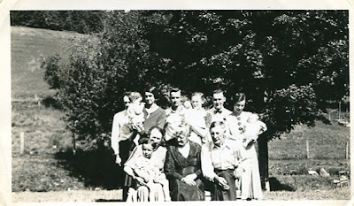
Robert James Wilson was born August 25, 1932 and died of leukemia on August 16, 1950. Gloria Jeanette Wilson entered life on October 5, 1934, William Boyd Wilson March 9, 1936 and Annabel Wilson, July 31, 1938.

by Glenn N. Holliman
Shirley Sorrell, great great grandaughter of Isaac and Caroline Greer Wilson continues to share photographs she has collected of her parents, grandparents, aunts and uncles and cousins.
Below, pictures in the 1940s of Roger Donnelly, left, followed to the right by Mayme Donnelly. Next moving right is John T. Sutherland and his wife, Mayme's daughter, Rebekah Donnelly Sutherland. The picture was taken at the Mayme Donnelly home in Sutherland, North Carolina.

In 1937, in Sutherland, a picture was taken of the oldest children of Bessie and Conley Wilson, who are also the grandchildren of John (1855-1928) and Rebecca (1862-1952) who is sitting center on the front row.
Back row, left to right are: Bessy's oldest son, Boyd Wilson and his wife, Lexie holding the baby named Gloria. Then Coney's oldest son, Argus and his wife, Grace Wilson holding baby Betty. Finally on the back row is Conley's daughter Marie and husband Don Marsh with baby Shirley Marsh.
In the front, left is Bessie Wilson Wilson holding Boyd's son, Robert. Then Rebecca Wilson Wilson and finally Conley Wilson.
Robert James Wilson was born August 25, 1932 and died of leukemia on August 16, 1950. Gloria Jeanette Wilson entered life on October 5, 1934, William Boyd Wilson March 9, 1936 and Annabel Wilson, July 31, 1938.

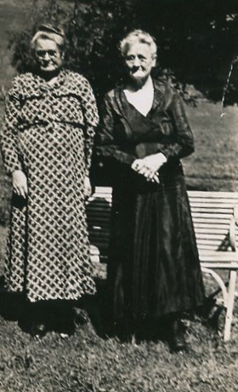

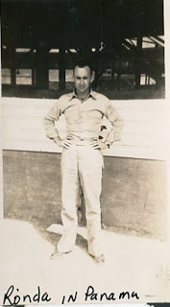
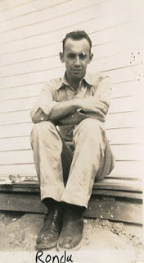
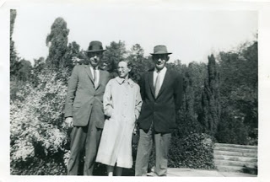

by Glenn N. Holliman
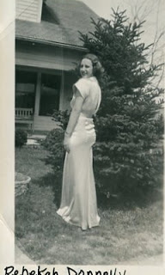
i have had his discharge and medals, but made a shadow box for my brother with all of that a few years ago. I know he served in wwll in Panama and India in the Air force getting out in 1943 i think . My mom was in the army and worked in DC. is there some special info that u need for me to get i will try.
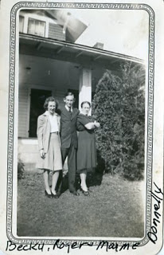
by Glenn N. Holliman
We continue our exploration of the branch of the Wilson-Greer-Donnelly of Shirley Sorrell, avid family historian. Below in the 1930s, Becky Donnelly Sutherland, Mayme Wilson Donnelly and Roger Donnelly at their home in Sutherland, North Carolina.
Roger Gus Donnelly, 11-10-1928, died 4-11-2009. Roger, a Korean War veteran, was a heavy equipment operator, strip mining coal the majority of the time in West Virginia.
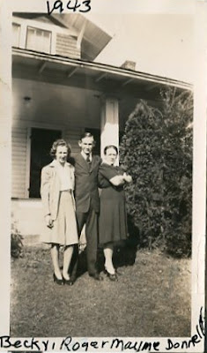
Above in 1943, here are the same three, siblings and their mother, Mayme Donnelly with Becky and Roger. Becky Donnelly, aunt of Shirley Sorrell. Rebekah Sue Donnelly Sutherland was born 9-28-21 and died 8-8-1999
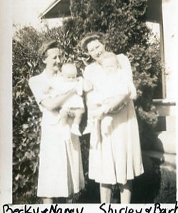
Above, the same house in Sutherland, Becky now married to Sutherland holds Nancy, her only child. Right is Barbara Donnelly McCall, another daughter of Mayme Wilson Donnelly, who is holding young Shirley Sorrell. The date is approximately 1948.

