We continue our exploration of the branch of the Wilson-Greer-Donnelly of Shirley Sorrell, avid family historian. Below in the 1930s, Rebekah Sue Donnelly Sutherland, Mayme Wilson Donnelly and Roger Gus Donnelly at their home in Sutherland, North Carolina.
The son of Mayme Wilson Donnelly, Roger Gus Donnelly, b 11/10/1928, died 4/11/2009. Roger, a Korean War veteran, was a heavy equipment operator, strip mining coal the majority of the time in West Virginia. Below Mayme, Roger and Becky.
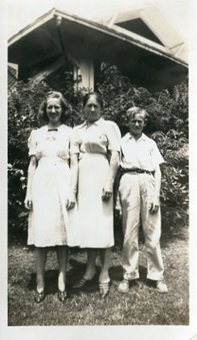

Below in 1943, here are the same three, siblings and their mother, Mayme Donnelly with Becky and Roger. Becky Donnelly is the aunt of Shirley Sorrell, and was born 9/28/1921 and died 8/8/1999.

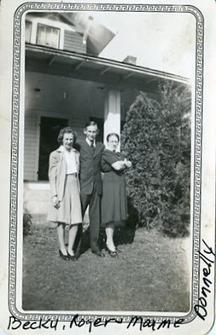

Below, the same house in Sutherland, Becky now m Donnelly arried to ??? Sutherland holds Nancy, her only child. Right is Barbara McCall , another daughter of Mayme Wilson Donnelly, and who is holding young Shirley Sorrell. The date is approximately 1948.

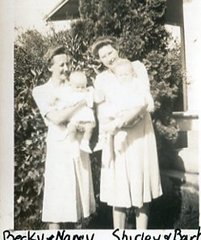

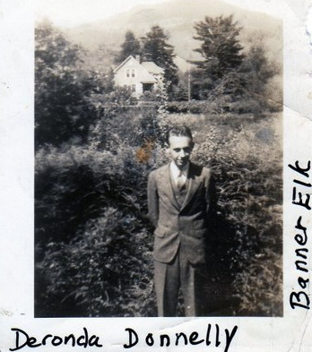
Attended Leigh McCray College.

Shirley's father, date?
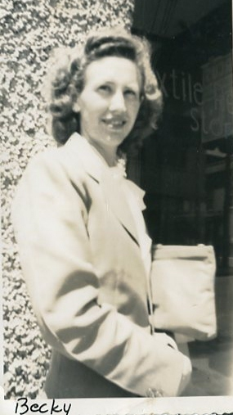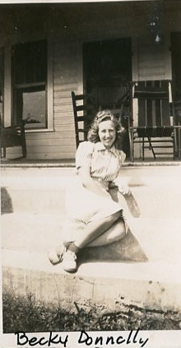

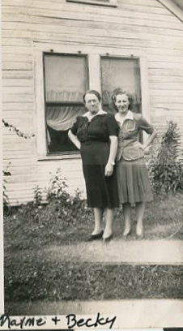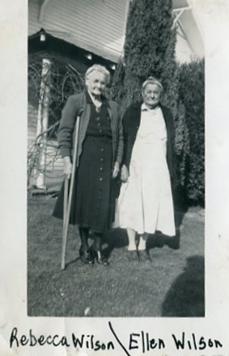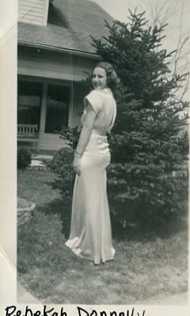

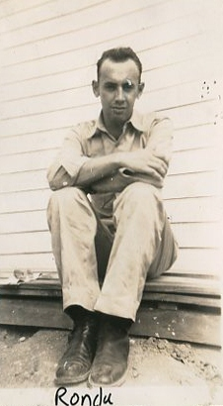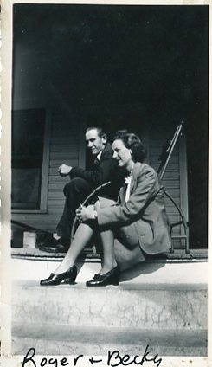
Roger moved to West Virginia, married Pauline Wilson Roark, one son from from first marriage. Uncle Roger worked in coal mines and road construction in Tennessee. Owned place in Shady Valley, Tennessee. No children. Was in Korean War. Roger b Nov 10, 1928 and d. April 2011.

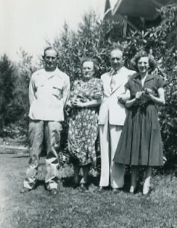 Uncle Roger, Grandmother Mayme, Johnny and Becky. Taken at Sutherland. Mayme's parent's were John and Rebecca Wilson. Mamye's husband was Thomas Earl Donnelly. First child was T.E. Donnelly, Jr. T.E. Donnelly was a salesman for McQuire Hardware. Was a traveling salesman like his father, Gustavius Donnelly, m. to Elizabeth Romaninger.
Becky, Roger and Deronda were brother and sisters. Mother was Becky.

Mayme d May 10, 1975. Earl Donnelly died Dec. 28, 1964.

Becky grad from A.S.U. Married John Thomas Sutherland, Jr., Greyhound Bus Driver. Becky taught school before marriage. Becky and John T. Sutherland moved to Raleigh. Child was Nancy. Nancy was married to Dave Broyles. He is passed away. Nancy lived in Raleigh, NC and moved to S.C. Birth and death dates coming. Becky m. Nov. 20, 1942; Johnny not in service.

Deronda and Shirley's family lived in Boone (where Shirley was born). Later moved to Richmond, VA. Both Deronda and Shirley's mother both in WWII. Went to secretarial school, and she joined WACS. Lived in Washington, DC when in Army. Deronda was in India and Phillipines.
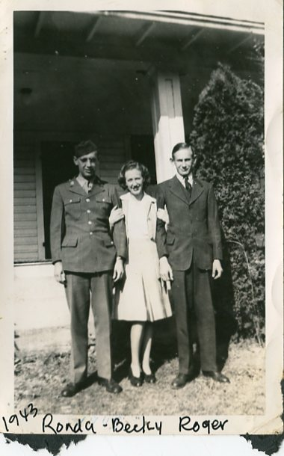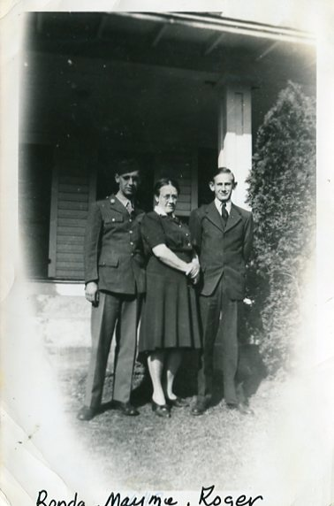
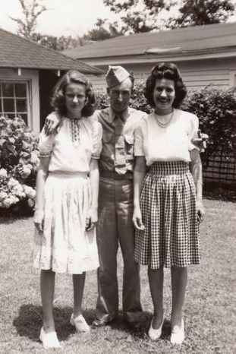
Shirley Sorrell | 10:21 PM (8 hours ago)
to me

Hope you got everything i sent. i had a time copy the list i did. Sorry Gloria is on there twice. i was cutting and pasting. called Dale Wilson's mom Betty to find out who the other baby was that my Aunt Becky was holding..Hope you can read the Numbers i did them in red this time..will help with what ever you need .
In talking with Betty(Dale's mother) tonight, she told me Earl was out west when this picture was taking. He was only grandchild missing in the grand children pic of 1935.
Son-in-laws
1.Earl was a salesman for a hardware store where his dad also worked.
2.Arlie ran a store in Mabel community.He taught in Watauga and Wilkes county schools. they later moved to Rebecca Wilson(his mother in laws) to care for her.
3.Chall Osborne was a farmer in Ashe. He and Minnie went out west to tend sheep.
4.William graduated from Trinity College (now Duke University), class of 1914 and before that he attended the Trinity Park School in Durham for a few years. After graduation he served in the U.S. Army and was stationed at Fort HoodI . William worked for Liggett & Myers Tobacco Company in Durham from 1920 – 1959.
Roger moved to West Virginia, married Pauline Wilson Roark, one son from from first marriage. Uncle Roger worked in coal mines and road construction in Tennessee. Owned place in Shady Valley, Tennessee. No children. Was in Korean War. Roger b Nov 10, 1928 and d. April 2011.

Uncle Roger, Grandmother Mayme, Johnny and Becky. Taken at Sutherland. Mayme's parent's were John and Rebecca Wilson. Mamye's husband was Thomas Earl Donnelly. First child was T.E. Donnelly, Jr. T.E. Donnelly was a salesman for McQuire Hardware. Was a traveling salesman like his father, Gustavius Donnelly, m. to Elizabeth Romaninger.
Becky, Roger and Deronda were brother and sisters. Mother was Becky.

Mayme d May 10, 1975. Earl Donnelly died Dec. 28, 1964.

Deronda and Shirley's family lived in Boone (where Shirley was born). Later moved to Richmond, VA. Both Deronda and Shirley's mother both in WWII. Went to secretarial school, and she joined WACS. Lived in Washington, DC when in Army. Deronda was in India and Phillipines.

Earl, Mayme, TE and Deronda Donnelly @1919 at Gus and Flora Donnelly
home in Sutherland community. Mary donnelly, Earl's youngest sister in
the back.
Please let me know u got this
You have been sent 1 picture.

Roger Gus died 4/11/2009.

5. Bower Duncan Bower was an educator serving as teacher, principal and superintendent in Ashe County schools. He attended Appalachian and Wake Forest. He served in World War I. He served as magistrate for Ashe county for many years
6. Shirley Hurt worked as a salesman for a paint company in Greensboro and did Landscaping. He died young.
Rebecca Ann Wilson (1862) is how she spelled her name. three grandchildren were named after her. But my aunt Rebekah was the only one who spelled it different. i have not seen any documents that have it anyway except Rebecca for her.
Back row Chall Osborne(Minnie), William Wilson(cal), Bower Duncan(Margaret or Maggie), Arlie Wilson(Bessie)
Front row: Earl Donnelly(Mayme), Shirley Hurt(Ruth) That should be all six of the girls.
thanks , shirley

