by Glenn N. Holliman

**As observed in early posts, the majority of the 20th Century descendants of Isaac (1822-1864) and Caroline Greer Wilson (1828-1911), left family farms and pursued occupations in the communities and cities usually far from ancestral roots in Sutherland, Ashe County, North Carolina.**

**In the United States, the number of persons employed in agriculture fell constantly from the Civil War to 1950 as agricultural mechanization and specialization increased, and as jobs in the industrial and manufacturing sectors proved more lucrative and attractive than subsistence farming.  Such was the case with the ancestors of Shirley Sorrell who kindly shares these photographs. - GNH**

[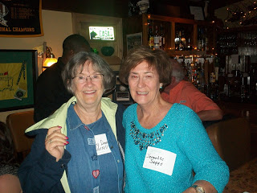](http://3.bp.blogspot.com/-TMnxp-n1irY/Vb-JbLcmF7I/AAAAAAAAJ14/JvSuZUqu1vQ/s1600/2014+7-18+Boone,+NC+Shirley+Sorrill+and+Jeanette+Suggs2.JPG)

*Above at the Wilson-Greer and Families Seminar in 2014 in Boone, North Carolina, left Shirley Sorrell and right, distant cousin Jeanette Suggs.*

**The lineage of Shirley Sorrell**

Her parents:   **Deronda** (1918-1966) and **Barbara McCall Donnelly** (1922-1965)

Her parental grandparents:   **Thomas Earl** (1892-1964)  and **Mayme Wilson Donnelly** (1892-1975)

Her great grandparents:  **John** (1855-1928) and  **Rebecca Wilson Wilson** (1862-1954)

Her great great grandparents:  **Isaac and Caroline Greer Wilson** (the same as this writer)

*Below, Shirley's father, Ronda Donnelly who served in India and Panama during World War II.* Ronda and wife, Barbara, lived in Boone, North Carolina (where Shirley was born) and later moved to Richmond, Virginia.    Shirley's mother, Barbara McCall, also served in World War II.  She joined WACS as a secretary during the war and lived in Washington, DC when in Army.  Sadly, both Shirley's parents died young.

[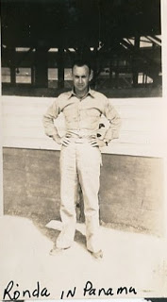](http://1.bp.blogspot.com/-PpdWc7e52f8/Vb-KM_rl4QI/AAAAAAAAJ2I/Cp9KA42lRvY/s1600/1940s+Ronda+Donnely+.jpg)

[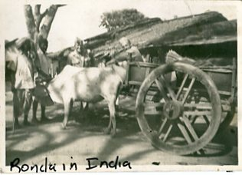](http://3.bp.blogspot.com/-TNqTItKWOp0/Vb-KBYmb9CI/AAAAAAAAJ2A/PjFahFsvHow/s1600/1940s+India,+Ronda,+Shirley+Sorrell's+father+in+the+war.jpg)

*Below, left to right in the 1940s, Roger Donnelly, his mother, Mayme Donnelly, John Sutherland and his wife, Mayme's daughter, Becky Donnelly Sutherland.*

[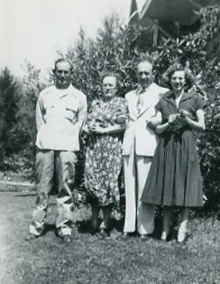](http://3.bp.blogspot.com/-Oj_QcF9Gszg/Vb-LbxPybeI/AAAAAAAAJ2U/QNASmobT-3I/s1600/1940s+Roger+Donnelly,+Mayme+Donnelly,+John+Sutherland+and+wife,+Becky+Donnelly+Sutherland.jpg)

Roger (1928-2011) moved to West Virginia, married Pauline Wilson Roark, who had one son from a previous marriage. Later,  Roger worked in coal mines and road construction in Tennessee and owned a place in Shady Valley, Tennessee.  He served  in the Korean War.

*Shirley, add information on Becky and John Sutherland*.

[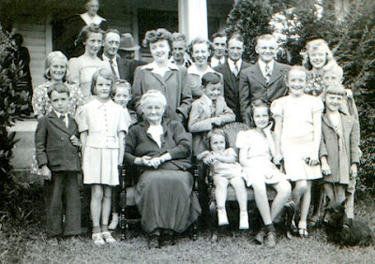](http://3.bp.blogspot.com/-Zv5QyWZCj38/Vb-QdIkJE5I/AAAAAAAAJ2k/zhO2us86If0/s1600/1942+JohnRebeccaWilsongrands-+greats.jpg)

The Grandchilden and Great Grandchildren of Rebecca Wilson Wilson, 1937

 Extreme back: Vern Wilson

 Back row: ?, Marie Wilson Marsh, Boyd Wilson, ?, Roger Donnelly, Angus Wilson

 2nd row: ?, Shirly Marsh, Virginia Hurt, Becky Donnely, Ernest Wilson, Meredith Duncan, Shirley Hurt, Joe Donnelly

 Front row: Bill Wilson, Marie Wilson, Rebecca Wilson, Robert Wilson, (in chair) Anna Bell Wilson, Becky Wilson, Becky Hurt, Betty Wilson

[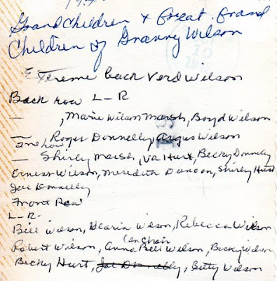](http://2.bp.blogspot.com/-rL0ukAxBXM4/Vb-QdRn2iZI/AAAAAAAAJ2o/qfIv28h7_aA/s1600/1942+Wilsons+grands+identified.jpg)

*All are invited to join in building the family tree at Wilson-Greer-Osborne-Forrester-Donnelly and Associated Families of Western NC at Ancestry.com.  Just write to glennhistory@gmail.com for an invitation.*