Stewart Button, Family Friend
by Bishop Holliman

In reviewing the letters and photographs of the 1930s, I continue to come up on the name of The Rev. Stewart Button of Irondale, Alabama. My father, Bishop Holliman, knew 'Button' in the middle and late 1930s and renewed the relationship in the 1970s. I remember stories about Mr. Buttons liberal views (liberal for the Hollimans who were largely Republicans in the 1930s and 40s), and have wondered who how he became such friends of the family. Here are my father's memories. - GNH

"Mr. Butten was a native of Ireland. I don't know the year he came to the U.S., but he ended up in East Tennessee, attending Maryville College, and eventually becoming pastor of the Presbyterian church in Irondale, Alabama about 1933. He also pastored a church near Trussville and one other out by Lake Purdy. They were very small, and he preached at a different one, I guess, each Sunday.

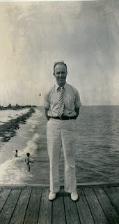
He was about Robert Daly, Sr.'s age (my brother-in-law who had married Vena Holliman in 1928), so they became very close friends The Dalys, who lived next door to me (the Ulyss and Pearl Caine Holliman house) took Mr. Butten under their wings. He was not married and had no family in the States, so he welcomed their friendship . . He went with Vena, Robert, Loudelle (Holliman Ferrell) to the Chicago World's Fair in 1933 and to Florida several summers.He became like one of the family and became sort of a role model for me as I was a young teen-ager, and was always around the Dalys when Mr. Butten was there.
Irondale, of course, was a very conservative congregation, but I guess it was Mr. B's Irish wit that endeared him to the church and community. He seemed to be a good fit, but he was way ahead of the time and place with his social and liberal views about religion, politics and race, yet he managed to get along well with all the folks.
Right, Mr. Button in Florida with the Dalys in the 1930s.

Once, though, he spanked a little boy who had misbehaved at the Bible school one day. The boy's daddy brought suit against him, and the newspaper picked up the story, and it got ll the way to Belfast, Ireland. It was seen by Mr.B's family there, and that's how they learned that he was in the ministry and what he was doing! The law suit was eventually dropped and nothing came of it.
Mr. B drove a motor cycle to his various churches, as an automobile was too expensive. I guess that was also his way of flouting the establishment. He was well-educated, a well-read man. He enjoyed engaging Robert (and me) in heated discussions about current events, FDR, and other issues of the day. He would usually end up every Sunday night at the Dalys, and I would often be there to hear their discussions and engage in arguments with them.

He left Irondale in 1937, taking a church in Knoxville, Tennessee, lived there several years, moving to some job in Ohio, and eventually went into library work. After Mr. B. moved to Knoxville, that summer 1937, he returned to Irondale on a visit, and I went back to Knoxville with hm and stayed at the home of one of the members. They had a boy my age, and we went up to the Smokies, my first time there and climbed the Chimney Tops. I rode the train back to Birmingham, always a thrill for me.

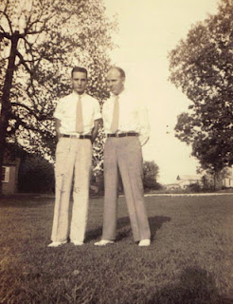
Above, Stewart Button right with Bishop Holliman left. Note the stylish white shoes in 1937.

Next posting, more on Mr. Button and the family….

Stewart Button, Family Friend, Part II
by Bishop Holliman

"Mr. Button married in the early 1940s and later moved back to Chattanooga and ended up in Knoxville. In 1975, he attended my younger daughter's, Alice Holliman Murphy, wedding in Cookeville, Tennessee. My wife and I visited him in a nursing home once and also in his home. His wife, Hazel, died before he did.

Below, Hazel and Stewart Button visit with Ralph Holliman in 1975 at the wedding of Alice Holliman and Bill Murphy. At that time, Mr. Button was retired and Ralph, Bishop Holliman's youngest brother, was a corporate executive in Chicago.
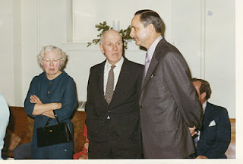

He went back to Ireland once, I'm sure, after Hazel died, and visited his old homeplace. He is buried near, Seymour, Tennessee. Robert Daly, Sr. died in 1959, and Mr. Button lived on into the 1980s."

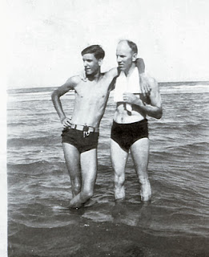
Compare the photo above with the one on the right of the same Ralph Holliman, age perhaps 15, the tallest of the Ulyss and Pearl Caine Holliman children, leaning on Mr. Button at one of those memorable Florida vacations the Robert Daly's made possible for the family.
Next posting a letter by Mr. Button on the death of Pearl Caine Holliman....

Stewart Button, Family Friend, Part III
by Glenn N. Holliman

The beloved mother of seven children, Pearl Caine Holliman, pictured below, died of heart failure on May 5, 1955. This is one of the last photos taken of her, again, on the lawn between her home and the Robert W. Dalys. Born in 1888 in Fayette, Alabama, she married Ulyss S. Holliman in 1906, and with him and their growing family moved in 1917 to Irondale, Alabama, a suburb of the then growing city of Birmingham.
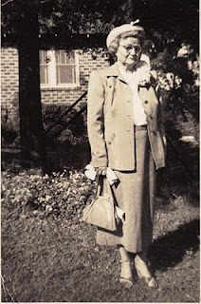
Stewart Button wrote the following letter to Mary Daly Herrin, the oldest of Grand Mama Holliman's 17 grand children. Sadly, some were too young to have known of her warmth and caring. Her memory lives today for those of us grandchildren who were fortunate enough to have sat around that long and large Holliman table at Christmas, that Mr. B. eludes to in his letter.
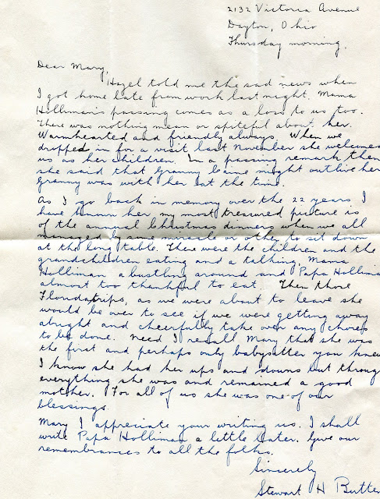

Next, more memories of Irondale, Alabama....in the 1920s and 30s.

