The Hymn of Abbots Leigh

In 1942, England was fighting for its existence. Even though the Yanks had entered the war, Rommel's African Corp continued to bottle up and occasionally whip the British Army at the front door of Egypt. Nazi U-Boats were sinking record number of ships off the U.S. coast and throughout the North Atlantic.
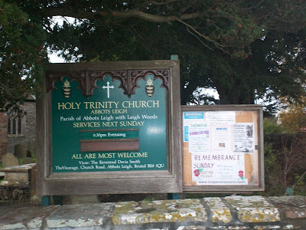

After the 1940 Blitz, the British Broadcasting System moved its wireless service from bombed out central London to Bristol, a long stone’s throw from Abbots Leigh. A new melody was needed for some wonderful words that up until then had been set to the same tune as an Axis' powers national hymn. Just would not do.

A BBC composer, Cyril Vincent Taylor, lived near Abbots Leigh, and composed in those dark days of 1942 a new melody. He named it 'The Hymn of Abbots Leigh'. Christians throughout the world know it best by the name "Glorious Things of Thee are Spoken". One likes to think that the Hollymans sleeping in the Holy Trinity Church might in their slumber have heard echoes of this joyful anthem. Below, a Hollyman gravestone in Abbot Leigh.
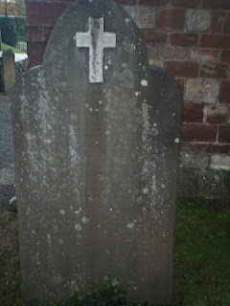
The fields of Abbots Leigh have for hundreds of years provided excellent crop and grazing land. The farm house below is where ancestors of Hollymans have lived, including Sheila Wallace Cooper, whose mother, Caroline, had the maiden name Hollyman.
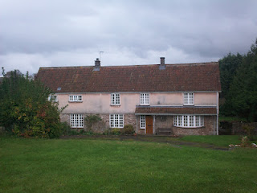

Next the Hollymans of Clevedon....

