Tuesday, June 5, 2012

The Parents of James Grantson Holliman, Part I
by Glenn N. Holliman

Who are the Parents and Grandparents of James Grantson Holliman (1750 - 1836)?
Several months ago, I posted articles on Hollimans who settled in West Alabama in the 1830s and their descendants who live there to this day. The Alabama Hollimans (and others) descend from James Grantson Holliman, my generation's 4th great grand father who was born in Johnston County, North Carolina in 1750 and died in Lancaster County, South Carolina in 1836. Some of his children, one being Cornelius Holliman, my 3rd great grandfather, moved to Alabama the year their father died.
The Hollimans (various spellings) began to leave southern Virginia, generally Isle of Wight and Surrey Counties, in the decades after the Tuscarora tribe was displaced from North Carolina in the 1710s and 1720s. As with thousands of others, they began to settle south of the Virginia border in the tidewater, sand hill and piedmont sections of eastern North Carolina. The spelling of Holliman varied from generation to generation and from county clerk to county clerk. Hence, one find Hollomans, Hollemans and other variations after the 'y' in Holyman gave way to other vowels.
As with almost all genealogies there are 'missing gaps' or uncertainties of the names of ancestors. What follows hopefully a mystery solved concerning my generation's 5th great grandparents.
The names of the parents and grandparents of James Grantson Holliman have been a puzzle to many. A popular Holliman family lineage web site states that Christopher Holliman Sr. (d 1691) begat Christopher Holliman, Jr. (true enough) who begat John Holliman (true) who begat Jesse Holliman (true) who was the father of James Grantson Holliman (not supported by evidence).
Several years ago over dinner in Virginia with my cousin Dr. Rhodes Holliman (who along with his late father Cecil Rhodes) is an accomplished Holliman historian, observed that the family lineage between Christopher Sr. and James Grantson was 'soft' and had some holes in it. Coming from a person highly immersed in Holliman history, and who has continued to build on his father's extensive research, well, this got my attention. Dr. Rhodes Holliman, below, has been stalwart in keeping the flame of the history of Alabama Hollimans burning brightly.
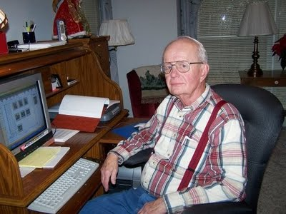
Then I heard from Maxine Wright, persistent and careful Holliman researcher from Arkansas and another descendant of James Grantson Holliman, who discovered a host of reasons that challenge this ‘conventional’ line.Then I noticed on the Tina Peddie chat room other cousins, Joe Parker and Jeanette Holiman, who are always very well researched, also challenged the above lineage. Ron Holliman from Alabama raised my doubts also with information on Samuel Holliman's historic home near Rocky Mount, North Carolina.

Take a minute below to review the 'traditional' lineage that is posted widely on the Internet and many Ancestry.com sites. The web site done a number of years ago represents a mountain of work by a distant cousin for which we all should be grateful. However, as with any historical research and interpretation (especially mine), we need to keep probing and critiquing. Genealogy is a process.

The Web Lineage that is challenged but still on the web and Ancestry sites -
Christopher Holyman, Sr. (1618 - 1691) (DNA testing proves this Christopher is my ancestor)
to
Christopher Holliman, Jr. (1660 ca - 1733)
to
John Holliman (d 1751), wife - Elizabeth
to
Jesse Holliman, (d 1812), wife Charity Coffer in 1753
to
James Grantson Holliman (1750 - 1836), my 4th Great Grandfather
Now in the next posting, Jeanette Holiman Stewart will prove a negative and demonstrate the above lineage is not POSSIBLE.

Tuesday, June 19, 2012

The Parents of James Grantson Holliman, Part II
by Glenn Holliman
Below is a synopsis of the reasoned impossibility that my 17th and 18th century family lineage could have developed as outlined in the previous post. This is prepared by Jeanette Holiman Stewart, who along with Dr. Rhodes Holliman, Joe Parker, Ron Holliman and Maxine Wright, has studied this issue extensively. Below, Jeanette Holiman Stewart at the Spring Hill Baptist Cemetery near Bluff, Alabama on April 9, 2011 on an excursion to explore Holliman family sites. - GNH
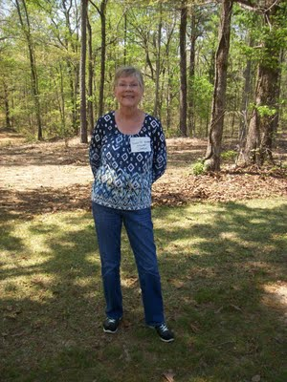
Why Jesse and Charity Cofer Holliman Cannot be John Grantson Holliman's Parents! by Jeanette Holiman Stewart
"I can't begin my synopsis without also paying tribute to another Holliman doctor, this one being Dr. Sidney A. Holleman of Ft. Worth, Texas. In 2003, Dr. Holleman wrote a book on Hollemans in Louisiana, which stimulated my thinking on Jesse Holleman. I owe this Dr. Sidney Holleman, Dr. Rhodes Holliman and many others a salute for their research. Below are my time line and thoughts.
1737 - Jesse Holliman, born in Isle of Wight, VA
1740 - Charity Cofer born in Isle of Wight, VA (sometimes Coffer)
1753 - Age 16, marriage of Jesse to Charity Frances Cofer, Isle of Wight (IOW), VA
1755 – Susannah Holliman names Jesse Holliman in her Isle of Wight will.
1771, 1772, 1784, 1787, 1787, and 1791 - Jesse Holliman witnessed wills in Isle of Wight Co. Hard to do so if he is supposed to be living in North Carolina.
1771 - Age 34, Appraised John Jones Estate, IOW, VA
1779 - Age 42, Replaces James Cofer as surveyor of IOW, Virginia Revolutionary War Patriot, held a civil engineering position surveying roads for the military. They had to have roads to move troops around, just like today.
1783 - Age 46, Executor for Thomas Cofer's Estate, IOW, VA
1790 - Age 53, Residence, IOW, VA
1798-1801 - Joint Minister with John Gwaltney of Mill Swamp Baptist Church, IOW, VA
1801 - Age 64, Became guardian of IOW orphan John Fones
1810 - Age 73, Residence, IOW, VA
1816 - Age 79, Marriage to Frances Stringfield, IOW, VA by John Gwaltney
Listed in the Ministers Returns of Marriage, IOW Co. Marriage Register
1819-1820 - Age 82-83 Minister Mill Swamp Baptist Church, IOW, VA
1829 - Age 83, Residence IOW, VA
25 Sep 1824 - Age 87, Will, IOW, VA, Will Bk Vol 17, pgs 101-102
Dec 1824 - Age 87, Death, IOW, VA
Jesse Holliman lived a long and productive life, and I would be glad to claim him as my 5th Great Grandfather, but the evidence denies this possibility. In 1835 James Grantson Holliman, when applying for his Revolutionary War pension, stated he was born in 1750 in Johnston Co., NC. We have records of his life demonstrating James Grantson did live and farm and in Johnston County, some 100 miles southeast of Isle of Wight County, Virginia during the 1760 to 1780s.
James Grantson Holliman could not be a son of Jesse and Charity Cofer Holliman. As demonstrated above, Jesse and Charity lived all their very well-document lives in Isle of Wight Co. One doubts Charity had James Grantson when she was only 10 years old in Johnston County, North Carolina!

So did another Jesse Holliman exist in Johnston Co., NC? Yes, but the Jesse Holliman in North Carolina lived there in 1811, with no mention of such a name before that."
So then who might be James Grantson Holliman's parents?
We will explore that issue in the next post, and we now have an answer!

Wednesday, June 27, 2012

The Parents of James Grantson Holliman, Part III
by Glenn N. Holliman
From Christopher Holyman, Sr. (1618 - 1691) to James Grantson Holliman (1750 - 1836) - The Lineage
In the last post cousin Jeanette Holiman Stewart of Texas demonstrated to my satisfaction that James Grantson Holliman's parents could not have been Jesse and Charity Cofer Holliman of Isle of Wight County, Virginia. The dates and locations do not work.
As a descendant of James Grantson and Christopher, Sr (DNA testing), I was curious as to who my missing ancestors are. So are others, one being a careful and thoughtful genealogist, another distant cousin, Joe Parker, again of Texas. I share below his thesis with you. And Joe, calls it that, his thesis. We both agree that genealogy is a process where information is gathered, assessed, and lineages tested by time and additional research.
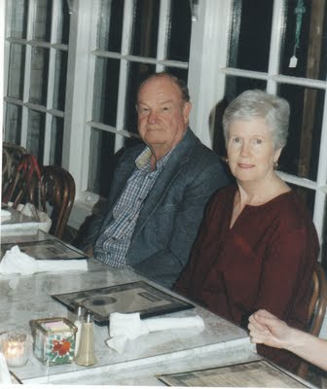
Above, Joe and Gladys Parker
Joe wrote me the following several months ago, and I quote,
"Based on what I have been looking at the last few months, it is my personal belief that James Grantson Holliman was a grandson of Richard Holliman who died in 1711. The author of the Hollyman book, George A. Holleman, has that one of Richard's grandsons is name 'James'. This James lives in the correct era, and mingled with Hollimans who are descendants of the Richard Holliman (a son of Christopher Holyman, Sr.), all in Johnston County, North Carolina.
Until further information comes along, I am going to go along with this opinion. Somewhere out there, there is a thread of evidence that does point out his father and his lineage. Just find it and properly identify it."
So Joe proposes (and I am in agreement with him with the evidence in hand including my own research) this branch of the James Grantson Holliman tree:
Christopher Holyman, Sr. (1618 -1691) and unknown wife (Anne)
to
Richard Holliman (1660s ca -1711) and Margaret Jordan House Holliman
to
Samuel Holliman (1707 -1789) and
to
James Grantson Holliman (1750 -1836)
During our Holliman Round Table in Fayette, Alabama on October 14 and 15, 2011, Lynn Holliman of Texas and I discussed the above with Joe. Thanks to the work of Walt O. Holliman, who died 2003, we were able to examine his additional research in detail. Walt's evidence bore out Joe and Jeanette Stewart's research. By legal records such as wills, land deeds and military service, no one else qualifies as James Grantson Holliman's father.
Samuel Holliman appears to be the great grandfather that many family genealogists have been searching for decades.

