The Sibblings of Pearl Caine Holliman
by Bishop Holliman, 2011, her son

Mama (Pearl Caine Holiman, 1888-1955)) had two sisters, one brother. Floyd Caine (1883-1966) was the oldest, and I think he may have had some schooling above what would have been high school in his day, as he became a druggist. (Melton Holliman, my brother, learned the trade from him.) Floyd was a couple of years older than Mamma, married, had four children. They lived in Inglenook section of Birmingham, where his drug store was located. He and his wife were separated--not divorced--. They had three girls, Maureen, Annie Lou and Mildred, and one son, we called Jr. He was youngest child.
We seldom saw any of his family. I can remember going to their house only one time. After (William Lee, 1862-1937) Grand Pa Caine died, and even after we moved to Johnson City, Tennessee (1952) Floyd lived with Grandma, as I guess he had no other place to go. Even though he was still married, he was having an affair with some woman of which my mother did not approve, so there was an estrangement between them.
I was too young to understand what was going on, so I never did know the details. I always felt Floyd had a better education than the others.I think he was afflicted with "asthma" and in fact, had created a medicine that he sold. I think we always hoped he would pass the formula on to Melton. Floyd smoked cigars and the odor in grandma's house was terrible after he was there for awhile. I remember talking to him once about classical music, a field in which he seemingly had some interest.
We lost touch with him and his family after leaving Trussville (1952), and after grandma's death in 1957, so I don't know what year he died (1965). His daughter, Mildred, lived in Murfreesboro, Tennessee or somewhere down that way, maybe after we moved to Cookeville, Tennessee (1964) but I never made contact with her. Jr. had enlisted in the navy before Pearl Harbor, so I never had any contact with him, even long before that time. The girls, Maureen and Annie Lou, were never close with Loudelle or Vena Bishop's sisters.
It's sad that families do not stay connected, but life styles often determine our relationships, and with Floyd, the connection was not strong, even though he gave Melton his start, and maybe the two of them stayed connected more than I or the rest of the family knew. Floyd would bring a can of beer to Grandma, and that my mother did not approve at all, and that added to their estrangement. Grandma claimed the beer helped her kidneys but Mama did not buy that.
But enough of this for now. The snow is still falling. Dad.
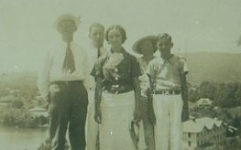
That picture is of Daddy, Mama, Me, Virginia and Ralph. It would have been made probably 1938 when we went to a church assembly at Taccoa Falls, Ga. for a few days. While there, we went to Lake Junaluska and did other sight-seeing in South Carolina, N.C. and Georgia. I think you have another picture in your collection made on that same trip.
Believe Robert Daly's birthday was in August. "Ten years older" was just a round figure. They were married in June 1928--Vena would have been 19 the following December, I'Robert, I guess, was nearing 27.
Floyd Caine was Lula's son, Mama's brother. More about him later. Dad
Rain, sleet and snow here today

FEB 21, 2011
Before FDR's New Deal, ordinary workers did not get vacations and/or take trips often, at least not in our world at that time. In 1934 , Vena (Holliman Daly), Robert (Daly), Mary (Daly Herrin) and Virginia (Holliman Cornelius) and I went to Fort Walton Florida for two weeks. Then, in 1935, we made our second trip there, and while we were there, Mamma (Pearl Caine Holliman, 1888-1955), Daddy (Ulyss, 1884-1965), Ralph (1925) and Euhal (1912 -1989) drove down in Daddy's car and stayed just a few days.
I don't know that Daddy got a paid vacation at that time, so he may have just taken a few days off without pay. Thus, 1935 was the first time I know of his taking a trip in my life time. But that was not unusual--only folks in jobs such as Robert had got time off and could afford to travel. Back then, it was all day trip to Panama City, and not everyone had an automobile. Anyway, when 1936 summer came, the Dalys made their usual trip to Florida, taking Virginia and me with them. We went first to Clearwater for a week, then up to Panama City, where Mama, Daddy, Ralph, Melton (Holliman, 1908-1958) and Ida (Hughes Holliman) had settled for a week, and that's where we were when the hurricane struck. I don't recall their taking any trip in 1937. I had finished high school and was no longer going with the Dalys.
I recall Daddy saying he rode the train to Texas when he was 17 years old to visit cousins out there. I don't know of any other travel he'd done. Dad

Vena (Holliman Daly) was born in December 1909. We always thought he (Robert Daly, 1901-1959) was 10 years older, so he must have been born in 901. Unless you have something indicating otherwise, set 1901 as his DOB
I believe Robert's birthday was in August. "Ten years older" was just a round figure. They were married in June 1928--Vena would have been 19 the following December, Robert, I guess, was nearing 27.
Floyd Caine (1883-1966) was Lula's son, Mama's brother. More about him later. Dad
Rain, sleet and snow here today
Well, as to how much beer she (Lula Hocutt Caine, 1861-1957) drank is not known, very little, I'm sure, but to Mama, any amount would have been too much, so I'd leave out any reference to her beer drinking. I never saw her drink any, and was very rare, I'm sure. I never heard Grandma make any reference to his drinking, so it must not have been an issue with her. But it was with Mama. In the days of the open saloon life must have been pretty awful at times, and that's one reason why Mama and Daddy were opposed to Al Smith in 1928 and FDR in 1932, because they were in favor of repealing the 18th Amendment. And having been exposed to their adamant opposition to that movement, I thought the world might collapse when liquor was finally legalized in Alabama!

I never did know who moved to Irondale first, the Hollimans or the Caines from Fayette County, Alabama. That's just a subject that I never felt inspired to ask, but I wish now I had. We just did not talk about such things. Why they settled in Irondale, I never did know. I don't know if Daddy already had a job or acquired one after he moved there or not. He could have settled in some other part of Birmingham, I guess, to have been nearer the Birmingham Elec. Co. Why Irondale? I have an idea the Cooks followed the Hollimans, and maybe the Hollimans followed the Caines? It was not until 1931 that Daddy bought a car, so transportation would have been a concern in 1918-19. Street cars ran into Irondale at the time, so there was the matter of a long ride twice a day-to and fro. All I know about the Caines is that he (William) worked for the L&N RR. I don't know when or how he obtained the job, but he worked through the Depression until his retirement in 1936 or 1937...... To be continued!!

I don't know that I've ever seen that picture. Where did you get it? It must be Daddy and maybe one of the boys--Jim? or Leland? Uncle Leland lived with us one winter when he worked in Birmingham. I don't know how in the world any of us could have survived an additional body in that cold house. All of us were at home then except maybe Melton and Vena.
No indoor plumbing, no central heat, very little privacy. It must have been an awful burden on all of us. Extra cooking, no bath tub, outdoor toilet, yet, we survived. I remember the time because Ralph was still almost an infant because he couldn't say my name plain and Leland would mock him saying "Biashup'. So, that would have meant the time was still in the 1920s, and Vena would have still been home, and maybe Melton too.
We learned to love Uncle Leland (Holliman,1880-1970)), and I'm sure we'd say he was our favorite uncle. For our Christmas present, he bought a bushel of apples. I think he worked for the Continental Gin Co, but not sure. Sometime later, he lost part of his arm in an accident on the job. He recovered from that and I think did well. They had only one child, Marguerite, who he claimed was the first Holliman to obtain a college degree--from Athens College, They lived in Tuscumbia. I recall visiting them only once, when I was 15. Leland outlived Daddy, and lived in Atlanta with Marguerite. I do not know the year of his death. I had contact with Marguerte up until her death, She visited us once in Johnson City when her husband was up there on business. I guess this is enough of that chapter.

Aunt Maude (Caine,1893-1940) was a few years younger than Mama. She evidently suffered some form of "polio" as a young girl, "T.B. of the bone" was the only reference I recall hearing about her condition., as she was crippled and had to use crutches all the time. I don't know how she was able to work on the farm and raise 4 children like she did. They lived in the house above us until they moved to the farm about 1930 or 1929. Ivalene was born after they left Irondale. Maude was very scared of storms, and when a cloud came up, she would hobble down the hill to out house to stay until the danger had passed. I guess the children came with her. I remember the dog, Billy" did! She was a good woman, a hard worker. Virginia, Ralph, Mama and I went one summer to their home near Leeds and stayed a week, I'm sure. Mama got sick while we were there, and that was very unusual thing to have happen. On the farm, Maude did all the cooking, maybe even milked, tended a garden, etc, all the chores a housewife/mother as expected to perform. They were faithful members of the Baptist church.
As, I've mentioned before, going to their house in the summer for a week or two was a great treat for a 12 year old boy. We worked in the fields, however, thinning corn, chopping cotton and picking tomatoes. Uncle Lee would take the produce to the Farmer's Market in Birmingham to sell. I'm sure they made very little money during those Depression years.
One Christmas Eve, maybe 1931 or 1932, Vena, Robert, mama, I guess Ralph, Virginia and I went to their house to take them gifts of food, maybe some toys and other goodies for their Christmas. They had already gone to bed before we got there, but we aroused them up, and had an enjoyable time sharing the Christmas spirit with them, and they seemed very appreciative. Ivalene would have been too young to remember that event, but I don't recall it ever being mentioned again by any of the Cooks.
I remember Mama saying "Only Robert Daly would have made this trip on Christmas Eve." Though it was only 25-30 miles from Irondale, this was before road were paved, and going that distance over a gravel, twisting road was an ordeal, especially on a cold night.
Maude died in 1940, I guess from all sorts of complications. I never did see Lee again after that time. Jamie lived in Moody, just above Leeds, until his death three years ago. I went back to the funeral with Mary and E.C, and Ellen. Ivalene still lives in Birmingham, and I think Mary stays in touch with her some.
Before the Cooks moved to the farm, Uncle Lee had been a policeman in Irondale, I think, for a short time, I'm sure, and I can barely remember that. Then he operated a garage on the edge of Irondale, and I recall Euhal working there one summer. I guess it was the Great Depression that drove them to the farm.
I guess this is enough about the Cooks. One more to go--Vista!

I don't know what it cost to ride the street car in 1918. It was always seven cents in my day. I would get on the bus in Irondale, pay seven cents, free transfer in Woodlawn to a street car and ride all the way past Legion Field, walk several blocks up to Birmingham-Southern. To transfer in down town Birmingham to other parts of the city cost two cents more. Until past the big War everybody rode the trolleys as not many folks had an auto and I knew of no family or anyone. who had two cars. So, there was a demand for Daddy's work at Birmingham Electric Co. as street cars were in demand and someone was needed to keep them running, so even though the Depression on, street cars grew in demand, and particularly during the war.
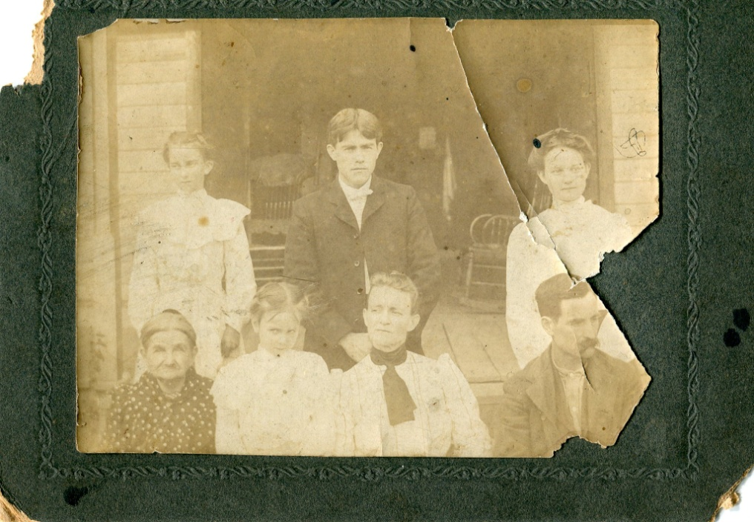
Haven't been able bring up that picture, but I know the one you're asking about. Yes, it was the three sisters, and they appear to be propping , or holding, Maude up. I have no idea the date of the picture, but I'm sure it was made before they all left Fayette.
The only memory I have of Bill Holliman (1870-1941), Daddy's oldest brother is that he had never been to Birmingham until 1934 (I think that was the year). He visited us in Irondale from Fayette, Alabama one summer, and I have forgotten how he got there, maybe he was brought there by Cecil. Not sure. I can't recall our having gone to Fayette that summer. Anyway, we took great pleasure in showing him the city. I have always thought that he looked after his dad and stepmother, even though I'm sure he had no money, but at least he was there with them. Have you had any contact with his offspring?

