These are additional Hollyman I am finding in the parish records.
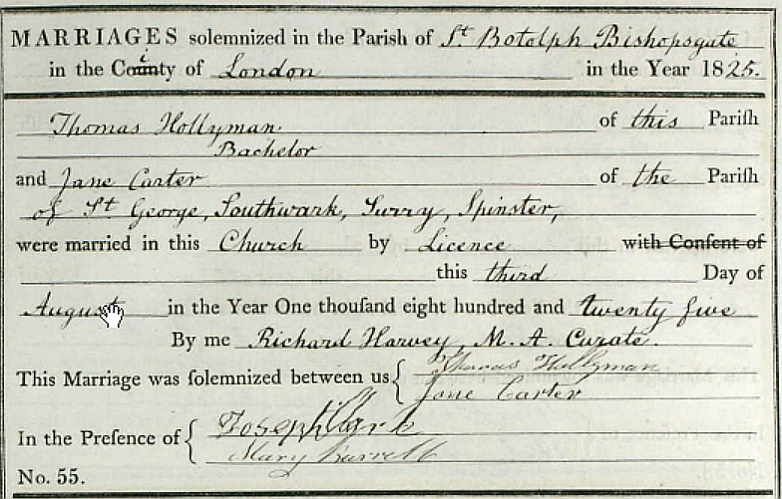
Thomas Hollyman marries a Jane Carter at St Botolph, Bishopsgate in 1825. Both sign their names.
The address relates to the Black Raven, Bishopsgate
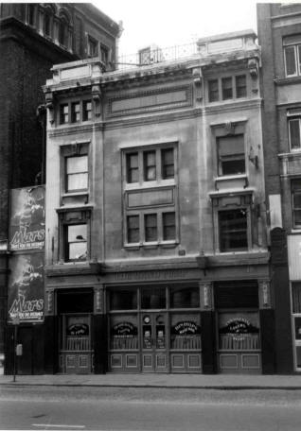
They are at the Black Raven between at least 1828 and 1837. The building is at 136 Bishopsgate Street without in 1851 and up to 1915, before the road was renumbered; At 185 & 187 Bishopsgate Street by 1938; This pub was named the Black Raven until 1975 when it was renamed the Pump. In 1982 it was further renamed the Handpump. The pub was closed and demolished in 1987. This pub was rebuilt in the form shown in the photograph in 1912 as it was in 1986, shortly before demolition.

In 1826, at 195 Bishopsgate Street we have a Thomas and Jane Hollyman. A baptism of their daughter Frances occurs on October 29th 1826. Thomas is a wine merchant. Who is he?
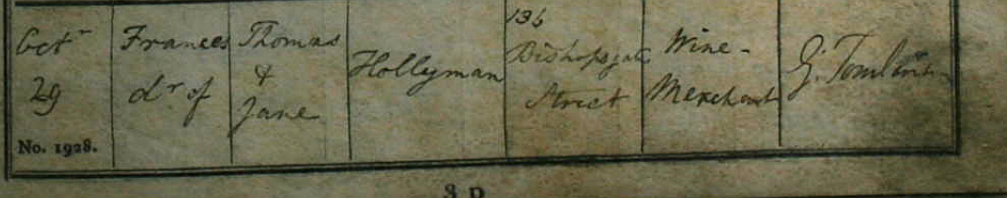
In 1828, A son, Richard, is born to Thomas and Jane; Thomas is now listed as a Licensed Victualler. This time the address is listed as 136 Bishopsgate Street, Richard Hollyman is baptised on 1st June 1828.
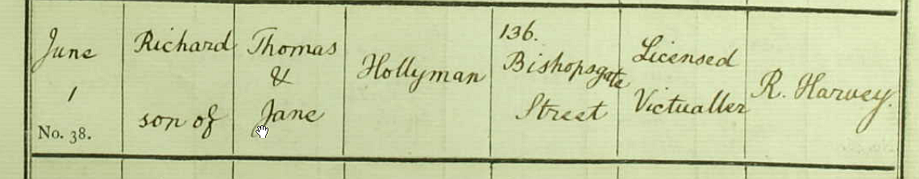
Emma is born on the 30th August, 1833 at 136 Bishopsgate Street.
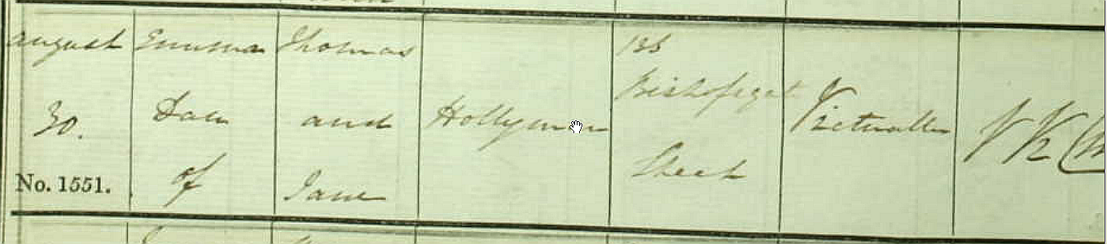

29th Jan 1835/Thomas Hollyman/victualler and wine and spirit merchant/../../Sun Fire Insurance Records ****

Elizabeth is born in August 18th, 1837. Thomas is now described as a publican.
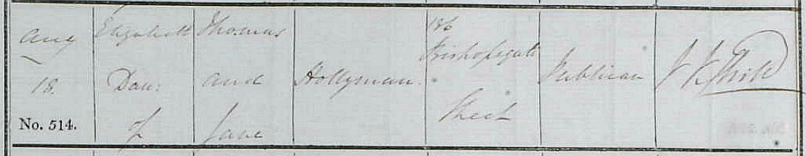
In 1839, A son, George, is born to Thomas and Jane; Thomas is now listed as a Publican. This time the address is listed as Mountfield Place, Kennington, George Hollyman is born on August 15th, and baptised on 15th September 1839 at St Botolph.
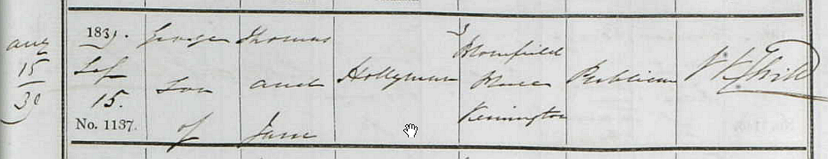

By the 1841 census, Jane is living in Princes Road, Lambeth and a widow taking in Laundry.
1841/Jane Hollyman/../Laundry/30/Surrey/Census
1841/Frances Hollyman/../15/Surrey/Census
1841/Emma Hollyman/../8/Surrey/Census
1841/Thomas Hollyman/../4/Surrey/Census
1841/George Hollyman/../1/Surrey/Census
By 1851, their daughter, Emma is a barmaid at the Belvedere Tavern, 1 Penton Street :
1851/Caroline Rouse/Tavern Keepers Daughter/19/Clerkenwell, Middlesex/Census
1851/Georgiana Gaunt/Housekeeper, Widow/49/North Mimms, Hertfordshire/Census
1851/Alexander McDiarmid/Barman/21/Maryebone, Middlesex/Census
1851/Emma Hollyman/Barmaid/17/Bishopsgate, Middlesex/Census
1851/David Morgan/Porter/27/Bishopsgate, Middlesex/Census
1851/Phebe Dew/House Servant/36/Attle Bridge, Norfolk/Census
1851/William Medden/Waiter/20/Pancras, Middlesex/Census
And in 1851, their son Thomas is an ‘inmate’ at the Licensed Victuallers School
#
In 1851, a James Hollyman is a 19 year old barman at the London Apprentice, Old Street Road.
http://pubshistory.com/LondonPubs/Shoreditch/LondonApprentice.shtml

On 23rd April 1857 there is a marriage in St Marylebone area between a James Hollyman and Annie Elizabeth Hepworth. His father is Thomas Hollyman, a deceased Licensed victualler. James is also listed as a Licensed Victualler with residence at Albany Street.
See notes above for the likely Thomas Hollyman:
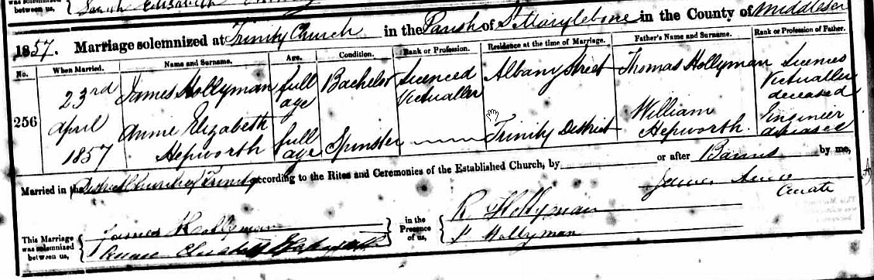

James Hollyman & Ann Elizabeth baptise Edward Hollyman at 57 Britannia Street, Notting Hill on August 22nd 1858. James Hollyman is a Licensed Victualler, and this address is the Britannia.

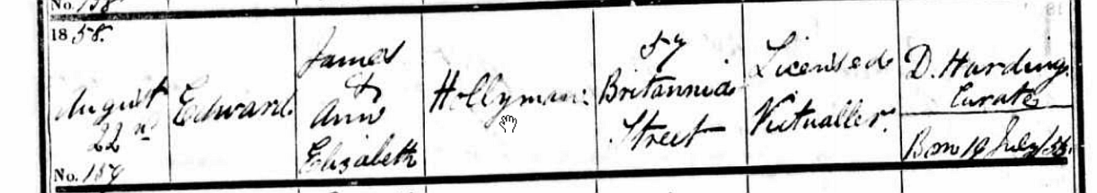
By 20th January 1861, another child is born: Thomas, their new son; and the address is at 17 Foley Street. A birth date of December 2nd 1860 is also recorded. This is the York Minster.
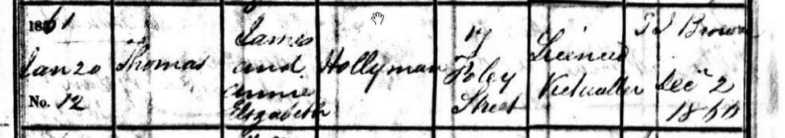

York Minster, 16 & 17 Foley Street, Marylebone :
1861/James Hollyman/Licensed Victualler/29/Bishopsgate/Census ****
1861/Elizabeth Hollyman/Wife/25/Lambeth, Surrey/Census
1861/Frances Hollyman/Daughter/3/St Pancras, Middlesex/Census
1861/James Hollyman/Son/1/St Pancras, Middlesex/Census
1861/Thomas Hollyman/Son/4 months/St Pancras, Middlesex/Census
1861/Margaret Norton/House Servant/38/Fleet Street, Middlesex/Census
1861/Eliza Arch/House Servant/15/Whitechapel, Middlesex/Census
1861/George Venah/Waiter/21/St Pancras, Middlesex/Census

On November1862, Alice Amelia is born at 17 Foley Street.
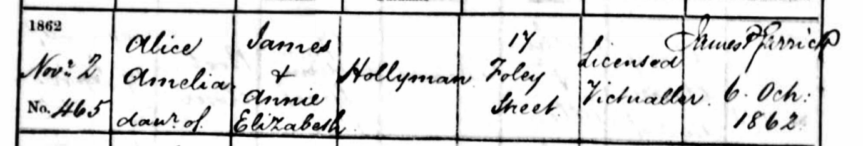

By 1866, Arthur William Hollyman is born at 20 Frederick Place, Islington.
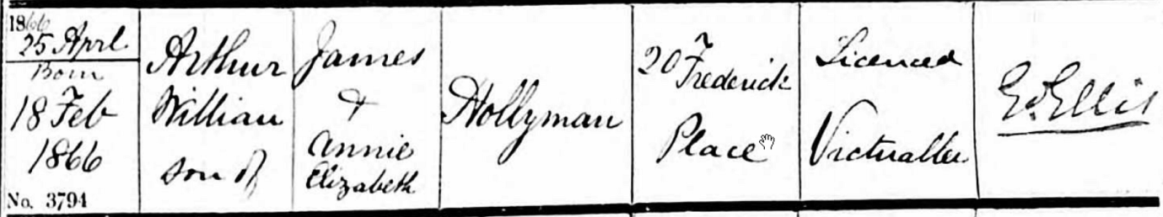

They have moved to the Hole in the wall by 1869 -
Hole in the Wall, 1 Gloucester Street, Queens Square, St George Martyr :
1869/Jas Hollyman/../../../Post Office Directory ****

1871/James Hollyman/Licensed Victualler/39/Bishopsgate Street Within/Census ****
1871/Ann E Hollyman/Wife/35/Lambeth, Surrey/Census
1871/Edward Hollyman/Son/14/St Pancras, Middlesex/Census
1871/Frances Hollyman/Daughter/13/St Pancras, Middlesex/Census
1871/Thomas Hollyman/Son/10/St George the Martyr, London/Census
1871/Arthur Hollyman/Son/5/Islington, Middlesex/Census
1871/William Hayton/Servant/27/Fiskerton, Salisbury/Census

On April 19th, 1874, Kate is born in to James and Annie Elizabeth Hollyman. James is now a Wine merchant in Brompton Road.
