**Some Memories of Irondale, Alabama, the 1920s to the 1940s**

by H. Bishop Holliman 2013

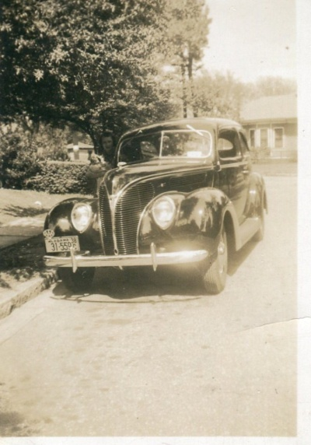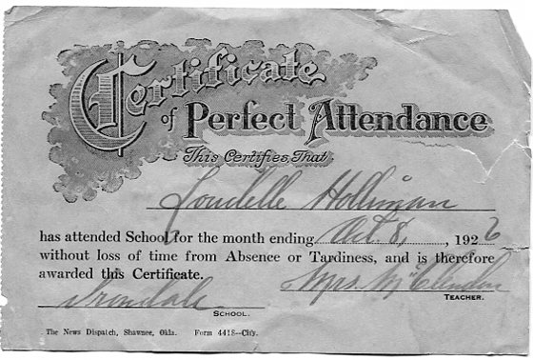

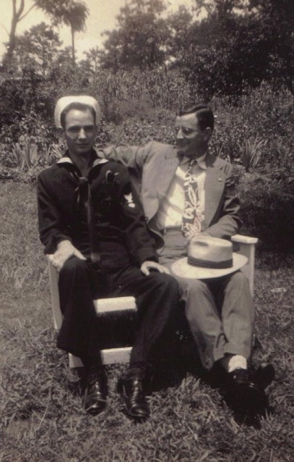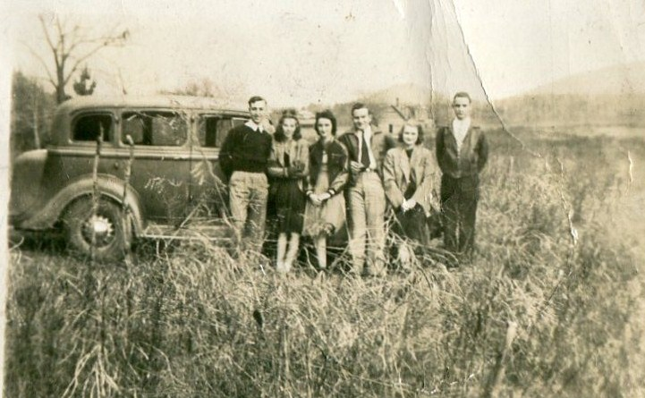

***Photographs of Irondale, Alabama****...top left, Loudelle Holliman Ferrell's 1938 Pontiac and top right Loudelle Holliman Ferrell's perfect attendance certificate from Mrs. Joe McClendon 1926; bottom left Bishop and Melton Holliman, home to Irondale on military leave, February 1945 and bottom right, 1938 youth outing - Bishop Holliman, far right with Margaret Martin on his left; Virginia Holliman Cornelius, 3rd from left.*

*For reprints, contact Glenn N. Holliman, P.O. Box 240, Newport, Pennsylvania 17074 or glennhistory@gmail.com.*