Saturday, April 30, 2011

Ulyss and Pearl Caine Holliman and their Descendants
by Glenn N. Holliman

More on Loudelle Holliman Ferrell, 1914 - 1998
the Fourth Child of Ulyss and Pearl Holliman

In 1917, Ulyss moved his family to E.F. Montgomery's planned subdivision on the hill overlooking the Southern and L & N railroad yards in Irondale, Alabama. The Hollimans first lived in a house on 2nd Avenue, just a few blocks from the center of town.

This picture was made in 1920 a few months after Bishop Holliman's birth. In the back are Vena and holding baby Bishop (b 1919) is Melton. The children in front are Euhal left, and partially obscured, Loudelle. Around this time, Ulyss realized he needed a bigger house for the five children, so he purchased a lot from the Bishop family at 2300 3rd Avenue.

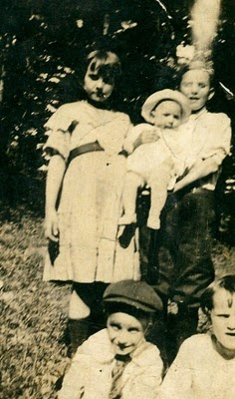
Below is a truly amazing photo from 1924 on the Cahawba River. Let's see, the youngster in the foreground is my father, Bishop. Behind his is Euhal, Loudelle,and Melton. In the right foreground is their father, Ulyss S. Holliman, my grandfather.
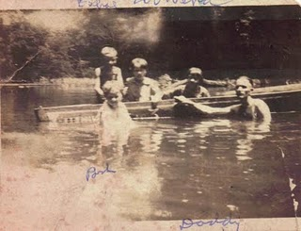
Note: The information and opinions expressed in these family biographies are those of the writer alone. Comments, corrections and additions are most welcome. The purpose of these articles is to capture a period and family in American history and to pass this legacy along to future generations who share the common bond of family. My thanks to Charles H. Ferrell for the loan of many of the pictures.
Next posting, more on Loudelle and the new house....
Posted by Glenn N. Holliman at 7:12 AM
Email ThisBlogThis!Share to TwitterShare to FacebookShare to Google Buzz
Labels: Bishop, Euhal, Loudelle, Melton, Vena

0 comments:

Monday, February 28, 2011

Ulyss and Pearl Caine Holliman and their Descendants
by Glenn N. Holliman
1912 or 1914? Is the Baby Euhal or Loudelle?
The 1910 U.S. Census lists Ulyss and Pearl Holliman living in Precinct 1 in Fayette, Alabama. Granted the numbers might be somewhat inaccurate with Ulyss listed as age 26 (b 1884 which is correct), but Pearl as 21 on April 15, 1910, which would make her born in 1889 Traditionally the family lists her birthday as February 1887.
What is the age of the below photograph and who is the baby? On the left is Vena Holliman Daly and on the right is Melton Holliman. The third child born was Euhal Holliman in 1912 when Melton was four and Vena 2 1/2 years of age. Melton appears about 5 or 6 in this photo and Vena could be 3 or 4, making this picture of a one-year old Euhal in his stroller. Loudelle would be born in 1914, and conceivably this could be her as a baby, but why would not Euhal be included? Perhaps there is a missing photo. Can any family member definitely identify whether this be Euhal or Loudelle Holliman Ferrell?
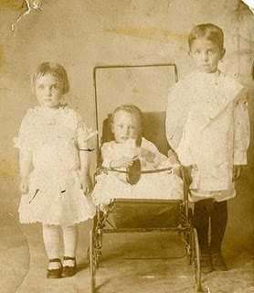
Having a picture taken was still a formal and expensive process in 1912. Melton is dressed in a quasi-feminine outfit typical of the formal attire of young boys of that day. Vena is also wearing leggings and a very fancy dress. The 1910 Census does not list a trade or profession for Ulyss. One can surmise this photograph was an financial extravagance for a growing, young family for whom the breadwinner was probably a mill worker in the local lumber yard. Employment opportunities in Fayette were limited at the time, and Ulyss was not a farmer. As his family grew, so did expenses.
When regular and more lucrative employment beckoned in the 'Magic City' of Birmingham later in the decade, the family would move.
More later.....
Posted by Glenn N. Holliman at 6:37 AM 0 comments
Email ThisBlogThis!Share to TwitterShare to FacebookShare to Google Buzz
Labels: Melton, Pearl Caine Holliman, Ulyss Holliman, Vena

Tuesday, February 22, 2011

Ulyss and Pearl Caine Holliman and their Descendants
by Glenn N. Holliman
Ulyss's Wise Selection of a Wife
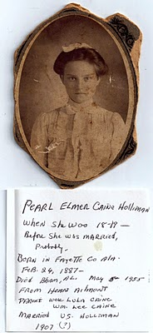
Above is pictured Pearl Caine as a young lady. Those dark eyes must have attracted Ulyss. The comments are by Bishop Holliman, their fifth child, who is not sure when his parents were married. He thinks 1907. More research is needed, but I believe it was 1906.
Ulyss and the rest of his descendants are fortunate that a young 19 year old, Pearl Caine, agreed to marry him in 1906. Pearl balanced Ulyss's quiet, sometimes grumpy nature (at least when he was older). She was loving, generous, strong willed and terribly hard working. She is remembered warmly by surviving children and grandchildren old enough to remember.
Born in Fayette County, Alabama in 1887, she died of a heart attack May 5, 1955, stricken at her home in Irondale, Alabama. She survived in the hospital until all her children could arrive and say goodbye.
The couple had seven children. They are:
Melton Pearson Holliman (1907 - 1958)
Vena Vivian Holliman Daly Buckheit (1909 - 1990)
Euhal Arlington Holliman (1912 - 1989)
Loudelle Holliman Ferrell (1914 - 1998)
Homer Bishop Holliman (1919)
Virginia Ruth Holliman Cornelius (1922)
William Ralph Holliman (1924)
In my blog at http://hollimanfamilyhistory.blogspot.com/, I have separate pages on each of these children. In time, I shall be removing those pages and moving their stories and additional information to this blog at http://ulyssholliman.blogspot.com/.
More in a few days....
Posted by Glenn N. Holliman at 1:26 AM 1 comments
Email ThisBlogThis!Share to TwitterShare to FacebookShare to Google Buzz
Labels: Pearl Caine Holliman

Wednesday, February 16, 2011

Ulyss and Pearl Caine Holliman and their Descendants
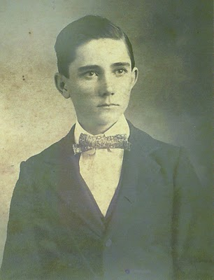
Ulyss S. Holliman
1884 - 1965

by Glenn N. Holliman

In February 2010, with the help of my daughter, GraceHolliman, I began publishing articles on the Hollimanfamily. An abundance of material made available by cousins Rhodes Holliman, Ron Holliman and others, plus my own research, has led me further back into our family past than I had originally planned or thought possible. I intend to continue to write and publish such information at http://hollimanfamilyhistory.blogspot.com/.

However, thanks to my father, sisters and cousins, I have accumulated a tremendous number of photographs and letters. Of the seven children of Ulyssand Pearl Caine Holliman, four have left us. Memories of a time and place in Southern and American history are slipping away. My cousins and I are not getting younger. Thanks to the internet, it is possible to collect information easily and share it with family. With this new blog, I hope to focus exclusively on my father's parents, their families and descendants.

The young man above is my grandfather. Rhodes Holliman made this photograph available to me. This picture resembles my own father, Bishop Holliman (b 1919) as a young man in the 1930s. There is also a strong resemblance to my Uncle Ralph Holliman, whom his daughters, Pam and Kathy may notice. Probably this picture was made in Fayette, Alabama in the late 1890s, perhaps in the year 1900.

Ulyss was the last born of six brothers to a Civil War veteran, John ThomasHolliman, and his second wife, Martha Jane Walker Holliman. John seems to have been a simple farmer who worked hard to bring in a crop each year and cloth and feed his many boys. He died in 1930 and Martha Jane, shortly after. They died poor leaving little in worldly goods. However, they gave their sons a sense of morality and purpose. Their sons, whatever their career paths and financial success or lack of it, seemed to have all been of high moral character.

Ulyss was gifted with his hands, and spent his adult life working first in the wood mill in Fayette, and then in 1918 as a carpenter with the Birmingham Electric Company, repairing the wooden street cars. He retired in 1949 at the age of 65.

This grandfather of mine was taciturn, a person of few words and he had difficulty showing emotion (other than annoyance perhaps). This was balanced by his strong work ethic, rising early and stoking a coal fire in the winter, commuting a long distance from the home in Irondale, Alabama to the street car yard, and then back again late in the evening. Until Roosevelt's New Deal, he worked six days a week, had no sick days and no vacation time.

In 1906 he married one of the Caine sister's in Fayette, one Pearl Caine. Together this couple would have seven children. In future articles, I will be writing of Grand Mother Holliman and the seven children.

Opinions expressed are mine alone. I welcome comments, critique and especially additional memories and photos. Please let me know if one wishes a photo removed or commentary edited. No photos of current under age descendants are published. My email address is Glennhistory@gmail.com. My thanks to the family for the use of materials.

Posted by Glenn N. Holliman at 12:19 PM 0 comments
Email ThisBlogThis!Share to TwitterShare to FacebookShare to Google Buzz
Labels: Ulyss Holliman
Home
Subscribe to: Posts (Atom)

Followers

Blog Archive
- ▼ 2011 (12)
  - ► May (1)
  - ► April (4)
  - ► March (4)
  - ▼ February (3)
    - Ulyss and Pearl Caine Holliman and their Descendan...
    - Ulyss and Pearl Caine Holliman and their Descendan...
    - Ulyss and Pearl Caine Holliman and their Descendan...

Thursday, March 31, 2011

Ulyss and Pearl Caine Holliman and their Descendants
by Glenn N. Holliman
Euhal Arlington Holliman (1912 - 1989),
the Third Child of Ulyss and Pearl Holliman
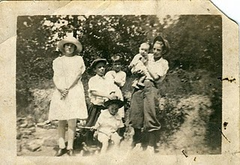
The Ulyss and Pearl Holliman family moved to Irondale from Fayette, Alabama in 1917, and Ulyss settled in to his new job at the Birmingham Electric Company. The above photograph is from 1924. Left to right: Vena, Euhal holding Virginia, Bishop in front with the stick, and Melton holding the youngest, his brother Ralph Holliman. Vena is dressed formally (age 15) and both Euhal (age 10) and Melton (age 16) are wearing the style of the time, knickers. (This style of boy's pants is frozen in time today as the uniform of baseball players.) Note Euhal, Melton and Bishop (only 4) are all wearing caps or hats.
Melton was born in 1908, and before the Great Depression in 1927, he obtained a position in his Uncle Floyd Caine's drug store. Euhal came of age right in the middle of the Depression, and jobs were scarce. He went to work for a local grocery store, and spent his career in the food business.
He met a pretty young lady named Edna Westbrook (below) and in 1936 they married. Six children were eventually born of this union which lasted 54 years!
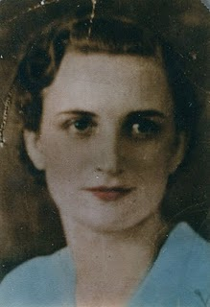

Edna Westbrook Holliman (1916 - 1992), a native of Cherokee County, Alabama, married Euhal July 9, 1936. Edna is the daughter of Annie Josie Naugher Westbrook and Thomas Edward Westbrook. Daughter Tommie Holliman Allen believes they met in East Lake, Alabama, when Edna's sister's boyfriend, later Tommie's uncle, introduced them. Edna was 18 when this picture was taken.

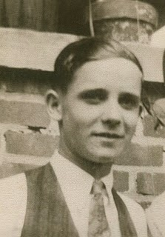
This is young handsome Euhal, probably about 1935.
A hard worker all his life, he was a leader in the Irondale Lion's Club, his labor union and in retirement, the Irondale Auxiliary Police. Super market chains appeared in America after World War II, and wages were low and benefits few. A leader in the labor union movement, Euhal helped organize and lead grocery workers to better compensation and working conditions during his career at chains Jitney Jungle, Piggly Wiggly, Kroger and Brunos as produce manager, before retiring in 1972.
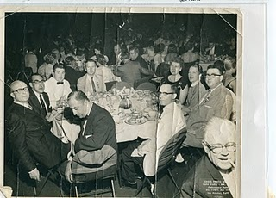
Euhal, center right, in the white coat at a national union convention in California in 1956.
Like his three brothers, he took his physical for the Army in World War II, but due to age and having four children to support, he was not called up. The family lived in Gadsden, Alabama in the 1940s until the middle 1950s. In 1956, they moved to the Ulyss and Pearl Holliman home in Irondale, living there for the rest of Euhal and Edna's lives.
Next Posting, the Children of Euhal and Edna....
Note: The information and opinions expressed in these family biographies are those of the writer alone. Comments, corrections and additions are most welcome. The purpose of these articles is to capture a period and family in American history and to pass this legacy along to future generations who share the common bond of family .My thanks to Tommie Holliman Allen and Bishop Holliman for the pictures.
Posted by Glenn N. Holliman at 2:51 AM 0 comments
Email ThisBlogThis!Share to TwitterShare to FacebookShare to Google Buzz
Labels: Bishop and Melton, Edna Holliman, Euhal, Loudelle, Vena

Wednesday, March 23, 2011

Ulyss and Pearl Caine Holliman and their Descendants
by Glenn N. Holliman
Vena and Robert Daly, Sr. and their Influence on the Holliman Family
In the mid 1920s, Robert Daly, Sr. began working for American Traders Bank in Woodlawn, Alabama. Later it became the American National Bank of Birmingham. In addition to being manager of the Woodlawn branch, he would become as a vice president of the larger corporation.

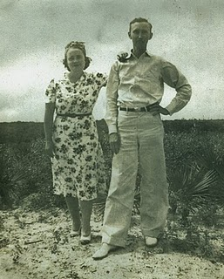
Robert loved to travel and vacation in Florida. Above are Vena and Robert in 1935. Robert was incredibly generous with his time and company to the siblings of Vena. He made himself a beloved figure to the three youngest Holliman children - Bishop, Virginia and Ralph - who often went with the Dalys to Panama City and Daytona Beach, Florida. Both Vena and Robert were tremendous role models for their generation, and later for their many nieces, nephews and grandchildren. After the death of Pearl Caine Holliman in 1955, the center of Holliman gatherings moved to Vena and Robert's 'white house' on the east side of Irondale.
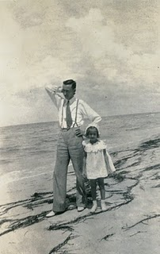
Vena and Robert would have two children, Mary Daly Herrin, born 1932 and Robert Daly, Jr., born 1943. Above is Mary in 1936, age 4 with her father at a Florida beach. They both seem formally dressed for a stroll in the sand! Belowin winter 1944, Mary and her young brother, Bob, attempt to enjoy a light snow. In the background is the Daly house built in the early 1930s, adjacent to the Ulyss and Pearl family home at 2300 3rd Avenue, Irondale, Alabama.
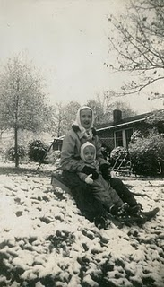

Sadly, Robert, Sr. suffered for years from congestive heart failure and died suddenly at his home in 1959. In the 1960s, Vena served as a sorority house mother at the Universities of Alabama and Mississippi. In 1971, she remarried Phil Buckheit, a successful newspaper publisher from Spartanburg, South Carolina. After he died in 1977, she returned to Birmingham, and lived in a condo on Red Mountain next to her sister, Virginia Holliman Cornelius. Vena died 1990. One of her grand daughters, Iris Daly Williams, recently reminisced that visiting her grandmother in the 1980s was like visiting a queen. Vena had a presence and gracefulness that her family admired and loved, as this nephew can attest.
Next the third child of Ulyss and Pearl Holliman....
Note: The information and opinions expressed in these family biographies are those of the writer alone. Comments, corrections and additions are most welcome. The purpose of these articles is to capture a period and family in American history and to pass this legacy along to future generations who share the common bond of family. My thanks to Mary Daly Herrin for allowing the use of these materials.
Posted by Glenn N. Holliman at 2:47 PM 0 comments
Email ThisBlogThis!Share to TwitterShare to FacebookShare to Google Buzz
Labels: Jr., Mary Daly, Robert Daly, Vena Daly

Wednesday, March 16, 2011

Ulyss and Pearl Caine Holliman and their Descendants
by Glenn N. Holliman
Vena Vivian Hollman Daly Buckheit (1909 - 1990),
the Second Child of Ulyss and Pearl Caine Holliman

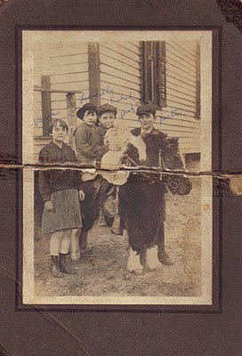

Above left to right are Vena, Loudelle, Euhal, Bishop and Melton Holliman in 1920. The pony may have belonged to Mrs. T.C. Burgess who lived at the bottom of the hill below the Irondale, Alabama house. She had two children, John Hugh and Sadie Mae. Mr. Burgess owned the hardware store that Robert and George Daly purchased in 1944.
Vena was 8 in 1917, when Ulyss and Pearl Holliman moved their four children and themselves to the growing suburb of Irondale, Alabama. The population of Birmingham and its environs were exploding. Founded in the 1870s, Birmingham grew in forty years from 3,086 to 178,816! Jobs were plentiful as the infrastructure of the steel industry and the city grew. Ulyss Holliman, now age 32, with many mouths to feed, left Fayette County and work in the lumber yard, to become a carpenter with the Birmingham Electric Company.
As Birmingham grew horizontally, street car lines pushed to all corners and into the suburbs. Ulyss helped keep the wooden carriages and benches in good repair. Ironically, when Ulyss was born there were no street cars in Birmingham, and when he died in 1965, there were not street cars in Birmingham.
Vena, the oldest daughter helped her mother, Pearl, care for the growing brood, which expanded by three more children after Ulyss found secure employment, and the family settled into new housing in Irondale.
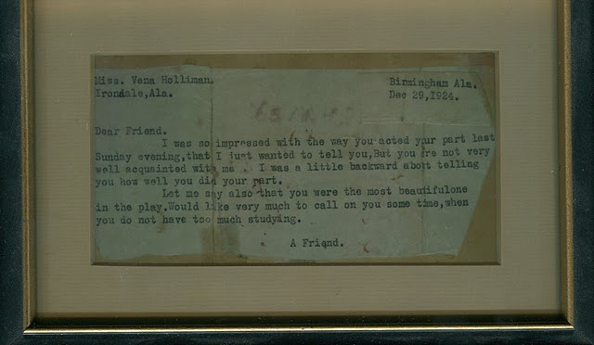
In December 1924, twenty-one year old Robert Daly, grandson of an Irish immigrant who came to Alabama to build railroads, watched Vena in a Christmas pageant in the Irondale Methodist Church. Robert, smitten over the cute 15 year old, sent her the above note and by her 19th birthday in 1928, she became his bride! Below is the newspaper clipping of the happy occasion. Click on the pictures to make them larger.
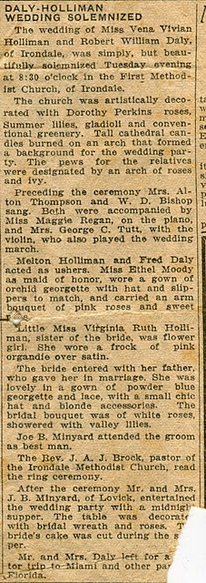
More soon on the Daly family and how they impacted on the life of the three youngest children....
Note: The information and opinions expressed in these family biographies are those of the writer alone. Comments, corrections and additions are most welcome. The purpose of these articles is to capture a period and family in American history and to pass this legacy along to future generations who share the common bond of family. My thanks to Mary Daly Herrin for making these materials available..
Posted by Glenn N. Holliman at 2:05 AM 0 comments
Email ThisBlogThis!Share to TwitterShare to FacebookShare to Google Buzz
Labels: Robert Daly, Sr., Vena Daly

Tuesday, March 8, 2011

Ulyss and Pearl Caine Holliman and their Descendants
by Glenn N. Holliman
Melton Pierson Holliman (1908 - 1958),
the First Child of Ulyss and Pearl Caine Holliman
Below is pictured Melton in 1938, probably on the front steps of the home he and Ida Hughes Holliman, shared in Irondale, Alabama. Melton in his teens began working in Uncle Floyd Caine's drug store and learned how to prepare medicines. He was the first child out of the nest so to speak, being born in Fayette, Alabama, and moving to Irondale when he was nine years of age. In the 1920s, the requirements to be a pharmacist were more relaxed than in the 21st Century, and by 1940, Melton became a pharmaceutical salesman for Wyeth, eventually moving to Mobile, Alabama.
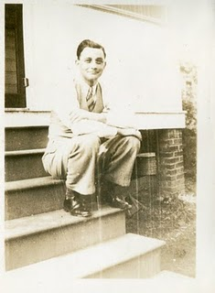
In 1932, he and Ida (1905 - 1995) were married, and in 1943 adopted a beautiful red headed daughter, Pati (Patsy to her father), who grew up with a vivacious personality. Scarcely had they become a family of three before Melton was drafted into the U.S. in August 1943 at the height of World War II. He trained in camps in Georgia and Texas, and for months moved from replacement station to replacement station (Pennsylvania, New York and England) before arriving in France in late July 1944. There he served as a medic in a battalion that was trained to treat chemical warfare casualties.
Thankfully, there was no chemical warfare in Europe during this war, and so he served a medic in a medical receiving station in France. In November 1944, age 36, he was diagnosed with high blood pressure and evacuated first to England, then back to the States, stopping at a hospital in Long Island, and finally at a facility in Jackson, Mississippi. In March 1945, he was discharged, and returned to work as a pharmaceutical salesman.
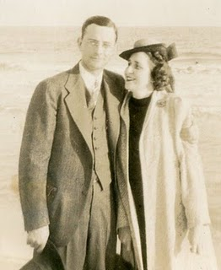
Melton and Ida Holliman, 1935
His genial, kindly manner, honesty and knowledge of the trade made him immensely successful. The family built a modern home in Mobile, and were active in the Baptist Church. He served on the Mayor's Advisory Council for the local hospital and was a frequent lecturer to the medical community. However, there were shadows over this happiness. Ida suffered from ill health time to time, and in 1955 Melton, a sometime smoker, experienced a heart attack. Treatment in that decade was complete rest. After several months, Melton went back to work, but after a game of golf in 1958, he died suddenly of a massive heart attack. Ida passed away in 1995, the rest of her long life a widow.
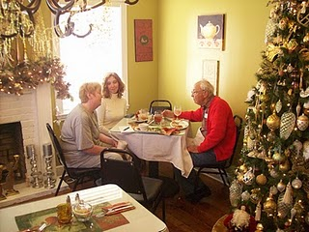
Their legacy lives on through the life of Pati, her three daughters and now grandchildren, whom she shares with her husband of decades, George Hairston. Pictured above in late November 2010, are left to right Holly Hairston, Pati's oldest daughter, Pati Holliman Hairston and Melton's brother, Bishop Holliman. Holly owns a lovely cafe near Trussville, Alabama.
Note: The information and opinions expressed in these family biographies are those of the writer alone. Comments, corrections and additions are most welcome. The purpose of these articles is to capture a period and family in American history and to pass this legacy along to future generations who share the common bond of family.
Posted by Glenn N. Holliman at 1:19 AM 0 comments
Email ThisBlogThis!Share to TwitterShare to FacebookShare to Google Buzz
Labels: Bishop Holliman, Holly Hairston, Ida Hughes Holliman, Melton Holliman, Pati Holliman Hairston
Newer PostsOlder PostsHome
Subscribe to: Posts (Atom)

Followers

Blog Archive
- ▼ 2011 (12)
  - ► May (1)
  - ► April (4)
  - ▼ March (4)
    - Ulyss and Pearl Caine Holliman and their Descendan...
    - Ulyss and Pearl Caine Holliman and their Descendan...
    - Ulyss and Pearl Caine Holliman and their Descendan...
    - Ulyss and Pearl Caine Holliman and their Descendan...
  - ► February (3)

Saturday, May 7, 2011

Ulyss and Pearl Caine Holliman and their Descendants
by Glenn N. Holliman

More on Loudelle Holliman Ferrell, 1914 - 1998,
the Fourth Child of Ulyss and Pearl Holliman

The Holliman children were growing up by 1928. Melton had gone to work in his Uncle Floyd Caine's drug store, and Vena became Mrs. Robert Daly that year. Charles H. Ferrell, Loudelle's older son, made this photo below available to me. Vena is on the left and Loudelle, now all of 14 and looking very grown up, is wearing a fashionable hat of the 1920s. The young ladies are in short skirts as a revolution in fashion occurred after World War I. Hem lines rose!
Both are standing in front of the then new home at 2300 3rd Avenue, Irondale. One can see the wooden steps in the background. It was a winter's day. No sidewalk yet on the street nor paved roads. The sidewalks and water system would go in the 1930s and 40s as part of a New Deal Public Works Administration program. That's right....the seven Holliman brothers and sisters grew up in a house without running water and in door facilities. Not until the late 1930s was an indoor bathroom installed. Oh yes, the good ole days!

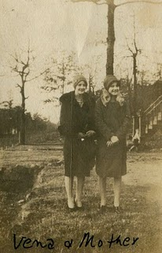

Below is another photo of Loudelle, second from left with the penetrating eyes. The other girls are believed to be friends and not relations. Notice the fascinating hair styles of 1930. Compare Loudelle's eyes with the February 22, 2011 post of Pearl Holliman. One can see a startling resemblance when Loudelle was Pearl's age.
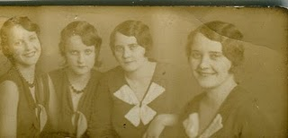

Note: The information and opinions expressed in these family biographies are those of the writer alone. Comments, corrections and additions are most welcome. The purpose of these articles is to capture a period and family in American history and to pass this legacy along to future generations who share the common bond of family.

More Loudelle and family next post....
Plan now to attend the Holliman and Associated Families Genealogical Round Table at the Fayette County, Alabama Civic Center, 10 am to 3 pm, Saturday, October 15, 2011. For information and reservations for lunch, contact Glenda Norris at gnorris@bcbsal.org or Glenn Holliman at Glennhistory@gmail.com. Sessions to include Tracing the Holymans from England to Alabama, Holliman Farm Sites in Fayette County and sharing of information on Associated Families. All invited!
Posted by Glenn N. Holliman at 7:25 AM 0 comments
Email ThisBlogThis!Share to TwitterShare to FacebookShare to Google Buzz
Labels: Loudelle, Vena
Newer PostsOlder PostsHome
Subscribe to: Posts (Atom)

Followers

Blog Archive
- ▼ 2011 (12)
  - ▼ May (1)
    - Ulyss and Pearl Caine Holliman and their Descendan...
  - ► April (4)
  - ► March (4)
  - ► February (3)

