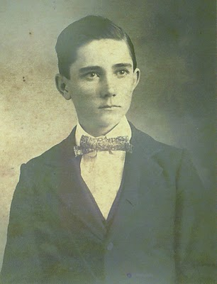
Ulyss S. Holliman
1884 - 1965
by Glenn N. Holliman

In February 2010, with the help of my daughter, Grace Holliman, I began publishing articles on the Holliman family. An abundance of material made available by cousins Rhodes Holliman, Ron Holliman and others, plus my own research, has led me further back into our family past than I had originally planned or thought possible. I intend to continue to write and publish such information at http://hollimanfamilyhistory.blogspot.com/.

However, thanks to my father, sisters and cousins, I have accumulated a tremendous number of photographs and letters. Of the seven children of Ulyss and Pearl Caine Holliman, four have left us. Memories of a time and place in Southern and American history are slipping away. My cousins and I are not getting younger. Thanks to the internet, it is possible to collect information easily and share it with family. With this new blog, I hope to focus exclusively on my father's parents, their families and descendants.

The young man above is my grandfather. Rhodes Holliman made this photograph available to me. This picture resembles my own father, Bishop Holliman (b 1919) as a young man in the 1930s. There is also a strong resemblance to my Uncle Ralph Holliman, whom his daughters, Pam and Kathy may notice. Probably this picture was made in Fayette, Alabama in the late 1890s, perhaps in the year 1900.

Ulyss was the last born of six brothers to a Civil War veteran, John Thomas Holliman, and his second wife, Martha Jane Walker Holliman. John seems to have been a simple farmer who worked hard to bring in a crop each year and cloth and feed his many boys. He died in 1930 and Martha Jane, shortly after. They died poor leaving little in worldly goods. However, they gave their sons a sense of morality and purpose. Their sons, whatever their career paths and financial success or lack of it, seemed to have all been of high moral character.

Ulyss was gifted with his hands, and spent his adult life working first in the wood mill in Fayette, and then in 1918 as a carpenter with the Birmingham Electric Company, repairing the wooden street cars. He retired in 1949 at the age of 65.

This grandfather of mine was taciturn, a person of few words and he had difficulty showing emotion (other than annoyance perhaps). This was balanced by his strong work ethic, rising early and stoking a coal fire in the winter, commuting a long distance from the home in Irondale, Alabama to the street car yard, and then back again late in the evening. Until Roosevelt's New Deal, he worked six days a week, had no sick days and no vacation time.

In 1906 he married one of the Caine sister's in Fayette, one Pearl Caine. Together this couple would have seven children. In future articles, I will be writing of Grand Mother Holliman and the seven children.

Opinions expressed are mine alone. I welcome comments, critique and especially additional memories and photos. Please let me know if one wishes a photo removed or commentary edited. No photos of current under age descendants are published. My email address is Glennhistory@gmail.com. My thanks to the family for the use of materials.

Friday, December 24, 2010

Ulyss and Pearl Caine Holliman Descendants
by Glenn N. Holliman

Christmas in Alabama 1946
A Gathering of the Children and Grandchildren of Ulyss and Pearl Caine Holliman

World War II was over and the soldiers, sailors and airmen had come home to new families and careers. At Christmas time 1946, my Grandmother Pearl Caine Holliman, employed a photographer to come and photograph her family using the new invention of flash bulbs. All her children and their spouses were home, again, for the holidays at 2300 3rd avenue, Irondale, Alabama.

Three of her sons (Melton, Bishop and Ralph) and one son-in-law,(Walter Cornelius) had served over seas during the war. Her fourth son, Euhal, was ordered to a pre-induction physical, but due to his age and number of dependents, he was never called. The other two son in laws - Robert Daly and Charles Ferrell were over age. During the war and in the two years after, all seven children of Ulyss and Pearl became parents, three for the second, third or fourth times (Vena and Robert Daly, Loudelle and Charles Ferrell and Euhal and Edna), and four (Melton and Ida, Bishop and Gerry, and Virginia and Walter Cornelius, and Ralph and Motie) for the first time!

The Baby Boomer Generation was underway, and would not cease for this family until 1956. Bishop, Virginia and Ralph all married during the war. Two of these three marriages would end in divorce decades later. The four marriages made in times prior to World War II survived until the death of the first spouse.

While many of my cousins have grown up enjoying and wondering about this photograph, many of the second cousins have not seen or studied it. Here it is along with commentary of the family. Any errors are mine alone; corrections and clarifications always welcome. There is another photograph made in 1950 which I am saving for another occasion.

Pause and reflect this Christmas season how joyful Ulyss and Pearl were to have this large family, safe and secure, around them that year as the world recovered from war. Imagine that this was happening in other Holliman and related families all across the nation. (Click twice and the picture will enlarge.)
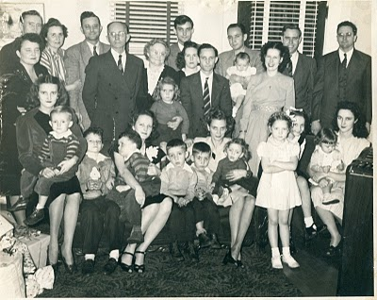Front row, left to right: Mary Daly holding her three year old brother, Robert W. Daly, Jr., Charles Halford Ferrell, next to his mother, Loudelle Holliman Ferrell who is holding John Melton Ferrell. Next are Euhal and Edna's twin boys, Jerry and Terry, and then Edna holding Jean Holliman. Standing tall is Pati (Hairston), Melton and Ida's daughter, and peeking behind her is Carolyn Ferrell (Tatum). Finally on the front row is Virginia Holliman Cornelius holding her first daughter, Nancy Carol Cornelius (Morton).

Back row, left to right. Vena Holliman Daly stands in front of her husband, Robert Daly, the parents of Mary and Bob. The Dalys married in 1928. Next Ida has her arm around Melton Holliman, her husband since 1932. The parents and grandparents of this large family are next - Ulyss and Pearl Caine Holliman, married in 1906, when Ulyss was 22 and Pearl 18. They are 62 and 58 years old respectively when this picture was taken.

Grandmother Holliman has her arm around Anne Holliman (Phillips), eldest daughter of Euhal and Edna. Euhal in the stripped tie stands next to his daughter, and just behind him is Motie, the wife of Ralph (tallest in back row). Their first daughter, Pamela, will be born in 1947.

Holding the four month old baby boy on the back row is my father, Bishop Holliman, and next to that baby (yours truly) and smiling broadly is my mother, Geraldine Stansbery Holliman.
Behind Gerry is Walter Cornelius, Virginia's husband, and at the far right, looking distinguished as always, is The Rev. Charles Ferrell, husband of Loudelle since 1935.

Twelve cousins are pictured in this December 1946 gathering. Mary Daly (Herrin) was the first born in 1931; the last born was my sister, Alice Holliman (Murphy) in 1956. Altogether, there would be 19 great grandchildren. Sadly, Grandmother Holliman who died in May 1955 did not live to hold all of them. She dearly loved her family.

Merry Christmas to all of us still living who were present that day and to the additional cousins, children, grand children and great grand children who have come after us! And a grateful and loving remembrance of those who were present in 1946 but who have left the family in this life. God Bless Us Everyone!!!

Monday, May 16, 2011

