Wednesday, February 16, 2011

Ulyss and Pearl Caine Holliman and their Descendants
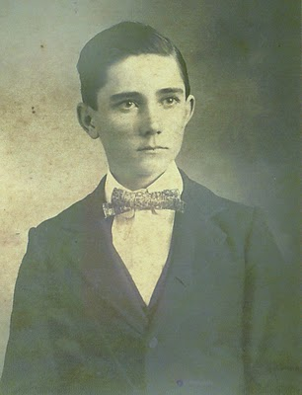
Ulyss S. Holliman
1884 - 1965

by Glenn N. Holliman

In February 2010, with the help of my daughter, GraceHolliman, I began publishing articles on the Hollimanfamily. An abundance of material made available by cousins Rhodes Holliman, Ron Holliman and others, plus my own research, has led me further back into our family past than I had originally planned or thought possible. I intend to continue to write and publish such information at http://hollimanfamilyhistory.blogspot.com/.

However, thanks to my father, sisters and cousins, I have accumulated a tremendous number of photographs and letters. Of the seven children of Ulyssand Pearl Caine Holliman, four have left us. Memories of a time and place in Southern and American history are slipping away. My cousins and I are not getting younger. Thanks to the internet, it is possible to collect information easily and share it with family. With this new blog, I hope to focus exclusively on my father's parents, their families and descendants.

The young man above is my grandfather. Rhodes Holliman made this photograph available to me. This picture resembles my own father, Bishop Holliman (b 1919) as a young man in the 1930s. There is also a strong resemblance to my Uncle Ralph Holliman, whom his daughters, Pam and Kathy may notice. Probably this picture was made in Fayette, Alabama in the late 1890s, perhaps in the year 1900.

Ulyss was the last born of six brothers to a Civil War veteran, John ThomasHolliman, and his second wife, Martha Jane Walker Holliman. John seems to have been a simple farmer who worked hard to bring in a crop each year and cloth and feed his many boys. He died in 1930 and Martha Jane, shortly after. They died poor leaving little in worldly goods. However, they gave their sons a sense of morality and purpose. Their sons, whatever their career paths and financial success or lack of it, seemed to have all been of high moral character.

Ulyss was gifted with his hands, and spent his adult life working first in the wood mill in Fayette, and then in 1918 as a carpenter with the Birmingham Electric Company, repairing the wooden street cars. He retired in 1949 at the age of 65.

This grandfather of mine was taciturn, a person of few words and he had difficulty showing emotion (other than annoyance perhaps). This was balanced by his strong work ethic, rising early and stoking a coal fire in the winter, commuting a long distance from the home in Irondale, Alabama to the street car yard, and then back again late in the evening. Until Roosevelt's New Deal, he worked six days a week, had no sick days and no vacation time.

In 1906 he married one of the Caine sister's in Fayette, one Pearl Caine. Together this couple would have seven children. In future articles, I will be writing of Grand Mother Holliman and the seven children.

Opinions expressed are mine alone. I welcome comments, critique and especially additional memories and photos. Please let me know if one wishes a photo removed or commentary edited. No photos of current under age descendants are published. My email address is Glennhistory@gmail.com. My thanks to the family for the use of materials.

Tuesday, February 22, 2011

Ulyss and Pearl Caine Holliman and their Descendants
by Glenn N. Holliman
Ulyss's Wise Selection of a Wife
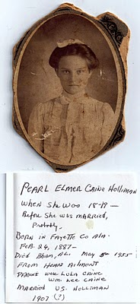
Above is pictured Pearl Caine as a young lady. Those dark eyes must have attracted Ulyss. The comments are by Bishop Holliman, their fifth child, who is not sure when his parents were married. He thinks 1907. More research is needed, but I believe it was 1906.
Ulyss and the rest of his descendants are fortunate that a young 19 year old, Pearl Caine, agreed to marry him in 1906. Pearl balanced Ulyss's quiet, sometimes grumpy nature (at least when he was older). She was loving, generous, strong willed and terribly hard working. She is remembered warmly by surviving children and grandchildren old enough to remember.
Born in Fayette County, Alabama in 1887, she died of a heart attack May 5, 1955, stricken at her home in Irondale, Alabama. She survived in the hospital until all her children could arrive and say goodbye.
The couple had seven children. They are:
Melton Pearson Holliman (1907 - 1958)
Vena Vivian Holliman Daly Buckheit (1909 - 1990)
Euhal Arlington Holliman (1912 - 1989)
Loudelle Holliman Ferrell (1914 - 1998)
Homer Bishop Holliman (1919)
Virginia Ruth Holliman Cornelius (1922)
William Ralph Holliman (1924)
In my blog at http://hollimanfamilyhistory.blogspot.com/, I have separate pages on each of these children. In time, I shall be removing those pages and moving their stories and additional information to this blog at http://ulyssholliman.blogspot.com/.
More in a few days....

February 28, 2010

Ulyss and Pearl Caine Holliman and their Descendants
by Glenn N. Holliman
1912 or 1914? Is the Baby Euhal or Loudelle?
The 1910 U.S. Census lists Ulyss and Pearl Holliman living in Precinct 1 in Fayette, Alabama. Granted the numbers might be somewhat inaccurate with Ulyss listed as age 26 (b 1884 which is correct), but Pearl as 21 on April 15, 1910, which would make her born in 1889 Traditionally the family lists her birthday as February 1887.
What is the age of the below photograph and who is the baby? On the left is Vena Holliman Daly and on the right is Melton Holliman. The third child born was Euhal Holliman in 1912 when Melton was four and Vena 2 1/2 years of age. Melton appears about 5 or 6 in this photo and Vena could be 3 or 4, making this picture of a one-year old Euhal in his stroller. Loudelle would be born in 1914, and conceivably this could be her as a baby, but why would not Euhal be included? Perhaps there is a missing photo. Can any family member definitely identify whether this be Euhal or Loudelle Holliman Ferrell?
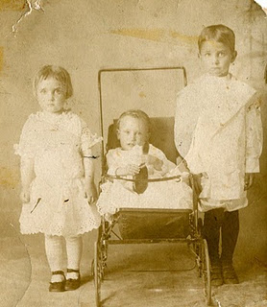
Having a picture taken was still a formal and expensive process in 1912. Melton is dressed in a quasi-feminine outfit typical of the formal attire of young boys of that day. Vena is also wearing leggings and a very fancy dress. The 1910 Census does not list a trade or profession for Ulyss. One can surmise this photograph was an financial extravagance for a growing, young family for whom the breadwinner was probably a mill worker in the local lumber yard. Employment opportunities in Fayette were limited at the time, and Ulyss was not a farmer. As his family grew, so did expenses.
When regular and more lucrative employment beckoned in the 'Magic City' of Birmingham later in the decade, the family would move.
More later.....
Posted by Glenn N. Holliman at 6:37 AM
Email ThisBlogThis!Share to TwitterShare to Facebook
Labels: Melton, Pearl Caine Holliman, Ulyss Holliman, Vena

0 comments:

Post a Comment

Tuesday, March 8, 2011

Ulyss and Pearl Caine Holliman and their Descendants
by Glenn N. Holliman
Melton Pierson Holliman (1908 - 1958),
the First Child of Ulyss and Pearl Caine Holliman
Below is pictured Melton in 1938, probably on the front steps of the home he and Ida Hughes Holliman, shared in Irondale, Alabama. Melton in his teens began working in Uncle Floyd Caine's drug store and learned how to prepare medicines. He was the first child out of the nest so to speak, being born in Fayette, Alabama, and moving to Irondale when he was nine years of age. In the 1920s, the requirements to be a pharmacist were more relaxed than in the 21st Century, and by 1940, Melton became a pharmaceutical salesman for Wyeth, eventually moving to Mobile, Alabama.
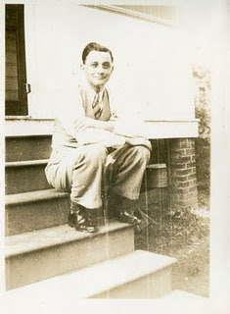
In 1932, he and Ida (1905 - 1995) were married, and in 1943 adopted a beautiful red headed daughter, Pati (Patsy to her father), who grew up with a vivacious personality. Scarcely had they become a family of three before Melton was drafted into the U.S. in August 1943 at the height of World War II. He trained in camps in Georgia and Texas, and for months moved from replacement station to replacement station (Pennsylvania, New York and England) before arriving in France in late July 1944. There he served as a medic in a battalion that was trained to treat chemical warfare casualties.
Thankfully, there was no chemical warfare in Europe during this war, and so he served a medic in a medical receiving station in France. In November 1944, age 36, he was diagnosed with high blood pressure and evacuated first to England, then back to the States, stopping at a hospital in Long Island, and finally at a facility in Jackson, Mississippi. In March 1945, he was discharged, and returned to work as a pharmaceutical salesman.
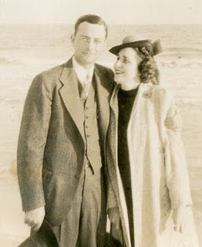
Melton and Ida Holliman, 1935
His genial, kindly manner, honesty and knowledge of the trade made him immensely successful. The family built a modern home in Mobile, and were active in the Baptist Church. He served on the Mayor's Advisory Council for the local hospital and was a frequent lecturer to the medical community. However, there were shadows over this happiness. Ida suffered from ill health time to time, and in 1955 Melton, a sometime smoker, experienced a heart attack. Treatment in that decade was complete rest. After several months, Melton went back to work, but after a game of golf in 1958, he died suddenly of a massive heart attack. Ida passed away in 1995, the rest of her long life a widow.
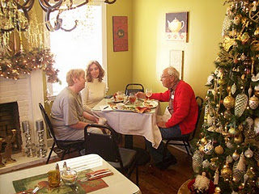
Their legacy lives on through the life of Pati, her three daughters and now grandchildren, whom she shares with her husband of decades, George Hairston. Pictured above in late November 2010, are left to right Holly Hairston, Pati's oldest daughter, Pati Holliman Hairston and Melton's brother, Bishop Holliman. Holly owns a lovely cafe near Trussville, Alabama.

Ulyss and Pearl Caine Holliman and their Descendants
by Glenn N. Holliman
Vena Vivian Hollman Daly Buckheit (1909 - 1990),
the Second Child of Ulyss and Pearl Caine Holliman

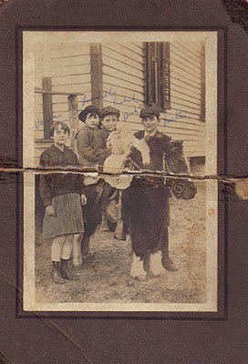

Above left to right are Vena, Loudelle, Euhal, Bishop and Melton Holliman in 1920. The pony may have belonged to Mrs. T.C. Burgess who lived at the bottom of the hill below the Irondale, Alabama house. She had two children, John Hugh and Sadie Mae. Mr. Burgess owned the hardware store that Robert and George Daly purchased in 1944.
Vena was 8 in 1917, when Ulyss and Pearl Holliman moved their four children and themselves to the growing suburb of Irondale, Alabama. The population of Birmingham and its environs were exploding. Founded in the 1870s, Birmingham grew in forty years from 3,086 to 178,816! Jobs were plentiful as the infrastructure of the steel industry and the city grew. Ulyss Holliman, now age 32, with many mouths to feed, left Fayette County and work in the lumber yard, to become a carpenter with the Birmingham Electric Company.
As Birmingham grew horizontally, street car lines pushed to all corners and into the suburbs. Ulyss helped keep the wooden carriages and benches in good repair. Ironically, when Ulyss was born there were no street cars in Birmingham, and when he died in 1965, there were not street cars in Birmingham.
Vena, the oldest daughter helped her mother, Pearl, care for the growing brood, which expanded by three more children after Ulyss found secure employment, and the family settled into new housing in Irondale.
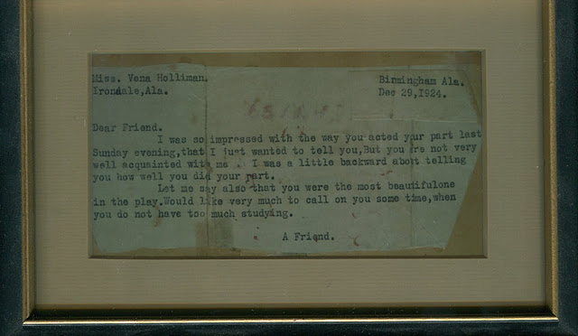
In December 1924, twenty-one year old Robert Daly, grandson of an Irish immigrant who came to Alabama to build railroads, watched Vena in a Christmas pageant in the Irondale Methodist Church. Robert, smitten over the cute 15 year old, sent her the above note and by her 19th birthday in 1928, she became his bride! Below is the newspaper clipping of the happy occasion. Click on the pictures to make them larger.
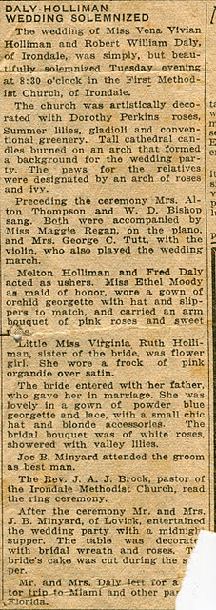
More soon on the Daly family and how they impacted on the life of the three youngest children....
Note: The information and opinions expressed in these family biographies

Ulyss and Pearl Caine Holliman and their Descendants
by Glenn N. Holliman
Vena and Robert Daly, Sr. and their Influence on the Holliman Family
In the mid 1920s, Robert Daly, Sr. began working for American Traders Bank in Woodlawn, Alabama. Later it became the American National Bank of Birmingham. In addition to being manager of the Woodlawn branch, he would become as a vice president of the larger corporation.

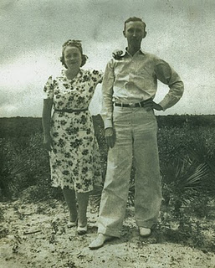
Robert loved to travel and vacation in Florida. Above are Vena and Robert in 1935. Robert was incredibly generous with his time and company to the siblings of Vena. He made himself a beloved figure to the three youngest Holliman children - Bishop, Virginia and Ralph - who often went with the Dalys to Panama City and Daytona Beach, Florida. Both Vena and Robe
rt were tremendous role models for their generation, and later for their many nieces, nephews and grandchildren. After the death of Pearl Caine Holliman in 1955, the center of Holliman gatherings moved to Vena and Robert's 'white house' on the east side of Irondale.
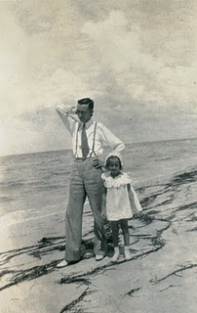
Vena and Robert would have two children, Mary Daly Herrin, born 1932 and Robert Daly, Jr., born 1943. Above is Mary in 1936, age 4 with her father at a Florida beach. They both seem formally dressed for a stroll in the sand! Belowin winter 1944, Mary and her young brother, Bob, attempt to enjoy a light snow. In the background is the Daly house built in the early 1930s, adjacent to the Ulyss and Pearl family home at 2300 3rd Avenue, Irondale, Alabama.
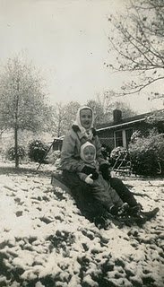

Sadly, Robert, Sr. suffered for years from congestive heart failure and died suddenly at his home in 1959. In the 1960s, Vena served as a sorority house mother at the Universities of Alabama and Mississippi. In 1971, she remarried Phil Buckheit, a successful newspaper publisher from Spartanburg, South Carolina. After he died in 1977, she returned to Birmingham, and lived in a condo on Red Mountain next to her sister, Virginia Holliman Cornelius. Vena died 1990. One of her grand daughters, Iris Daly Williams, recently reminisced that visiting her grandmother in the 1980s was like visiting a queen. Vena had a presence and gracefulness that her family admired and loved, as this nephew can attest.
Next the third child of Ulyss and Pearl Holliman....
Note: The information and opinions expressed in these family biographies are those of the writ

Ulyss and Pearl Caine Holliman and their Descendants
by Glenn N. Holliman
Euhal Arlington Holliman (1912 - 1989),
the Third Child of Ulyss and Pearl Holliman
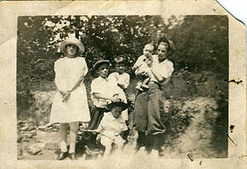
The Ulyss and Pearl Holliman family moved to Irondale from Fayette, Alabama in 1917, and Ulyss settled in to his new job at the Birmingham Electric Company. The above photograph is from 1924. Left to right: Vena, Euhal holding Virginia, Bishop in front with the stick, and Melton holding the youngest, his brother Ralph Holliman. Vena is dressed formally (age 15) and both Euhal (age 10) and Melton (age 16) are wearing the style of the time, knickers. (This style of boy's pants is frozen in time today as the uniform of baseball players.) Note Euhal, Melton and Bishop (only 4) are all wearing caps or hats.
Melton was born in 1908, and before the Great Depression in 1927, he obtained a position in his Uncle Floyd Caine's drug store. Euhal came of age right in the middle of the Depression, and jobs were scarce. He went to work for a local grocery store, and spent his career in the food business.
He met a pretty young lady named Edna Westbrook (below) and in 1936 they married. Six children were eventually born of this union which lasted 54 years!
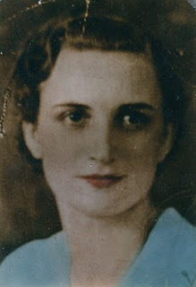

Edna Westbrook Holliman (1916 - 1992), a native of Cherokee County, Alabama, married Euhal July 9, 1936. Edna is the daughter of Annie Josie Naugher Westbrook and Thomas Edward Westbrook. Daughter Tommie Holliman Allen believes they met in East Lake, Alabama, when Edna's sister's boyfriend, later Tommie's uncle, introduced them. Edna was 18 when this picture was taken.

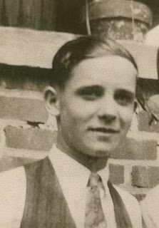
This is young handsome Euhal, probably about 1935.
A hard worker all his life, he was a leader in the Irondale Lion's Club, his labor union and in retirement, the Irondale Auxiliary Police. Super market chains appeared in America after World War II, and wages were low and benefits few. A leader in the labor union movement, Euhal helped organize and lead grocery workers to better compensation and working conditions during his career at chains Jitney Jungle, Piggly Wiggly, Kroger and Brunos as produce manager, before retiring in 1972.
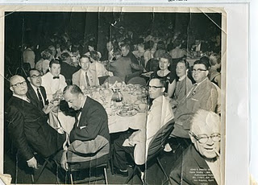
Euhal, center right, in the white coat at a national union convention in California in 1956.
Like his three brothers, he took his physical for the Army in World War II, but due to age and having four children to support, he was not called up. The family lived in Gadsden, Alabama in the 1940s until the middle 1950s. In 1956, they moved to the Ulyss and Pearl Holliman home in Irondale, living there for the rest of Euhal and Edna's lives.
Next Posting, the Children of Euhal and Edna....

Friday, April 8, 2011

Ulyss and Pearl Caine Holliman and their Descendants
by Glenn N. Holliman

The Children of Euhal and Edna Westbrook Holliman
Euhal and Edna Westbrook Holliman were fortunate to have six children, five of whom survive to this day.
They are:
Melton Terry and Alvin Jerry Holliman, twins (b 1940) - Jerry died of heart disease in his home state of Alaska in 2003. This cute 1941 picture was taken on the Holliman family lawn in Irondale, Alabama.
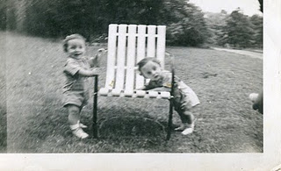

Ann Holliman Phillips (b 1943) is in the right of the picture below, held by her mother, Edna. Euhal holds newborn baby Jean Holliman. Euhal's family lived in Gadsden, Alabama in the 1940s and through the middle of the 1950s. This picture again seems to have been taken in Irondale in 1944.
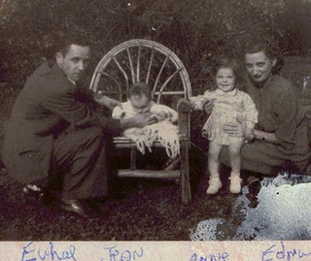

Mary Jean Holliman (b 1944) At the 1970 family reunion at E.C. and Mary Daly Herrin's home in Irondale, this picture was taken of Jean, Billy and their mother, Edna. In the far right is Carol Daly, Robert Daly, Jr's wife, holding their son, John Daly.

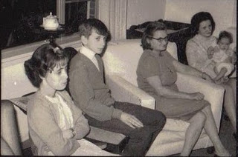
Tommie Holliman Allen (b 1954), is pictured in November 2010 at the Irondale Cafe with her Uncle Bishop Holliman. Some of the space occupied by the Irondale Cafe is the same location as the Daly Hardware Store from 1944 until its closing in the early 1960s. The store was owned by brothers Robert, Sr. (Vena's husband) and George Daly.
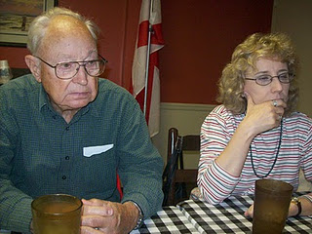

Billy Holliman (b 1955) - Below is the 50th Anniversary celebration for Edna and Euhal. Left to right are Tommie, Jean, Ann, Euhal, Edna, Terry, Jerry and Billy Holliman in this 1985 photograph.
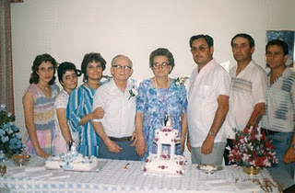

Next, An Alaskan memorial to Jerry Holliman....
Note: The information and opinions expressed in these family biographies are those of the writer alone. Comments, corrections and additions are most welcome. The purpose of these articles is to capture a period and family in American history and to pass this legacy along to future generations who share the common bond of family .My thanks to Tommie Holliman Allen for pictures.

Ulyss and Pearl Caine Holliman and their Descendants
by Glenn N. Holliman
Jerry Holliman, a Remembrance
Jerry in 1954, at school in Gadsden, Alabama, age 14.
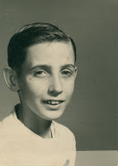
My first cousin, Jerry, died in 2003 at age 62 of a heart attack while on a fishing trip in Alaska. He is the first of the nineteen first cousins of the seven children of Ulyss and Pearl Holliman to pass away. Perhaps Jerry, although too young to leave his family, died in circumstances he might have chosen - fishing in his beloved Alaska. One of the great pleasures of his father, Euhal, was joining the twin sons, Jerry and Terry, searching for salmon in Alaskan rivers.
Jerry was six years older than me, and the last time I saw him was around 1960. Bob Daly and I were teamed up against the twin brothers playing tackle football on the Daly lawn in Irondale. As a kid, it was always a thrill to be included in games with my older male cousins. While in the Army at Ft. Bragg, NC, Jerry briefly visited our home in Florence, South Carolina.
Another memory I have is of the two brothers, probably in the mid-1950s, having a brotherly tussle in the dark parking and storage area under Grandmother Holliman's house in Irondale. It was spooky and dank under the house, and I always was afraid to explore it. So I watched from the outside as the two boys engaged in fist-a-cuffs. I think their father broke up the fight.
Brothers always have brotherly quarrels, especially so twin brothers seeking their own identity. Perhaps that is what attracted Alaska to them, the 49th new state with opportunities and a chance to build a life. Our branch of the Holliman family had lived in the south since 1650, and in the early 1960s both brothers migrated to the Great Northwest. Their immigration personifies the Holliman diaspora of our generation. Terry had been stationed in the state during the service, and he must have told Jerry of the attractiveness of the Alaskan outdoors.
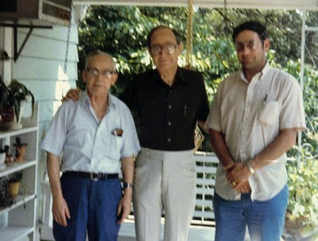
The above photo of Euhal, Bishop and Jerry Holliman was taken in 1985 on the porch of the old Holliman home in Irondale.
This thoughtful memorial to Jerry was published by Alaskan Airlines in July, 2003 in Anchorage.
"Jerry, 62, died July 16 of a heart attack while on a fishing vacation in Kenai with his wife, Dona Holliman, also an Alaska Airlines employee. 'We feel this emptiness in our hearts with the sudden loss of a friend like Jerry,' said Davis Burris, Anchorage CSM. 'He touched the lives of everyone he came into contact with everyday, and that was almost everyone in the Anchorage station.'
In 1995, Jerry received the highest honor that an Alaska employee can receive: Customer Service Legend. As native of Alabama, Jerry moved to Anchorage and began his career with the airline in 1964. He was the station's top seniority ramp service agent. In addition to his wife, a 39 year lead CSA - air freight agent, Jerry is survived by a daughter and son-in-law, Renee Holliman and Kevin McKinney, two grand daughters and several siblings, including an identical twin brother, Terry."
No doubt Euhal and Edna, both hard-working individuals, would have been proud to read how others felt about Jerry. I know his cousins are.
Next, the Fourth Child of Ulyss and Pearl Caine Holliman....
Note: The information and opinions expressed in these family biographies are those of the writer alone. Comments, corrections and additions are most welcome. The purpose of these articles is to capture a period and family in American history and to pass this legacy along to future generations who share the common bond of family .My thanks to Tommie Holliman Allen for the information..

Ulyss and Pearl Caine Holliman and their Descendants
by Glenn N. Holliman
Loudelle Holliman Ferrell, 1914 - 1998
the Fourth Child of Ulyss and Pearl Holliman
Loudelle Holliman Ferrell was born in Fayette, Alabama in 1914, the 2nd daughter of Pearl and Ulyss Holliman. Ulyss worked in the nearby lumber mill, and probably walked to and from his home which was located not far from his parent's house, John Thomas and Martha Jane Walker Holliman. In the late 1990s with Charles Holliman and his first cousin, my father, Bishop Holliman, we visited the little white frame house, perhaps a 1,000 square feet in size, where Ulyss and Pearl were raising their growing family. The couple had been married 7 years and had four children to support.
Below is a photograph of Loudelle Holliman Ferrell as a baby in 1914, the year World War I broke out in Europe. This war would feed the already rapid economic expansion of Birmingham, Alabama. By the time Loudelle was three, the family moved to a new subdivision begun in an older part of Jefferson County - Irondale.
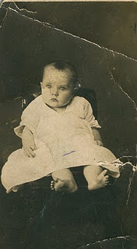
Below is a photograph, perhaps 1917, made in Fayette, Alabama. Left to right: Loudelle (with a new haircut evidently), Euhal and Vena Holliman. Vena hold one of her first cousins, a Cook child and a second Cook cousin on the far right. Maude Caine, one of Pearl's sisters, married a Cook in Fayette. As with the Holliman's, the Cooks moved also to Irondale and during the 1920s inhabited a home just behind the Ulyss Holliman house. Around 1930 the Cook's moved to a farm near Leeds, Alabama. Maude, who had tuberculosis of the spine as a child, was physically disabled, and died around 1940.
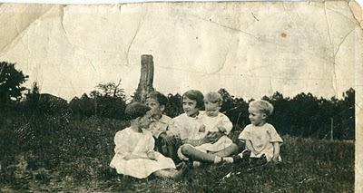
Note: The information and opinions expressed in these family biographies are those of the writer alone. Comments, corrections and additions are most welcome. The purpose of these articles is to capture a period and family in American history and to pass this legacy along to future generations who share the common bond of family
More on Loudelle and family in next post...

Ulyss and Pearl Caine Holliman and their Descendants
by Glenn N. Holliman

More on Loudelle Holliman Ferrell, 1914 - 1998
the Fourth Child of Ulyss and Pearl Holliman

In 1917, Ulyss moved his family to E.F. Montgomery's planned subdivision on the hill overlooking the Southern and L & N railroad yards in Irondale, Alabama. The Hollimans first lived in a house on 2nd Avenue, just a few blocks from the center of town.

This picture was made in 1920 a few months after Bishop Holliman's birth. In the back are Vena and holding baby Bishop (b 1919) is Melton. The children in front are Euhal left, and partially obscured, Loudelle. Around this time, Ulyss realized he needed a bigger house for the five children, so he purchased a lot from the Bishop family at 2300 3rd Avenue.

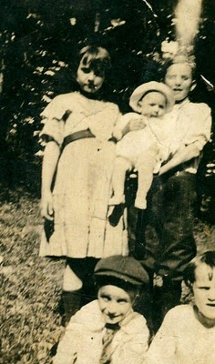
Below is a truly amazing photo from 1924 on the Cahawba River. Let's see, the youngster in the foreground is my father, Bishop. Behind his is Euhal, Loudelle,and Melton. In the right foreground is their father, Ulyss S. Holliman, my grandfather.
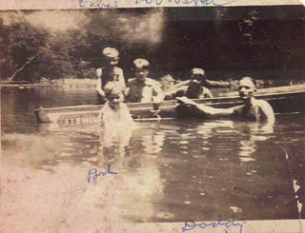
Note: The information and opinions expressed in these family biographies are those of the writer alone. Comments, corrections and additions are most welcome. The purpose of these articles is to capture a period and family in American history and to pass this legacy along to future generations who share the common bond of family. My thanks to Charles H. Ferrell for the loan of many of the pictures.

Ulyss and Pearl Caine Holliman and their Descendants
by Glenn N. Holliman

More on Loudelle Holliman Ferrell, 1914 - 1998,
the Fourth Child of Ulyss and Pearl Holliman

The Holliman children were growing up by 1928. Melton had gone to work in his Uncle Floyd Caine's drug store, and Vena became Mrs. Robert Daly that year. Charles H. Ferrell, Loudelle's older son, made this photo below available to me. Vena is on the left and Loudelle, now all of 14 and looking very grown up, is wearing a fashionable hat of the 1920s. The young ladies are in short skirts as a revolution in fashion occurred after World War I. Hem lines rose!
Both are standing in front of the then new home at 2300 3rd Avenue, Irondale. One can see the wooden steps in the background. It was a winter's day. No sidewalk yet on the street nor paved roads. The sidewalks and water system would go in the 1930s and 40s as part of a New Deal Public Works Administration program. That's right....the seven Holliman brothers and sisters grew up in a house without running water and in door facilities. Not until the late 1930s was an indoor bathroom installed. Oh yes, the good ole days!

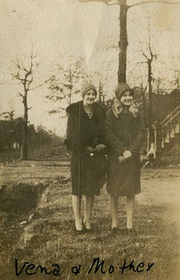

Below is another photo of Loudelle, second from left with the penetrating eyes. The other girls are believed to be friends and not relations. Notice the fascinating hair styles of 1930. Compare Loudelle's eyes with the February 22, 2011 post of Pearl Holliman. One can see a startling resemblance when Loudelle was Pearl's age.
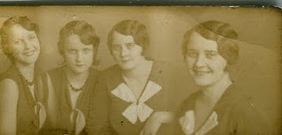

Note: The information and opinions expressed in these family biographies are those of the writer alone. Comments, corrections and additions are most welcome. The purpose of these articles is to capture a period and family in American history and to pass this legacy along to future generations who share the common bond of family.

More Loudelle and family next post....
Plan now to attend the Holliman and Associated Families Genealogical Round Table at the Fayette County, Alabama Civic Center, 10 am to 3 pm, Saturday, October 15, 2011. For informat

Ulyss and Pearl Caine Holliman and their Descendants
by Glenn N. Holliman
More on Loudelle Holliman Ferrell, (1914 - 1998)
the Fourth Child of Ulyss and Pearl Holliman
In this 1929 photo below, young and lovely Loudelle, embraces her 68 year old maternal grandmother, Lula Caine. Grandma Caine, as she was known to most of us, was born in 1861 and died in 1957. Her father, Manassas Hocutt, succumbed in 1863 of injuries from the Battle of Stones River in Murfreesboro, Tennessee and is buried in an unmarked grave. At the same battle, and escaping uninjured, was Loudelle's paternal grandfather, John Thomas Holliman. (Note, earlier in a post, I had mislabeled this photograph as Vena Holliman Daly; Bishop Holliman corrected the error for me.)
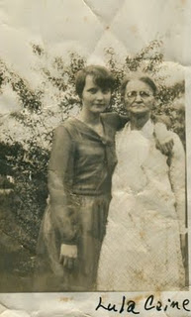

Below, Loudelle, age 17, strikes a coquetish pose in the winter of 1931. I don't know who the little boy is in the right corner nor the location of the photo. Notice Loudelle's moderate heels and white socks. Her son, Charles Halford Ferrell, told me in November 2010 when I scanned this picture that his mother, Loudelle, had once been Miss Birmingham! I am still startled that Pearl or Ulyss Holliman, conservative, evangelical Christians, allowed such! Perhaps the event is not so amazing at it seems. My father, Bishop Holliman, remembers the contest as more of Methodist event, sort of young person of the year celebration in Birmingham. I like Charles Halford's story better!

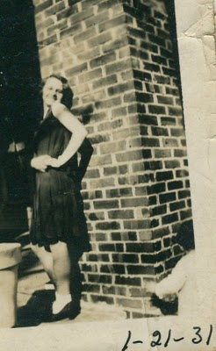

What Loudelle did not know in 1931 was that in a few years, she would meet a young Methodist minister, The Rev. Charles Ferrell. Below in 1928 Charles, right in the tie and apron, worked in an A & P grocery store, probably helping to pay his way through Birmingham-Southern College. Notice the type of store. The super markets in which Charles's brother-in-law, Euhal Holliman, would make his career had not yet developed in America. The pot bellied stove provided heat in the winter. It must have been stifling hot in Alabama summers.
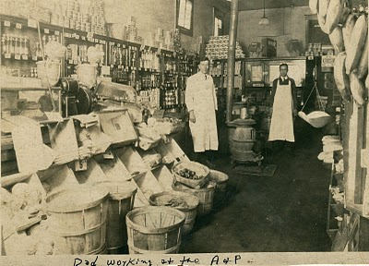
More later on this amazing couple....
Note: The information and opinions expressed in these family biographies are those of the writer alone. Comments, corrections and additions are most welcome. The purpose of these articles is to capture a period and family in American his

Ulyss and Pearl Caine Holliman and their Descendants
by Glenn N. Holliman

More on Loudelle Holliman Ferrell, (1914 - 1998)
the Fourth Child of Ulyss and Pearl Holliman

Here is the first picture I have of Charles and Loudelle together at a Methodist youth conference in 1934.
They are not yet standing together. Charles is fourth from the right, and Loudelle is third from the left.
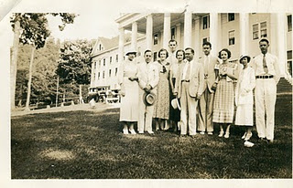

What a difference a year makes. Here is Loudelle on her wedding day in her wedding dress, sitting smartly on the edge of a convertible. Does any one know the model (the car that is)?
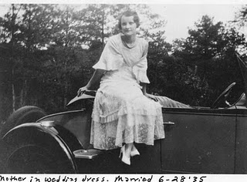

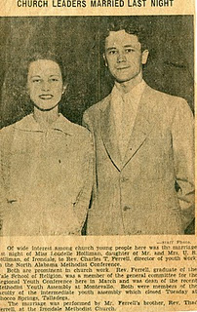

Above is the happy couple and their newspaper announcement. Click on the photo and it will enlarge.

Next their three children.....

Ulyss and Pearl Caine Holliman and their Descendants
by Glenn N. Holliman

More on Loudelle Holliman Ferrell, (1914 - 1998)
the Fourth Child of Ulyss and Pearl Holliman

By 1937, Charles Halford Ferrell had entered the family. The stroller was typical of the time - all metal with hard rubber wheels. Plastic had not yet become a developed product in America. Charles is in fashion for the times - white shoes.

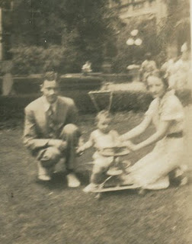

A year later, Carolyn Ferrell Tatum entered this life. Here she is carried as a baby by her grandmother, Pearl Holliman. The Robert Daly, Sr. house is in the background. Pearl was 51 years old in 1938.
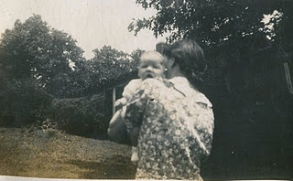

This is a 1953 school photo of John Melton Ferrell, born 1942. He was the last of three children by Charles and Loudelle.
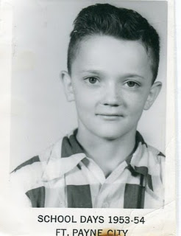

Note: The information and opinions expressed in these family biographies are those of the writer alone. Comments, corrections and additions are most welcome. The purpose of these articles is to capture a period and family in American history and to pass this legacy along to future generation

Ulyss and Pearl Caine Holliman and their Descendants
by Glenn N. Holliman

More on Loudelle Holliman Ferrell, (1914 - 1998)
the Fourth Child of Ulyss and Pearl Holliman

Here are the three Ferrell children, all grown up in the 1970s. Charles H. Ferrell would become a United Methodist minister and later a YMCA director.
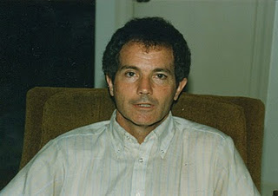

Favoring her mother, Carolyn resides in North Carolina with grown children and grandchildren.
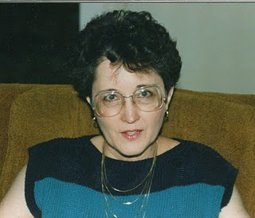

John Melton Ferrell resides in Massachusetts with his family, where he retired in 2010 as a YMCA director.
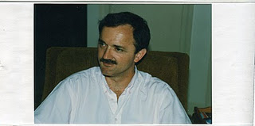

Note: The information and opinions expressed in these family biographies are those of the writer alone. Comments, corrections and additions are most welcome. The purpose of these articles is to capture a period and family in American history and to pass this legacy along to future generations who share the common bond of family.

More soon.....

Ulyss and Pearl Caine Holliman and their Descendants
by Glenn N. Holliman

More on Loudelle Holliman Ferrell, (1914 - 1998)
the Fourth Child of Ulyss and Pearl Holliman

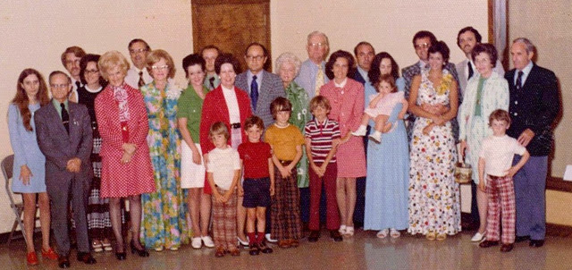

Above is the1973 retirement photograph of Charles Ferrell surrounded by family members. Charles, assisted so wisely by Loudelle, had a distinguished career in the Methodist ministry, serving the largest churches in the North Alabama Conference. For a time he was District Superintendent. Modestly Charles stands behind Loudelle (flowery dress right between her sister Virginia and Carol Daly).
This will not be easy but let me make a stab at identifying whom I can. Everyone's help requested. Okay, - left to right: Tommie Holliman Allen, her father, Euhal in the suit. Behind Euhal is Barnes Tatum, and in front of him, Carolyn Ferrell Tatun. In red is Virginia Holliman Cornelius, Charles Ferrell, Loudelle Holliman Ferrell, Carol Daly, Dr. Bob Daly, Gerry Holliman in the red sweater (I will come back to the children), Bishop Holliman, Vena Holliman Daly Buckheit and Phil in the light blue suit. Mary Daly Herrin in red with her husband, E.C. Herrin. The lady in the long blue dress holding the baby --- hmmmm...don't know; John Ferrell's family. Charles Halford Ferrell in the checkered coat holding his wife. John Melton Ferrell is next to his brother Charles. The couple on the far right, must be Ferrells.
As to the four children on the very front, I cannot identify them. Today they would be in their 40s. I believe John Daly is one of the children. Ouch!
Here are Charles and Loudelle on their 50th anniversary in 1985.
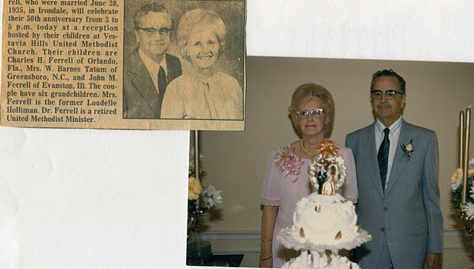
Note: The information and opinions expressed in these family biographies are those of the writer alone. Comments, corrections and additions are most welcome. The purpose of these articles is to capture a period and family in American history and to pass this legacy along to future generations who share the common bond of family.
Next another child of Ulyss and Pearl Holliman and continued photographs of numerous family members....
Plan now to attend the Holliman and Associated Families Genealogical Round Table at the Fayette County, Alabama Civic Center, 10 am to 3 pm, Saturday, October 15, 2011. For information and reservations for lunch, contact Glenda Norris at gnorris@bcbsal.org or Glenn Holliman at Glennhistory@gmail.com. Sessions to include Tracing the Holymans from England to Alabama, Holliman Farm Sites in Fayette County and sharing of information on Associated Families. All invited

Ulyss and Pearl Caine Holliman and their Descendants
by Glenn N. Holliman
Homer Bishop Holliman, 1919
the Fifth Child of Ulyss and Pearl Caine Holliman
Two years after Ulyss Holliman moved his family from Fayette, Alabama to a suburb of the economically prosperous city of Birmingham, a fifth child was born. His name was Homer Bishop Holliman. Why the Homer? We don't know what Ulyss and Pearl were thinking, except it was not unusual in the family to have Latin and Biblical names - Uriah, Cornelius, Elijah, Ezekiel and Ulysses had mixed with John, James, Thomas, William and Christopher for generations.
Bishop was the last name of a good friend of Ulyss, G.D. Bishop who in 1921 would sell Ulyss a lot on 3rd Avenue, Irondale where the family would build a six room house (minus a bathroom) in 1922. In that house first Ulyss and Pearl would raise their family from the 1920s to Pearl's death in 1955, and then later Euhal and Edna Holliman from 1956 until the early 1990s.

Below, Bishop in the family chicken yard, holding a hen in Irondale.
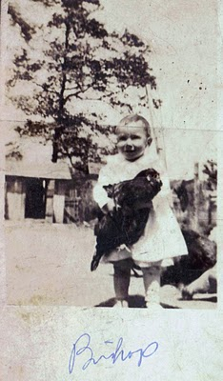
In the new subdivision of Irondale, Bishop would grow, attend school, play a lot of sand lot baseball, and even clay court tennis on the hill behind the house. His Mother's sister, Aunt Maude lived behind them, and the children would play with the Cook children, their first cousins.
Bishop graduated from high school in 1937, and with help and encouragement from two dynamic brother-in-laws, Robert Daly and Charles Ferrell, he enrolled in Birmingham-Southern College. With the encouragement of Charles and Loudelle Holliman Ferrell, Bishop was active in state and regional Methodist youth activities, even being elected president of the North Alabama Youth Conference. In 1937 he won a Young Republican's speaking contest in Memphis, railing against government intrusion on the private sector of the economy.
Ironically, Bishop would spend his career as an administrator and manager of the Social Security Administration, a federal program created during Franklin D. Roosevelt's New Deal. The agency provides old age pensions and disability payments for the American people.
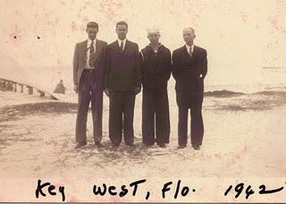
Above this photo is of Ralph, Charles Ferrell, Bishop and Ulyss Holliman at Bishop's duty station in Key West, Florida. The war was its most despairing in the winter of 1942, and Bishop was the only son in service at that time.
In November 1941, he joined the U.S. Navy. Pearl Harbor day found him at the barracks in Norfolk, Virginia. His parents, the Ferrells and his tall younger brother Ralph, drove all the way from Irondale to Key West, Florida in February 1942 to see him. Singapore fell that month, and shortly there after the Japanese took Bataan and Corregidor. German U-Boats sank dozens of freighters and tankers off the East Coast of the United States. It was a scary and unnerving time. A year later in 1943, two of his brothers, Ralph and Melton, joined him on active military service.
Back home in Irondale in the Robert Daly, Sr. home, that February 1942, Walter Cornelius married Virginia Holliman, Bishop's younger sister. By 1943, brother-in-law Walter would be in the Army Air Corp. The Holliman family was at war.
Note: The information and opinions expressed in these family biographies are those of the writer alone. Comments, corrections and additions are most welcome. The purpose of these articles is to capture a period and family in American history and to pass this legacy along to future generations who share the common bond of family.

Ulyss and Pearl Caine Holliman and their Descendants
by Glenn N. Holliman

Homer Bishop Holliman, 1919
the Fifth Child of Ulyss and Pearl Caine Holliman

America was changing dramatically during the 1920s and 1930s. The rise of the automobile culture accelerated the national economy and gave citizens the ability to travel and observe the various parts of a large nation. By the 1930s, even in the midst of an economic depression, paved roads and more powerful and reliable car engines began to allow middle and laboring class Americans to explore their country, previously not possible for the average family.

This was unprecendented, and in the life of Bishop Holliman, we can observe a young man, growing up and leaving Irondale, not just physically but intellectually and culturally (but never emotionally!). It was a journey millions of others of his generation, including his siblings, would make with increased mobility and the exposure to other peoples that World War II and the open highway would bring.

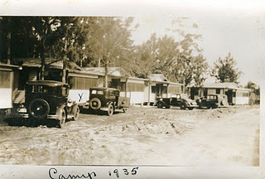

The photo above reveals a Florida tourist camp of 1935, a typical vacation residence, one where the Dalys and Holliman children - Virginia, Bishop and Ralph - would stay during the mid and late 1930s. The Holiday Inn was still a generation in the future. Primitive by 21st Century standards, sans air conditioning and with little plumbing, these cabins and early Fords and Chevrolets allowed the average Alabama family to take a vacation, visit the Gulf Coast and the Southern Mountains. The world began to grow larger to the generation that came of age in the 1930s and 1940s.

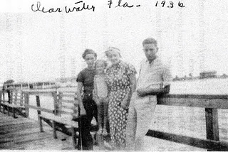

Above vacationing in Clearwater, Florida in 1936 are left to right Virginia Holliman Cornelius, Mary Daly Herrin, Vena Holliman Daly and Bishop Holliman. These trips, financed basically by the largest of Robert Daly, opened up new worlds to the younger children of Ulyss and Pearl Holliman. Their lives and careers would be considerably different from their parents and grandparents.
Note: The information and opinions expressed in these family biographies are those of the writer alone. Comments, corrections and additions are most welcome. The purpose of these articles is to capture a period and family in American history and to pass this legacy along to future generations who share the common bond of family.
More of a Changing World and Family in the next post....
Posted by Glenn N. Holliman at 4:46 AM
Email ThisBlogThis!Share to TwitterShare to Facebook
Labels: Bishop Holliman, Mary Daly Herrin, Vena Daly, Virginia Holliman Cornelius

0 comments:

Ulyss and Pearl Caine Holliman and their Descendants
by Glenn N. Holliman

Homer Bishop Holliman, 1919
the Fifth Child of Ulyss and Pearl Caine Holliman

The automobile gave unpresidented freedom to the generation that came of age in the 1930s. Bishop was able to travel and see parts of America that his parents could have only dreamed about. Below Bishop on the right, in 1939 traveled north to Canada and New York City to see the World's Fair. One of his Irondale friends, is on the left.

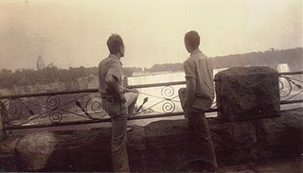
Below, Vena (far left) and Robert Daly, 3rd from left, provided transportaton for Virginia Holliman Cornelius (2nd from left) and Bishop to various state parks in Alabama during the late 1930s.
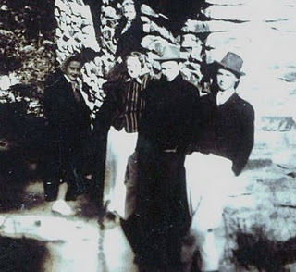
At home, Virginia Holliman Cornelius (3rd from left) and her brother, Bishop, far right, enjoyed friendships with fellow Irondale Methodist Church members. The automobile culture extended the suburbs far beyond Irondale. One new suburb was Trussville, Alabama, a community to which Bishop would move his new family in 1950.
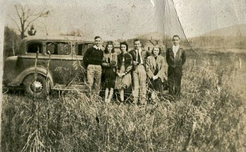
Note: The information and opinions expressed in these family biographies are those of the writer alone. Comments, corrections and additions are most welcome. The purpose of these articles is to capture a period and family in American history and to pass this legacy along to future generations who share the common bond of family.
More of Alabama in the late 1930s and early 1940s in the next posting....
Posted by Glenn N. Holliman at 9:21 AM
Email ThisBlogThis!Share to TwitterShare to Facebook
Labels: Bishop Holliman, Robert Daly, Vena Daly, Virginia Cornelius

Ulyss and Pearl Caine Holliman and their Descendants
by Glenn N. Holliman

Homer Bishop Holliman, 1919
the Fifth Child of Ulyss and Pearl Caine Holliman

As it did for hundreds of millions who occupied the globe in the 1940s, World War II changed for ever the lives of the seven siblings of Ulyss and Pearl. For Bishop the war meant almost four years of service in the U.S. Navy from November 1941 until September 1945. His brothers, Melton and Ralph, sixteen years apart in age, were taken also into the service, both into the U.S. Army in 1943, both discharged in 1945.

The many letters and photographs that survive from that time tell of worry, loneliness and sacrifice on both the home front as well as the brothers who all went overseas to the European Theatre. Walter Cornelius, the husband of Virginia Holliman whom she married in February 1942, also served in the Army. Imagine the prayers that were lifted up from 2300 3rd Avenue by my Grandmother Holliman during those years. Below are Pearl, age 55, and in February 1942, the only son yet in service, Bishop, during a visit to Key West, Florida, his duty station.

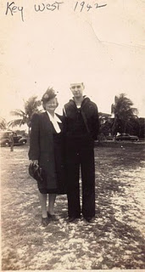

Bishop would become a radioman on two destroyers, the USS Barker and the USS Butler. In July 1943, his ship participated in the Invasion of Sicily and was on the receiving end of some Luftwaffe bombs. On D-Day 1944, he was sailing through the Straits of Gibraltar. In August 1945, he was in Norfolk, Virginia about to be assigned to the Pacific Theatre when the war with Japan ended. A month later, he and his young bride, Geraldine Stansbery, were in Birmingham, and Bishop was finishing his last year at Birmingham-Southern College.
Bishop, as did millions of others, traveled and experienced situations that broadened his world view and challenged social conventions. For many it had been a time of trauma and violence. The G.I.s came home, and the country began to change rapidly. Sadly, over 200,000 Americans and 6,000 Alabamians did not return.
Below, one of Bishop's ships in the North Atlantic on convoy duty during a war time winter. His duty was to listen for German U-Boat signals and help triangulate their location.
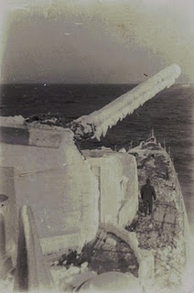

The U.S.S. Barker at sea during the war. All of 1,200 tons in size, these ships, armed with four inch guns and depth charges, escorted millions of troops and thousands of supply ships across the dangerous waters of the North Atlantic from 1941 to 1945. Both Ralph and Melton Holliman were on these troop ships in the middle 1940s en route to and from England. Their brother-in-law, Walter, was assigned to the Central Pacific, Saipan.
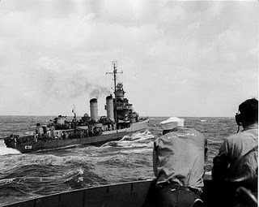
Next, the rapid Post War changes that swept over Bishop and his family....
Note: The information and opinions expressed in these family biographies are those of the writer alone. Comments, corrections and additions are most welcome. The purpose of these articles is to capture a period and family in American history and to pass this legacy along to future generations who share the common bond of family.

Posted by Glenn N. Holliman at 4:30 AM
Email ThisBlogThis!Share to TwitterShare to Facebook
Labels: Bishop Holliman, Pearl Caine Holliman

0 comments:

Post a Comment
Newer PostOlder PostHome
Subscribe to: Post Comments (Atom)

Followers

Blog Archive
- ▼ 2011 (42)
  - ► December (5)
  - ► November (3)
  - ► October (3)
  - ► September (3)

Ulyss and Pearl Caine Holliman and their Descendants
by Glenn N. Holliman
Homer Bishop Holliman, 1919
the Fifth Child of Ulyss and Pearl Caine Holliman

As the war came to a close, Bishop Holliman wed the girl, Geraldine Stansbery, whom he had met while on liberty in Philadelphia in 1942. They kept in touch, and on June 26, 1945, married in Philadelphia. When Japan surrendered, Bishop was discharged and in September 1945, he returned to Birmingham-Southern College. As with millions of others, he used the G.I. Bill to pay for his education and support the family. Government subsidized housing in Elyton Village near 'Southern' provided shelter as Gerry and Bishop established their family. Bishop in 1947 started teaching at David Lipscomb Junior High. Later he taught history at the new Shades Valley High School, and in summers earned a M.Ed. from the University of Alabama.

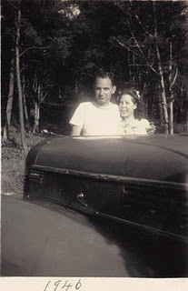

Above, Bishop had a new wife and an old car, a 1937 Chevrolet in 1946. Thirteen million soldiers came home, restarted their lives and caught up on family life. Millions of babies were soon born, and the 'Boomer' generation was created. Over a ten year period, Bishop and Gerry became the parents of three children - Glenn (1946), Becky (1950) and Alice (1956).

Below, Lula Hocutt Caine was 88 years old when this photograph was made in 1949. Bishop was 29, and the three year old in the bottom of the picture, was his hyper-active son, Glenn Holliman, born 1946. Grandma Caine, as she was known, was born in 1861 and lost her own father, Manassetts Hocutt, to the Battle of Stones River in 1863. Imagine, she lived through the Civil War, the Spanish American War, World War I, World War II and the Korean War before passing away in 1957!
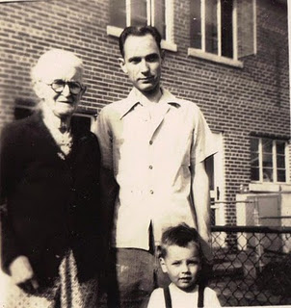

And as did millions of young American families, the Hollimans moved to the suburbs - Trussville, Alabama a few miles north of Irondale in 1950. Below, Bishop's family in 1951 - a two-bedroom, one bath home now on the Historical Register in Trussville. The house cost approximately $7,000, or about 7 times the price of a new Plymouth or Ford.

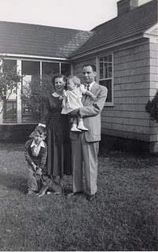

In 1951, Bishop Holliman made approximately $1,500 for teaching school. Over Christmas that year, he worked at the post office and bought the family a Motorola 17 inch, black and white television, for almost $200, a significant portion of his annual income!
The dog in the photo was named Sport, but he came down with mange, and in those days, the skin disease could not be cured. I remember the police came to the house, took the dog to the back yard behind the garage and shot him. Mother kept me inside.
Note: The information and opinions expressed in these family biographies are those of the writer alone. Comments, corrections and additions are most welcome. The purpose of these articles is to capture a period and family in American history and to pass this legacy along to future generations who share the common bond of family.
Plan now to attend the Holliman and Associated Families Genealogical Round Table at the Fayette County, Alabama Civic Center, 10 am to 3 pm, Saturday, October 15, 2011. For information and reservations for lunch, contact Glenda Norris at gnorris@bcbsal.org or Glenn Holliman at Glennhistory@gmail.com. Sessions to include Tracing the Holymans from England to Alabam

Ulyss and Pearl Caine Holliman and their Descendants
by Glenn N. Holliman

Homer Bishop Holliman, 1919
the Fifth Child of Ulyss and Pearl Caine Holliman

Of the four sons of Ulyss and Pearl, all left Irondale, Alabama for career reasons, although Euhal moved back to Birmingham from near by Gadsden, Alabama in 1955. In that generation, we see the diaspora of the Holliman sons. In the generation of their children and their sisters's children, of the 18 cousins living, only five remain in the Birmingham area at this writing (Charles Ferrell, Mary Herrin, Patti Holliman Hairston, Jean Holliman and Tommie Holliman Allen).

Granted, earlier generations of Holliman children had moved across the country from Virginia to North Carolina to Alabama (by 1836), and others then on to Texas, Arkansas and Missouri, but the 18th and 19th Century Hollimans had been looking for land to farm - new fresh, unworked soil lying fallow waiting for the plow. There were no new farmers of the children and grand children of Ulyss and Pearl Holliman. Beginning with Ulyss's generation and his brothers, one observes the increasing diversity of American occupations as society and industry grew more complex.
The below photograph of Bishop and Gerry Stansbery Holliman was taken in 1958 in W. Columbia, South Carolina, one of the many homes of the family as Bishop climbed a career ladder. The three children are left to right: Becky Holliman Payne, Alice Holliman Murphy and Glenn Holliman. When this picture was taken all commercial air travel in America was by propeller and there were no Interstate Highways. With the exception of small Volkswagens and Fiats, almost all automobiles sold in America were made in Detroit, Michigan. The rent on the three bedroom house behind us was $80 a month, heated with oil, and cooled with one small window air conditioner.
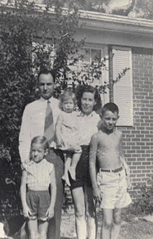

Bishop left school teaching in January 1952 to take a position with the Social Security Administration, a government retirement and disability program born in the New Deal year of 1935. So in the summer of 1952 Bishop moved his family from the Irondale area (where he thought he would spend his life) to East Tennessee and later to other southern towns as he climbed the managerial ladder. By 1964, he alighted in Cookeville, Tennessee as manager of the office there. It was a good fit. There was a university (Tennessee Tech) where his three children went to college and met their spouses. Gerry and Bishop became the mainstay of the local Methodist Church, and both were active in community organizations. Bishop served as head of the United Way, Rotary Club and Red Cross during the 1960s and 1970s.
In 1990, Bishop married Anne McGauphlin of Hartsville, South Carolina, whom he had first met in 1940 when both attended Methodist youth fellowships in Lake Junaluska, North Carolina. Unfortunately, Anne died of cancer in 1999. Left to right are Glenn, Bishop, Anne, Alice and Becky. Click on photos to enlarge.
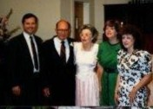

In January 1983, he retired from his federal work. The year 1988 saw the dissolving of his war time marriage (not the first or last marriage to do so). His former Methodist youth friend, Anne McGaughlin of Hartsville, South Carolina became his new bride in 1990. Their marriage was happy until her death due to cancer in 1998. In 2000, he looked up a widow he had known in earlier decades in Gadsden, Alabama. Before the year was out, Ellen Cox became the new Mrs. Holliman. They live today near her family in Avila, Indiana. My father continues to astound us!

In 2002, Virginia Holliman Cornelius, Bishop's only surviving sister, celebrated her 80th birthday. Left to right are Virginia, her daughter, Carol Cornelius Morton, Bishop and wife, Ellen Cox Holliman.
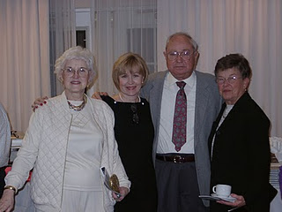

Ulyss and Pearl Caine Holliman and their Descendants
by Glenn N. Holliman

Virginia Ruth Holliman Cornelius, 1922
the Sixth Child of Ulyss and Pearl Caine Holliman

Born in Irondale, Alabama, my Aunt Virginia was the third and last daughter of my grandparents. Below in 1923 is baby Virginia on the left in the hat, with an unnamed baby on the right.
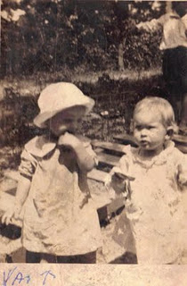
Below is a fantastic photograph from cousin Charles Halford Ferrell of four of the Holliman siblings from 1928. Left to right is Virginia, Ralph in the wheel barrel, and his two oldest sisters, Loudelle and Vena, who are both in bib overalls! Notice the car with the canvas top in the background.
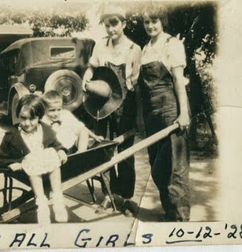

Below in the middle 1930s, Virginia is supervising young Mary Daly Herrin's dip in the Gulf of Mexico. Robert Daly took his extended family every summer to Florida to enjoy sun and sand. Paved roads and more reliable automobiles made middle class vacations possible by the third decade of the 20th Century. As with her brother Ralph and Bishop, Virginia attended and graduated from Shades-Cahaba High School. As with the rest of the family World War II would change her world forever.

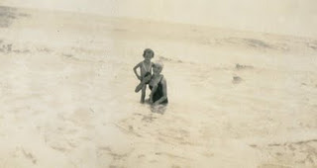

More Next Post on the sixth Child of Ulyss and Pearl Caine Holliman....

The information and opinions expressed in these family biographies are those of the writer alone. Comments, corrections and additions are most welcome. The purpose of these articles is to capture a period and family in American history and to pass this legacy along to future generations who share the common bond of family.
Plan now to attend the Holliman and Associated Families Genealogical Round Table at the Fayette County, Alabama Civic Center, 10 am to 3 pm, Saturday, October 15, 2011. For information and reservations for lunch, contact Glenda Norris at gnorris@bcbsal.org or Glenn Holliman at Glennhistory@gmail.com. Sessions to include Tracing the Holymans from England to Alabama, Holliman Farm Sites in

Ulyss and Pearl Caine Holliman and their Descendants
by Glenn N. Holliman
Virginia Ruth Holliman Cornelius, 1922
the Sixth Child of Ulyss and Pearl Caine Holliman
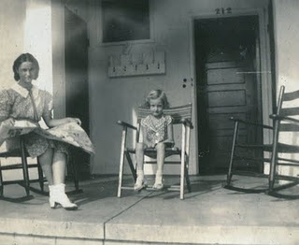
In 1937, Robert Daly rented a house in Miami, Florida for his summer vacation in the Sunshine state. As usual his sister-in-law Virginia went along to help supervise Mary Herrin, now six years old. Here the two sit on a porch. Note Virginia's dress and shoes.
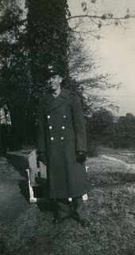
And the war came....Virginia met a gregarious young student while in high school, Walter Cornelius. He later attended Howard College (now Samford University) in Woodlawn. By late January 1942, they were married, and by 1943, Walter (above) was in uniform. Here he is in the yard between the Holliman and Daly houses in Irondale, a lawn where countless photographs were taken from the 1930s to the 1950s.
While Walter was in school in 1942 and 1943, Virginia began working in her brother-in-law's bank in Woodlawn. Robert Daly had lost several men to the draft by 1942, and Virginia started working, temporarily. Little did she know it would be a life-time career, and she would pioneer women in Alabama banking.
After World War II, Walter returned home from the Pacific, finished law school and began a career at an attorney. For Virginia and Walter, two girls were soon born - Nancy Carol Cornelius Morton(1945) and Susan Cornelius Williams (1949).
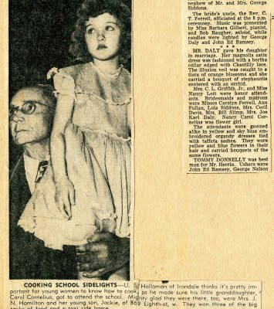
The above clipping ran in 1950 in the Birmingham News. It shows, of all things, Ulyss Holliman with Carol Cornelius, five years old, at a cooking school in downtown Birmingham. Forgive this grandson of Ulyss, but it is difficult for me one to fathom my grandfather attending a cooking demonstration and second, taking a grandchild with him! On the right of the clipping is a portion of Mary Daly and E.C. Herrin's 1951 wedding article. My thanks to cousin Mary for the loan of the article which I scanned into my computer.
More on the sixth child of Ulyss and Pearl Caine Holliman in the next post....

Ulyss and Pearl Caine Holliman and their Descendants
by Glenn N. Holliman
Virginia Ruth Holliman Cornelius, 1922
the Sixth Child of Ulyss and Pearl Caine Holliman

Below is a charming 1959 Christmas card of Carol and Susan Cornelius at their home in Homewood, Alabama. Both girls now live in Texas with their own families and grandchildren.
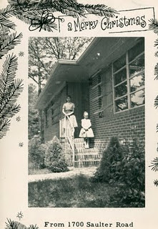

On Virginia's 80th birthday in 2002, her daughters prepared a lovely multi-page biography of their Mother. I can't improve on it, so I reproduce it here with their permission. Just click on the pages and it will enlarge for reading purposes.

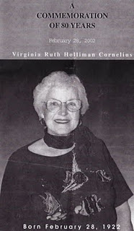

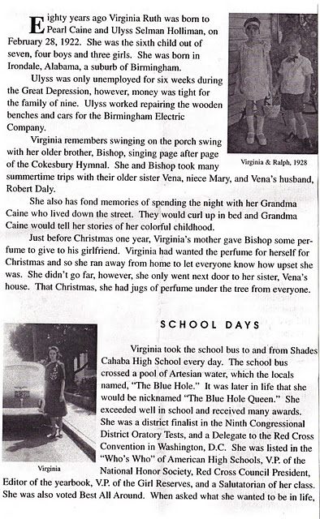
Here is a photo from the 2002 birthday party when this biography was presented.Left to right, Motie Holliman, who has passed away, Ralph Holliman, Virginia, Bishop Holliman and Bishop's wife, Ellen Cox Holliman. Ralph is in the insert picture in the biography above.

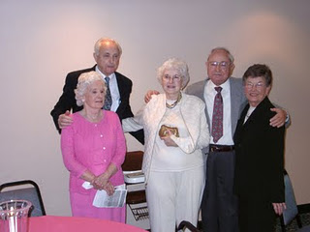

More of her printed biography in the next post....
Note: The information and opinions expressed in these family biographies are those of the writer alone. Comments, corrections and additions are most welcome. The purpose of these articles is to capture a period and family in American history and to pass this legacy along to future generations who share the common bond of family.
Plan now to attend the Holliman and Associated Families Genealogical Round Table at the Fayette County, Alabama Civic Center, 10 am to 3 pm, Saturday, October 15, 2011. For information and reservations for lunch, contact Glenda Norris at gnorris@bcbsal.org or Glenn Holliman at Glennhistory@gmail.com. Sessions to include Tracing the Holymans from England to Alabama, Holliman Farm Sites in Fayette County and sharing of information on Associated Families. All invited All invited, including the Holliman social at the Rose House Inn, Fayette, 5:30 pm to 9 pm, Friday, October 14th.

Ulyss and Pearl Caine Holliman and their Descendants
by Glenn N. Holliman
Virginia Ruth Holliman Cornelius, 1922
the Sixth Child of Ulyss and Pearl Caine Holliman
We continue to post the 2002 biography of Virginia as prepared by her family.
Continued from the previous posting...
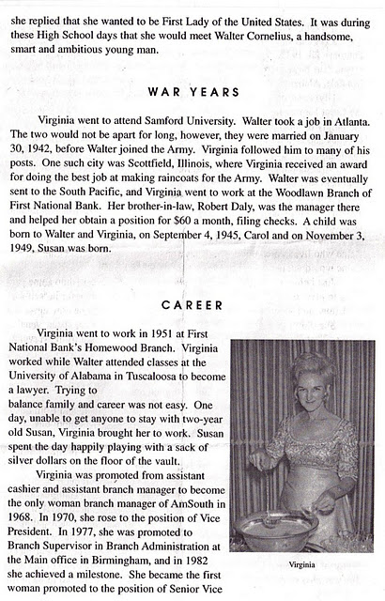
Below, in 1970, Virginia, right, visits with her sister, Loudelle Holliman Ferrell.
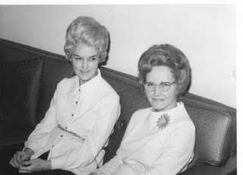
Photo by Glenn Holliman at Mary and E.C. Herrin's, Irondale, Alabama
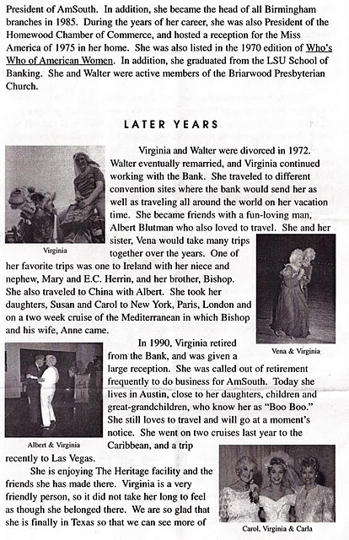

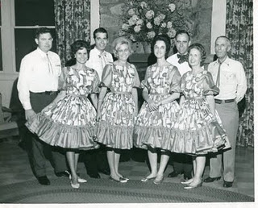
Virginia and Walter, second from right, in happy days in the 1960s.
More Next Posting on this pioneer in Alabama business....
Note: The information and opinions expressed in these family biographies are those of the writer alone. Comments, corrections and additions are most welcome. The purpose of these articles is to capture a period and family in American history and to pass this legacy along to future generations who share the common bond of family.

Ulyss and Pearl Caine Holliman and their Descendants
by Glenn N. Holliman
Virginia Ruth Holliman Cornelius, 1922
the Sixth Child of Ulyss and Pearl Caine Holliman

We continue from the previous post with the printed biography of my Aunt Virginia Holliman Cornelius, a pioneer for women in Alabama banking. Virginia lives today in Austin, Texas near her children.
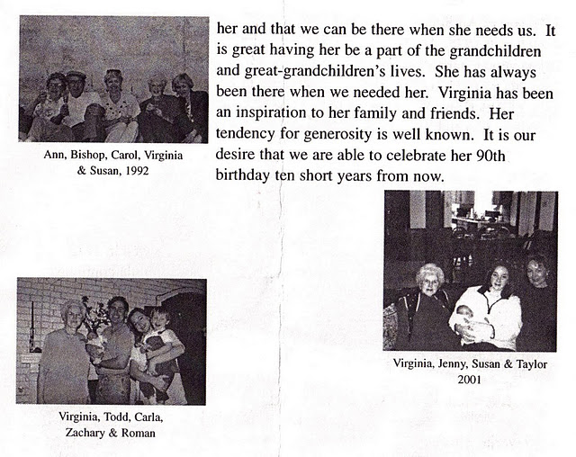

Below, Vena, Ralph, Virginia and Bishop, four brothers and sisters in 1978 in Birmingham, Alabama.
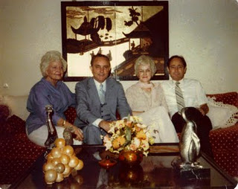

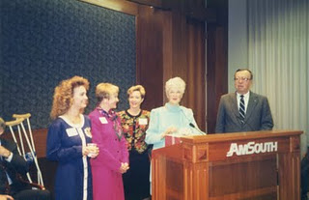
Above, grand daughter, Carla Schesta, Carol Cornelius Morton, Susan Cornelius Williams, Virginia, and an Am South executive at her retirement in 1990 in Birmingham, Alabama. The clippings from Am South through the years describing Virginia's career have been many.
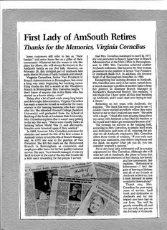
Below, the immediate family as of 2002 of Virginia.
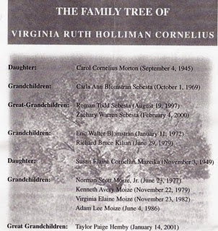

Next posting, before featuring the seventh child of Ulyss and Pearl Caine Holliman, we shall detour to the 1930s for a nostalgic look of summer vacations by Bishop Holliman, the fifth child.
Note: The information and opinions expressed in these family biographies are those of the writer alone. Comments, corrections and additions are most welcome. The purpose of these articles is to capture a period and family in American history and to pass this legacy along to future generations who share the common bond of family.
Posted by Glenn N. Holliman at 6:35 AM

Ulyss and Pearl Caine Holliman and their Descendants
Earlier this year, 91 year old Bishop Holliman, the fifth child of Ulyss and Pearl Caine Holliman, penned some nostalgic memories of vacationing with his family in Florida in the middle 1930s. My father mailed copies to numerous of my cousins, but with his permission, I place his words in this space in order to reach a larger audience. Glenn N. Holliman
The Golden Summers of the 1930s, Part I
by H. Bishop Holliman 2011
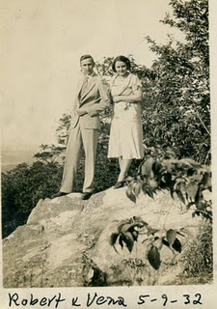
Introduction -
"Several years ago, my great nephew, Clayton Herrin, suggested I
write a few words about trips my sibilings and I made to Florida with Clayton's mother, Mary Daly Herrin, and his grandparents,
Robert W. and Vena Holliman Daly in the 1930s. He said he had heard us talk about those times, and he thought it would be good to put in writing that period of history for the benefit of his generation
and those that follow. So that is what I have done - probably more than anyone wants to read. But I have included many other bits of history about the family and events of those years that I think are worth recording. Good reading!"
Above are Robert and Vena Daly, somewhere on a trip other than Florida, and most formally dressed for an outing. In May 1932, Herbert Hoover was in the White House and the Depression was nearing its nadir. The Democrats that summer were about to nominate the governor of New York, Franklin D. Roosevelt, as their presidential candidate. History was about to turn again. GNH
"In the summer of 1934, I was 14 years old and had graduated from the 9th grade at Irondale school. My sister, Virginia was 12, and Ralph, my youngest brother, was 10. Both siblings Euhal and Loudelle were still living at home. My oldest brother, Melton, had been married for two years, and Vena for six. Melton worked in the drug store at Five Points in Birmingham, filling prescriptions; Loudelle at Woolworths and Euhal for Hill Grocery Company. Vena, Robert and their new daughter, Mary, lived next door to us, the Ulyss and Pearl Caine Holliman house, 2300 3rd Avenue on the hill in Irondale, Alabama. Robert had built two brick houses in the early 1930s, and lived in the one closest to our home Daddy had constructed in 1921.
Daddy (Ulyss S. Holliman) worked at the street car company (Birmingham Electric Company) full time, having lost only six weeks of work during the Great Depression in the summer of 1933. Robert was manager of the Woodlawn Bank, a branch of the First National in Birmingham.
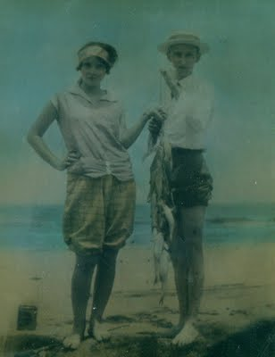
This wonderful 1928 picture of young Vena and Robert showing off their catch of the day was taken in Miami on their honeymoon. The photo hangs in their daughter's home in Irondale, Alabama. There is a startling resemblance between young Robert Sr. and son, Robert Daly, Jr. Vena, all of age 19, is looking very coquettish in the picture. GNH
Vena and Robert had married in June 1928 at the Irondale Methodist Church, and went to Miami on their honeymoon, driving a four-door black Dodge automobile. This was the first of many long trips they would take during the next thirty or so years. Before the start of the next summer - 1929 - Robert had traded for a used Packard roadster with a rumble seat, and they drove to Mammoth Cave, Kentucky and over to the Indian Reservation in North Carolina.
I mention these little incidents to point out that in 1929 and on through the 1930s, during the Depression years, not many people, in fact, only a very few people in Irondale, could afford the luxury of driving Packard automobiles, or taking a vacation. Or enjoying the semblance of a comfortable life like taking long automobile trips without worrying about their next meal.
Fate had smiled kindly on Robert and Vena, and, fortunately for Virginia, Ralph and me, we shared in their good fortune! Not only did they share their goods with we three youngest children, but also with the entire family. Robert had been in the family as long as we could remember. He gave us gifts at Christmas even before they were married, and he continued to shower us with love and affection and presents as long as he lived. I don't know how or why he and Vena put up with us as they did - not only with we three youngest only, but with all the family as needs and opportunities arose."
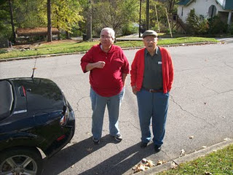
Clayton Herrin, left , who asked his great uncle, Bishop Holliman, right, to prepare some comments on the Dalys and Hollimans in the 1930s. Here the two stand in front of the Ulyss and Pearl Caine Holliman home at 2300 3rd Avenue, Irondale, Alabama in November 2010. In 1956 with their children, Euhal and Edna Holliman moved into the house and lived in it to their passing.

Ulyss and Pearl Caine Holliman and their Descendants
The Golden Summers of the 1930s, Part II
by H. Bishop Holliman 2011
"In the summer of 1929, Daddy (Ulyss Holliman 1884 - 1965) bought an electric cook stove, a rare appliance for that time and place. Up until then Mama (Pearl Caine Holliman 1888 - 1955) had had to cook on a coal stove, which, of course, was an unbearable thing in the summer. But not many folks in Irondale, Alabama enjoyed the luxury of such a thing at that time.
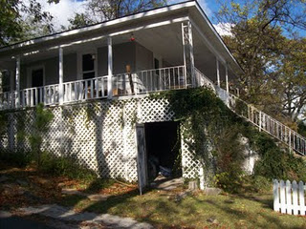
Left, a side view of the Ulyss Holliman house at 2300 3rd Avenue, Irondale, Alabama. Constructed in 1921, the home had six rooms and no indoor plumbing facilities until 1938. This photo was taken in November 2010.
I remember this event so well because the stove was installed while Vena and Robert were on their trip to Kentucky and North Carolina. They took Euhal (1912 - 1989) with them on this trip. He was 17 years old, and I remember his saying when he returned that he sat in the rumble seat and waved to the girls they passed along the way! So Euhal was the first of the family to enjoy a long auto trip with the Dalys. Our time - and Loudelle's - would come later.
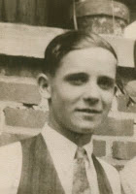
Above Euhal Holliman, ca 1935
By the summer of 1930, the Great Depression was in full sway, though I was too young to understand the implications of any of it. I thought folks had always been unemployed. The freight trains that came through Irondale, which we could plainly see from our front porch, had always carried hobos as far as I knew, so I was not impressed one way or the other by the evidence around me. If Daddy had been out of a job, as so many of our acquaintances were, I am sure I would have been more aware of what was happening.
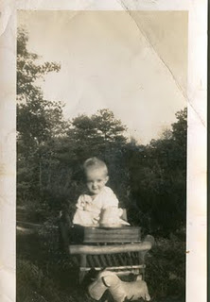
.
Mary Daly was born in June 1931, so they did not go anywhere that summer. At that time, 1931, they were living in the 2nd brick house (the one next to the woods) on our block. I remember Bill Fortenberry on the afternoon of June 15, 1931, who worked for his brother Ed in the local grocery store, saying to me that I was now an 'uncle'. I thought that made me more mature than I was!
Right, Mary Daly Herrin in Irondale, 1932.
I guess the summer of 1932 was much like the previous summer. The Depression had deepened, and the thought of taking along trip was incomprehensible to most folks. Daddy was still working, and Euhal and Loudelle were working off and on. Radio was a fairly new kid on the block, even though Daddy had bought a Zenith in 1928 for the prodigious sum of $219, a huge amount in those days.
I remember Mama let me stay home from school in 1929 to listen to Herbert Hoover's presidential inauguration. In 1932 we listened to the Democratic Convention and heard the band playing over and over 'Happy Days are Here Again.'
The radio, along with the electric stove, made us among the first folks in Irondale to claim ownership of such modern conveniences."
Next more memories of the 1930s....
Posted by Glenn N. Holliman at 4:42 AM
Email ThisBlogThis!Share to TwitterShare to Facebook

Saturday, October 15, 2011

Ulyss and Pearl Caine Holliman and their Descendants
by Glenn N. Holliman
The Golden Summers of the 1930s, Part III
by H. Bishop Holliman 2011
"In the summer of 1933 many of FDR's programs were being developed and there was lots of news about the new President and what was happening in Washington. That summer I spent reading the 8th grade history book because I had been double-promoted from the 7th grade to the 9th. Mr. Millsap, the principal, had told me to study that book over the summer, so I did. In September 1933, I entered the 9th grade.
Below in Irondale, Alabama in 1934 are left, Ida Hughes Holliman, wife of Melton, and Loudelle Holliman. In 1935, Loudelle would marry an up and coming young Methodist minister, Charles Ferrell.
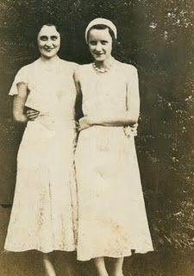
Loudelle was working at F.W. Woolworth Ten Cent Store on 3rd Avenue and 19th Street in Birmingham. She worked six days a week and made, I think, seven dollars a week! Her car fare was 14 cents day. I don't know what she did for lunch. Euhal was working in Hill's grocery store in East Lake, but I do not know how much he was paid.
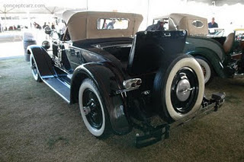
Right, a restored 1926 Packard with rumble seat the type in which Euhal Holliman enjoyed riding when Robert and Vena Holliman Daly took him for a long vacation ride!
By that summer, Robert Daly had sold his Packard Roadster and bought a Model A Ford from Cecil Bunt, who lived on the same street up on the hill. I never did know why he sold the Packard, or felt the need to move down to a lower level. That was not for me to know. The two-door Ford was probably a 1931 model.
Also in 1933, there came into Robert and Vena's life, and also into our family's lives, The Rev. Stewart Button, the new Presbyterian preacher in Irondale, one who was to impact our lives for many years.
Below, Irondale neighbor, Charles Pugh, Bishop Holliman and Stewart Button in front of the Holliman home at 2300 3rd Avenue, ca 1939.
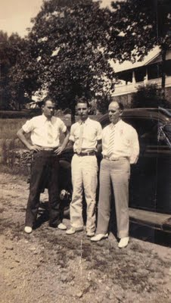
Mr. Button, or 'Button' as Robert Daly called him, was a native of Ireland and had come to the States in the late 1920s, attended Maryville College in Tennessee, a Presbyterian institute. A well educated man, he was about the same age as Robert but as yet unmarried. Robert and Vena took him under their wings, and from then on Mr. Button was like one of the family.
He was in and out of their house constantly, socialized with them and shared many hours of pleasant conversations. Maybe it was the Irish connection that tied them together. Anyway, he became a big part of their lives as long as they lived. Also, he had a great influence on my life as well."
Next, a Return again to the 1930s....
Posted by Glenn N. Holliman at 7:56 AM

Ulyss and Pearl Caine Holliman and their Descendants
The Golden Summers of the 1930s, Part IV
by H. Bishop Holliman 2011
"In the summer of 1933, the Robert Dalys, The Rev. Stewart Button and the Model A Ford all got together, left Irondale, Alabama and went to the Century of Progress (the World's fair ) in Chicago! Can you imagine anything more unusual than that!!! They left daughter Mary, now two years old, with Robert's sister, Lena and other Daly folks, on their farm, up above where Mary and E.C. Herrin live now (near the new Shades Valley High School in east Irondale).
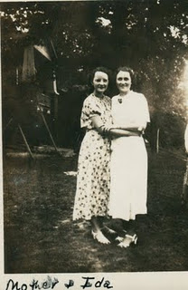
Right, Loudelle Holliman Ferrell and her sister-in-law Ida Holliman in front of the Daly house in Irondale, a new home built by Robert Daly in the early 1930s. The lawn on which Loudelle and Ida are standing was the shared lawn with the Ulyss Holliman home at 2300 3rd Avenue. Dozens of family photos were taken from the 1930s to 1990s at this site.
In addition, they took Loudelle with them! I guess they were gone a week. They must have been on the road a night each way, going and coming. I am sure Robert paid all the expenses for gas and overnight lodging. Maybe Mr. Button paid his hotel bill. Loudelle would not have had any money, and she lost a week's wages because there was no vacation time nor sick leave for hardly any one at that time, and surely not for ten cent store clerks. But this was Loudelle's time to travel with the Dalys!
To say that your relatives had gone to the World's Fair elevated in little Irondale, Alabama our prestige no end - even more so than riding in the rumble seat of the Packard! None of us knew of anyone else who had gone to Chicago, and certainly not to the Fair. It gave us a lot to talk about. Vena and Robert always brought souvenirs back to Virginia, Ralph and me, but I can't recall now what they brought this time. Loudelle picked up lots of pamphlets with coupons to order stuff, and I got on many mailing lists. Below, Vena Holliman Daly in 1934.
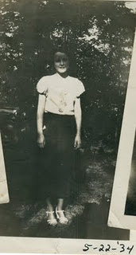
An interesting side bar - to add luster to this 1933 safari, the next summer, 1934, the noted gangster, John Dillenger, was shot and killed by FBI agents outside a Chicago theater. The four from Irondale like to claim that the hotel where they stayed the summer before was just a few blocks from where the Enemy No. One was gunned down! That gave them something to talk about (aside from being asked several times if they saw Sally Rand)!"
More exciting Irondale adventures in next post....

Ulyss and Pearl Caine Holliman and their Descendants
The Golden Summers of the 1930s, Part V
by H. Bishop Holliman 2011
Below, Virginia Holliman Cornelius, Mary Daly Herrin, Vena Holliman Daly, Robert W. Daly, Sr. and H. Bishop Holliman at Fort Walden, Florida, 1934. Stewart Button must have taken the picture.
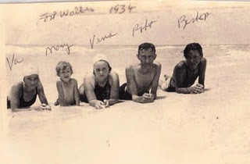
"I have never known why Vena and Robert felt it appropriate to take me along on their trip to Florida in 1934, the first of my 'three Golden Summers'. I can understand why they took Virginia along - Mary was just three years old, so Virginia was needed to baby sit her. But there was no earthly reason why they let me tag along, except out of the goodness of their hearts. Also, Mr. Button was included in this, the first of their many escapades to Florida. I don't recall any conversations that led up to the decision to take me with them.
Almost 5 million Model A Fords were built between 1927 and 1931. As Henry Ford said, one could have it in any color one wanted, as long as it was black! This is a plush model. The 1934 Daly car was more prosaic! GNH
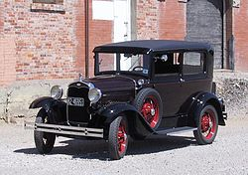
We left Irondale, Alabama on a Monday morning in July at about 3 am, riding in the Model A Ford. I have always remembered how exciting it was to be awakened that early and to head off to Florida, the first time I was to be out of Alabama and to view the ocean. So six of us - three adults, two young teenagers and one three year old - were stacked in the two door car. Our suit cases were slung over the hood on each side and may have even been tied to the fender opposite the driver's side. Remember...there was no such thing as air conditioning, no radio and no trunk to store luggage. Only two-lane roads, no fancy rest stops and very few eating places along the way. By today's standards it was murder! But we did not know any better. We were headed to Florida, and besides, gas was no more than 20 cents a gallon.
Our first stop was in Clanton, Alabama where we had breakfast at the Dixie Cafe on the main street. The cost was $2.50 for the six of us....ham and eggs and all the trimmings. I guess Robert paid for Mr. Button's share. Virginia and I had no money at all. I thought the price of our meal was astronomical, and I recall writing back home and telling Mama and Daddy how much we had already spent. We stopped in Dothan, Alabama to visit a Daly cousin, and we may have had lunch there.
I remember Virginia and I always wanting to visit places we had read about in our Alabama geography and history books, but the adults did not cotton to that idea so we never stopped. Our goal was to reach Panama City. We may have spent the night at a 'tourist court', reaching the ocean the next day; I am not sure now.
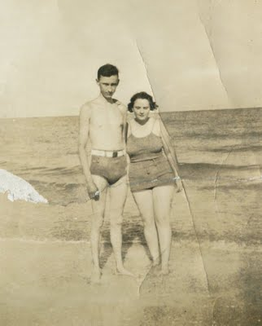
Young Robert Daly and wife, Vena, enjoy the beach in Florida. Their kindness opened up a larger view of the world to younger brothers and sister.
Whatever the day was, I remember how 'awed' I was when I first cast my eyes on the huge body of water that was Panama City Bay. I guess I had seen Lake Purdy, but it was not like that at all! The next day, I was even more 'awed', when we reached the beach at Fort Walton, Florida, a fairly new resort west toward Pensacola. There we settled for the next twelve days in a one-bath cabin, an oil cook stove, no radio. Air conditioning had not been heard of nor television. There were no near-by eating places, no movie houses nor other entertainment. But we were in Florida, and the beach was a couple of miles away, over the bridge that connected the town to the beach, and we thought it was pretty nice."
Next posting, more amazing adventures of a small town American family in the 1930s....
Posted by Glenn N. Holliman at 1:39 AM

Ulyss and Pearl Caine Holliman and their Descendants
The Golden Summers of the 1930s, Part VI
by H. Bishop Holliman 2011
The Summer of 1934 continued...
"Vena and Robert Daly did all the cooking, cleaning and whatever else had to be done. Looking back now from this distance, you have to wonder how they could have endured such a life style, even just for two weeks. Imagine, sharing the bath with a non relative, cooking for all of us all the time, hot humid weather and no attractions other than the beach and the fishing pier! I don't know how they did it but they did!
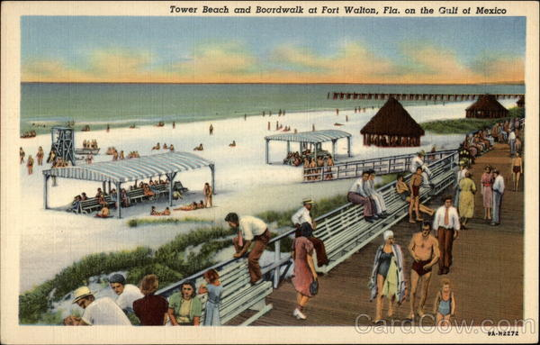
Above, Fort Waldon Beach, Florida in the late 1930s or early 1940s when a boardwalk and pier were the attractions, plus of course a beautiful beach and the Gulf of Mexico.
As far as I know, we all got along fine. Virginia and I did as we were told, and I never heard a cross word between Vena, Robert and Mr. Button. We had a nice little cabin (in the terminology of the times). I don't recall the number of bedrooms or other amenities and I have no idea how much it cost - very little, I am sure by today's standards. After our first night's rest, Mary said she slept on a log. We thought that was funny and I wrote home and told them about it!
The luxury cabin of the Daly's and Hollimans in the middle 1930s!
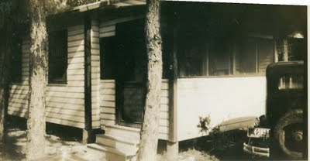
Most of our time at Fort Walton was spent in fishing, and I guess we went in the surf everyday also. The bridge across the bay to the beach was our fishing perch, and we caught more fish than I thought were in the ocean. Fish of all kinds - one afternoon Robert reeled in a stingray, something we had never heard of and we learned it was very poisonous. All of us were captivated by our catch each day, and Robert arranged to 'pickle' some of them in formaldehyde in jars and bring them back home to show off his piscatorial ability. He drove over to Pensacola to get the pickle juice and bottles. For many years after, his pickled fish were stored in his garage up on the Irondale hill. They were still there when I went into the Navy in November 1941.
Mary Daly Herrin and her baby sitter and Virginia Holliman Cornelius in Florida.
Such was our first trip to Florida - 1934. We arrived home on a Saturday afternoon, having been gone about 13 days. I remember being startled by how much the grass and the garden had grown during our absence. I am sure we all went to church the next day because we would have wanted to tell everyone we had been to Florida, how many fish we caught, and to show off our tans! We made several pictures - that are still in existence of our beach escapade of 1934. One of Robert fishing in the surf I thought was so good I sent it to the Birmingham News, but they never saw fit to print it."
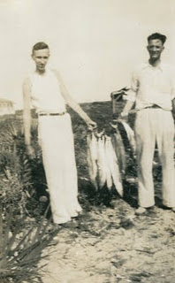
A fine day's worth of Florida fishing - Robert Daly and Stewart Button
Another Golden Summer in the next post....
Posted by Glenn N. Holliman at 1:13 AM

Ulyss and Pearl Caine Holliman and their Descendants
The Golden Summers of the 1930s, Part VII
by H. Bishop Holliman 2011
The Summer of 1935....
"I had completed my first year of high school at Shades Cahaba and would be 16 the coming December. Still too young to get a job, even if one had been available and even if I had been so inclined to pursue it! Robert always had yard work to do and he gave us loose change...which he always had...for Saturday afternoon chores. Also, one winter I earned some pennies for starting the fire each Sunday in the heater in the Presbyterian church....not enough to pay my way to Florida however.
When the summer of 1935 rolled around, the Dalys began to talk of another trip to the beach, and I guess Virginia and I pressured them to include us in their plans, though I do not remember any of that now. Mr. Button evidently was included also in the planning because he, along with Virginia and me, were in the Model A Ford on a Monday morning in August when we set out again for Florida.
Robert had received some brochures from the Mississippi Gulf that attracted him to that area. Also, Loudelle and Charles had spent their honeymoon at the "The Whitehouse", a luxury hotel in Biloxi in June, so maybe that helped lure him there instead of Florida.
Our first stop was in Tuscaloosa to chat with Glenn Barrow, the young principal of Irondale school was was attending classes there, working on another degree. He met us on the corner of the main street of the University and we talked for about 30 minutes. We felt bad that he had to attend classes and were going on a beach holiday. But such was life. He was a fine man, and we were glad to spend time with him.
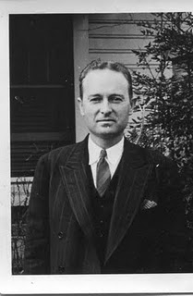
Glenn Barrow, right, served as a teacher and principal. After his death, during the war, Bishop Holliman named his first child in 1946 after this thoughtful educator.
We went on to Mississippi, arriving in Gulf Port about sun down, and were we ever disappointed! We saw immediately that the beaches along that coast did not measure up to those at Fort Walton and other Florida beaches. We spent the night there, but the next morning all of us agreed that we had rather go back to Fort Walton even if it ate up another day of our vacation. So, east went, along the Gulf Coast, through Mobile and Pensacola arriving late that afternoon in Fort Walton, in a cabin close to where were the previous summer. We felt at home there, and content to be back there for the next 10 to 12 days.
Our facilities and daily activities were much like those of the previous summer. Vena and Robert did the cooking. Mr. Button was a 'fun' person, and I guess he helped with dish washing, maybe. Virginia continued to look after Mary, and to this day, I can't think of anything I did except act as a good fishing buddy and surf swimmer. However it was not long before we had company!
Mary Daly Herrin on the beach in Florida.
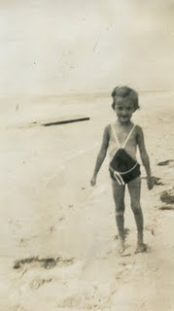
The 1935 tourist court or cabins would not, perhaps, be enticing to the 21st Century generation of Hollimans, Dalys, Herrins, Corneliuses and Ferrells!
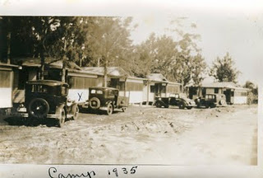
Over the past year we had done such a good job talking up the pleasures of a beach vacation....so much so that Mama and Daddy (Pearl Caine and Ulyss Holliman) decided to join us at Fort Walton for a few days. I don't know how they managed to pull it off...I am sure Daddy had to suffer a loss of wages for a week...but they did it! I have forgotten how long they stayed...less than a week. They brought with them my brothers, Ralph and Euhal and Euhal's girl friend, Anna Grace Bagley. They found a cabin near us and we all enjoyed a few days of fishing and surfing. All of us got along fine. This was Daddy's first real vacation and their first time ever to splurge. Daddy, born 1884 in Fayette, Alabama, was 51 that summer.
Below, Stewart Button and young Bishop Holliman survey their 'catches of the day' at Fort Walton, Florida.
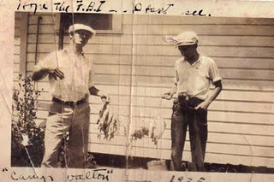
We returned home from Fort Walton on a Saturday in August, the other members having been back for several days. Our stay at the beach had been uneventful after their departure...lots of fishing and swimming. This may seem a mundane thing to mention now, but I remember our lunch on the way back was a sandwich shop in south Alabama. The sandwiches were 20 cents each...a humongous sum, we thought!"
Next posting, the Great Storm of 1936....

Ulyss and Pearl Caine Holliman and their Descendants
The Golden Summers of the 1930s, Part VIII
by H. Bishop Holliman 2011

The Summer of 1936 and the Great Storm....
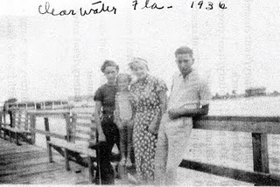
Above along a pier in Clearwater, Florida, 1936, left to right, Virginia Holliman Cornelius, Mary Daly Herrin, Vena Holliman Daly and Bishop Holliman.
"I don't recall now how our 1936 trip came about. Stewart Button had taken a church in Knoxville, Tennessee earlier in the year, but Virginia and I were still available. Ralph, I guess, was still considered too young to go. I would enter my last year of high school that fall, so this would be my last hurrah. That year we went further south, all the way to Clearwater, Florida and points in between. Robert had now acquired a new 1936 black two-door Plymouth, so now we would be travelling in style.
Below a restored 1936 four door Plymouth touring car.
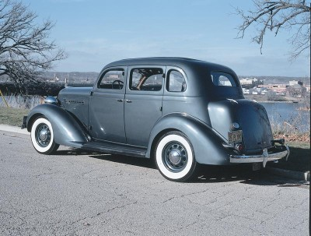
In Clearwater, we did not find the beach as white and sandy as those at Fort Walton and Panama City, so that took some of the shine off our stay there. Instead of a 'tourist cabin', we found a fully furnished home used mainly in the winter by a wealthy owner, so that made our stay more enjoyable. It was a few blocks from the beach and backed up to the bay. I have no idea what the rent was, but I am sure more than we had paid at Fort Walton. One day we drove down to Sarasota and over to St. Petersburg, and another time Robert rented a small boat and he and I went out into the bay to fish and got caught in a squall that came up quickly. We had left Vena, Mary and Virginia home to worry about us.
It had been planned early on that Mama, Daddy and Ralph would drive down to Panama City Beach during our two week stay. Soon Melton and Ida Holliman decided to join them, along with Ida's nephew, Earl Burton. Also, accompanying Mama, Daddy and Ralph would be Hoyt and Vivian Bryant, close family friends of Melton's age, who had lived next door in years past. After a week at Clearwater, we decided we would join them, so we drove up to Panama City, found a cabin where they were and settled down, we thought, for a fun time with friends and family. On the way, we stopped at a resort similar to Silver Springs called Waukulla Springs and took a boat ride."
Next the hurricane comes....
Posted by Glenn N. Holliman at 6:58 AM
Email ThisBlogThis!Share to TwitterShare to Facebook
Labels: Bishop Holliman, Mary Daly, Stewart Button, Vena Daly, Virginia Holliman Cornelius

0 comments:

Ulyss and Pearl Caine Holliman and their Descendants
The Passing of Virginia Holliman Cornelius, 1922 – 2011
by Glenn N. Holliman, a nephew

On November 3, 2011, after a long decline, my Aunt Virginia left this life in Austin, Texas. In the blog last summer (see older articles section), with the help of her daughters, Carol and Susan, we were able to share part of her story with the larger family. Her daughters had written and published a thoughtful biography of her on her 80th birthday in 2002, which they kindly let me reproduce.

Since the spring of 2011 with the writings of my father, Bishop Holliman, numerous cousins and family memorabilia and photographs, I have been preparing and posting articles on a generation of a Southern family that was deeply affected by the Great Depression and World War II.
Recently, I was able to visit and spend time with my surviving uncle, Ralph Holliman, now of Gulf Shores, Alabama. Later in this space, I will be sharing some of his story with his great nieces and nephews who have been born long after World War II and who will experience most of their lives in the 21st Century.
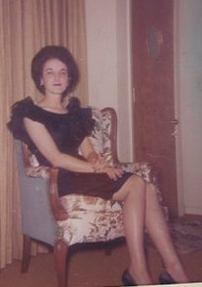
Virginia Holliman Cornelius, above, in 1964.

With the death of Virginia, my last aunt has passed away on my Father’s side of the family. Three girls were born to Ulyss and Pearl Caine Holliman, each unique and beautiful in different ways. Vena Holliman Daly Buckheit (1910 - 1990) married in 1928 to Robert Daly, Sr., a banker and fabulous mentor to Bishop, Virginia and Ralph Holliman during their growing up in Irondale, Alabama. Vena was full of grace and poise, dignified and soft spoken and a lovely Southern lady who brought charm and calm to the family.
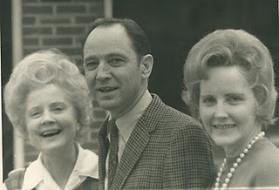
Above left Vena Holliman Daly Bucheit (1910 – 1990), Bishop Holliman (1919) and Loudelle Ferrell (1914 – 1996) at the 1970 Irondale, Alabama reunion.

Loudelle Holliman Ferrell (1914 – 1996), quiet, graceful, dignified, thoughtful, she married an up and coming Methodist minister, Charles H. Ferrell, in 1935. A graduate of Birmingham-Southern and Yale Divinity School, this well-educated man served as another strong role model for the three youngest Holliman children of that generation. By 1935, the two older brothers, Melton (1908 – 1958) and Euhal Holliman (1912 – 1989), had already married and left the parental home.
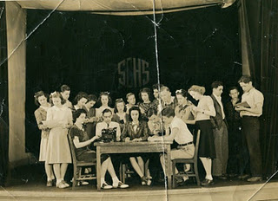
Above center is Virginia and to the left is her future husband, Walter Cornelius behind the type writer at Shades Cahaba High School. Third from the right may be Ralph Holliman, Virginia's younger brother.
At Shades Cahaba High School, Class of 1941, Virginia seems to have won every award and held every office possible. When one reviews The Owl, the school yearbook, she leaps out of many pages, sitting center in almost all the group photos, obviously the leader, the poised, already accomplished person readying to come of age in a world still dominated by the male gender.
In early winter of 1942, Virginia and Walter married at the home of Robert and Vena Daly in Irondale, Alabama. War interrupted that marriage, with Walter in 1943 entering the Army Air Corp and after training in the U.S., was stationed in Saipan. He was there as a ground crew person when the B-29 aircraft took off from nearby Tinian Island and dropped the atomic bombs that effectively ended the Pacific War.
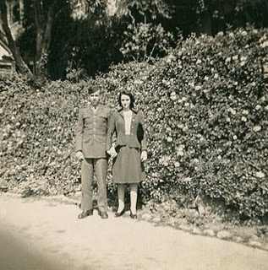
Virginia and Walter at one of his training stations in the United States before assignment to the Pacific.

During the War, Virginia took ‘temporary’ employment at her brother-in-law Robert Daly’s bank in Woodlawn, Alabama and remained in banking while giving birth in 1945 to Nancy Carol Cornelius Morton and in 1951 to Susan Cornelius Williams.
After the War using the G.I. Bill, Walter became an accomplished lawyer. Walter also was a talented guitar player and often led his own band. The couple would raise their daughters to maturity, before the war time marriage ended in divorce in the early 1970s. Walter died in 2006.
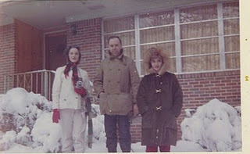
A rare, heavy snow in Birmingham in 1964 with Virginia, Walter and Carol Cornelius.
For Virginia, the employment opportunity of banking during World War II became a career, a pioneering enterprise for a woman of her generation. She broke many ‘glass ceilings’ in a male-dominated profession, and served as a role model for the females in her extended family and no doubt, a mentor for many in financial services. For this she was recognized in publications and by her peers.
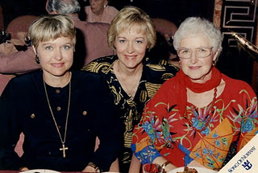
Three lovely ladies, above, Carol, Susan and their mother, Virginia on a 1990s cruise.
On November 20, 2011, members of her family gathered in Dallas, Texas to honor Virginia’s life and accomplishments. In spite of her tremendous career, I suspect she would say that her greatest accomplishments were the daughters, grandchildren and great grandchildren that gathered with other family members to celebrate a life well-lived.
For the record, I insert the Birmingham News obituary published November 7 and 8, 2011.
CORNELIUS, VIRGINIA H. Virginia H. Cornelius, of Birmingham, AL, passed from this life and into the presence of her Lord and Savior on 11/3/2011 at the age of 89. She was born in Irondale, AL, on 2/28/1922. Virginia graduated from Shades Cahaba High School and attended Samford University and LSU. She retired as Sr. VP of AmSouth Bank (now Regions Bank) and was the first woman to hold this position. Virginia is still remembered as the "First Lady of AmSouth". Her civic activities included: President Homewood Chamber of Commerce and Secretary for the Board of Trustees at Samford University. Virginia was published in the book, "You Too Can Be an Executive". Boo Boo, as her grandchildren called her, loved life and until she went into that "long goodbye of Alzheimer's", spent time with her family and friends, traveling, visiting, and babysitting her grandchildren. Virginia was preceded in death by her grandson, Eric Blomstran and five brothers and sisters. She will be remembered as a wonderful Christian woman who never hid her light and always strived to be the best in everything that she undertook. Virginia was and will continue to be a tremendous inspiration to all of us who had the wonderful privilege of knowing and loving her. She is survived her daughters, Carol C. Morton of San Antonio, TX, and Susan Williams of Cedar Park, TX, two brothers, 6 grandchildren and 8 great grandchildren. Virginia resided in San Antonio, TX, at the time of her death. The memorial service for her will be conducted at: Fellowship Bible Church, 9330 N. Central Expressway, Dallas, TX, at 4:00 p.m., November 20, 2011. RSVP to: (512) 626-3559 . In lieu of flowers, a tax deductible donation in memory of Virginia Cornelius may be made to one of the following: Barabbas Ministries, P.O. Box 461531, San Antonio, TX 78246-1531 or Fellowship Bible Church, 9330 N. Central Expressway, Dallas, TX 75231.

As one of seventeen first cousins of the seven children of Ulyss and Pearl Holliman, I marvel at the lives of my aunts and uncles. They were for our times “The Greatest Generation”. GNH

Comments, opinions and content are by the writer solely who welcomes critique and feedback from family members.

Posted by Glenn N. Holliman at 2:58 PM
Next the escape from the beach!

Posted by Glenn N. Holliman at 5:30 AM

Ulyss and Pearl Caine Holliman and their Descendants
The Golden Summers of the 1930s, Part X
by H. Bishop Holliman 2011

Off the Beach!
We resume our story told by Bishop Holliman as the Daly-Hollimans huddled, crowded, in their automobiles attempting to ride out the gathering storm of 1936 in Panama City, Florida.

In the photograph taken on another date, Robert W. Daly, Sr., leader of the Daly-Holliman vacations to Florida in the 1930s, walks the beach with his only daughter, Mary Daly Herrin. They look smartly dressed for beach-combing!
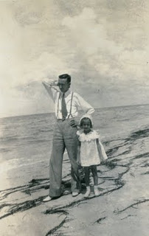
"Immediately, there was a tap on the car window and a man in uniform told us to leave the beach area at once, to drive inland, that the hurricane was ready to strike in full force, that we had to leave now! He spoke with great authority so we did not meander. Robert turned the car around and we headed out, lining up behind Daddy's car (Ulyss Holliman) and Melton's (Holliman), and away we all went!!
We headed inland as the man told us to do.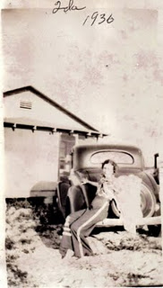
Ida Holliman, Melton Holliman's wife, perches on the Chevrolet coupe that drove part of the family off the beach in 1936.
Mama (Pearl Caine Holliman), Daddy, Ralph (Holliman, the younger brother), and Hoyt and Vivian Bryant were in Daddy's car, a 1933 four door Chevrolet with Holyt driving and leading the way. Right behind them drove Melton in a Chevrolet coupe, with Ida and Earl, and then came Robert, Vena (Holliman Daly), Mary, Virginia (Holliman Cornelius) and me, going we knew not where!
Just a few miles down the beach high way Daddy's car came to a complete stop! I guess all the excitement had caused it to flood out, as we say. Any way, it would not go any farther. What to do on a dark and stormy night, marooned on the side of the Gulf, trying to reach higher, safer and dryer ground? We did the only thing we could do. All those in Daddy's car piled into Robert's car with our party. That meant six adults, two teen-agers and a five year old. And off we went, leaving Daddy's car by itself, there next to the Gulf, at the mercy of the wind, the rain and ocean waves."
The 1933 Chevrolet of Ulyss Holliman stalled in the storm. Below is an advertisement for a two door version. Note the price and that the models are formally dressed, somewhat as were Robert and Mary Daly in the above photograph!
Next the road house of the refugees!
Posted by Glenn N. Holliman at 12:41 AM
Email ThisBlogThis!Share to TwitterShare to Facebook
Labels: Ida Hughes Holliman, Mary Daly Herrin, Robert Daly

0 comments:

December 31, 2011

Ulyss and Pearl Caine Holliman and their Descendants
The Golden Summers of the 1930s, Part XI
by H. Bishop Holliman 2011
From the web, a site entitled Storm Lifecycle - SOURCE: Wikipedia, 1936 Atlantic hurricane
"A tropical storm was first observed over the southern Bahamas on July 27. It tracked to the west-northwest, and made landfall a short distance south of Everglades City, Florida with winds of 60 mph (95 km/h). After crossing the state, it intensified over the eastern Gulf of Mexico and became a hurricane on July 30. The hurricane continued to strengthen, and hit the western Florida Panhandle with peak winds of 90 mph (145 km/h) on July 31. It weakened rapidly over land, and dissipated over western Alabama on August 1."
The story written by H. Bishop Holliman continues with the Robert Daly, Sr. and Ulyss and Melton Holliman cars carrying a frantic family, now terribly worried by a growing storm of water and wind and a 90 mile an hour hurricane as described in history above. - GNH
"Mama (Pearl Holliman, 1887 - 1955)), Daddy (Ulyss Holliman, 1884 - 1965)), Ralph (Holliman, 1924), Hoyt (Hughes, Ida Hughes Holliman's brother) and Vivian (Hoyt's wife) were in Daddy's car, a 1933 four door Chevrolet with Hoyt driving and leading the way. Right behind them drove Melton (1908 - 1958) with Ida (1910 - 1991) and Earl, and then came Robert (Daly, 1903 - 1959), Vena (Holliman Daly, 1910 - 1990), Mary (Daly Herrin, 1931), Virginia (Holliman Cornelius, 1922 - 2011) and me (Bishop Holliman, 1919), going we knew not where!
Just a few miles down the beach highway, Daddy's car came to a complete stop! I guess all the excitement had caused it to flood out, as we say. Any way, it would not go any father. What do do on a dark and stormy night, marooned on the side of the gulf, trying to reach higher, safer and dryer ground?
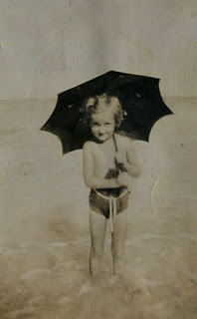
We did the only we could do. All those in Daddy's car piled into Robert's car with our party. That meant six adults, two teen-agers and a five year old. And off we went, leaving Daddy's car by itself, there next to the Gulf, at the mercy of the wind, the rain and ocean waves.
Left, Mary Daly Herrin, five years old in 1936, attempts to shield herself from either the sun or rain in Panama City, Florida.
I don't know how it was decided where we would go and when we would stop, or who decided when. At last, through, we reached DeFuniak Springs, which was inland and northwest of Panama City. Maybe the wind had died down and we felt we had reached a safe haven.
Both cars parked by an all-night honky-tonk, and they let us use the rest room and park up against the building. It must have been close to midnight by this time, and there seemed to be no let-up in the wind and rain. I guess some of us dozed a little, but I am not sure. It seemed the honky-tonk had a lot of customers and men came and went throughout the night, the weather be-damned. I was only 16 but I have often wondered just what kind of place that was."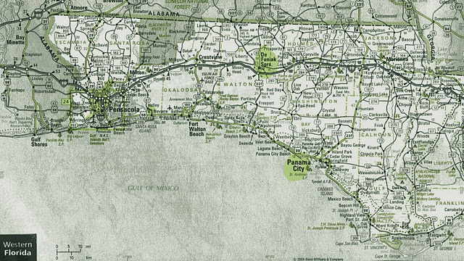
Above, a 2011 Florida road map showing in yellow Panama City and to the north, in yellow, Defuniak, Florida. The Hollimans drove from Panama City to Defuniak to ride out the storm. Unfortunately, they were driving north on the same path as the hurricane. If forecasts had been better in those days, they would have driven east to escape the brunt of the blast.
Next Riding Out the Storm....
Posted by Glenn N. Holliman at 9:39 AM 0 comments
Email ThisBlogThis!Share to TwitterShare to Facebook
Labels: Bishop Holliman, Mary Daly Herrin, Pearl Caine Holliman, Ralph Holliman, Robert Daly, Ulyss Holliman, Vena Daly, Virginia Holliman Cornelius

Thursday, December 22, 2011

Ulyss and Pearl Caine Holliman and their Descendants
The Golden Summers of the 1930s, Part X
by H. Bishop Holliman 2011

Off the Beach!
We resume our story told by Bishop Holliman as the Daly-Hollimans huddled, crowded, in their automobiles attempting to ride out the gathering storm of 1936 in Panama City, Florida.

In the photograph taken on another date, Robert W. Daly, Sr., leader of the Daly-Holliman vacations to Florida in the 1930s, walks the beach with his only daughter, Mary Daly Herrin. They look smartly dressed for beach-combing!
"Immediately, there was a tap on the car window and a man in uniform told us to leave the beach area at once, to drive inland, that the hurricane was ready to strike in full force, that we had to leave now! He spoke with great authority so we did not meander. Robert turned the car around and we headed out, lining up behind Daddy's car (Ulyss Holliman) and Melton's (Holliman), and away we all went!!
We headed inland as the man told us to do.
Ida Holliman, Melton Holliman's wife, perches on the Chevrolet coupe that drove part of the family off the beach in 1936.
Mama (Pearl Caine Holliman), Daddy, Ralph (Holliman, the younger brother), and Hoyt and Vivian Bryant were in Daddy's car, a 1933 four door Chevrolet with Holyt driving and leading the way. Right behind them drove Melton in a Chevrolet coupe, with Ida and Earl, and then came Robert, Vena (Holliman Daly), Mary, Virginia (Holliman Cornelius) and me, going we knew not where!
Just a few miles down the beach high way Daddy's car came to a complete stop! I guess all the excitement had caused it to flood out, as we say. Any way, it would not go any farther. What to do on a dark and stormy night, marooned on the side of the Gulf, trying to reach higher, safer and dryer ground? We did the only thing we could do. All those in Daddy's car piled into Robert's car with our party. That meant six adults, two teen-agers and a five year old. And off we went, leaving Daddy's car by itself, there next to the Gulf, at the mercy of the wind, the rain and ocean waves."
The 1933 Chevrolet of Ulyss Holliman stalled in the storm. Below is an advertisement for a two door version. Note the price and that the models are formally dressed, somewhat as were Robert and Mary Daly in the above photograph!
Next the road house of the refugees!
Posted by Glenn N. Holliman at 12:41 AM 0 comments
Email ThisBlogThis!Share to TwitterShare to Facebook
Labels: Ida Hughes Holliman, Mary Daly Herrin, Robert Daly

Thursday, December 15, 2011

Ulyss and Pearl Caine Holliman and their Descendants
The Golden Summers of the 1930s, Part IX
by H. Bishop Holliman 2011

The Hurricane Approaches...

"Our place at Panama City was on the same street, a few cabins up from where all the others were staying. The highway ran between our place and the beach, a very convenient location. One day all of us were deep-sea fishing and some of us got sick. I don't remember catching many fish, but what I do remember is the hurricane that came up a few days later. It was a defining moment of our 1936 trip to Florida and an event we would remember and talk about the rest of our lives.

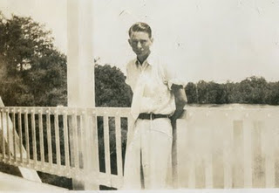
Young Bishop Holliman on vacation in Florida, wearing a white tie?
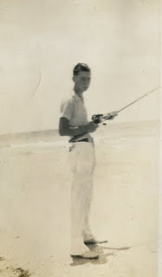
Before the hurricane came ashore, Bishop and other families members fished along the Panama City inlets.
We read in the paper that a strong storm was approaching the Gulf Coast that summer of 1936, but we did not pay much attention to the warning. Remember, we did not have ready access to a radio so the paper was all we had to rely on. The morning of the storm dawned cloudy and very windy. We were not able to stay on the beach due to the stinging sand of Panama City that was whipped up by the raging wind. It went on like that all day, so we sat and waited for nightfall, hoping things would be better tomorrow.
The Holliman Clan and Company remained in their cabin a few doors closer to the beach and across the street from us About 8 o'clock that night we thought we felt the house shake, so Robert Daly, Sr. herded us out to this car, and we sat, thinking the wind would let up soon. I don't know why we felt the car would be a safer place than the house. But about 9 o'clock we noticed a big stir in the house down the street and we wondered what was going on. We soon found out."
Next the escape from the beach!

Posted by Glenn N. Holliman at 5:30 AM 0 comments
Email ThisBlogThis!Share to TwitterShare to Facebook
Labels: Bishop Holliman, Robert Daly, Sr.

Thursday, December 8, 2011

Ulyss and Pearl Caine Holliman and their Descendants
The Passing of Virginia Holliman Cornelius, 1922 – 2011
by Glenn N. Holliman, a nephew

On November 3, 2011, after a long decline, my Aunt Virginia left this life in Austin, Texas. In the blog last summer (see older articles section), with the help of her daughters, Carol and Susan, we were able to share part of her story with the larger family. Her daughters had written and published a thoughtful biography of her on her 80th birthday in 2002, which they kindly let me reproduce.

Since the spring of 2011 with the writings of my father, Bishop Holliman, numerous cousins and family memorabilia and photographs, I have been preparing and posting articles on a generation of a Southern family that was deeply affected by the Great Depression and World War II.
Recently, I was able to visit and spend time with my surviving uncle, Ralph Holliman, now of Gulf Shores, Alabama. Later in this space, I will be sharing some of his story with his great nieces and nephews who have been born long after World War II and who will experience most of their lives in the 21st Century.
Virginia Holliman Cornelius, above, in 1964.

With the death of Virginia, my last aunt has passed away on my Father’s side of the family. Three girls were born to Ulyss and Pearl Caine Holliman, each unique and beautiful in different ways. Vena Holliman Daly Buckheit (1910 - 1990) married in 1928 to Robert Daly, Sr., a banker and fabulous mentor to Bishop, Virginia and Ralph Holliman during their growing up in Irondale, Alabama. Vena was full of grace and poise, dignified and soft spoken and a lovely Southern lady who brought charm and calm to the family.
Above left Vena Holliman Daly Bucheit (1910 – 1990), Bishop Holliman (1919) and Loudelle Ferrell (1914 – 1996) at the 1970 Irondale, Alabama reunion.

Loudelle Holliman Ferrell (1914 – 1996), quiet, graceful, dignified, thoughtful, she married an up and coming Methodist minister, Charles H. Ferrell, in 1935. A graduate of Birmingham-Southern and Yale Divinity School, this well-educated man served as another strong role model for the three youngest Holliman children of that generation. By 1935, the two older brothers, Melton (1908 – 1958) and Euhal Holliman (1912 – 1989), had already married and left the parental home.
Above center is Virginia and to the left is her future husband, Walter Cornelius behind the type writer at Shades Cahaba High School. Third from the right may be Ralph Holliman, Virginia's younger brother.
At Shades Cahaba High School, Class of 1941, Virginia seems to have won every award and held every office possible. When one reviews The Owl, the school yearbook, she leaps out of many pages, sitting center in almost all the group photos, obviously the leader, the poised, already accomplished person readying to come of age in a world still dominated by the male gender.
In early winter of 1942, Virginia and Walter married at the home of Robert and Vena Daly in Irondale, Alabama. War interrupted that marriage, with Walter in 1943 entering the Army Air Corp and after training in the U.S., was stationed in Saipan. He was there as a ground crew person when the B-29 aircraft took off from nearby Tinian Island and dropped the atomic bombs that effectively ended the Pacific War.
Virginia and Walter at one of his training stations in the United States before assignment to the Pacific.

During the War, Virginia took ‘temporary’ employment at her brother-in-law Robert Daly’s bank in Woodlawn, Alabama and remained in banking while giving birth in 1945 to Nancy Carol Cornelius Morton and in 1951 to Susan Cornelius Williams.
After the War using the G.I. Bill, Walter became an accomplished lawyer. Walter also was a talented guitar player and often led his own band. The couple would raise their daughters to maturity, before the war time marriage ended in divorce in the early 1970s. Walter died in 2006.
A rare, heavy snow in Birmingham in 1964 with Virginia, Walter and Carol Cornelius.
For Virginia, the employment opportunity of banking during World War II became a career, a pioneering enterprise for a woman of her generation. She broke many ‘glass ceilings’ in a male-dominated profession, and served as a role model for the females in her extended family and no doubt, a mentor for many in financial services. For this she was recognized in publications and by her peers.
Three lovely ladies, above, Carol, Susan and their mother, Virginia on a 1990s cruise.
On November 20, 2011, members of her family gathered in Dallas, Texas to honor Virginia’s life and accomplishments. In spite of her tremendous career, I suspect she would say that her greatest accomplishments were the daughters, grandchildren and great grandchildren that gathered with other family members to celebrate a life well-lived.
For the record, I insert the Birmingham News obituary published November 7 and 8, 2011.
CORNELIUS, VIRGINIA H. Virginia H. Cornelius, of Birmingham, AL, passed from this life and into the presence of her Lord and Savior on 11/3/2011 at the age of 89. She was born in Irondale, AL, on 2/28/1922. Virginia graduated from Shades Cahaba High School and attended Samford University and LSU. She retired as Sr. VP of AmSouth Bank (now Regions Bank) and was the first woman to hold this position. Virginia is still remembered as the "First Lady of AmSouth". Her civic activities included: President Homewood Chamber of Commerce and Secretary for the Board of Trustees at Samford University. Virginia was published in the book, "You Too Can Be an Executive". Boo Boo, as her grandchildren called her, loved life and until she went into that "long goodbye of Alzheimer's", spent time with her family and friends, traveling, visiting, and babysitting her grandchildren. Virginia was preceded in death by her grandson, Eric Blomstran and five brothers and sisters. She will be remembered as a wonderful Christian woman who never hid her light and always strived to be the best in everything that she undertook. Virginia was and will continue to be a tremendous inspiration to all of us who had the wonderful privilege of knowing and loving her. She is survived her daughters, Carol C. Morton of San Antonio, TX, and Susan Williams of Cedar Park, TX, two brothers, 6 grandchildren and 8 great grandchildren. Virginia resided in San Antonio, TX, at the time of her death. The memorial service for her will be conducted at: Fellowship Bible Church, 9330 N. Central Expressway, Dallas, TX, at 4:00 p.m., November 20, 2011. RSVP to: (512) 626-3559 . In lieu of flowers, a tax deductible donation in memory of Virginia Cornelius may be made to one of the following: Barabbas Ministries, P.O. Box 461531, San Antonio, TX 78246-1531 or Fellowship Bible Church, 9330 N. Central Expressway, Dallas, TX 75231.

As one of seventeen first cousins of the seven children of Ulyss and Pearl Holliman, I marvel at the lives of my aunts and uncles. They were for our times “The Greatest Generation”. GNH

Comments, opinions and content are by the writer solely who welcomes critique and feedback from family members.

Posted by Glenn N. Holliman at 2:58 PM 0 comments
Email ThisBlogThis!Share to TwitterShare to Facebook
Labels: Bishop Holliman, Carol Morton, Loudelle Ferrell, Ralph Holliman, Susan Williams,Vena Daly, Virginia Holliman Cornelius, Walter Cornelius

Tuesday, December 6, 2011

Ulyss and Pearl Caine Holliman and their Descendants
The Golden Summers of the 1930s, Part VIII
by H. Bishop Holliman 2011

The Summer of 1936 and the Great Storm....
Above along a pier in Clearwater, Florida, 1936, left to right, Virginia Holliman Cornelius, Mary Daly Herrin, Vena Holliman Daly and Bishop Holliman.
"I don't recall now how our 1936 trip came about. Stewart Button had taken a church in Knoxville, Tennessee earlier in the year, but Virginia and I were still available. Ralph, I guess, was still considered too young to go. I would enter my last year of high school that fall, so this would be my last hurrah. That year we went further south, all the way to Clearwater, Florida and points in between. Robert had now acquired a new 1936 black two-door Plymouth, so now we would be travelling in style.
Below a restored 1936 four door Plymouth touring car.
In Clearwater, we did not find the beach as white and sandy as those at Fort Walton and Panama City, so that took some of the shine off our stay there. Instead of a 'tourist cabin', we found a fully furnished home used mainly in the winter by a wealthy owner, so that made our stay more enjoyable. It was a few blocks from the beach and backed up to the bay. I have no idea what the rent was, but I am sure more than we had paid at Fort Walton. One day we drove down to Sarasota and over to St. Petersburg, and another time Robert rented a small boat and he and I went out into the bay to fish and got caught in a squall that came up quickly. We had left Vena, Mary and Virginia home to worry about us.
It had been planned early on that Mama, Daddy and Ralph would drive down to Panama City Beach during our two week stay. Soon Melton and Ida Holliman decided to join them, along with Ida's nephew, Earl Burton. Also, accompanying Mama, Daddy and Ralph would be Hoyt and Vivian Bryant, close family friends of Melton's age, who had lived next door in years past. After a week at Clearwater, we decided we would join them, so we drove up to Panama City, found a cabin where they were and settled down, we thought, for a fun time with friends and family. On the way, we stopped at a resort similar to Silver Springs called Waukulla Springs and took a boat ride."
Next the hurricane comes....
Posted by Glenn N. Holliman at 6:58 AM 0 comments
Email ThisBlogThis!Share to TwitterShare to Facebook
Labels: Bishop Holliman, Mary Daly, Stewart Button, Vena Daly, Virginia Holliman Cornelius

Thursday, November 24, 2011

Ulyss and Pearl Caine Holliman and their Descendants
The Golden Summers of the 1930s, Part VII
by H. Bishop Holliman 2011
The Summer of 1935....
"I had completed my first year of high school at Shades Cahaba and would be 16 the coming December. Still too young to get a job, even if one had been available and even if I had been so inclined to pursue it! Robert always had yard work to do and he gave us loose change...which he always had...for Saturday afternoon chores. Also, one winter I earned some pennies for starting the fire each Sunday in the heater in the Presbyterian church....not enough to pay my way to Florida however.
When the summer of 1935 rolled around, the Dalys began to talk of another trip to the beach, and I guess Virginia and I pressured them to include us in their plans, though I do not remember any of that now. Mr. Button evidently was included also in the planning because he, along with Virginia and me, were in the Model A Ford on a Monday morning in August when we set out again for Florida.
Robert had received some brochures from the Mississippi Gulf that attracted him to that area. Also, Loudelle and Charles had spent their honeymoon at the "The Whitehouse", a luxury hotel in Biloxi in June, so maybe that helped lure him there instead of Florida.
Our first stop was in Tuscaloosa to chat with Glenn Barrow, the young principal of Irondale school was was attending classes there, working on another degree. He met us on the corner of the main street of the University and we talked for about 30 minutes. We felt bad that he had to attend classes and were going on a beach holiday. But such was life. He was a fine man, and we were glad to spend time with him.
Glenn Barrow, right, served as a teacher and principal. After his death, during the war, Bishop Holliman named his first child in 1946 after this thoughtful educator.
We went on to Mississippi, arriving in Gulf Port about sun down, and were we ever disappointed! We saw immediately that the beaches along that coast did not measure up to those at Fort Walton and other Florida beaches. We spent the night there, but the next morning all of us agreed that we had rather go back to Fort Walton even if it ate up another day of our vacation. So, east went, along the Gulf Coast, through Mobile and Pensacola arriving late that afternoon in Fort Walton, in a cabin close to where were the previous summer. We felt at home there, and content to be back there for the next 10 to 12 days.
Our facilities and daily activities were much like those of the previous summer. Vena and Robert did the cooking. Mr. Button was a 'fun' person, and I guess he helped with dish washing, maybe. Virginia continued to look after Mary, and to this day, I can't think of anything I did except act as a good fishing buddy and surf swimmer. However it was not long before we had company!
Mary Daly Herrin on the beach in Florida.
The 1935 tourist court or cabins would not, perhaps, be enticing to the 21st Century generation of Hollimans, Dalys, Herrins, Corneliuses and Ferrells!
Over the past year we had done such a good job talking up the pleasures of a beach vacation....so much so that Mama and Daddy (Pearl Caine and Ulyss Holliman) decided to join us at Fort Walton for a few days. I don't know how they managed to pull it off...I am sure Daddy had to suffer a loss of wages for a week...but they did it! I have forgotten how long they stayed...less than a week. They brought with them my brothers, Ralph and Euhal and Euhal's girl friend, Anna Grace Bagley. They found a cabin near us and we all enjoyed a few days of fishing and surfing. All of us got along fine. This was Daddy's first real vacation and their first time ever to splurge. Daddy, born 1884 in Fayette, Alabama, was 51 that summer.
Below, Stewart Button and young Bishop Holliman survey their 'catches of the day' at Fort Walton, Florida.
We returned home from Fort Walton on a Saturday in August, the other members having been back for several days. Our stay at the beach had been uneventful after their departure...lots of fishing and swimming. This may seem a mundane thing to mention now, but I remember our lunch on the way back was a sandwich shop in south Alabama. The sandwiches were 20 cents each...a humongous sum, we thought!"
Next posting, the Great Storm of 1936....
Posted by Glenn N. Holliman at 6:28 AM 0 comments
Email ThisBlogThis!Share to TwitterShare to Facebook
Labels: Euhal Holliman, Glenn Barrow, Robert Daly, Ulyss Holliman

Thursday, November 10, 2011

Ulyss and Pearl Caine Holliman and their Descendants
The Golden Summers of the 1930s, Part VI
by H. Bishop Holliman 2011
The Summer of 1934 continued...
"Vena and Robert Daly did all the cooking, cleaning and whatever else had to be done. Looking back now from this distance, you have to wonder how they could have endured such a life style, even just for two weeks. Imagine, sharing the bath with a non relative, cooking for all of us all the time, hot humid weather and no attractions other than the beach and the fishing pier! I don't know how they did it but they did!
Above, Fort Waldon Beach, Florida in the late 1930s or early 1940s when a boardwalk and pier were the attractions, plus of course a beautiful beach and the Gulf of Mexico.
As far as I know, we all got along fine. Virginia and I did as we were told, and I never heard a cross word between Vena, Robert and Mr. Button. We had a nice little cabin (in the terminology of the times). I don't recall the number of bedrooms or other amenities and I have no idea how much it cost - very little, I am sure by today's standards. After our first night's rest, Mary said she slept on a log. We thought that was funny and I wrote home and told them about it!
The luxury cabin of the Daly's and Hollimans in the middle 1930s!
Most of our time at Fort Walton was spent in fishing, and I guess we went in the surf everyday also. The bridge across the bay to the beach was our fishing perch, and we caught more fish than I thought were in the ocean. Fish of all kinds - one afternoon Robert reeled in a stingray, something we had never heard of and we learned it was very poisonous. All of us were captivated by our catch each day, and Robert arranged to 'pickle' some of them in formaldehyde in jars and bring them back home to show off his piscatorial ability. He drove over to Pensacola to get the pickle juice and bottles. For many years after, his pickled fish were stored in his garage up on the Irondale hill. They were still there when I went into the Navy in November 1941.
Mary Daly Herrin and her baby sitter and Virginia Holliman Cornelius in Florida.
Such was our first trip to Florida - 1934. We arrived home on a Saturday afternoon, having been gone about 13 days. I remember being startled by how much the grass and the garden had grown during our absence. I am sure we all went to church the next day because we would have wanted to tell everyone we had been to Florida, how many fish we caught, and to show off our tans! We made several pictures - that are still in existence of our beach escapade of 1934. One of Robert fishing in the surf I thought was so good I sent it to the Birmingham News, but they never saw fit to print it."
A fine day's worth of Florida fishing - Robert Daly and Stewart Button
Another Golden Summer in the next post....
Posted by Glenn N. Holliman at 1:13 AM 0 comments
Email ThisBlogThis!Share to TwitterShare to Facebook
Labels: Mary Daly Herrin, Robert Daly, Stewart Button, Virginia Holliman Cornelius
Older PostsHome
Subscribe to: Posts (Atom)

Followers

Blog Archive
- ▼ 2011 (42)
  - ▼ December (5)
    - Ulyss and Pearl Caine Holliman and their Descendan...
    - Ulyss

Ulyss and Pearl Caine Holliman and Descendants

Monday, February 20, 2012

Ulyss and Pearl Caine Holliman and their Descendants
War Comes and Changes Everything
by Bishop Holliman
Bishop Holliman, a native of Irondale, Alabama, continues his memoirs of the coming of World War II and its impact on his life and family....
"I checked with the draft board, and learned I would probably be inducted that fall – October or November, 1941. I had already decided I would join the Navy rather go into the Army, as the first draftees were having a terrible time at Camp Blanding in Florida and I wanted no part of that. I would not sign up thought until I had to. We still did not know if America would get into the war.

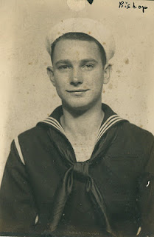
Bishop Holliman, born December 17, 1919, in the U.S. Navy from November 1941 until September 1945.
I also made the decision not to return to Birmingham Southern College that September since it appeared I would not be able to finish the semester – a decision I have wondered ever since if it was a wise one. I learned later that I probably would have been deferred until the end of the term. But all that is hind-sight.

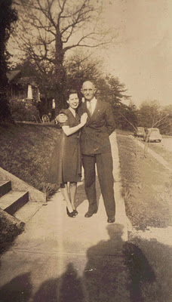
Right, Geraldine Stansbery Holliman, formerly from Philadelphia, visited Irondale, Alabama in February 1945 prior to her marriage to Bishop Holliman in June 1945. Here Ulyss Holliman, in an unusual display of affection, has his arm around Gerry!
I don’t recall how long Vena, Robert and Mary (the Daly family that lived next door to the Hollimans) remained at Daytona, probably for a month. I had obtained a temporary job at Sloss-Sheffield steel and Iron Company, so I was out of touch with goings on and getting ready to make my exit from home and Birmingham. I had a good friend who worked at S.S. Steel and Iron, who got me the job. I was paid, I think, 75 cents an hour, more money than I had ever seen.
I worked up until the end of October, joining the Navy Friday, November 13, 1941. Mama, Daddy Ralph, Vena and Robert came to the train station to see me off!
I came out of the war unscathed, married a pretty girl from Philadelphia who became the mother of my children, so don’t look back."
Next, back to Florida in the 1950s....
Posted by Glenn N. Holliman at 12:05 PM 0 comments
Email ThisBlogThis!Share to TwitterShare to Facebook
Labels: Bishop Holliman, Robert Daly, Ulyss Holliman Geraldine Stansbery Holliman

Monday, February 6, 2012

Ulyss and Pearl Caine Holliman and their Descendants
The Golden Summers of the 1930s Give Way to the Turbulent 1940s by H. Bishop Holliman 2011
"On July 1, 1941, I registered for the World War II draft, an event that had lasting consequences for me, as it had on everyone else of my age group. At the time, I was working in a New Deal temporary job in Birmingham, Alabama and at Hill’s Grocery Store on Saturday, planning to return to college in September.
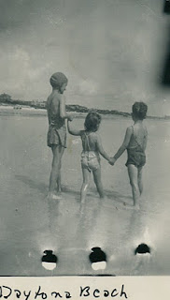

My brother-in-law Robert W. Daly, Sr., his wife - my sister, Vena and my niece, Mary, already had been to Daytona that summer for two weeks, and here in August they were going back again! Robert had a very stressful job at the Woodlawn bank, and he decided he should spend at least a month away from it. So they took off again. This time I went with them to help drive in case Robert did not feel up to driving all the way. So, I quit both jobs and made my last trip to Florida as a foot loose and fancy free lad.
Left, Mary Daly Herrin in the bathing cap supervises her cousins, Carolyn and Charles Ferrell at Daytona Beach, Florida the last summer before America went to war. Photos courtesy of Charles H. Ferrell.
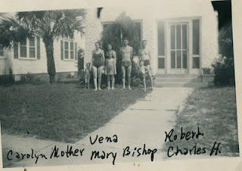
Left to right that late summer in Daytona Beach, Florida: Carolyn and Loudelle Ferrell, Vena and Mary Daly, Bishop Holliman, Robert Daly and Charles Halford Ferrell. Germany invaded the Soviet Union June 22, 1941. America was only a few months from being thrust into the growing war.

Robert rented a house (pictured above) similar to the one we had had at Clearwater, Florida in 1936. Thus, we were prepared to stay as long as allowed by the bank. A few days into our stay, Loudelle, Charles, Halford and Carolyn joined us. I think they were living in Jacksonville, Alabama at the time where Charles was the Methodist pastor. There we were - a big part of the Ulyss and Pearl Holliman family, enjoying our stay on the beach in the summer of 1941.
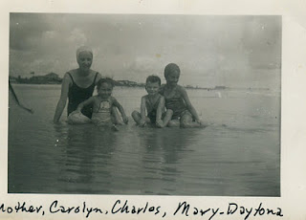
But it all ended too soon. Mama wrote from home in Irondale, Alabama to tell me I had received a notice from the draft board to report, adding that 'you had better get back home'. I planned to hitch hike, which was a popular way for college boys to travel in that day. But Loudelle would not hear of that, so she pretended that they also had to get home, and that I should ride with them. And so I did."
Next posting, the War comes and everything changes....
Posted by Glenn N. Holliman at 1:14 PM 0 comments
Email ThisBlogThis!Share to TwitterShare to Facebook
Labels: Bishop Holliman, Carolyn Ferrell Tatum, Charles H. Ferrell, Loudelle Holliman Ferrell, Mary Daly Herrin, Robert Daly

Tuesday, January 24, 2012

Ulyss and Pearl Caine Holliman and their Descendants
The Golden Summers of the 1930s, Part XV
by H. Bishop Holliman 2011
"So, thus ended my third Golden Summer with the Robert Dalys and my sister, Virginia Holliman Cornelius. By next summer, 1937, I had finished Shades Cahaba and was hoping to enter Birmingham Southern College that Fall, also trying to pick up odd jobs. I had reached the age where I would have to start paying my way, and that realization posed all sorts of problems for me. My days of romping on the beach were over and done with!!"
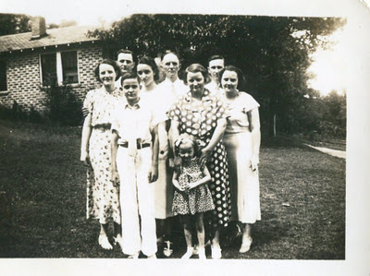
Above are eight of the thirteen family members who were caught in the 1936 hurricane. This photo was taken in 1936 in the yard between the Dalys and Hollimans in Irondale, Alabama, a natural photo spot to catch the afternoon sun.
The youngster with the long tie on the front row is Ralph Holliman, about 12 years old. The young girl is Mary Herrin, born 1931, with her grandmother’s hands resting on her shoulders. Her grandmother is Pearl Caine Holliman, age approximately 49 in this photo and not wearing glasses at that time.
Back row left to right are Ida Hughes Holliman, her husband Melton Holliman, Virginia Holliman, probably 14 in this photo, Ulyss Holliman and Robert Daly, Sr. just behind his wife, Vena Holliman Daly. Perhaps Bishop Holliman took the photo.

As an aside, notice how young Pearl Caine Holliman appears in this picture. In just a few years, she will age noticeably with the advent of World War II and three sons going to war. - GNH

"However, Vena, Robert, Mary and Virginia went to Miami the next summer, and Mr. Stewart Button returned to Irondale and went with them. Upon their return, I went to Knoxville with Mr. B. staying with a church family there, and we climbed Mt. LeConte in the Smokies. Virginia may have gone with them again in 1938 or 1939…I am not sure. My youngest brother, Ralph, went with them in whatever year it was Virginia did not go, even though he has forgotten it!"

In the surf in Florida – left to right – Stewart Button, unidentified, Robert Daly, Mary Daly Herrin, Ralph Holliman and Vena Holliman Daly.
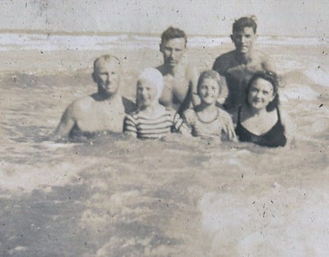
In 1937 Robert Daly, Sr. took the below photo in Miami, Florida of a Pan Am passenger transport, a flying boat which made regular runs to Havana, Cuba and Latin America. This was a massive aircraft for its day, a Sikorsky S-42, all aluminium capable of 150 mph carrying 32 passengers. Range was an amazing 3,000 miles (very lightly loaded), and it still took five days to carry passengers with luggage from Miami to Buenos Aires! - GNH
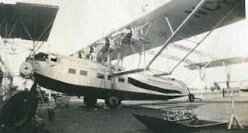

Next, more family memories by Bishop Holliman....
Posted by Glenn N. Holliman at 1:00 PM 0 comments
Email ThisBlogThis!Share to TwitterShare to Facebook
Labels: Mary Daly Herrin, Ralph Holliman, Robert Daly, Stewart Button, Vena Daly

Tuesday, January 17, 2012

Ulyss and Pearl Caine Holliman and their Descendants
The Golden Summers of the 1930s, Part XIV
by H. Bishop Holliman 2011
In late 1936, the 16 year old Bishop Holliman wrote a 'book' on the great hurricane of 1936 that his family had experienced in the pan handle of Florida. In 2011, 91 years old, he wrote the story from memory as I now have pocession of the 75 page tome. In comparing my Father's memories to what he wrote three - quarters of a century earlier, he has remembered well and factually in his senior years. Naturally the 1936 work is much more detailed and includes some danger not included in his 2011 memoirs. Still a fascinating look at an America three-quarters a century ago. - GNH
In November 2010, below my Father, back to camera, visited his boyhood home, Irondale, Alabama again. This photo shows him conversing with the unidentified person who now lives in the house (behind her) on 2nd Avenue where his brother, Melton and his wife, Ida Hughes Holliman, lived in the late 1930s. His 2011 narrative continues....
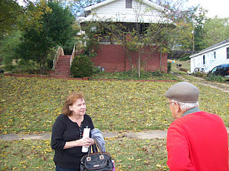
"Melton and Ida were living in the house across from Grandma Lula Caine (in Irondale, Alabama), just down the hill from us. Ida had an old Underwood typewriter that she let us peck on from time to time. So several days after we returned home I got the bright idea of writing up a history of our experience in Florida and of the storm, typing it all out of her type writer. Truly a hunt and peck system. I have forgotten how long it took me to get the job done.

The title was 'The Storm Warnings Were Posted', and I don’t know how I came up with such a threatening name for my story. Daddy was so impressed with my work he showed it to a Birmingham News reporter, thinking he could make something of my work. But alas, nothing ever came of it and the reporter returned it after a few weeks. Today, this great literary production is in possession of my son, Glenn Holliman."
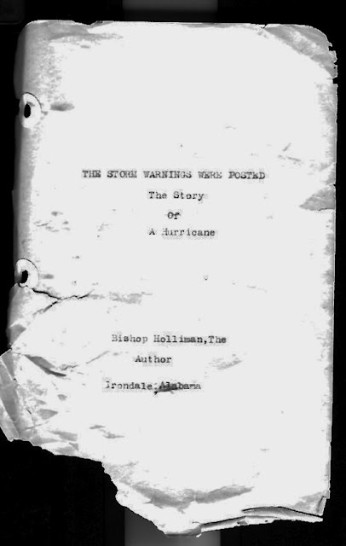
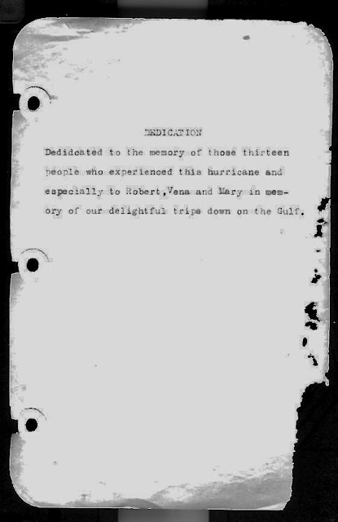
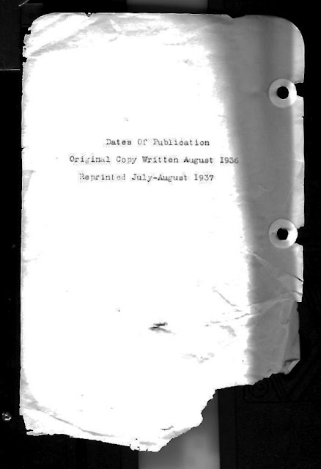

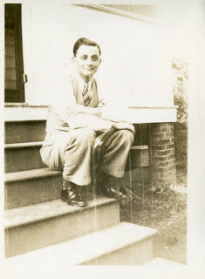
Right, Melton Holliman ca 1938 in a photo perhaps taken on the steps of the house on 2nd Avenue, Irondale, Alabama shown above. By this time in his life, Melton had begun what would be a successful career selling pharmacological medicines.
Next the Golden Summers give way to World War II....
Posted by Glenn N. Holliman at 1:31 PM 0 comments
Email ThisBlogThis!Share to TwitterShare to Facebook
Labels: Alabama, Bishop Holliman, Irondale, Melton Holliman

Tuesday, January 10, 2012

Ulyss and Pearl Caine Holliman and their Descendants
The Golden Summers of the 1930s, Part XIII
by H. Bishop Holliman 2011
From memory written in 2011, 92 year old Bishop Holliman continues his narrative of his summers in the 1930s, 75 years earlier.
"The next week Daddy (Ulyss S. Holliman) called a reporter for the Birmingham morning paper, the Age-Herald, and gave him an account of our experience in the Florida hurricane. His story came out on the front page, listing all our names and what our feelings were about our ordeal."
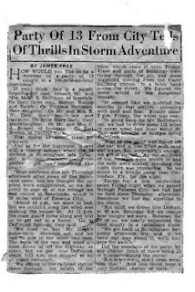
As the faded newspaper is difficult to read, I include this material which seems to be the story prepared by James Free, reporter, before publication. GNH

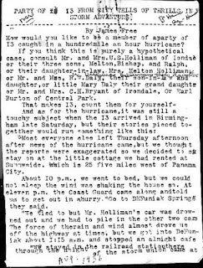

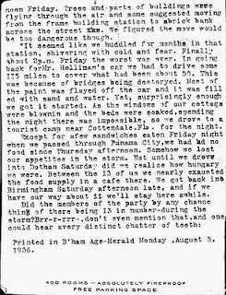

Next post, the 75 page book that young Bishop Holliman wrote and typed in 1936.

Posted by Glenn N. Holliman at 1:05 PM 0 comments
Email ThisBlogThis!Share to TwitterShare to Facebook
Labels: Bishop Holliman

Tuesday, January 3, 2012

Ulyss and Pearl Caine Holliman and their Descendants
The Golden Summers of the 1930s, Part XII
by H. Bishop Holliman 2011
The story of the West Florida hurricane of 1936 continues by H. Bishop Holliman.
“We learned through folks in the building that the railroad depot would be a safe place for us to go, once it was safe to get out on the street, so soon after daylight that’s where we went. There was no chance of getting breakfast as the wind and rain continued in full force, and we knew we had better stay put. So we did.
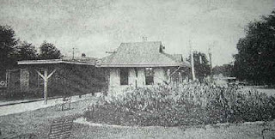
Taken from the Defuniak Springs, Florida history web site is this photograph of the L & N Railroad station where the Holliman family took shelter. Hmmm....it does not look all that substantial as a structure.
All morning long the wind blew and blew and the rain poured and poured. I remember seeing objects such as signs, limbs and other stuff flying through the air. Up in the morning the L & N passenger train that ran between Jacksonville and New Orleans pulled into the station. Its appearance gave us some hope, as we believed if the train could get through maybe the worst was over.
In all the fury, there was no panic and no hysteria throughout our ordeal from the youngest to the oldest. During the morning other refugees came into the building and one told us the gadget that measured the wind’s intensity was rising and that was a a good sign. I remember Melton’s saying that he hoped it reached a thousand! (Probably this was a barometer indicating rising pressure; the storm was passing.)
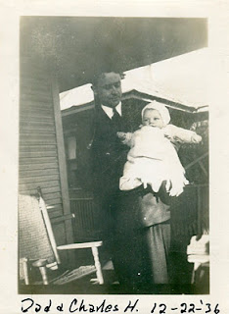
Left, the young minister, Charles Ferrell holds his new son, Charles Halford Ferrell, the second grand child of Ulyss and Pearl Caine Holliman.
All during the morning, though, we were concerned about Loudelle and Charles and Euhal and Edna back in Birmingham. There was no way to let them know what was happening to us and that so far we were safe. Loudelle was just about a month from bringing Charles Halford into the world. And Euhal and Edna has been married only a month. So our concerns were not confined to our fate there in the depot. I know now that Mama and Daddy, especially, were carrying a lot of weight on their shoulders that we young ones could not realize.
Below Edna Westbrook Holliman, age 18, the new bride of Euhal Holliman, the third child and second son of Ulyss and Pearl Caine Holliman. Edna and Euhal waited in Birmingham, worried about the family caught in the Florida storm.
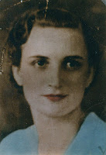
Around one o’clock the wind seemed to have subsided a little, so Hoyt and Melton dared to go out in search of some food for all of us. Maybe they found some, I don’t remember now from this this distant date. But about mid-afternoon, the wind let up, the sun came out and we all seemed alive again. We piled into the two cars and headed back to Panama City Beach, hoping Daddy’s car would still be there and that our belongings would also.
It was close to dark when we arrived at our destination. Limbs and trees were strewn all along the highway on the way, but thankfully, the houses were still there with all our belongings. The first thing we saw though was Daddy’s car, which had lost some paint due to flying sand. It was still where we left it, but would it start? It did, right off. We immediately packed up, loaded the cars and headed north as the sun sank in the west, glad to be safe and sound and on the way home!

It was a Friday night and we drove all the way to Dothan, Alabama, before stopping to eat and/or finding lodging for the night. We arrived home late Saturday afternoon, happy to be safe with lots to talk about."
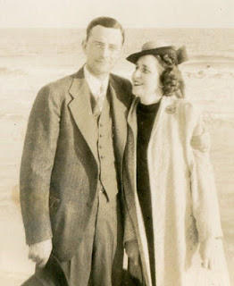
Left, Melton and Ida Holliman were caught in the storm with other members of their family.
Next post, recording the story of the storm in newspaper and in print.....
Posted by Glenn N. Holliman at 11:55 AM 0 comments
Email ThisBlogThis!Share to TwitterShare to Facebook
Labels: Bishop and Melton, Charles Ferrell, Charles H. Ferrell Edna Holliman, Euhal Holliman, Robert Daly, Ulyss Holliman

Friday, December 30, 2011

Ulyss and Pearl Caine Holliman and their Descendants
The Golden Summers of the 1930s, Part XI
by H. Bishop Holliman 2011
From the web, a site entitled Storm Lifecycle - SOURCE: Wikipedia, 1936 Atlantic hurricane
"A tropical storm was first observed over the southern Bahamas on July 27. It tracked to the west-northwest, and made landfall a short distance south of Everglades City, Florida with winds of 60 mph (95 km/h). After crossing the state, it intensified over the eastern Gulf of Mexico and became a hurricane on July 30. The hurricane continued to strengthen, and hit the western Florida Panhandle with peak winds of 90 mph (145 km/h) on July 31. It weakened rapidly over land, and dissipated over western Alabama on August 1."
The story written by H. Bishop Holliman continues with the Robert Daly, Sr. and Ulyss and Melton Holliman cars carrying a frantic family, now terribly worried by a growing storm of water and wind and a 90 mile an hour hurricane as described in history above. - GNH
"Mama (Pearl Holliman, 1887 - 1955)), Daddy (Ulyss Holliman, 1884 - 1965)), Ralph (Holliman, 1924), Hoyt (Hughes, Ida Hughes Holliman's brother) and Vivian (Hoyt's wife) were in Daddy's car, a 1933 four door Chevrolet with Hoyt driving and leading the way. Right behind them drove Melton (1908 - 1958) with Ida (1910 - 1991) and Earl, and then came Robert (Daly, 1903 - 1959), Vena (Holliman Daly, 1910 - 1990), Mary (Daly Herrin, 1931), Virginia (Holliman Cornelius, 1922 - 2011) and me (Bishop Holliman, 1919), going we knew not where!
Just a few miles down the beach highway, Daddy's car came to a complete stop! I guess all the excitement had caused it to flood out, as we say. Any way, it would not go any father. What do do on a dark and stormy night, marooned on the side of the gulf, trying to reach higher, safer and dryer ground?
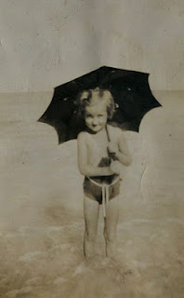
We did the only we could do. All those in Daddy's car piled into Robert's car with our party. That meant six adults, two teen-agers and a five year old. And off we went, leaving Daddy's car by itself, there next to the Gulf, at the mercy of the wind, the rain and ocean waves.
Left, Mary Daly Herrin, five years old in 1936, attempts to shield herself from either the sun or rain in Panama City, Florida.
I don't know how it was decided where we would go and when we would stop, or who decided when. At last, through, we reached DeFuniak Springs, which was inland and northwest of Panama City. Maybe the wind had died down and we felt we had reached a safe haven.
Both cars parked by an all-night honky-tonk, and they let us use the rest room and park up against the building. It must have been close to midnight by this time, and there seemed to be no let-up in the wind and rain. I guess some of us dozed a little, but I am not sure. It seemed the honky-tonk had a lot of customers and men came and went throughout the night, the weather be-damned. I was only 16 but I have often wondered just what kind of place that was."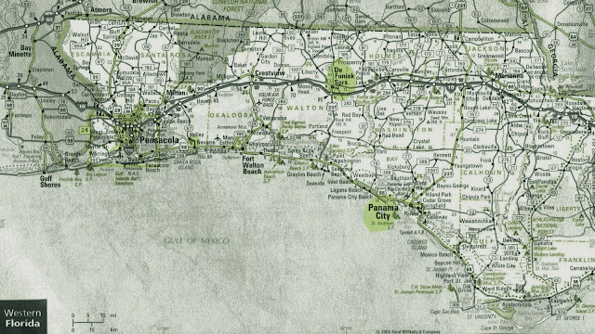
Above, a 2011 Florida road map showing in yellow Panama City and to the north, in yellow, Defuniak, Florida. The Hollimans drove from Panama City to Defuniak to ride out the storm. Unfortunately, they were driving north on the same path as the hurricane. If forecasts had been better in those days, they would have driven east to escape the brunt of the blast.
Next Riding Out the Storm....
Posted by Glenn N. Holliman at 9:39 AM 0 comments
Email ThisBlogThis!Share to TwitterShare to Facebook
Labels: Bishop Holliman, Mary Daly Herrin, Pearl Caine Holliman, Ralph Holliman, Robert Daly, Ulyss Holliman, Vena Daly, Virginia Holliman Cornelius
Older PostsHome
Subscribe to: Posts (Atom)

Followers

Blog Archive
- ▼ 2012 (6)
  - ▼ February (2)
    - Ulyss and Pearl Caine Holliman and their Descendan...
    - Ulyss and Pearl Caine Holliman and their Descendan...
  - ► January (4)
- ► 2011 (42)

