Dear Glenda:

Uriah died on 8 May 1862 in Okolona, MS, after the battle at Corinth. Cause of death: measles and pneumonia. His son, Charles Daniel, died from the same disease, same place. Mary Polly was there to attend their deaths and see to their burials. She contracted measles for her effort but rode a mule back home to Fayette County and survived. Uriah was 46 years old and had no business being in the CSA Army. I think that he joined because he had 4 sons in the War: James Franklin, John Thomas, Charles Daniel and Elijah. Elijah joined when he was about 15 and died of typhoid at age 18 in LaGrange, GA. The grave sites of Uriah and Charles Daniel are in the "unknown" section of the Confederate Cemetery in Okolona, MS.

I have searched the family for a photo of Uriah. No luck. Regarding a photo of Mary Polly in her youth, I know of none. However, I talked with her youngest son, Joshua Warren, of Vernon, AL, where she died in 1913. Joshua died in 1944. I got a lot of info from him.

As far as I know, there are no known pictures of Charles Daniel or Elijah. Keep in mind there were several Elijahs in our ancestry.

Here is a list I sent to Glenda about 5 years ago. It is about as complete as my memory will allow. RBH

----- Original Message -----

From: Doc Holliman
To: Glenda Norris
Sent: Wednesday, October 12, 2005 12:53 PM
Subject: Uriah's family:

Dear Glenda: I just found this and modified it a little to begin your next lesson. It is abstracted from previous correspondence with others. I will elaborate on this family group in my next correspondence. Just print this and store it. I wrote this about 4 years ago and I can add much to this info now. Just found a big file on Warren, son of James Grantson, who is mentioned in my first letter. He moved to AR. He will be my third family group to send: Cornelius, Charles, Warren.

URIAH H. HOLLIMAN: The son of Cornelius Holliman and his first wife, Elizabeth Plyler. Uriah born on July 6th, 1816 in Lancaster County, SC. He married Mary Polly Lucas at Tuscaloosa on August 31st, 1836. Performing the ceremony was the Rev. John Walters, M.G. She was 17 years old. They had 13 children. Uriah joined the Confederate Army in 1862 at the age of 47 ! He was Pvt. Uriah H. Holliman, Company B of the 9th Alabama Battalion of Volunteers, 26th Regiment, CSA. He died of measles and pneumonia at Okolona, MS, on May 8th, 1862, attended by his wife until death. Their son, Charles Daniel, same military unit, same place, died on May 12, 1862, of the same diseases. Their grave sites are unknown but probably in the Confederate Cemetery in Okolona, MS.

MARY POLLY LUCAS HOLLIMAN: The daughter of Charles Daniel Lucas and Mary Unknown. Mary Polly was born on Jan. 2nd, 1819, in South Carolina. She married Uriah H. Holliman on August 31st, 1836. Performing the ceremony was Rev. John Walters, M.G. She was a midwife and herb doctor in northern Fayette County for most of her life. She had 13 children. She died on July 6th, 1913, at the home of her youngest son, Joshua Warren Holliman at Vernon, AL, on July 6th, 1913, with burial at Springhill Cemetery just north of Bluff in Fayette Co., AL.

OFFSPRING OF URIAH AND MARY POLLY LUCAS:

1. Mary Elizabeth Holliman, born Sept. 12th, 1837, died Oct. 9th, 1841.

2. James Franklin Holliman, born Jan. 28th, 1839, died 13 May, 1911. 1st Lt., Co. B, 58th Alabama Infantry Regt., captured at Missionary
Ridge, TN, on Nov. 25th, 1863. Spent the remainder of the War in Johnson's Island Prison Camp for Confederate Officers, in
Erie, Ohio. He was released on June 13th, 1865. He returned to Fayette County to become a teacher and farmer. He married
Rebecca Utley Stewart on July 2nd, 1865. They had 4 children (3 boys and a girl). Rebecca died and JFH married one of his
former students, Bertha Lee Powell. The had 5 children (3 boys and 2 girls). JFH and both wives are buried at the Holliman-
Stewart Cemetery, Bluff, AL.

3, Sarah Jane Holliman, born Oct. 3, 1840 in Fayette County, died Oct. 15, 1915, buried at Cottonwood Cemetery, 6 miles east
of Eustace, Texas. She married Charles Stephen Copprell in Fayette County on July 13th, 1864.

4. Charles Daniel Holliman, born May 6th, 1842, died May 12, 1862 of diseases mentioned above while in the Confederate Army.
Burial probably in the Confederate Cemetery, Okolona, MS.

5. John Thomas Holliman, born April 23, 1844, died July 12th 1930 in Fayette County. Burial at Caines Ridge Cemetery, 4 miles
south of Fayette, AL, on Route 159. Was known as "Hico John" to distinguish him from 2 others of the same name in the
county. Married (1) Sarah Corbett: one child, William Perry. She died in childbirth. Married (2) Martha Jane Walker: 5 sons.
JTH was a Pvt. in Company H. 41st Alabama Infantry Regr., CSA. He surrendered at Petersburg, VA, on Feb. 15th, 1865,
near starvation. He took the oath and was parolled to a farmer in Indianapolis, Indiana, where he worked until the fall of 1865
and then walked home to Fayette County, AL.

6. Elijah Holliman, born April 16th, 1846, died July 10th, 1864, from typhoid while serving in the Confederate Army. He was a
Pvt. in Company I of the 56th Alabama Partisan Rangers. He died in a Confederate Hospital near Lagrange, GA: burial site
unknown.

7. Nancy Palestine Holliman, born April 7th, 1848, died Dec. 12th, 1923. Married John Pinion: no issue. She is buried near her
mother, Mary Polly, in Springhill Cemetery near Bluff, AL.

8. Cornelius Holliman, born Dec. 16th, 1849, in Fayette County. Married Sarah Elizabeth Smith at Fayette. Moved to Rockdale,
Milam County, Texas.

9. William Perry Holliman, born March 29th, 1852, in Fayette County. Married Sarah Holliman, a distant cousin and daughter
of Warren C. Holliman and Mary Blakeney of Newtonville, AL. Moved to Rockdale, Milam County, Texas. Resided near
Cameron, Texas.

10. Martha Ann Holliman, born June 27th, 1854, married Rufus Buckner. Resided near Alvord, Texas.

11. Rebecca Drucilla Holliman, born March 4th, 1856. Married John Thomas Holliman, cousin, and son of Warren C. Holliman
Mary Blakeney of Newtonville, AL. Moved to Ardmore, OK. He was called "Black John" due to the color of his hair and
to distinguish him from two other John Ts living Fayette County at the same time.

12. Emily Frances Holliman, born March 14th, 1858 in Fayette Co. Married (1) Abner McClung in Fayette County. Moved to
Eustace, Texas, where she had relatives and there married Joe Reynolds.

13. Joshua Warren Holliman, born Aug. 26th, 1860, died Jan. 6th, 1944. Married Martha Goulsby, resided in Vernon, Lamar
County, AL, until his death. Buried in Vernon. His mother, Mary Polly Lucas Holliman, died at his home in 1913.

Dear Glenda: I'm taking this off a CD and upgrading a bit. Thes are the children of Uriah and Mary Polly in chronologic order.

Mary Elizabeth (1837 - 1841) Burial site unknown: probably Springhill at Bluff. She died at age 4.

James Franklin Holliman, Lt., CSA (1839 - 1913) Married twice: Rebecca Utley Stewart, then Bertha Lee Powell. You have a photo of Bertha Lee, your great-great-great aunt. Lt. JFH died on 13 May 1911. Burial: Holliman-Stewart Cem., Bluff Community, Fayette County. I will ultimately send you photos of several of his kids by both wives.

Sarah Jane Holliman (1840 - 1915) married Charles Stephen Copprell (Copprelli), Pvt., 58th Ala. Infantry Regt.. Charles was in the same outfit with Lt. JFH, was wounded, but was not captured. Among other jobs, he drove an ambulance in the CSA. He was an immigrant from Genoa, Italy. I have a photo of this couple made in Texas where they settled and died. Both are buried at Cottonwood Cemetery, Eustace, Texas. They left a big family that is still in Texas and their descendants have an annual reunion. I have photos of their grave stones.

Charles Daniel Holliman, Pvt., CSA, (1842 - 1862) Died with his father, Uriah, in Okolona, MS, during the Civil War. They died of disease 4 days apart: Uriah - May 8th, 1862: Charles Daniel - May 12th, 1862.

John Thomas Holliman, Pvt., CSA, (1844 - 1930) married Sarah Corbett (one son, William: she died in childbirth) Married Martha Jane Walker (5 sons). I'll talk about their sons later. Burial: Caines Ridge Cem., Fayette County.

Elijah Holliman, Pvt., CSA (1846 - 1864) Died of typhoid on 10 July 1864 in Lagrange, GA, during the Civil War. Burial in the Confederate Cemetery there. He died at 18 years ! Have a photo of his grave stone. Here is one of the Elijahs. You'll see another in the Charles Holliman line.

Nancy Palestine Holliman (1848 - 1923) Married John Pinion. No issue. Buried next to her mother, Mary Polly, in Springhill Cemetery, Bluff, AL. You have a photo of her grave stone, I believe. I have a good photo of her. I'll send both again.

Cornelius Holliman (1849 - died in Milam County, Texas). Married Sarah Elizabeth Smith in Fayette, AL. Here is another Cornelius ! I don't know where they are buried.

William Perry Holliman (1852 - died near Cameron, Texas) Married a distant cousin, Sarah Holliman, in Fayette County, AL. Don't know where they are buried.

Martha Ann Holliman (1854 - died near Alvord, Texas) Married Rufus Buckner. Don't know where they are buried.

Rebecca Drucilla Holliman (1856 - moved to Ardmore, OK) Married John T. Holliman, a cousin, son of Warren C. and Mary Blakeney. More on Warren C. when I talk about children of Charles and Barbary Walters. Don't know where Drucilla and John are buried.

Emily Frances Holliman (1858 - moved to Eustace, Texas). Married (1) Abner McClung in Fayette County, AL. Married (2) Joe Reynolds in Texas. Don't know where they are buried.

Joshua Warren Holliman (1860 - 1944). Married Martha Goulsby. Lived and died at Vernon, AL. His mother, Mary Polly Lucas, lived wth them in old age and died at their home in 1913. I have a photo of their grave in Vernon, Lamar County, AL. One grandchild is still alive in B'ham but I can't get him to cooperate: Dan Clark Holliman who lives just off old Rt. 31 south of B'ham. I've written him off as a lost cause. Joshua will appear again in another line.

Here is the mob from which we descend. Mary Polly was a midwife and delivered all of her brood of 13 without help ! JOHN THOMAS HAD 5 SISTERS AND 7 BROTHERS.

Note that 5 of your great-great-great aunts and uncles moved to Texas and one to OK., after the Civil War. All looking for federal land patents (land grants). Texas is full of Hollimans today. The CNN broadcaster, John Holliman, who was killed in an auto accident in GA, was a descendant of one of these lines. He was on live TV from Baghdad when George, Sr. drove Iraq out of Kuwait.

This will give you a little more to deal with regarding our SC immigrant ancestor, CORNELIUS. The above stuff gives you your first lesson on name duplication.

Love, Uncle Rhodes Hope you had a great time in Fayette County and found some of the graves on the maps.

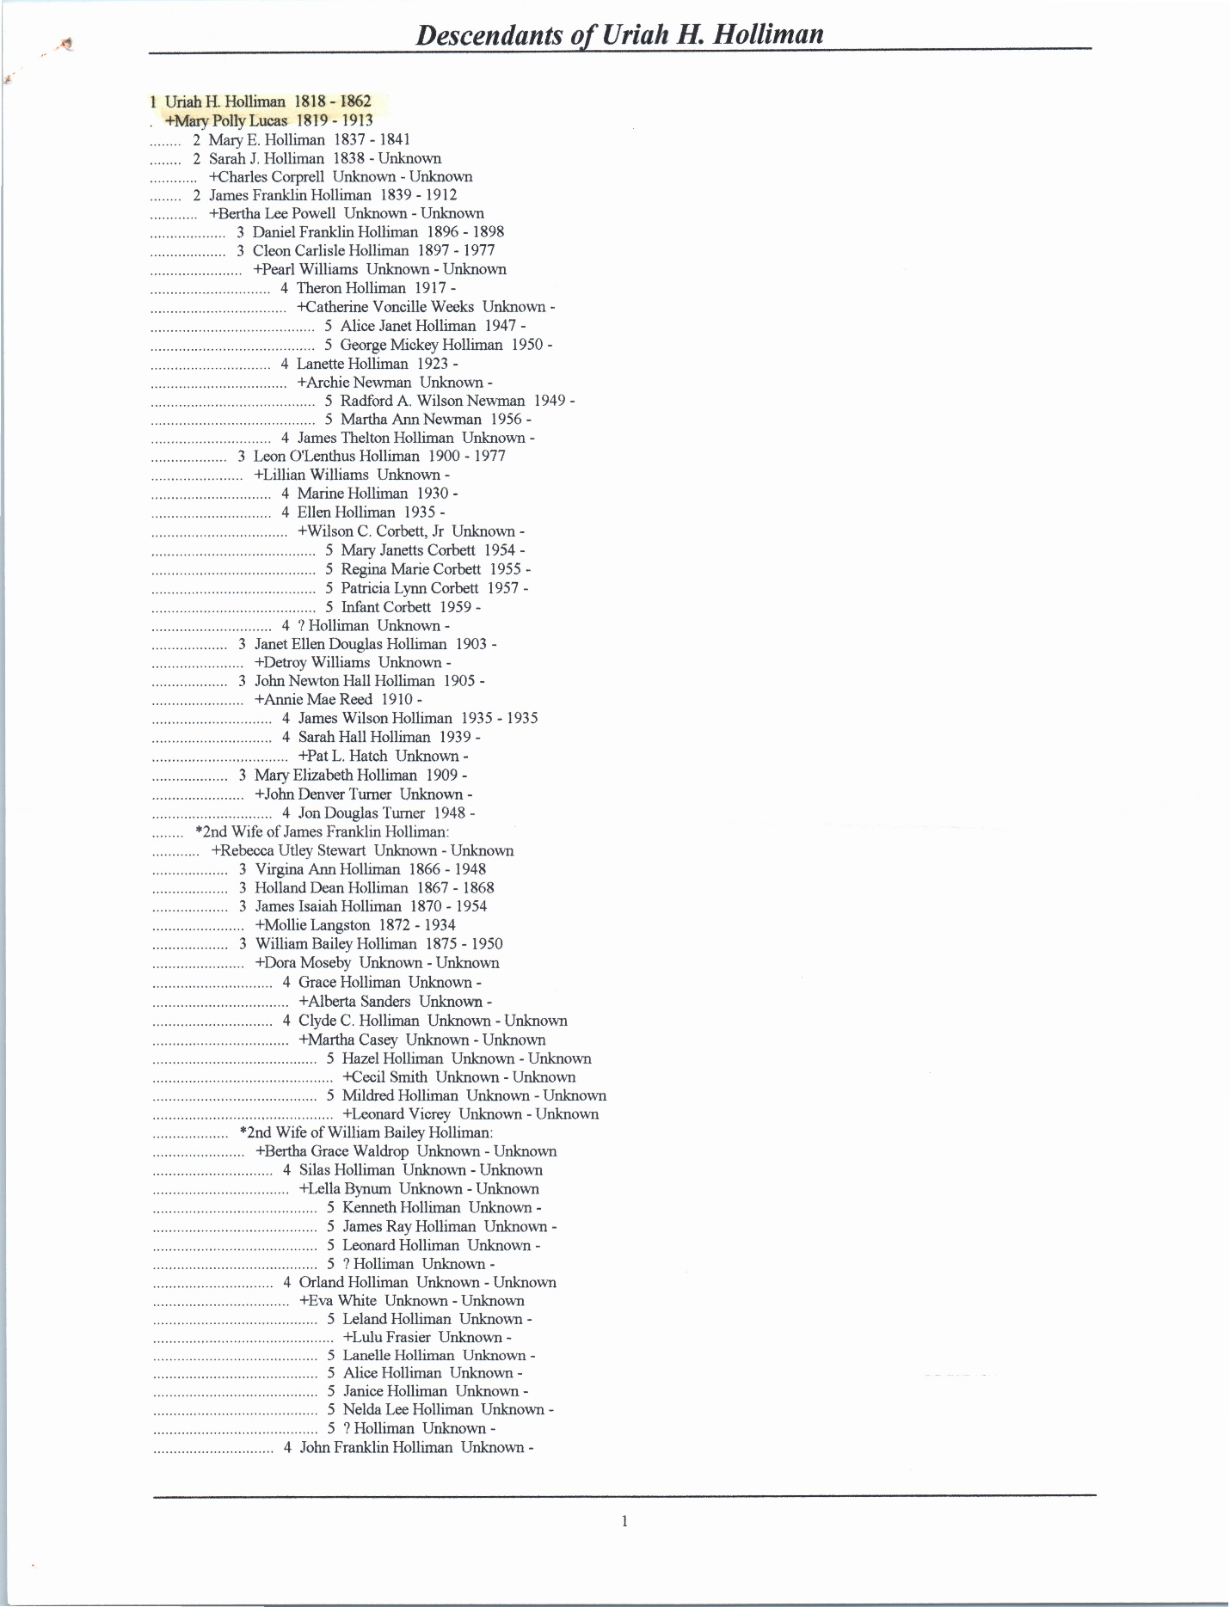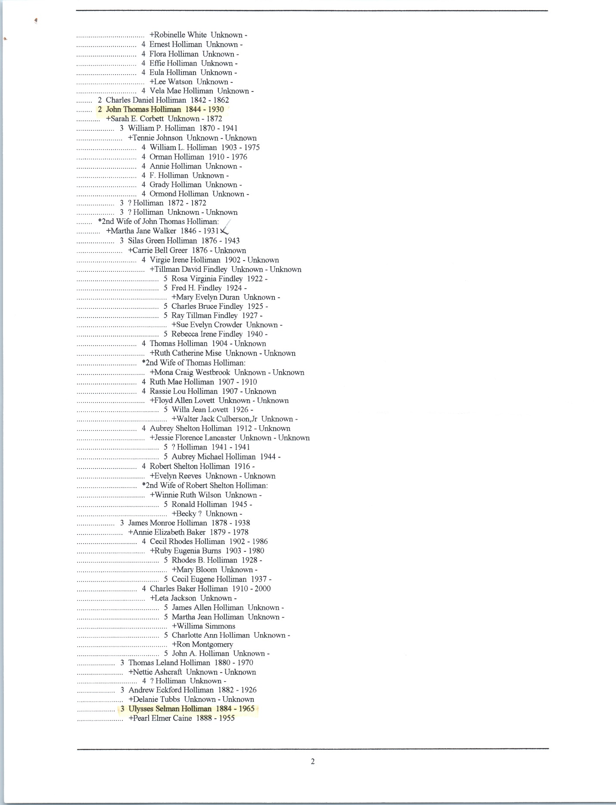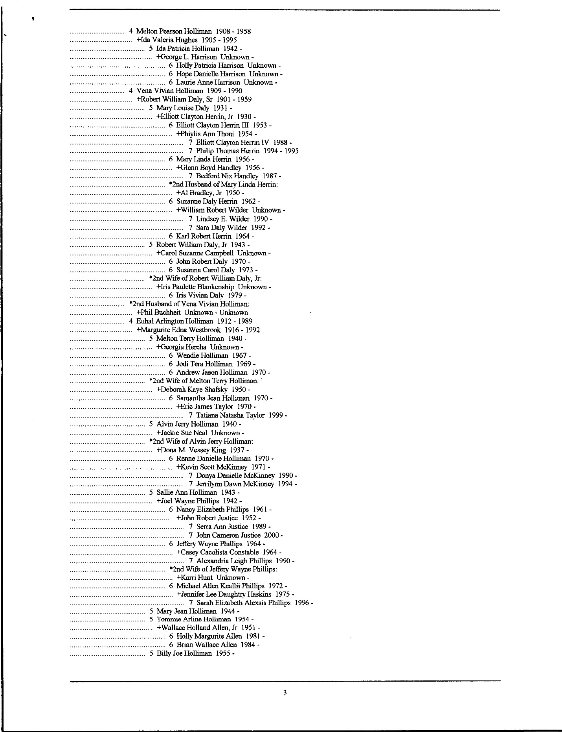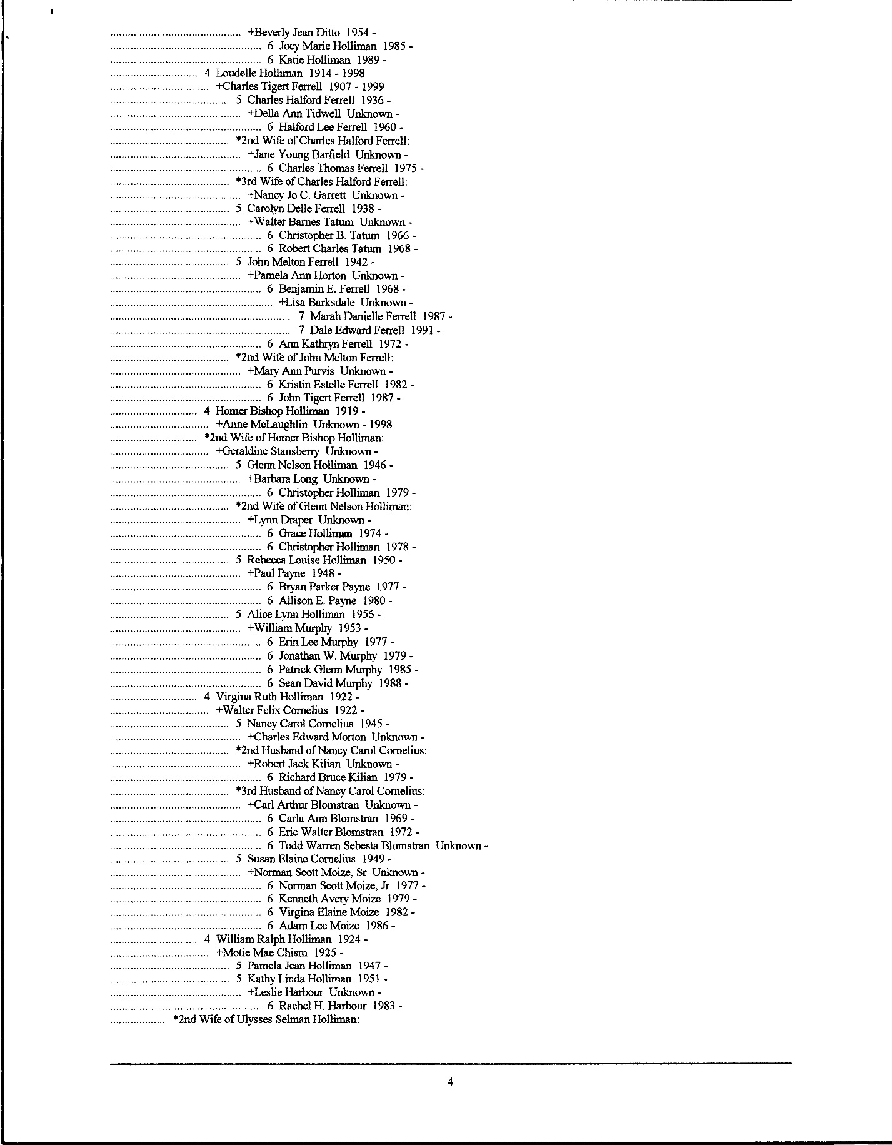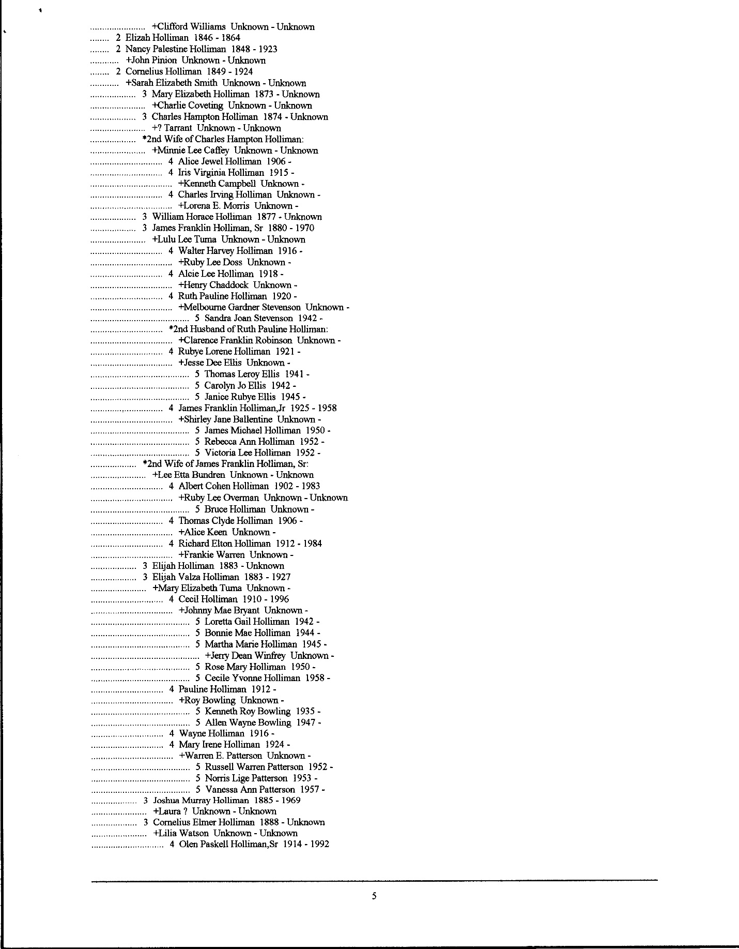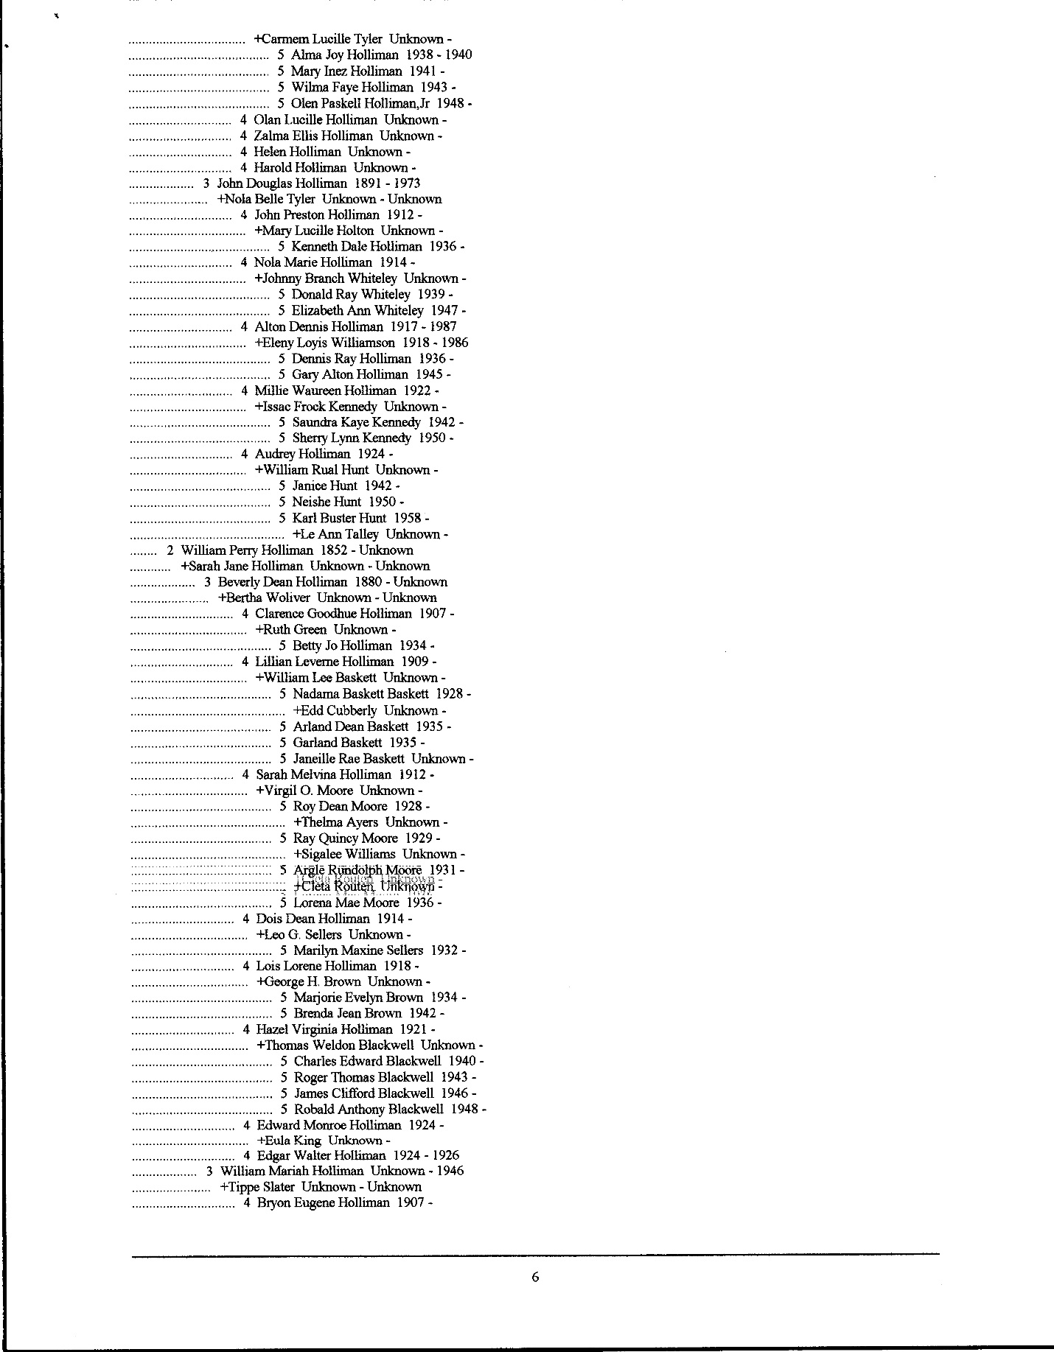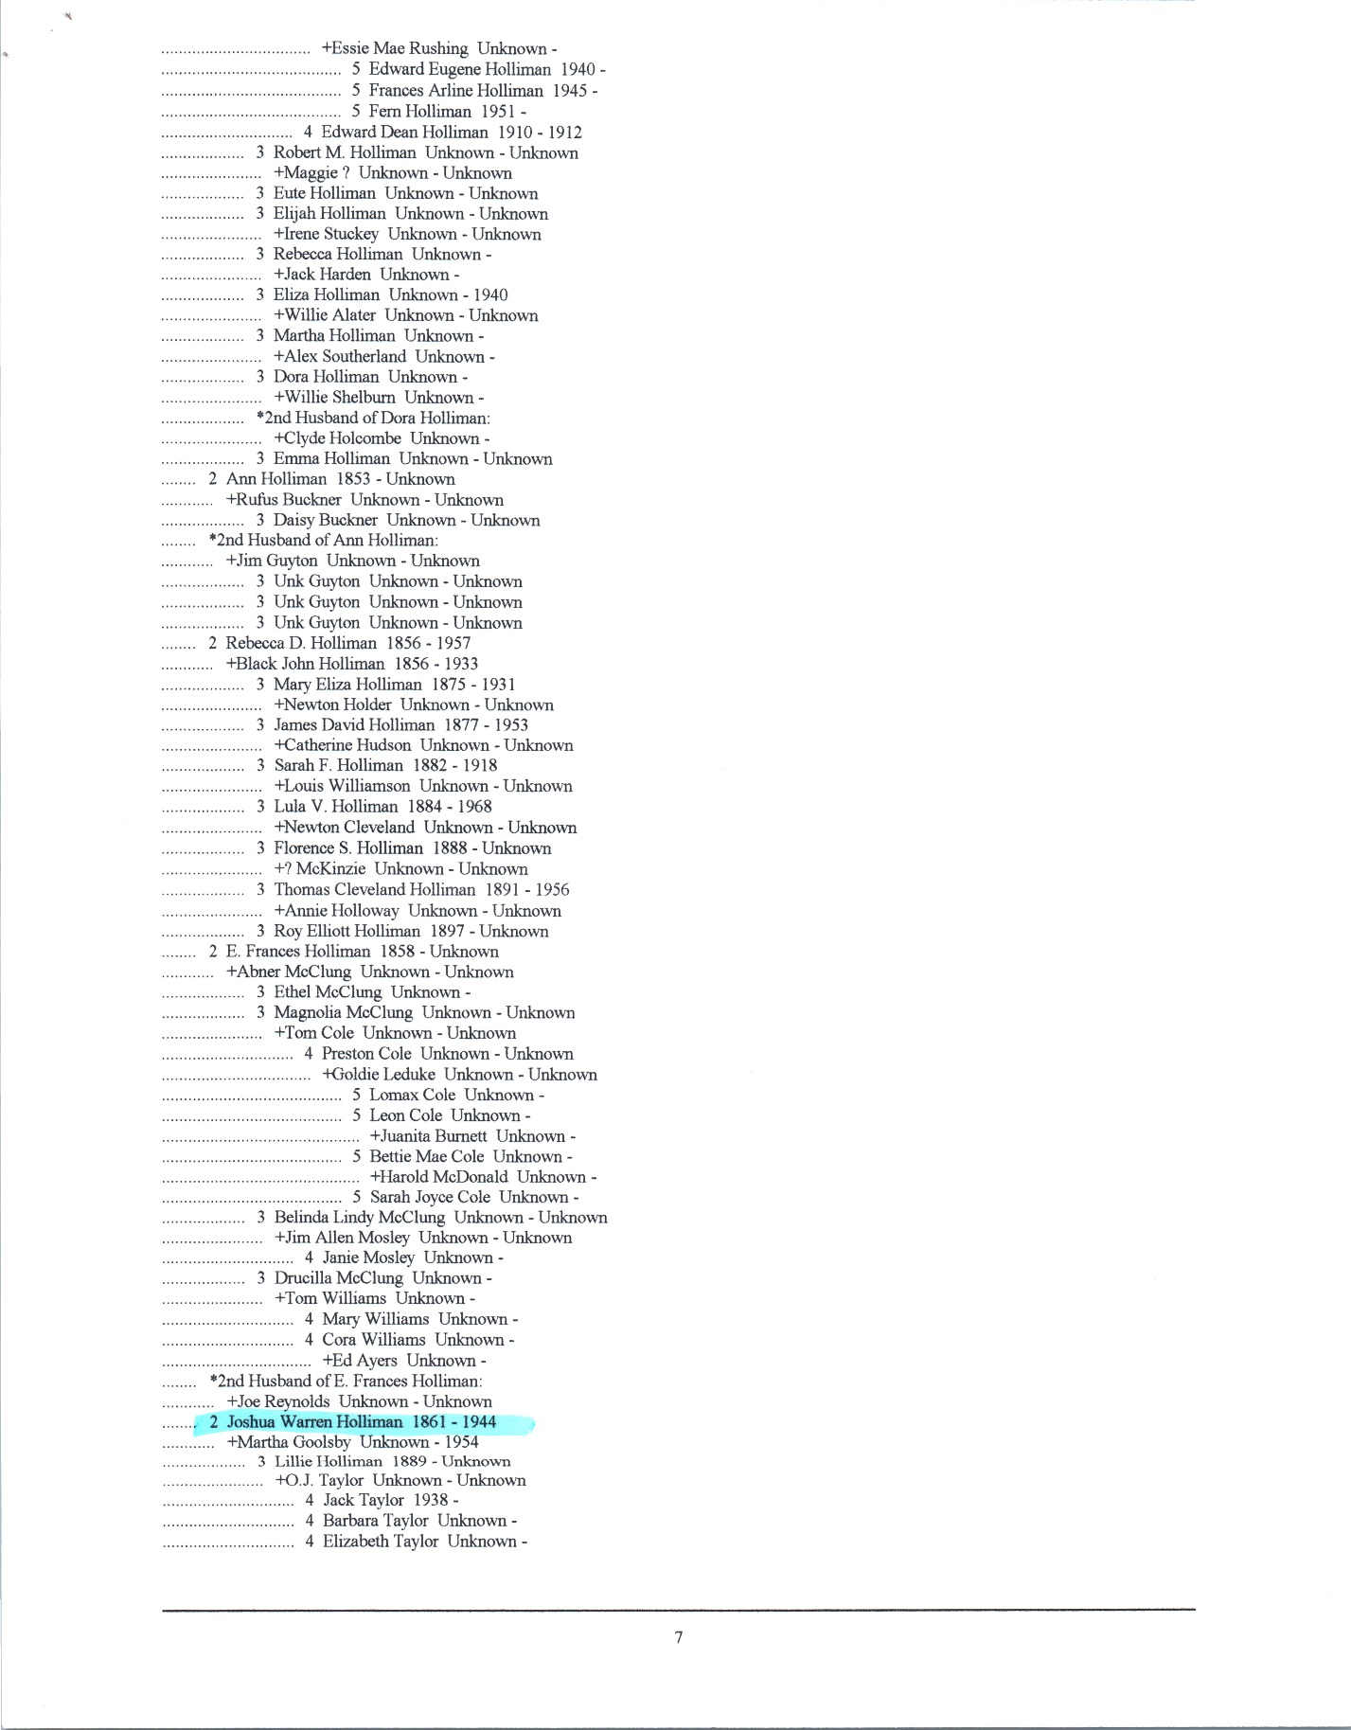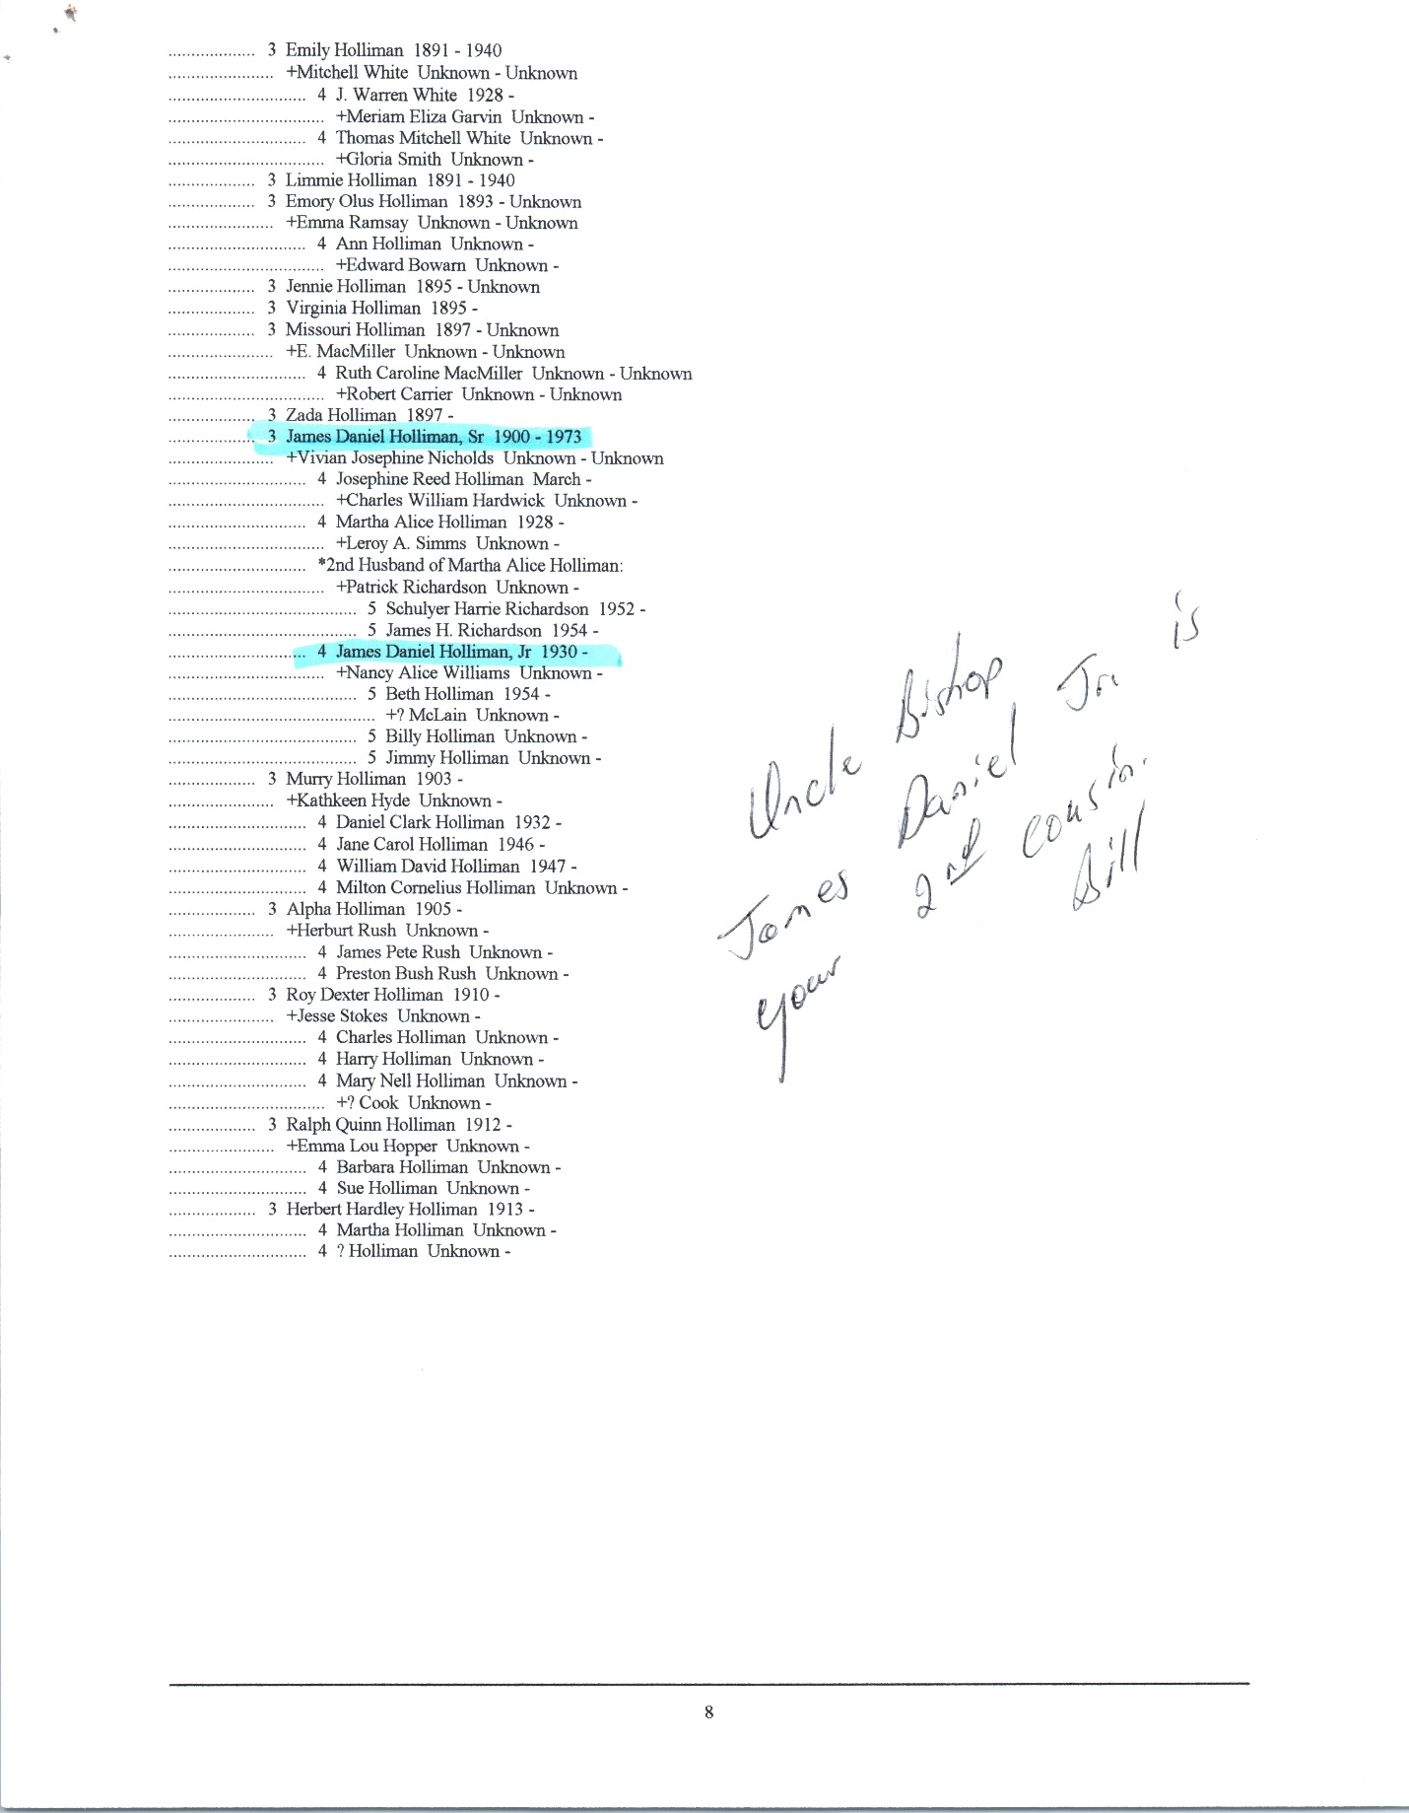
All the information that I have on Martha Ann =olliman is as follows: she was the 10th child of Uriah Holliman and Mary =olly Lucas. Martha was born on June 27th, 1854. She married Rufus =uckner and they resided near Alvord, Texas. Mary Polly had 13 children, =he last was a boy, Joshua Warren Holliman, born August 26, =860. Uriah and 4 of his sons joined the Confederate Army: James =ranklin, Charles Daniel, John Thomas, and Elijah. Uriah =as 46 years old when he joined the Army. Uriah, Charles Daniel anf =lijah died in the Civil War of disease. Only James Franklin and John =homas (my great grandpa) survived the War. Mary Polly had her =irst child in 1837 and the last in 1860. She delivered all of them by herself =!

If you will send me your email address, ='ll scan you a copy of the only known photo of Mary Polly. No pictures exist of =Uriah. I'm sorry that I can't be of better help. I've gone =hrough my notes and those of my Dad, who was a fine genealogist. Dad died in 1986 at the age =f 83. I'm 76. Best regards, Dr. R. B. Holliman, M.D. (ret.) New email:
=nbsp; &=bsp; docholliman@adelphia.net&nbs=;

----- Original Message -----

From: Lillian Holloway
To: Doc Holliman
Sent: Tuesday, October 12, 2004 =1:46 AM
Subject: Re: holliman =ncestry

Dear Mr. Hollima,
Thank you for your reply. Annie =aisy (Daisy Anna) Holliman's grandmother was Mary "Polly" Lucas Holliman m =riah Holliman. One of my aunts told me last night that Annie's father =as rumored to be an Anderson, he later asked Martha to marry him and she =efused.
I found Annie and Martha living with =ary (Polly) in an 1880 Census, listed with Emily Holliman McClung and her baby =alinda (husband desc?), Nancy P Holliman, J.W. Holliman. Their names were =pelled Holomon in the census.
Anyway, now my search leads to =ndersons in Marion. Lamar and fayette counties.
Thank you for your help.
Lillian Holloway
----- Original Message -----

From: Doc Holliman
To: Lillian Holloway =/DIV>
Sent: Monday, October 11, =004 4:48 PM
Subject: Re: holliman =ncestry

I might be able to help you if I knew who =as the father of Martha Ann Holliman. Also, where did Martha Ann =ive when she gave birth to Daisy ? This sounds like some of the descendants of Elijah Holliman of Millport, Alabama, (Lamar =ounty) or Warren C. Holliman of Newtonville, AL (Fayette County). This =air of brothers sired a great number of offspring. My new =mail address is: docholliman@adelphia.net&nbs=; Sincerely. R. B. Holliman, M.D. =ret.)
----- Original Message ----- =/DIV>

From: Lillian Holloway =/DIV>
To: holliman@psknet.com
Sent: Sunday, October 10, =004 7:27 PM
Subject: holliman =ncestry

Dear Mr. Holliman,
I am not certain where to start =o...I am a descendant of Annie Daisy Holliman daughter of Martha Ann =olliman. My aunt tells me Annie was an illegitimate child and Rufus Buckner =as not her father. Not that the moral issue of this bothers me in the =east, I am trying to trace my ancestry. my great grand father was James =ollis Guyton who married Daisy. My grandfather was William Austin Guyton who =arried Nannie Mae Brock. Though there is tons of information on the =uyton men, there is not much on their wives!
I have found the information you =ent to the Lamar Co., AL website (very exciting, thank you) which has been a =reat help, but I wondered if you may have any more information on =nna Daisy. Any help would be greatly appreciated.

Thank You,
L Holloway

Elijah didn't survive the War. He was in the mounted Partisan Rangers (a mean cavalry outfit). He reported ill to St. Mary's Hospital (Confederate) in LaGrange, GA, on 4 July 1864. Diagnosis: typhoid. Very common disease in the War. Acquired from drinking fecally polluted water. He died on 10 July 1864, and was buried in the Confederate Cemetery there. I have a photo of his grave stone.

Survivors of the War were the oldest brother, Lt. James Franklin, captured at Missionary Ridge, TN, in Nov., 1863: Pvt. John Thomas who surrendered from the trenches at Petersburg, VA, on 15 Feb. 1865. James Franklin spent the remainder of the War as a prisoner at Johnson's Island Prison in Lake Erie, near Sandusky. He was released in June of 1865. The War ended on 9 April 1865, at Appomattox CH.

Died in the War: the father, Uriah, and sons, Chas. Daniel and Elijah. Three out of 5 ! A son-in-law, Chas. Stephen Copprell, was also in the War. More on him later. He was married to Elijah's daughter, Sarah Jane Holliman. I have a pic of them which I will scan to you soon.

Love, Uncle Rhodes

