by Glenn N. Holliman

Descendants of Christopher Holyman (d 1691) who reside in Virginia to this Day....

We continue to report on the descendants of Christopher Holyman (1618-1691), who live in the Isle of Wight County and Richmond, Virginia. My thanks to the distant cousins who kindly shared their time and photographs. There will be several more articles on Isle of Wight County, which to most Holymans (and many various spellings) is our American ancestral starting point.

Below, Caroline Holleman Thomas and her husband, Bill, in their Richmond, Virginia home earlier this year. Caroline is the sister of Joseph Howard Holleman, Jr., about whom I wrote in the last post. Both are children of Joseph Howard Holleman, Sr. and Bessie Faircloth Holleman. Bill and Caroline are retired educators.
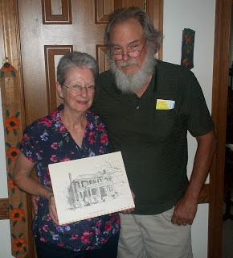

Above, Caroline holds a drawing of the 1830 Holleman House located along the Blackwater River near the Mill Swamp Baptist Church in Isle of Wight, Virginia. Caroline and Bill had their wedding rehearsal dinner by romantic candlelight in the historic home in December 1962. The dinner party was hosted by her Aunt Louise and Uncle Algenon (Nonnie) Holleman.

Most persons in the U.S who bear the Holleman name (and various spellings such as Holliman, Holloman, etc.) trace their linage to this farm adjacent to the Mill Swamp near the Blackwater River in Isle of Wight County, Virginia.

If there be a 'Plymouth Rock' for Hollimans, this is the place although, of course, the brick 1830 home was not built during the 17th Century. Christopher Holyman's original home, most probably a log cabin, would have lasted only 20 to 40 years as a habitable house. Since the 1680s, Hollemans have lived on the same land patented by Christopher Holyman during the reign of King Charles II of England.

Below, this water color is in the pocession of Sarah Barlow Wright of Smithfield, a first cousin of Caroline Holleman Thomas. Mrs. Wright has told me that the clapboard building on the right of the painting pre-dates the Federal style home, and was the Holleman home while the 1830 building was being constructed. The out building still stands today, probably of 18th Century construction.
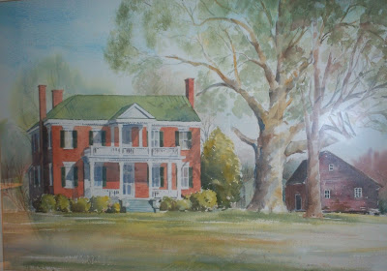

Below, Algenon Holleman who with his wife, Louise, hosted the 1962 rehearsal dinner for their niece, Caroline Holleman, and Bill Thomas. Algenon's son, William Joseph (Billy Joe) Holleman, owns the home today. His son, Joseph (Joey) Holleman, lives in the historic home with his family.
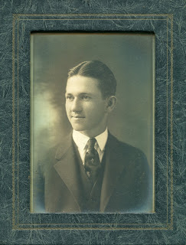
This above photograph is courtesy of Sarah Barlow Wright, whose mother, Gladys Holleman Barlow, grew up in the early 1900s at the Holleman House. We will begin their stories in the next posting.

Next more on the Hollemans of Isle of Wight, Virginia....

Have questions about Holliman family history? You are invited to join the Hollyman Email List at Hollyman-Subscribe@yahoogroups.com and the Hollyman Family Facebook Page located on Facebook at "Hollyman Family". Post your questions and perhaps one of the dozens Holyman cousins on the list will have an answer. For more information contact Tina Peddie at desabla1@yahoo.com, the list and Facebook manager for Hollyman (and all our various spellings!). Mrs. Peddie can assist also in any DNA research.
Since early 2010, I have been publishing research and stories on the broad spectrum of Holliman (Holyman) family history at http://hollimanfamilyhistory.blogspot.com/ . For stories on my more immediate family since the early 20th Century, I have been posting articles since early 2011 at http://ulyssholliman.blogspot.com/ .
Let's save the past for the future! If you have photographs, letters, memorabilia or research you wish to share, please contact me directly at glennhistory@gmail.com. Several of us have an on-going program of scanning and preserving Holyman and related family records. Write please and tell us of your items. Thanks to the Internet, we are able to scan, upload to the web (with your permission) and return the materials to you.

