Virginia Holliman Cornelius and Families
Virginia Ruth Holliman Cornelius, 1922
the Sixth Child of Ulyss and Pearl Caine Holliman

Born in Irondale, Alabama, my Aunt Virginia was the third and last daughter of my grandparents. Below in 1923 is baby Virginia on the left in the hat, with an unnamed baby on the right.
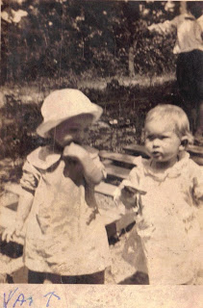
Below is a fantastic photograph from cousin Charles Halford Ferrell of four of the Holliman siblings from 1928. Left to right is Virginia, Ralph in the wheel barrel, and his two oldest sisters, Loudelle and Vena, who are both in bib overalls! Notice the car with the canvas top in the background.
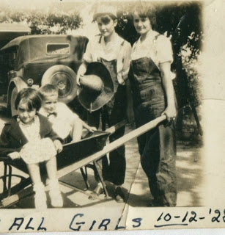

Below in the middle 1930s, Virginia is supervising young Mary Daly Herrin's dip in the Gulf of Mexico. Robert Daly took his extended family every summer to Florida to enjoy sun and sand. Paved roads and more reliable automobiles made middle class vacations possible by the third decade of the 20th Century. As with her brother Ralph and Bishop, Virginia attended and graduated from Shades-Cahaba High School. As with the rest of the family World War II would change her world forever.

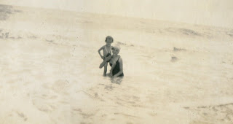

More Next Post on the sixth Child of Ulyss and Pearl Caine Holliman....

Virginia Ruth Holliman Cornelius, 1922
the Sixth Child of Ulyss and Pearl Caine Holliman
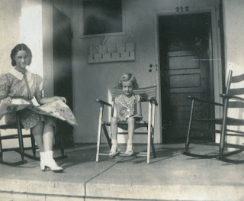
In 1937, Robert Daly rented a house in Miami, Florida for his summer vacation in the Sunshine state. As usual his sister-in-law Virginia went along to help supervise Mary Herrin, now six years old. Here the two sit on a porch. Note Virginia's dress and shoes.
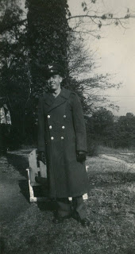
And the war came....Virginia met a gregarious young student while in high school, Walter Cornelius. He later attended Howard College (now Samford University) in Woodlawn. By late January 1942, they were married, and by 1943, Walter (above) was in uniform. Here he is in the yard between the Holliman and Daly houses in Irondale, a lawn where countless photographs were taken from the 1930s to the 1950s.
While Walter was in school in 1942 and 1943, Virginia began working in her brother-in-law's bank in Woodlawn. Robert Daly had lost several men to the draft by 1942, and Virginia started working, temporarily. Little did she know it would be a life-time career, and she would pioneer women in Alabama banking.
After World War II, Walter returned home from the Pacific, finished law school and began a career at an attorney. For Virginia and Walter, two girls were soon born - Nancy Carol Cornelius Morton(1945) and Susan Cornelius Williams (1949).
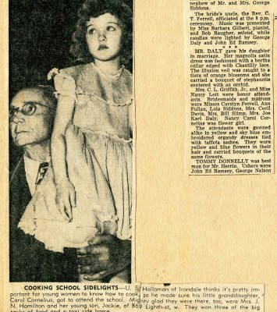
The above clipping ran in 1950 in the Birmingham News. It shows, of all things, Ulyss Holliman with Carol Cornelius, five years old, at a cooking school in downtown Birmingham. Forgive this grandson of Ulyss, but it is difficult for me one to fathom my grandfather attending a cooking demonstration and second, taking a grandchild with him! On the right of the clipping is a portion of Mary Daly and E.C. Herrin's 1951 wedding article. My thanks to cousin Mary for the loan of the article which I scanned into my computer.
Virginia Ruth Holliman Cornelius, 1922
the Sixth Child of Ulyss and Pearl Caine Holliman

Below is a charming 1959 Christmas card of Carol and Susan Cornelius at their home in Homewood, Alabama. Both girls now live in Texas with their own families and grandchildren.
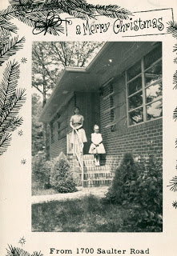

On Virginia's 80th birthday in 2002, her daughters prepared a lovely multi-page biography of their Mother. I can't improve on it, so I reproduce it here with their permission. Just click on the pages and it will enlarge for reading purposes.

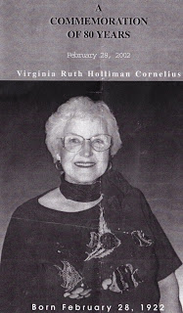

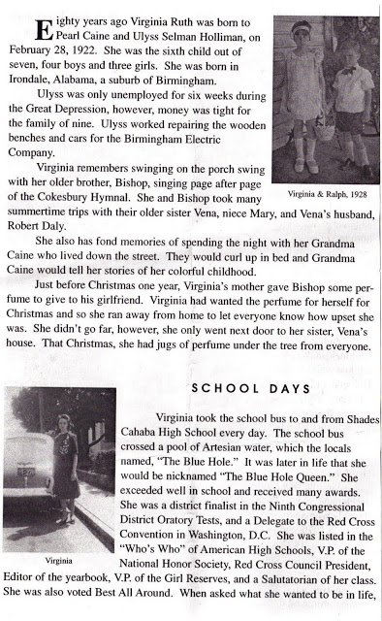
Here is a photo from the 2002 birthday party when this biography was presented. Left to right, Motie Holliman, who has passed away, Ralph Holliman, Virginia, Bishop Holliman and Bishop's wife, Ellen Cox Holliman. Ralph is in the insert picture in the biography above.

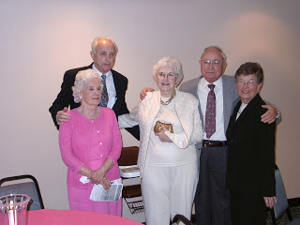

More of her printed biography in the next post....
Note: The information and opinions expressed in these family biographies are those of the writer alone. Comments, corrections and additions are most welcome. The purpose of these articles is to capture a period and family in American history and to pass this legacy along to future generations who share the common bond of family.

Virginia Ruth Holliman Cornelius, 1922
the Sixth Child of Ulyss and Pearl Caine Holliman
We continue to post the 2002 biography of Virginia as prepared by her family.
Continued from the previous posting...
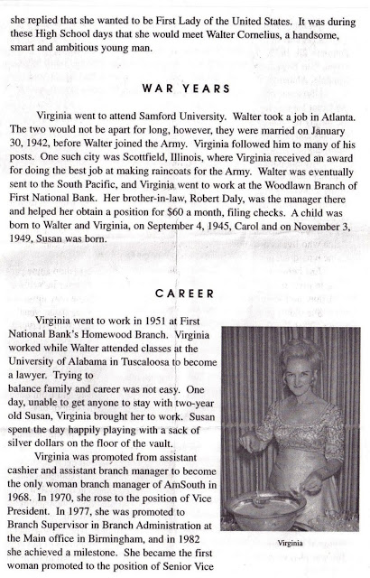
Below, in 1970, Virginia, right, visits with her sister, Loudelle Holliman Ferrell.
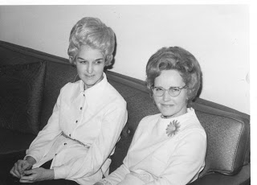
Photo by Glenn Holliman at Mary and E.C. Herrin's, Irondale, Alabama
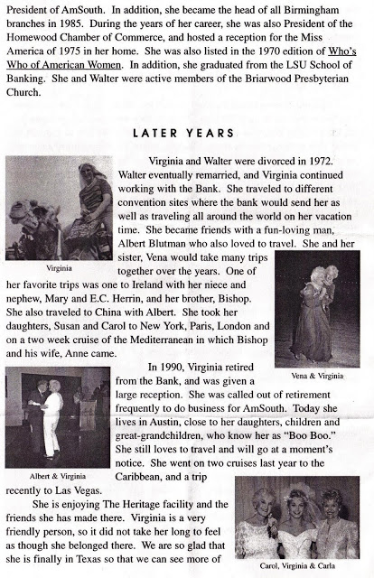

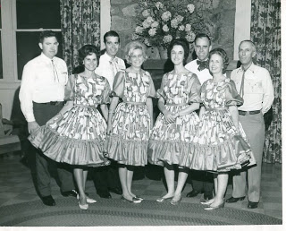
Virginia and Walter, second from right, in happy days in the 1960s.
More Next Posting on this pioneer in Alabama business....
Virginia Ruth Holliman Cornelius, 1922
the Sixth Child of Ulyss and Pearl Caine Holliman

We continue from the previous post with the printed biography of my Aunt Virginia Holliman Cornelius, a pioneer for women in Alabama banking. Virginia lives today in Austin, Texas near her children.
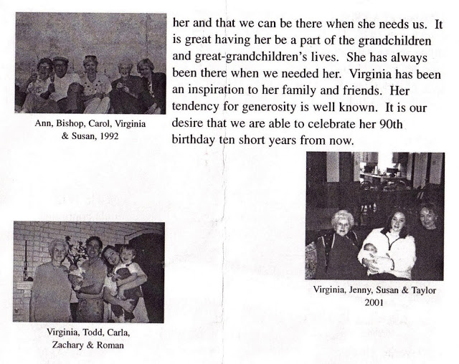

Below, Vena, Ralph, Virginia and Bishop, four brothers and sisters in 1978 in Birmingham, Alabama.
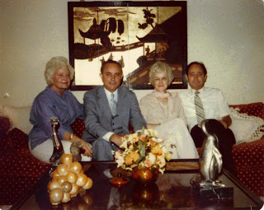

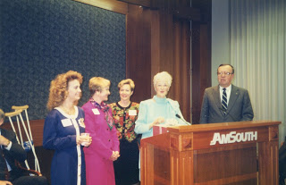
Above, grand daughter, Carla Sebesta, Carol Cornelius Morton, Susan Cornelius Williams, Virginia, and an Am South executive at her retirement in 1990 in Birmingham, Alabama. The clippings from Am South through the years describing Virginia's career have been many.
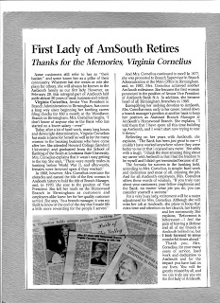
Below, the immediate family as of 2002 of Virginia.
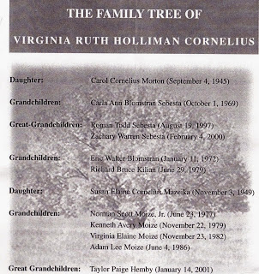

Next posting, before featuring the seventh child of Ulyss and Pearl Caine Holliman, we shall detour to the 1930s for a nostalgic look of summer vacations by Bishop Holliman, the fifth child.
Note: The information and opinions expressed in these family biographies are those of the writer alone. Comments, corrections and additions are most welcome. The purpose of these articles is to capture a period and family in American history and to pass this legacy along to future generations who share the common bond of family.

The Passing of Virginia Holliman Cornelius, 1922 – 2011
by Glenn N. Holliman, a nephew

On November 3, 2011, after a long decline, my Aunt Virginia left this life in Austin, Texas. In the blog last summer (see older articles section), with the help of her daughters, Carol and Susan, we were able to share part of her story with the larger family. Her daughters had written and published a thoughtful biography of her on her 80th birthday in 2002, which they kindly let me reproduce.

Since the spring of 2011 with the writings of my father, Bishop Holliman, numerous cousins and family memorabilia and photographs, I have been preparing and posting articles on a generation of a Southern family that was deeply affected by the Great Depression and World War II.
Recently, I was able to visit and spend time with my surviving uncle, Ralph Holliman, now of Gulf Shores, Alabama. Later in this space, I will be sharing some of his story with his great nieces and nephews who have been born long after World War II and who will experience most of their lives in the 21st Century.
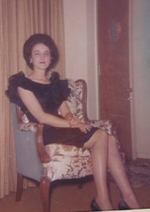
Virginia Holliman Cornelius, above, in 1964.

With the death of Virginia, my last aunt has passed away on my Father’s side of the family. Three girls were born to Ulyss and Pearl Caine Holliman, each unique and beautiful in different ways. Vena Holliman Daly Buckheit (1910 - 1990) married in 1928 to Robert Daly, Sr., a banker and fabulous mentor to Bishop, Virginia and Ralph Holliman during their growing up in Irondale, Alabama. Vena was full of grace and poise, dignified and soft spoken and a lovely Southern lady who brought charm and calm to the family.
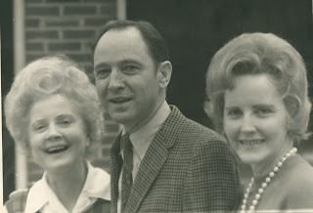
Above left Vena Holliman Daly Bucheit (1910 – 1990), Bishop Holliman (1919) and Loudelle Ferrell (1914 – 1996) at the 1970 Irondale, Alabama reunion.

Loudelle Holliman Ferrell (1914 – 1996), quiet, graceful, dignified, thoughtful, she married an up and coming Methodist minister, Charles H. Ferrell, in 1935. A graduate of Birmingham-Southern and Yale Divinity School, this well-educated man served as another strong role model for the three youngest Holliman children of that generation. By 1935, the two older brothers, Melton (1908 – 1958) and Euhal Holliman (1912 – 1989), had already married and left the parental home.
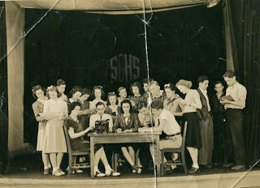
Above center is Virginia and to the left is her future husband, Walter Cornelius behind the type writer at Shades Cahaba High School. Third from the right may be Ralph Holliman, Virginia's younger brother.
At Shades Cahaba High School, Class of 1941, Virginia seems to have won every award and held every office possible. When one reviews The Owl, the school yearbook, she leaps out of many pages, sitting center in almost all the group photos, obviously the leader, the poised, already accomplished person readying to come of age in a world still dominated by the male gender.
In early winter of 1942, Virginia and Walter married at the home of Robert and Vena Daly in Irondale, Alabama. War interrupted that marriage, with Walter in 1943 entering the Army Air Corp and after training in the U.S., was stationed in Saipan. He was there as a ground crew person when the B-29 aircraft took off from nearby Tinian Island and dropped the atomic bombs that effectively ended the Pacific War.
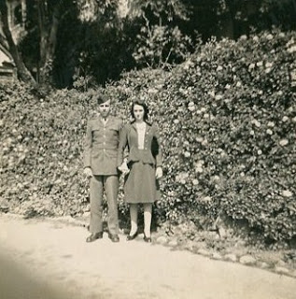
Virginia and Walter at one of his training stations in the United States before assignment to the Pacific.

During the War, Virginia took ‘temporary’ employment at her brother-in-law Robert Daly’s bank in Woodlawn, Alabama and remained in banking while giving birth in 1945 to Nancy Carol Cornelius Morton and in 1951 to Susan Cornelius Williams.
After the War using the G.I. Bill, Walter became an accomplished lawyer. Walter also was a talented guitar player and often led his own band. The couple would raise their daughters to maturity, before the war time marriage ended in divorce in the early 1970s. Walter died in 2006.
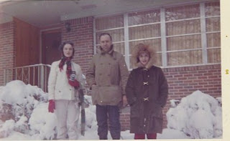
A rare, heavy snow in Birmingham in 1964 with Virginia, Walter and Carol Cornelius.
For Virginia, the employment opportunity of banking during World War II became a career, a pioneering enterprise for a woman of her generation. She broke many ‘glass ceilings’ in a male-dominated profession, and served as a role model for the females in her extended family and no doubt, a mentor for many in financial services. For this she was recognized in publications and by her peers.
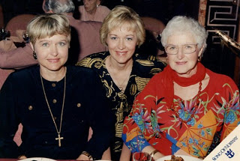
Three lovely ladies, above, Carol, Susan and their mother, Virginia on a 1990s cruise.
On November 20, 2011, members of her family gathered in Dallas, Texas to honor Virginia’s life and accomplishments. In spite of her tremendous career, I suspect she would say that her greatest accomplishments were the daughters, grandchildren and great grandchildren that gathered with other family members to celebrate a life well-lived.
For the record, I insert the Birmingham News obituary published November 7 and 8, 2011.
CORNELIUS, VIRGINIA H. Virginia H. Cornelius, of Birmingham, AL, passed from this life and into the presence of her Lord and Savior on 11/3/2011 at the age of 89. She was born in Irondale, AL, on 2/28/1922. Virginia graduated from Shades Cahaba High School and attended Samford University and LSU. She retired as Sr. VP of AmSouth Bank (now Regions Bank) and was the first woman to hold this position. Virginia is still remembered as the "First Lady of AmSouth". Her civic activities included: President Homewood Chamber of Commerce and Secretary for the Board of Trustees at Samford University. Virginia was published in the book, "You Too Can Be an Executive". Boo Boo, as her grandchildren called her, loved life and until she went into that "long goodbye of Alzheimer's", spent time with her family and friends, traveling, visiting, and babysitting her grandchildren. Virginia was preceded in death by her grandson, Eric Blomstran and five brothers and sisters. She will be remembered as a wonderful Christian woman who never hid her light and always strived to be the best in everything that she undertook. Virginia was and will continue to be a tremendous inspiration to all of us who had the wonderful privilege of knowing and loving her. She is survived her daughters, Carol C. Morton of San Antonio, TX, and Susan Williams of Cedar Park, TX, two brothers, 6 grandchildren and 8 great grandchildren. Virginia resided in San Antonio, TX, at the time of her death. The memorial service for her will be conducted at: Fellowship Bible Church, 9330 N. Central Expressway, Dallas, TX, at 4:00 p.m., November 20, 2011. RSVP to: (512) 626-3559. In lieu of flowers, a tax deductible donation in memory of Virginia Cornelius may be made to one of the following: Barabbas Ministries, P.O. Box 461531, San Antonio, TX 78246-1531 or Fellowship Bible Church, 9330 N. Central Expressway, Dallas, TX 75231.

As one of nineteen first cousins of the seven children of Ulyss and Pearl Holliman, I marvel at the lives of my aunts and uncles. They were for our times “The Greatest Generation”. GNH

