The Passing of Virginia Holliman Cornelius, 1922 – 2011
by Glenn N. Holliman, a nephew
On November 3, 2011, after a long decline, my Aunt Virginia left this life on November 3, 2011 in Austin, Texas. In the blog last summer (see older articles section), with the help of her daughters, Carol and Susan, we were able to share part of her story with the larger family. Her daughters had written and published a thoughtful biography of her on her 80th birthday in 2002, which they kindly let me reproduce.
Since the spring of 2011 with the writings of my father, Bishop Holliman, numerous cousins and family memorabilia and photographs, I have been preparing and posting articles on a generation of a Southern family that was deeply affected by the Great Depression and World War II. Recently, I was able to visit and spend time with my surviving uncle, Ralph Holliman, now of Gulf Shores, Alabama. Later in this space, I will be sharing some of his story with his great nieces and nephews who have been born long after World War II and who will experience most of their lives in the 21st Century.
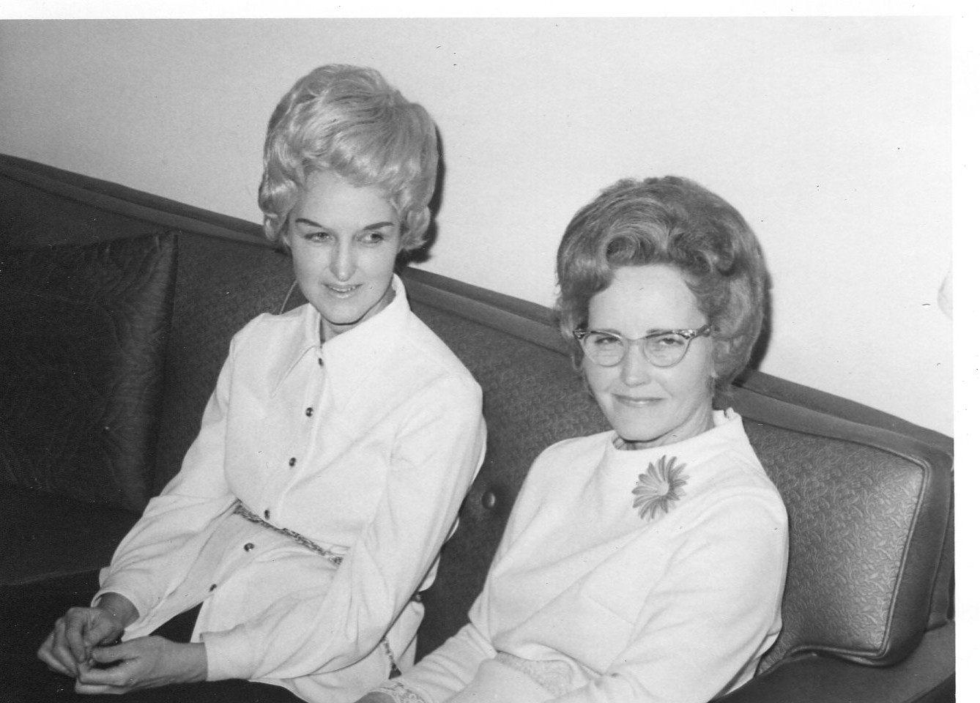
Above at an Irondale family reunion in 1970 are sisters Virginia Holliman Cornelius (1922 – 2011) and Loudelle Holliman Ferrell (1914 – 1996).
With the death of Virginia, my last aunt has passed away on my Father’s side of the family. Three girls were born to Ulyss and Pearl Caine Holliman, each unique and beautiful in different ways. Vena Holliman Daly Buckheit (1910 - 1990) married in 1928 to Robert Daly, Sr., a banker and fabulous mentor to Bishop, Virginia and Ralph Holliman during their growing up in Irondale, Alabama. Vena was full of grace and poise, dignified and soft spoken and a lovely Southern lady who brought charm and calm to the family.
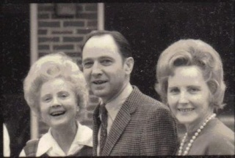
Above left Vena Holliman Daly Bucheit (1910 – 1990), Bishop Holliman (1919) and Loudelle Ferrell (1914 – 1996) at the 1970 Irondale, Alabama reunion.
Loudelle Holliman Ferrell (1914 – 1996), quiet, graceful, dignified, thoughtful, she married an up and coming Methodist minister, Charles H. Ferrell, in 1935. A graduate of Birmingham-Southern and Yale Divinity School, this well-educated man served as another strong role model for the three youngest Holliman children of that generation. By 1935, Melton (1908 – 1958) and Euhal Holliman (1912 – 1989) had already married and left their parental home.
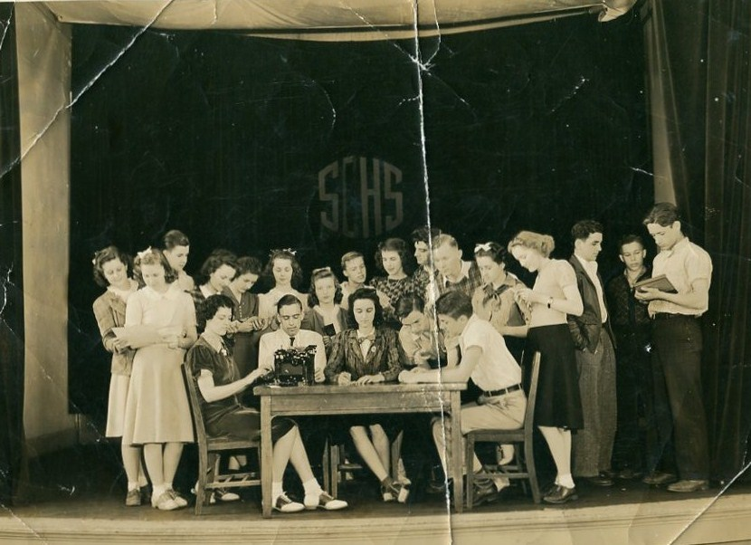
Above center is Virginia and to the left is her future husband, Walter Cornelius.
At Shades Cahaba High School, Class of 1941, Virginia seems to have won every award and held every office possible. When one reviews The Owl, the school yearbook, she leaps out of many pages, sitting center in almost all the group photos, obviously the leader, the poised, already accomplished person readying to come of age in a world still dominated by the male gender. In this picture above her future husband and father of Carol and Susan Cornelius, Walter Cornelius, sits to her left.
In early winter of 1942, Virginia and Walter married at the home of Robert and Vena Daly in Irondale, Alabama. War interrupted that marriage, with Walter in 1943 entering the Army Air Corp and after training in the U.S., was stationed in Saipan. He was there as a ground crew person when the B-29 aircraft took off from nearby Tinian Island and dropped the atomic bombs that effectively ended the Pacific War.
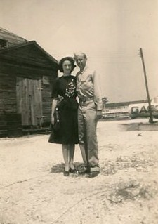
Virginia and Walter at one of his training stations in the United States before assignment to the Pacific.
During the War, Virginia took ‘temporary’ employment at Robert Daly’s bank in Woodlawn, Alabama and remained in banking while giving birth in 1945 to Nancy Carol Cornelius Morton and in 1951 to Susan Cornelius Williams. After the War using the G.I. Bill, Walter became an accomplished lawyer. Walter also was a talented guitar player and often led his own band. The couple would raise their daughters to maturity, before the war time marriage ended in divorce in the early 1970s. Walter died in 2006.
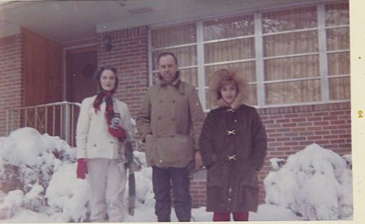
A rare, heavy snow in Birmingham in 1964 with Virginia, Walter and Carol Cornelius.
For Virginia, the employment opportunity of banking during World War II became a career, a pioneering enterprise for a woman of her generation. She broke many ‘glass ceilings’ in a male-dominated profession, and served as a role model for the females in her extended family and no doubt, a mentor for many in financial services. For this she was recognized in publications and by her peers.
On November 20, 2011, members of her family gathered in Dallas, Texas to honor Virginia’s life and accomplishments. I suspect she would say that her greatest accomplishments were the daughters, grandchildren and great grandchildren that gathered with other family members to celebrate a life well-lived.
For the record, I insert the Birmingham News obituary published November 7 and 8, 2011.
VIRGINIA H. CORNELIUS
CORNELIUS, VIRGINIA H. Virginia H. Cornelius, of Birmingham, AL, passed from this life and into the presence of her Lord and Savior on 11/3/2011 at the age of 89. She was born in Irondale, AL, on 2/28/1922. Virginia graduated from Shades Cahaba High School and attended Samford University and LSU. She retired as Sr. VP of AmSouth Bank (now Regions Bank) and was the first woman to hold this position. Virginia is still remembered as the "First Lady of AmSouth". Her civic activities included: President Homewood Chamber of Commerce and Secretary for the Board of Trustees at Samford University. Virginia was published in the book, "You Too Can Be an Executive". Boo Boo, as her grandchildren called her, loved life and until she went into that "long goodbye of Alzheimer's", spent time with her family and friends, traveling, visiting, and babysitting her grandchildren. Virginia was preceded in death by her grandson, Eric Blomstran and five brothers and sisters. She will be remembered as a wonderful Christian woman who never hid her light and always strived to be the best in everything that she undertook. Virginia was and will continue to be a tremendous inspiration to all of us who had the wonderful privilege of knowing and loving her. She is survived her daughters, Carol C. Morton of San Antonio, TX, and Susan Williams of Cedar Park, TX, two brothers, 6 grandchildren and 8 great grandchildren. Virginia resided in San Antonio, TX, at the time of her death. The memorial service for her will be conducted at: Fellowship Bible Church, 9330 N. Central Expressway, Dallas, TX, at 4:00 p.m., November 20, 2011. RSVP to: (512) 626-3559. In lieu of flowers, a tax deductible donation in memory of Virginia Cornelius may be made to one of the following: Barabbas Ministries, P.O. Box 461531, San Antonio, TX 78246-1531 or Fellowship Bible Church, 9330 N. Central Expressway, Dallas, TX 75231.

As one of seventeen first cousins of the seven children of Ulyss and Pearl Holliman, I marvel at the lives of my aunts and uncles. They were for our times “The Greatest Generation”. GNH

