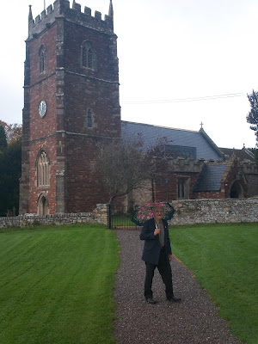

A Visit to Abbots Leigh, Somerset....

Fred Cooper on a showery day stands in front of The Church of the Holy Trinity, Abbot Leigh, where his wife and her ancestors rest.

In the late autumn of 2011, distant cousin Fred Cooper, who married into the Somerset, England Hollyman family, took my wife, Barb, and me on a tour of Hollyman sites southeast of the Cathedral city of Bristol, England.

Readers of this blog will remember that from 1554-1558, one John Holyman, served as Roman Catholic bishop of the Bristol diocese. John Holyman as born in Cuddington, Buckinghamshire, and after a dangerous career in the priesthood during Tutor times, held the Episcopate during the reign of Mary Tutor.

Fred pauses by a Hollyman family memory stone. In honour of his believed late wife, Sheila Wallace Cooper, whose mother was a Hollyman, Fred has gathered an impressive amount of genealogical data on her family. At his passing, Fred intends that a copy of the massive work on Somerset Hollymans goes to the Bristol archives.
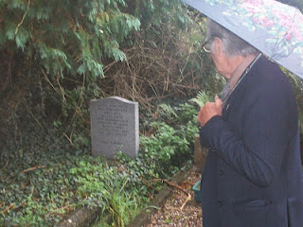

The village of Abbots Leigh has a fascinating history. While on the run after his disastrous defeat at Worcester in 1651, Charles II took refuge in the manor house in Abbots Leigh. He rested for three days before moving on. The Norton family, who sheltered the disguised stranger, had no idea who he was until after he had left!

While staying at Abbots Leigh, Charles deflected suspicion by asking a soldier, who had been in the King's personal guard, to describe the young King's appearance and clothing at the recent battle. The trooper looked at Charles and remarked, "The King was at least three inches taller than you."

Today the historic Monarch's Way footpath passes through the village. Horse riders in 2011 take advantage of a modern roadway to find their own way through Abbots Leigh on a rainy day.
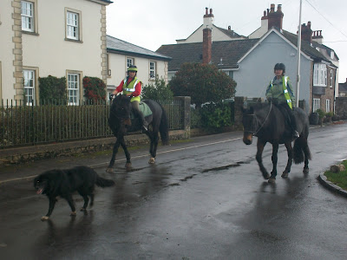

Next more Hollyman ancestors in Abbots Leigh....

