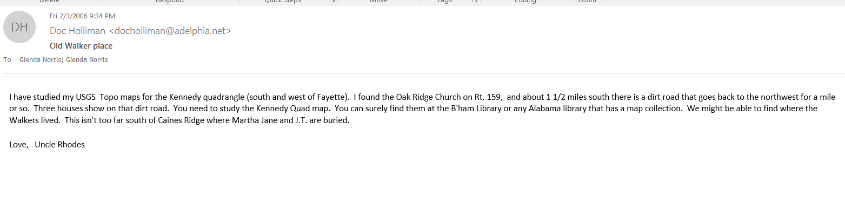

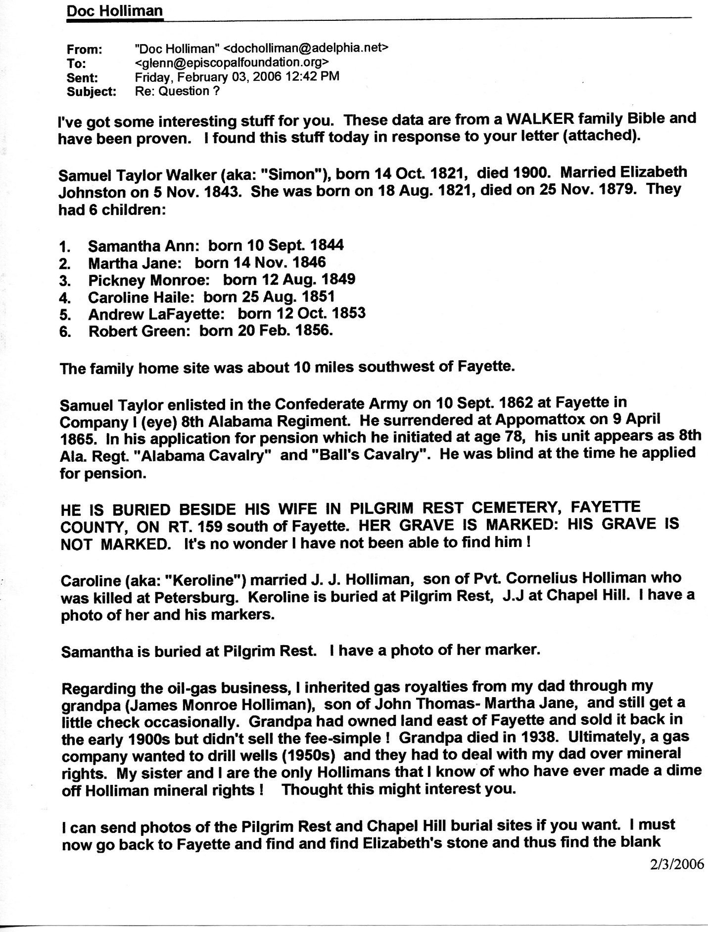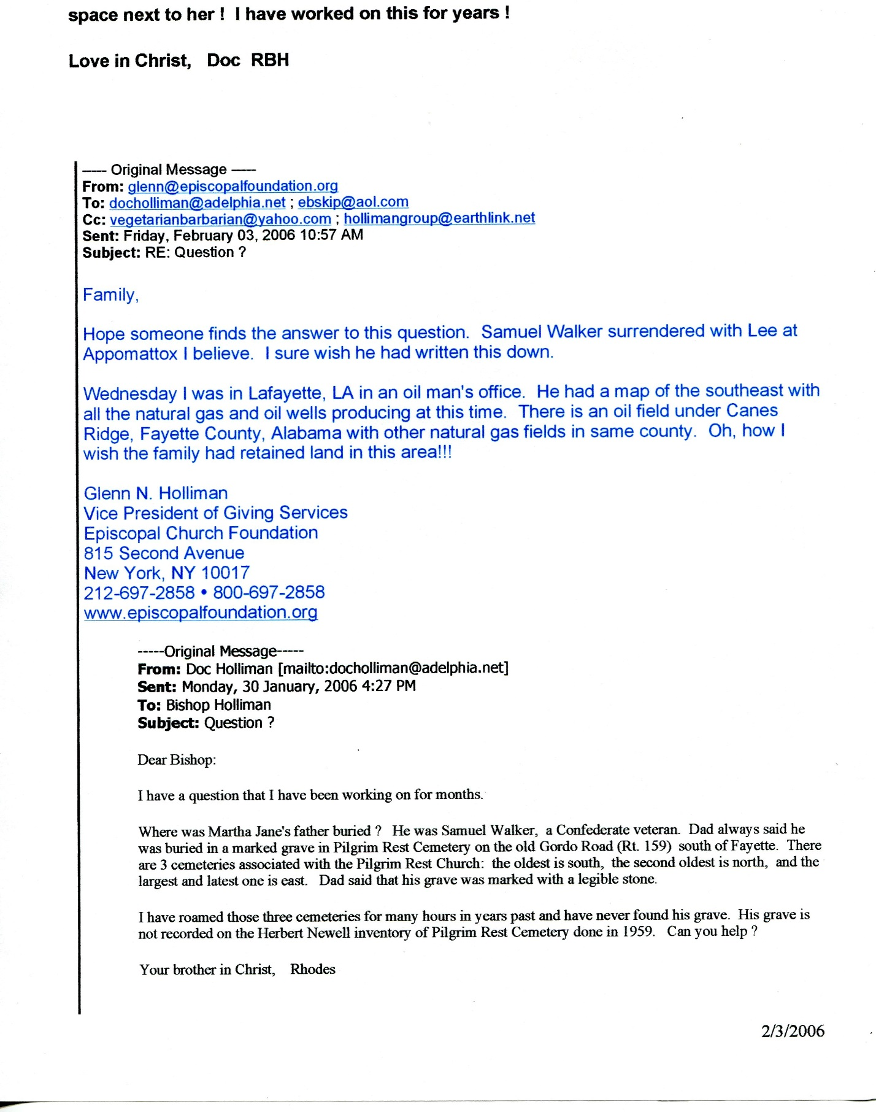 Sam’s 2nd wife was NOT Salina….it is SARENA!!!!!!!!

I did a search on Ancestry.com (I’m doing a free 14 day “trial”).

This is what I found:
Samuel T. Walker
HOME in 1900: Hico, Fayette, Alabama
Martha C. Walker 50- wife
Cathus T. Walker 22- son
Father
White
Pinkney M. walker 49 - Head
Samuel T. Walker 78 - Father
Sarena Walker 74 – S-mother

Sam and Sarena lived with Sam’s son “Pinkney” and his wife Martha. Cathus and Ulus must be Pinkney and Martha’s son’s…

I’ve been searching for a “salina” all this time. Papa had it wrong in his book. Its weird though because I have found a marriage record which matches the marriage date of Sam and Sarena…but it does have Sarena’s spelling as Salina…go figure?????
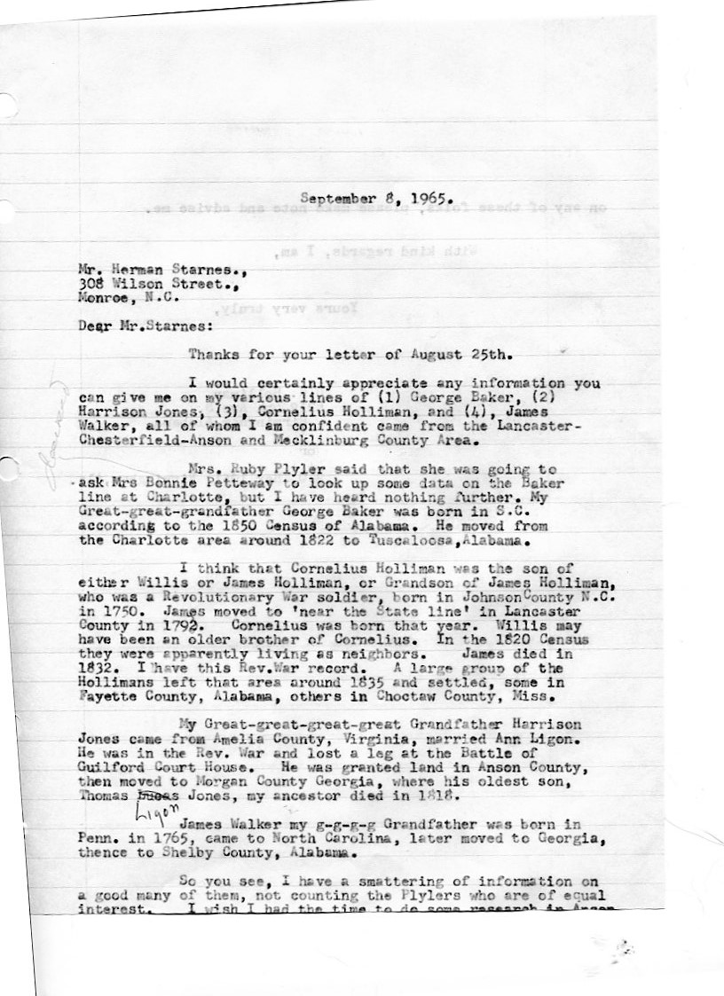 On Tue, Feb 5, 2013 at 2:48 PM, Glenda Norris <gnorris@bcbsal.org> wrote:
Went to a Shelby County Alabama historical site. Found a few things on the Walkers:
1820 Census
James Walker
Showed 2 males living in household over 21
3 males under 21 years
2 females over 21
2 females under 21
Total of 9
1830 Census
Alex Walker
Andrew Walker
James Walker
James Walker
John Walker
Richard Walker
1840 census
Andrew Walker
James Walker
John Walker
Joseph Walker
T.T. Walker
Marriage records 1821
Andrew Walker – Jane Gamble Feb 1, 1821
Aron Gamble – Deidama Walker – October 21, 1919 (wonder if this Walker is related to James and married a sister of Jane Gamble).
All this saying, been thinking about Samuel Taylor….
Found his marriage records on the website as well.
Walker, Samuel Johnson, Elizabeth 11/05/1843 145
1840 census shows Samuel still living in Shelby County (obviously since he married in 1843).
The 1850 list walkers, but does not show names….

Fayette County, Alabama
~ Pilgrim Rest Baptist Church Cemetery ~
Location: About five miles south of Fayette on State Hwy 59 ~ “Very Old” and “Old” sections are near the church (S35-T16S-R13W); “New” section is across the highway from church (S2-T17S-R13W)
Copied by: Herbert M. Newell Jr. & Jeanie Patterson Newell - 30 Jul & 8 Aug 1958 ~ (additions/corrections are highlighted)
[ Very Old Section ]
CAIN, Felix T., son of W.L. & L.C. Cain - Jan 10, 1886 - Feb 1, 1887
EDMONDS, F.A. - July 12, 1860 - Apr 13, 1880
HOLLIMAN, Keroline, wife of J.J. Holliman - Aug 25, 1851 - Sept 15, 1921 ~ (first name: Kerloine?)
LABOON, Samantha A. Walker, wife of F.M. Laboon - Sept 10, 1844 - July 25, 1881 ~ (md. Jan 1, 1871)
RICHARDSON, Sidney H., son of G.W. & M.A. Richardson - Feb 7, 1885 - June 24, 1886
WALDEN, Tom J. - Aug 3, 1863 - Oct 30, 1957
WALKER, Elizabeth - Oct 18, 1821 - Nov 25, 1879 ~ (nee JOHNSTON; wife of Samuel Walker; md. Nov 5, 1843) [2]
WALKER, Samuel Taylor - Oct 14, 1821 - 1900 ~ (unmarked grave; dates from family records) [2]
[ Old Section ]
BRANYON, J.A. - July 1, 1804 - Aug 6, 1884
CARAWAY, Andrews H. - Dec 25, 1849 - Sept 1, 1931
CARAWAY, Martha E. Branon, wife of A.H. Caraway - Oct 18, 1855 - Mar 22, 1886 ~ (md. Feb 9, 1873)
CARAWAY, Sarah Frances - Feb 25, 1858 - Aug 31, 1925
CARRAWAY, Cullen Bascom - d. July 11, 1958 ~ aged 74y-5m-3d
COLLINS, Green B. - Dec 1819 - Mar 13, 1895
COLLINS, Phebe - Aug 28, 1817 - Feb 16, 1904
TURNES, Minnie Yerby - Feb 3, 1870 - Oct 22, 1944
WALKER, Almer - Sept 13, 1881 - July 22, 1889 ~ aged 7y-10m-9d
YERBY, Allice C. - Jan 13, 1857 - Sept 28, 1861
YERBY, Curtis C. - Mar 28, 1874 - May 2, 1891
YERBY, Francis M. - July 13, 1829 - Aug 10, 1887
YERBY, Lidia - Jan 11, 1833 - Jan 7, 1891 ~ (md. Feb 15, 1850)
YERBY, W.W. - May 10, 1859 - Sept 24, 1861
[ New Section ]
ABERNATHY, C.J. (Jr.) - Nov 4, 1923 - June 9, 1953
ABERNATHY, Ella Plyler - Dec 16, 1879 - July 19, 1954
ABERNATHY, Guy, son of M.J. & A.G. Abernathy - July 23, 1905 - Mar 5, 1907
ABERNATHY, Peter - Sept 15, 1933 - June 13, 1938
ABERNATHY, Zebedee C. - June 20, 1916 - Apr 30, 1951 ~ Ala. T. Sgt., 377 A.F. Air SVC (date of birth: June 30?)
ALEXANDER, Betty Jo - Nov 19, 1949 - Feb 6, 1950
BEARD, Infant dau - May 4, 195_ ~ (year of death hard to read)
BLACK, William B. - Dec 17, 1875 - Jan 27, 1950
BRANYON, Jack W. (Rev.) - Nov 6, 1928 - Nov 5, 1955 ~ (last name: BRAYNON?)
CARAWAY, Elmer R. - Mar 29, 1885 - Jan 4, 1903
CARAWAY, Nora E. - 1864 - 1943
CARAWAY, Willia N. - 1857 - 1913
CHANNELL, John A. - May 5, 1887 - Apr 10, 1951
CONNER, R.B. - July 14, 1868 - Sept 18, 1917
DAVIS, Addie - Nov 3, 1851 - Aug 8, 1922
DAVIS, Charles N. - Apr 11, 1881 - Feb 17, 1920
DAVIS, Eunice Fay, dau of Mr. & Mrs. M.L. Davis - Sept 8, 1913 - Jan 25, 1918
DAVIS, Henry - Feb 28, 1849 - Sept 11, 1930
DAVIS, Lizzie - 1882 - 1954
DAVIS, Wardie May, dau of N.C. & Lizzie Davis - May 14, 1907 - July 17, 1911
FREEMAN, Allen H. ~ Co. H, 41 Ala. Inf., C.S.A. (Allen Hamby Freeman, b. 1830 in SC; d. 13 Dec 1895; md. Martha Evaline CROW) [1]
FREEMAN, Charles M. - 1871 - 1946 ~ (Charles Marion Freeman, son of Allen & Martha Freeman, b. July 1871; d. 22 Apr 1946; md. Lona/Lonia LINDSEY) [1]
FREEMAN, Claude L. - Dec 22, 1898 - Aug 23, 1949
FREEMAN, Col - 1869 - 1954 ~ (Collie Freeman; recorded with brother Ollie as grandsons in Allen H. Freeman household on 1880 U.S. census) [1]
FREEMAN, Colly - 1901 - 1902
FREEMAN, Eloil, dau of W.L. & M.E. Freeman - Aug 27, 1895 - Apr 25, 1901
FREEMAN, G.W. (Rev.) - Nov 23, 1845 - Jan 6, 1920
FREEMAN, Hollis - 1908
FREEMAN, John A. - July 12, 1862 - Aug 1913 ~ (son of Allen & Martha Freeman) [1]
FREEMAN, Julia, wife of Rev. G.W. Freeman - May 6, 1842 - Nov 25, 1929
FREEMAN, Lonia L. - 1884 ~ (nee Lona/Lonia LINDSEY, wife of Charles M. Freeman, b. Oct 1883, d. 1969/1971; may have had middle initial "C.") [1]
FREEMAN, Lumie, son of C.N. & L.C. Freeman - Jan 15, 1899 - June 22, 1899 ~ (Lennie Freeman, son of Charles & Lona Freeman) [1]
FREEMAN, Mamie Ellis, wife of L.L. Freeman - 1890 - 1906
FREEMAN, Mary Ella - Jan 3, 1877 - May 6, 1956
FREEMAN, Michael W. - July 21, 1873 - Feb 23, 1949
FREEMAN, Mollie J. - Oct 6, 1878 - Apr 10, 1952
FREEMAN, Rose Etta - 1875
FREEMAN, Stella - 1898 - 1901
FREEMAN, Sweet, son of W.L. & M.E. Freeman - Feb 8, 1903 - July 9, 1903
FREEMAN, Tirrie, son of W.L. & M.E. Freeman - Nov 28, 1909 - Oct 15, 1915
FREEMAN, Una - 1909 - 1911
FREEMAN, William L. - May 14, 1860 - June 26, 1929 ~ (son of Allen & Martha Freeman) [1]
GLADDEN, M.F. - Feb 17, 1860 - June 18, 1868
GLADDEN, V.V. - Mar 8, 1864 - Dec 18, 1864
GREGG, Dessie (Mrs.) - d. June 12, 1957
GREGG, Oliver C., son of Mr. & Mrs. O.F. Gregg - 1915 - 1916
HAYWOOD, ___on - Jan 2, 1861 - June 18, 1863 ~ (first name unreadable)
HOLLIMAN, Ector - Apr 4, 1910 - July 16, 1956 ~ (son of John A. Holliman & Martha E. ABERNATHY) [4]
HOLLIMAN, James Everet - Feb 4, 1930 - Nov 29, 1932 ~ (son of John A. Holliman & Martha E. ABERNATHY) [4]
HOLLIMAN, John A. - Feb 12, 1889 - Nov 1, 1970 ~ (son of Francis Marion Holliman & Nancy Jennie HENDERSON) [4]
HOLLIMAN, Martha E. - Feb 23, 1887 - Jan 20, 1962 ~ (nee Martha "Evie" ABERNATHY, wife of John A. Holliman) [4]
HORN, Alonzo F. - 1875 - 1945
HORN, Marsh - 1850 - 1894
HORN, Media - 1880 - 1958
HORN, Robert M. - Sept 5, 1914 - Dec 22, 1943
HORN, Roserzema Lindsey - Dec 29, 1879
HORN, Sallie - 1852 - 1937
HORN, Son of Mr. & Mrs. F.A. Horn - 1899 ~ (only one date)
HORNE, G.A. - Oct 4, 1868 - Feb 1892
HORNE, G.W. - Jan 11, 1831 - June 16, 1912
HORNE, R.A. - Jan 22, 1832 - Nov 19, 1897
HUGHES, Argie P. (Mrs.) - d. Mar 21, 1958 ~ aged 80y-5d
IVY, Evelyn Glover - May 20, 1920 - Dec 25, 1952
JACKS, S.M. (Rev.) - 1883 - 1939
JOHNSON, Curt - 1879 - 1942
JOHNSON, Erma - 1881 - 1919 ~ (nee Erma E. NELSON, dau of W.J. & T.J. Nelson; wife of Curtis "Curt" Johnson) [3]
JOHNSON, James V. - Dec 24, 1938 ~ Ala. Wagoner, 324 Inf, 81 Div.
JOHNSON, Jeanette - 1848 - 1950
LINDSEY, Adel, dau of R.T. & Zora Lindsey - May 30, 1910 - Dec 16, 1912
LINDSEY, Garland - Oct 9, 1893 - Aug 11, 1895
LINDSEY, Houston - Apr 11, 1917 - Dec 21, 1945
LINDSEY, Infant of J.A. & O.E. Lindsey - b./d. June 14, 1908
LINDSEY, J.C., wife of J.W. Lindsey - Feb 15, 1853 - Mar 26, 1913 ~ (nee Judah Catherine TAYLOR, wife of John W. Lindsey; census records show 1851 as birth year) [1]
LINDSEY, James M. - Dec 4, 1828 - July 18, 1903
LINDSEY, John Dewey - Aug 5, 1898 - Aug 3, 1899
LINDSEY, John H. - Sept 1, 1880 - Mar 30, 1928 ~ (son of John & Judah Lindsey; census records show 1881 as birth year) [1]
LINDSEY, John T., son of J.A. & O.E. Lindsey - May 18, 1905 - Feb 18, 1906
LINDSEY, Laura Horn - 1906 - 1954
LINDSEY, Nancy J. - Nov 22, 1833 - Nov 6, 1915 ~ (wife of James M. Lindsey) [1]
LINDSEY, R.B. - Aug 5, 1906 - July 5, 1908
LINDSEY, R.T. - Dec 11, 1859 - May 16, 1911
LYNN, John G. - 1874 - July 31, 1956 ~ aged 74y-4m-28d
LYNN, Oma - 1891 - June 5, 1957
McDONALD, Stanley W. - d. May 23, 1955 ~ aged 1y-20d
NELSON, Amiiel W. - Aug 26, 1895 - Mar 4, 1896
NELSON, Doar I., wife of W.M. Nelson - Dec 18, 1872 - Jan 26, 1916
NELSON, H.G. - June 30, 1878 - Aug 22, 1937 ~ (Horace Greely Nelson, son of W.J. & T.J. Nelson) [3]
NELSON, Infant dau of Mr. & Mrs. W.A. Nelson - b./d. Jan 25, 1935
NELSON, Rachel Joe - b./d. 1939
NELSON, T.J., wife of W.J. Nelson - 1851 - 1921 ~ (nee Talitha Jane RAY, dau of Eligha Ray & Lucy Ann WRIGHT; wife of Jefferson Nelson; d. 14 Nov 1921) [3]
NELSON, Tomie Arrelia - Jan 12, 1901 - July 27, 1902
NELSON, Vaudine, dau of W.M. Nelson - Oct 14, 1911 - Sept 2, 1914
NELSON, Velma - Sept 17, 1902 - Apr 25, 1952
NELSON, W.J. - 1848 - 1912 ~ (William Jefferson Nelson; d. July 1, 1912) [3]
NELSON, William M. - Nov 15, 1872 - May 11, 1946 ~ (Willard Manley Nelson, son of W.J. & T.J. Nelson) [3]
NEWTON, Mary Frances, dau of Mr. & Mrs. N.G. Newton - Feb 22, 1934 - Mar 22, 1934
P_____, H.A. ~ (last name unreadable, no dates)
PLYLER, Cecil, son of L.A. & L.P. Plyler - 1915 - 1917
PLYLER, D.F. - 1853 - 1934
PLYLER, Henry A. - June 25, 1860 - Oct 30, 1865
PLYLER, Infant dau of L.A. & L.P. Plyler - 1910 ~ (only one date)
PLYLER, James W. - Jan 18, 1881 - Sept 9, 1919
PLYLER, Nancy - Dec 6, 1822 - Sept 30, 1906
RAY, Thomas - d. Aug 4, 1935 ~ aged 92y; Co. B, 41 Ala. Inf., C.S.A.
RICHARDSON, George W. - 1858 - 1892
RICHARDSON, M.E., dau of G.W. & M.A. Richardson - Nov 6, 1886 - Sept 20, 1904
ROBERTS, James Wiley - Sept 28, 1870 - Nov 15, 1954
ROBERTS, Jessie - Apr 18, 1902 - Oct 26, 1937
ROBERTS, Lolar - Mar 9, 1871 - Nov 12, 1948
ROGERS, Etta Yerby - Jan 10, 1867 - July 15, 1951
SAVAGE, Louvenia, dau of E.A. & V.A. Savage - Nov 12, 1906 - May 10, 1914
SHEPHERD, James L. - 1876 - 1943
SHEPHERD, Pearl - 1879 - 1957 ~ “Mother”
ST. JOHN, Essie Gilreath - 1881 - 1950
STILL, Roy (Jr.) - 1945 - 1953
TAYLOR, Alice Little (Mrs.) - d. Apr 16, 1955 ~ aged 72y-1m-18d
TURNER, George W. - Mar 1, 1875 - Nov 30, 1925
TURNER, Lela, wife of George W. Turner - Dec 14, 1874 - Jan 24, 1929
TURNER, Moody - May 13, 1901 - July 16, 1924
WALDEN, Donie, wife of W.G. Walden - d. 1900
WALDEN, Infant son of George & Donie Walden - b./d. 1900 ~ (buried with mother)
WALDEN, Minnie Bell (Mrs.) - d. July 19, 1856 ~ aged 84y-7m-14d
WALKER, Belva, dau of A.L. & Georgia Walker - Sept 7, 1884 - Jan 12, 1894
WARD, Sophia Horn - 1859 - 1948
WILSON, Frank (Rev.) - July 22, 1846 - Apr 22, 1927
WILSON, Monica Richardson - 1866 - 1949
WILSON, Sarah Jane, wife of Rev. Frank Wilson - Apr 22, 1844 - Aug 8, 1897
WRIGHT, Julia (Mrs.) - Jan 13, 1875 - Jan 18, 1937 ~ “Mother”
YERBY, Adaline - Mar 5, 1839 - Aug 25, 1916 ~ “His wife”
YERBY, Hogan - Jan 18, 1803 - Nov 14, 1895
YERBY, Isaac S. - Mar 6, 1836 - May 24, 1922
YERBY, John T. - Feb 4, 1833 - Sept 20, 1928
YERBY, Louvenia F. - Aug 6, 1847 - May 25, 1912 ~ “Mother”
YERBY, Mach. A. - Aug 27, 1872 - Feb 12, 1912
YERBY, Maggie - June 16, 1866 - June 12, 1891
YERBY, Mahaly A. Walden, wife of I.S. Yerby - Apr 13, 1855 - July 4, 1876 ~ (md. Dec 18, 1873)
YERBY, S.E. - Mar 30, 1868 - Jan 6, 1923
YERBY, W.I. - Sept 4, 1847 - Aug 15, 1894 ~ “Father”
This material generously transcribed from the written records by
Richard W. SEYM0UR
Additional sources:
[1] Betty Cash, e-mail message, 30 Nov 2003
[2] Glenda Norris & R.B. "Doc" Holliman, e-mail message, 03 Jan 2007
[3] Hill Wright, e-mail message, 10 Apr 2008
[4] Juanita Holliman, e-mail message, 24 May 2008

