The Walter O. Holliman Family History Collection
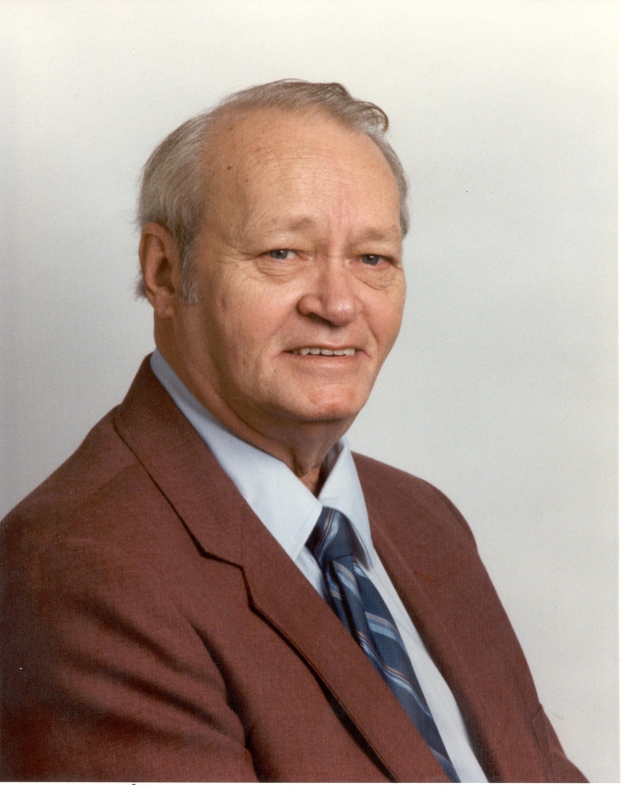
1927 – 2003
In the Fall of 2011, the children of family historian, Walter O. Holliman, late of Pelham, Alabama placed in my custody ten boxes of genealogical work that had been researched and prepared by their father. Walt died before the full capacity of the Internet and family web sites were developed. Today, we are fortunate to have the ability to share materials that in decades past would have stayed hidden in family attics and garages.
It is my pleasure to review Walt’s work and share it with the larger Holliman (various spellings) and associated families. This is a work in progress, and as each document is reviewed and edited, I will be posting his work with an explanation of the status of the material and its scope.

Document #1 – Descendants of Samuel Holliman, prepared January 18, 1997
This is the tree trunk if you will of Walt’s work – his direct line as he understood it in 1997 of Samuel Holliman, born 1707 in Surry County, Virginia and died in 1789. To my knowledge, he never polished or published this document. One can see his word processing errors, in the margins his notes of corrections, inserts and marked through sentences and in some cases whole paragraphs.
So take the work carefully, realizing that Walt, as are all good genealogists, was constantly revising biographies as new papers and research become available.
What I like about Walt’s work is that he documents everything as historians are trained to do. One can look into the end notes and see where he found the material. He even prepared for the reader an index of names and locations. The following fifty-one pages are a gold mine of information for Holliman ancestors.
Your comments and additional information always welcome.
Glenn N. Holliman, B.S., M.A. and M.Ed.

