Back to the 19th Century...A Series of Articles on the Hollimans and Related Families of Fayette County, Alabama

We continue our series of the April 9, 2011 tour of Holliman sites in Fayette County, Alabama led by Glenda Norris, descendant of Christopher Holyman, Sr (1618 - 1691).
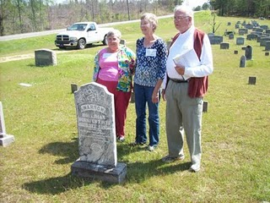

Above at the Chapel Hill Cemetery near Newtonville, Alabama are from left to right: Faye Gardner (Reform, Alabama), Jeanette Holiman Stewart (Austin, Texas) and Lenwood Holliman (Gordo, Alabama). In this April 9, 2011 photograph, they stand behind the grave of Civil War veteran Warren Holliman (1833 - 1908), a son of Charles Holliman (1795 - 1852), of whom the three are descended. Warren is misspelled Warron on his tombstone.

Warren Holliman's story...

In 1836, numerous children accompanied the three brothers, Cornelius, Charles and Warren Holliman, on their journey from the North Carolina/South Carolina border to Fayette County. One of the children of Charles Holliman and wife, Barberry (sometimes Barbara) Walters, was their son, Warren, age 3 at the time.
According to U.S. Census records Fayette County had a population of over 3,000 in 1830, and would more than double in size to over 6,000 in 1840 as immigrates moved west to the yet untitled soil of Alabama.

Warren married Mary Polly Blakeney, the daughter of Thomas and Sarah Kemp or Roberts? Blakeney. Thomas (1800 - 1892) was a son of William Blakeney and a grandson of Capt. John Blekeney, 1732 - 1832. The Blakeneys had migrated to Alabama from Chesterfield, South Carolina. Warren and Polly would have 11 children, 3 girls and 8 boys which helped entrench the Holliman name in the area.

Warren's generation came of age as the American Union dissolved and Civil War engulfed our ancestors. Warren and his two brothers, Cornelius and Elijah, and cousins (including my great grandfather, John Thomas Holliman) joined with other Fayette Countians in enlisting in the 41st Alabama Infantry Regiment. Warren was known as the 'strong man' of the county. He could pick up a bale of cotton (500 pounds) and walk with it!

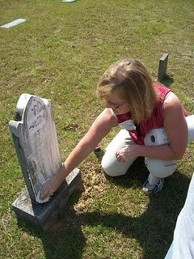
Glenda Norris uses a genealogical technique she learned from Rhodes Holliman, the application of shaving cream to faded tombstones, to reveal hidden names and dates.

In the next post, Warren Holliman's historic war service with the 41st Alabama Infantry Regiment....Glenn N. Holliman

