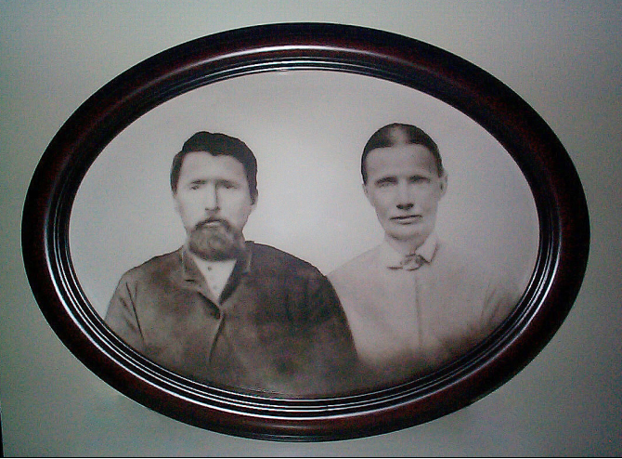

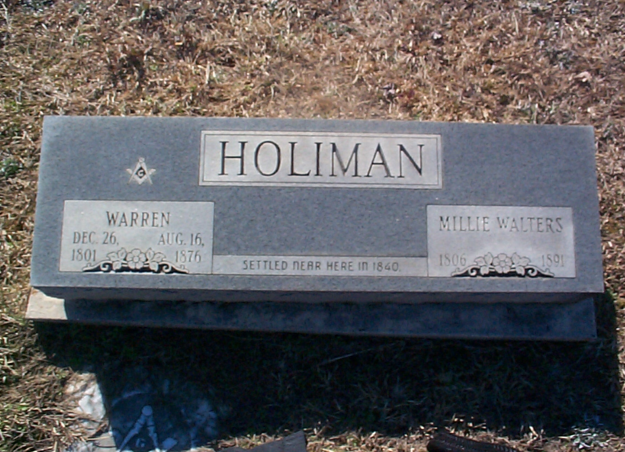----- Original Message -----

From: Doc Holliman
To: Glenda Norris ; Glenda Norris
Sent: Thursday, October 27, 2005 4:16 PM
Subject: A surprise !

Here is a photo of your GREAT - GREAT - GREAT - GREAT - GREAT Uncle and Aunt !!!! Warren and Millie Walters Holiman who departed Newtonville (Fayette County) for Arkansas in 1840. This is the oldest known photo that I have ever seen within our family. Warren was a brother of Cornelius, your 4 great grandpa. Remember, the early pioneers from SC to Fayette County examined the land in 1832 and immigrated in 1835. I wanted to talk about Warren later but this was too good to keep ! My source still lives in Arkansas. Warren changed the name of "Holliman" to "Holiman" when he departed AL. I am busy working this source to death while he is still receptive.

He has sent me 12 photos of Warren related images and I will be improving on these with Photoshop-7. The attached photo is not too good. I will work on the image and improve it. Warren was born about 1800 but I will formalize this date with further study.

This is exactly what I needed to get my mind off tomorrow's butcher shop. A great deal more to follow as I get photos restored and biographical information.

