ACKNOWLEDGEMENTS
Since retirement in 2010, I have been deeply engaged in researching my paternal and maternal roots. With the luxury of time and resources and the assistance of many, I have explored the Internet, archives and libraries of the USA and United Kingdom searching for clues and evidence of my British ancestors.
In this adventure, I have been greatly assisted by the research of Bob Hollyman-Mawson of Wales, who has compiled an awesome directory of Holliman names. Fred Cooper, whose mother-in-law in Bristol, England was a Hollyman, has researched over 400 years of Somerset Hollymans and shared his massive material with me. We are still trying to connect the dots with the Somerset branch, but some day we will do so.
Below left, the late Fred Cooper and Glenn N. Holliman at Fred's home in Bristol. Below right, Jeanette Holiman Stewart and Bob Hollyman-Mason in Wales. Jeanette manages the Holyman Ancestry.com web site.
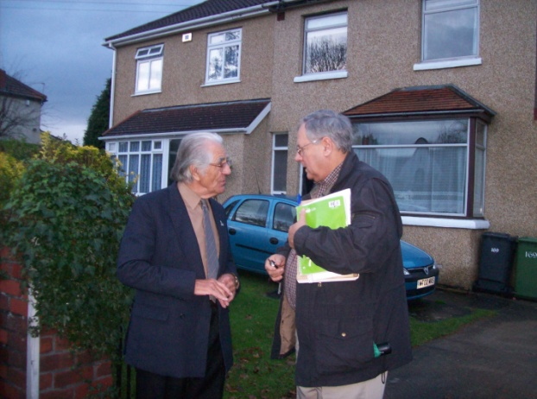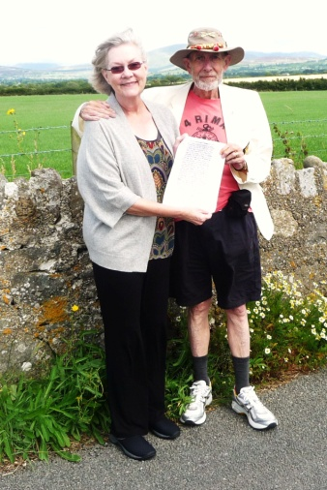
Below in High Wycombe, Buckingshire, Lindsay and Madeleine Holliman, and center, Anne Holmes, professional genealogist, at the parish church where Holyman ancestors are no doubt resting
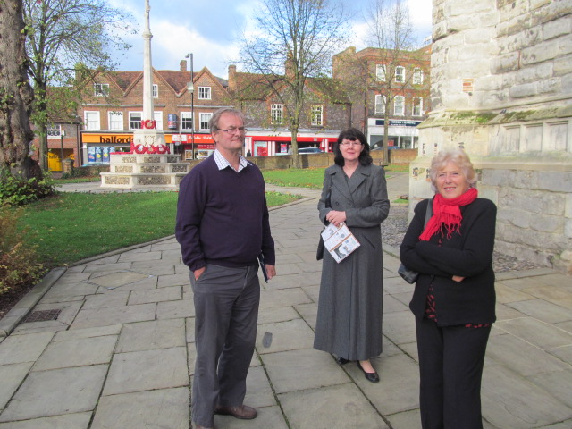
Below, left to right, Peter Smith, researcher of Buckinghamshire, and this writer.
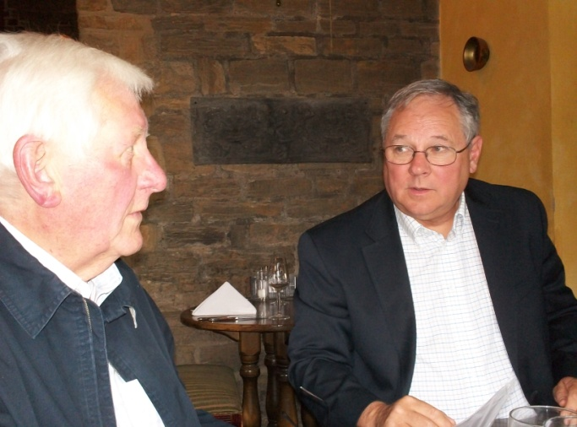
In this venture, I have been guided also by genealogist Peter Smith of Bedfordshire and the rich research of professional family historian, Anne Holmes of Buckinghamshire. Jayne Sullivan of Bristol shared her family lineage as have others through the Internet.
Clinching this research was a 2014 DNA test comparing the results of Lindsay Holliman of Northamptonshire, England with my DNA. Both our paper trails took us to a common direct grandparent, Thomas Hollyman of Cuddington, Buckinghamshire, U.K., died 1558. Much to our mutual delight, the scientific comparison confirmed our relationship and our mutual research! Thanks Lindsay for all your research and sharing.
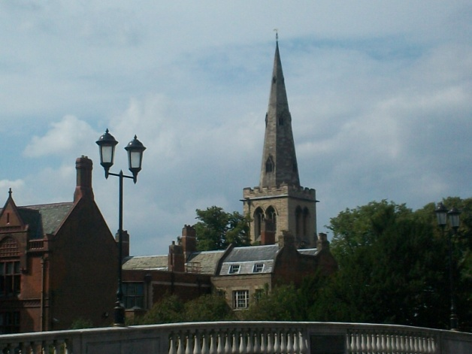
In order to insure an easier read, I have attached footnotes, other records and sources in the Appendix. So with considerable confidence, but with the caveat that, no doubt, additional information will be forthcoming in future investigations, I offer the family tree as we know it today. As ever your feedback, additions and corrections welcome. - glennhistory@gmail.com
Left, the parish of St. Peter's in Bedford, Bedfordshire, England where Thomas Holyman married in 1609.

THE PATERNAL FAMILY TREE OF
MOST AMERICAN HOLLIMANS AND VARIOUS SPELLINGS

Possible Ancestors

Richard Holyman (lived in 1345), High Wycombe, Buckinghamshire, England

Richard Holyman (lived 1376), Haddenham, Buckinghamshire, England
New Richard or son of Richard?

Richard Holyman (lived in 1379), High Wycombe, Buckinghamshire, England
New Richard or son of a Richard?

Richard Holyman (lived 1386-88), High Wycombe, Buckinghamshire, England
Son of Richard?

Richard Holyman (lived 1436 and 1449), Cuddington, Buckinghamshire, England
Son or grandson of a Richard?

Richard Holyman (lived in 1491), Cuddington, Buckinghamshire, England
Relative of John Holliman (d 1521)

Proven Ancestors by Records and DNA

John Holyman (d 1521), Cuddington Buckinghamshire, England

John Holyman (d 1533), Cuddington Buckinghamshire, England
Son of John

Thomas Holyman (1500 ca - 1558), Cuddington, Buckinghamshire, England
Son of Richard

Christopher Holyman ( - 1588), Sherington, Buckinghamshire, England
Third Son of Thomas

Thomas Holyman (1580 ca - 1650 ca), Bedford, Bedfordshire, England
Second Son of Christopher

Christopher Holyman Sr. (1618 - 1691), Isle of Wight County, Virginia
Second Son of Thomas

Christopher, Jr., William, Thomas, Richard Holyman, Ann (John Atkinson) Holyman and Mary (James Atkinson) Holyman, Isle of Wight County, Virginia
Children of Christopher Holyman, Sr.

Readers are encouraged to visit the Holyman Ancestry.com massive family tree always under construction by Jeanette Holiman Stewart. Additional information on the above lineage is available. Contact Jeanette at htreemaker@outlook.com.
It is an awesome feeling to hold in one’s hands a paper signed by a distant English ancestor in the early 1500s, half a millennium ago! Below are Holyman wills and the signature of John Holyman, d. 1521 in the Buckinghamshire Archives, England. Photograph by Glenn Holliman 2012.
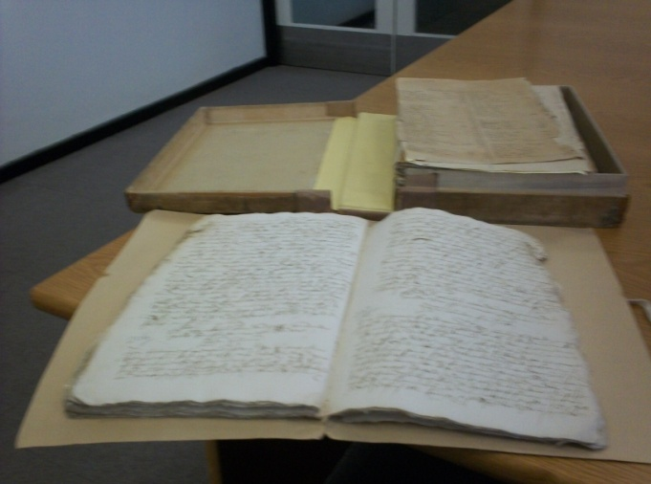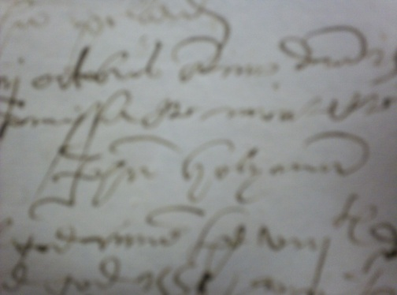
The Hollymans are English
The name Holliman (or Holyman, Hollyman, Holleman, Holloman, etc) is English. Surnames began to be used extensively in the 13th Century, and by the 1400s and 1500s, persons with the name of Holyman can be found in records in Buckinghamshire, Nottinghamshire, Worcestershire, Kent and Hertfordshire. As early as 1345, one Richard Holyman appears in High Wycombe, Buckinghamshire. Perhaps Holymans spread throughout England from Buckinghamshire or possibility the name appeared in other venues separate from the Wycombe, Haddenham and Cuddington Holymans.
Left and right of this country road in Cuddington, Buckinghamshire, England, one Thomas Holyman courted in the early 1500s one Dorothy Clark, daughter of respected yeoman farmer Christopher Clark. Thomas (d 1558) and Dorothy named their second son Christopher (d 1588), whose second son Thomas (d ca 1650) named his second son Christopher (1618-1691). This Christopher sailed to Virginia in 1650 and founded the Holyman families of America.
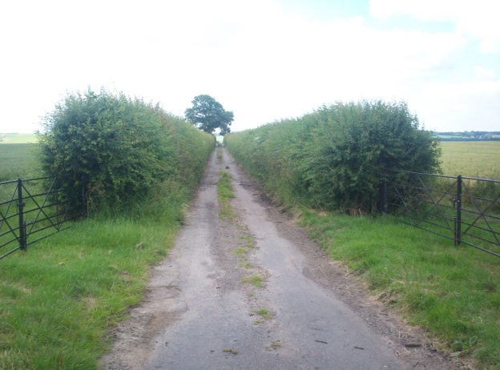
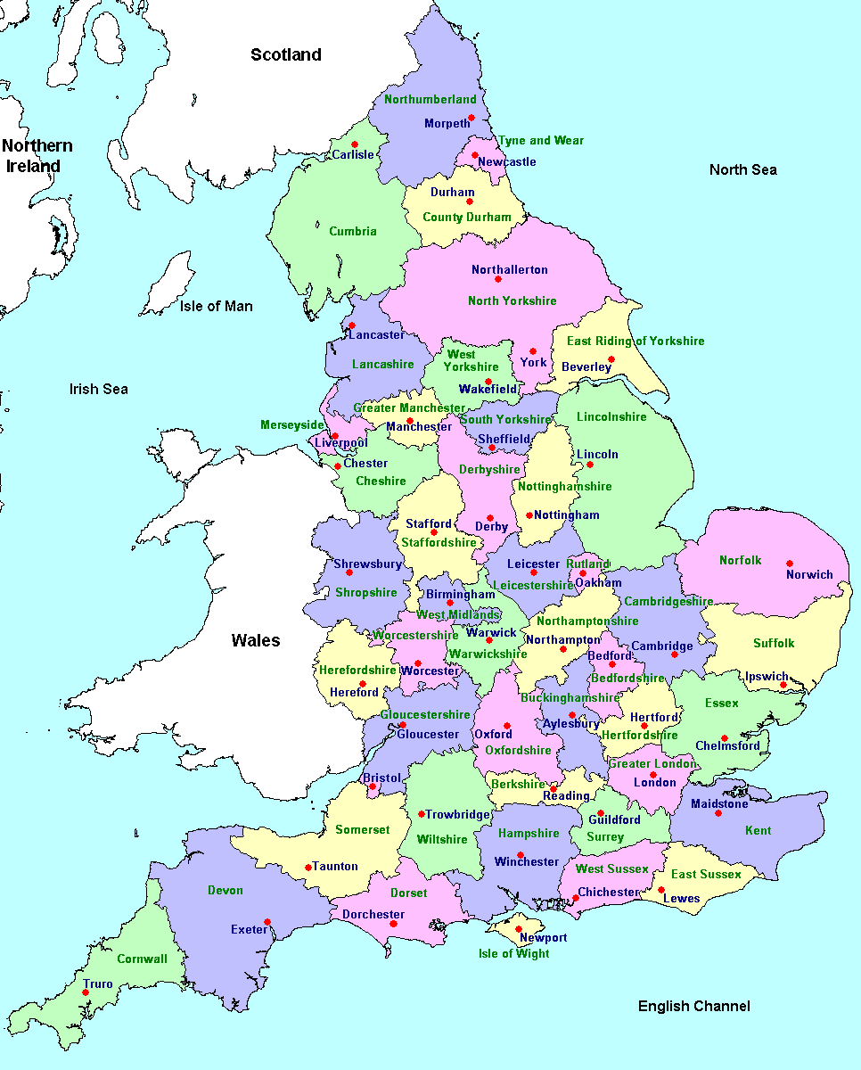Above is a map of England. London is in the southeast corner. Just west of London is Aylesbury in Bedfordshire. Review the map below of Buckinghamshire. Circled is Cuddington where Holymans were farming in the 1400s. Just south by a mile or so is Haddenham, another Holyman settlement. Dinton, home of the Lees, is to the northeast toward Aylesbury. High Wycombe, the earliest Holyman recorded, is in the southeast corner.
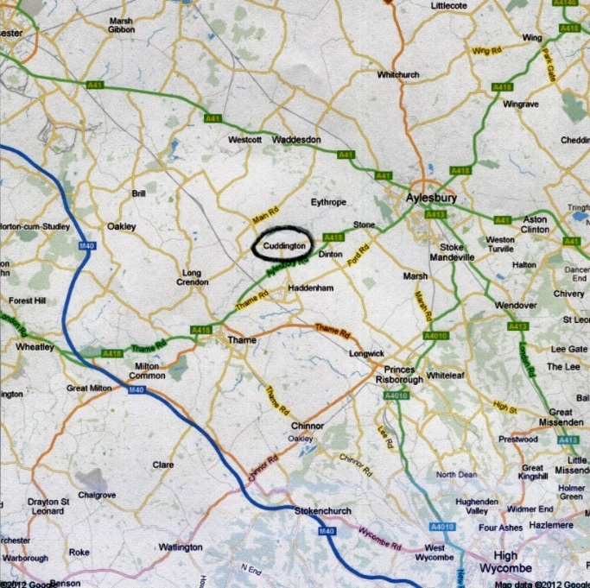
HIGH WYCOMBE, BUCKINGHAMSHIRE
Our Holyman history opens in High Wycombe, lower right corner of the previous map, in the 1300s. Long serving medieval king, Edward III was on the throne, his reign often embroiled in war with France. The name of the village, 900 or so population in the Middle Ages, was Chipping Wykham, a market town located on a road roughly half way between central London and Oxford. In the 19th Century, the famed prime minister Benjamin Disraeli, lived in Hughendon Valley, a mile from the town. During World War II, High Wycombe was the headquarters of the British Bomber Command. Today, the central city has a large immigrant population.
Cuddington, important to our story, is only a few hours by slow horse or even walking from High Wycombe. Cuddington was and is a small community approximately forty miles west of London, near the M-40, a 20th Century super highway. Persons by the name of Holyman lived in this community until the dawn of the 20th Century.
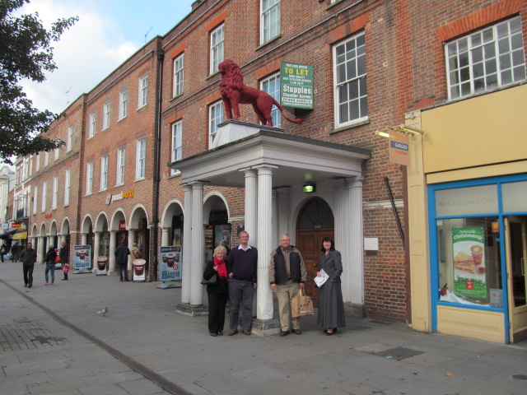
Above Madeleine, Lindsay and Glenn Holliman with genealogist Anne Holmes in 2014 standing on High Street in High Wycombe where an ancestor, Richard Holyman, lived in the 1300s.
The first Holyman name to appear in history from which most American Hollimans are descended is probably one Richard Holyman of High Wycombe, whose name is recorded in a 1345 legal record. The family survived that decade the Black Plague, because the same name, is mentioned in 1349. And, perhaps a son, Richard Holyman shows up in 1379 in a chancery court case in High Wycombe.
In 1386, a Richard Holyman, perhaps the same person as the 1379 Richard, was a member of Parliament from High Wycombe during the reign of Richard II. That was the decade in which Chaucer wrote Canterbury Tales. Chaucer was a freshman in Parliament at the same time as Richard. Did they know each other?!
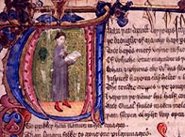
An illustrated manuscript from the prologue to 'The Canterbury Tales' by Chaucer, the first great writer of England and fellow member of the House of Commons with Richard Holyman in 1386-88.
HADDENHAM, BUCKINGHAMSHIRE
Yet before Richard Holyman went to Parliament, we have an 1376 event when a Richard Holyman purchased a tenancy of a messuage and 17 acres of land in Haddenham, Buckinghamshire! Was this the same Richard who went to Commons or was this a son or nephew establishing a farm in a village 8 or so miles from High Wycombe next to Cuddington? We do not know.
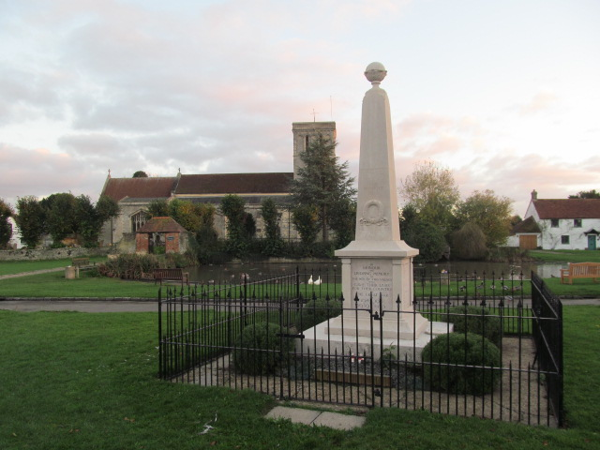
Right in 2014, the parish church, lake and war memorial in Haddenham, Buckinghamshire. Holymans lived in this village as well as Cuddington, a mile or two away.
Turmoil in England
The 1400s were a time of disturbances in England. Henry IV overthrew Richard II. His son, Henry V and others sought to incorporate France into their kingdom. The French Maid of Orleans, Joan of Arc, led a counter-attack against English influence, armies and territory on the continent.
An English child king, regency intrigues, royal mental illness and rapacious appetite for family power were realities leading England into the generational strife known as the War of the Roses. Two extended factions, one Yorkish and one Lancastrian, were fighting for royal power. The conflict ended after thirty years in 1485 when the young Tudor King Henry VII defeated Richard III at Bosworth Field. This founder of the Tudor line successfully passed along royal power to a series of dynamic offspring in the 16th Century.
CUDDINGTON, BUCKINGSHIRE
Yet during this long English civil war of the middle to late 1400s, the Holyman family maintained its wealth and influence in a small manor located on the western edge of Cuddington, Buckinghamshire. These are our ancestors, the Holymans.
Popular Internet genealogical sites have stated that the village Tring, Hertfordshire, approximately 45 miles northwest of London, is our ancestral home. My research moves us ten or so miles to the west, although Holymans, undoubtedly distant cousins, did live (and still do) in Tring. My first visit to the village of Cuddington in 2010, still less than 1,000 in population, uncovered a wealth of information. The remains of manor farm on the western edge of Cuddington are known to this day as The Holyman Farm.
Four direct Holyman grandfathers were born in Cuddington. They are: John, d 1521; John, d 1533; Thomas, d 1558; Christopher, d 1588.

We know a great deal about these four because they all left wills that have been studied carefully. All sired numerous children. Thomas Holyman married Dorothy Clark from a successful local family. Her father's name was Christopher, which became the name of their second son, Christopher, thus establishing this first name in the Holyman lineage.

Economically and socially the family fortunes peaked in the middle 1500s, with the marriage of Christopher into a wealthy family, the Lees of Dinton, Buckinghamshire.

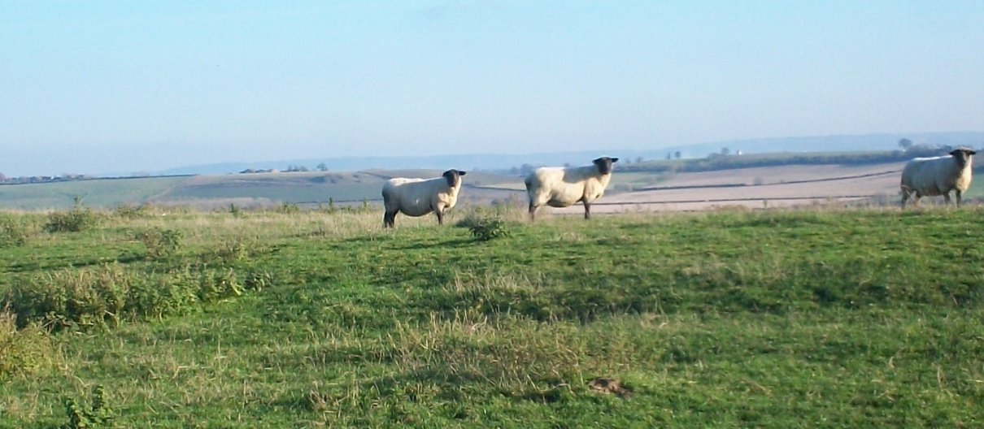
Above, sheep graze at Cuddington, Buckinghamshire, 2012.

Below, the Holyman manor of Cuddington in the mid 1700s, now destroyed. Note the size of the central home. The stables, still standing, are the 'C' shaped structures with the current Holyman farm house just to the right top of the yard.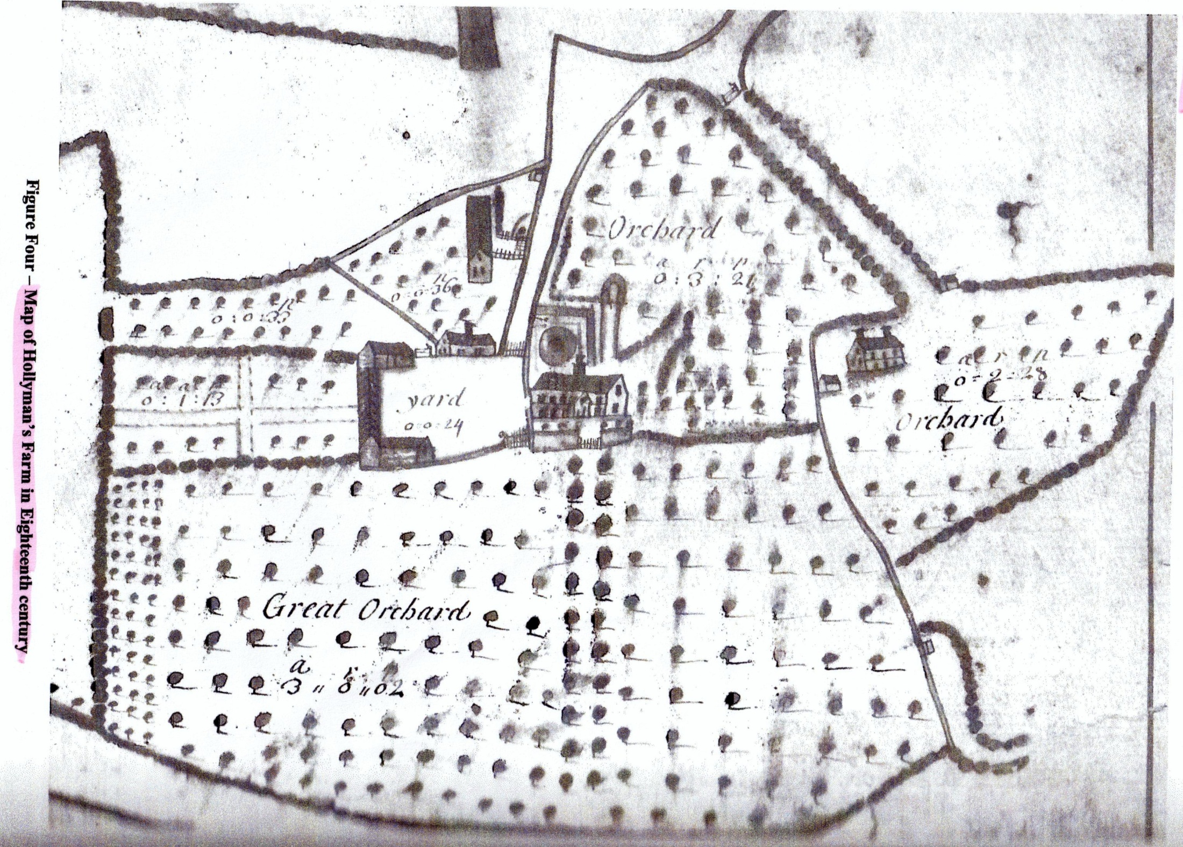
Below, St. Nicholas Church in Cuddington where Holymans are buried in the grave yard and in the church itself.
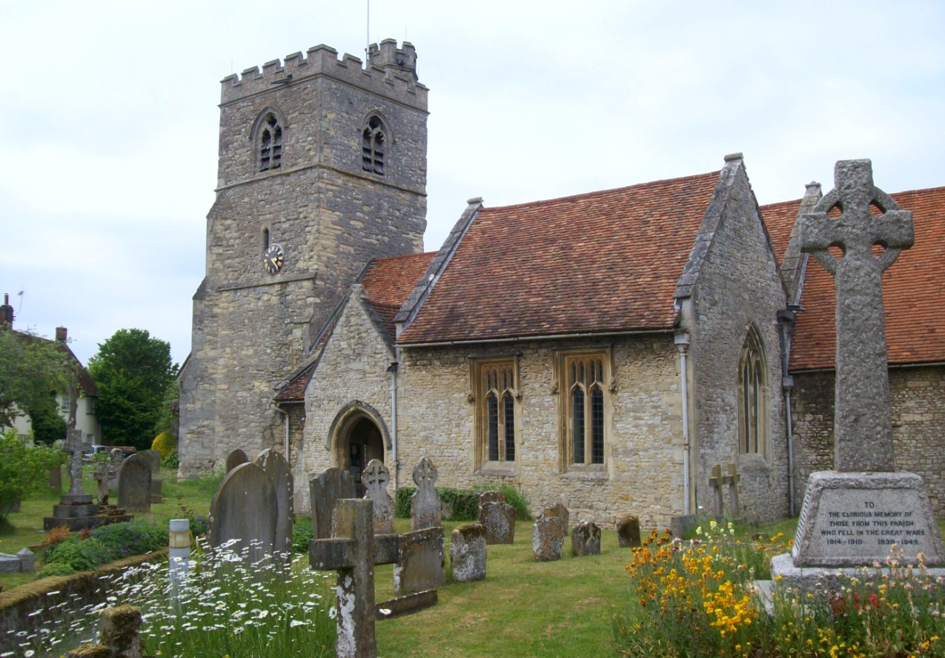
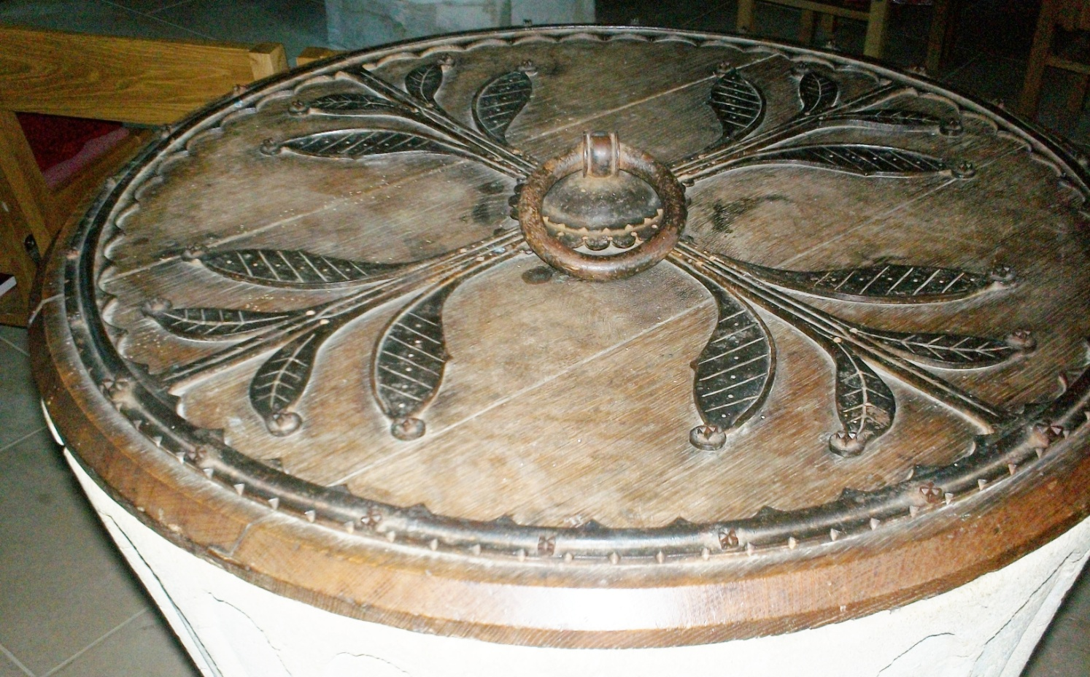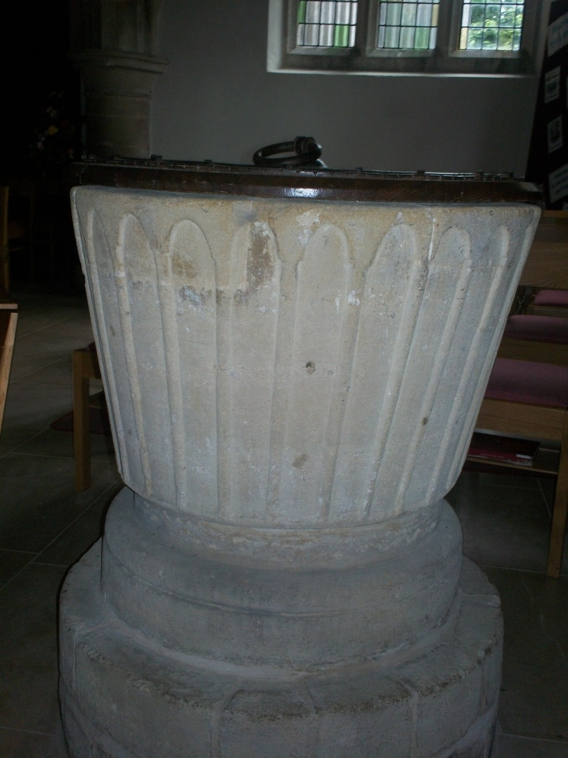
Above, the 13th Century baptism trough from which generations of Holymans were baptized, first as Roman Catholics and after the Reformation as Anglicans. Direct great father, John Holyman (d 1521) was buried in the church yard. Reflecting an increase in wealth and prominence, John Holyman (d 1533) was interred in the church itself. Thomas Holyman (d 1558) left a Protestant will, unlike his father and grandfather who prefaced their wills with Catholic introductions.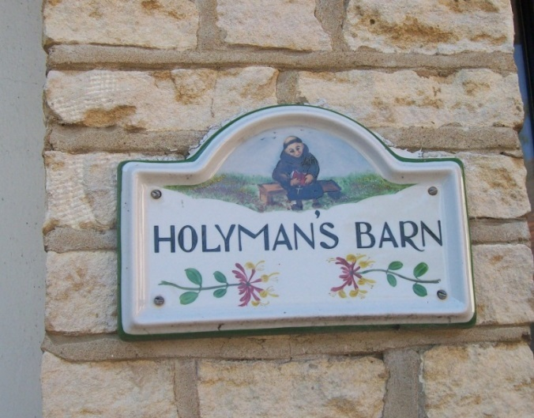This sign is on the renovated stables of the Holyman Farm in Cuddington, Buckinghamshire, England. The monk represents The Rt. Rev. John Holyman (1495-1558) who was a Roman Catholic brother and later Bishop of Bristol.
While we are uncertain as to relationship, in 1495, one John Holyman was born in Cuddington, and grew up to be the second Bishop of Bristol, England. This is the century of which most Americans know more about than any other thanks to the Tudor monarchs of Henry VIII, ‘Bloody Mary’, Elizabeth I and the Spanish Armada.
Our priest ancestor, John Holyman, was appointed a bishop during the reign of Queen Mary Tudor who attempted to restore the Roman Catholic Church in her brief reign of seven years. To this end, between 1554 and 1558 (both Queen and Bishop died that year), Bishop John Holyman in his diocese allowed five Protestants to be burned at the stake for failure to recant their radical beliefs.
Being a celibate priest, this John is not the direct father of our line, but is an uncle or cousin. Is Bishop John the brother of one Thomas Holyman of Cuddington, who is the son and grandson of two earlier John Holymans? Thomas's 1558 will states he left some of his estate to his third son, Christopher Holyman.
Below, the Holyman farm in the courtyard of the 1699 Holyman thatch cottage in Cuddington, Buckinghamshire, England. Left to right are Jim Stewart, husband of Jeanette Holiman Stewart in blue. Background is Caroline Stonham, owner of the cottage and far right is Barbara L. Holliman, wife of Glenn N. Holliman.
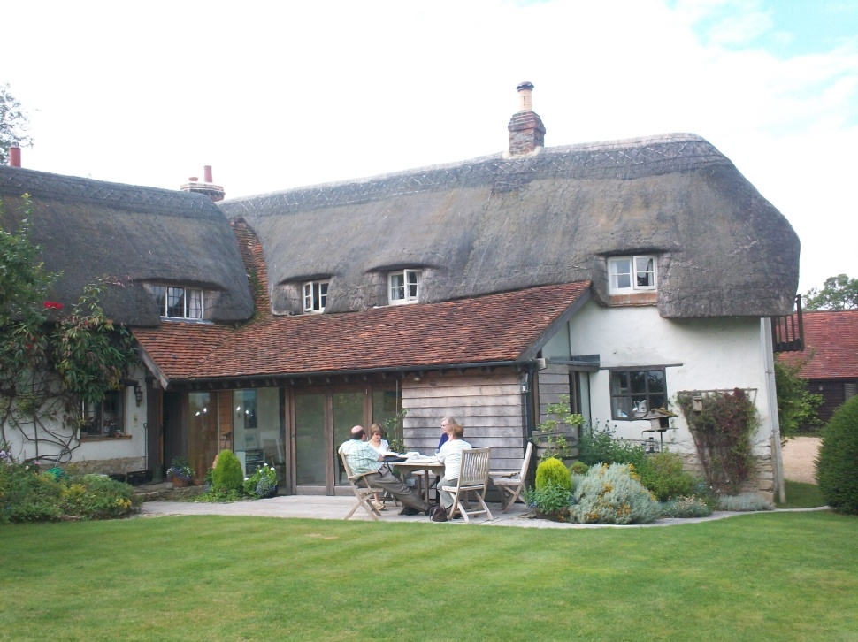 Below Glenn Holliman and Jeanette Holiman Stewart stand on the ground in Cuddington, England where the Holyman manor house is believed to have stood.
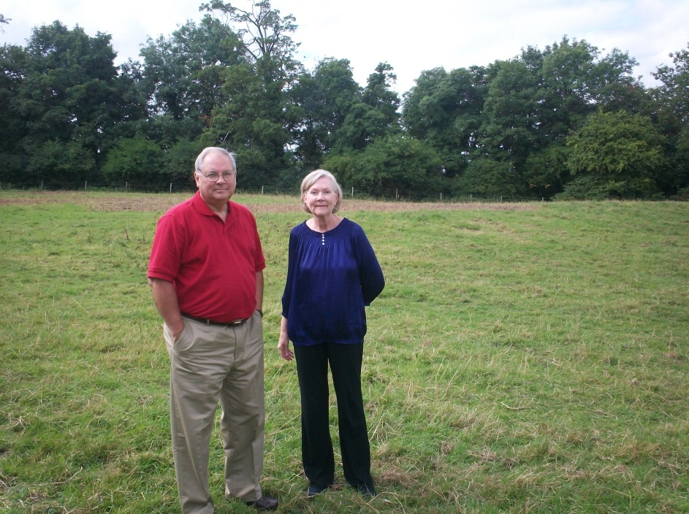
DINTON, BUCKINGHAMSHIRE
Below, the parish of St. Peter and St. Paul in Dinton, five miles from Cuddington, and home of the Lee Family. Margaret Lee married Christopher Holyman (d 1588), the grandfather of Christopher Holyman, Sr. (1618-1691). The Lees were a prominent family attested by brasses covering the graves of Margaret's grandparents in the church sanctuary. Margaret's nephew would inherit Hartwell House near Aylesbury, a massive, beautiful complex and now a National Trust hotel. Margaret's second son, Thomas Holyman, father of Christopher Holyman (1618-1691), economically went in an opposite direction and became an innkeeper and leather worker in Bedford, Bedfordshire.
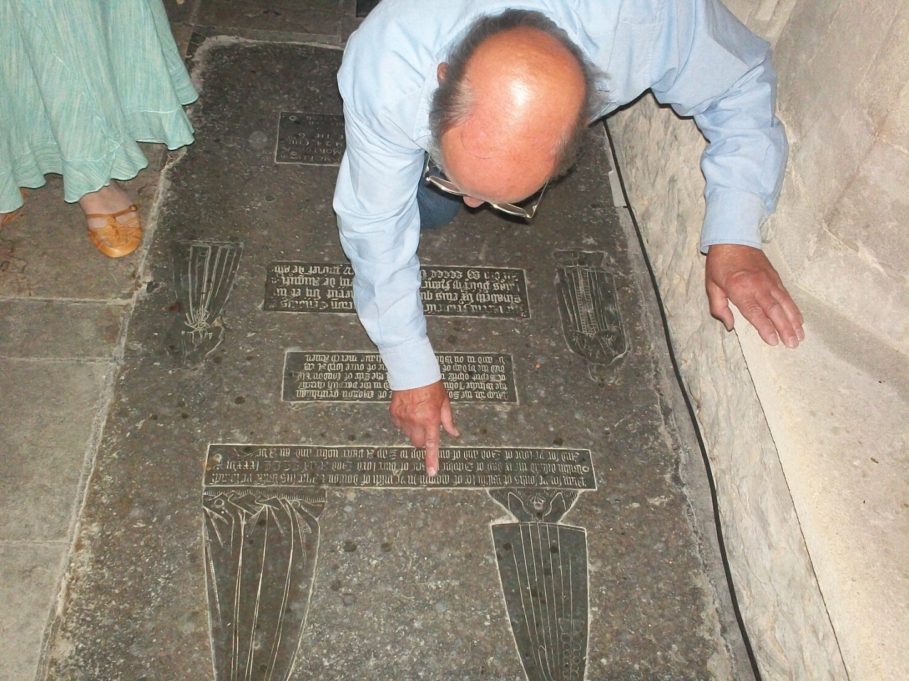
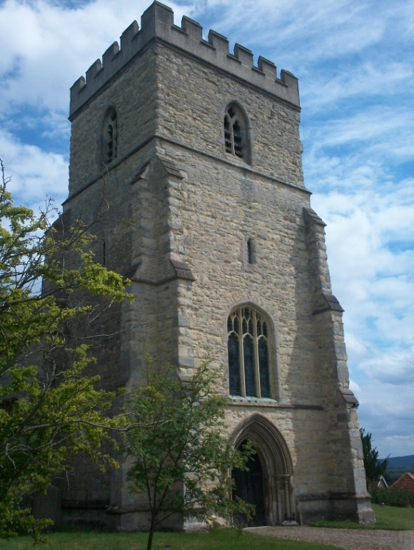

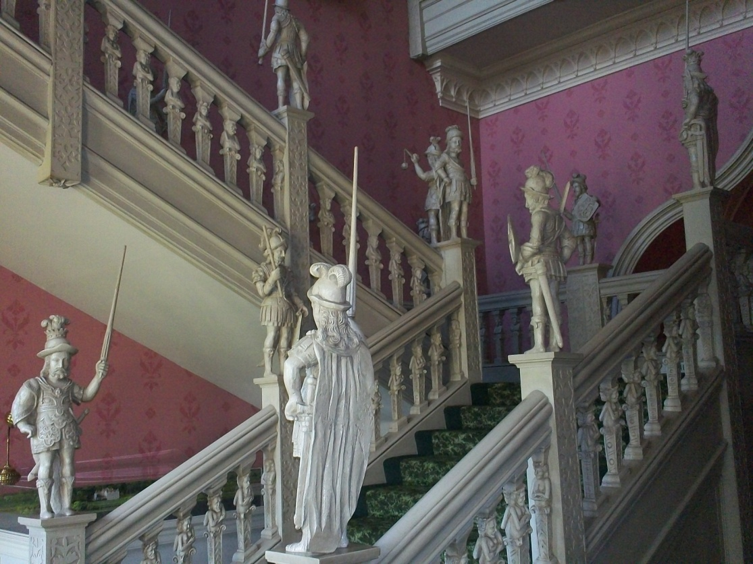
Notice above one of the ormate staircases in the Hartwell House.

Below, a recent cover of a Hartwell House booklet, showing its magnificence and importance in English history.

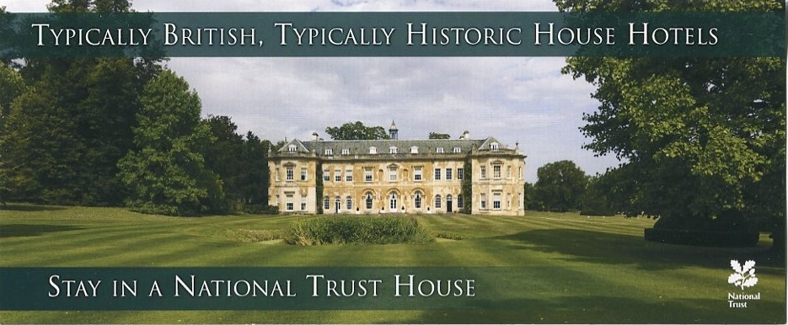

'The estate's history stretches back nearly a thousand years while he house itself dates from the 17th century. In the early 19th century the exiled King of France, Louis he XVIII, held court here and more recently Bill Clinton addressed the American people from Hartwell's library.'

SHERINGTON, BUCKINGHAMSHIRE
This Christopher Holyman (observe how the names alternate) died in 1588 in Cuddington but the will was probated in Sherington, Buckinghamshire, a parish town approximately 25 miles north of Cuddington and 12 miles west of Bedford, Bedfordshire. Christopher did occupy property in Sherington and was an influential lay leader in his Anglican parish.
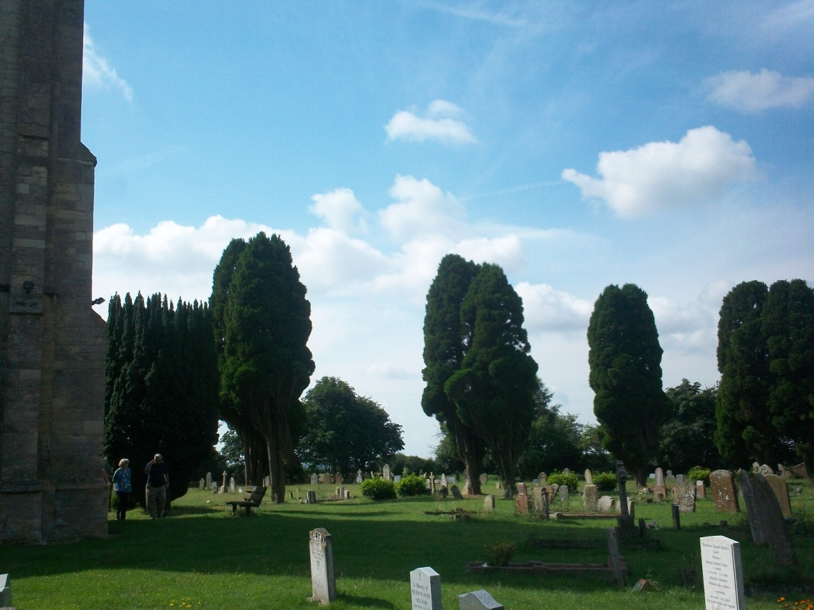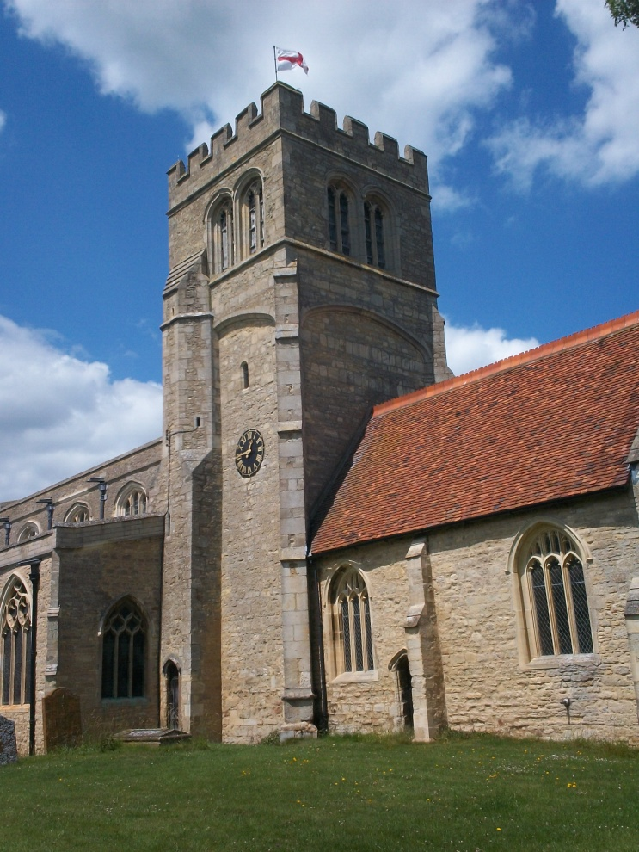
Previous the church grave yard in Sherington where Christopher Holyman may be buried. A member of the distinguished Queen's Guard of Queen Elizabeth, he died the same year as the Spanish Armada. The map below shows London in relationship to Bedford, Bedfordshire. The northern X is the location of Sherington. The southern X marks the community of Cuddington.
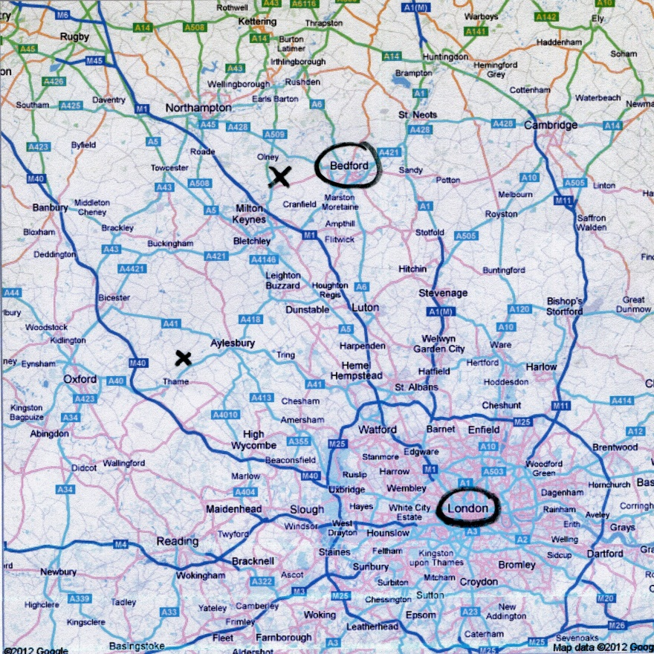
The d 1588 Christopher, whose Sherington life is recorded in several places, left 40 pds. to his second son, Thomas Holyman, who also is listed in a school record in Sherington. Thomas would move 12 miles east to Bedford, Bedfordshire.

BEDFORD, BEDFORDSHIRE
This Thomas (d ca 1650) married a Heleana Poynard (spelled several ways) in Bedford in 1609. Bedford is a market town only a dozen miles from Sherington by road and an obvious location for a second son to seek his fortune. I have found no Thomas Holyman or any Holyman living in Bedford prior to our Thomas.
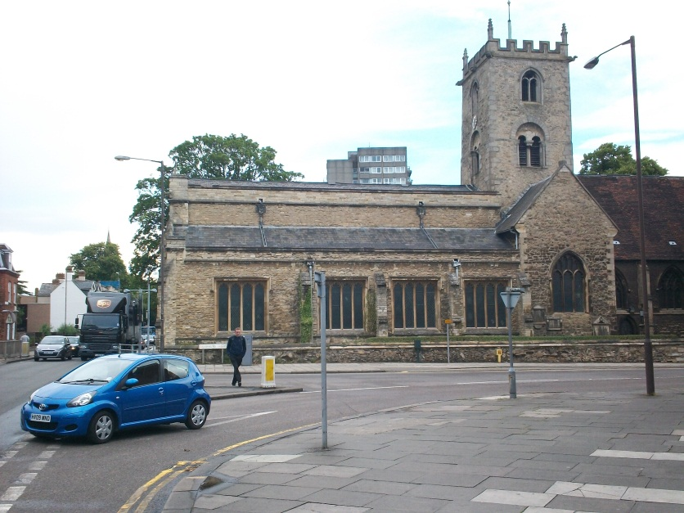
Above south of the Ouse River in Bedford, Bedfordshire stands the former parish church of St. Mary’s. Christopher, Judith and other children of Thomas and Heleana (Eleanor in some places) Holyman were baptized here. Photo by Glenn Holliman, an 8th great grandson in 2011.
Thomas and Eleanor’s second son was named Christopher and born in 1618. This is the Christopher Holyman (1618-1691) who arrived in Jamestown, Virginia in 1650 with his sister, Judith, born 1621, also in Bedford and baptized at St. Mary’s parish astride the Ouse River.
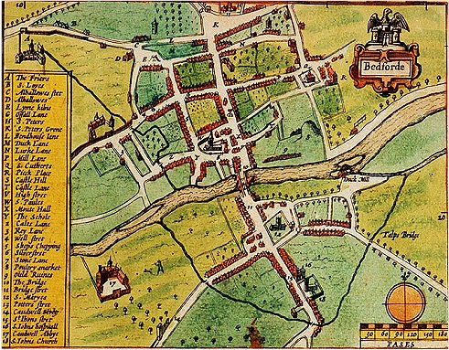
Above, this map of Bedford shows St. Mary's parish just south of the River Ouse. The Blue Boar Inn is the in the block, south west of the church.
In 2013 Jeanette Holiman Steward stands on the spot of the Blue Boar Inn where Christopher Holyman, Sr. lived. St. Mary's is in the background and his now an archives. Today a computer store occupies the location! In that archives Jeanette and this writer examined an excavated 17th Century leather shoe from Bedford.
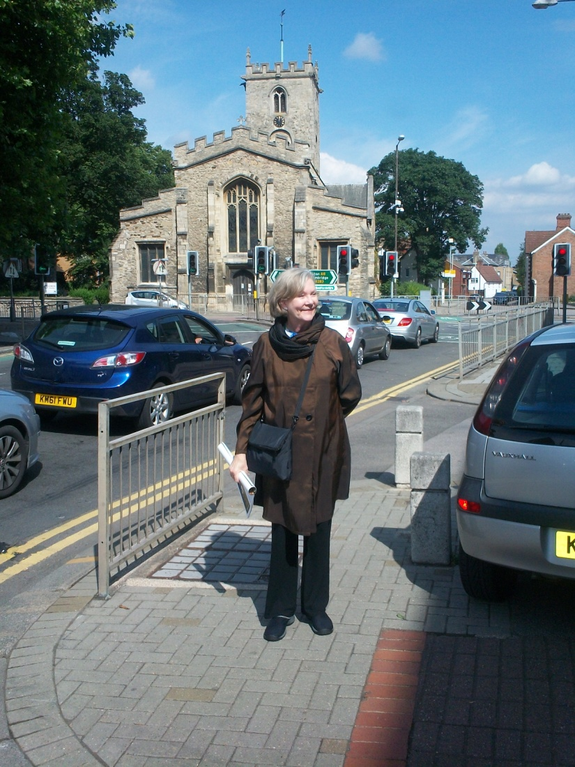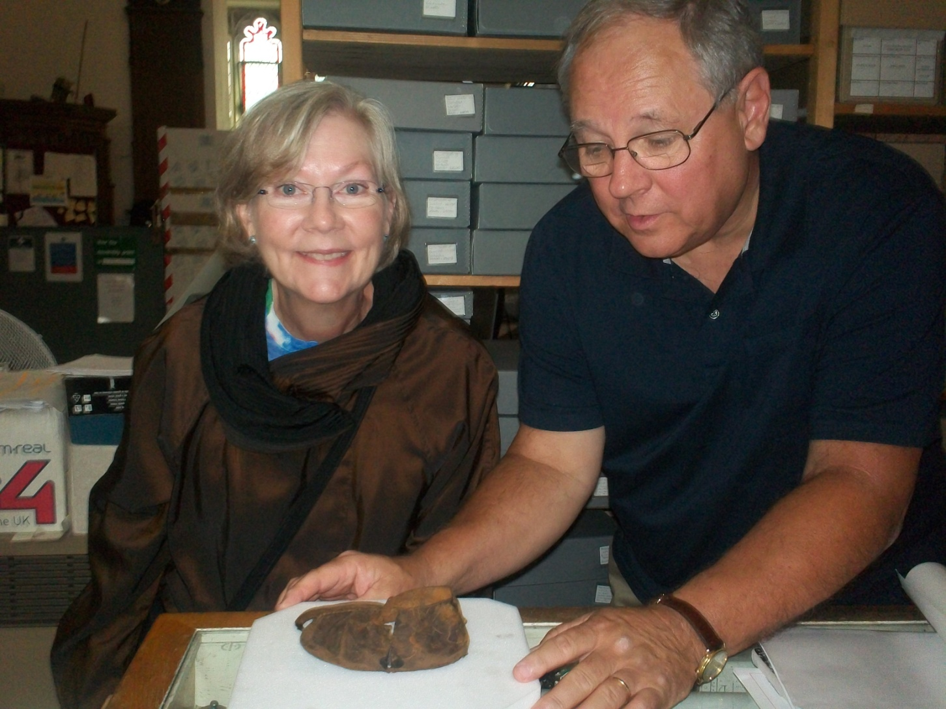

Below graves at St. Mary's. The parents and siblings of Christopher and Judith Holyman, who migrated to Virginia in 1650, most probably lie here.
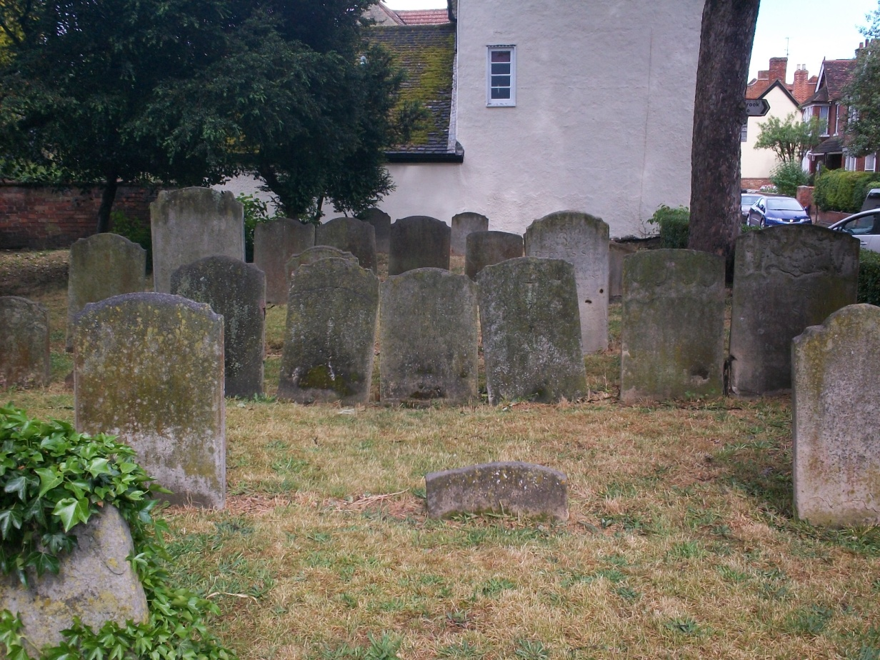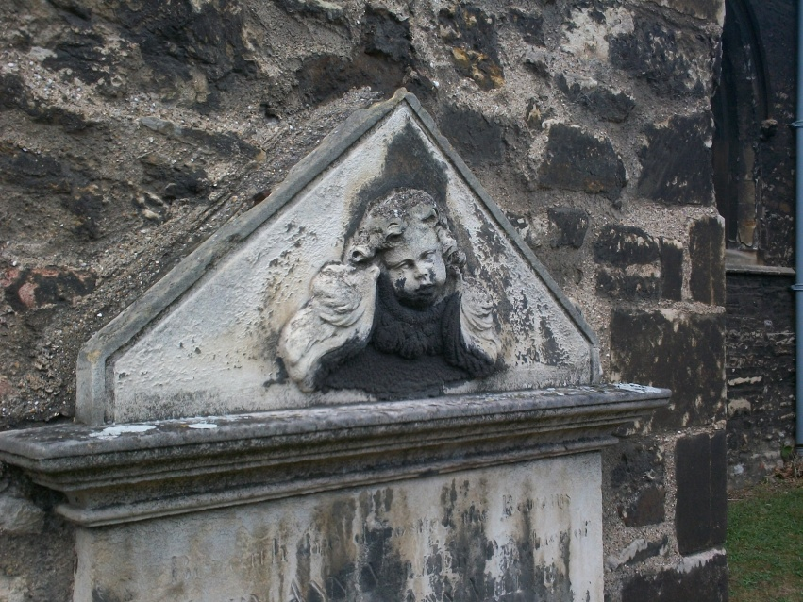
Generally speaking, second sons did not inherit very much in the way of real property. After a few generations, our soon-to-be American Christopher must have had significant economic reasons for migrating to Virginia. A second major reason might have been another English Civil War.
After Elizabeth I died in 1603, the Stuarts of Scotland came to the throne. Shakespeare wrote MacBeth and King James Stuart insured a modern version of the Bible was properly translated into English. Unfortunately, after the death of James I, his son, Charles I, proceeded in arrogant ways to antagonize Parliament. Who had the power to tax and rule? The House of Commons or a kingship encased in Divine Right theory?
In the 1640s, a civil war broke out, Charles eventually lost his head and Oliver Cromwell came to rule the English Commonwealth. Within a year of King Charles’ death, Christopher and Judith Holyman migrated to Virginia.
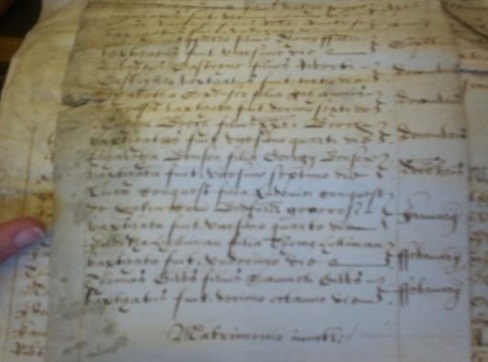
The actual transcripts from the Church of England’s Bedfordshire Diocesan records from 1618 listing the birth of Christopher Holyman, founder of the American Holliman family. – Photo taken by Glenn N. Holliman, Bedford, England 2011

Holymans in Colonial Virginia
Why the migration? Probably for lack of economic opportunities in an England recovering from war and still at war in Ireland. Christopher, the second son of a second son of a third son, needed to make a living. A few other Holymans, at least one a distant cousin, were already in North America, and perhaps knowledge of their passage enticed our Christopher to move.
Below in 1650, the year of Christopher's migration, the Virginia colony was but a small foothold on the North American continent.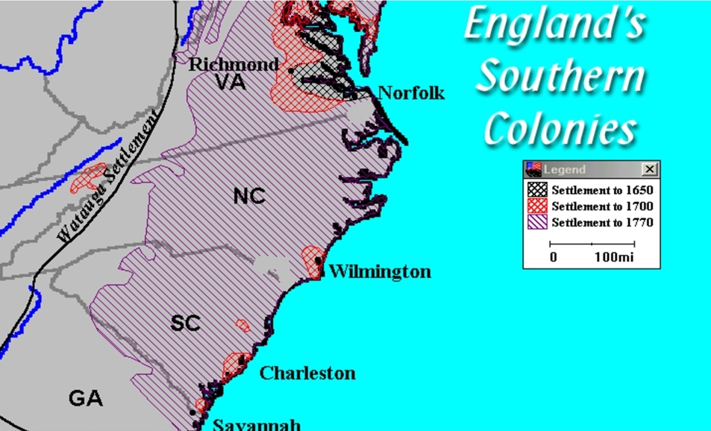
One distant cousin, Ezekiel Holyman, descended from the Cuddington Holymans, had been living in New England since the early 1630s. Ezekiel baptized Roger Williams, founder of Rhode Island, and helped found the American Baptist Church. His great-great uncle The Rt. John Holyman, must have turned in his Roman Catholic grave (which is located in Long Hanborough, Oxfordshire). Ezekiel left no male descendants.
Another Holyman, John, was living in Virginia where he died and left a will, two weeks before our Christopher arrived in 1650. Perhaps John was a Sherington or Cuddington Holyman? He was not a brother of Christopher as a brother named John elected to remain in Bedford and begin his own family (so parish records reveal). This John left no family. Another brother of Christopher remained in Bedford and evidently attended the non-conformist church of one John Bunyan, the Puritan Protestant who wrote Pilgrim’s Progress!
In May of 1650, our Christopher, my generation’s 7th great-grandfather, stepped ashore in Jamestown, Virginia. Perhaps 20,000 or so English persons then lived in the Virginia colony which had barely survived starving times, disease and numerous Indian attacks since its 1607 founding.
The modern map below shows Jamestown where Christopher and his sister Judith landed. She probably quickly married as males outnumbered females at that time. Christopher is next mentioned in 1661 purchasing land along the Cypress River in what is now Smithfield, Virginia. A wife, Anne, co-signed the deed. Her last name is lost to history.
The second wife was named Mary Gray. Anne and Christopher did have six children, four boys and two girls. By 1684, he owned over 1,000 acres of land in Isle of Wight County in an area called Mill Swamp nestled along the Surrey County line, not far from the Blackwater River. A large X marks the Mill Swamp location. To this day, some Hollemans still live at this location!
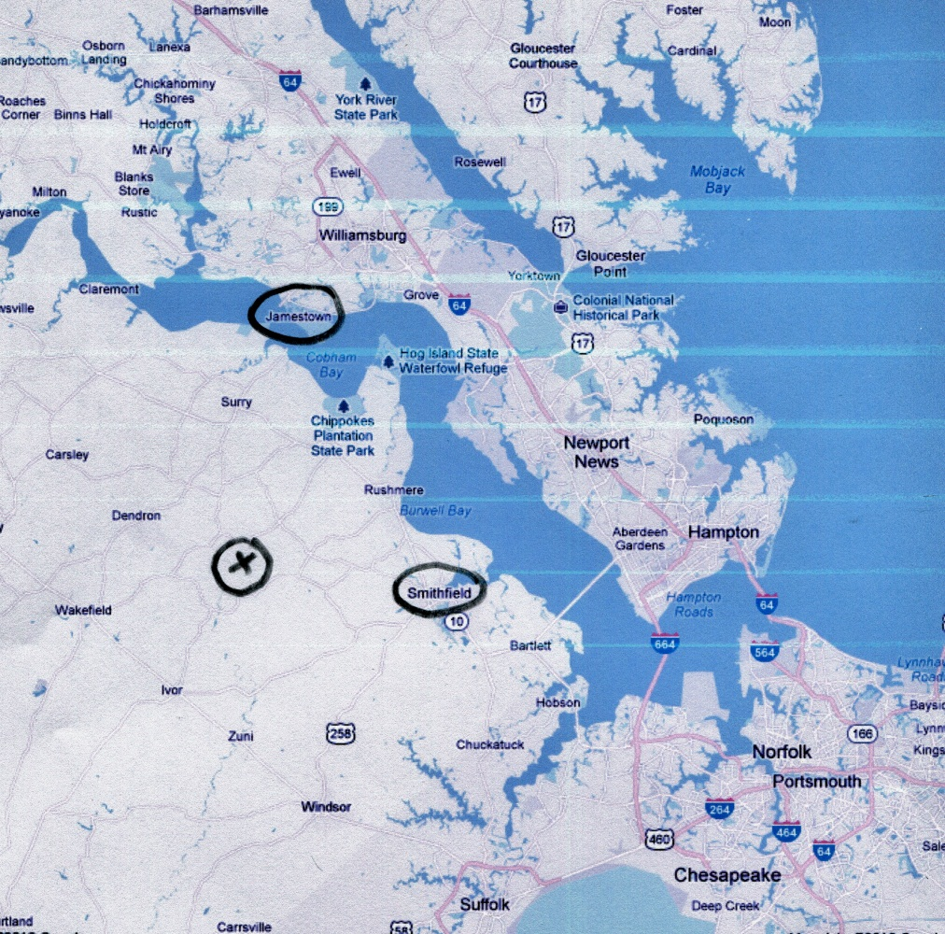
The Holleman House in the 1980s
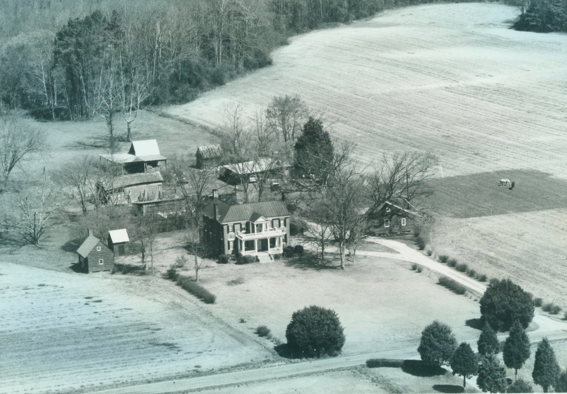
Built in the early 1830s, this Federal period home named the Holleman House, stands on the site of the original plantation of Christopher Holyman who died in 1691. The first Holyman would have lived in a log house, long since decayed. A family cemetery stands 50 yards from the present house. Hollemans have lived continuously at this location since the 1680s in Isle of Wight, Virginia, bordering Surry County and the Blackwater River. Photo courtesy of Sarah Barlow Wright, a Holleman descendant.

PAGE NOTES AND RESOURCES
Longer articles and primary sources have been posted since 2010 at my blog at http://hollimanfamilyhistory.blogspot.com/. Listed below by pages are the article dates and additional information.

P. 2: July/August/September 2012 at http://hollimanfamilyhistory.blogspot.com/ for articles on Fred Cooper and stories of the Hollymans of Bristol and Somerset, England. August and September 2011 blog articles discuss the Worchester Hollymans and speculate if they be the Somerset ancestors of Jayne Sullivan and Bob Hollyman-Mawson.

Pages 3 - 7: Bob Holyman-Mawson of Carnaervon, Wales discovered at Wycombe.comx the information on Richard Holyman of 1386. Anne Holmes provided the following timeline from her research.

Early HOLYMANS in Buckinghamshire - Timeline (excluding known Wills)

1345 Feet of Fines (abstract online at www.medievalgenealogy.org.uk)

A Richard HOLYMAN mentioned in Feet of Fines connected to land in Wycombe, Hughenden, Little Missenden or Wykham (Banbury)

1349, Apr. 26 - Feet of Fines (abstract online at www.medievalgenealogy.org.uk)

As above in 1345, Richard HOLYMAN mentioned connected to same land in Hughenden, Little Missenden and Wykham (Banbury)

1376 Antiquities of Buckinghamshire

In 1376 a fine of messuages and lands occured between Richard Holyman of Haddenham and John Bolere and Margery his wife. The right to Richard Holyman. This was in the reign of King Edward III.

1376 Feet of Fines (abstract online at www.medievalgenealogy.org.uk)

A Richard HOLYMAN purchases tenancy of a messuage and 17 acres of land in
Haddenham.

1379 Abstract at National Archives Discovery website

A case against a Richard Holyman of High Wycombe and Thomas Palmer of Thame appears at the Chancery Court. Holyman and Palmer owe £12 to a Thomas Barentyn.

1386 - 1388 Detail online at www.historyofparliamentonline.org

Anne Holmes: Richard HOLYMAN represented Chipping or High Wycombe as MP for the borough. This infers Richard was a Burgess of the town at that time and probably had the residence of a property in the High Street.

1436 – Date Southfryfolk, 24 March 1436, William Alisandre and Richard Holyman to deliver seisin of property in 564 to parties of the same. Signed Henry Somer, chancellor of Exchequer; FREEFOLK; Appointment of attorney 44M69/C/565 1436/7

1448/9 BAS Publication-Haddenham and Cuddington: The Early History of Two Buckinghamshire Villages, p24

A John HOLLYMAN appears in Cuddington paying twenty pence to pasture two cows and calves in the demesne land of Cuddington.

1490, Jan. 8 - Land made available to Richard Holyman of Cuddington.

1491 Hartwell Collection held at Bucks Record Office, Aylesbury

Feoffment by Richard HOLYMAN of Cuddington to John LEE of Moreton in Dinton, John HOLYMAN of Cuddington and Wm HAYLY of H. of a toft between the lord’s toft and a toft late of Thos HARE………with 1 acre in the fields. Given at Southrope.

1505 Hartwell Collection held at Bucks Record Office Aylesbury

Feoffment by Richard CULVERHOUSE of Moreton to Richard BARNARD, William BARNARD, John HOLYMAN and John BENNETT of a messuage in Moreton with 26 acres of land and pasture belonging to it all………….

1507, June 27 - John Baldwyn, John Hall and John Basset recover some property from Thos Greneway and John Clark.
1522 - Account between Thomas Lee and Francis his brother concerning F. occupying T.L.'s pastures at Moreton between 24 Jan 1521 and 21 Feb. 1522.
1527 BAS Publication-Haddenham and Cuddington: The Early History of Two Buckinghamshire Villages, p41

John HOLLYMAN took over the ‘farm’ of Cuddington from the Priory for a lease of thirty years and on his death in 1531 handed this on to his son Thomas who was still farming the manor in 1541/2

1552 - Certificate for Musters for Bucks
Loans to the King at the rate of £100-£300. £10 per £100:
John Holiman £30
William Holiman £6
John Holiman Jnr £1
Ellin Holiman £1
Thomas Holiman £1

1552 - William Holyman of Barming, husbandman, to William Isley of Brasted, esq. for an annual payment of 40s. for 28 years; assignment of a lease made 3 Oct. 1552, by Edward Welshe of Bermondsey, Surrey, gent. to Stephen Waygorne of Chevening, ripier, deceased, whose widow, Elizabeth, William Holyman had married. A Kent shire Holyman.

1556 - Brought by John Lennard against William Holyman and Elizabeth, his wife, for waste committed on property in Chevening [Copy made 1710]

1558 – 1579 - Comber v Holyman. Plaintiffs: Thomas Comber. Defendants: Richard Holyman. Subject: debt, Staffordshire

1560 - Will of Thomas Holyman, Yeoman of Coddington, Buckinghamshire

1566 – Hungate and Holyman v. Holyman, Jobson and others in Star Chamber, STAC 5/H73/25.

1574 BAS Publication - as above p41

A Richard HOLLYMAN was involved with a case with Rochester Prior concerning bedripe that was owed to the chief ‘farmer’ of the manor of Haddenham.

1578, April 10, John Holyman of Cuddington purchases 3 acres property from the estate of his father, Thomas Holyman.

1587 – Purefey v. Holyman and others, STAC5/P61/24

1590 – Richard Holyman the younger of Cuddington purchases land from Charles Fytche of Haddenham, yeoman. Close (5 acres in West Mead, Cuddington for 80 pounds . Hungate and Holyman v. Holyman, Jobson and others

1594, July 13 - Agreement that T.L. and R.L. shall not drive swine from T.L.'s house in M. through a great close of pasture called the Gallow field in the occupation of Richard Saunders the yr, nor shall they drive kine through the Gallow field to be milked. Land demised in the manor of Moreton to Thos Lee and Ralph his son for a term of 95 years on Apr 1 1538 for a term of 95 years. Thos and r.L. demised to Fra Lee a clase called Little Grove and other parcels. Later Sounders family acquired the land, but Lees kept driving pigs and cows over it.

1642 Bucks contributions to Ireland 1642: Robert Hollyman 5/=five shillings: a quarter of a £1

Pages 8 - 11: The wills of John Holyman (1521), John Holyman (d 1533) and Thomas Holyman (d 1558) to be found December 2012, January/February/March 2013 at http://hollimanfamilyhistory.blogspot.com/. I have written many articles on the Cuddington Holymans: May 2012/July/August 2010, Mrs. Caroline Stonham, owner of the Holyman House in Cuddington has been most gracious over several years sharing information and inviting Hollimans into her home. Bob Holyman-Mawson shared his research on Thomas Holyman’s 1558 will. Christopher Holyman of Sherington and his 1588 will, I reviewed in Buckinghamshire Archives. Additional biography on Christopher and his son, Thomas Holyman (married 1609 in Bedford) were found in the Milton-Keynes, Buckinghamshire public library local history section which I visited in 2011. In 2012 I collected more information on the 1500 Holymans of Cuddington at the Archives in Aylesbury.

Pages 10 & 11: June/ July August/September/October 2010 articles for the life of The Rev. John Holyman and sources at http://hollimanfamilyhistory.blogspot.com/. Mrs. Peggy Cattell of Cuddington, the local historian, kindly shared with me her biographical paper on The Rt. Rev. John Holyman. He is found also in many sources of the Tudor period. Also articles on research of Tring, Hertfordshire Holymans and Ezeikel Holyman of Rhode Island.

P. 12: The research on the Lee and Holyman family connections gathered by professional genealogist Anne Holmes of Buckinghamshire, England. Her sources include William Betham's 1805 work 'The Baronetage of England', George Lipscombe's 1847 volume 'The History and Antiquities of the County of Buckingham' and the peerage.com at http://www.thepeerage.com/, the Ashmolean Museum web page on brass rubbings in churches in Buckinghamshire and 'The Victoria County History of Buckinghamshire' on line at http://www.british-history.ac.uk/. Anne Holmes also has a blog of Buckinghamshire history at www.bucksancestors.co.uk. For additional information go to April/ May 2013 http://hollimanfamilyhistory.blogspot.com/.

Pages 13 & 14: September/October 2011 at http://hollimanfamilyhistory.blogspot.com/ information and resources on Christopher Holyman of Sherington and more information on Cuddington Holymans.

Pages 14-17: August 2011/April 2012 articles at http://hollimanfamilyhistory.blogspot.com/ discussion of the Bedford, Bedfordshire Holymans. Information on Christopher and Judith Holyman, brother and sister, were found in Bedfordshire, England archives parish records in 2011. Both are listed in LDS records on the web. Roger Smith, researcher and active in Bedfordshire Historical Society provided many leads.

P. 18: Ezekiel Holyman’s story is found at Baptist web sites and Weedon Family records in The Register of New England Families, which state his relationship to Cuddington Holymans.

Pages 19 and 20: Several sources besides web sites reveal these early transactions. In addition to John Bennett Boddie's book, Blanche Adams Chapman's Wills and Administrations of Isle of Wight County, Virginia, 1647 - 1800, Books 1 - 3 contains considerable legal recordings of the Holyman families. Chapman's book is available through Heritage Books, 65 E. Main Street, Westminister, Maryland 21157. For additional information go to April 2010, November and December 2010, January 2011, November 2011, and October 2012 at http://hollimanfamilyhistory.blogspot.com/.
George A. Holleman in 1953 wrote the first important work on the history of the Holliman families in Virginia. Tina Peddie added lineages in a later edition of the book. Numerous Virginia land and will records tell the story of Christopher Holyman, Sr. (1618-1691). Sarah Barlow Wright, a Holleman descendant in Smithfield, made numerous photographs and information available. The Library of Virginia in Richmond contains many references to Hollemans in Isle of Wight and Surrey Counties.

For additional information on the Holyman Families, one may visit www.bholliman.com, a virtual archive for manuscripts on the Hollimans and associated families. Blogs with Holliman stories are found at http://hollimanfamilyhistory.blogspot.com and http://ulyssholliman.blogspot.com.

Also admittance to the Facebook page is available by contacting Tina Peddie who also manages a yahoo chat room for Holyman researchers. She may be reached at desabla1@yahoo.com. The Holyman Ancestry.com Tree maintained by Jeanette Holiman Stewart who may be reached at htreemaker@outlook.com.
Errors and omissions are my responsibility, and I welcome corrections and observations. This continues to be a work in progress. Please contact me at glennhistory@gmail.com.

