Wednesday, January 2, 2013

When We Were English, Part XIL
by Glenn N. Holliman
Return to England, Part 3, The John Holyman Will of 1533
In my last post, we examined the will of the person I believe to be my generation's 12th great grandfather, John Holyman of Cuddington, Buckinghamshire, England. With this article, we begin a review of his elder son, my very probable 11th great grandfather, John Holyman's will. Here is a portion of the 1533 will, with other sections to follow in my next articles.
Each line of the will is numbered and the explanations refer to the numbered lines. Genealogist Anne Holmes of Buckinghamshire is due the credit for her transcription and interpretations of a will almost 500 years old! (Although any errors are mine alone.)
This will is markedly different from John's father's which we examined in my last post. The Reformation is sweeping Europe and is engulfing England. King Henry VIII has fallen in love with Anne Bolyen and in early 1533 married her, she several months pregnant with a child who would become Queen Elizabeth I.
The Pope had refused Henry a divorce from his still living first wife, Catherine of Spain and mother of Mary Tudor. When a conservative Archbishop of Canterbury died, Henry appointed Thomas Cramner, a supporter of the growing Protestant tide. Cramner hastily granted Henry his divorce and conducted the rites of marriage for Henry and Anne.
Into this gathering maelstrom which divided the clergy and laity of England, strode a monk, Brother John Holyman of Cuddington, baptised in 1495 at the same font from which his probable uncle and cousin, the John Holymans, d 1521 and d 1533, had been sprinkled with holy water. As I have written earlier Brother John Holyman boldly stood at St. Paul's Cross in London and on several occasions decried the divorce, the remarriage and the growing radicalism of many English concerning their faith.
With this background of the early 1530s, we can better understand the will of John Holyman of 1533. The first 20% is a homage to the Roman Catholic Church. The will of John's son Thomas Holyman in 1558 will read very much differently, much more Protestant. Again my thanks to genealogist Anne Holmes for this transcription taken from the original will in the Aylesbury, Buckinghamshire archives.
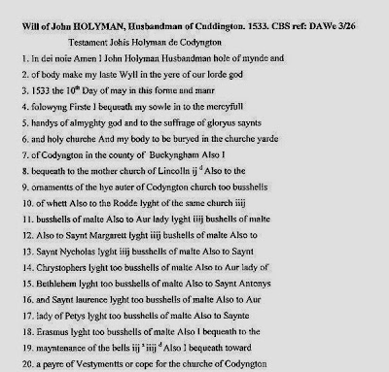

Line 1 - John identifies himself as a husbandman, a term to describe a free tenant farmer or small landowner. A yeoman farmer, higher up in social status, would have had more acreage than a husbandman. As the Oxford Companion to Local and Family History (1996) states the words yeoman and husbandman were gradually replaced in the 18th and 19th centuries in England by 'farmer'. Interesting that this John describes himself as a husbandman, as the Holymans rose economically and socially in the 1500s.
Line 6 - He directs, as did his father, to be buried in the St. Nicolas church yard, Cuddington.
Line 8 - He leaves a bequest to the Diocese of Lincoln cathedral.
Lines 9 -18 - John Holyman leaves bequests, bushels of malt barley, for the holy lights on the High Altar and for the altars of St. Mary, St. Margaret, St. Nicolas, St. Christopher, our Lady of Bethlehem, St. Antony, St. Laurence, our Lady of Peter's light and St. Erasmus or Elmo. This tells us the parish is still Roman Catholic with numerous altars and chapels for various saints. In 1534, Henry VIII will have himself proclaimed the head of the English Church replacing the Roman Catholic pope. English churches will soon change.
It is not unusual to find in English parishes even today the posting of legacies to the local church. This one in Cuddington, Buckinghamsire recognizes one Nicholas Almond for his bequests in his will. However, no sign hangs for John Holyman whose bequests were made when the parish was Roman Catholic and not Anglican. Photograph November 2012.
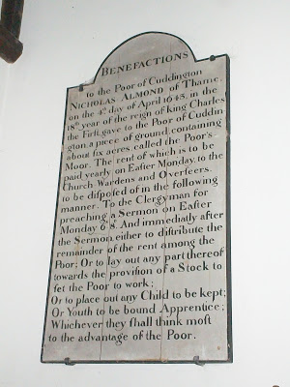
Line 19 - Bells remain to this date in St. Nicolas in Cuddington.
Line 20 - He leaves funds for the purchase of a pair of vestments or cope, another indication of John's support of the Roman faith, then under growing criticism in an England in political turmoil due to Henry VIII's 'Great Matter' - the divorce of Queen Catherine and remarriage to Anne Bolyen.
His cousin, nephew or in-law, Brother John Holyman, later Roman Catholic Bishop of Bristol, would have approved mightily of this will!
Next post, more of John Holyman's will of 1533....

Friday, February 1, 2013

When We Were English, Part LI
by Glenn N. Holliman
Continuing the 1533 Will of John Holyman of Cuddington....and a Surprise Relative Listed!
Below two family historians, yours truly left and professional genealogist, Anne Holmes, right, examine the 16th Century wills of the Holyman family of Cuddington, Buckinghamshire. We are pictured in the Buckinghamshire archives in Aylesbury, England, November 2012.
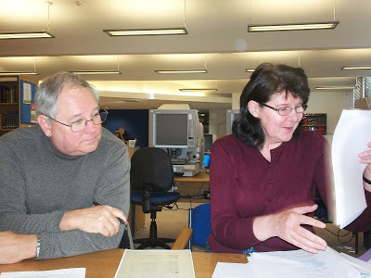

The 1533 Will of John Holyman continued....
﻿

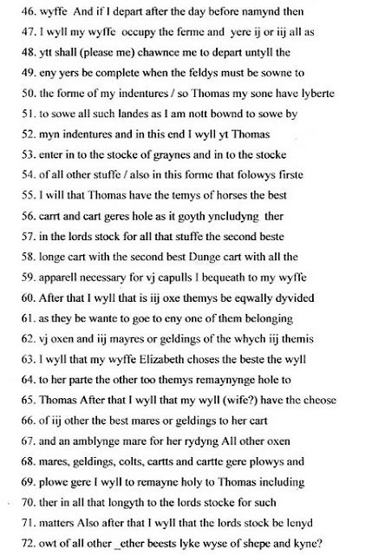

As we continue to review John Holyman's will, one is struck by his meticulous descriptions and abundance of 16th Century wealth.

Line 56 - A cart geres hole according to Ms. Holmes is translated as 'cart gears whole', that is machinery connected with the carts, harnesses and such.

Lines 58 to 62 - Here John leaves his wife his second best carts, including the dung cart (this is a farm). The couples are probably pairs of oxen. The wife does receive the best mare or gelding.

Line 70 - An interesting term of which Ms. Holmes describes as follows: "The lords stock: this was probably animals that the tenant looked after for the lord of the manor at the tenant's own cost, perhaps part of the tenant's copyhold agreement. It was common practice for tenants in the the medieval and early modern period to look after animals, at their own expenses for either the lord of the manor or the church. In some areas in England this practice continued into the twentieth century."

﻿
﻿
﻿
﻿
Lines 73 - 84 - John continues to divide his abundance of worldly goods between his wife, son Thomas and God Children. Notice he has lumber and timber to leave. As John made a will and has much property to distribute, we know he was a relatively wealthy man of his time. As Anne Holmes has written, the Holymans were a family on the rise in the 16th Century.

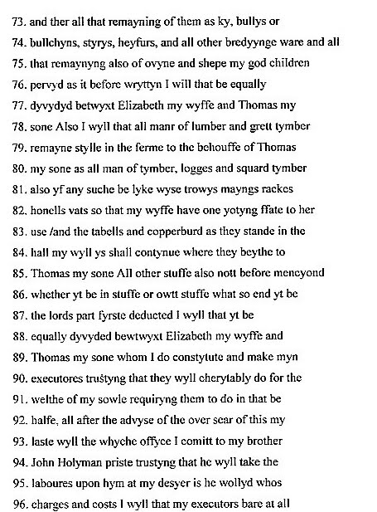

Lines 88 - 90 - Wife Elizabeth and son Thomas are appointed executors of the estate.

But look who is appointed overseer of the will!

Lines 93 - 95 - For those of us you have studied the relationship of The Rt. Rev. John Holyman, Bishop of Bristol, 1554-1558, and prominent opponent of Henry VIII's divorce of Anne Bolyen, to the our lineage, these are important sentences. I quote again from genealogist Anne Holmes:

"John Holyman priste almost certainly refers to the John HOLYMAN who was to become Bishop of Bristol. John is requesting the priest to be the overseer of is will. There is no financial bequest other than that to cover any expenses incurred in the task of overseer. John calls him 'brother' . It is unlikely they were siblings. It is possible the were cousins or kinsmen. The other possibility is the testator John HOLYMAN had married the sister of the priest. It was not illegal to marry a first cousin or other cousin at that time."

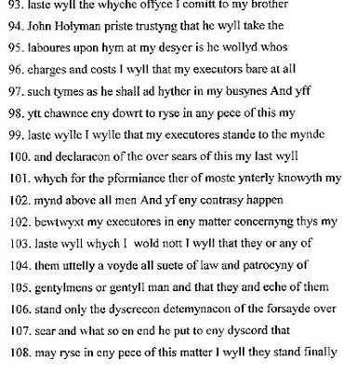

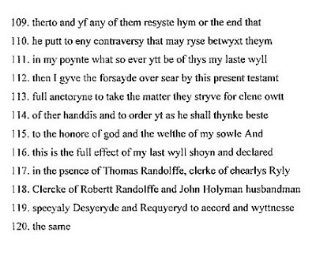
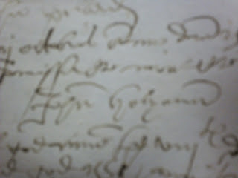

And so, John signs his will, signature above, a comprehensive document. In the next post, we will examine son Thomas' will, the off spring whom evidence indicates is probably my generation's 10th great grandfather.

Saturday, March 2, 2013

When We Were English, Part LIII
by Glenn N. Holliman
Continuing the Will of Thomas Holyman, 1558....
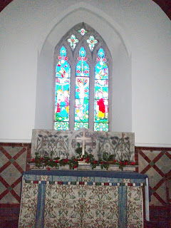
﻿
Above the altar in the sanctuary of St. Nicolas Church,
Cuddington, Buckinghamshire, England.
We continue our study of the Will for which accumulated evidence indicates was prepared by my 10th great grandfather - Thomas Holyman, yeoman farmer of Cuddington, Buckinghamshire. The Will continues beginning on line nine. Click on Will and it will enlarge.
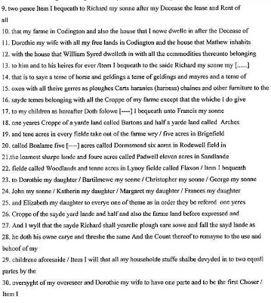

Lines 9 - 13 - Thomas announces that after his wife Dorothy dies, his first born son Richard is to inherit a considerable portion of the estate. This is called by the legal term 'primogeniture' in which the estate is handed down to the eldest son, generation after generation. According to Anne Holmes, professional genealogist who has explored the Holyman family and Cuddington, Richard died in October 1603 and is buried at St. Giles, Cripplegate, London.

One can presume that this great Uncle Richard Holyman had wealth enough to enjoy the countryside at Cuddington and a house in London. The year 1603 was not just any year in English history. The historic reign of Elizabeth I ended and James VI of Scotland became James I of England and began the ill-fated Stuart dynasty. And there was a writer named Shakespeare on the south side of the Thames writing some timeless plays.

Lines 22-26 - Christopher Holyman, my 9th great grandfather and his siblings received a year's crop from the said yard (acreage). He received a modest inheritance as did his brothers other than the first born, Richard. Christopher had to make his way in the world without significant inherited resources. As we shall see later, a good marriage would help.

Information on what had become a prominent family increased during the time of Thomas (d 1558). There were numerous children: Francis who married a person named Mary, died in Cuddington about 1603. Next a John Holyman (no doubt named after his grandfather) died about 1578 in London, and then Christopher, Bartholomew and George Holyman.

Dorothy Holyman, a sibling named after her mother, married John Clark 6 November 1582 in nearby Hughenden, Buckinghamshire. John may have been a cousin on his mother-in-law's side of the family.

Then follow Elizabeth, Frances, Katherine and Margaret.

Below yours truly stands November 2012 on the site of the Holyman manor house of the 16th Century. In the background are the Holyman farm fields and barns, hundreds of years old.

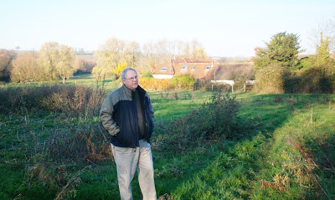

Next post, we finish studying the Will of a Roman Catholic family about to become Anglican as a Queen dies and Elizabeth I comes to the throne of an island nation - England!

Friday, April 12, 2013

When we were English LVI
by Glenn N. Holliman
Christopher Holyman makes his way in Elizabethan England...
Sometime in the late 1560s or 1570s, the persons, of which cumulative evidence indicates are my 9th great grandparents, married. They were Christopher Holyman, a son of Thomas Holyman (d 1558) who died in 1588 in Cuddington, Buckinghamshire, England and Margaret Lee, daughter of Thomas Lee of Dinton, Buckinghamshire. The Lees were substantial landowners and persons of prominence in Buckinghamshire. We shall explore this important maternal line in the next post.
According to professional genealogist, Anne Holmes of England, during the mid to late 16th Century the Holymans of Cuddington achieved their highest level of social and economic prominence. In that era, Elizabeth I securely held the throne, her Sea Dogs such as Francis Drake raided Spanish treasure ships, and the realm settled on a religious compromise between Roman Catholicism and rising Puritanism. That middle way is known as the Church of England, the Anglican Church if you will. In the United States, this form of Protestantism is known today as the Episcopal Church.
When Christopher and Judith Holyman (whom I contend were grandchildren of this first Christopher Holyman) arrived in Virginia in 1650, they were Church of England, no longer Roman Catholics as had been their grandfather at his birth. Nor were they non-conformists as was their distant cousin, Ezekiel Holliman, a founder of the American Baptist Church in the Rhode Island plantations.
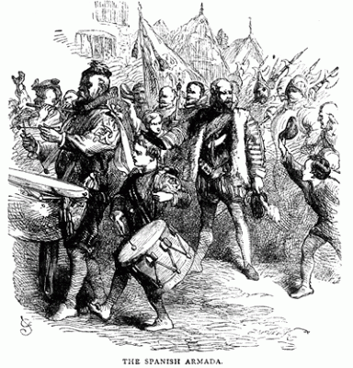

English soldiers mustered to repel the expected Spanish invasion in 1588, As an officer of the Queen's Guard, Christopher Holyman, d 1588, may have rallied with his men.
Thomas Holyman (d 1558) had numerous children and, as we noted in previous posts, according to the laws and customs of the time, the first born son, Richard, inherited the bulk of the estate. Our Christopher, who may have been a minor when his father died, received only some income from the harvest from one of the numerous lands of Richard.
Thus, Christopher and his brothers who inherited little had to make their own way in the world, generally through the church or the military, or one could step down the social ladder and become a tradesman. Alas, one of Christopher and Margaret's sons, one Thomas Holyman (d ca 1650) of Bedfordshire, inherited very little and became a member of the merchant class in the early 1600s, a story to be explored later.
Margaret Lee probably bought a substantial dowry into the marriage with Christopher and that no doubt eased his way in life. We know from several sources he was a prominent person in Sherington, Buckinghamshire, the location where he lived comfortably with his wife and growing numbers of children in the 1580s.
Seeking a career, landless Christopher joined the Army. When and where we do not know, but the year he died in 1588, he was a member of the prestigious Queen's Guard, a company of soldiers who served at the Queen's pleasure. To give us some idea of the status of this elite group, in the 1590s, a few years after Christopher's death, the famous Sir Walter Raleigh, a favorite of Queen Elizabeth, commanded the Guard. Raleigh, North Carolina takes its name from this entrepreneur, adventurer and later writer, who attempted to found the doomed Roanoke Colony in the 1580s.
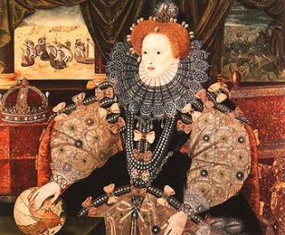

Above Elizabeth I, the Armada Portrait celebrating the victory of 1588.
The Queen's Guard survives to this day, well known to American tourists who have witnessed the Changing of the Guard in their bright red uniforms and tall bear furred head gear every day at 11 a.m. at Buckingham Palace, London.
Was Christopher called out during the feared invasion by the Spanish Armada in 1588? Was he in the field at Kent when Elizabeth marshaled the country's land forces in readiness? Did our 9th great grandfather hear his Queen forcefully proclaim that she had the feeble body of a woman but the heart of a king (such as her father Henry VIII)?
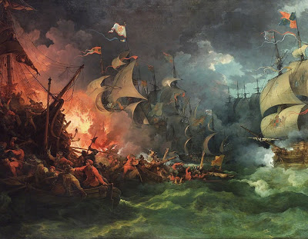

The English fire ships wrought havoc to the Spanish fleet as captured in this painting of the time.

Fortunately this gathering of English soldiers was never tested. At Gravesends, the courageous Sir Francis Drake maneuvered his smaller ships close to the hulking Spanish galleons. He sent fire ships to panic the anchored enemy fleet. Many of the larger, less agile Spanish titans, caught fire and burned. The panicked Iberian fleet scattered only to be battered by fierce storms that decimated the remainder of the shattered Spanish fleet. King Phillip II of Spain, once Elizabeth's brother-in-law, prayed aloud asking how he, a Catholic king, could have so displeased God?!
The invasion threat receded, the English soldiers returned home, but did our Christopher leave with the germ of a common killer of soldiers, a camp fever? He died in December 1588, not an old man.
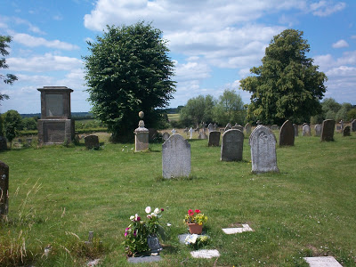

Above the parish cemetery in Sherington, England. Photo taken 2011.

Is Chris buried in the grave yard in Cuddington, his ancestral home, or in Sherington where he and his wife, Margaret Lee, raised their family of children, one being a young Thomas at the time of his father's death? We do not know.
Next Post, Christopher Holyman marries well into prosperous Lee family, wealthy and growing more so!

Friday, April 26, 2013

When We Were English, Part LVII
by Glenn N. Holliman
The Family of Margaret Lee Holyman....
This post continues our exploration of the life and extended family of Christopher Holyman, d. 1588, of Sherington, Buckinghamshire, England. Evidence indicates he is a son of John Holyman, d. 1558, of Cuddington, Buckinghamshire and that his grandfather was Christopher Clark of the same shire. This appears to be the origin of the first name Christopher which still appears to this generation in the Holyman families (and various spellings) in the United States.
Thanks be to the research of professional genealogist Anne Holmes of Buckinghamshire, England, we have information on the wife of Christopher Holyman, d. 1588. This person, whom I believe is a direct great grandmother of mine, was Margaret Lee of Moreton in the parish of Dinton, Buckinghamshire.
The Lees were a family of landed gentry, who settled in the area sometime in the 15th Century. Margaret's father was Thomas Lee who died in 1572. In his will, he does not describe himself as either gentleman or knight. However, his son, Thomas, Margaret's brother, who died in 1626 does describe himself as a knight in is Will, a person of high social status in Stuart England.
This brother-in-law of Christopher Holyman married Eleanor Hampden, the sister of Sir Alexander Hampden. After the death of Alexander Hampden in 1618, a major estate passed into the Lee family through Eleanor (his sister), that being the Hartwell House of Dinton.
Below in 2012, Anne Holmes and yours truly shared a pub meal in Aylesbury, Buckinghamshire and reviewed family history. Upon rising from the table, we discovered the print behind us was ironically of the Lee family Hartwell House. Photo by Barbara Holliman.
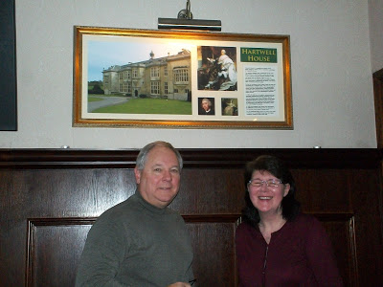

Anne Holmes speculates Thomas Lee, d 1626, acquired his knighthood possibly through the Hartwell Estate. "By the end of the 17th Century, the Lees had become Baronets. In contrast, the Holyman family star in Buckinghamshire was at its brightest in the mid 16th Century when Thomas Holyman (d 1558) had the manor of Cuddington and his kinsman, The Rt. Rev. John Holyman, was Bishop of Bristol.
In the mid 16th century, the Holyman and Lee families would probably have been seen as contemporary equals in social status hence the marriage of Christopher Holyman to Margaret Lee" write Mrs. Holmes.
Eleanor Lee (nee Hampden) would then be a sister-in-law to Christopher Holyman (d 1588). According to The Victoria County History of Buckinghamshire, Eleanor and Thomas had twenty-four children! This great aunt died in 1633, one would imagine of exhaustion, and is buried in Dinton, Buckinghamshire. The following plaque in the parish church records her 'achievement' and also her kindness to the poor. (Click on copy twice to enlarge.)
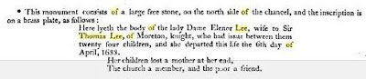

References for this article are found at http://www.british-history.ac.uk/report.aspx?compid=62771&;strquery=Lee and William Betham's late 19th Century publication The Baronetage of England
Next Post, more on the fascinating Lee family of Buckinghamshire....

Friday, May 10, 2013

When We Were English, Part LVIII
by Glenn N. Holliman
More on the Lees and Holymans of Buckinghamshire...the Story Continues....
The research on the Lee and Holyman family connections has been gathered by professional genealogist Anne Holmes of Buckinghamshire, England. Her sources include William Betham's 1805 work 'The Baronetage of England', George Lipscombe's 1847 volume 'The History and Antiquities of the County of Buckingham' and the peerage.com at http://www.thepeerage.com/ , the Ashmolean Museum web page on brass rubbings in churches in Buckinghamshire and 'The Victoria County History of Buckinghamshire on line at http://www.british-history.ac.uk/ . Anne Holmes also has a blog of Buckinghamshire history at www.bucksancestors.co.uk .
The person I believe to be my 9th great grandfather, Christopher Holyman (d 1588) married Margaret Lee of Moreton, Buckinghamshire sometime between 1572 and 1578. A son of Thomas Holyman (d 1558) of Cuddington, Buckinghamshire, Christopher could have been born anytime between 1538 and 1557. Thus he died young possibly only in his 40s.
Margaret was the daughter of Thomas Lee who died in 1572. Margaret's mother was Ursala Yates Lee. This Thomas had a father named Francis Lee, whose father, John Lee, died in London in March 1503. John's father was one William Lee who died in October 9, 1486. William's wife was named Anne.
The Lee's evidently originated in High Legh and Lyme in Cheshire. During the overthrow of King Richard II in the 1390s, the family supported the reigning Richard and later underwent 'persecution' for opposing the successful new king, Henry IV. The family then settled in Moreton in the parish of Dinton, Buckinghamshire adjacent to Hartwell.
One of the oldest monuments in the Dinton church is of William Lee, Esq. and Anne, his wife. For five generations the Lees resided at Moreton, where the ruins of the house surrounded by a moat are still visible. Below, the church in Dinton where Lees worshipped and were buried prior to the early 1600s. This pictured was made by Anne Holmes in May 2013. Christopher Holyman (d 1588) and Margaret Lee may have married at this church.
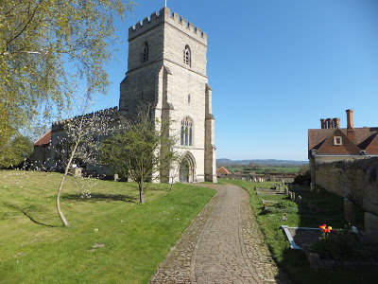
Margaret Lee Holyman's brother, another Thomas Lee (d 1626) married an Eleanor Hampden (they had 24 children as described in a previous post). When Eleanor's brother died, the Lees acquired the manor house Hartwell and Thomas, the title of Knight. By the middle of the 1600s, the Lees had become barons.
Below the Hartwell House today is a National Trust hotel with a storied past. For photos of the current house with beautiful interiors click on www.hartwell-house.com/the-hotel . Photo taken November 2012.
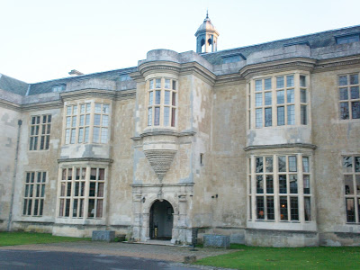

Below, the chapel at Hartwell House where Lees were entombed beginning in the early 1600s.
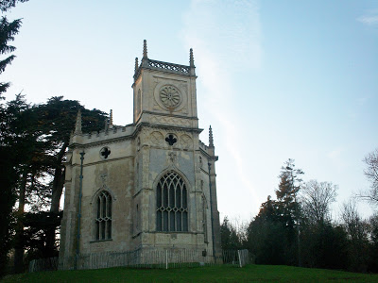
The monument below hangs in the parish cemetery at Cuddington, historic home of the Holyman families of America. This 19th Century Lee is probably a distant cousin of the Holymans. Eleanor and Thomas Lee of the late 1500s had so many children that Lee became a popular name in Buckinghamshire. Some authorities speculate this is the origin of the Robert E. Lee family of Virginia but this has not been proven one way or another. Photos taken November 2012.
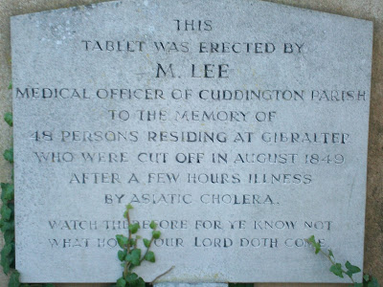
While the Lee family 'star' continued to rise in the 17th Century, some Holyman descendants of the Lee line moved down the social and economic scale. And that story will take us up to the momentous decision of another Christopher Holyman (1618-1691) to stake his fortune and future in Virginia in the year 1650.

Next posting on England examines of the children of Christopher and Margaret Lee Holyman....

