WHEN WE WERE ENGLISH, PART XXXVI
Additional Clues to our British Origins
By Glenn N. Holliman
In the summer of 2011, Bob Holloman of Mississippi informed me that he had found on the web a listing for a Hollyman family history in the national library of Wales. The author was Robert Hollyman-Mawson, who has a Facebook page. With Bob’s encouragement, I contacted the other Bob, an Englishman who lives in Wales, a rugged and mountainous region in the western United Kingdom. A correspondence began which resulted in a visit to Caernarvon, Wales by your truly in November 2011.
Bob has proved a wealth of family information, put me into contact with other Hollymans in the U.K. and gave me an important clue as to the American Holliman’s origins in England.
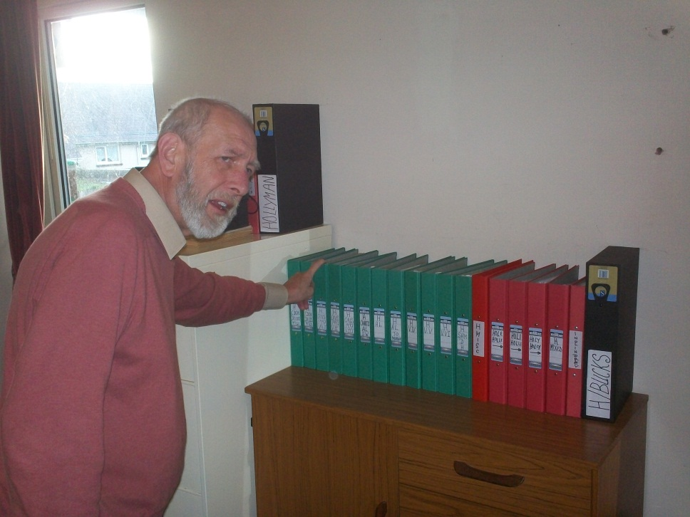
Bob Hollyman-Mawson has an organized and comprehensive collection of records on the last 350 years of his Hollyman ancestors. Above are just a portion of his volumes of meticulous research maintained in the study of his Carnarvon, Wales home.
Born in Nottingham, England, Bob has lived all but a few months of his life in Wales, in historic Caernarvon where the Princes of Wales are invested. A Royal Navy sailor in his youth, he is active in veteran organizations and is an avid student of U.S. Civil War history. A Hollyman descended through his mother and grandmother, he has amassed records of Hollymans (and associated spellings) from around the world. Recently Bob has begun preparing his materials to post in the near future on his own web site.

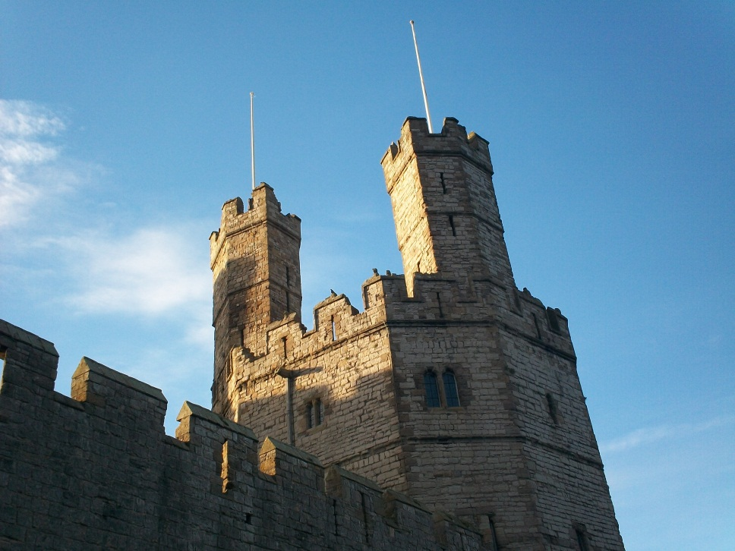
Caernarvon Castle over looks the harbour of this former Roman settlement, the most western outpost in Great Britain of that ancient empire.
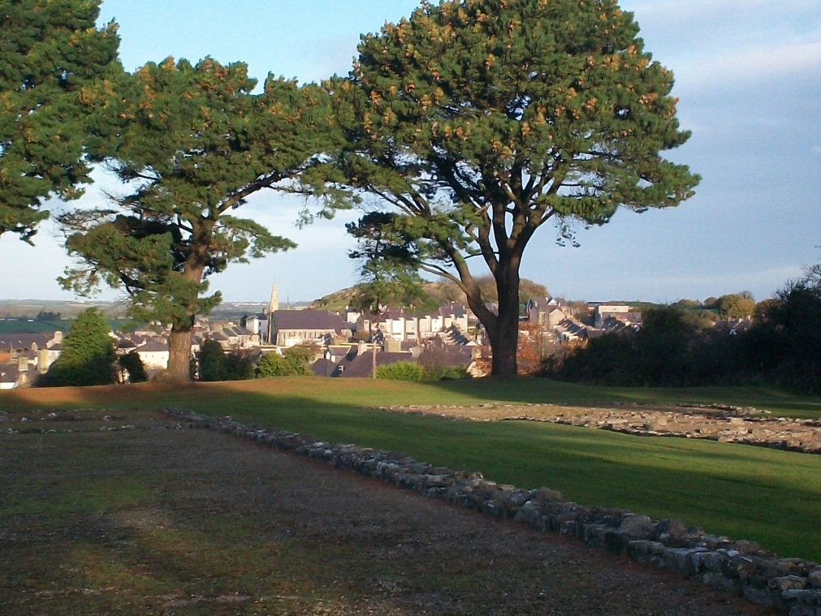
Above are the ruins of a Roman settlement now looking west to the city of Carnarvon. This 1,800 year old site is only a block from Bob Hollyman-Mawson’s home.
Carnarvon, a historic Welsh city which incorprates thousands of years of human habitations, reminds American Hollimans of the complexity of our British heritage. We are composed Stone Age, Celtic, Roman, Angle, Saxon, Jute, Danish and French Norman DNA. Mix this together, stir for several thousand years and one becomes British. Sail to the New World, add yet more cultures and races, plus several hundred additional years and one becomes an American.
More on Bob Hollyman-Mawson and his insights in the next post….

WHEN WE WERE ENGLISH, PART XXXVII
Additional Evidence of Buckinghamshire Roots
By Glenn N. Holliman

Add map of Bedford and bucks.
In previous articles (see Archives), evidence has been presented that:
- Christopher Holyman, Sr., who arrived in Jamestown, Virginia in 1650 and died in 1691, had been born in 1618 in Bedford, Bedfordshire, England. (My generation’s 7th great grandfather)
- and that his father was Thomas Holyman of Bedford, who was schooled and raised in the late 1500s in nearby Sherington, Buckinghamshire, and is listed in his father’s will as a second son. (If this thesis be correct, Thomas is my 8th GGF)
- and that Thomas’s father was one Christopher Holyman whose will was administered in Sherington, Buckinghamshire in 1589. (Making this Christopher my 9th GGF)
- and now thanks to information provided by Bob Hollyman-Mawson, the above Christopher according to an abstract will died in 1588 in Cuddington, Buckinghamshire, evidently Christopher’s childhood home and the location of a prominent Holyman family.
- and that in 1558, one Thomas Holyman died in Cuddington and in his will left legacies to several children, one being a Christopher Holyman! Serious question – is this Christopher Holyman the gentle man who died in 1588 in Cuddington and whose will was proved in Sherington, 30 or so miles north, the same Christopher listed in this 1558 will? Is this Thomas Holyman who died in 1558 in Cuddington my generation’s 10th great grandfather?!
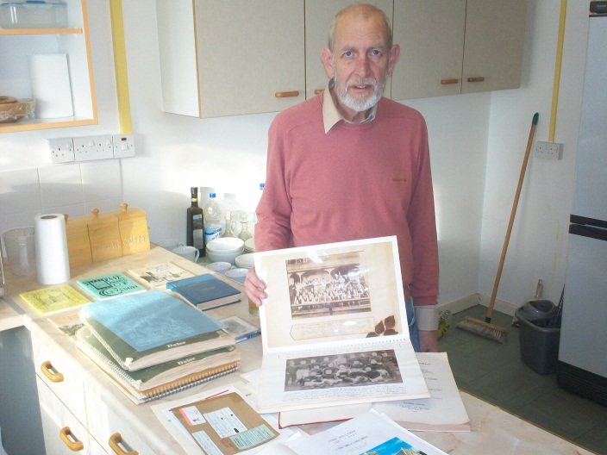
Above, Bob Hollyman-Mawson presents more of his research. He has in hand information from the original records concerning the wills of Christopher Holyman (1589) and Thomas Holyman (1558), both of Buckinghamshire, England. Bob is a graduate from the University of Wales in linguistics.
If so, then we seem to have found the missing piece of evidence tying the American Holymans to the paradoxical families of The Rt. Rev. John Holyman, Roman Catholic Bishop of Bristol, and enemy of the Reformation and Ezekiel Holyman, a Nonconformist and a founder of the Baptist Church in Rhode Island, USA!
More research is to be accomplished:
1. Learning more about Christopher Holyman who died in 1588, the suspected grandfather of our Christopher Holliman who died in 1691 in Virginia.
2. Studying carefully the original will of Thomas Holyman (1558) of Cuddington, Buckinghamshire.
3. Discovering the name and details of this Thomas Holyman’s father and ancestors.
4. Ascertaining how long the Holyman family had been in the Cuddington, Buckinghamshire area. Additional information is now surfacing from another source, family genealogist Peter Smith of Bedfordshire, suggesting that the Holyman’s may have originated in London.
5. Discovering how connected Bob Hollyman-Mawson’s family, whose origins are in the Bristol and Somersetshire, England area of the middle 1600s, is to the Buckinghamshire Holymans.
Before exploring the probable Somerset and Buckinghamshire Holyman connections, let’s look more closely at the Holyman’s of Cuddington…

WHEN WE WERE ENGLISH, PART XXXVIII
A Deeper Look into Buckinghamshire Roots
By Glenn N. Holliman
Cuddington, some nine miles from Aylesbury and forty or so miles east of London, was and is a small village. There is a pub and an ancient village church. If you look below at this hand drawn map provided by Carolyn Stonham, a professor who lives in Holyman House (1698) on the site of the 15th CenturyHolyman Manor House (long since decayed), one can understand better the dimensions of the small town.
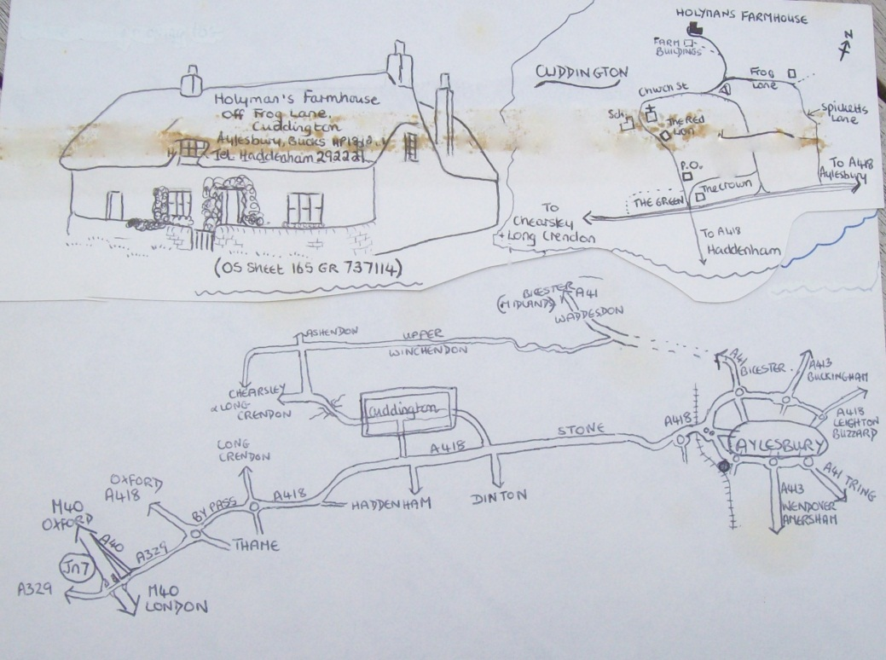
This map is in three parts. The bottom half shows Cuddington in relationship to Aylesbury (rt) and the M-40, a major motorway which flows west toward Oxford and east toward London.
The upper right part of the map is a visual of the village with the Holyman Farm in the upper middle. The left upper part of the map is the 1698 Holyman House where Professor Stonham lives today, a thatched roofed cottage. Unfortunately the remains of sticky tape have marred the map a bit.
If one recalls my last article, I advanced the thesis that one Thomas Holliman of Cuddington (will – 1558) is a direct grandfather of mine. Hmmm…if so who begat Thomas and when and from where did these Cuddington Holymans appear?
Below is another document Professor Stonham shared with me and which my wife copied with our digital camera. This is a muster and tax roll representing two generations. The muster certificate is from 1522 and the manorial survey from 1555.
Notice that a Thomas Holliman is listed on both. In the earlier document, John Holiman is the wealthiest. In the later document, Thomas Holyman (Holiman) is recorded as the person with the most wealth. Is this Thomas my generation’s 10th great grandfather?
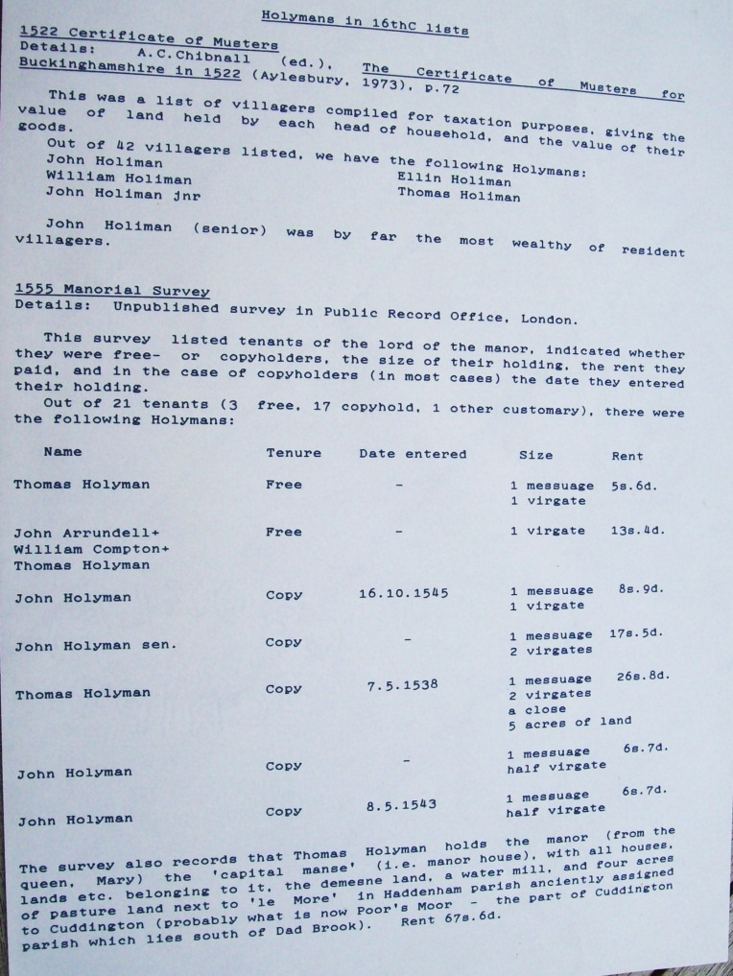
This Thomas Holyman did quite well, holding the manor and land granted by Queen Mary Tudor. Let’s reflect a bit….Mary Tudor tried in her reign from 1553 – 1558 to restore the Roman Catholic Church to England. Here Cardinal Pole appointed a parish priest and former monk, John Holyman of Cuddington, as Bishop of Bristol. John died in 1558, one month after Queen Mary.
Did the Holyman family in Cuddington benefit from the benevolence of the Queen because the family, especially The Rt. Rev. John Holyman, were loyal to the old faith, the Roman Catholic Church?
Did the fortunes of the Holymans begin to unravel with the establishment of the Protestant Church of England during the reign of the next queen – Elizabeth from 1558 – 1603?
Did the surviving Holymans flow with the times. One notes from published sources that Chistopher Holyman (will – 1589) of Cuddington and Sherington is listed as a member of Queen Elizabeth’s guard. Hmmm….much to consider and a lot of questions that cannot be easily if ever answered.

WHEN WE WERE ENGLISH, PART XXXIX
by Glenn N. Holliman
That Holyman Manor House
Below is the site of the 15th Century Holyman Manor House in Cuddington, Buckinghamshire as it looked in 2010. Today it is pasture land as part of the remaining Holyman farm. 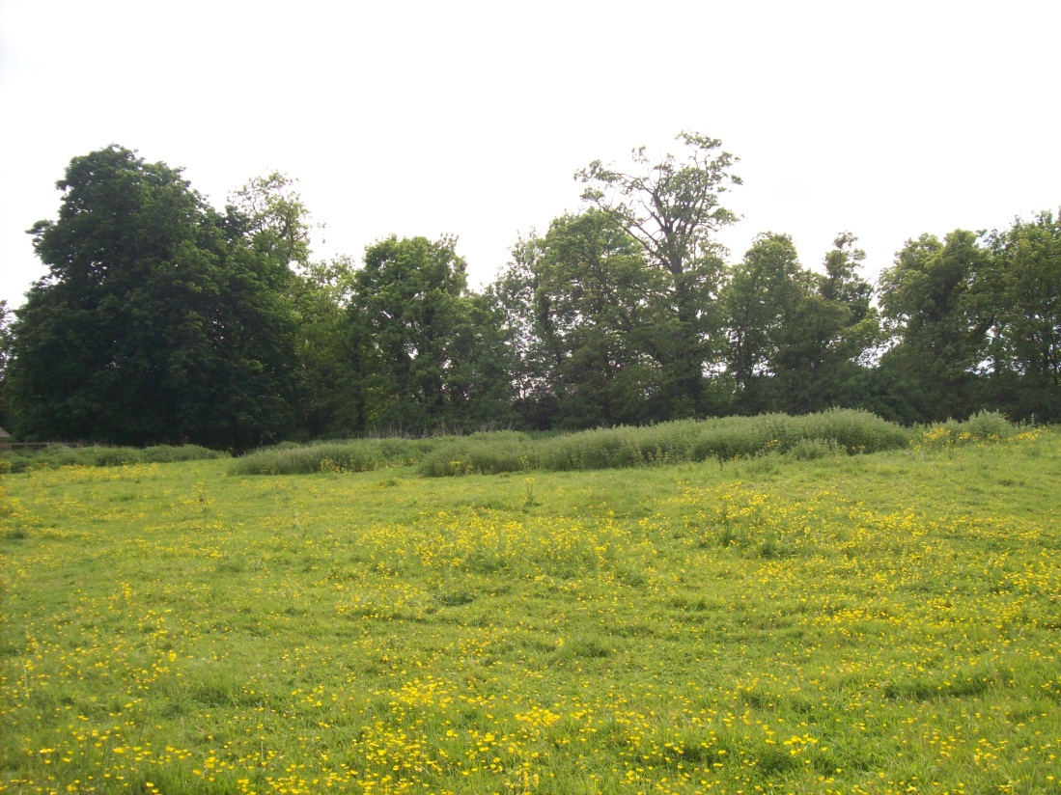
In 1851, a survey was done of the farm and the document below records what was left over a century and a half ago.
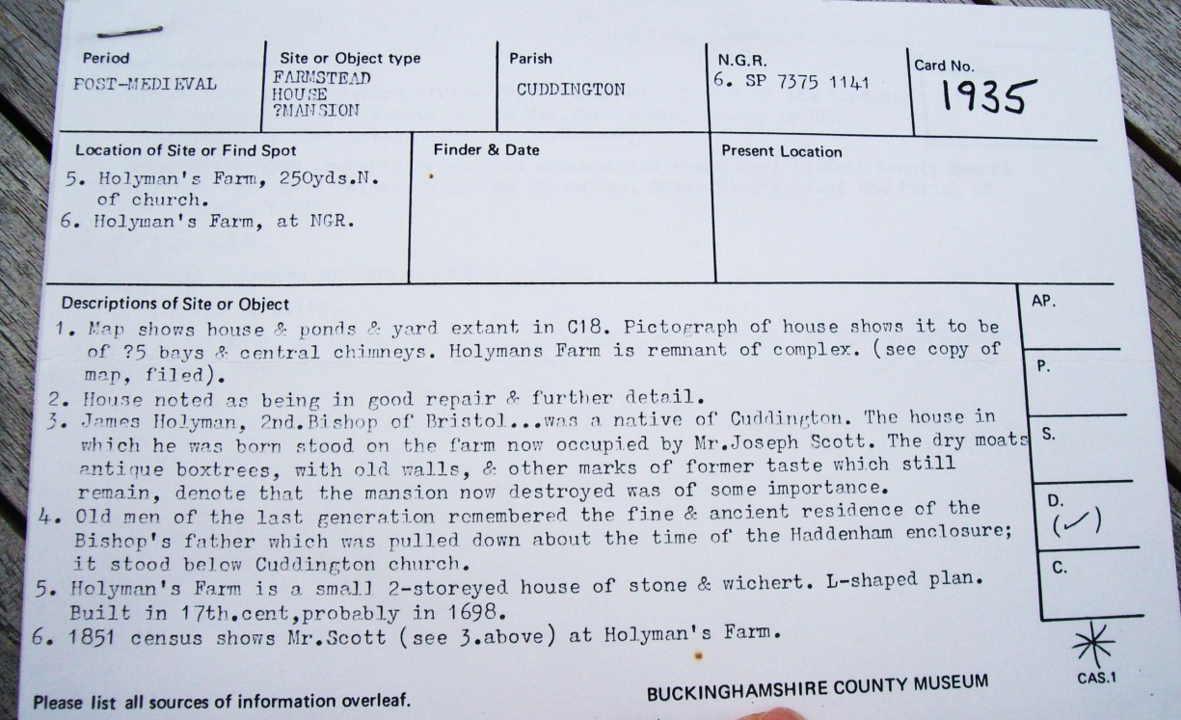
Notice item 3 above in this statement about a post-medieval site. James (an error; it is John) Holyman is listed accurately as the 2nd Bishop of Bristol. A Mr. Joseph Scott lived on the property in the middle 1800s. Dry moats, boxtrees and old walls still stood at that time and that ‘the masion now destroyed was of some importance’.
Item 4 states that house lasted until the early 1800s. A smaller 1698 stone and thatched cottage as well as stables do remain in 2010.
What might have this minor manor house looked like? The map below from the 1700s gives us some idea of the size of the farm and a look at the manor house. It appears to be three floors (dormer windows and attic as the 3rd floor) with a small tower and wind vane on top center.
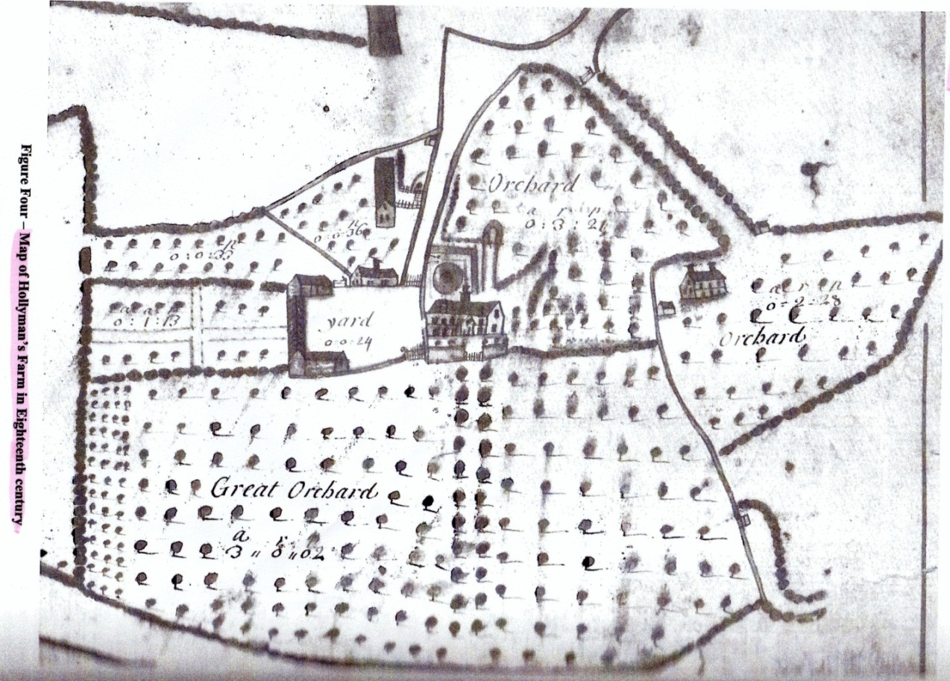
By the 1700s, the Holymans must have been producing considerable cider judging from the number of apple orchards.
What more can be learned? I must return to the archives in Aylesbury, Buckinghamshire for more research. For now, thanks to the current owner of the Holyman farm in Cuddington, we have the above and a view into our ancestral past.

