[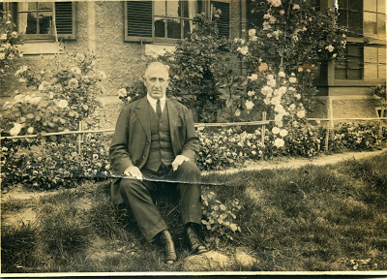](http://4.bp.blogspot.com/-5OJO6JiRXq8/Unll7dPQAiI/AAAAAAAAGzI/S4lo7B-k_kw/s1600/The+Rev.+William+A.+Wilson+in+Japan1.jpg)