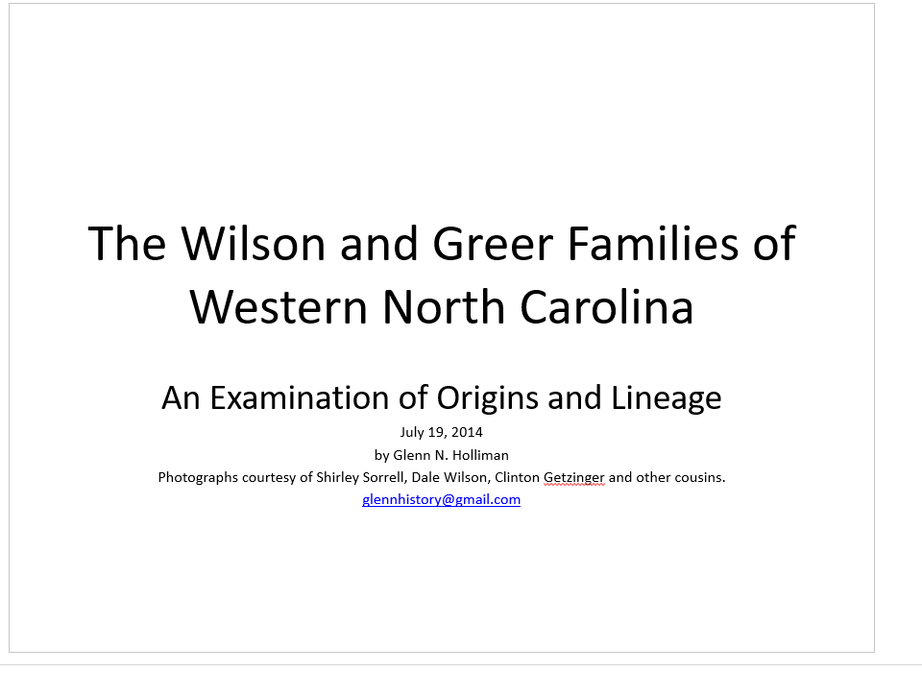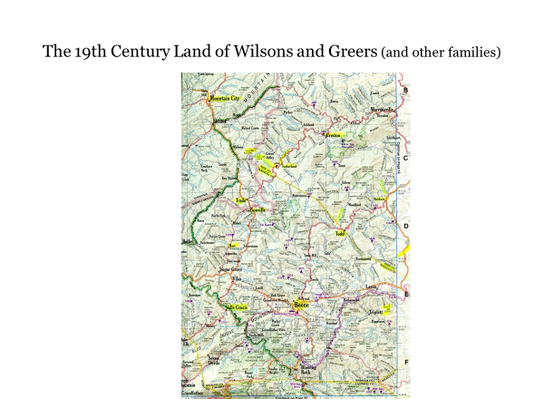In yellow, are some of the locations where Boones, Wilcoxsons, Wilsons, Greers, Donnellys, Adams, Osbornes, Forresters and other associated families settled and where descendants live to this day. Ancestors came from England, Wales and Scotland, settling in Pennsylvania and the Chesapeake colonies before moving south and west in the middle 1700s. Their challenges were eastern colonial governments, Native Americans, the government of King George III, geography, weather and eventually during a vicious Civil War, their neighbors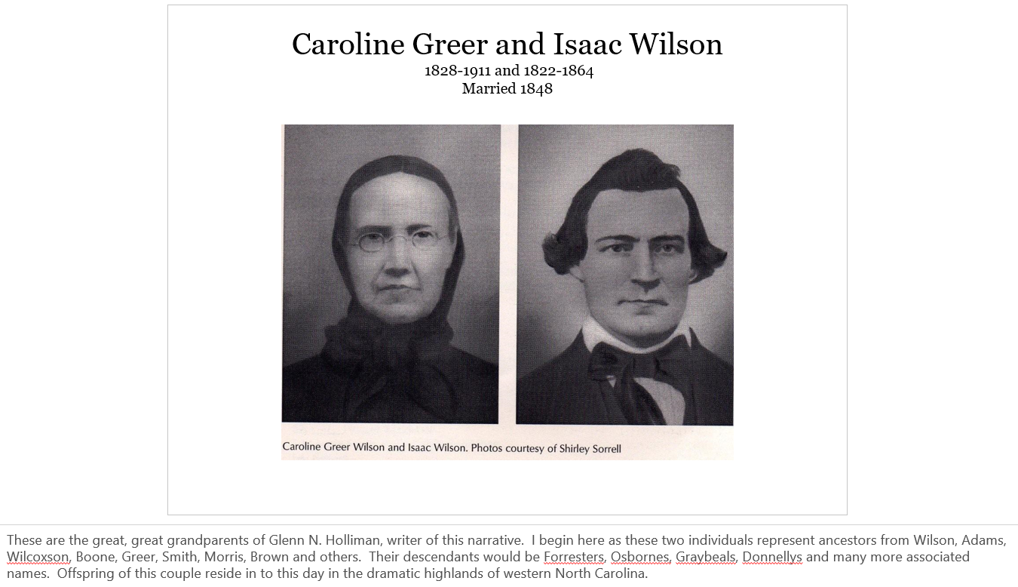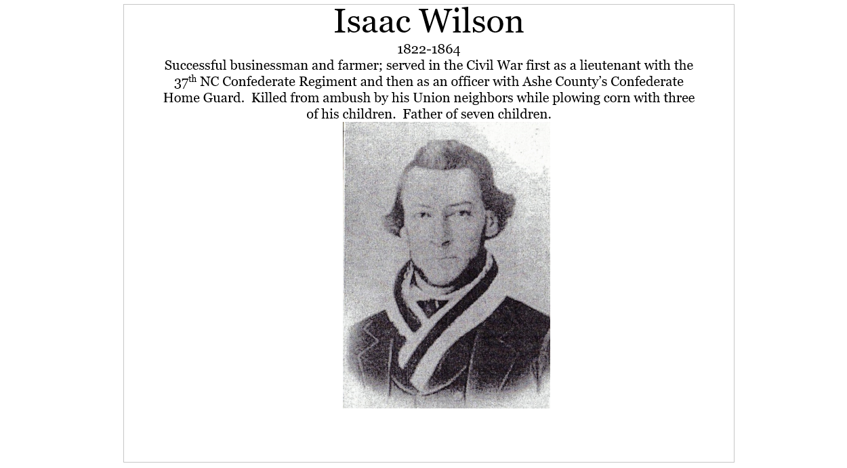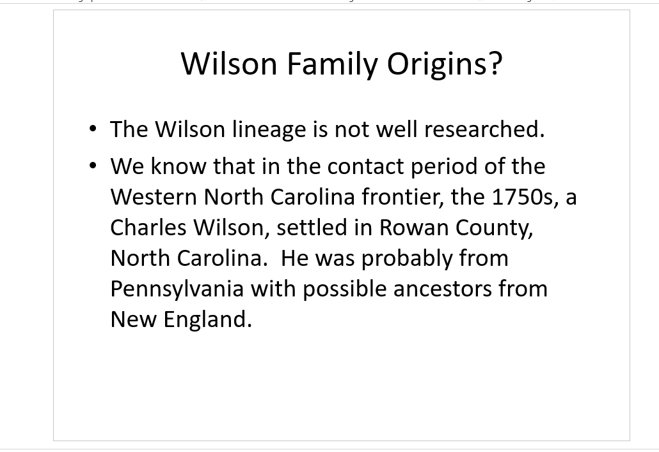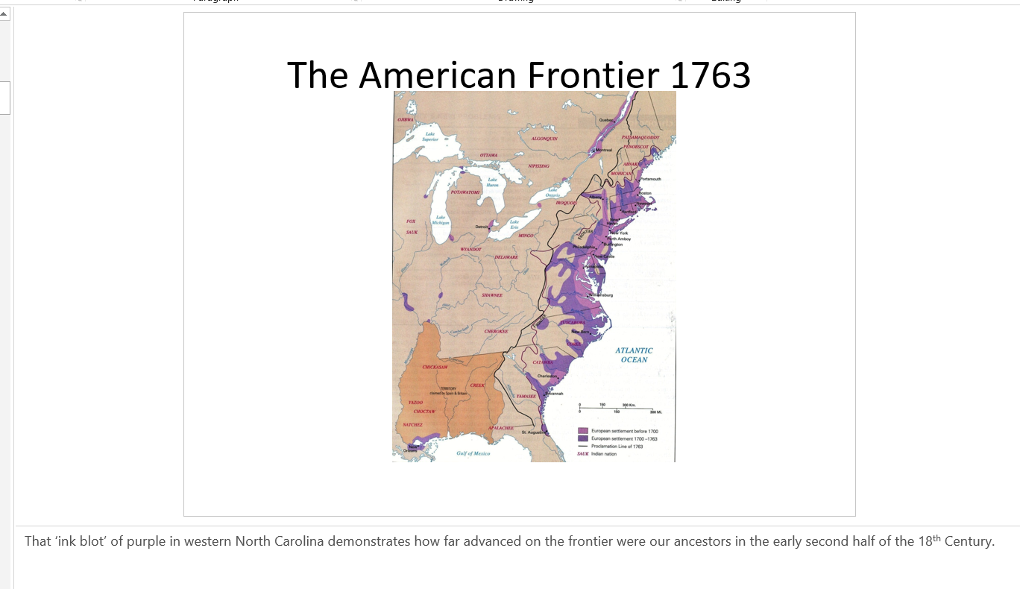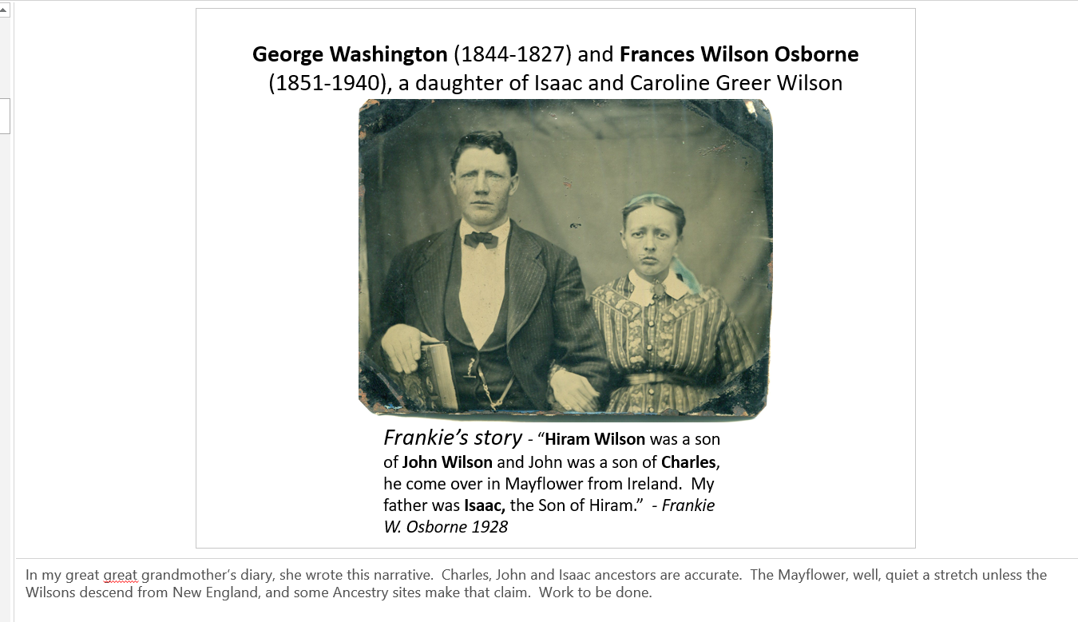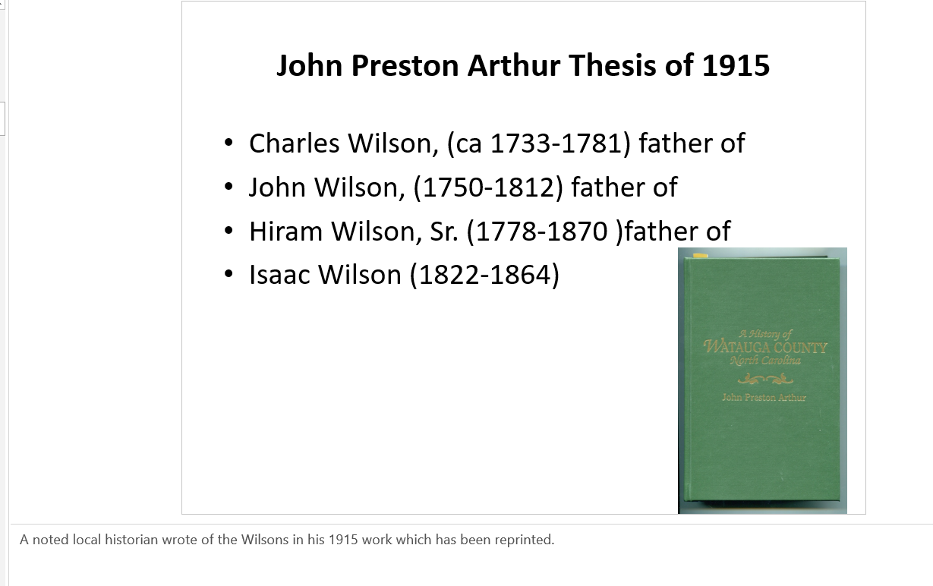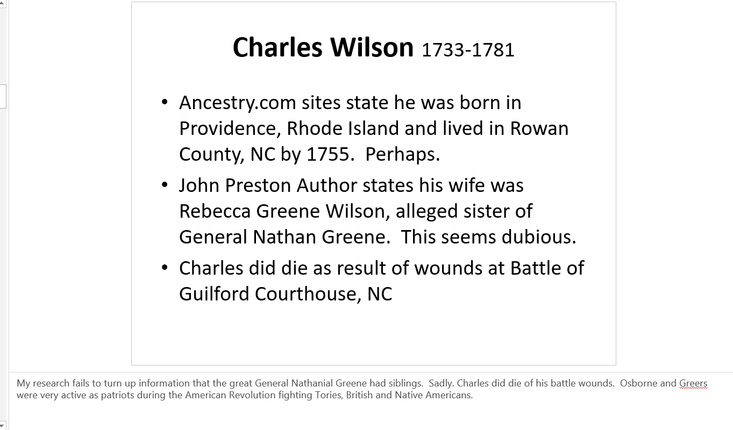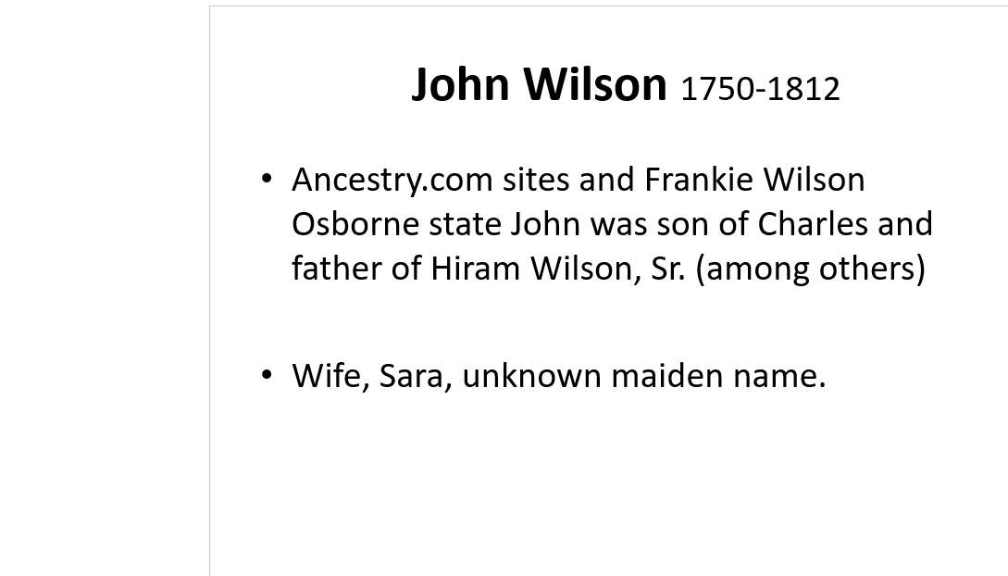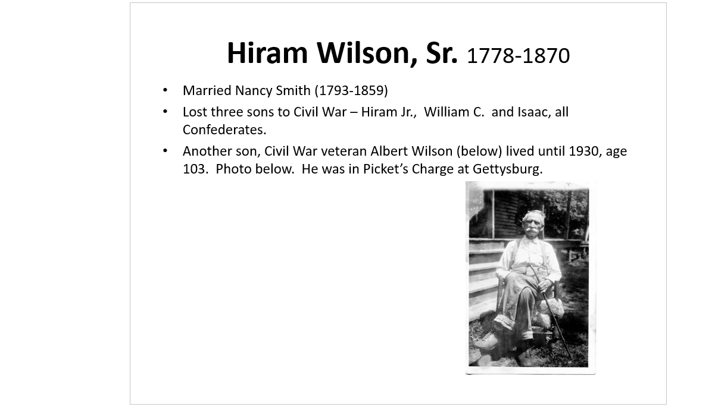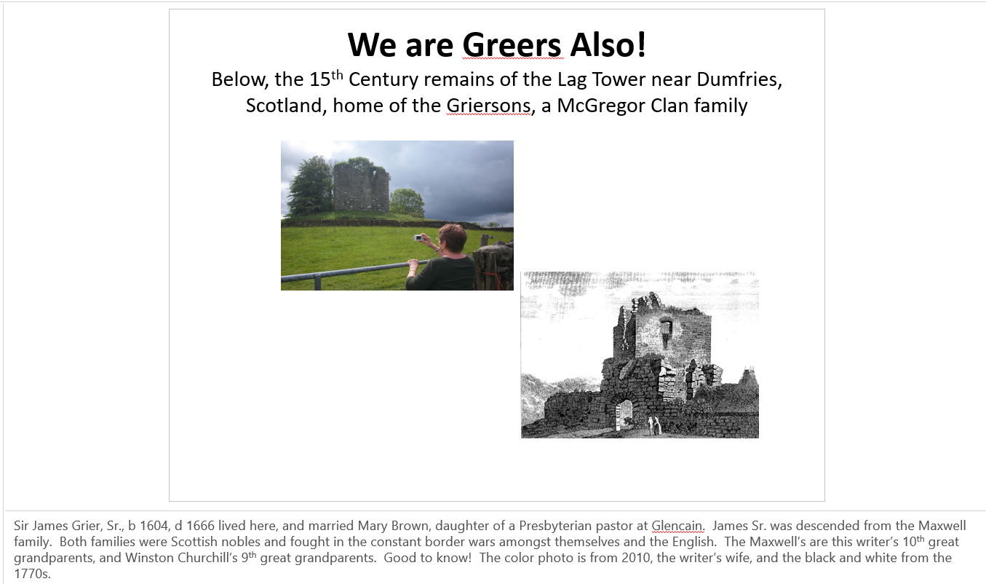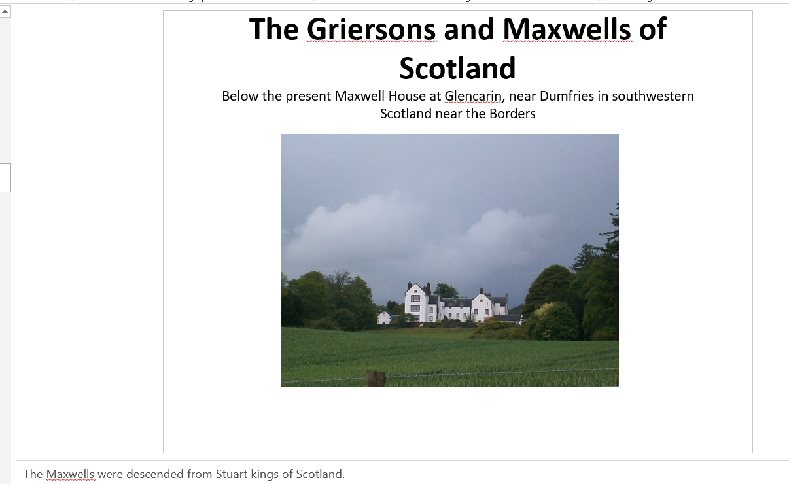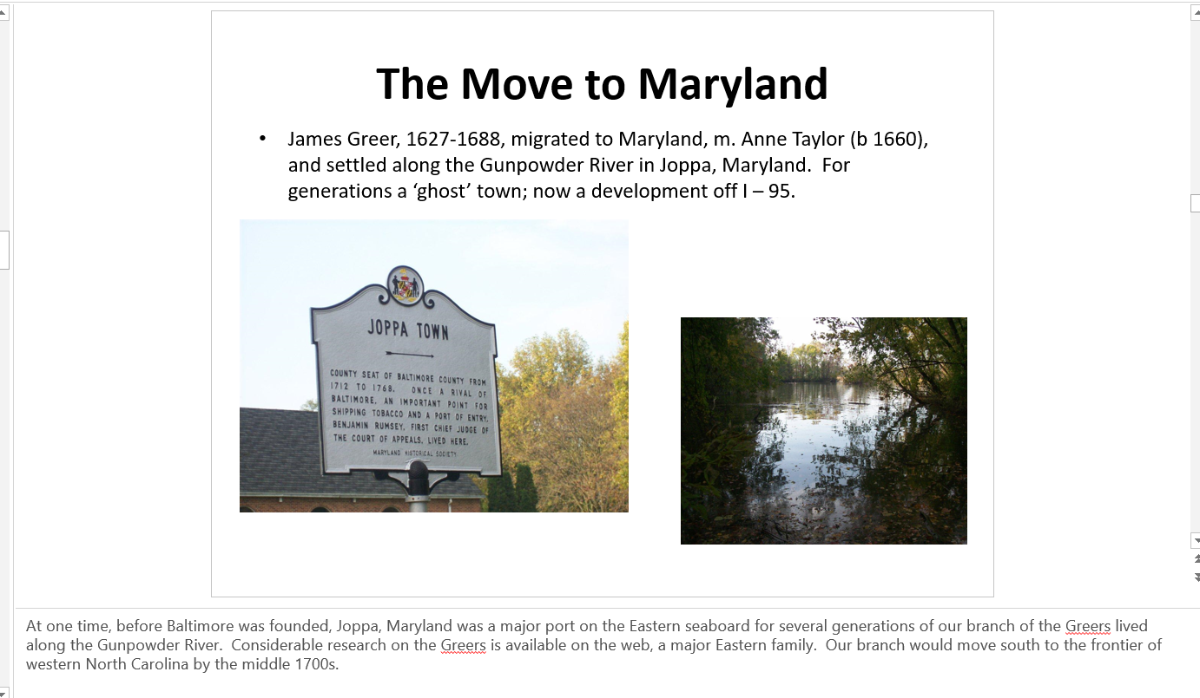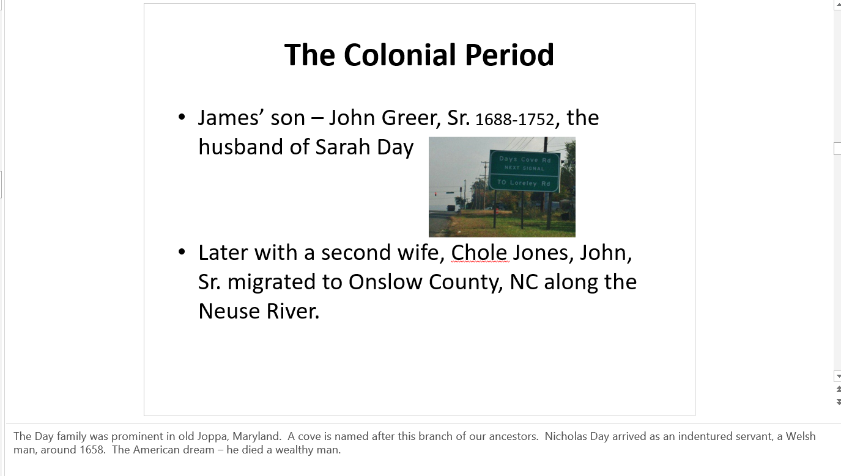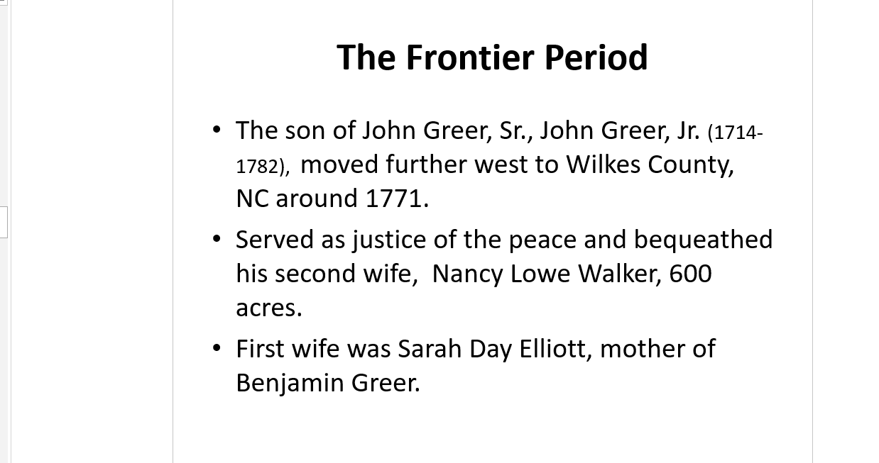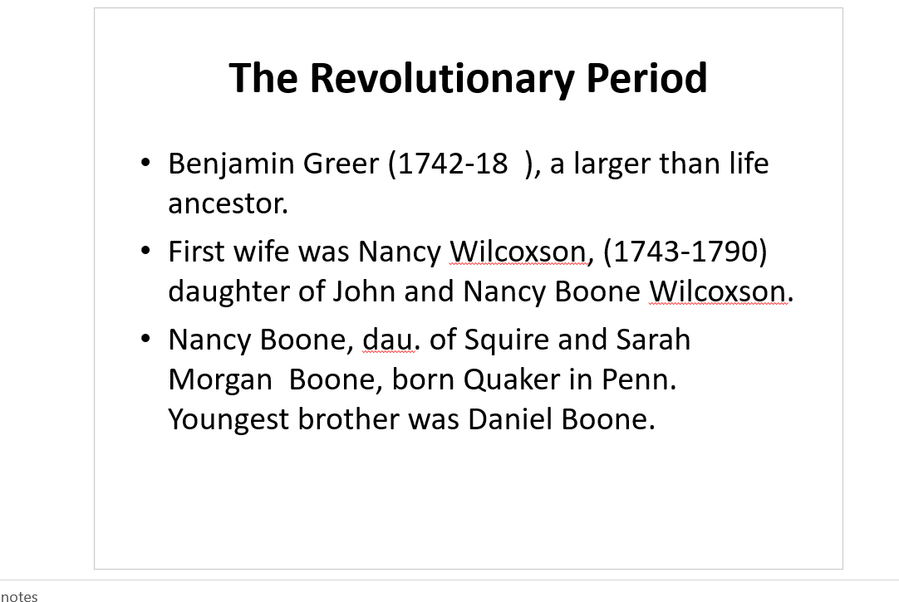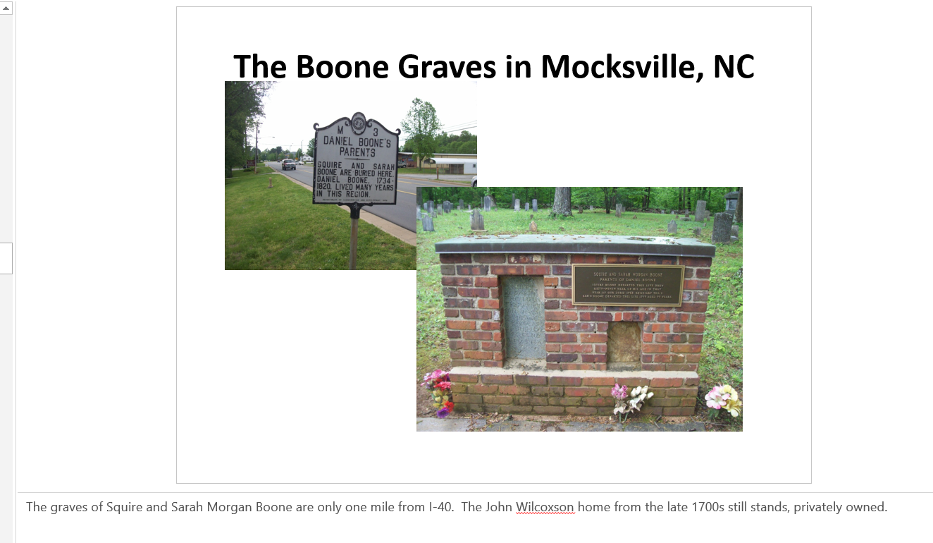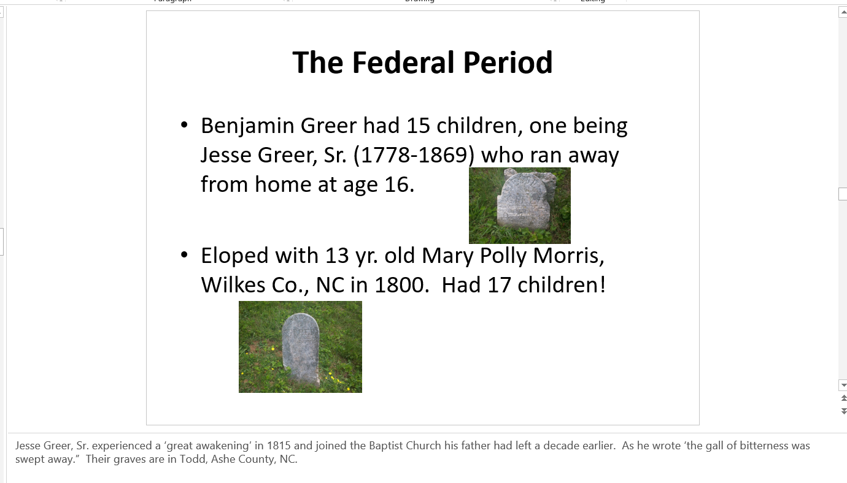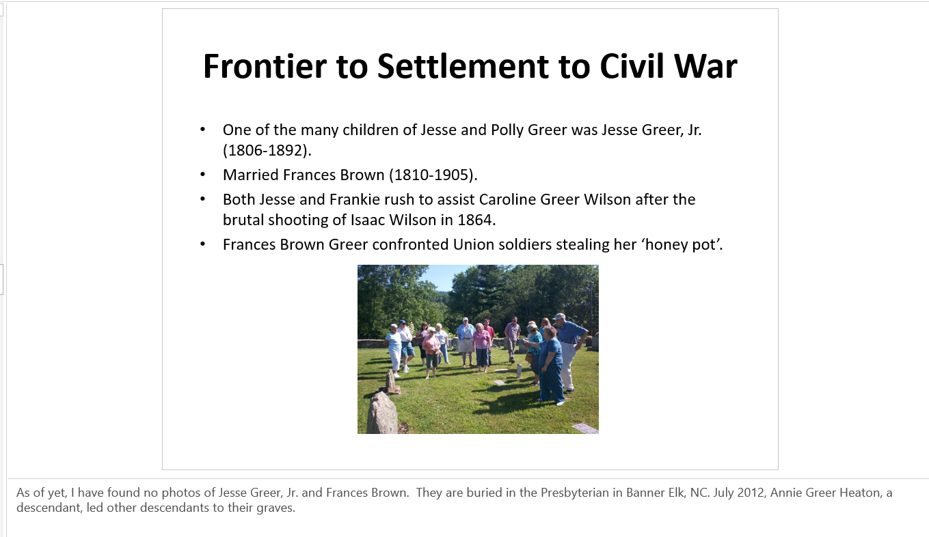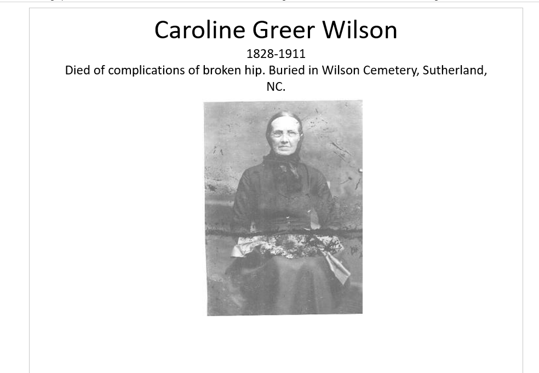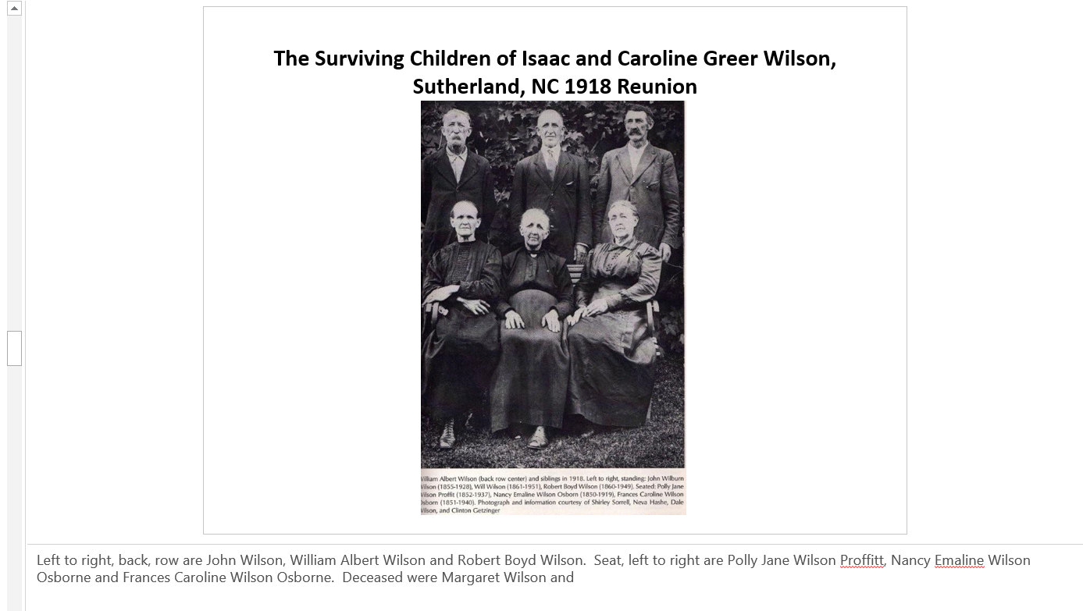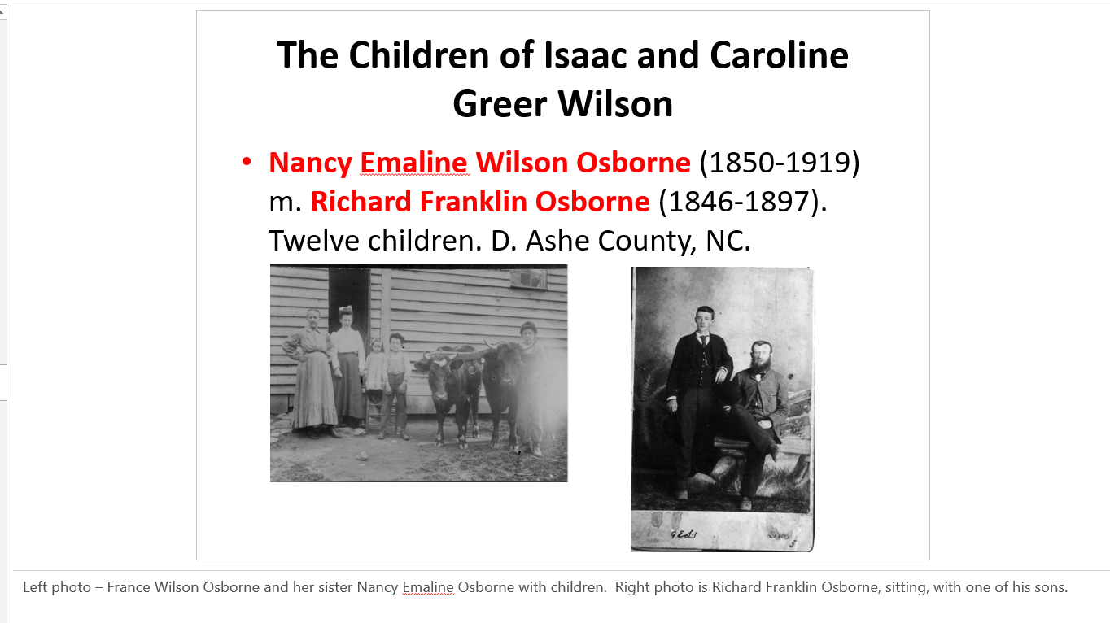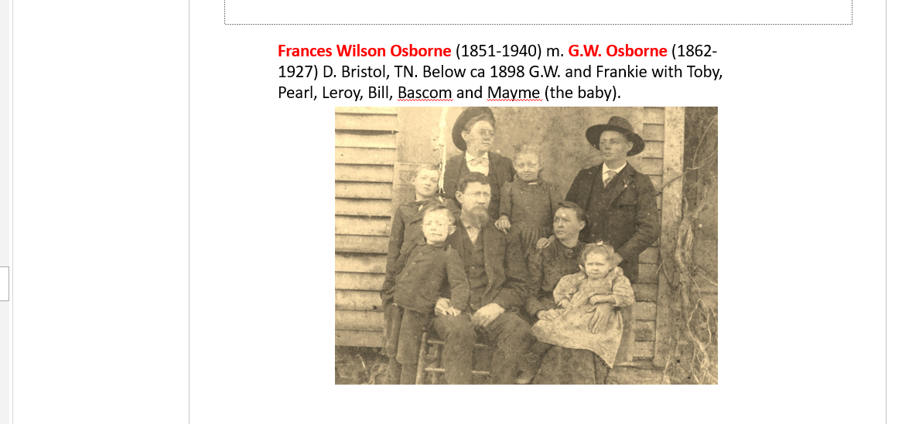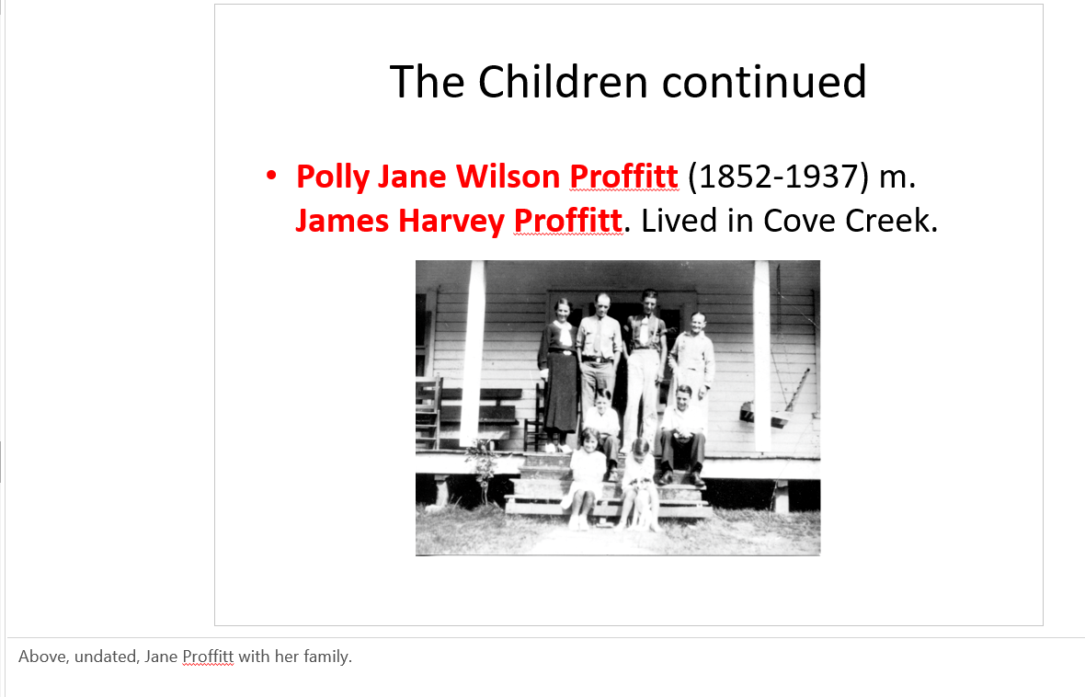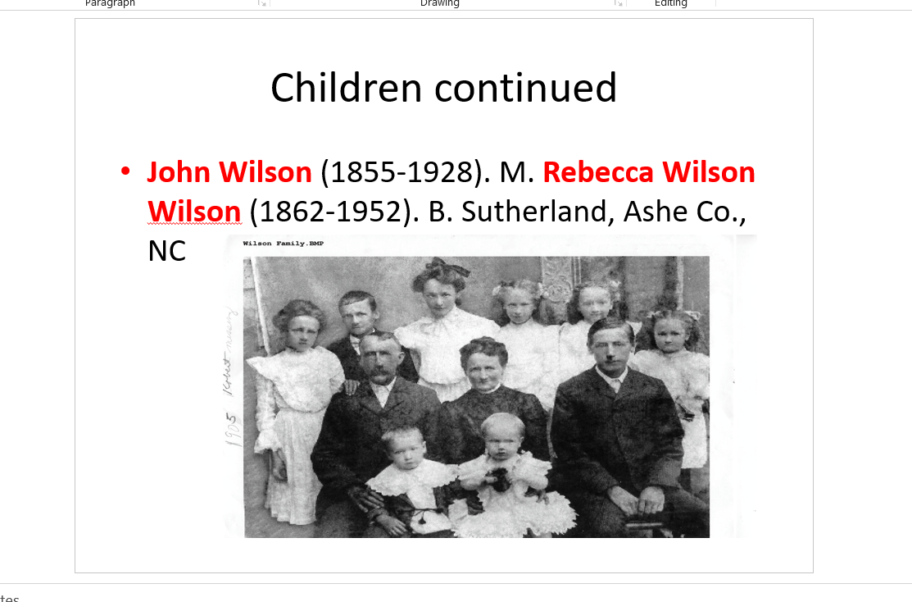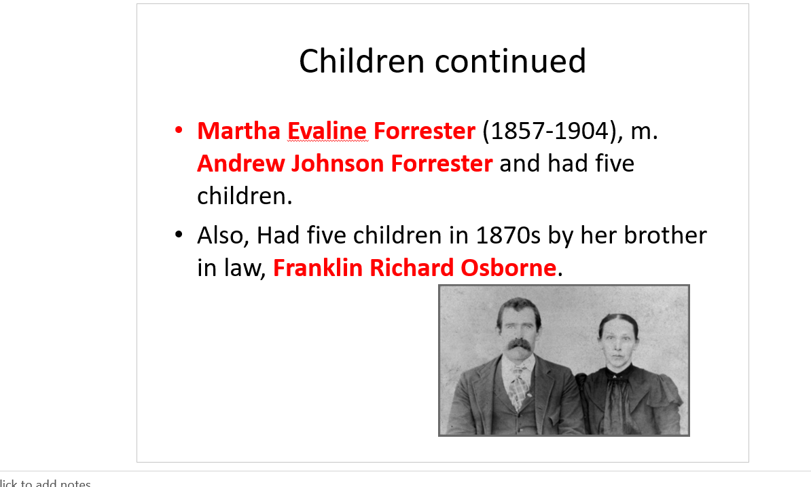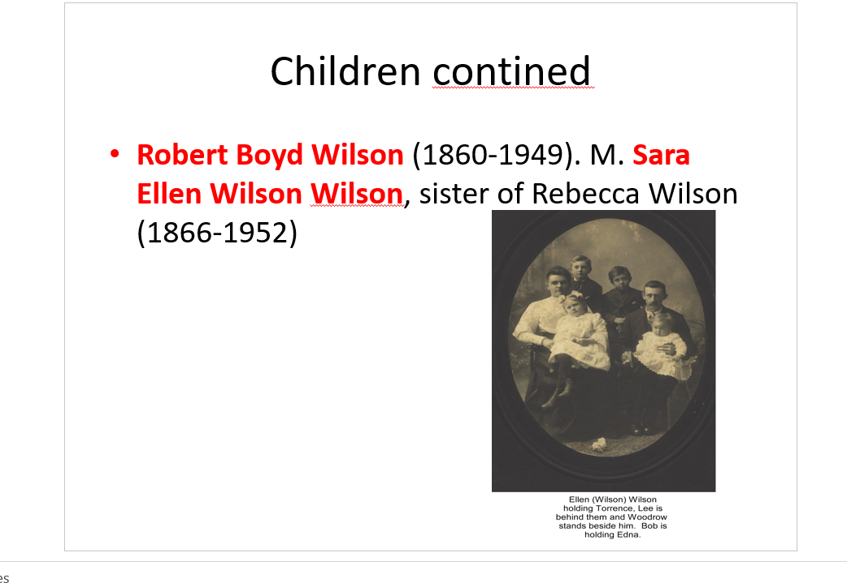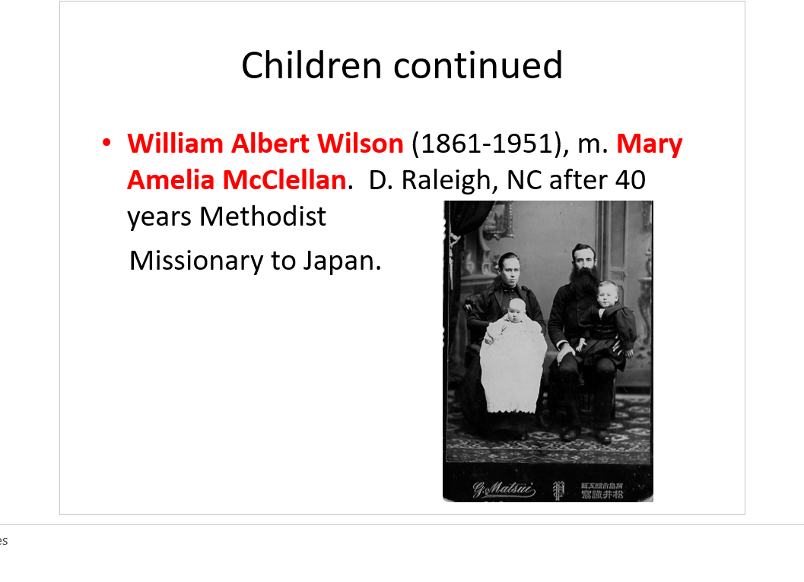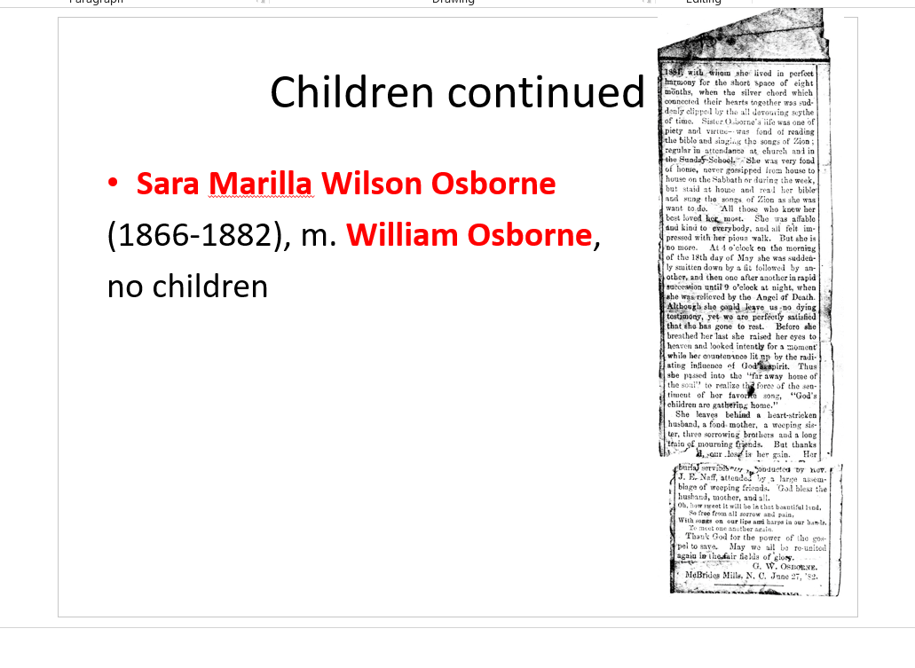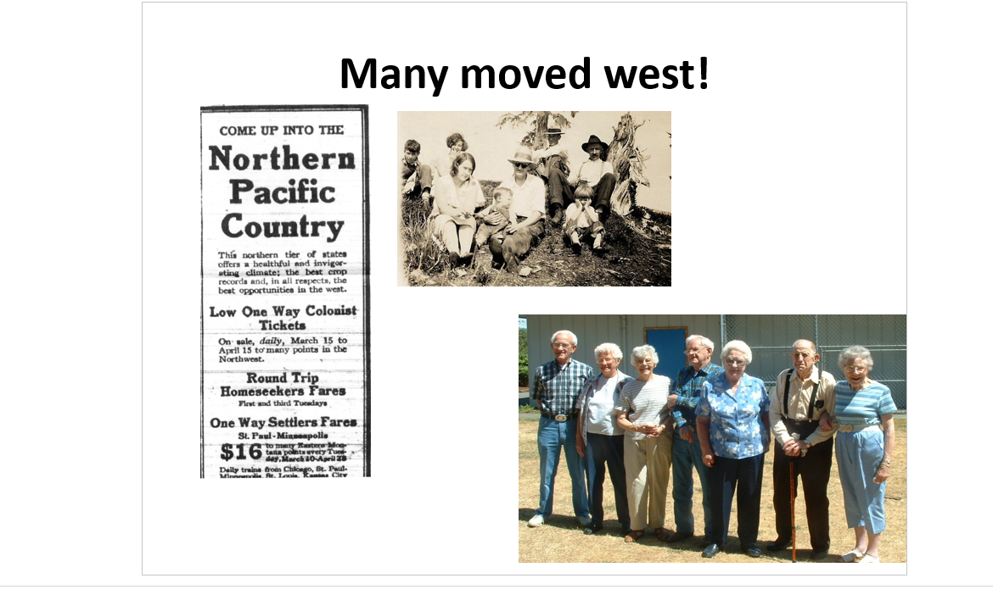By 1914, ad from Boone, NC newspaper, many had taken the train west as the mountainous terrain and high birth rate could not support the many offspring of the Wilson, Greers, Osborne and other associated families. These photos are of Osborne descendants in Washington State couretesy of Jeannie Bond. “The black and white photo was taken about 1930 in Skagit County, Washington State. L to R in back: Cecil Mark Osborne (son of William I. Osborne) Beulah Martin, Charlie Martin, William I. Osborne (grandson of Lt. Isaac Osborne, son of Nancy Emmaline Wilson Osborne).
L to R in Front: Helen M. Osborne Anderson (daughter of William I. Osborne), V. Duane Anderson (son of Helen) Vernon Anderson (husband of Helen), Juanita K. Osborne (daughter of William I. Osborne)
The Martins were friends of the Osbornes and former residents of Ashe Co. North Carolina, as was W.I. Osborne

And the color photo was taken about 2000 at one of the Osborne Family Reunions held in Sedro Woolley, WA, the third Saturday of July since 1969.
L to R: C. Mark Osborne (B: 1919); Juanita K. Osborne Doran Wilson (1917-2009); Betty Alice Doran Osborne (wife of Derward); Derward H. Osborne (B:1916); Helen M. Osborne Anderson Pocock (1912-2014); Claude Pocock (husband of Helen); Clara Jane Pocock Osborne (widow of Chester C. Osborne)
Note: C. Mark, Juanita, Derward, Helen, and Chester C. Osborne are children of William I. Osborne who was the son of Nancy Emmaline Wilson and Richard Franklin Osborne.
All of William's children were born in Skagit County, WA.” – Jeanie Bond