This summer, come join your distant cousins, and rediscover your ancestral roots in the beautiful high mountains of Western North Carolina.
If you have in your family tree the names of Greer, Greer, Wilson, Osborne, Brown, Baird, Boone, Wilcoxson, Forrester, Proffitt, Mast and many others, you will find lost cousins and new history on your ancestral roots.
Family historians Clinton Getzinger and Glenn Holliman, both descendants of Isaac and Caroline Greer Wilson, are hosting an educational reunion and tour of historic family sites in Watauga and Ashe Counties, North Carolina, June 25 – 27, 2012.
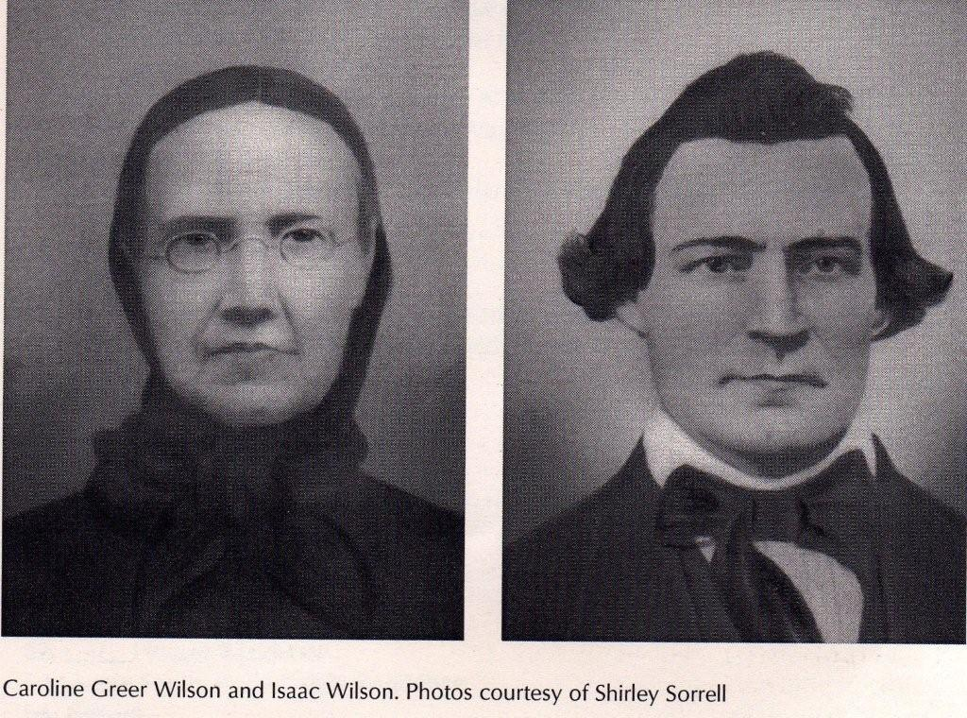
Lodging has been suggested and a fascinating agenda has been prepared to include among other items:
June 25, 2012 – Group dinner at 6 pm at restaurant to be determined. Location will depend on numbers who can attend. We welcome local relatives as those who will be traveling long distances. A first, short background seminar will be given by Clinton and Glenn on our ancestors from Scotland, the immigration to the Cherokee and Revolutionary War frontier, our relationship to Daniel Boone and other frontier men and women and the events that made American history.

June 26, 2012 -
9 am – Leave for day’s activities
9:30 am - A visit to Todd General Store and the grave sites of Jesse Greer, Sr. and Mary Polly Morris Greer. Polly eloped with Jesse at age 13 in 1800 and lived happily ever after, 17 children later!
11:00 am - Time at the Ashe County History Museum with curator Don Long who will share the community’s version of the Wilson-Potter Feud and the Benjamin Greer-Benjamin Cleveland kidnapping during the Revolutionary War. A gift shop and rest rooms are available.
2:00 pm – After a short lunch in Jefferson, Ashe County, we travel to Sutherland to meet Shirley Sorrell, who will show us the old Wilson farm, the Cemetery and the field where Isaac Wilson was bushwhacked. Other cemeteries will be visited and the Donnelly Store. After this stop, we return to lodging.
6:00 pm – Again a group dinner in Boone for fellowship and sharing.
June 27 –
10:00 – Meet in Banner Elk to visit Jesse Greer, Jr. and Frances Brown Greer homesite and graves, plus another family cemetery. Time with Annie Heaton, great granddaughter of the above and keeper of considerable family memorabilia including historic notebooks of Isaac Wilson and Jesse Greer, Jr.
12:00 – Group lunch in Elk Park with Annie Heaton. Official tour and our time together is over. Folks can visit local tourist sites and enjoy the mountain vistas!
Please make your lodging reservations directly with the recommended places below, but let us know if you are coming. There will be handouts on family history, maps, etc and we need to make reservations for food.

HEADQUARTERS LODGING FOR THE WILSON-GREER REUNION
June 25 – 27, 2012, Boone, North Carolina
Both the Baird House and Lazy Bear Lodge are holding rooms until March 10. After that date, no guarantees, but the Boone, North Carolina area has many fine motels to book.
THE BAIRD HOUSE bairdhouse@charter.net or info@bairdhouse.com
HOME |  | ABOUT |  | LODGING |  | and and |  | SPECIALS |  | CONTACT

THE LAZY BEAR LODGE
A North Carolina Bed and Breakfast Mountain Retreat,
Near the Blue Ridge Parkway & the Pisgah National Forest
315 Lazy Bear Trail ~ Vilas, North Carolina (NC) 28692
Telephone: 828-963-9201
Email: info@lazy-bear-lodge.com
Website: A Vilas NC Bed and Breakfast Retreat

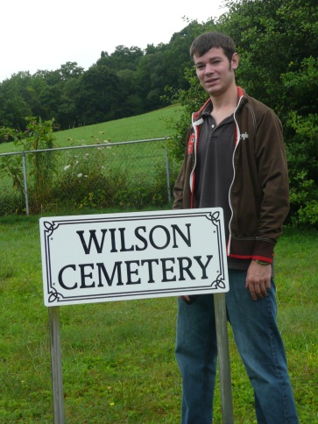 Above, Sean Murphy of Texas, a great, great, grandson of Isaac and Caroline Greer Wilson at the ancestral farm and cemetery in Ashe County, North Carolina.
Below, Geraldine Stansberry Holliman Feick, a great granddaughter of Isaac and Caroline Greer Wilson at the family’s Sutherland United Methodist Church near the Wilson farm. Her grandparents were George Washington and Frances Wilson Osborne, both of Ashe County. Gerry will be attending the reunion tour.
.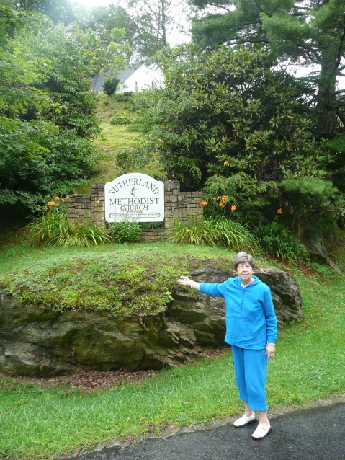
We look forward to greeting you in North Carolina! Please let us know when you make your reservations and when you will be arriving so we may have adequate materials and arrangements made. We want to send you the final agenda.
For information and confirmations, please contact:
Clinton Getzinger at steg1812@gmail.com or 757-235-3111 or Glenn Holliman at glennhistory@gmail.com or 717-567-3006/ cell 717-425-9625.
Many Thanks…. Clinton and Glenn, descendants of Isaac and Carolina Greer Wilson

