THE FAMILIES OF FRANCES WILSON OSBORNE AND G.W. OSBORNE, JR.
PHOTOGRAPHS AND ARTICLES ON THE HISTORY OF THE ANCESTORS AND DESCENDANTS OF FRANCES WILSON OSBORNE (1851-1940) AND GEORGE WASHINGTON OSBORNE, JR. (1846 - 1927)

THE FAMILIES OF FRANCES WILSON OSBORNE AND G.W. OSBORNE, JR.

4/23/11

When We Were Greers, Part XVIII
by Glenn N. Holliman
The Battle that Saved the Revolution in the South
October 7, 1780 found the Americans in an attack position at King's Mountain, South Carolina with Capt. Greer's company embedded in Col. Cleveland's regiment on the north side of Ferguson's powerful defensive lines.

Much of the success of the American Revolution rested in the courage of the Mountain Men - Greer, Osborneand others - who were about to charge up that hill into musket fire and bayonet.
On the afternoon of October 7, 1780, Capt. Benjamin Greer, my 5th great grandfather, stood ready to lead his company forward through swampy ground and up the dangerous slopes of King's Mountain. Colonel Cleveland's regiment, in which Greer served, is located on the map below represented with the letter 'G'.
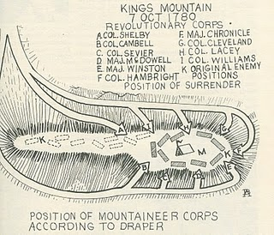
It seemed every man followed the advice of Col. Shelby to use rock and tree in the laborious advance up the hill and into enemy fire. Cleveland's regiment was ten minutes late getting started due to the marshy terrain, and once moving forward ran into musket fire and the bayonet. Gradually the Patriot forces, some 1,840 of them, over came the 1,000 or so Tories and British troops.
Major Patrick Ferguson, wearing a bright red coat, was an easy target on horseback. Many claimed they fired the bullet that put an end of his life. Ferguson's boot caught in his stirrup and his body, continuing to receive lead, was dragged hundreds of yards. With his death, the battle ended in a massive Patriot victory.
When British General Cornwallis heard of the defeat, he reduced his ambitions in the Carolinas. After the Battle of Guilford Courthouse, North Carolina, a Pyrrhic victory the next year, he 'cornered' himself at Yorktown, Virginia. Bottled up by Washington and the French fleet, he surrendered in October 1781, a year after the Battle of King's Mountain After six years of combat, the American Revolution was won.

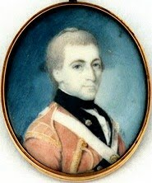
Who fired that shot that killed the arrogant Scotsman Ferguson (pictured above)? Watauga County, North Carolina historian, John Preston Arthur, probably reporting local folklore, wrote in 1915 that the American Patriot was none other than Benjamin Greer! Other historians have listed the names of other soldiers. One suspects a dozen American marksmen may have fired at Ferguson, so plainly visible dressed in a red coat on a large horse.
One hopes this ancestor of ours finally obtained some rest that winter of 1780/81. His summer of 1780 is, of course, literally one for the history books. He made war on both the Cherokee, Tories and the British Empire. In these endeavors, he was successful. Was his work done? Not yet. The back country of Wilkes County still suffered from Tory infestation, some neighbors against neighbors.
Next, Benjamin Greer rescues his King's Mountain commander, Col. Benjamin Cleveland, from a Tory band.
POSTED BY GLENN N. HOLLIMAN AT 4:05 AM 1 COMMENTS
LABELS: BENJAMIN GREER

4/9/11

When We Were Greers, Part XVII
by Glenn N. Holliman
Benjamin Greer Gives a Hint!
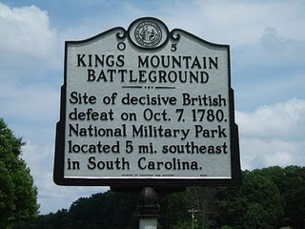
John Preston Arthur in his work on Watauga County, North Carolina history, published in 1915, records an incident during 1780 hostilities that resonated through the decades.. The piece of folklore or fact (probably leans toward 'fact') deals with a private soldier, Capt. Benjamin Greer who chewed tobacco, and Col. Benjamin Cleveland, a commander in the Patriot militia who was not usually concerned about legal or mannerly niceties.
This story tells us something more about the personality of this ancestor. I lift it verbatim from Arthur's work.
"Greer's Hint - This 'hint' is thus accounted for by Dr. Draper (a 19th Century historian) in a note at foot of page 442: Greer was one of Cleveland's heroes. One of his fellow solders stole his tobacco from him, when he threatened he would whip him for it as soon as he should put his eyes on him.
Cleveland expostulated with Greer, telling him his men ought to fight the enemy and not each other. "I will give him a hint of it, anyway," said Greer, and when he met the tobacco pilferer he knocked him down.
Greer's hint was long a by-word in all that region. - Col. W.W. Lenoir."
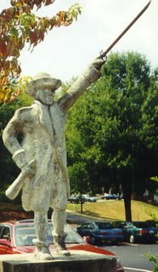
A deteriorated statue stands of Col. Benjamin Cleveland in Wilkes County, North Carolina, home of Cleveland and the Greer families. While no statue or portrait exists of Benjamin Greer, it is of family pride that Cleveland announced Greer 'a hero'.
POSTED BY GLENN N. HOLLIMAN AT 1:47 AM 0 COMMENTS
LABELS: BENJAMIN GREER

4/5/11

When We Were Greers - Special Edition
by Glenn N. Holliman
Yes, Winston Churchill is a Distant Cousin!
Recently, I read more carefully my email newsletter from the Grierson family history site in Scotland. As readers of this blog may recall (look in the archives section, lower right of this posting) last October 2010, I published information our the Scottish roots of our Greer connections.
My generation's 9th great grandparents were Sir James Grier (about 1604 - 1666) and Mary Brown of Dumfrieshire, Scotland. James was born at Capenoch, a large home near Thornhill, north of Dumfries. This couple had numerous children, one being James Grier (Greer) born 1627 who died in Maryland 1688, the founder of my branch of American Greers.
Below is the Maxwelton House located in Kirkland, near Dumfries, Scotland. Maxwelton House has changed since the early 1600s when the Griersons and Maxwells called it home. Formerly known as Glencairn, this estate later was acquired by the Laurie family. Here the famous Scottish song, Annie Laurie, was written.
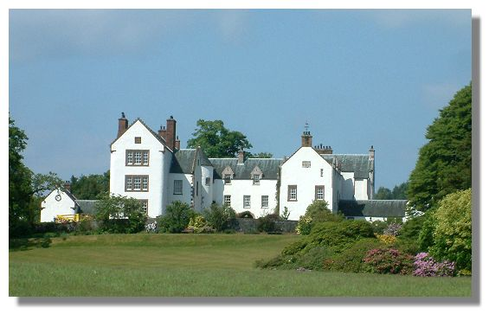
Sir James' parents (my generation's 10th great grandparents) wereSir William Grierson (cir 1567 - 1629) and Nichola Maxwell,born about 1578. Located near Kirkland, the Maxwelton House is a Scottish national treasure (above) and open to the public for tours. You may google Maxwelton House and enjoy stories and views of one of our ancestor's 'modest' homes. You may do the same for Capenoch. Sir William, our 10th great grandfather, was the 9th Lord of Lag.
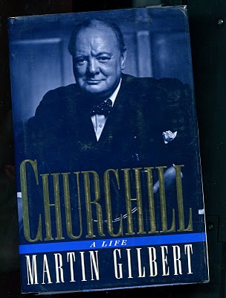
The connection? Thanks to an article by Mike Grierson, published in the January 2011 Clan Grierson e-newsletter, we know thatWinston Leonard Spencer Churchill, the British prime minister who led Great Britain and Western Civilization through World War II, is also the 9th great grandson of Sir William Grierson and Nichola Maxwell!
Pictured is the cover of one of the more comprehensive biographies of Winston Churchill. This work by Martin Gilbert, published in 1991, is a page-turner regardless of its intimidating 1,000 plus pages.
Want to know more about your Scottish connections? Contact clangrierson.com/clan-grierson/ and sign up for the newsletter, view the photos of Capenoch, and learn more about your Scots ancestors and your own tartan!
Next post, back to our Benjamin Greer of the 1700s in Western North Carolina....petulant like his cousin, Winston!
POSTED BY GLENN N. HOLLIMAN AT 9:56 AM 0 COMMENTS
LABELS: NICHOLAS MAXWELL, WILLIAM GRIERSON
Newer PostsOlder PostsHome
Subscribe to: Posts (Atom)

PAGES
- Home
- Web Sites and Publications
- Contributers
- Family Lineage

POPULAR POSTS
- 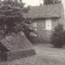
We Are Also Boones, Part 4
by Glenn N. Holliman ( Source for this posting is largely from In the Footsteps of Daniel Boone by Randell Jones. Photos taken from the wo...
More Adema and Stansbery Photographs, No. 9
by Glenn N. Holliman 2010 Rob Adema took this photograph of his parents, Gay and Bob Adema along with yours truly (far left) at their s...
We Are Also Wilcoxsons - Part III
by Glenn N. Holliman The Wilcoxsons and Boones, 18th Century Pioneers in Central North Carolina and Kentucky Sources include www.planetmur...
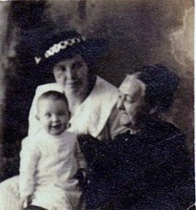
Frances Wilson Osborne with daughter, Mayme Osborne Stansbery and granddaughter Louise Stansbery Sherwood

LABELS
Abraham Lincoln Ada Osborne Anne TaylorArthur Taylor Arthur Taylor Caroline Greer Wilson Ashe County Bascom K. Osborne Bascom Wilson OsborneBenjamin Greer Benjamin Greer; Jesse Greer Bishop L. Osborne Bob Adema Capt. Jesse Greer Caroline Greer Wilson; Isaac Wilson Charles I Charles IICharles Stansbery Charles WilsonChristopher Holliman Cloe Jones GreerDamascus Daniel Boone Daniel Wilcoxson David Wright Don FeickDoris Osborne Akers Eddie C. Osborne Edward Morgan Elizabeth PowellElizabeth Wilcoxson Cutbirth Flea AkersFrances Wilson Osborne Frazier KingG.W. Osborne Gayle Adema George BooneGeorge Washington Osborne George Wilcoxson Geraldine Stansbery Holliman Feick Gladys Osborne Adema Glenn HollimanHiram Wilson Howard Adema Hugh II James Grantson Holliman James GreerJames Grier Jesse Boone Wilcoxson John Greer John Taylor John Wilcoxson John Wilson Jonathan Murphy Joppa Jr. Jr. Sarah Day Greer Leroy Osborne Louise Stansbery Sherwood Luke Stansbery Margaret Hill Taylor Margaret Phinney Taylor Marion Lee Osborne Mary Brown Mayme Osborne Stansbery Nancy Lowe Walker Nancy Wilcoxson Greer Nicholas Day Nicholas Maxwell Pauline Osborne Pearl Osborne Wright Peggy Noeltner Phyllis AkersRachel Bryan Rachel Wilcoxson BryanRebecca Payne Rob Adema; Peggy Noeltner Rob Adema; Phyllis Akers Sarah Anne Elliott Sarah Boone Sarah Boone Wilcoxson Sarah Cox Sarah Day Sarah Day Greer Sarah Lowe Day Sarah Mary Oppy Sarah Morgan Sarah Morgan BooneSean Murphy Sir James Grier Squire Boone Sr Sr. Sr. Nicholas Day Sr.; Nancy Boone Wilcoxson The Rev. William A. WilsonToby Osborne Tom Adema Vance SherwoodVirginia Osborne Vivian Randall OsborneWilliam Grierson William Penn

BLOG ARCHIVE

THE FAMILIES OF FRANCES WILSON OSBORNE AND G.W. OSBORNE, JR.
PHOTOGRAPHS AND ARTICLES ON THE HISTORY OF THE ANCESTORS AND DESCENDANTS OF FRANCES WILSON OSBORNE (1851-1940) AND GEORGE WASHINGTON OSBORNE, JR. (1846 - 1927)

THE FAMILIES OF FRANCES WILSON OSBORNE AND G.W. OSBORNE, JR.

8/31/10

More Adema and Stansbery Photographs, No. 5
by Glenn N. Holliman

More Photographs from the Collection of Bob Adema
Saying Good Bye at the Wright's home in Damascus, Virginia
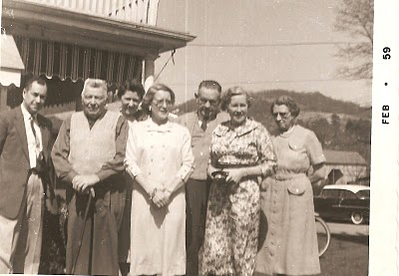

Okay, I need some help with this one. I failed to record the names of everyone. The photo above were taken in 1959. Aunt Pearl and Uncle Dave are present. Can the rest be identified? I will try: far right is my Great Aunt Pearl. Moving right to the left is Gladys and Howard Adema, right? Then Doris Akers but who is the young woman behind her? Then my Great Uncle Dave and moving far left is Elmer (Flea) Akers? How close did I come?

Note: Phyllis wrote and believes man between Doris and Gladys is a brother of Dave, named Lawrence. Is the woman behind Doris and Uncle Dave a wife or daughter of 'Lawrence'? Sept. 2, 2010
The Sons of Leroy Osborne - 1910s?

The second child born to live to maturity of G.W. and Frankie Wilson Osborne was Leroy Milburn Osborne (2/17/1879 - ?). He lived in Cleveland, Tennessee in 1936 and was married to LenaHolsclaw (9/17/1879 - ?). They had three boys, seen below: Ralph Summers, Albert Leslie and Robert Lafayette Osborne. A girl was named Lucille Osborne. I do not know who is whom below. These are first cousins of my mother, Geraldine Stansbery HollimanFeick. I believe Leroy was a farmer, although his address was 1016 16th Street, Cleveland, TN.

Two brothers married Holtsclaws. Toby married Alta Holsclaw(perhaps spelled Holtzclaw or Holtsclaw). I believe they may have married these girls when the family lived in Ashe Co., NC or shortly thereafter. More research needed, but I assume they were sisters. I love the knickers on the two young cousins.
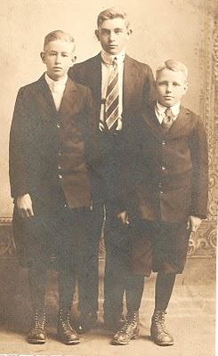
More Soon....
POSTED BY GLENN N. HOLLIMAN AT 12:37 PM 0 COMMENTS

8/29/10

More Adema and Stansbery Photographs, No. 4
by Glenn N. Holliman
Our review of the photos of Bob Adema continues.

1930

Unless I am mistaken, this is my uncle Charles S. Stansbery, Jr, age approximately 12, with his grandmother, Frances Wilson Osborne. Charles would join the Army Air Corp in 1937 and have a long career before retiring in the early 1960s. He married Anne Smith of Philadelphia in 1943 after having known her only five weeks. Their life long love affair began at the Stage Door Canteen when he was home on leave (his mother, Mayme Osborne and sisters, Louise Stansbery Sherwood and Geraldine Stansbery HollimanFeick, my mother, were living in Pennsylvania at the time). Frankie, the inspiration of this on going blog, seemed to be dressed always in a black dress. She would have been almost 80 years old in this photograph. I believe the picture was taken in Bristol, Tennessee, Mayme's home from 1919 to 1941.
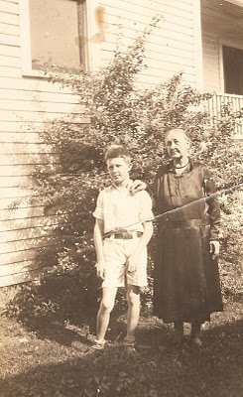
1930s

Below is a photo of Pearl Osborne Wright, my great aunt, and the wife of Dave Wright. They met in Damascus, Virginia and married in Afton, Tennessee in 1912. In 1922, after the death of Dora Kruger Osborne, Pearl and Dave took in and raised Bascomb K., Gladys and Doris Osborne.
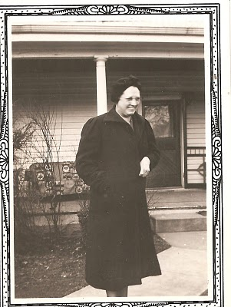
1930s

Below, standing on the left of this photo is Howard Adema of Buffalo, New York, who married Gladys Osborne. Howard was helping direct a Civilian Conservation Camp (CCC), a New Deal agency attempting to combat the Depression by employing young men to work in America's forests to develop parks and national forests. The man of the right was his boss. While stationed in Virginia working for the CCC, he met Gladys and the southern girl moved north when they married. Their children are Peggy, Robert and Alan.
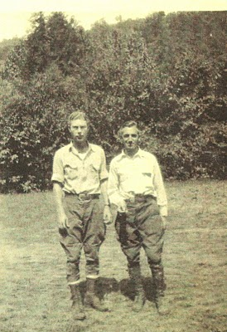
More photos of relatives soon....
POSTED BY GLENN N. HOLLIMAN AT 4:06 AM 0 COMMENTS

8/28/10

More Adema and Stansbery Photographs, No. 3
by Glenn N. Holliman

I continue to post photos provided by Bob Adema and his family albums.
1938

If you will revisit the previous post, you will note this setting and persons are almost identical as when just the female cousins were snapped. This picture is of the ladies with spouses. My mother, Geraldine Stansbery, Mayme Osborne's second daughter, is far left and at age 15, unmarried, but with a brilliant smile!

Moving to the right from mother is Frazier King, the husband of Louise Stansbery, my aunt who has her arm in his. This marriage was ill-fated and dissolved after only a year and half. Frazier's family owned King's Department Stores in East Tennessee.

To the right of Louise is Howard Adema and his wife, Gladys, the parents of Bob Adema and Peg Adema Noeltner. Elmer 'Flea' Akers stands next to his wife, Doris. 'Flea' and Doris had two children, Phyllis and David.
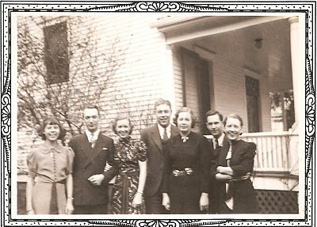
This series of photos was taken in front of David and Pearl Osborne Wright's home in Damascus.

1930s

Below is a cute photo of 'Flea' and Doris Osborne Akers in southwest Virginia. So formal in those days with Flea wearing a tie and Doris in high heels and yet curled up on the grass in front of a cabin. Doris is my mother and Aunt Louise's first cousin by Bascomb Osborne. Flea and Doris are the parents of Phyllis and David Akers. Phyllis has been sharing photos and information also with me on our family.
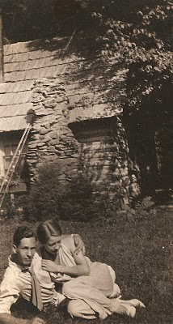
More soon from the collection by Bob Adema, from photos saved by his father Howard Adema (photo above).
POSTED BY GLENN N. HOLLIMAN AT 6:00 AM 0 COMMENTS
LABELS: DAMASCUS, DORIS OSBORNE AKERS, FLEA AKERS, FRAZIER KING,GERALDINE STANSBERY HOLLIMAN FEICK, GLADYS OSBORNE ADEMA, HOWARD ADEMA, LOUISE STANSBERY SHERWOOD

8/24/10

More Adema and Stansbery Photos, No. 2
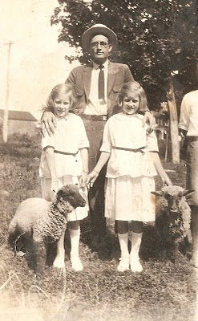
by Glenn N. Holliman

1920s

This is Bascomb Osborne, my great uncle (1887 - 1970) with his two daughters, Doris and Gladys. I love the straw hat of the times and the sheep. Where was this taken? Damascus, Virginia after his wife, Dora Kruger Osborne, died in 1922?
1938

Years have passed and Gladys and Doris have grown up and married. Left to right in Damascus, Virginia are Geraldine, age 15, my mother; Louise, my aunt, Gladys and Doris. My mother was age 15, and she was striking a saucy poise that day!
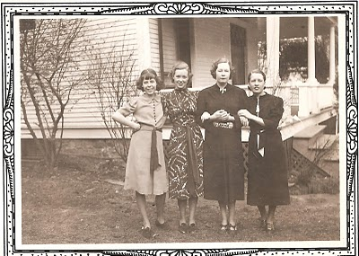
More tomorrow.....
POSTED BY GLENN N. HOLLIMAN AT 7:37 AM 0 COMMENTS
LABELS: BASCOM WILSON OSBORNE, DORIS OSBORNE AKERS, GERALDINE STANSBERY HOLLIMAN FEICK, GLADYS OSBORNE ADEMA, LOUISE STANSBERY SHERWOOD

8/23/10

Photos Rediscovered and Shared, No. 1

by Glenn N. Holliman

Photos from Adema and Stansbery Albums

August 21, 2010 I visited at Port Colborne, Ontario my second cousins, Bob and Gayle Adema and their son, Rob. Rob, who lives in Buffalo, NY had visited my Newport, PA last month. Bob and Gayle, my daughter Grace and I had visited last March in Florida along with Bob's sister, Peggy Noeltner.

We discovered new and old photos, some they had, some I had from my mother, Geraldine Stansbery and her sister, the late Louise Stansbery Sherwood.

Bob and I are of the same generation, and G.W. and Frankie Osborne are our great grandparents. Bob's grandfather is Bascomb Osborne and my grandmother is his sister, Mayme Obsorne. Go to the Family Lineage page to review the family tree.

Here are some new and shared photos, and I will stay with them for several weeks. For those of you just dying to know more about the Wilcoxson family, you must be patient!
Below are identical photos of Doris and Gladys Osborne, 1921. The one on the left was in the Adema album and is labeled. The one on the right was in the Stansbery album. After 90 years these pictures are joined again. Doris and Gladys were the daughters of Bascomb and Dora Kruger Osborne. Tragically Dora died of a weakened heart at age 32 in 1922, and because Bascomb was unable to care for them property, the two girls and their brother, Bascomb K., went to live with Pearl Osborne Wright and her husband Dave in Damascus, Virginia, outside of Bristol.

Gladys is the mother of Bob, Alan and Peg Adema Noeltner. Doris is the mother of Phyllis and Dave Akers.
Both these girls are first cousins of my mother, Geraldine Stansbery Holliman Feick.
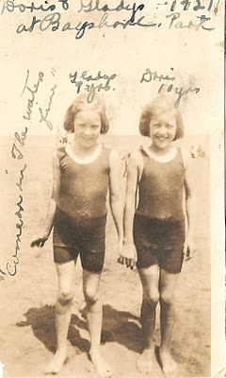
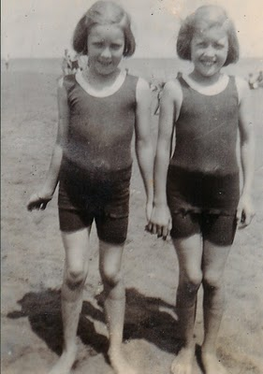
My thanks to Bob and Gayle for their kind lunch and hospitality and to their son, Rob, who scanned all these photos. Since 1940, the Adema family has enjoyed a cottage on the north shore of Lake Erie, experiencing soft, cool summer breezes and gazing at water and passing lake freighters.

More photos later this week!
POSTED BY GLENN N. HOLLIMAN AT 5:22 AM 0 COMMENTS
LABELS: BOB ADEMA, GAYLE ADEMA, ROB ADEMA; PEGGY NOELTNER

8/16/10

We Are Also Wilcoxsons - Part I
by Glenn N. Holliman

From Nottingshire to North Carolina...
Sources for this posting from Pat Hagan, Wilcoxson scholar and the Willcockson Genealogy Library

One of my generation's 8th great grandfather was John Wilcoxson, born about 1666 in Cossal, Nottingshire, England. We do not have the name of his wife, but on March 10, 1691/92 when Pennsylvania was only a decade old, one George Wilcoxson, my generations' 7th great grandfather, was born. The home was in Haverford, Pennsylvania. (see maps below)

(If my math is correct one has the potential for 512 8th great grandparents, or 256 8th grand fathers. So above is one of 256!)
Below is a map of parts of Derbyshire and Nottingshire, England. The yellowed area is Cossal, now just off the M 1, the major north - south artery for automobile and lorry traffic from London to Scotland. The fabled Sherwood Forest (now a feeble recreation of the medieval woodlands of Robin Hood) is a few miles to the northeast of this map. London is approximately 90 miles to the south of this map.

Breadsall, the red circled area, is the location of a fabulous Marriott Hotel located in an old country house and priory. Breadsall Priory Hotel is highly recommended as Barb and I have stayed there numerous times. Ironically I had no idea we were only a few miles from the home of my generation's 8th great grandfather.
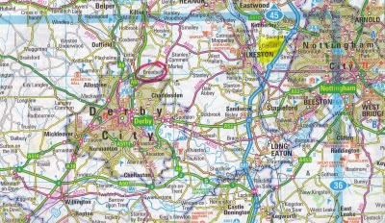

John Wilcoxson must have been a Quaker because George would marry one Elizabeth Powell, my generation's 7th great grandmother in a Quaker ceremony April 15, 1719. Elizabeth was the daughter of Rowland Powell (another 8th great grandfather!) of Haverford Township in Chester, County.
By 1730 and perhaps earlier, George and Elizabeth Wilcoxson settled in Uwchlan, PA, a Welsh settlement, now located on Highway 100, just off the Pennsylvania Turnpike. George worked as a weaver and a farmer. Eventually, the family owned 95 acres.

Unfortunately, death came early to both George and Elizabeth (1739 and 1740). At least four children survived, Mary, age 5, who was taken in by a friend, and two sons, John and George, who went to live with Squire Boone and his wife Sarah Morgan Boone. Both George and Squire were weavers, and lived 15 to 20 miles apart. Another son, Isaac Wilcoxson (1724 - 1766) followed the extended family to North Carolina, as he is buried in the same cemetery as Squire and Sarah Morgan Boone.

Uwchland (spelled by the U.S. Post Office as Uwchland) means in Welch - upland. Ironically, for a Welsh Quaker settlement, the two places of worship in the township today are Jewish and Roman Catholic.
Below circled and yellowed are three locations of the Wilcoxson family in Pennsylvania from 1691 to 1750. The black circle, far right, is Haverford, now one of the most wealthy townships in America. Founded in 1691, the word in Welsh is reported to mean 'goat crossing'. Double click on the map and it will enlarge.
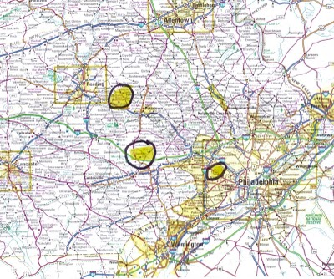
The center black circle is Uwchlan, the 95 acre farm of George and Elizabeth Powell Wilcoxson. The top left circle is the Squire Boone homestead. In the late 1600s and early 1700s, this area of Pennsylvania was very much the frontier line.

As we know, the Boones and Wilcoxsons will move together to North Carolina. In our next posting, we will follow the lives of John and Sarah Boone Wilcoxson, my generations 6th great grandparents....
POSTED BY GLENN N. HOLLIMAN AT 1:43 AM 0 COMMENTS
LABELS: ELIZABETH POWELL, GEORGE WILCOXSON, JOHN WILCOXSON,SARAH BOONE, SQUIRE BOONE

8/10/10

We Are Also Boones, Part 5
by Glenn N. Holliman
The Boones and Wilcoxsons Locate to North Carolina

By the late 1740s, Squire Boone had had enough of the Quaker Church disciplining him for this children marrying outside of the faith. In 1750 in somewhat of a huff, he sold his land, burned some of his belongings, and with children and in-laws, moved down the Shenandoah Valley, first stopping in Virginia and eventually settling in the Yadkin Valley in North Carolina. Although Cherokee wars sent the family back to Culpepper, Virginia in the 1750s, the families eventually settled in the rolling hills of Rowan County.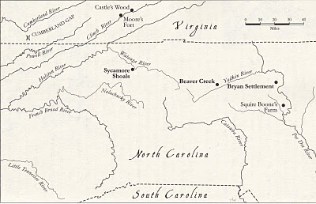
Map from Boone, A Biography by Robert Morgan. For educational purposes only and not for commercial gain.
For Squire and his wife, Sarah, this was their last stop. Squire, who was born in Devonshire, England in 1696, died in 1765. Lying next to him is Sarah Morgan Boone, who died in 1777. This monument is to my generation's 7th great grandparents.
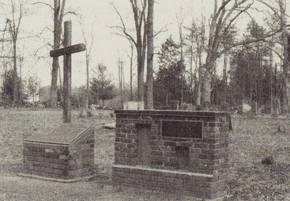Photo from In the Footsteps of Daniel Boone, for educational purposes only.

The cemetery is located just one mile off I -40 near Mocksville, North Carolina. What was once the wild frontier is now Interstate Exit 170 half way between Winston-Salem and Statesville. The graveyard is 1/2 mile northwest of Mocksville on US 601.
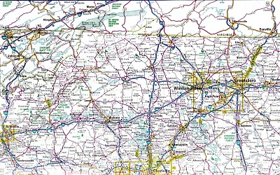Double click to enlarge the map.

Next posting, the adventures of the Wilcoxson's in North Carolina and Kentucky....
POSTED BY GLENN N. HOLLIMAN AT 2:37 AM 0 COMMENTS
LABELS: JOHN WILCOXSON, SARAH BOONE, SARAH MORGAN BOONE, SQUIRE BOONE

8/2/10

We Are Also Boones, Part 4
by Glenn N. Holliman
(Source for this posting is largely from In the Footsteps of Daniel Boone by Randell Jones. Photos taken from the work published by John J. Blair, Winston-Salem, NC. There is no commercial intent to using these photos; education for family only.)

In our last posting, George Boone moved his family fromDevonshire, England to Philadelphia. His many children began to marry, including Squire Boone to Sarah Morgan. This couple had 11 children, the first being Sarah Boone, who in 1743 married outside the Quaker faith to John Wilcoxson. Sarah and John were my generation's 6th great grandparents.

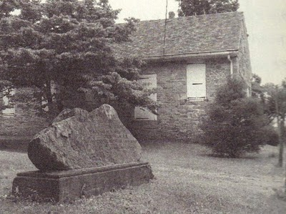
George Boone (my generation's 8th great grandfather) donated land in Oley, Pennsylvania for a log meeting house for the Society of Friends (Quakers) (photo left). Later, Oley was divided into two parts, with the southern portion named Exeter, after the English town where George Boone had sold woven goods a quarter century earlier.

The historian Randell Jones notes the stone in front of the 1759 Quaker Meeting House commemorates both the Boone and Lincoln families. A niece of Squire Boone married one Abraham Lincoln, the grandfather of the future president. This Lincoln would help Daniel Boone blaze the Cumberland Gap Trail. If my analysis is correct then our family (all those of you reading this) share common great grandparents with the Great Emancipator. How about that?! I suppose such makes Ole Abe a distant cousin.

Squire Boone's cabin was only 1.5 miles from the Meeting House about 10 miles east of Reading, Pennsylvania in the Birdsboroarea. Below is the stone cellar above which my 7th great grandfather built a log house for his family.
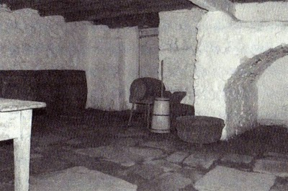
The Boone Homestead of our 7th and 6th great grandparents is operated by the Pennsylvania Historical and Museum Commission. The site is open to visitors and details can be found at http://www.danielboonehomestead.org/. Another excellent site to review our genealogy is http://www.boonesociety.org/. I recently joined the Boone Society and have received much family information from a well-researched group of distant cousins. I recommend the Boone Society for their depth of knowledge and their careful research (and they are nice people).

Next posting, the family leaves the Quaker faith and Pennsylvania....
POSTED BY GLENN N. HOLLIMAN AT 1:20 PM 1 COMMENTS
LABELS: ABRAHAM LINCOLN, GEORGE BOONE, JOHN WILCOXSON
Newer PostsOlder PostsHome
Subscribe to: Posts (Atom)

PAGES
- Home
- Web Sites and Publications
- Contributers
- Family Lineage

POPULAR POSTS
We Are Also Boones, Part 4
by Glenn N. Holliman ( Source for this posting is largely from In the Footsteps of Daniel Boone by Randell Jones. Photos taken from the wo...
More Adema and Stansbery Photographs, No. 9
by Glenn N. Holliman 2010 Rob Adema took this photograph of his parents, Gay and Bob Adema along with yours truly (far left) at their s...
We Are Also Wilcoxsons - Part III
by Glenn N. Holliman The Wilcoxsons and Boones, 18th Century Pioneers in Central North Carolina and Kentucky Sources include www.planetmur...
Frances Wilson Osborne with daughter, Mayme Osborne Stansbery and granddaughter Louise Stansbery Sherwood

LABELS
Abraham Lincoln Ada Osborne Anne TaylorArthur Taylor Arthur Taylor Caroline Greer Wilson Ashe County Bascom K. Osborne Bascom Wilson OsborneBenjamin Greer Benjamin Greer; Jesse Greer Bishop L. Osborne Bob Adema Capt. Jesse Greer Caroline Greer Wilson; Isaac Wilson Charles I Charles IICharles Stansbery Charles WilsonChristopher Holliman Cloe Jones GreerDamascus Daniel Boone Daniel Wilcoxson David Wright Don FeickDoris Osborne Akers Eddie C. Osborne Edward Morgan Elizabeth PowellElizabeth Wilcoxson Cutbirth Flea AkersFrances Wilson Osborne Frazier KingG.W. Osborne Gayle Adema George BooneGeorge Washington Osborne George Wilcoxson Geraldine Stansbery Holliman Feick Gladys Osborne Adema Glenn HollimanHiram Wilson Howard Adema Hugh II James Grantson Holliman James GreerJames Grier Jesse Boone Wilcoxson John Greer John Taylor John Wilcoxson John Wilson Jonathan Murphy Joppa Jr. Jr. Sarah Day Greer Leroy Osborne Louise Stansbery Sherwood Luke Stansbery Margaret Hill Taylor Margaret Phinney Taylor Marion Lee Osborne Mary Brown Mayme Osborne Stansbery Nancy Lowe Walker Nancy Wilcoxson Greer Nicholas Day Nicholas Maxwell Pauline Osborne Pearl Osborne Wright Peggy Noeltner Phyllis AkersRachel Bryan Rachel Wilcoxson BryanRebecca Payne Rob Adema; Peggy Noeltner Rob Adema; Phyllis Akers Sarah Anne Elliott Sarah Boone Sarah Boone Wilcoxson Sarah Cox Sarah Day Sarah Day Greer Sarah Lowe Day Sarah Mary Oppy Sarah Morgan Sarah Morgan BooneSean Murphy Sir James Grier Squire Boone Sr Sr. Sr. Nicholas Day Sr.; Nancy Boone Wilcoxson The Rev. William A. WilsonToby Osborne Tom Adema Vance SherwoodVirginia Osborne Vivian Randall OsborneWilliam Grierson William Penn

BLOG ARCHIVE

Contributers
by Glenn N. Holliman
The Adema and Holliman Families
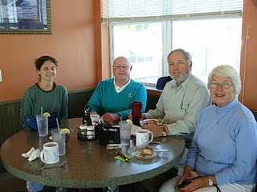
Grace Holliman, far left, is a great-great grandaughter of G.W. and Frances Wilson Osborne. Next to her (left to right) are three of G.W. and Frankie's great-grandchildren, Bob Adema,Glenn N. Holliman (Grace's father) and Peg Adema Noeltner. Bob and Peg, brother and sister, are descended through Bascom Osborne and Glenn and Grace throughMayme Osborne Stansbery, two of G.W. and Frankie's seven children. Photo made by Gay Adema in Florida, March 2010.
Glenn, with the help of Grace, is the compiler of this blog and responsible for any errors of commission or omission. He is a former history teacher and now retired from the Episcopal Church Foundation. He and his wife, Barbara, live in Newport, Pennsylvania on 15 acres of woodland where they raise free-range cats.
Another Adema member not pictured is Rob Adema, Bog and Gay's son, who has researched the family for years and generously shares information. A reunion is set with the Ademas late August 2010 to explore further family roots.
Geraldine Stansbery Holliman Feick
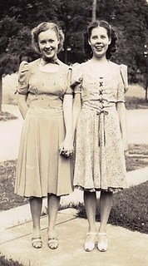
My mother (above right) has saved family papers and photos all her life, and with them I have been able to reconstruct the 20th century of the Stansbery and Osborne families. Her sister, the lateLouise Stansbery Sherwood (above left), had savedFrances Wilson Osborne's diary of 1912 - 1940 which has served as a guide to that time period. The original diary is now in the archives of the Center for Appalachian Studies, Boone, North Carolina. The photo above is from Bristol, Tennessee, approximately 1940.
The Boone Society web site (http://www.boonesociety.org)
is an outstanding resource with many dedicated officers to assist one in exploring this part of our family tree. In particular three individuals have provided new and exciting information: Dorothy Mack, Pat Hagan and Janet de la Pena. You may contact these individuals through the web site or checking with me.
Home
Subscribe to: Posts (Atom)

12/29/10

When We Were Greers, Part IX
by Glenn N. Holliman
Joppa Town, Maryland - A Place for Family Weddings!

During their first marriage, Sarah and John had numerous children. Our direct ancestor is one of their sons, John Greer, Jr., my generation's 6th great grandfather, who was born 1714, again on the Gunpowder River. He would die May 1782 in Wilkes County, North Carolina. Notice the migration south. Much of this extended family will settle in North Carolina, including our direct ancestors.

John Greer Jr. married Sarah Day Elliott at the St. John's Parish in Joppa, Maryland in 1736. A second wife would be Nancy Lowe Walker.

Below is the plot of land, roped off, where the church stood.Samuel and Mary Harrod Stansbery (Stansbury) also married at this location in 1761. In the left background is a 1962 structure, the Episcopal Church of the Resurrection, signifying the rebirth of Joppa in the 1960s, two hundred years after it achieved ghost town status.
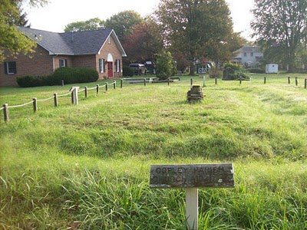
In the 1960s a real estate development company, realizing the potential of a location along slow moving rivers, near I - 95 and only 25 miles from downtown Baltimore, created a 'new' Joppa Town. Below is an advertisement from that era. Click twice and the images will enlarge. Oh, to have 1960 prices with 2010 incomes!
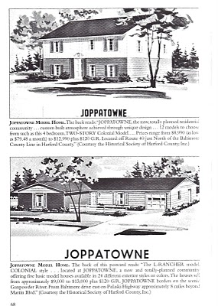
Next posting, we follow the Greers to the Mountains of Western North Carolina....
POSTED BY GLENN N. HOLLIMAN AT 11:33 AM 0 COMMENTS
LABELS: JOHN GREER, JR., SARAH ANNE ELLIOTT

12/19/10

When We Were Greers, Part VIII
by Glenn N. Holliman

The Troubled Marriage of John, Sr. and Sarah Day Greer

My generation's 7th great grandfather, John Greer, Sr. was born about 1688 along the Gunpowder River in Joppa, Maryland. He married Sarah Day, b 1686 in Baltimore County, at St. John's Parish, March 4, 1704.

John Greer, Sr. inherited the 75 acres that Arthur Taylor had given James Greer and Anne Taylor, and seems to have traded this land and others, buying and selling acreage around the Joppa area, a land speculator if you will. For example, in 1718, he sold land which stood above Nicholas Day's plantation and near to an Indian cabin. An interesting tidbit of history has made it through the centuries - in 1738 John Sr. was bitten by a rattle snake above the mouth of the Long Green River.
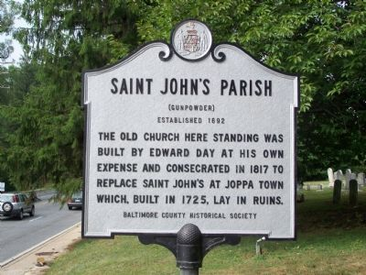St. John's Episcopal Parish moved several times in its history. Both John Greer, Sr. and John Greer, Jr. would be married in the parish. As Joppa Town deteriorated, Edward Day, a descendant of our Day ancestors, built a new St. John's. Ironically, another set of my 7th GGPs were married at St. John's - Samuel and Mary Harrod Stansbury on April 1, 1761. All you Stansberys, please make a mental note. In time, we will trace the Stansbery line from Maryland to Tennessee and beyond.

He was evidently snake bit in marriage also. According to vestry books in Baltimore County, our John Greer Sr. found himself admonished for co-habitating unlawfully with one Chloe Jones. While no date is given, he claims to have married Cleo. They had four children, evidently born out of wedlock.

My generation's 7th GGM, Sarah, went to live with a son, Aquillaat the Chilimara Plantation in Maryland, and later she remarried one Obadiah Pritchett. We are not sure when Sarah died - sources differ but her name is on no legal deed releases after 1747. Greer family compilations put her death between 1742 and 1747.

John Greer, Sr. with his second family of children immigrated west and south. They were living in Onslow County, North Carolina in 1752 when John died at the age of 72. One source states there were debts and the four new, minor children, were bound out to pay off his debts after his death.

The will states he left twelve pence sterling to his six sons and three daughters. However, to John Greer, Jr. (my generation's 6 GGF), Sr. left his Negro man, Jack, and two hunting guns. John Sr. may have been a gunsmith, as he left his gun stock tools and all tools to his 'Dearly Beloved Wife Cloe Greer', who was also the executrix. This court was held at Johnston on the New River in Onslow County July 1752. This is the first time human slavery emerges in a direct ancestral will.

(Most of the above was taken from Genealogy.com under the name of John G. Greer. Sources include land, rent and court records in Baltimore County, Maryland. The Greer family history, starting on the Gunpowder River in Maryland has been well researched. Google the names, and one can spend many hours sorting through the materials. Beware, as is normal in genealogy, not all dates and names agree.)

POSTED BY GLENN N. HOLLIMAN AT 10:42 AM 0 COMMENTS
LABELS: CLOE JONES GREER, JOHN GREER, JR. SARAH DAY GREER, SR.

12/11/10

When We Were Greers Part VII
by Glenn N. Holliman

The Lord of Lag

My lords and ladies of the MacGregor Clan, before we begin to move forward in the American colonial period, I wanted to share some pictures I found on line of our Greer ancestry in Scotland. North of Dumfries, Scotland is a small village named Dunscore. Move east a few miles (one can do this on a Google map) and lo and behold standing next to a farm house are the remains of the manor house, a quasi-castle of the Lord of Lag, the Greer family from which James Greer, my generation's 8th GGF, immigrated in the 1670s. His father (9th GGF) was Sir James Grier, a descendant of the MacGregor clan. See October 22, 2010 posting.
The remains of Lag Tower, 1790 print. The remains of the tower and 'castle' look dramatic in this 220 year old print. Remember the facility was constructed no later than the 1400s.
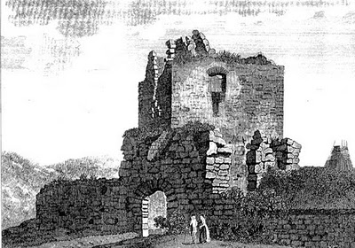
Below is a decidedly unromantic picture of the remains taken from a Google street map in 2007. Note the red farm equipment in front of the castle. A barn and farm house are to the right of this photo. You can locate this yourself. Go to Google Maps and drill down to to Dunscore, Scotland, about 7 miles northeast of Dumfries. Move your little 'yellow man' a few miles east over Holm Road. Look to the right (south), and you will spot this ruin below. This was and is an isolated part of the world. Many long, cold dreary nights; perhaps that is why our ancestors perfected Scotch!
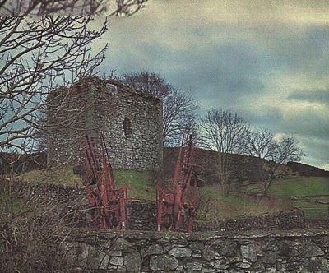
Next posting, back to the New World and Colonial Times....
POSTED BY GLENN N. HOLLIMAN AT 2:54 PM 1 COMMENTS
LABELS: JAMES GREER, SIR JAMES GRIER

12/2/10

When We Were Greers, Part VI
by Glenn N. Holliman

What do we know of our Day ancestors?
(Continuing the series of ancestral families of G.W. and Frances Wilson Osborne)

Sarah Day, my generation's 7th Great Grand Mother (7th GGM), was born 1686 in Baltimore, Maryland and died March 1758 in same county. She married John Greer, Sr. (7th GGF) March 4, 1704 in Joppa, Maryland at St. John's Episcopal parish.
Her father was Nicholas Day (8th GGF), 1635 abt in Wales, England - 1704 in Baltimore, and mother Sarah Lowe (8th GGM). The couple married in 1684 in Baltimore Co., Maryland. Sarah was the daughter of William Lowe.
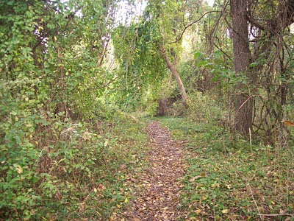This trail through the woods at Joppa, Maryland leads down to the Gunpowder River. Imagine if you can, wharfs, dray men, live stock and thousands of hogsheads of tobacco being loaded in ocean going cargo ships. Now a grown up river side with only a few monuments to mark the ghost town. Photos October 2010 by the author.
Nicholas Day's father was named also Nicholas Day (9thGGF) and mother was Sarah Cox (9th GGM). The birthplaces of these 9th GGParents are unknown but they married in Maryland.

The last few posts have been confusing, so I have added under the Family Lineage page these new family trees. What is evident is all these ancestors were farmers raising tobacco, and most likely corn and livestock. Their lives centered about the Gunpowder River and the town ofJoppa.
In this photo below one observes the silted Gunpowder River. On this site in the first half of the 1700s were wharfs, perhaps as many as a hundred lining the river. This particular location is located precisely in the center of the western edge of Old Joppa. It is difficult to envision what was once here - one of the premier ports of the Western Hemisphere in its day. This is an Eastern ghost town!
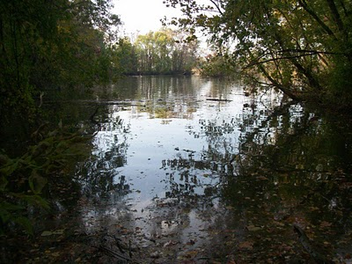
More of our ancestors next posting....
POSTED BY GLENN N. HOLLIMAN AT 2:56 AM 0 COMMENTS
LABELS: JOHN GREER, NICHOLAS DAY, SARAH COX, SARAH DAY, SARAH LOWE DAY, SR.
Newer PostsOlder PostsHome
Subscribe to: Posts (Atom)

PAGES
- Home
- Web Sites and Publications
- Contributers
- Family Lineage

POPULAR POSTS
We Are Also Boones, Part 4
by Glenn N. Holliman ( Source for this posting is largely from In the Footsteps of Daniel Boone by Randell Jones. Photos taken from the wo...
More Adema and Stansbery Photographs, No. 9
by Glenn N. Holliman 2010 Rob Adema took this photograph of his parents, Gay and Bob Adema along with yours truly (far left) at their s...
We Are Also Wilcoxsons - Part III
by Glenn N. Holliman The Wilcoxsons and Boones, 18th Century Pioneers in Central North Carolina and Kentucky Sources include www.planetmur...
Frances Wilson Osborne with daughter, Mayme Osborne Stansbery and granddaughter Louise Stansbery Sherwood

LABELS
Abraham Lincoln Ada Osborne Anne TaylorArthur Taylor Arthur Taylor Caroline Greer Wilson Ashe County Bascom K. Osborne Bascom Wilson OsborneBenjamin Greer Benjamin Greer; Jesse Greer Bishop L. Osborne Bob Adema Capt. Jesse Greer Caroline Greer Wilson; Isaac Wilson Charles I Charles IICharles Stansbery Charles WilsonChristopher Holliman Cloe Jones GreerDamascus Daniel Boone Daniel Wilcoxson David Wright Don FeickDoris Osborne Akers Eddie C. Osborne Edward Morgan Elizabeth PowellElizabeth Wilcoxson Cutbirth Flea AkersFrances Wilson Osborne Frazier KingG.W. Osborne Gayle Adema George BooneGeorge Washington Osborne George Wilcoxson Geraldine Stansbery Holliman Feick Gladys Osborne Adema Glenn HollimanHiram Wilson Howard Adema Hugh II James Grantson Holliman James GreerJames Grier Jesse Boone Wilcoxson John Greer John Taylor John Wilcoxson John Wilson Jonathan Murphy Joppa Jr. Jr. Sarah Day Greer Leroy Osborne Louise Stansbery Sherwood Luke Stansbery Margaret Hill Taylor Margaret Phinney Taylor Marion Lee Osborne Mary Brown Mayme Osborne Stansbery Nancy Lowe Walker Nancy Wilcoxson Greer Nicholas Day Nicholas Maxwell Pauline Osborne Pearl Osborne Wright Peggy Noeltner Phyllis AkersRachel Bryan Rachel Wilcoxson BryanRebecca Payne Rob Adema; Peggy Noeltner Rob Adema; Phyllis Akers Sarah Anne Elliott Sarah Boone Sarah Boone Wilcoxson Sarah Cox Sarah Day Sarah Day Greer Sarah Lowe Day Sarah Mary Oppy Sarah Morgan Sarah Morgan BooneSean Murphy Sir James Grier Squire Boone Sr Sr. Sr. Nicholas Day Sr.; Nancy Boone Wilcoxson The Rev. William A. WilsonToby Osborne Tom Adema Vance SherwoodVirginia Osborne Vivian Randall OsborneWilliam Grierson William Penn

BLOG ARCHIVE

Family Lineage
One's Generations of Great Grandparents
Relation Greatest Possible Number
Grandparents (GP) 4
Great Grandparents (1 GP) 8
2 GGP 16
3 GGP 32
4 GGP 64
5 GGP 128
6 GGP 256
7 GGP 512
8 GGP 1,024
9 GGP 2,048
10 GGP 4,096
11 GGP 8,192
12 GGP 16,384
13 GGP 32,768
If 25 years is a generation, than 13 generations is 325 years. Subtract 325 years from this decade, and one is discussing ancestors from the 1680s. However, it is rare that one does not have cousins, who do not know they are cousins, marrying.
For my grown children, I know this has happened in their tree (their parents share a common 2 GGP), greatly reducing the number of GGPs for them. - Glenn N. Holliman
The Descendants of G.W. and Frances Wilson Osborne
Sources include the Diary of Frances Osborne, Applachian State University Genealogical Collection and Writings by Geraldine Stansbery Holliman Feick, grand daughter of G.W. and Frances Osborne.
Marion Lee Osborn - D August 31, 1874, age six days (From a printed remembrance. Probably buried in Wilson Cemetery, Oscar Wilson Cove Road, Ashe Co., North Carolina).
Thomas 'Toby' Miles Osborne - B January 26, 1876 - D?. Moved from Bristol, Tennessee to Sumner, Washington in early 1920s. His children were Eddie Lawrence Osborne, Russell Miller Osborne and Pauline Osborne Smith. Pauline, a favorite grand daughter of Frankie, married Bennett Winston Smith. By the late 1930s, they had a son 'Bennie' and later a daughter. Toby's first wife, Alta Holtsclaw, died August 18, 1933; she had been born 5/19/1896. Toby remarried but her name is not known.
Leroy Milburn Osborne - B February 17, 1879 - D 2/17/1948). In the 1910s, Roy lived in Cleveland, Tennessee. In 1936, his address was 1016 16th Street. According to his grand daughter, Betty Osborne Price, interviewed October, 2010 at age 85, he owned a trucking company. His wife was Lena Holtsclaw (m September 17, 1899) D 1948. They had four children: Ralph Summers Osborne (the father of Betty Osborne Price), Albert Leslie Osborne, Robert Lafayette Osborne and Lucille Osborne.
Bishop L. Osborne - B December 13, 1881 in Ashe County, North Carolina - D June 1965 in Bristol, Tennessee. Bishop was a multi-talented man. He worked as an accountant at King's Department Store, but also wrote and published poetry and columns for the local newspaper. This writer has in his possession a collection of his poems given to me by my mother, which reflect Bishop's patriotic and religious beliefs. His wife (m 7/13/1907) was Cora E. Broyles Osborne (2/25/1880 - 7/9/1976). Due to a cleft foot, she always wore long dresses. They had one son, now deceased, Vivian Randall Osborne (4/27/1908 - 9/6/1974). All are buried in the family plot at East Hill Cemetery in Bristol.
Eddie C. Osborne - B April 25, 1885 D August 29, 1886, age 1 year and 4 months, 4 days. (From a printed remembrance) Probably buried in Wilson Cemetery in Ashe Co., NC.
Bascomb Wilson Osborne - B July 5, 1887 - D August 1970) In the 1910s, lived in Baltimore, Maryland and after the death of his first wife, Dora Catherine Kruger (age 33, buried Woodlawn Cemetery, Baltimore, MD), relocated to Louisville and then Owensboro, Kentucky. He worked for Brodie Motor Company, a Dodge dealership. His second wife's name was Ada. They lived in 1936 at 730 Walnut Street, Owensboro, KY.
Bascom had three children by his first wife: Bascom K. Osborne, Doris Ethel Osborne Akers and Gladys Pearl Osborne Adema. Broken emotionally by Dora's sudden death, the three children went to live with their Aunt Pearl Osborne and her husband David Wright in Damascus, Virginia in 1922. Pearl and David raised the children.
Bascomb K. Osborne - B 1910 - D 1977. Joined the U.S. Navy in 1927 as an enlisted man, served in the Pacific during World War II and retired a high ranking officer.
Doris Osborne married 'Flea' Akers. They had a daughter Phyllis Akers and a son Michael Akers.
Gladys Osborne married Howard Adema from Buffalo, NY and in 1938 lived at 39 W. Balcom Street. A daughter, Peggy Adema Noeltner and a son, Bob Adema live at least part time in Florida. Bob and his wife, Gay, spend the summers in Ontario, Canada.
William (Bill) Vestal Osborne - B July 22, 1892 - D?. Lived at 1634 7th Avenue, Los Angeles, California in 1938. He was the used car manager of a Ford dealership, Pico Motors in L.A. His wife, whom he married 18/10/1920 was Kathern Shields Rader. They had one daughter, Margaret Shields Osborne, whose nickname was 'Willy". There is information the family resided in Bristol, Tennessee until moving west in the early 1920s.
Pearl Edna Osborne Wright - B March 1, 1890 in Mast, North Carolina and D August 20, 1980 in Damascus, Virginia. She married her husband Robert David Wright on December 20, 1911 in Greenville, TN. While they had no children themselves, they raised Bascom's three children. David was in charge of the local electric company and died 12/16/1962
Mayme Osborne Stansbery - B January 16, 1896 - D December 3, 1943. She married Charles S. Stansbery of Afton, Tennessee on April 29, 1914. They had three children: Louise Stansbery Sherwood, Charles S. Stansbery, Jr. and Geraldine Stansbery Holliman Feick.
The Maternal Lineage of Frances Wilson Osborne
Frances Wilson Osborne
Caroline Nancy Greer Wilson (1828, Ashe Co., NC - 1911, Ashe Co., NC), who is the daughter of
Franklin (Frankie) Brown Greer (1810 - 1905, Ashe Co., NC), who is the daughter of
Mary Polly Morris Greer (1800, Yadkin Co., NC - 1880, Ashe Co., NC).
The Descendants of Mayme Osborne Stansbery (1/16/1896 - 12/3/1943) and Charles Skelt Stansbery Sr (12/5/1893 - 11/19/1957)
Frances Louise Stansbery Sherwood (1/27/1915 in Afton, TN - 6/20/2006 in Knoxville, TN), m. Vance R. Sherwood 1941.
Charles S. Stansbery, Jr (nicknamed Red due to his hair color ) (6/15/1918 in Afton, TN - 2006), m. Anne Duthil Smith of Philadelphia, PA in 1943.
Patricia Geraldine Stansbery Holliman Feick m. H. Bishop Holliman, June 26, 1945 in Philadelphia; m. The Rev. Donald Feick, June 1989 in Shippensburg, PA.
The Children of Charles Skelt Stansbery Sr and Lucy Lee Barkley (11/111912 - 6/25/1978)
Anne Stansbery (1935 - 1936) in Afton, TN. A twin sister died at birth.
Nancy Stansbery Higginbotham
Jean Stansbery Dobbs (3/1944 - 9/9/1999), Buried at Stone Dam Road Methodist Church next to her father.
The Parents, Brothers and Sisters of Charles Skelt Stansbery Sr.
Parents: William Luther Stansbery (4/29,1861 at Hopewell, Knox County, TN - 4/9/1943 in Afton, TN). Annie Eliza McCray Stansbery (12/20/1863 at Jonesboro, TN - 1/11/1936), m. 1/1/1884. Annie died when her night gown ignited as she stood next to an open fireplace in her home.
William's father was Pryor Lee Stansbery, an Union Civil War veteran. An earlier grandfather was a N.C. Revolutionary War veteran, Luke Stansbery, incarcerated by the British in Charleston, SC in 1780. The Stansberys immigrated to Maryland in the 1660s after several generations in the Netherlands. Originally from England, probably Devonshire. (Note: My first wife, Lynn Draper Armstrong (5/28/1946) and this writer share a common great-great grandfather, Pryor Lee Stansbery who is buried at the New Hope Baptist Cemetery in Knoxville, TN.)
Children:
Margaret Edith Stansbery (10/15/1884 - 10/26/1954) in Bristol, VA. Married Roe Williams, 5/19/1907. One son, J.C. Williams.
George Lee Stansbery (11/14/1886 - 9/25/1965 in Jefferson City, TN.) M. Annie Lee Stansbery 12/20/1906, one son and two girls.
James Arthur Stansbery (12/19/1888 - 6/14/1969 in Virginia). M. Nellie Homes 3/4/1914.
Fred Walker Stansbery (5/9/1891 - 5/27/1969 in Greenville, TN). M. Flor Eunice Dennis (11/11/1891 in Bristol, VA.) M. 9/10/1913.
Charles Skelt Stansbery Sr. (12/5/1893 - 11/19/1957 in Afton, TN). M. Mayme Tarrence Osborne 4/29/1914 and who died 12/3/1943 in Philadelphia, PA of a abdominal infection. Buried in East Hill Cemetery, Bristol, TN. The couple divorced in 1933. Charles is buried in Afton, TN in the Stone Dam Road Methodist Church cemetery with his second wife, Lucy Lee Barkley Stansbery and daughter Jean Stansbery Dobbs. Charles Stansbery is this writer's grandfather.
William Cecil Stansbery (12/15/1896 0 d. ?). Was a doctor in Cleveland, TN. M. Etta Mayers Henley, 9/20/1925. They had one son, a dentist and one daughter.
Harry Price Stansbery (12/14/1899 - D ?). Lived in Georgia as of 1981. M. Zola Rymer 6/18/1924.
Selma R. Stansbery (4/10/1902 and died two days later.)
Eva Kate Stansbery (9/10/1903 - 1979 or 1980 in Afton, TN). M. Guy Williamson 14/14/1922, one son Guy, Jr.
Descendants of Vance R. and Louise Stansbery Sherwood
Vance R. Sherwood, Jr.
Descendants of Charles S. and Anne Duthil Stansbery
Susan Stansbery MacKenzie
The Children of Susan Stansbery MacKenzie
A. Roxanne Hayes
B. Gavin Stansbery
Descendants of Patricia Geraldine Stansbery Holliman Feick and H. Bishop Holliman
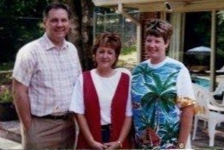

1996 photo of Glenn Holliman, Rebecca Payne Holliman and Alice Holliman Murphy, the three children of Geraldine Stansbery Holliman Feick and Bishop Holliman

1. Glenn N. Holliman
2. Rebecca Louise Holliman Payne
3. Alice Lynn Holliman Murphy
The Descendants of Bascomb Wilson (1887 - 1970) and Dorothy Catherine Kruegar Osborne (1889 - 1922)
Children:
1. Bascomb Krueger Osborne (3/19/1910 - 2/1977) M. Edith Stineau (1907 - 1987). One daughter - Virginia Marie Osborne (1941 - 1995), no children. M. to Adrian Hagen and James Maltis.
2. Doris Ethyl Osborne (2/25/1912 - 7/1987) M. Elmer Fickle Akers (1909 - 1976). Two children - Phyllis Anne Akers and David George Akers .
3. Gladys Pearle Osborne (6/10/1913) m. Howard Maynard Adema (8/31/1909 in Buffalo, NY - 4/7/1984 in Florida). Children from this marriage were:
A. Robert Howard Adema m. Gayle Elizabeth Maischoss in Buffalo, NY.
B. Alan Adema
C. Peg Adema Noeltner
The Descendants of George Boone
Sources are The Boone Society, Inc. (www.boonesociety.org) and Greer Family Records.
Last English Generation: George Boone (1636 - 1696) m. Sarah Oppy (1628 - 1708) Buried at St. Magdelene Parish, Stoke Canon, Devonshire. George was a blacksmith and had at least three children, one being George Boone Jr. George and Sarah Oppy Boone were my generation's 9th great grandparents (9th GGP).
First American Generation: A son, George Boone, one who would immigrate to the New World. (3/19/1666 - 7/27/1744). Born at Stoke Canon and worked as a weaver. M. Mary Mogridge on 8/16/1689, who was born in Bradninch, 8 miles from Exeter in 1669. Daughter of John Mogridge and Mary Milton. Mary died 2/21740. Both buried in Friends Burying Ground in Exeter Township, Pennsylvania. Mary had been baptised at St. Disen's Church on Sept. 23, 1668. George and Mary Mogridge were my generation's 8th great grandparents (8th GGP).
Second Generation: Squire Boone (B 11/25/1696), baptised at St. Disen's Church, Bradninch, Devonshire, England. Squire m. Sarah Morgan on July 23, 1720 at the Gwynned Meeting of Quakers, Berks Co, PA. Squire died 1/2/1765 and Sarah in 1777. Both buried at Mocksville, North Carolina in Old Joppa Cemetery. Sarah b 1700 at Bala Wales, PA. Her father, Edward Morgan b at Bela Coty, Wales or at Bolas Merionethshire, Wales. Moved to 'Welsh Tract" at Gwynedd, Montgomery Co., PA shortly after 1691 and before 1704. D 7124 at Gwynedd, PA. A tailor. Wife Elizabeth Jarman. Squire and Sarah Morgan Boone were my 7th great grandparents (7th GGP).
Third Generation: Sarah Boone b 6/7/1724, the first of eleven children at New Britain Twp., PA. She died 1815 Madison Co., KY at the home of a daughter Elizabeth Cutbirth. Her brother Daniel, b 10/22/1734, was the 6th child of Squire and Sarah Morgan Boone. Sarah m. John Wilcoxson on 5/29/1742 at Exeter, PA. John b 9/6/1720 at either Cossa Notts, England or at Berks Co., PA. Death date uncertain but not killed by an Indian on 2/3/1782 near Bryant's station, KY as some web sites state. John and Sarah Boone Wilcoxson were my 6th GGP. John's parent's, George and Elizabeth Powell Wilcoxson were my 7th GGP.
Fourth Generation: The first born of Sarah Boone and John Wilcoxson, Nancy Wilcoxson (3/17/1743 - d 10/3/1790) married Benjamin Greer (2/9/1746 - 10/23/1816). Nancy and Benjamin were my generation's 5th GGP.
Fifth Generation: The sixth born of the frontier fighter Benjamin Greer and Nancy was Jesse Greer, Sr. (11/14/1778 - 89/20/1860) who eloped in 1800 with 13 year old, Mary Polly Morris (naughty boy). However the marriage did well - 17 children! Jesse and Mary Morris were my 4th GGP. A lot of distant cousins from this generation!
Sixth Generation: Born on 12/16/1806 was Jesse Greer, Jr. He was present when his son-in-law, Isaac Wilson, was bushwhacked in June 1864. His wife was a strong woman in her own right, Frances Brown Wilson ( 11/16/1810 - 12/2/1905) who fought Union troops herself in 1864. Jesse Jr. died 2/11/1892. Jesse and Frances Brown Wilson were my 3rd GGP.
Seventh Generation: Caroline Greer Wilson (12/10/1828 - 3/25/1911) and her husband Isaac (1822 - 1864) are the parents of Frances Wilson Osborne, this writers great-grandmother. Isaac and Caroline Greer Wilsons were my 2nd GGP.
Eight Generation: Frances Wilson Osborne (1851 - 1940) and George Washington Osborne (1846 - 1927) will raise seven children to maturity. They are Toby, Roy, Bishop, Bascom, Bill, Pearl and Mayme Osborne. Mayme is this writer's grandmother.
The Descendants of James Grear (Greer)
Sources are the Notebook of the Jesse Greer Family, Genealogy Collection, Appalachian State University and the Greer Genealogical Website at rootsweb.com.
Scottish Generation: Roger Grierson, the 8th Lord of Lag, married Helena Douglas (b before 1560 - d 1578), Roger was born ca 1520 and died August 1593). Roger and Helena were my 11th GGP.
Scottish Generation: My generation's 10th GGP were Sir William Grierson, 9th Lord of Lag, and Nicola Maxwell (b ca 1578). Sir William was born between 1567 and 1575 and died January 21, 1629. Nicola was the daughter of William Maxwell, Lord Herries, my 11th GGF. Sir William and Nicola married May 9, 1593.
Last Scottish Generation: Sir James Grier was born 1604 and died 1666 in Dumfries, Scotland. His wife was Mary Browne, b. ca 1604 at Glencairn, Dumfriesshire, Scotland. This couple are my 9th GGP. They married ca 1626. John ( b ca 1570 at Glencairne, Dumfries) and Sarah Hope Browne (b ca 1570), the parents of Mary Browne are my 10th GGP.
First American Generation: My generation's 8th great grandfather, James Grear (1627 - 1688 ca) of Dumfries, Scotland was transported on November 2, 1675 by Samuel Gibbons to Maryland; statement signed by the Roman Catholic proprietor, Governor Charles Calvert, grandson of the founder, Lord Baltimore. James Grear, Jr. marries circa 1680 or 1688 Ann Taylor (1662 - 1716), daughter of Arthur Taylor and Margaret Hill Taylor. James dies perhaps 1688. Ann dies May 13, 1716. Arthur Taylor's father is named John Taylor. Ann Taylor is my generation's 8th GGM.
Second Generation: John Greer, Sr. born ca. 1688 along Gunpowder River, Maryland. He marries Sarah Day, daughter of Nicholas and Sarah Day at St. John's Anglican Parish March 4, 1704 at Joppa. John Sr. dies 1752 in Onslow Country, North Carolina. Sarah, John's wife, probably died before 1747. They are my generation's 7th GGP. Sarah is the daughter of Nicholas Day and Sarah Lowe, my 8th GGP. John Sr. would marry a second time between 1745 - 1750 to Chloe Jones.
Third Generation: John Greer, Jr. born ca 1714 on the Gunpowder River. His first wife was Sarah Ann Elliott, and they are the parents of Benjamin Greer. They married in 1736 at St. John's Parish, Joppa, Maryland. His 2nd wife was Nancy Anne Lowe Walker, b. 1714. In 1756, John Jr. moved to North Carolina. He died May 1782 in Wilkes Country, North Carolina. John Greer Jr. and Sarah Ann Elliott are my generation's 6th GGP.
Fourth Generation: Benjamin Greer born February 9, 1746 in Albemarle County (Charlottesville area), Virginia. Benjamin marries Nancy Wilcoxson in 1767. Nancy died October 31, 1790. Benjamin died October 23, 1816 at Green River, Kentucky. Benjamin and Nancy are my 5th GGP.
Fifth Generation: Jesse Greer Sr. born November 14, 1778 in Wilkes County, North Carolina and died September 20, 1869. He married 13 year old Mary Polly Morris on January 17, 1800. She died in Ashe County, NC February 29, 1880. Mary's parents were Henry and Mary Morris. This prolific couple who produced 17 children, are my 4th GGP. Henry and Mary Morris are my 5th GGP.
Sixth Generation: Jesse Greer Jr. born December 16, 1806 in Ashe County, North Carolina. His future wife, Francis (Frankie) Brown born December 16, 1810 at Ashe County. They married 1826. Jesse Greer, Jr. and Francis Brown Greer are my generation's 3rd GGP.
Seventh Generation: Caroline Nancy Greer born December 10, 1828. Her future husband, Isaac Wilson, borne December 16, 1822. She and Isaac marry March 25, 1849. Isaac is killed June 1864; Caroline survives until 1911. Issac and Caroline are my generation's 2nd GGP.
Eight Generation: My generation's great grandmother born in 1851, Frances Wilson who will marry G.W. Osborne in 1867. He dies in 1928 and Frankie lives until 1940. G.W. and Frankie are my Great Grandparents.
The Descendants of John Taylor
Sources include LDS ancestral File and the Greer Genealogical Website at roots web.com.
First American Generation: John Taylor (1629 - 1675) married a woman named Margaret (b 1629 in England), unknown last name. John and Margaret are my generation's 10th GGF. John was born in England and died in Baltimore Co., Maryland.
Second Generation: Arthur Taylor (? - 1687) married Margaret Hill (1629 ca - 1678), daughter of Roger Hill (b 1610) in 1658 in Baltimore Co., Maryland. Born in England, Margaret died at Baltimore Co., Maryland. Arthur and Margaret Hill Taylor are my 9th GGP.
Third Generation: Ann Taylor was born 1662 in Maryland, married James Greer ca 1682 and died May 13, 1716. She married three times, and is my 8th GGM. After my 8th GGF died she married Lawrence Richardson and Oliver Harriott.
The Descendants of Nicholas Day
Sources include LDS ancestral File and the Greer Genealogical Website at roots web.com.
Last Welsh Generation: ??
First American Generation: Nicholas Day born in Wales, died 1704 in Baltimore Co., Maryland. His wife was Sarah Lowe. They are my 8th GGP.
Second Generation: Sarah Day (1686 ca - ca 1747) was born Baltimore Co., Maryland, and married John Greer, Jr. on March 4, 1704 at the original St. John's Parish in what is now the Edgeworth Officer's Club at Aberdeen Proving Ground. Sarah and John Greer, Sr. are my 7th GGP.

0 COMMENTS:

POST A COMMENT

2/28/11

When We Were Greers XIV
by Glenn N. Holliman

The Gathering Storm - The Tide of Revolution Sweeps Over the Carolinas...

...and into the mountains and valleys of the Appalachian highlands. Many Cherokee and Shawnee, infuriated by the continued encroachment of American settlers, became allies of the British during the American Revolution. Bottled up by General George Washington outside of New York City, the British turned their forces and energies southward. Under Generals Clinton and Cornwallis, the British invaded Georgia and South Carolina in 1779 and 1780.

Tory sympathizers arose in the Carolinas and in essence a civil war swept the Colonial South as neighbor turned against neighbor. This maelstrom of the late 1770s and early 1780s engulfed my families - the Greers, Wilsons, Wilcoxsons, Osbornes, Boones, Stansberys and Hollimans.

Walter Edgar's excellent work on the 1780 and 1781 conflict in the Carolinas captures the many battles, skirmishes and clashes that involved this writer's ancestral families. Highly recommended reading for those interested in this period of the American Revolution.
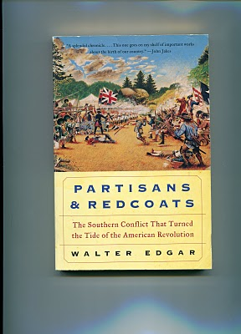
In later articles I will write of Luke Stansbery, a great grandfather, who was captured at the fall of Charleston in 1780 and was incarcerated for a year. James Grantson Holliman, my 4th great grandfather on my father's side of the family, served six months in the North Carolina patriot militia. I have written how the Boones and Wilcoxsons held the Kentucky frontier from the British and Shawnee at Boonesborough. Great grandfathers and uncles in the Osborne line did their share of fierce fighting also, which I also will explore later.
For now we concentrate on Benjamin Greer, my generation's fifth great grandfather. We know that in the summer of 1780, he served as a captain in the militia invading and destroying Cherokee villages in eastern Tennessee. Pension requests on file indicate enlisted men served under Capt. Greer that summer and state the month.
Young chiefs, furious that older chiefs had sold so much of Indian hunting grounds, had thrown in their lot with the British and sent their braves to harass the settler's frontier. Benjamin and others, including our Osborne family, responded.
Search and Destroy
During my Vietnam service in the 1960s, the U.S. Army engaged in what were called 'search and destroy' missions, that is invading suspected Vietnamese communist territory and/or villages destroying suspected arms cashes, food and shelters. Similar tactics were adopted in 1780 when North Carolina militiamen led, on at least one occasion by Captain Benjamin Greer in July and August, swept through a portion of what is now East Tennessee, burning villages and destroying crops and livestock. Ironically the Cherokee had absorbed a considerable portion of Anglo culture even to the extent of raising hogs and cattle.

The Cherokee, men, women and children, generally escaped into the coves and high mountains hiding from and occasionally harassing the superior Patriot forces. After the violent sweep through villages, the Cherokee returned to their destroyed huts and corn crops, and faced a winter of hunger. Many died as a result, and the Indian threat to the East Tennessee, Southern Virginia and Western North Carolina frontier diminished.

The North Carolina militia then turned its attention to the invasion by Lt. General Earl Cornwallis and his officers such as the infamous Col. Baastre Tarleton and Major Patrick Ferguson.

That incursion of the British and uprising by Tory sympathizers led to the pivotal battle in the Southern campaign - the historic Battle of Kings Mountain.
Next posting - the Battle that Turned the Tide of War
POSTED BY GLENN N. HOLLIMAN AT 9:24 PM 0 COMMENTS
LABELS: BENJAMIN GREER, JAMES GRANTSON HOLLIMAN, LUKE STANSBERY

2/20/11

When We Were Greers, Part XIII
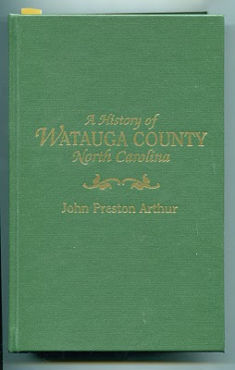
by Glenn N. Holliman
Benjamin Greer, A Son of the Wild Frontier
(Among sources are: "Going Home for History, The Greer Family of Wilkes County, North Carolina, Roots Web on Ancestry.Com and the web site of genealogists Judith and Ralph Terry, Coleman County, Texas. )

Ben descended from the Scottish clan of Macgregors, a vigorous tribe of sometime cattle rustlers and brigands that drove other clans and the English to distraction. Born on the Virginia frontier, Augusta or Albermarle County on February 9, 1746, he married a niece of Daniel Boone, Nancy Wilcoxson, in 1767 at Old Fields, Rowan County, North Carolina. Like her uncle and other relatives, the Greers, Bryans, Boones and Wilcoxsons fought Indians, Tories and on occasion the British Army. Later in life Benjamin took on his local Baptist Church!

Some of what we know of Benjamin is from the 1915 work of John Preston Arthur in his History of Watauga County (North Carolina) available now as a reprint from Genealogical Publishing, Baltimore, Maryland.

A frontiersman, Ben lived to see Tennessee and Kentucky settled, the fighting of a second American War of Independence with the English, and his brood of children and grandchildren spread his genes throughout the mountains and valleys of Tennessee, North Carolina and Kentucky. On October 23, 1816, he laid down his burden and died in Green River, Kentucky at the home of a daughter.
For one violent year from the summer of 1780 to the summer of 1781, as a militia captain, Ben, his brother Jesse and their men stalked and fought through the mountains of North Carolina and Tennessee, and when they and others were through, a new nation was born. Here is what we know of the story of my generation's fifth great grandfather.
He and Nancy Boone Wilcoxson (May 17, 1743 - October 30, 1790) had ten children, before Nancy died in Wilkes County, North Carolina. Benjamin remarried Sarah Atkinson Jones, the widow of Thomas Jones and daughter of Edmund Atkinson. This couple had five children, making Ben the father of 15 Greers, a family that would continue to multiply. Among the children of Nancy and Benjamin was one Jesse Greer, Sr., born 1778. This Jesse is my generation's 4th great grandfather, and we will later examine his interesting story.

We know in 1767 in Bedford County, Virginia, Ben sold to one Mathew Tolbot 163 acres his father, Jesse Greer, had given him. With the proceeds he moved to Wilkes County (then Rowan County), North Carolina, married Nancy and purchased land on both sides of Cub Creek.

Here on the frontier, they raised their children. Fate intervened with the American Revolution in which Ben and his brother, Jesse, another militia captain took part. In the next articles we will examine three episodes in Ben's military career. They are:

- The 1780 Cherokee-Militia conflicts in what is now East Tennessee
- The 1780 Battle of Kings Mountain
- The 1781 Rescue of Col. Ben Cleveland from Tories

Next article, the Clash of Cherokee and Frontiersmen
POSTED BY GLENN N. HOLLIMAN AT 4:08 AM 0 COMMENTS
LABELS: BENJAMIN GREER; JESSE GREER, CAPT. JESSE GREER, SR.; NANCY BOONE WILCOXSON

2/9/11

When We Were Greers, Part XII
by Glenn N. Holliman

The Will of John Greer, Jr. 1782

When John Greer, Jr. (my generation's 6th great grandfather) died in 1782 in Wilkes Country, North Carolina, the Revolutionary War had just ended with the defeat of Cornwallis at Yorktown, Virginia. The back country of North Carolina had been divided between Tories, those that supported the Crown, and a larger number of American Patriots. The Greer families would be caught up in both the divisions of the Revolution in the 1770s and 80s, and the bitter war of the 1860s. In each conflict, the family would experience violence and hardship.

As noted in the last post, John Greer, Jr. was born in Joppa, Maryland and migrated down the Great Valley Road of Virginia, stopping in Augusta County in 1746 to give birth to my generation's 5th great grandfather, Benjamin Greer. According to Ancestry.com/~krworley/p2.htm, the Greers arrived in SurryCounty (now Wilkes County), North Carolina about 1771.

The Regulator Movement was in full swing in western North Carolina as backwoods families protested high taxes and lack of representation in the colonial capitol of New Bern. In 1778, John was appointed a justice of the peace for the first court after the organization of Wilkes County. Evidently, the family was a leader in the community which is borne out in the careers of at least two of his sons.
Below is a contemporary road map of the Wilkes County, North Carolina area. Wilkesboro is some 74 miles west of Winston-Salem and 30 some odd miles east of Boone. The Greers, Boones,Wilsons, Osbornes, Wilcoxsons and other families kin to my generation moved to this frontier in the 1760s and 1770s. Click twice on the map to enlarge.
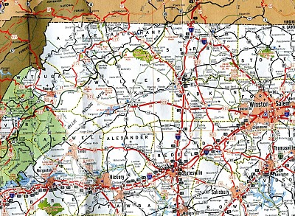
In 1782, John Greer, Jr. died and his will was probated. To his second wife Nanney he left the plantation of 492 acres, and then to son Jessey after the death of Nanney. (Jessey would be a captain in the American Revolution).

There were slaves in this family, a bit unusual for the frontier but not for the amount of acreage the Greers farmed. Bequeathed in continued human bondage was a Negro girl, Pheby to John's daughter Ann Mitchell, and to daughter Hannah Demoss, a Negro girl, Hannah. Hannah had married the local sheriff, Lewis Demoss.

The remainder of the estate was divided equally amongst these children: Aqulla, John, Benjamin (my 5th great grandfather), Joshua, Jessey, Rachel Mitchell, Sarah Hardgrave and HannahDemoss. The executors were wife Nancy (spelled differently here) and a friend, John Brown. Witnesses were Archelus Walker (a next door neighbor), Nancy Walker and Sarah Greer.

On the tax list of 1782, Ann Greer, presumably the widow, has 600 acres and four slaves. The majority of the family lived in Captain Abraham Demoss's district.

Next posting - Benjamin Greer, a son of the Wild Frontier!
POSTED BY GLENN N. HOLLIMAN AT 11:20 AM 0 COMMENTS
LABELS: BENJAMIN GREER, JOHN GREER, NANCY LOWE WALKER
Newer PostsOlder PostsHome
Subscribe to: Posts (Atom)

PAGES
- Home
- Web Sites and Publications
- Contributers
- Family Lineage

POPULAR POSTS
We Are Also Boones, Part 4
by Glenn N. Holliman ( Source for this posting is largely from In the Footsteps of Daniel Boone by Randell Jones. Photos taken from the wo...
More Adema and Stansbery Photographs, No. 9
by Glenn N. Holliman 2010 Rob Adema took this photograph of his parents, Gay and Bob Adema along with yours truly (far left) at their s...
We Are Also Wilcoxsons - Part III
by Glenn N. Holliman The Wilcoxsons and Boones, 18th Century Pioneers in Central North Carolina and Kentucky Sources include www.planetmur...
Frances Wilson Osborne with daughter, Mayme Osborne Stansbery and granddaughter Louise Stansbery Sherwood

LABELS
Abraham Lincoln Ada Osborne Anne TaylorArthur Taylor Arthur Taylor Caroline Greer Wilson Ashe County Bascom K. Osborne Bascom Wilson OsborneBenjamin Greer Benjamin Greer; Jesse Greer Bishop L. Osborne Bob Adema Capt. Jesse Greer Caroline Greer Wilson; Isaac Wilson Charles I Charles IICharles Stansbery Charles WilsonChristopher Holliman Cloe Jones GreerDamascus Daniel Boone Daniel Wilcoxson David Wright Don FeickDoris Osborne Akers Eddie C. Osborne Edward Morgan Elizabeth PowellElizabeth Wilcoxson Cutbirth Flea AkersFrances Wilson Osborne Frazier KingG.W. Osborne Gayle Adema George BooneGeorge Washington Osborne George Wilcoxson Geraldine Stansbery Holliman Feick Gladys Osborne Adema Glenn HollimanHiram Wilson Howard Adema Hugh II James Grantson Holliman James GreerJames Grier Jesse Boone Wilcoxson John Greer John Taylor John Wilcoxson John Wilson Jonathan Murphy Joppa Jr. Jr. Sarah Day Greer Leroy Osborne Louise Stansbery Sherwood Luke Stansbery Margaret Hill Taylor Margaret Phinney Taylor Marion Lee Osborne Mary Brown Mayme Osborne Stansbery Nancy Lowe Walker Nancy Wilcoxson Greer Nicholas Day Nicholas Maxwell Pauline Osborne Pearl Osborne Wright Peggy Noeltner Phyllis AkersRachel Bryan Rachel Wilcoxson BryanRebecca Payne Rob Adema; Peggy Noeltner Rob Adema; Phyllis Akers Sarah Anne Elliott Sarah Boone Sarah Boone Wilcoxson Sarah Cox Sarah Day Sarah Day Greer Sarah Lowe Day Sarah Mary Oppy Sarah Morgan Sarah Morgan BooneSean Murphy Sir James Grier Squire Boone Sr Sr. Sr. Nicholas Day Sr.; Nancy Boone Wilcoxson The Rev. William A. WilsonToby Osborne Tom Adema Vance SherwoodVirginia Osborne Vivian Randall OsborneWilliam Grierson William Penn

BLOG ARCHIVE

1/24/11

When We Were Greers, Part XI
by Glenn N. Holliman

The Greers Move Through the Great Valley of Virginia
to Relocate in North Carolina

Both my generation's 7th and 6th grandfathers, John Greer, Sr. and John Greer, Jr. left Maryland and moved south and west to the then frontier of western North Carolina. John, Sr. left to establish a new family. John, Jr. to acquire virgin farm land made available as the Cherokee were pushed from their historic hunting grounds.

John Greer, Jr. was born in Joppa, Maryland sometime between 1714 and 1718. He married at St. John's Episcopal Church inJoppa one Sarah Elliott, my generation's 6th great grandmother. John, Jr. would die in Wilkes Country, North Carolina in theYadkin River Valley in May 1782. An early settler to the area, he must have prospered as he served his community as a justice of the peace. His wife then was Nancy Lowe Walker.

The map below captures the American frontier of 1763 when English Crown established the Proclamation Line, the black line in this map that stretches from New England to Georgia. No colonial settler was allowed to purchase or take Indian land west of the line. The dark purple reflects colonial settlement from 1700 to 1760.

The Greers, Boones, Wilcoxsons and another of our relations moved from Maryland and Pennsylvania down the Shenandoah to the purple circle next to the word 'frontier' in western North Carolina. Notice how far in advance this area in the YadkinValley around Wilkes County, North Carolina was from other Carolina settlements. This area was hunting ground for the Cherokee (just over the Proclamation line in what is now Tennessee).
This is a reproduction from Making America, published 2003 byHoughton Mifflin Company, and is not to be used for commercial purposes.

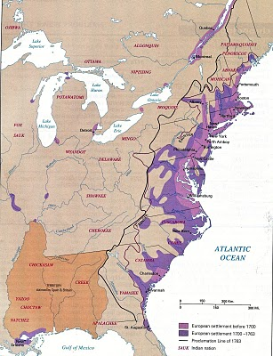
The move from the Chesapeake south evidently took place in several stages. My generation's 5th great grandfather, the Revolutionary War patriot, Benjamin Greer, was born February 9, 1746 in Augusta Country, Virginia, near the town of Staunton. Augusta County is smack in the middle of the Shenandoah Valley and was and is the Great Road from the Northeast to the Southwest in the Eastern United States. For the past half century, one travels on I-81 and since the dawn of the automobile age, U.S. Highway 11.

Our ancestors - the Osbornes, Greers, Wilcoxsons, Boones,Wilsons and many others, the majority Scotch-Irish who poured off the ships in Philadelphia - began in earnest in the 1730s and 1740's to settle the back country of Virginia. With the defeat of the Tuscarora nation in eastern and central North Carolina, the Carolina frontier was pushed west toward the foothills and mountains of the Appalachian chain, into Cherokee and later, Shawnee hunting territory.

In the next postings, more of our frontier families in a contested land....

POSTED BY GLENN N. HOLLIMAN AT 2:51 AM 0 COMMENTS
LABELS: DANIEL BOONE, JOHN GREER, JOHN WILCOXSON, NANCY LOWE WALKER

1/10/11

When We Were Greers, Part X
by Glenn N. Holliman
More on Nicholas Day, my Generation's 8th Great Grandfather
and William the Conqueror!
I thought I had exhausted my notes on the Greers, Days andTaylors in Joppa Town, Maryland when I chanced upon some more materials. Below is information in part from Wally Garchowat Ancestry.ca. His work adds to the tapestry we have on our Chesapeake Bay roots.
The date of birth for Nicholas Day is uncertain, anywhere from 1620 to 1635, but he seems to have come from Wales. He died before February 4, 1704/5. Queen Anne would be on the throne of England at that time, and Maryland a colony for 70 odd years. Philadelphia had been founded only a quarter century before, so the British settlement of North America was still unfolding.
In the General Land Office Patents, the Land Commissioner's Office in Annapolis, is a statement that on February 22, 1658, "Nicholas Day, a grown man sells himself into 'slave bondage' for 'ship transportation' to the New World. He along with seven others bound himself to Richard Owens who granted them their freedom and notified his 'Lordship Grace' that they were entitled to 50 acres of land." Our 8th great grandfather evidently was an indentured servant who put in his time, and then began a successful transition to that of a colonial land owner and planter.
June 3, 1693, this great grandfather of ours purchased 200 acres of land along the Gunpowder River, a tract called 'William the Conqueror'. He paid 1200 pounds of tobacco for this extravagantly named acreage near the Gunpowder Falls. A few months later he bought another 150 acres for 300 pounds of tobacco, a piece named 'Lesser Chance'. He held onto this land until his death, when he bequeathed it to Nicholas Jr.

His daughter, Sarah Day - named after her mother - received part of his stock of 'hoggs'. Well, Sarah had married John Greer, Sr. in 1704, and lived on Greer land. Of course, no one knew how troubled Sarah's marriage to John Greer, Sr. (my generation's 7thgreat grandfather) would be, and that he would be hauled before a parish vestry in Joppa and charged with infidelity. Embarrassing to say the least.

The land 'William the Conqueror'? Purchased eventually by a King family who gave their name to a rural village along the Gunpowder. Google Kingsville, Maryland and 'William the Conqueror' and discover an area map and photographs of more recent colonial buildings. A marker stone with Edward Day's name on it near Highway 1 still stands. Edward Day was a descendant of our Nicholas Day.

The Gunpowder River below the Falls at Joppa Town, Maryland down stream from Kingsville, Maryland. Here the river is silted and marshy just before it flows into the Chesapeake Bay. Photo by the writer 2010.
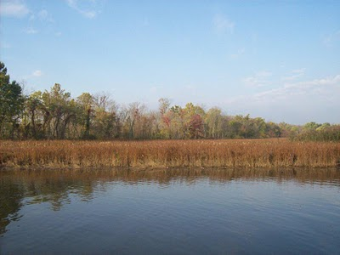
However, the point of this article to demonstrate a rags to riches story of a great grand father, who evidently arrived as an indentured servant and died a man of some means. This is a prototype example of the America Dream in the life of an ancestor.
For more information and photographs, go to the Greater Kingsville Civic Association, Inc. on the web.
POSTED BY GLENN N. HOLLIMAN AT 2:48 AM 0 COMMENTS
LABELS: JOHN GREER, NICHOLAS DAY, SARAH DAY GREER, SR.
Newer PostsOlder PostsHome
Subscribe to: Posts (Atom)

PAGES
- Home
- Web Sites and Publications
- Contributers
- Family Lineage

POPULAR POSTS
We Are Also Boones, Part 4
by Glenn N. Holliman ( Source for this posting is largely from In the Footsteps of Daniel Boone by Randell Jones. Photos taken from the wo...
More Adema and Stansbery Photographs, No. 9
by Glenn N. Holliman 2010 Rob Adema took this photograph of his parents, Gay and Bob Adema along with yours truly (far left) at their s...
We Are Also Wilcoxsons - Part III
by Glenn N. Holliman The Wilcoxsons and Boones, 18th Century Pioneers in Central North Carolina and Kentucky Sources include www.planetmur...
Frances Wilson Osborne with daughter, Mayme Osborne Stansbery and granddaughter Louise Stansbery Sherwood

LABELS
Abraham Lincoln Ada Osborne Anne TaylorArthur Taylor Arthur Taylor Caroline Greer Wilson Ashe County Bascom K. Osborne Bascom Wilson OsborneBenjamin Greer Benjamin Greer; Jesse Greer Bishop L. Osborne Bob Adema Capt. Jesse Greer Caroline Greer Wilson; Isaac Wilson Charles I Charles IICharles Stansbery Charles WilsonChristopher Holliman Cloe Jones GreerDamascus Daniel Boone Daniel Wilcoxson David Wright Don FeickDoris Osborne Akers Eddie C. Osborne Edward Morgan Elizabeth PowellElizabeth Wilcoxson Cutbirth Flea AkersFrances Wilson Osborne Frazier KingG.W. Osborne Gayle Adema George BooneGeorge Washington Osborne George Wilcoxson Geraldine Stansbery Holliman Feick Gladys Osborne Adema Glenn HollimanHiram Wilson Howard Adema Hugh II James Grantson Holliman James GreerJames Grier Jesse Boone Wilcoxson John Greer John Taylor John Wilcoxson John Wilson Jonathan Murphy Joppa Jr. Jr. Sarah Day Greer Leroy Osborne Louise Stansbery Sherwood Luke Stansbery Margaret Hill Taylor Margaret Phinney Taylor Marion Lee Osborne Mary Brown Mayme Osborne Stansbery Nancy Lowe Walker Nancy Wilcoxson Greer Nicholas Day Nicholas Maxwell Pauline Osborne Pearl Osborne Wright Peggy Noeltner Phyllis AkersRachel Bryan Rachel Wilcoxson BryanRebecca Payne Rob Adema; Peggy Noeltner Rob Adema; Phyllis Akers Sarah Anne Elliott Sarah Boone Sarah Boone Wilcoxson Sarah Cox Sarah Day Sarah Day Greer Sarah Lowe Day Sarah Mary Oppy Sarah Morgan Sarah Morgan BooneSean Murphy Sir James Grier Squire Boone Sr Sr. Sr. Nicholas Day Sr.; Nancy Boone Wilcoxson The Rev. William A. WilsonToby Osborne Tom Adema Vance SherwoodVirginia Osborne Vivian Randall OsborneWilliam Grierson William Penn

BLOG ARCHIVE

7/25/10

We Are Also Boones, Part 3
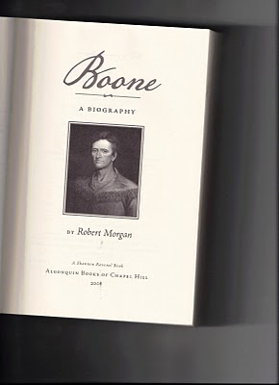
by Glenn N.Holliman
Sources include the Boone Society web site and members;History of the Boone, Bryan and MorganFamilies by Roberta Stuart Sims,Shreveport, LA; web site - Daniel Boone, Berks County's Gift to the West; the excellent work,Boone, A Biographyby Robert Morgan; and research by Pat Hagan on the Wilcoxson family.

In 1720 Squire Boone, a son of George and Mary Mogridge Boone married Sarah Morgan. Her father was a Welsh American planter of note, one Edward Morgan, my generation's 8th great grandfather.

The family tree below is from Robert Morgan's Boone, A Biography available from Algonquin Books of Chapel Hill, 2008.

Double click to enlarge the document. This reproduction and others are intended for educational purposes only, and not for commercial gain.
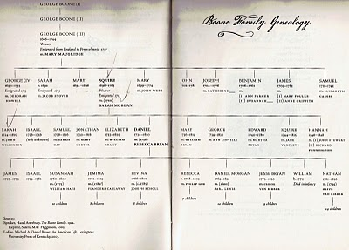
The marriage of my 7th great grandparents took place in North Wales in Gwynned Township, where both Welsh and English Quakers had settled. Squire and Sarah first moved to a farm in Bucks County, PA, but finding the community too crowded for aBoone, Squire soon moved to what is now Berks Country, where he bought land adjoining this father, George Boone, the great grandparent who moved the family to America.

In the 1720s, Berks County was the frontier and Blue Mountains, a few miles to the north, were a wall between the Europeans and Indians. The Squire Boones built a house over a spring, as a precaution because of possible Indian attacks. Part of the building still stands and is a historical park near Reading, Pennsylvania.
The map below is from Robert Morgan's work, one of the best recent works on Daniel Boone with considerable information on my generation's 7th and 6th great grandparents. Double click the map and it should become larger. This writer lives 25 miles northwest of Harrisburg, formerly Harris's Ferry.
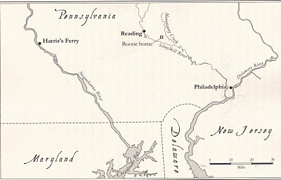
Squire and Sarah had 11 children, the first being my 6th great grandmother, Sarah Boone, born 4/7/1724 in New Britain Twp., PA. She died 1815 in Madison County, Kentucky.
Sarah, my 6th great grandmother, married John Wilcoxson on May 29, 1742 in Exeter, PA. Some genealogists believe she was with child at marriage. This plus the fact John was not a Quaker led to differences between Squire Boone and his local Quaker Church, difficulties which would eventually lead to Squire leaving the Quaker congregation and, in fact, leaving Pennsylvania!
John's father is believed to be George Wilcox, who lived in Philadelphia, a weaver, who died in 1739. John's mother was Elizabeth Powell, daughter of Rowland Powell from Haverford, Chester Co. The couple married in 1718, and John was born 9/6/1720.

This posting has been full of family tree information. Next posting we will discover more about the Boone family in Pennsylvania....
POSTED BY GLENN N. HOLLIMAN AT 1:47 PM 0 COMMENTS
LABELS: EDWARD MORGAN, JOHN WILCOXSON, SARAH BOONE, SARAH MORGAN

7/18/10

We Are Also Boones, Part 2
by Glenn N. Holliman
(Adapted from a document by Roberta Stuart Sims of Shreveport, LA)
Below is the harbour of Bristol, England at low tide several hundred years ago. Three members of the Boone family, including Squire Boone, our great grandfather, sailed from Bristol, first in 1712 and other members in 1717. Ironically for this writer, another distant relative, The Rt. Rev. John Holyman, was Bishop of the Bristol Cathedral (see background) from 1554 to 1558.
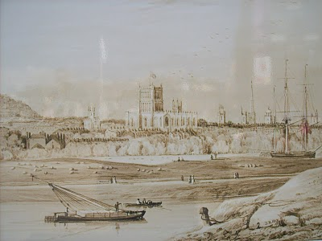
The Boones and thousands of others sailed to Philadelphia, a colony founded by William Penn (below) , an activist in the Society of Friends or Quakers. Penn's fair treatment of Native Americans reduced the threat of frontier warfare, and made settlement in Pennsylvania doubly attractive.
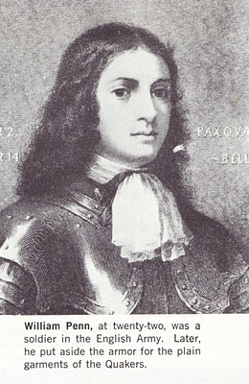
Below the harbour at Philadelphia where the Boone family landed and settled in lands outside of the city in the 1710s. By the early 1710s, Philadelphia was the largest city in the English colonies, and would remain so for another hundred years.
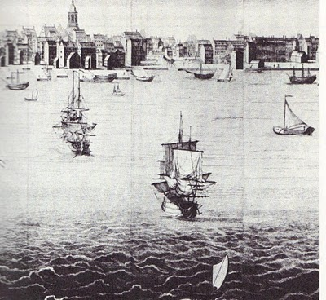George Boone took 400 acres and built a log cabin in Olay, later to be called Exeter, PA. This great grandfather of ours died in 1744 leaving 8 children, 52 grandchildren and 10 great grandchilddren. The offspring were a blend of Engish, German, Welsh and Scotch becoming, well, Americans within a generation.
Next posting, the life of Squire Boone....
POSTED BY GLENN N. HOLLIMAN AT 4:57 PM 0 COMMENTS
LABELS: GEORGE BOONE, SQUIRE BOONE, WILLIAM PENN

7/10/10

We Are Also Boones
By Glenn N. Holliman
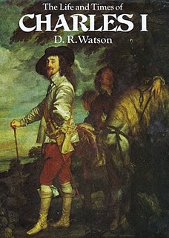
The families of G.W. Osborne and Frankie Wilson Osborne helped settle the Appalachian frontier and defeat the British Armies in the Revolutionary War. In our examination of our pioneer ancestors, I begin with one of our most famous ancestral families, the Boones. Yes, my generation's 6th great uncle was Daniel Boone himself. But let's begin the story in England where we first have information on our earlier grandparents.

In 1636, Charles I (Portrait and book right) was on the throne of England, fighting verbally and, within a decade physically, with his Parliament. England was on the edge of a civil war that would determine whether political power lay with the House of Commons or the Crown. This civil war would be important for the development of representative democracy in the American colonies as well as in England.

In that year in the southwestern part of the country, near Exeter, in a village known as Stoke Canon, one George Boone was born. His parents are unknown according to authorities at the Boone Society. George Boone earned his living as a blacksmith, and died 1696. He and his wife, Sarah Mary Oppy, are buried at St.Magdelene Parish in Stoke Canon.

They married in 1665, and the next year, 1666, a son, anotherGeorge Boone, entered the world.
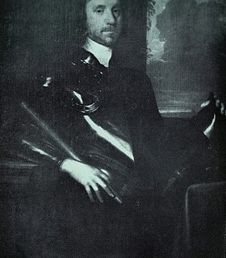

While this second George Boone grew to manhood, England suffered through a violent civil war which resulted inOliver Cromwell(portrait left)ruling England as a Commonwealth without a monarchy throughout the 1650s. With Cromwell's death, England turned again to the Stuart family and invited Charles II to the throne, although with reduced powers. No more Divine Right of Kings even with the Stuart family restoration.

So by the early 1660s, King Charles Stuart II (portrait and book below), the son of the executed Charles I, sat in London's Whitehall Palace on the throne overseeing a growing empire. Virginia, Maryland, Massachusetts, Connecticut, Rhode Island and after the Dutch wars, New York and New Jersey were New World English colonies.

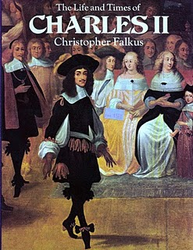
One can be assured the Boones did not dress so fashionably as King Charles II (above) who was popular with the 'ladies'.

In the 1680s, this King Charles II, still paying off political debts for his restoration, deeded a huge chuck of North America to the son of one of his noble friends, William Penn. Penn belonged to a growing Christian sect, the Society of Friends or Quakers as they were called.

Our George Boone, now grown, married and with a growing family, was intrigued by the Friends, who sat patiently in informal worship waiting for an 'Inner Light' before speaking or 'quaking'. No priests or bishops were allowed within this democratic, egalitarian and pacifist denomination whose members refused to doff their hats to anyone.

George, himself a tanner and weaver, married Mary MiltonMogridge, daughter of John Mogridge and Mary Milton. Mary had been born in Bradninch, 8 miles from Exeter in 1669. They raised a large family, and one of the sons was named Squire Boone (b 1696).

George Boone was an ambitious man, and restless in Devonshire. He heard of William Penn's new and successful colony along the Delaware River, a colony where the founding city was named Philadelphia or city of brotherly love. The Quaker, with his growing family, was ready to make the dramatic move to the New World and leave behind his ancestral homeland.

Next post we learn of the trip across the North Atlantic to Pennsylvania and a new life on America's frontiers....
POSTED BY GLENN N. HOLLIMAN AT 4:40 PM 0 COMMENTS
LABELS: CHARLES I, CHARLES II, DANIEL BOONE, GEORGE BOONE, SARAH MARY OPPY, WILLIAM PENN

7/7/10

Photos in the Post WWII Era
by Glenn N. Holliman

Last night, July 6, Rob Adema visited Barb and me here in Newport, PA, as he was en route to business calls in Central Pennsylvania. Rob is a great great grandson of G.W. and Frankie Osborne, through their son, Bascom, a brother of my grandmother, Mayme Osborne Stansbery. Bascom is sometimes spelled with or without a 'b' on the end.
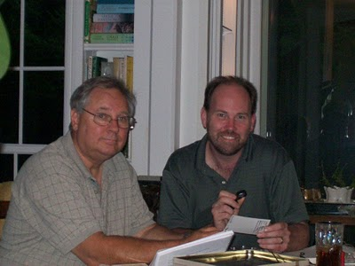Photo above is l to r, Glenn Holliman (b 1946) and Rob Adema (b 1966) July 6, 2010 in Newport, Pennsylvania practisinggenealogy. Glass is of Coca-Cola, sort of. Photo by Barbara Holliman.

We sat up late examining documents and old photographs. In celebration of his visit, I am posting several photos we looked at closely as they reflect both his direct line and our over lapping families. I believe the 1945 photo is courtesy of Phyllis Ackers, and the 1954 picture, a family snapshot by my father.

A contemporary photo of Rob's parents, Bob and Gay, and his Aunt Peg Adema can be found on the Contributors page of this blog. August 20, Barb and I will be visiting Rob and his parents, Bob and Gay, outside of Buffalo, NY to look at more family memorabilia of when our ancestors lived in Southwest Virginia, East Tennessee and Western North Carolina.

Now the Wilson/Osborne frontier families, under many different names, are spread across the nation.
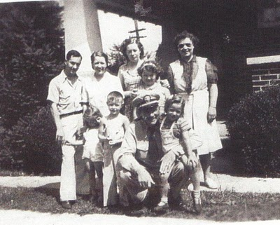
Photo above taken approximately 1945 at the Elmer 'Flea' Akers home in Damascus, Virginia of the children and grandchildren of Bascom Wilson Osborne, one of the five son's of G.W. and Frankie Osborne. Back row, l to r - 'Flea' Akers, Doris Osborne Akers, Gladys Osborne Adema, Edith Osborne (wife of Bascom Kruger Osborne, who is kneeling). Front row, l to r - Phyllis Akers, Bobby Adema, Peg Adema, Uncle 'Bab' Bascom K. Osborne, in Navy uniform, and his daughter, 'Gini' Osborne.
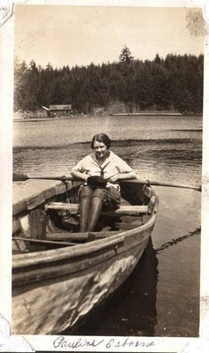Photo of Pauline Osborne Smith, daughter of Thomas 'Toby' Osborne, one of the five sons of G.W. & Frankie, in the early 1930s rowing a boat. In the photo below, she is pictured in the 1950s with her children in a visit to her first cousin, Geraldine Stansbery Holliman Feick.

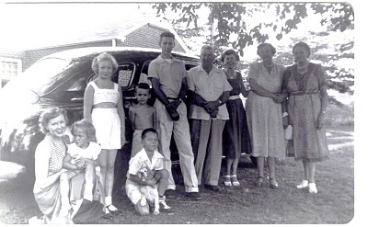Taken in the summer of 1954 in Johnson City, Tennesse at the home of Geraldine Stansbery and her husband, Bishop Holliman. Left to right in front of the 1948 Plymouth are: Louise Stansbery Sherwood (daughter of Mayme Osborne Stansbery), Rebecca Louise Holliman Payne, then 4 years old on her aunt's knee, and standing is one of Pauline Osborne Smith's children, name unknown.
Kneeling with his Cocker Spaniel, Sandy, is the writer, Glenn Holliman, age 7. Behind standing sans shirt is Vance R. Sherwood, Jr., also age 7, now a published clinical psychologist. The tall young man is another of Pauline's children, name unknown.
Continuing left to right are Dave Wright, husband of Pearl Osborne Wright, Geraldine (Gerry) Stansbery, sister of Louise Sherwood, Pauline Osborne Smith (whose photo above is of her rowing a boat), and Pearl Osborne Wright, who is Geraldine and Louise's aunt.

Pauline and children lived in Sumner, Washington at the time. Pearl and David Wright in Damascus, and Louise and her son, Vance, in Knoxville, Tennessee.

An aside, it was Dave Wright who in 1912 gave his mother-in-law, Frankie Osborne, her first automobile ride from Damascus to Glade Valley, Virginia and back!

More family history in the next posting....
POSTED BY GLENN N. HOLLIMAN AT 11:00 AM 0 COMMENTS
LABELS: BOB ADEMA, DAVID WRIGHT, DORIS OSBORNE AKERS, FLEA AKERS,GLADYS OSBORNE ADEMA, JR., LOUISE STANSBERY SHERWOOD, PAULINE OSBORNE, PEARL OSBORNE WRIGHT, PHYLLIS AKERS, REBECCA PAYNE,VANCE SHERWOOD

7/1/10

We Are Also Wilsons
by Glenn N. Holliman
The father of my great grandmother, Frances Wilson Osborne, was Isaac Wilson (1822 - 1864). This note appears in Frankie's Diary, July 23, 1928 after a visit to see relatives in Ashe County, NC.
"Hiram Wilson was a son of John Wilson and John was a son of Charles; he come over in Mayflower from Irland (sp.). My father was Isaac, the son of Hiram."
Since I transcribed the above last year I have thought Frankie accurate about the four fathers. The local Watauga, NC historian John Preston Arthur stated the same in his writings and wrote that Charles Wilson immigrated from Pennsylvania to North Carolina. Another Wilson family from East Tennessee may have come over on the Mayflower but there is no evidence that our branch did so. More investigation is due this matter.

So what do we know about these forefathers of ours? Here's the timeline I have been able to put together from Internet sources and A History of Watauga County, NC, by John Preston Arthur, 1915.
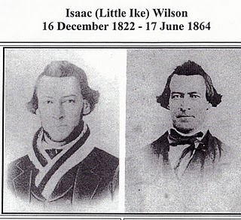
These photos are found on the web site of Johnson County, Tennessee historical society. The left photo is of Isaac Wilson in his 20s in the 1840s, when photographs has just been developed. The one of the right is probably about the time he was murdered in 1864. Notice his hair style has not changed through the decades. Isaac's son, William A. Wilson, the family genealogist and memoir writer, evidently had the original and made copies for his nieces and nephews.
The web site also reveals Isaac was in Company E, 37th Regiment NC Troopers. He was home on leave when bushwhacked by his neighbors the Potters and a Tom Stout, Union sympathisers. W.A. Wilson's story of the episode can be found at the Johnson County Tennessee Genealogy Page on the Internet.
Prior to 1750 - Charles Wilson immigrates from Pennsylvania to North Carolina. We do not know his birthplace or father's name.
1750 - John Wilson was born in North Carolina, and his wife Sara, unknown last name, in 1752, also in NC.
1770 - John Wilson and Sara marry.
1780 - Charles Wilson, according to John Preston Arthur, is killed at the Battle of Guildford Court House during the Revolutionary War, fighting as an officer under General Nathaniel Greene. We have no birth date on Charles, but according to Frankie, he is the father of John Wilson. Local historian, Arthur agrees with Frankie and even argues that Charles Wilson is relative by marriage to the legendary Nathaniel Greene. This writer has researched this and doubts this proposition.
1787, On 11/2/1787 in Rowan, NC, Hiram Wilson is borne, Frankie's grandfather. His wife, Nancy Smith was born about 1786, also in Rowan.
1799 - John Wilson dies.
1812 - Hiram and Nancy Smith Wilson marry on 9/12/1812 in Rowan, NC and settle at Cove Creek in Ashe County, NC in 1815.
1822 - Frankie's father, Isaac Wilson is born 12/16/1822. James Madison is president of the U.S. at this time.
1828 - Caroline Nancy Greer is born 12/10/1828 in Ashe Co.
1849 - Caroline and Isaac Wilson marry 3/25/1849.
1851 - 6/20/1851, Frances Wilson (Osborne) born in Ashe Co., NC.
1864 - 6/17/1864, Isaac Wilson shot from ambush. Frankie's father and two uncles die in Civil War. Hiram is present at his son's funeral and provides assistance to the now widowed Caroline Greer Wilson.
One of the assassins, Thomas Stout, was captured and held overnight in Cove Creek (Ashe County, NC) at Hiram's farm. The next day several relatives and friends recovered Tom Stout and started to Camp Vance in Morgantown, NC with him. Tom Stout never arrived. Several months later a noose was found on Rich Mountain, and after examination the remains of Stout were discovered in a shallow grave. His widow retrieved what was left of Stout and buried him in her family cemetery.
1867 - Frankie marries G.W. Osborne. (These are my generations' great grandparents.)
1879 - Hiram Wilson dies in Watauga Co., NC.
1911 - 8/9/1911, Caroline Greer Wilson dies and is buried in Wilson Cemetery, Oscar Cove, NC.
Next posting, we examine another branch of our Osborne/Wilson family tree....
POSTED BY GLENN N. HOLLIMAN AT 4:33 PM 0 COMMENTS
LABELS: CHARLES WILSON, G.W. OSBORNE, HIRAM WILSON, JOHN WILSON
Newer PostsOlder PostsHome
Subscribe to: Posts (Atom)

PAGES
- Home
- Web Sites and Publications
- Contributers
- Family Lineage

POPULAR POSTS
We Are Also Boones, Part 4
by Glenn N. Holliman ( Source for this posting is largely from In the Footsteps of Daniel Boone by Randell Jones. Photos taken from the wo...
More Adema and Stansbery Photographs, No. 9
by Glenn N. Holliman 2010 Rob Adema took this photograph of his parents, Gay and Bob Adema along with yours truly (far left) at their s...
We Are Also Wilcoxsons - Part III
by Glenn N. Holliman The Wilcoxsons and Boones, 18th Century Pioneers in Central North Carolina and Kentucky Sources include www.planetmur...
Frances Wilson Osborne with daughter, Mayme Osborne Stansbery and granddaughter Louise Stansbery Sherwood

LABELS
Abraham Lincoln Ada Osborne Anne TaylorArthur Taylor Arthur Taylor Caroline Greer Wilson Ashe County Bascom K. Osborne Bascom Wilson OsborneBenjamin Greer Benjamin Greer; Jesse Greer Bishop L. Osborne Bob Adema Capt. Jesse Greer Caroline Greer Wilson; Isaac Wilson Charles I Charles IICharles Stansbery Charles WilsonChristopher Holliman Cloe Jones GreerDamascus Daniel Boone Daniel Wilcoxson David Wright Don FeickDoris Osborne Akers Eddie C. Osborne Edward Morgan Elizabeth PowellElizabeth Wilcoxson Cutbirth Flea AkersFrances Wilson Osborne Frazier KingG.W. Osborne Gayle Adema George BooneGeorge Washington Osborne George Wilcoxson Geraldine Stansbery Holliman Feick Gladys Osborne Adema Glenn HollimanHiram Wilson Howard Adema Hugh II James Grantson Holliman James GreerJames Grier Jesse Boone Wilcoxson John Greer John Taylor John Wilcoxson John Wilson Jonathan Murphy Joppa Jr. Jr. Sarah Day Greer Leroy Osborne Louise Stansbery Sherwood Luke Stansbery Margaret Hill Taylor Margaret Phinney Taylor Marion Lee Osborne Mary Brown Mayme Osborne Stansbery Nancy Lowe Walker Nancy Wilcoxson Greer Nicholas Day Nicholas Maxwell Pauline Osborne Pearl Osborne Wright Peggy Noeltner Phyllis AkersRachel Bryan Rachel Wilcoxson BryanRebecca Payne Rob Adema; Peggy Noeltner Rob Adema; Phyllis Akers Sarah Anne Elliott Sarah Boone Sarah Boone Wilcoxson Sarah Cox Sarah Day Sarah Day Greer Sarah Lowe Day Sarah Mary Oppy Sarah Morgan Sarah Morgan BooneSean Murphy Sir James Grier Squire Boone Sr Sr. Sr. Nicholas Day Sr.; Nancy Boone Wilcoxson The Rev. William A. WilsonToby Osborne Tom Adema Vance SherwoodVirginia Osborne Vivian Randall OsborneWilliam Grierson William Penn

BLOG ARCHIVE

6/30/10

The Parents of Frances Wilson Osborne
Troubled Times
by Glenn N. Holliman
Photographed below are Caroline Greer Wilson (1828 - 1911) and her husband, Isaac Wilson (1822 - 1864), the parents of Frankie Wilson Osborne. The couple married in Ashe Co., NC in 1849.
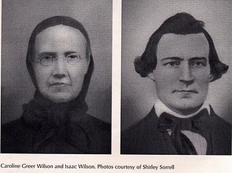Isaac Wilson was a successful trader and farmer, owning several hundred acres of timber, pasture and cultivated fields nestled along the Tennessee and North Carolina borders. The elevation of the farm is over 3,000 feet and surrounded by tall mountains. When the Civil War broke out in Ashe County, North Carolina, he sided with the South and became a lieutenant in the Confederate Army. At this writing we know little of his service record.
In the early 1860s law and order broke down in an Appalachian society where cousin fought cousin. Ironically, the Wilsons owned no slaves although Caroline was a fierce Confederate.
The disorder of the times resulted in a type of guerrilla warfare, neighbor against neighbor. On June 16, 1864, my great-great grandfather became a victim when several of his neighbors shot him from ambush in the back while he was plowing his corn field. He died within a few hours. A vicious circle of revenge began that produced additional widows. It was an ugly time, and many years were needed for passions to subside.
My great-grandmother, who was with her father when the shooting occurred, told the story to my mother, Geraldine Stansbery Holliman Feick, who shared it with me when I was growing up in the 1950s. Only in the first decade of the 21st century did I discover this story on the internet and the book,Neighbor to Neighbor by my great-great uncle William A. Wilson.
Isaac's wife, Caroline, was 36 years old and left with 8 children, all 14 or younger. With help from family and children, she harvested the corn crop that summer and many seasons thereafter. On several occasions in 1864 her home was invaded and ransacked by Union sympathizers. Once she encountered Federal cavalry who were ready to confiscate her horse, when a cousin in the Union patrol vouched for her. She escaped without injury and with her animal.
Obviously, a strong and vibrant woman, she lived until 1911, dying from complications of a broken hip. She and her husband are buried in Wilson Cemetery in Oscar Wilson Cove near Sutherland, North Carolina in Ashe County.
In 2009, my mother, my sister Rebecca Holliman Payne and nephew Sean Murphy visited the cemetery. At the entrance to the Cove is a general store kept by some distant cousins, the Boyds, descendants of the Wilsons. The younger Boyd told us of how Caroline hid the family pewter in a hole in the nearby creek to keep the valuables from the Union Army. Such is our family story....
Next posting, more tales of our Wilson/Osborne ancestors....
POSTED BY GLENN N. HOLLIMAN AT 9:00 AM 0 COMMENTS
LABELS: CAROLINE GREER WILSON; ISAAC WILSON, GERALDINE STANSBERY HOLLIMAN FEICK, REBECCA PAYNE, SEAN MURPHY

6/25/10

A Book About Our Family
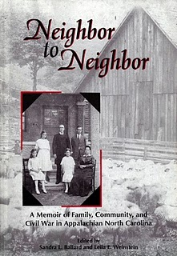by Glenn N. Holliman
In 2007, The Center for Appalachian studies at Appalachian State University in Boonesboro, North Carolina (a town named after one of our ancestors) published an 180 page book entitledNeighbor to Neighbor. The volume is about the family of Frances Wilson Osborne, my generation's great grandmother. Edited by Sandra L. Ballard and Leila E. Weinstein, most of the paper back is a memoir by my generation's great, great uncle The Rev. William A. Wilson (1861 - 1951). His photo (right) and family are on the cover.
Born in Wilson Cove, near Sutherland, Ashe County, North Carolina, William was the last of eight children born to Isaac Wilson and Caroline Greer Wilson. He was the best educated of the children, having graduated from Trinity College (now known as Duke). Raised a Southern Methodist, he was ordained a pastor in that denomination.
In 1890, he accepted a call as a missionary to Japan, and spent the next forty one years mainly in the Hiroshima district. Every ten years he was granted a paid furlough. In his first decade in Japan, he met and married Mary Amelia McClellan, another Southern Methodist missionary. They were to have four children.
In the work Neighbor to Neighbor, Will shares his memories of growing up in the Western North Carolina mountains near Boone, NC to the south east, and Mountain City, Tennessee to the west. He collected stories and tales from his mother and siblings, and in his old age gathered them up in a memoir that remained unpublished in book format until recently.
Of particular interest is the story of the 'bush whacking' and murder of my generation's great, great grand father, Confederate Lt. Isaac Wilson in June 1864 while he was plowing his corn. My generation's great grandmother, Frankie Wilson Osborne, was with him when bullets fired from ambush took his life. Great great grandfather Isaac is buried in the Wilson Cemetery in Oscar Wilson Cove. His son, the Rev. William A. Wilson, the author of the poignant memoir, lies near him.
Neighbor to Neighbor can be ordered from the Appalachian State University bookshop. If they are out of the work, please contact Sandra Ballard, editor of the Appalachian Journal. The volume contains several photographs of Frankie Wilson Osborne and information on both her and G.W. Osborne, Jr., her husband and my great grandfather.
Will tells a story of an America that my grandchildren would not recognize. If you want your children to understand the violence and tragedy of the Civil War, have them read this book. Our immediate ancestors lived and suffered in a manner we can scarce imagine in the 21st century.
Next post, more on our Appalachian Mountain roots....
POSTED BY GLENN N. HOLLIMAN AT 10:06 PM 0 COMMENTS
LABELS: ASHE COUNTY, CAROLINE GREER WILSON; ISAAC WILSON, THE REV. WILLIAM A. WILSON

6/20/10

Short Biographies of the Children of Frankie and G.W. Osborne
by Glenn N. Holliman
Seven children of my great grand parents grew to maturity. Two died in infancy. Although G.W. and Frankie were married in 1867, Frankie did not give birth until 1874. Perhaps there were medical complications. Once the first child was born, many more came until 1893, when Frankie was 42 years old. The information below was drawn from Frankie Osborne diaries.
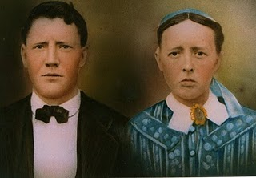This photograph of G.W. and Frances Wilson Osborne is believed to have been taken about the time of their wedding in 1867. Obviously it has been colored. Did they travel to Boone, North Carolina to have their photo taken, the nearest town large enough to have had a professional photographer? Photo courtesy of cousin Phyllis.
As I read over the names below, I am disappointed we know so little of the uncles, not even the dates when several of them died. (More research will reveal these dates.) We know considerable about the descendants of the two daughters as the Stansbery/Holliman families are in touch with the Aker/Adema families, sharing information.
Any information relatives have is welcome. I hope later to do pieces on each uncle and aunt below, and of course their descendants, the many of you who receive this blog. Any corrections or additions encouraged.
Marion Lee Osborne- D August 31, 1874, age six days, Frankie printed a remembrance of this infant sixty years later. Marion is probably buried in Wilson Cemetery, Oscar Wilson Cove Road, Ashe Co., North Carolina.
Toby Miles Osborne - B January 26, 1876 - D?. Moved from Bristol, Tennessee to Sumner, Washington in early 1920s. It is believed he was in the automobile business. His children were Eddie Lawrence Osborne, Russell Miller Osborne and Pauline Osborne Smith. Pauline, a favorite grand daughter of Frankie, married Bennett Winston Smith. By the late 1930s, they had a son 'Bennie'. Toby's first wife, Alta died August 18, 1933. Toby remarried but her name is not known.
Leroy Milburn Osborne - B February 17, 1879 - D?. In the 1910s, Roy lived in Cleveland, Tennessee. In 1936, his address was 1016 16th Street. It is believed he was a farmer. His wife was Lena (B September 17, 1899). They had four children: Ralph Summers Osborne, Albert Leslie Osborne, Robert Lafayette Osborne and Lucille Osborne.
Bishop L. Osborne - B December 13, 1881 in Ashe County, North Carolina - D June 1965 in Bristol, Tennessee. Bishop was a multi-talented man. He worked as an accountant at King's Department Store, but also wrote and published poetry and columns for the local newspaper. This writer has in his possession a collection of his poems given to me by my mother, which reflect Bishop's patriotic and religious beliefs. His wife was Cora E.Broyles Osborne. Due to a cleft foot, she always wore long dresses. They had one son, now deceased, Vivian Randall Osborne. All are buried in the family plot at East Hill Cemetery in Bristol.
Eddie C. Osborne - B April 25, 1885 D August 29, 1886, age 1 year and 4 months, 4 days. (From a printed remembrance) Probably buried in Wilson Cemetery in Ashe Co., NC.
Bascom Wilson Osborne - B July 5, 1887 - D August 1970) In the 1910s, lived in Baltimore, Maryland and after the early death of his first wife, Dora Catherine Kruger (age 33, buried WoodlawnCemetery, Baltimore, MD), relocated to Louisville and thenOwensboro, Kentucky. He worked for Brodie Motor Company, a Dodge dealership. His second wife's name was Ada. They lived in 1936 at 730 Walnut Street, Owensboro, KY.
Bascom had three children by his first wife: Bascom K. Osborne, Doris Ethel Osborne Akers and Gladys Pearl Osborne Adema. Broken emotionally by Dora's sudden death, the three children went to live with their Aunt Pearl Osborne and her husband David Wright in Damascus, Virginia in 1922. Pearl and David raised the children.
- Bascom K. Osborne - B 1910 - D 1977. Joined the U.S. Navy in 1927 as an enlisted man, served in the Pacific during World War II and retired a high ranking officer.
- Doris Osborne married 'Flea' Akers. They had a daughter Phyllis and a son Michael Akers.
- Gladys Osborne married Howard Adema from Buffalo, NY and in 1938 lived at 39 W. Balcom Street. A daughter, Peggy AdemaNoeltner and a son, Bob Adema live in Florida.
William (Bill) Vestal Osborne - B July 22, 1892 - D?. Lived at 1634 7th Avenue, Los Angeles, California in 1938. He was the used car manager of a Ford dealership, Pico Motors in L.A. His wife, whom he married in 1920 was Kathern Rader. They had one daughter, Margaret Shields, whose nickname was 'Willy". There is information the family resided in Bristol, Tennessee until moving west in the early 1920s.
Pearl Osborne Wright - B March 1, 1890 in Mast, North Carolina and D August 20, 1980 in Damascus, Virginia. She married her husband Robert David Wright on December 20, 1911. While they had no children themselves, they raised Bascom's three children. David ran the local electric company, a new high tech industry.
Mayme Osborne Stansbery - B January 16, 1896 - D December 3, 1943. She married Charles S. Stansbery of Afton, Tennessee on April 29, 1914. They had three children: Louise StansberySherwood, Charles S. Stansbery, Jr. and Geraldine StansberyHolliman Feick. Charles S. Stansbery Sr. ran the repair department of the Bristol Ford dealership in the 1920s.
Two Observations
Two, if not three of the sons, went into the automobile industry, taking jobs in the transportation revolution that occurred during their life times. Of the two son-in-laws, one directed a local electric company and another repaired Fords. When these uncles were born these occupations did not exist! This was a time of rapid economic change moving from the muscle power of horses and mules to automobiles and tractors.
Of the five sons, three moved from upper East Tennessee, the historical homeland (along with Western North Carolina and Southwest Virginia for 150 years). Bill to California, Toby to Washington state and Bascom, first to Baltimore and then Kentucky. Roy stayed in East Tennessee but moved to Cleveland, near Chattanooga. While Pearl and Mayme married locally and stayed in the area, the sons were part of the Osborne diaspora. Bishop Osborne was the only son to remain in Bristol, Tennessee.
Next posting, we will explore further the lives of G. W. and Frances Wilson Osborne.
POSTED BY GLENN N. HOLLIMAN AT 11:50 AM 0 COMMENTS
LABELS: BASCOM K. OSBORNE, BASCOM WILSON OSBORNE, BISHOP L. OSBORNE, DORIS OSBORNE AKERS, EDDIE C. OSBORNE, GLADYS OSBORNE ADEMA, LEROY OSBORNE, MARION LEE OSBORNE, TOBY OSBORNE, VIVIAN RANDALL OSBORNE

6/17/10

Reaching Out to Many Branches of the Osborne/Wilson Tree
by Glenn N. Holliman
Those of you reading this posting are descendants of Frances Wilson Osborne (1851 - 1940) and George Washington Osborne, Jr. (1846 - 1927). The ancestors of this couple braved the North Atlantic to come to the New World. Some of these persons, our great grandparents, uncles and aunts, became the most famous frontier men and women in American history. Many were pioneers who fought Native Americans, later the British and Tories, and finally each other in a Civil War that took the lives of many of our direct ancestors.
The descendants and ancestors of this couple go by the names of Osborne, Wilson, Greer, Wilcoxson, Brown, Boone, Morris, Wright, Adema, Noeltner, Aker, Sherwood, MacKenzie, Hayes, Holliman, Stansbery, Payne, Murphy, Hensley and Jahn. No doubt more can be added.
By using this blog site articles and photos can be archived and available to all family members. Your comments, articles, family trees, corrections, photographs, diaries and old letters are most welcome. In this format I, you and loved ones can hand off our family stories to the future. I invite all to join. My email address is Glennholliman@Embarqmail.com.
Frankie Osborne, as my generation's great grandmother is known, was born deep in the Appalachian Mountains of Ashe County, North Carolina. Millard Fillmore was president of the United States when she entered this world, and Franklin D. Roosevelt when she died. She lived through and during four major wars including the one that most affected her life, the American Civil War (1861-1865).
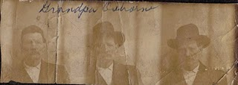
This triple photo display of George Washington Osborne, Jr is in an album passed down from Mayme Osborne (one of G.W.'s two daughters) to Louise Stansbery Sherwood and her sister, Geraldine Stansbery Holliman Feick. G.W. appears to be in his 50s which would date these pictures in the 1890s.
Frankie's father and several cousins died in that war, and her husband to be, George Washington Osborne, Jr. was wounded twice. If G.W. (as he was known) had not encountered a nasty knife thrust into his side from a Union sympathizer, he and Frankie might not have met and married. She was 14 when G.W. came to her house, deep in Wilson Cove near Trade, Tennessee, to recuperate from his injury.
Frankie nursed the 19 year old G.W., and in January 1867, when she was all of 15 1/2 years, they married. That marriage lasted until G.W.'s death in June 1927 in Bristol, Tennessee. Six sons and two daughters grew to maturity from this couple.
In our next posting, we will begin to explore the lives of G.W. and Frankie and their children.
POSTED BY GLENN N. HOLLIMAN AT 2:59 PM 0 COMMENTS
LABELS: FRANCES WILSON OSBORNE, GEORGE WASHINGTON OSBORNE,GERALDINE STANSBERY HOLLIMAN FEICK, JR., LOUISE STANSBERY SHERWOOD, MAYME OSBORNE STANSBERY, PEARL OSBORNE WRIGHT
Home
Subscribe to: Posts (Atom)

PAGES
- Home
- Web Sites and Publications
- Contributers
- Family Lineage

POPULAR POSTS
We Are Also Boones, Part 4
by Glenn N. Holliman ( Source for this posting is largely from In the Footsteps of Daniel Boone by Randell Jones. Photos taken from the wo...
More Adema and Stansbery Photographs, No. 9
by Glenn N. Holliman 2010 Rob Adema took this photograph of his parents, Gay and Bob Adema along with yours truly (far left) at their s...
We Are Also Wilcoxsons - Part III
by Glenn N. Holliman The Wilcoxsons and Boones, 18th Century Pioneers in Central North Carolina and Kentucky Sources include www.planetmur...
Frances Wilson Osborne with daughter, Mayme Osborne Stansbery and granddaughter Louise Stansbery Sherwood

LABELS
Abraham Lincoln Ada Osborne Anne TaylorArthur Taylor Arthur Taylor Caroline Greer Wilson Ashe County Bascom K. Osborne Bascom Wilson OsborneBenjamin Greer Benjamin Greer; Jesse Greer Bishop L. Osborne Bob Adema Capt. Jesse Greer Caroline Greer Wilson; Isaac Wilson Charles I Charles IICharles Stansbery Charles WilsonChristopher Holliman Cloe Jones GreerDamascus Daniel Boone Daniel Wilcoxson David Wright Don FeickDoris Osborne Akers Eddie C. Osborne Edward Morgan Elizabeth PowellElizabeth Wilcoxson Cutbirth Flea AkersFrances Wilson Osborne Frazier KingG.W. Osborne Gayle Adema George BooneGeorge Washington Osborne George Wilcoxson Geraldine Stansbery Holliman Feick Gladys Osborne Adema Glenn HollimanHiram Wilson Howard Adema Hugh II James Grantson Holliman James GreerJames Grier Jesse Boone Wilcoxson John Greer John Taylor John Wilcoxson John Wilson Jonathan Murphy Joppa Jr. Jr. Sarah Day Greer Leroy Osborne Louise Stansbery Sherwood Luke Stansbery Margaret Hill Taylor Margaret Phinney Taylor Marion Lee Osborne Mary Brown Mayme Osborne Stansbery Nancy Lowe Walker Nancy Wilcoxson Greer Nicholas Day Nicholas Maxwell Pauline Osborne Pearl Osborne Wright Peggy Noeltner Phyllis AkersRachel Bryan Rachel Wilcoxson BryanRebecca Payne Rob Adema; Peggy Noeltner Rob Adema; Phyllis Akers Sarah Anne Elliott Sarah Boone Sarah Boone Wilcoxson Sarah Cox Sarah Day Sarah Day Greer Sarah Lowe Day Sarah Mary Oppy Sarah Morgan Sarah Morgan BooneSean Murphy Sir James Grier Squire Boone Sr Sr. Sr. Nicholas Day Sr.; Nancy Boone Wilcoxson The Rev. William A. WilsonToby Osborne Tom Adema Vance SherwoodVirginia Osborne Vivian Randall OsborneWilliam Grierson William Penn

BLOG ARCHIVE

3/24/11

When We Were Greers, Part XVI
by Glenn N. Holliman
Rallying the Troops at Alexander's Fork on the Green River
Near Gilbert Town, North Carolina the Over the Mountain men and other regional militias gathered on October 3, 1780 and prepared to continue their march toward the forces of Major Patrick Ferguson, commander of British troops in the area. Ferguson had pledged to bring fire and sword to the Anglo-frontier in the Appalachian Mountains. Enraged, Patriot militia prepared to fight back. Others joined them.
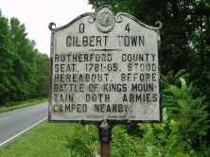
The morning of October 3, 1780, reinforced by troops from South Carolina and Georgia, Col. John Sevier assembled the troops for a meeting. Gathering the rugged, buck skinned men in a circle,Capt. Benjamin Greer's commander and neighbor, Col. Benjamin Cleveland of Wilkes County, North Carolina, spoke first. Cleveland at the time was already up to 250 pounds, round in shape and in his early 40s. A jovial man and one with a large appetite he is reported to have weighted 450 pounds at his death (probably a sudden heart attack at age 69 while eating). He was known by his men as Old Roundabout. Cleveland, for whom Cleveland, Tennessee and Cleveland County, South Carolina are named, adopted the personal soubriquet as his plantation's name in Wilkes County.
Like, my fifth great grandfather Greer, Cleveland had endured a summer of fighting the Cherokee, and probably felt fatigue. However, he rose to the occasion and told those assembled they had a priceless opportunity to serve their country, and to leave a rich heritage to their children. He further spoke words offering men a way out if they feared to go further.
Col. Shelby then proposed that those who desired to leave to step three paces to the rear. No one did. A murmur of applause rose from the hundreds of men, proud of what they were doing. Shelby advised that in soon meeting the foe they were to advance Indian style, hiding behind trees and rocks, killing and disabling all one could.
The troops were then dismissed to prepare several meals and for a march. Colonels Cleveland and McDowell found some whiskey and shared it amongst the men.
Major Patrick Ferguson, commander of British forces, knew of this large group of Patriot militia. Fearing to be outnumbered, Ferguson set up a defensive perimeter in rugged terrain just over the North Carolina border in South Carolina.
The scene and words quoted above are from the book (see below) by Pat Alderman, published, of course, by the Overmountain Press, Johnson City, Tennessee. I found this copy in December 2010 at the Historical Center in Jonesborough, Tennessee. If a visitor there, do drop in and tour the Center and its adjacent museum.
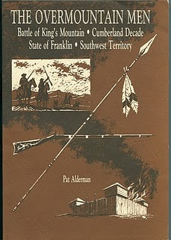
The stage was set for the Battle of King's Mountain....
POSTED BY GLENN N. HOLLIMAN AT 7:42 AM 0 COMMENTS
LABELS: BENJAMIN GREER

3/10/11

When We Were Greers, Part XV
by Glenn N. Holliman

The Battle of Kings Mountain,
a Major Turning Point in the American Revolution
The Carolinas were in an uproar in 1780 as the British rolled up patriot militias in South Carolina and destroyed a Continental Army and it's commander General Gates at Camden. Irregular patriots - Francis Marion and Thomas Sumpter - led guerrilla bands to challenge the resupply trains of the Crown. British Lt. General Earl Cornwallis's subordinates Tarelton and Fergueson were heavy handed in suppressing the rebellion - taking few prisoners. Major Ferguson enraged the frontier settlers, especially the "Watauga" mountain men when he threatened to burn all homes and farms if they gave opposition to the British forces.
The American "Over the Mountain Men" took the threats personally and mobilized their militia at Sycamore Shoals (now Elizabethton, Tennessee) and under Colonels Isaac Shelby and John Sevier poured through the gaps in the Appalachian mountains. In Wilkes County, nestled against the Tennessee line, one Colonel Ben Cleveland, a rotund and tough leader, called out the local militia yet again that summer. Captain Benjamin Greer, serving under Cleveland, and his soldiers mustered quickly and joined in the march that was to become on October 7, 1780 - the Battle of Kings Mountain!
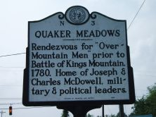
On September 30, 1780, Greer and the North Carolinians rendezvoused with Shelby and Sevier at Quaker Meadows in what is now Morganton, North Carolina . These combined forces, joined by other militia including at least one Osborne relative of my family, began marching south where waited Major Patrick Ferguson and some 1,000 or so Tories and Americans who served in the British Army.
If Ferguson could destroy the militia army, Georgia and the Carolinas would remain in British hands. If not Cornwallis and his regulars would be isolated, surrounded by an increasing hostile population. The Crown would be lost to the South, and quite possibly, finally, the multi-year attempt to quash the American rebellion. Much depended on the coming fight.
By October 3, 1780, the combined militia forces had advanced to Bedford Town, North Carolina where the patriot colonels believed Ferguson might be in waiting. It was time to call the men to order and confront them with the reality of the coming fight.
Next, the Rally before Battle

POSTED BY GLENN N. HOLLIMAN AT 1:29 AM 0 COMMENTS
LABELS: BENJAMIN GREER
Newer PostsOlder PostsHome
Subscribe to: Posts (Atom)

PAGES
- Home
- Web Sites and Publications
- Contributers
- Family Lineage

POPULAR POSTS
We Are Also Boones, Part 4
by Glenn N. Holliman ( Source for this posting is largely from In the Footsteps of Daniel Boone by Randell Jones. Photos taken from the wo...
More Adema and Stansbery Photographs, No. 9
by Glenn N. Holliman 2010 Rob Adema took this photograph of his parents, Gay and Bob Adema along with yours truly (far left) at their s...
We Are Also Wilcoxsons - Part III
by Glenn N. Holliman The Wilcoxsons and Boones, 18th Century Pioneers in Central North Carolina and Kentucky Sources include www.planetmur...
Frances Wilson Osborne with daughter, Mayme Osborne Stansbery and granddaughter Louise Stansbery Sherwood

LABELS
Abraham Lincoln Ada Osborne Anne TaylorArthur Taylor Arthur Taylor Caroline Greer Wilson Ashe County Bascom K. Osborne Bascom Wilson OsborneBenjamin Greer Benjamin Greer; Jesse Greer Bishop L. Osborne Bob Adema Capt. Jesse Greer Caroline Greer Wilson; Isaac Wilson Charles I Charles IICharles Stansbery Charles WilsonChristopher Holliman Cloe Jones GreerDamascus Daniel Boone Daniel Wilcoxson David Wright Don FeickDoris Osborne Akers Eddie C. Osborne Edward Morgan Elizabeth PowellElizabeth Wilcoxson Cutbirth Flea AkersFrances Wilson Osborne Frazier KingG.W. Osborne Gayle Adema George BooneGeorge Washington Osborne George Wilcoxson Geraldine Stansbery Holliman Feick Gladys Osborne Adema Glenn HollimanHiram Wilson Howard Adema Hugh II James Grantson Holliman James GreerJames Grier Jesse Boone Wilcoxson John Greer John Taylor John Wilcoxson John Wilson Jonathan Murphy Joppa Jr. Jr. Sarah Day Greer Leroy Osborne Louise Stansbery Sherwood Luke Stansbery Margaret Hill Taylor Margaret Phinney Taylor Marion Lee Osborne Mary Brown Mayme Osborne Stansbery Nancy Lowe Walker Nancy Wilcoxson Greer Nicholas Day Nicholas Maxwell Pauline Osborne Pearl Osborne Wright Peggy Noeltner Phyllis AkersRachel Bryan Rachel Wilcoxson BryanRebecca Payne Rob Adema; Peggy Noeltner Rob Adema; Phyllis Akers Sarah Anne Elliott Sarah Boone Sarah Boone Wilcoxson Sarah Cox Sarah Day Sarah Day Greer Sarah Lowe Day Sarah Mary Oppy Sarah Morgan Sarah Morgan BooneSean Murphy Sir James Grier Squire Boone Sr Sr. Sr. Nicholas Day Sr.; Nancy Boone Wilcoxson The Rev. William A. WilsonToby Osborne Tom Adema Vance SherwoodVirginia Osborne Vivian Randall OsborneWilliam Grierson William Penn

BLOG ARCHIVE

5/7/11

When We Were Greers, Part XIX
by Glenn N. Holliman
Capt. Benjamin Greer Saves Col. Benjamin Cleveland from a Tory Patrol!
During the years 1775 to 1781, not all Americans were in revolt against Great Britain. Those who remained faithful to the Crown were called Tories, and they numbered perhaps 1/3rd of the colonial population. In the frontier mountains of Western North Carolina, Southwest Virginia and the new land of Kentucky, law and order suffered, and numerous families grouped together according to their loyalties.
With the Patriot victory at King's Mountain and the gradual weakening of Lord Cornwallis's regular British Army, the tide of success began to move quickly away from Tory sympathizers. However, notorious quasi-outlaw Tory bands still roamed the highlands of the Carolinas. One group was led by William Riddle, and in the spring of 1781, he and his men kidnapped one of the heroes of King's Mountain, Col. Benjamin Cleveland, Capt. Benjamin Greer's commanding officer.
In addition to leading men to victory at King's Mountain and against Cherokee Indians, Cleveland had executed several Tories, without benefit of trial. That was a controversial act even for the frontier, and Cleveland only by a slim margin dodged imprisonment or worse. Revenge of a sort came when Riddle and his men captured Cleveland. An alarm went up over the mountains of Wilkes County, now Watauga County, North Carolina. Among those who rushed to Cleveland's aid was our ancestor, Benjamin Greer.
Below a 19th Century photo of the mountain terrain where Benjamin Greer rescued Benjamin Cleveland, and according to one source, dispatched the Tory Riddle to his glory!
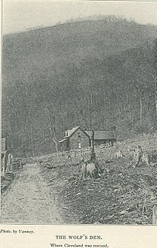
John Preston Arthur in his 1915 work A History of Watauga County recounts that on April 22, 1781, Riddle and a gang of six to eight men bodily snatched Cleveland from a neighbor's home. In pursuit, Ben Greer and a few associates, including one Samuel McQueen who had fought with Greer in East Tennessee against Indians the year before, ambushed Riddle at the mouth of Elk Creek at a fork on the New River in what is now Watauga County. At the Wolf's Den, Benjamin Greer is alleged to have shot and killed Riddle.
Another tale (and the one officially recognized by Wilkes County historians) is that a wounded Riddle was transported to what is now Wilkesboro, North Carolina and was hung with several others. The 'hanging' oak stood for years, and today, a plaque recognizes the spot.
My generation's 5th great grandfather experienced one adventuresome year from the summer of 1780 to the spring of 1781. Later that October, Cornwallis surrendered to George Washington at Yorktown, Virginia, and the frontier people settled down to have an abundance of babies. Benjamin Greer's life has another tale to tell before we bid him adieu.
Next post, Ben Greer and the Baptist Church....
POSTED BY GLENN N. HOLLIMAN AT 4:59 AM 0 COMMENTS
LABELS: BENJAMIN GREER
Newer PostsOlder PostsHome
Subscribe to: Posts (Atom)

PAGES
- Home
- Web Sites and Publications
- Contributers
- Family Lineage

POPULAR POSTS
We Are Also Boones, Part 4
by Glenn N. Holliman ( Source for this posting is largely from In the Footsteps of Daniel Boone by Randell Jones. Photos taken from the wo...
More Adema and Stansbery Photographs, No. 9
by Glenn N. Holliman 2010 Rob Adema took this photograph of his parents, Gay and Bob Adema along with yours truly (far left) at their s...
We Are Also Wilcoxsons - Part III
by Glenn N. Holliman The Wilcoxsons and Boones, 18th Century Pioneers in Central North Carolina and Kentucky Sources include www.planetmur...
Frances Wilson Osborne with daughter, Mayme Osborne Stansbery and granddaughter Louise Stansbery Sherwood

LABELS
Abraham Lincoln Ada Osborne Anne TaylorArthur Taylor Arthur Taylor Caroline Greer Wilson Ashe County Bascom K. Osborne Bascom Wilson OsborneBenjamin Greer Benjamin Greer; Jesse Greer Bishop L. Osborne Bob Adema Capt. Jesse Greer Caroline Greer Wilson; Isaac Wilson Charles I Charles IICharles Stansbery Charles WilsonChristopher Holliman Cloe Jones GreerDamascus Daniel Boone Daniel Wilcoxson David Wright Don FeickDoris Osborne Akers Eddie C. Osborne Edward Morgan Elizabeth PowellElizabeth Wilcoxson Cutbirth Flea AkersFrances Wilson Osborne Frazier KingG.W. Osborne Gayle Adema George BooneGeorge Washington Osborne George Wilcoxson Geraldine Stansbery Holliman Feick Gladys Osborne Adema Glenn HollimanHiram Wilson Howard Adema Hugh II James Grantson Holliman James GreerJames Grier Jesse Boone Wilcoxson John Greer John Taylor John Wilcoxson John Wilson Jonathan Murphy Joppa Jr. Jr. Sarah Day Greer Leroy Osborne Louise Stansbery Sherwood Luke Stansbery Margaret Hill Taylor Margaret Phinney Taylor Marion Lee Osborne Mary Brown Mayme Osborne Stansbery Nancy Lowe Walker Nancy Wilcoxson Greer Nicholas Day Nicholas Maxwell Pauline Osborne Pearl Osborne Wright Peggy Noeltner Phyllis AkersRachel Bryan Rachel Wilcoxson BryanRebecca Payne Rob Adema; Peggy Noeltner Rob Adema; Phyllis Akers Sarah Anne Elliott Sarah Boone Sarah Boone Wilcoxson Sarah Cox Sarah Day Sarah Day Greer Sarah Lowe Day Sarah Mary Oppy Sarah Morgan Sarah Morgan BooneSean Murphy Sir James Grier Squire Boone Sr Sr. Sr. Nicholas Day Sr.; Nancy Boone Wilcoxson The Rev. William A. WilsonToby Osborne Tom Adema Vance SherwoodVirginia Osborne Vivian Randall OsborneWilliam Grierson William Penn

BLOG ARCHIVE

11/25/10

When We Were Greers, Part V
by Glenn N. Holliman
More on our Day and Taylor Ancestors along the Chesapeake Bay
By the early 1700s Joppa Town was a major seaport on the Atlantic Coast. German settlers in Pennsylvania and the Scot Irish, who were filling the interior of Pennsylvania and Maryland, 'rolled' hogsheads of tobacco to the dozens of wharfs at Joppa. Below is an engraving from the Valentine Museum in Richmond, Virginia showing how Chesapeake planters moved their precious goods to port. The road from York, Pennsylvania to Joppa, Maryland was known as a 'rolling road'.
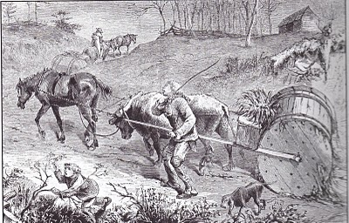
In 1724, a new town of Joppa was laid out on Taylor's Choice, in all probability part of our 9th great grandfather's Arthur Taylor's Choice (300 acres at least from the 1680s). In the photograph below ,is the historical marker with the 1960s Episcopal Church of the Resurrection in the background. In 1724, St. Johns Parish moved from Edgemore to Joppa on this site.
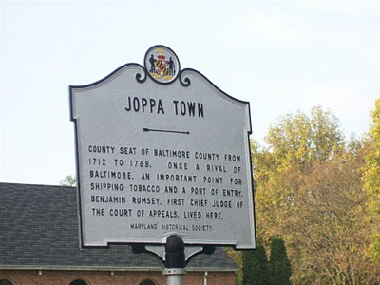
What do we know of our Taylor ancestors?
My generation's 8th great grandmother (8 GGM) was Anne Taylor b 1660 and married November 2, 1675 at the age of 15 to fifty year old James Greer (8th GGF) in Baltimore. Hmmm...a marriage for whose convenience? Our Anne died May 13, 1716 in Baltimore. One of their children would be John Greer, my 7th GGF.

Ann was the daughter of Arthur and Margaret Hill Taylor (9th GGPs). Margaret, our 9th GGM, has no accurate dates that I have found. Arthur was born in 1648, a bit before his parents, Johnand Margaret Phinney Taylor (10th GGPs) were married August 28, 1649 at St. Mary's Church, Lichfield, Stafford, England. John (10th GGF) was born 1629 and died 1675 in Baltimore.

Arthur, a successful planter, died November 1728.

More on the Greers and adjacent families in the next posting....
POSTED BY GLENN N. HOLLIMAN AT 3:00 PM 0 COMMENTS
LABELS: ANNE TAYLOR, ARTHUR TAYLOR, JAMES GREER, JOHN TAYLOR,MARGARET HILL TAYLOR, MARGARET PHINNEY TAYLOR

11/17/10

When We Were Greers, Part IV
by Glenn N. Holliman

In the early 1700s, our Ancestors Prospered along the Gunpowder River
Much of this article is from Maryland's Early Settlers Book, No. 18 under James Greer. On the Family Lineage
page, one will find new family trees under Greer, Taylor and Day. Please scroll to the bottom of the page for these
three expanded lineages.

By 1688 the marriage of James Greer, first generation Scotsman to Maryland, and Ann Taylor (my generations 8th great grand parents (8th GGP), resulted in the birth of John Greer, Sr (b. between 1682 - 1688). John, Sr. in 1704 married Sarah Day (my generation's 7th great grandparents), the daughter of Nicholas and Sarah Day (my generation's 8th great grandparents) at St. John's Episcopal parish at Joppa, then Baltimore County, now Herford county.

The church was an unpainted log structure, 20 ft by 40 ft that soon, as did most untreated wooden structures, crumbled before the elements. Today, the EdgewoodOfficer's Club of the famous Aberdeen Proving Ground occupies the site.

Days Cove, named after our Day family line, is a backwater bay of the Gunpowder River near Joppatown, Maryland. Our 8thgreat grandfather, Nicholas Day, owned land here near Interstate 95 and Highway 40, the Pulaski Highway. PhotostakenOctober 2010 by Glenn N. Holliman along Highway 40, the Pulaski Highway , south ofJoppatown.
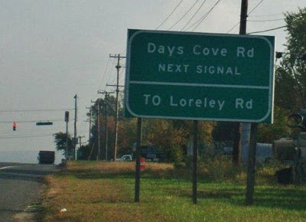
John and Sarah (7th great grandparents), purchased land near her father's plantation, Nicholas Day, along the Great Falls of the Gunpowder River. John's grandfather John Taylor (10th great grandfather), father of Arthur Taylor (9th great grandfather), lived near the ferry along the south side of the Gunpowder.

The old map belows shows Joppa, the Gunpowder, a ferry and the first roads in what is now Herford County, Maryland. The current major port of Baltimore is west of Joppa, not shown on this map.
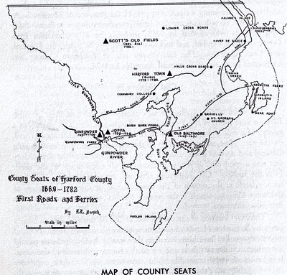
We know that in 1687, Arthur Taylor sold 75 acres of land from 'Arthur's Choice on the south side of a branch of the Gunpowder River, called Bird Run to James Greer and daughter, AnnTaylor Greer. Bird Run is now the Bird River which flows through a modern suburban mall in Whitemarch, Maryland, not far from Days Cove. Arthur Taylor was the oldest son of oneJohn Taylor. Arthur had acquired the property in 1683. This land will eventually become the site of Joppa, a major port that later disappears and becomes a classic American ghost town.

Ironically, also along the Gunpowder another family, theStansberys, had settled. Stansberys live in and around Baltimore to this day. One of the Stansbery families will treck south in the 1700s, and generations later will result in my grandfather,Charles S. Stansbery, Sr. (1893 - 1957). Charles will marryMayme Osborne, whose grand mother was, yes, one Caroline Greer Wilson (1828 - 1911). My immediate family has deep Maryland roots!

Yes, there are a lot of family names above and it can be confusing. More on these ancestors in later postings....For a Family Tree on Days, Taylors and Osbornes, please go to the Family Lineage Page found on this blog.
POSTED BY GLENN N. HOLLIMAN AT 1:08 AM 0 COMMENTS
LABELS: ARTHUR TAYLOR CAROLINE GREER WILSON, CHARLES STANSBERY,JAMES GREER, JOHN TAYLOR, MAYME OSBORNE STANSBERY, SARAH DAY GREER, SR, SR. NICHOLAS DAY

11/11/10

A Veterans' Day Salute
by Glenn N. Holliman
U.S. Army, Vietnam 1969
A Thank You to our Veterans

I suspect our family members have been represented in our country's battles from Colonial Chesapeake to the 21st Century Middle Eastern Wars. As it is impossible to list all of them in any kind of complete listing, I will let my nephew, Capt. Jonathan Murphy, USA, take the salute for all who been on active duty, the Reserves or National Guard. Jonathan is on duty somewhere in Afghanistan, his second tour in four years. His family waits for him in the States.

For a time he was Captain of the Guard at the Tomb of the Unknown Soldier in Washington, DC. Below are two photographs - one of Jonathan leading his platoon up the steps of the Memorial and the second of him walking the Guard. For those of us who have stood on guard in other fields and seas, including my father, uncles, nephews and cousins, we express our appreciation to him and all relatives who have gone before him.
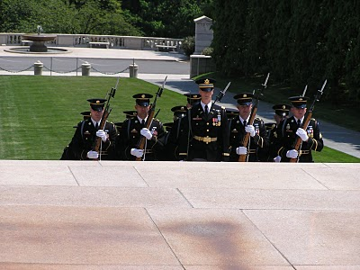
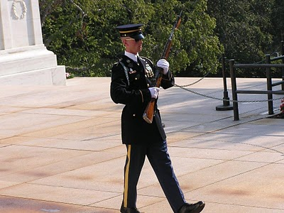
Among his ancestors are veterans of the French and Indian War, Revolution, War of 1812, Civil War, World War II, Viet Nam, the Cold War and recent Middle East conflicts. One great grandfather, Luke Stansbery (1750 - 1848), was a prisoner of war of the British in Charleston, SC 1780 during the American Revolution.
POSTED BY GLENN N. HOLLIMAN AT 2:59 AM 0 COMMENTS
LABELS: CHRISTOPHER HOLLIMAN, JONATHAN MURPHY, LUKE STANSBERY,SR.
Newer PostsOlder PostsHome
Subscribe to: Posts (Atom)

PAGES
- Home
- Web Sites and Publications
- Contributers
- Family Lineage

POPULAR POSTS
We Are Also Boones, Part 4
by Glenn N. Holliman ( Source for this posting is largely from In the Footsteps of Daniel Boone by Randell Jones. Photos taken from the wo...
More Adema and Stansbery Photographs, No. 9
by Glenn N. Holliman 2010 Rob Adema took this photograph of his parents, Gay and Bob Adema along with yours truly (far left) at their s...
We Are Also Wilcoxsons - Part III
by Glenn N. Holliman The Wilcoxsons and Boones, 18th Century Pioneers in Central North Carolina and Kentucky Sources include www.planetmur...
Frances Wilson Osborne with daughter, Mayme Osborne Stansbery and granddaughter Louise Stansbery Sherwood

LABELS
Abraham Lincoln Ada Osborne Anne TaylorArthur Taylor Arthur Taylor Caroline Greer Wilson Ashe County Bascom K. Osborne Bascom Wilson OsborneBenjamin Greer Benjamin Greer; Jesse Greer Bishop L. Osborne Bob Adema Capt. Jesse Greer Caroline Greer Wilson; Isaac Wilson Charles I Charles IICharles Stansbery Charles WilsonChristopher Holliman Cloe Jones GreerDamascus Daniel Boone Daniel Wilcoxson David Wright Don FeickDoris Osborne Akers Eddie C. Osborne Edward Morgan Elizabeth PowellElizabeth Wilcoxson Cutbirth Flea AkersFrances Wilson Osborne Frazier KingG.W. Osborne Gayle Adema George BooneGeorge Washington Osborne George Wilcoxson Geraldine Stansbery Holliman Feick Gladys Osborne Adema Glenn HollimanHiram Wilson Howard Adema Hugh II James Grantson Holliman James GreerJames Grier Jesse Boone Wilcoxson John Greer John Taylor John Wilcoxson John Wilson Jonathan Murphy Joppa Jr. Jr. Sarah Day Greer Leroy Osborne Louise Stansbery Sherwood Luke Stansbery Margaret Hill Taylor Margaret Phinney Taylor Marion Lee Osborne Mary Brown Mayme Osborne Stansbery Nancy Lowe Walker Nancy Wilcoxson Greer Nicholas Day Nicholas Maxwell Pauline Osborne Pearl Osborne Wright Peggy Noeltner Phyllis AkersRachel Bryan Rachel Wilcoxson BryanRebecca Payne Rob Adema; Peggy Noeltner Rob Adema; Phyllis Akers Sarah Anne Elliott Sarah Boone Sarah Boone Wilcoxson Sarah Cox Sarah Day Sarah Day Greer Sarah Lowe Day Sarah Mary Oppy Sarah Morgan Sarah Morgan BooneSean Murphy Sir James Grier Squire Boone Sr Sr. Sr. Nicholas Day Sr.; Nancy Boone Wilcoxson The Rev. William A. WilsonToby Osborne Tom Adema Vance SherwoodVirginia Osborne Vivian Randall OsborneWilliam Grierson William Penn

BLOG ARCHIVE

10/30/10

When We Were Greers, Part III
by Glenn N. Holliman
James Greer Comes to Maryland
(For the Greer lineage from Scotland to the G.W. and Frances Wilson Osborne generation in Western North Carolina and Tennessee, please go to the Lineage page of this blog; scroll to the bottom of the page. The material for this posting comes from a history of Herford County, Maryland and many Joppa, Maryland historical web sites.)

Born in 1627, my generation's 8th great grandfatherimmigrated from Dumfries, Scotland in 1677, old for a crossing and a new start in life. However, he must have been a young fifty. He married teenager Ann Taylor, born 1660, according to some sources, in Baltimore County, Maryland. Ann was the daughter of large land owner parents, Arthur and Margaret Taylor. Both the Taylors and Greers had land along the Gunpowder River inJoppa, Maryland. (More work remains to discover the Taylor family line.)
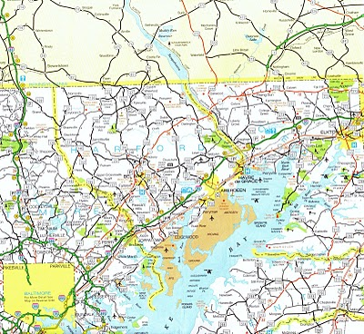
In the map above of modern Maryland, one will find Joppatown, a new town built in the 1960s on the site of old Joppa.Joppatown (lower middle - left on the map) is just off the busy railway and motor vehicle corridors from Washington, D.C. to Boston. Gunpowder State Park is in light green just south ofJoppatown. In the early 1700s, a common phrase in Maryland was that 'all roads lead to Joppa'.

Joppa was located on the Gunpowder River which flowed into the Chesapeake Bay. In the early 1700s Joppa was one of America's main ports as Baltimore City had not yet been founded. Planters like the Greers and Taylors grew tobacco and loaded it on the many wharves at Joppa.
As the back country of Pennsylvania developed in the first half of the 18th century (note map above), German and Scotch-Irish farmers 'rolled' their hogsheads of tobacco to Joppa and sent their crops to England. Joppa prospered but her days of commercial glory were numbered.

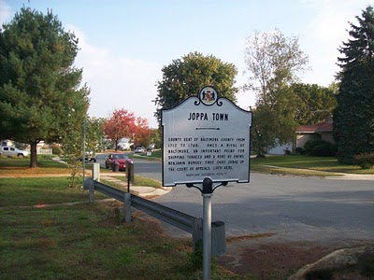
The historical marker above stands on the site of St. John's Episcopal Parish, now the site of Church of the Resurrection (Episcopal). The neighborhood was a model community built in the 1960s on the site of Joppa, which by the early 1800s had become a ghost town. Once Joppa was a leading North American port until the Gunpowder River silted up and year by year the number of ocean going vessels declined (along with the fortunes of the Greer families!)

More in the next posting on the Greers, other ancestral families of ours, and this
near-forgotten piece of American history.
POSTED BY GLENN N. HOLLIMAN AT 3:43 AM 0 COMMENTS
LABELS: ARTHUR TAYLOR, JAMES GREER, JOPPA

10/22/10

When We Were Greers, Part II
by Glenn N. Holliman

Actually, We Were MacGregors, Griers, Griersons and More!

Scotland today is part of the United Kingdom, which includes Northern Ireland, Wales and England. The rising of King James VI of Scotland in 1603 to the throne of England bound the two nations together after centuries of strife and warfare. Scotland had been determined to maintain its independence, and England wanted no restless and fierce neighbor at its northern door.

Our Greer ancestry in Scotland begins officially with Hugh II, a King of Dalriada, a long disappeared chiefdom, probably in the lowlands not far from the Roman Emperor Hadrian's wall. In the 7th century A.D., England was being invaded by Angles, Saxons and Jutes, and were in no condition to threaten their northern Celtic kin known as Picts.

This was 33 generations ago, and probably half of North America, Australia and the U.K. are descended from this line of Scots. An interesting one was Hugh IV or 'the Poisonous', who died in 822. Quaint name. The centuries rolled by and the MacGregor named emerged, and they were 'Sirs' and 'Thanes'. They seemed to rule and be ruled in Dumfrieshire, a county across the Solway Firth from Carlisle in Scotland.

The main market town was Dumfries, still a minor port city leading to the Irish Sea. Besides the home of some of our ancestors, Robert Burns, the great Scottish poet, and James Barrie, the writer of Peter Pan, hailed from the community. Our last Scottish ancestor was Sir James Grier Sr, b. 1604 at Cape Noch, Dumfrieshire. He married in 1626 to a Mary Brown, daughter of a Presbyterian pastor (She was from Glencairn). They would be my generation's 9th great grandparents. James Sr. died in 1666 at the place of his birth, Cape Noch, Thornhill, north of Dumfries.
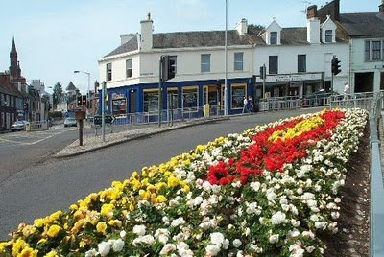Above to the right, the Dumfries and Galloway Family History near the town centre.
The couple did have a child named James Greer in 1627, born also at Cape Noch. This James is the first American, having caught a ship in 1677. He sailed to the Chesapeake Bay, Maryland and started a new life in the new world at the rather ancient age of fifty.

Below the Dumfries and Galloway Archives is located in the Burns House (yes, Robert) on Burns Street. Here are then two places to check out for family history on your next trip to Scotland. Easier yet, check them out on the Internet.

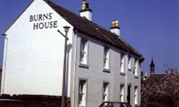
The Internet is swarming with Greer and McGregor sites. Two to check would be the Greer Genealogical Website and the Greer Family of Watagua County, North Carolina. Just Google Greer and you will be busy for days. I have posted our Greer lineage on the page labeled Family Lineage. Look to the bottom of the page.

Next posting, we will follow James Greer across the Atlantic to Maryland and see how he fares in the New World....
POSTED BY GLENN N. HOLLIMAN AT 2:52 PM 0 COMMENTS
LABELS: JAMES GREER, JAMES GRIER, MARY BROWN

10/15/10

When We Were Greers, Part I
by Glenn N. Holliman

Benjamin Greer, A Larger than Life Frontiersman from an Amazing Scottish Lineage!

As if the stories about the Boones and Wilcoxsons were not enough family lore to keep many genealogists busy, I now introduce a robust leader of the frontier, the 5thgreat grandfather of my generation, one Benjamin Greer. In the year 1767, Benjamin married Rachel Wilcoxson, niece of Daniel Boone. Between then and her death in 1790, the couple had ten children, one being Jesse Greer, Sr., whom we will later discuss. He later fathered five more children by a second wife, for a total of 15 newGreers.

Benjamin was born in February 9, 1746 in AlbemarleCounty, Virginia and died in Kentucky in 1810. His parents were from Maryland and earlier ancestors from Scotland. Benjamin could be the subject of a Hollywood movie as he chased Cherokee Indians, fought as a patriot captain at the Battle of King's Mountain, thrashed a soldier caught stealing, hung Tories and later told his Baptist Church what they could do with their rules on abstinence (from drink, not sex obviously).
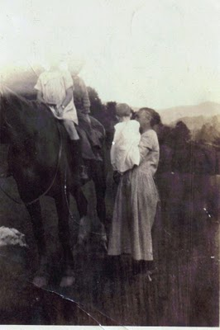In this faded photo above made in the early 1920s in the Appalachian Mountains, we see Frances Wilson Osborne, a great great grand daughter of Benjamin Greer, holding her latest grandchild, GeraldineStansberry. On the horse are Louise and CharlesStansbery.
During the life of Benjamin, the Greers, Osbornes andWilsons settled in Watagua and Ashe Counties, North Carolina. This photo was probably made in Sullivan County, Tennessee or Damascus, Virginia and was recently uncovered in the collection of Geraldine Stansbery Holliman Feick.
We will look carefully at Benjamin's large life in later postings, but will first examine our amazing Greer heritage. Actually one should say McGregor and that line goes back, believe it or not, to one Hugh II, born before 680 and King of the Scottish realm of Dalriada from 691 to 695. The name McGregor became Grierson and then Grier and Greer. Before coming to Maryland in the 1680s, our ancestors hailed from southern Scotland in and around Dumfrieshire. A map of that region is below.Double click on the map to enlarge.

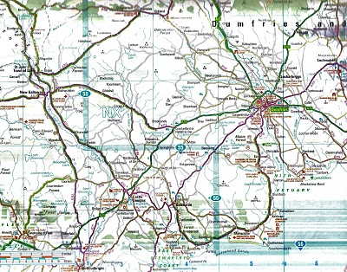
More on our Scottish heritage in the next posting....
POSTED BY GLENN N. HOLLIMAN AT 1:57 AM 1 COMMENTS
LABELS: BENJAMIN GREER, HUGH II, NANCY WILCOXSON GREER

10/6/10

When We Were Wilcoxsons, Part IV
by Glenn N. Holliman

Below, a map from Robert Morgan's book on Daniel Boone, available through Algonquin Books of Chapel Hill, NC. Notice the Cumberland Gap, Boonesborough and Bryan's Station, all important places in our family history. Click on the map and it will enlarge.

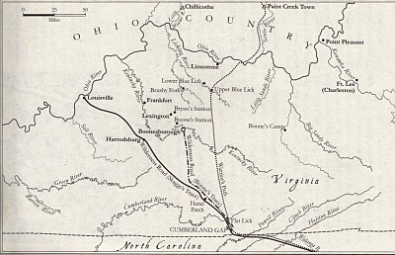
In 1779 Rachel Wilcoxson Bryan, my generation's fifth great aunt, settled with her relatives, Wilcoxsons and Bryan(t)s at Bryan's Station, Kentucky. (see map above for location) There were numerous Indian attacks, the most threatening in 1782 when the women of the Station prevented it firery destruction by carrying badly needed buckets of water from the spring to the Station while surrounded by Indians. A memorial exists for their efforts. A 5thgreat uncle, Daniel Wilcoxson, was a captain at the Station.
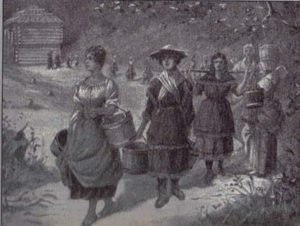Above from the Kentucky Historical Society, this drawing of the women, several our family members, leaving the protection of Bryan's Station, to collect water from a spring. The awed Shawnee held their fire, and the women returned safely to the fort with the precious liquid. The settlement was saved.

By 1779, now 60 years of age, and evidently prosperous, JohnWilcoxson and Sarah, returned to the Yadkin Valley leaving Kentucky to the younger children and kin. With the American Revolution underway and Lord Granville of England no longer owner of a huge portion of North Carolina, long time settlers such as John and Sarah could now register their land with the new government.

In January 1780, John began to do so for 640 acres on both sides of Bear Creek in Rowan County, NC. Bear Creek is so named because Sarah's younger brother, Daniel Boone, had killed over 90 bears in the area in one year. (Because Daniel and others had killed so much local game, hunters had to keep moving west.)

Seemingly no place seemed safe for the extended family. British General Cornwallis had invaded South Carolina and invaded North Carolina. The Revolutionary War was also a civil war, with neighbor against neighbor. John and Sarah may have left Kentucky to avoid hostile Indians. However, they returned to find a hostile British Army and Tories! Armies marched to and fro, the biggest North Carolina battles being at Guildford Court House and Kings Mountain. Our ancestors fought at both battles which we will feature in later posts.

Map from Robert Morgan's biography of Boone.

John died sometime after 1798, after selling the last of his North Carolina land to a son, William Wilcoxson, my generation's 5thgreat uncle. Of course, Wilcoxson land was adjacent to Squire Boone's settlement (see above map). Daniel Boone was married to Rebecca Bryan. John seemingly left no will that has been found. Nor do we know his grave site.

Sarah moved to live with a daughter, another pioneer woman, Elizabeth Wilcoxson Cutbirth ( my 5th great aunt). Sarah died there in Madison County, Kentucky in 1815. Another source has her living in southern Clark County, Kentucky, not far fromBoonesboro and dying at the home of her grandson, Jesse BooneWilcoxson, a son of Samuel Wilcoxson.

Next Nancy Wilcoxson marries Benjamin Greer....and more frontier turmoil!
POSTED BY GLENN N. HOLLIMAN AT 12:50 AM 0 COMMENTS
LABELS: DANIEL BOONE, DANIEL WILCOXSON, ELIZABETH WILCOXSON CUTBIRTH, JESSE BOONE WILCOXSON, JOHN WILCOXSON, RACHEL WILCOXSON BRYAN, SARAH BOONE WILCOXSON
Newer PostsOlder PostsHome
Subscribe to: Posts (Atom)

PAGES
- Home
- Web Sites and Publications
- Contributers
- Family Lineage

POPULAR POSTS
We Are Also Boones, Part 4
by Glenn N. Holliman ( Source for this posting is largely from In the Footsteps of Daniel Boone by Randell Jones. Photos taken from the wo...
More Adema and Stansbery Photographs, No. 9
by Glenn N. Holliman 2010 Rob Adema took this photograph of his parents, Gay and Bob Adema along with yours truly (far left) at their s...
We Are Also Wilcoxsons - Part III
by Glenn N. Holliman The Wilcoxsons and Boones, 18th Century Pioneers in Central North Carolina and Kentucky Sources include www.planetmur...
Frances Wilson Osborne with daughter, Mayme Osborne Stansbery and granddaughter Louise Stansbery Sherwood

LABELS
Abraham Lincoln Ada Osborne Anne TaylorArthur Taylor Arthur Taylor Caroline Greer Wilson Ashe County Bascom K. Osborne Bascom Wilson OsborneBenjamin Greer Benjamin Greer; Jesse Greer Bishop L. Osborne Bob Adema Capt. Jesse Greer Caroline Greer Wilson; Isaac Wilson Charles I Charles IICharles Stansbery Charles WilsonChristopher Holliman Cloe Jones GreerDamascus Daniel Boone Daniel Wilcoxson David Wright Don FeickDoris Osborne Akers Eddie C. Osborne Edward Morgan Elizabeth PowellElizabeth Wilcoxson Cutbirth Flea AkersFrances Wilson Osborne Frazier KingG.W. Osborne Gayle Adema George BooneGeorge Washington Osborne George Wilcoxson Geraldine Stansbery Holliman Feick Gladys Osborne Adema Glenn HollimanHiram Wilson Howard Adema Hugh II James Grantson Holliman James GreerJames Grier Jesse Boone Wilcoxson John Greer John Taylor John Wilcoxson John Wilson Jonathan Murphy Joppa Jr. Jr. Sarah Day Greer Leroy Osborne Louise Stansbery Sherwood Luke Stansbery Margaret Hill Taylor Margaret Phinney Taylor Marion Lee Osborne Mary Brown Mayme Osborne Stansbery Nancy Lowe Walker Nancy Wilcoxson Greer Nicholas Day Nicholas Maxwell Pauline Osborne Pearl Osborne Wright Peggy Noeltner Phyllis AkersRachel Bryan Rachel Wilcoxson BryanRebecca Payne Rob Adema; Peggy Noeltner Rob Adema; Phyllis Akers Sarah Anne Elliott Sarah Boone Sarah Boone Wilcoxson Sarah Cox Sarah Day Sarah Day Greer Sarah Lowe Day Sarah Mary Oppy Sarah Morgan Sarah Morgan BooneSean Murphy Sir James Grier Squire Boone Sr Sr. Sr. Nicholas Day Sr.; Nancy Boone Wilcoxson The Rev. William A. WilsonToby Osborne Tom Adema Vance SherwoodVirginia Osborne Vivian Randall OsborneWilliam Grierson William Penn

BLOG ARCHIVE

9/27/10

We Are Also Wilcoxsons - Part III
by Glenn N. Holliman

The Wilcoxsons and Boones, 18th Century Pioneers in Central North Carolina and Kentucky
Sources include www.planetmurphy.org; Ft. Boonesborough web site; Hazel A. Spraker's 1923 biography of the Boone Family and Robert Morgan's Boone, a Biography, 2008.

John and Sarah Boone Wilcoxson prospered in their new home in central North Carolina north of Salisbury. In both 1765 and 1772, John assisted in constructing or overseeing road development along the Yadkin River. Numerous children were born, several of whom would help to open Kentucky and fight Shawnee Indians and the British in coming decades.

The Yadkin Valley, once filled with game and hostile Native Americas, had tamed somewhat by the 1770s. Some family members were growing restless, attracted by possibilities of inexpensive land over the mountains. John and Sarah faced some choices in the late 1770s.

Sarah's brother, Daniel, other relatives and her own grown children, were caught up in the opening of Kentucky. A study of the record indicates John was perplexed whether to stay in what was now settled country, Yadkin Valley or move to the cheap lands of Kentucky. They were not longer a young couple, and their children were growing up, starting families of their own.
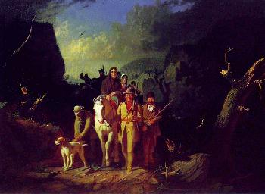This is a famous and romantic version of Daniel Boone, his wife, Rebecca Bryan Boone, and other members of our extended family venturing through Cumberland Gap en route in the late 1770s to the Dark and Bloody Ground of Kentucky. Kentucky was Shawnee hunting territory, and the Native Americans fought voraciously to keep the American settlers out. For a few years, until ultimately the Shawnee were defeated, the land was filled with anguish and death. An Eastern writer wrote up the deeds of one of the early explorers, settler, Indian fighter and long hunter, my sixth great uncle Daniel Boone, and he became one of the first America celebrities. His fame continues to this day.

Sometime around 1777 or 78, John and Sarah did move to Ft. Boonesborough, Kentucky. There is a monument today at Ft. Booneborough with the names of John and Sarah engraved, along with other Boone family members. See below.

An unknown descendant of Kentucky pioneers stand adjacent to the Boonesborough monument where John, Sarah, many Boones and other family member names are embedded.
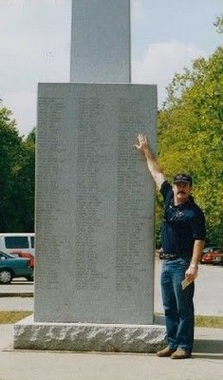
John and Sarah may have been at the famous September 1778 Battle of Ft. Boonesborough when 440 Shawnee Indians and 12 French-Canadians besieged the fort. Certainly other family members were. Sixty settlers, led by Daniel Boone, held off the attack for days, before Chief Blackfish broke off the fight. Below, a 1901 sketch of Ft. Boonesborough, now a state historical park.
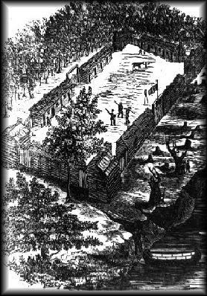
More on our Famous Frontier Family in the next post....
POSTED BY GLENN N. HOLLIMAN AT 1:14 AM 0 COMMENTS
LABELS: JOHN WILCOXSON, RACHEL BRYAN, SARAH BOONE WILCOXSON

9/20/10

We Are Also Wilcoxsons - Part II
by Glenn N. Holliman

Our Family Gathers in North Carolina
(Sources include Boone Family History and Genealogy at www.family-genealogy-online.com/little/boone.html, The Willcockson Society, the Salisbury, NC Enterprise-Recorder, July 24, 1975 and Salisbury Sunday Post, August 3, 1975)

Beginning in the 1750s, a migration, generally of Scotch-Irish, but also Welsh and early English colonists, began moving to the Cherokee Indian hunting grounds of Southwest Virginia and Western North Carolina. The colonists, generally second and third generations in America, thirst for land, and a lot of it, resulted in the ancestral families of our present generation moving from Pennsylvania and Maryland, south often through the Shenandoah Valley on the Great Wagon Road to the contested frontier.

The Wilcoxson's, my generation's 6th great grandparents, moving with the Boone family, acquired a land grant near the presentCooleemee, Davie County, NC. , formerly Rowan Co. There John and Sarah Boone Wilcoxson built a log cabin and continued to raise their expanding family on what became 800 acres of land. At the 'Shoals" where Cooleemee is now located (see below, center left), the Yadkin River could be forded for travel into Salisbury, NC. The original log cabins of the extended Boone family were built along this road.
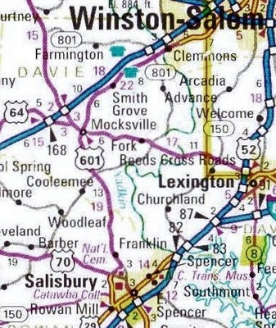
On a continuous tract of land over four miles in length, the families built cabins, and it is reasonable to assume they helped one another in the construction. John and Sarah built one of the better and larger houses between 1752 and 1756, using logs as large as 18 inches by 34 feet. This home, greatly enlarged and modernized, stands today, 225 years later!
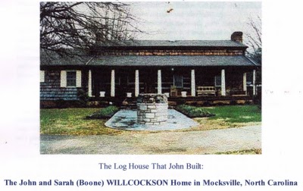
It consisted of one large 17 by 33 ft room where the family cooked, ate and adults slept. The floors were 3 inches thick of wood. The children, eventually there were 11, perhaps more, slept in a big attic room, which also provided protection in case of Indian attack.

We know that in this frontier the Quaker and Anglican Churches were left behind, and the families embraced what became the Boone's Baptist Church near their home. John and Sarah appear on the tax list in 1759. In 1778 the family moved to Booneborough, Kentucky, but after a year on the very dangerous frontier opened by Sarah's brother, Daniel, the Wilcoxsons returned to the log cabin. While in Kentucky, the Wilcoxsons were part of the pioneer party that defended the various settlements. At Boonesboroughtoday, the Wilcoxson names are listed along with the Boones.

The Wilcoxson's sold the house in 1787 to a Abraham Welty. The 1790 census of Yadkin Valley, Rowan Co., NC lists John and some of his family living on Bear Creek. The Mylar family married into the Wilcoxson and Boone families, and their web site lists much of this material (http://www.familytreecircles.com/journal_7466.html). One of John and Sarah's son-in-laws would be killed during an Indian attack in 1788.

Next posting, some more Wilcoxson frontier events....
POSTED BY GLENN N. HOLLIMAN AT 6:36 AM 0 COMMENTS
LABELS: DANIEL BOONE, JOHN WILCOXSON, SARAH BOONE WILCOXSON

9/14/10

More Adema and Stansbery Photographs, No. 9
by Glenn N. Holliman
2010

Rob Adema took this photograph of his parents, Gay and BobAdema along with yours truly (far left) at their summer home over looking Lake Erie. We are overlooking Cedar Bay at Pt. Claborne, Ontario. Bob's parents, Howard and Gladys Osborne Adema, purchased the home in 1940. We spent much of our day together, not just eating the Western New York favorite - beef on wick - but reviewing old photographs, the ones I have been running the past month.
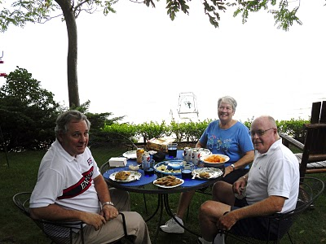Photo by Rob Adema
1940s

Is Bob in the photo below? Back row left to right are Flea and Doris Osborne Akers, then Gladys Osborne Adema, the girl is Virginia Osborne, the daughter of Bascomb K. Osborne (in the Navy uniform) and his wife Edith, far right, back row. Now I am on uneasy ground. I think front row looking down is Phyllis Akers, then Bob Adema (?), Bascomb K. and then Peg Adema Noeltner.
Where and when was this taken? Gladys and Doris are my mother's first cousins, all having grown up in the same area of southwest Virginia and upper East Tennessee in the 1920s and 30's.
From Phylllis Akers, Sept. 14, 2010: The picture of all of us was taken in front of Mom and Dad's house in Damascus. The people are: Back row, l to r - Flea Akers and Doris Osborne Akers, Gladys Osborne Adema, Edith Osborne - Bascom's (Bab) wife. 2nd row: Phyllis Akers, Bob Adema, & Peg Adema. Front, kneeling: Bascom (Bab) Osborne with daughter Gini. Don't know the date of that but looks like I'm sad that everyone is leaving.
Next posting, back to frontier days in Western North Carolina....
POSTED BY GLENN N. HOLLIMAN AT 8:16 AM 0 COMMENTS
LABELS: BASCOM K. OSBORNE, BOB ADEMA, DORIS OSBORNE AKERS, FLEA AKERS, GLADYS OSBORNE ADEMA, GLENN HOLLIMAN, PEGGY NOELTNER, ROB ADEMA; PHYLLIS AKERS

9/8/10

More Adema and Stansbery Photographs, No. 8
by Glenn N. Holliman
More Photos from the Collection of Bob Adema
1950
This is a photo of my Great Aunt Pearl and Great Uncle Dave Wright at their home in Damascus, Virginia. Dave, an electrician and in charge of the local electric service company, died in 1962. Pearl was born in Mast, North Carolina and died in Damascus in 1980 at the age of 90. They had no children themselves but raisedBascomb K., Gladys and Doris Osborne after their mother died in 1922. Can anyone identify the little boy on Dave's right?

Phyllis Akers wrote on September 9, 2010 that the boy is her brother, David Akers and continued: "Notice how Aunt Pearl is dressed up. I remember her always wearing a dress and stockings and heels even when she was carrying a load of sheets upstairs to make a bed. They had a bedroom on the main floor but they had boarders upstairs for many years. She must have washed, ironed and carried sheets up and down stairs way up into her 60's. I remember Mom saying that when she was sick, you could always tell when she was feeling better because she put her earrings on. Uncle Dave died just after I was married. Probably from another stroke. He was the first person I saw putting tons of salt on his food even before he tasted it. I remember Duane and I going to see him in the hospital."

David Akers sent the following on Sept. 9, 2010: Hi Glenn,
Thanks for the update. I have not been there yet but will check it out
after while. I have some old pictures of Uncle Dave at the control center
of the hydro-electric dam in Damascus if you would be interested. He was
the first lamp-lighter in Damascus and then moved into the first operator
position for the dam. He and the dam were later bought out by the
Appalachian Power Co. where I later worked for 30 yrs. and then retired.
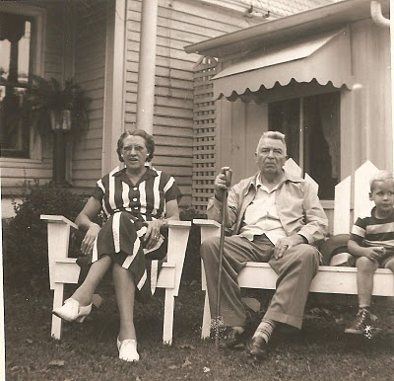

Below is Uncle Dave Wright at his kitchen table repairing radios which he did after retirement. This is a professional photograph taken in 1959.
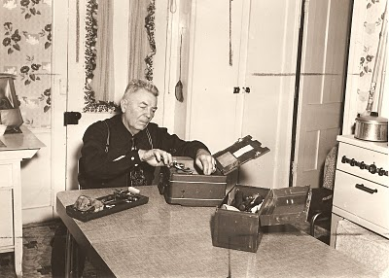
More soon....
POSTED BY GLENN N. HOLLIMAN AT 4:35 PM 0 COMMENTS
LABELS: DAVID WRIGHT, PEARL OSBORNE WRIGHT

9/4/10

More Adema and Stansbery Photographs, No. 7
by Glenn N. Holliman
More Photos from Bob Adema

1930s
Below is a photograph of my mother's first cousin, Gladys Osborne Adema, probably while on an outing in the Virginia mountains.
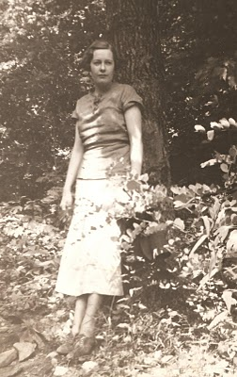
1995 in Ohio Cousins Revisit
Below, left to right are Geraldine Stansbery Holliman Feick (Gladys's first cousin), Bob Adema, a son of Gladys, Gladys and The Rev. Don Feick, my Mother's husband. Fr. Don, an Episcopal priest, had a parish in Ohio, and while there he and Gerry visited family she had not seen in over a generation. Bob is the cousin who has been sharing the family photos the past several postings.
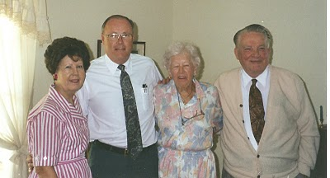
More soon of the family of Frances Wilson Osborne (1851 - 1940)
POSTED BY GLENN N. HOLLIMAN AT 12:06 AM 0 COMMENTS
LABELS: DON FEICK, GERALDINE STANSBERY HOLLIMAN FEICK, GLADYS OSBORNE ADEMA, TOM ADEMA

9/2/10

More Adema and Stansbery Photographs, No. 6
by Glenn N. Holliman
More photos from the collection of cousin Bob Adema.

1940s?

Left is my Mother's first cousin, Bascomb K. Osborne and on far right is his father, my Great Uncle Bascomb Osborne. Bascomb'ssecond wife, Ada stands behind Bascomb K's daugher, Virginia (Ginnie). The photo was probably taken in the late 1940s or early 1950s at the Osborne home in Owenboro, Kentucky. Bascomb was a Ford manager. The younger Bascomb, Uncle Bab as he was known to his nieces and nephews, had an outstanding career in the U.S. Navy. All in this photo are now deceased.
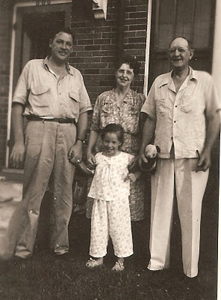
1930s

Below is another photo of Frances Wilson Osborne, my generation's Great Grandmother. As usual she is dressed in black. Whose front porch is this? I assume this was made in either Damascus, Virginia or Bristol, Tennessee. She often wears a wide black ribbon around her waist in photographs.
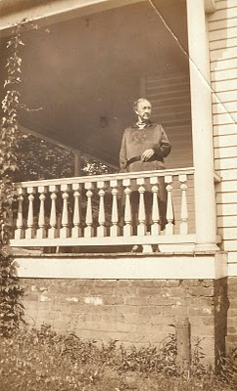
More soon....
POSTED BY GLENN N. HOLLIMAN AT 1:51 AM 0 COMMENTS
LABELS: ADA OSBORNE, BASCOM K. OSBORNE, BASCOM WILSON OSBORNE,FRANCES WILSON OSBORNE, VIRGINIA OSBORNE
Newer PostsOlder PostsHome
Subscribe to: Posts (Atom)

PAGES
- Home
- Web Sites and Publications
- Contributers
- Family Lineage

POPULAR POSTS
We Are Also Boones, Part 4
by Glenn N. Holliman ( Source for this posting is largely from In the Footsteps of Daniel Boone by Randell Jones. Photos taken from the wo...
More Adema and Stansbery Photographs, No. 9
by Glenn N. Holliman 2010 Rob Adema took this photograph of his parents, Gay and Bob Adema along with yours truly (far left) at their s...
We Are Also Wilcoxsons - Part III
by Glenn N. Holliman The Wilcoxsons and Boones, 18th Century Pioneers in Central North Carolina and Kentucky Sources include www.planetmur...
Frances Wilson Osborne with daughter, Mayme Osborne Stansbery and granddaughter Louise Stansbery Sherwood

LABELS
Abraham Lincoln Ada Osborne Anne TaylorArthur Taylor Arthur Taylor Caroline Greer Wilson Ashe County Bascom K. Osborne Bascom Wilson OsborneBenjamin Greer Benjamin Greer; Jesse Greer Bishop L. Osborne Bob Adema Capt. Jesse Greer Caroline Greer Wilson; Isaac Wilson Charles I Charles IICharles Stansbery Charles WilsonChristopher Holliman Cloe Jones GreerDamascus Daniel Boone Daniel Wilcoxson David Wright Don FeickDoris Osborne Akers Eddie C. Osborne Edward Morgan Elizabeth PowellElizabeth Wilcoxson Cutbirth Flea AkersFrances Wilson Osborne Frazier KingG.W. Osborne Gayle Adema George BooneGeorge Washington Osborne George Wilcoxson Geraldine Stansbery Holliman Feick Gladys Osborne Adema Glenn HollimanHiram Wilson Howard Adema Hugh II James Grantson Holliman James GreerJames Grier Jesse Boone Wilcoxson John Greer John Taylor John Wilcoxson John Wilson Jonathan Murphy Joppa Jr. Jr. Sarah Day Greer Leroy Osborne Louise Stansbery Sherwood Luke Stansbery Margaret Hill Taylor Margaret Phinney Taylor Marion Lee Osborne Mary Brown Mayme Osborne Stansbery Nancy Lowe Walker Nancy Wilcoxson Greer Nicholas Day Nicholas Maxwell Pauline Osborne Pearl Osborne Wright Peggy Noeltner Phyllis AkersRachel Bryan Rachel Wilcoxson BryanRebecca Payne Rob Adema; Peggy Noeltner Rob Adema; Phyllis Akers Sarah Anne Elliott Sarah Boone Sarah Boone Wilcoxson Sarah Cox Sarah Day Sarah Day Greer Sarah Lowe Day Sarah Mary Oppy Sarah Morgan Sarah Morgan BooneSean Murphy Sir James Grier Squire Boone Sr Sr. Sr. Nicholas Day Sr.; Nancy Boone Wilcoxson The Rev. William A. WilsonToby Osborne Tom Adema Vance SherwoodVirginia Osborne Vivian Randall OsborneWilliam Grierson William Penn

BLOG ARCHIVE

Web Sites and Publications
Source Materials for this Blog
Neighbor to Neighbor, published by Appalachian State University, 2007, Boone, NC., contains the memoirs of my great-great uncle, The Rev. William A. Wilson. Edited by Sandra L. Ballard and Leila E. Weinstein. Our extended family is very fortunate to have this work in print. Highly recommended.
For more general reading of the Civil War in Appalachia, look forThe Heart of Confederate Appalachia, Western North Carolina in the Civil War by John C. Inscoe and Gordon B. McKinney. Published by the University of North Carolina, Chapel Hill, in 2000, it records a war very much different than of Lee and Grant and their armies.
The Diary of Frances Wilson Osborne, transcribed by Glenn N. Holliman in 2009, is unpublished but available by email. From 1914 to 1940 my great grandmother irregularily recorded her life and times. There is much family history in her diary. If you want a better understanding of our roots, spend some time with these 100 plus pages.
The 1943 Diary of Mayme Osborne Stansbery, transcribed by Glenn N. Holliman in 2010, is unpublished but a compelling story of a Bristol, Tennessee family relocated by World War II to Philadelphia, Pennsylvania. My grandmother describes life in the turmoil of her personal world turned upside down by family and international events in the early 1940s. Sadly, before the year 1943 was over, Mayme died prematuraly at age 47. She is buried next to her parents at East Hill Cemetery, Bristol, Tennessee
Home
Subscribe to: Posts (Atom)

PAGES
- Home
- Web Sites and Publications
- Contributers
- Family Lineage

POPULAR POSTS
We Are Also Boones, Part 4
by Glenn N. Holliman ( Source for this posting is largely from In the Footsteps of Daniel Boone by Randell Jones. Photos taken from the wo...
More Adema and Stansbery Photographs, No. 9
by Glenn N. Holliman 2010 Rob Adema took this photograph of his parents, Gay and Bob Adema along with yours truly (far left) at their s...
We Are Also Wilcoxsons - Part III
by Glenn N. Holliman The Wilcoxsons and Boones, 18th Century Pioneers in Central North Carolina and Kentucky Sources include www.planetmur...
Frances Wilson Osborne with daughter, Mayme Osborne Stansbery and granddaughter Louise Stansbery Sherwood

