Hi Dr. Holliman, my husband has several Yerby relatives that were in the Civil War and
some in the 41st. I saw the page of photos and Warren & John Thomas Holliman. I
knew Warren was a brother to Elijah (married Jemima Yerby), was John Thomas a
brother to Elijah also? Do you have any idea where Elijah and Jemima are buried. We
found pension records for Elijah in AL. in 1902 or 1906 (not looking in my book at the
moment), but not sure where they died and are buried.
We are doing genealogy (and have been for about 7 years now, and have 30 inch and 3 inch
binders on them. So we go to cemeteries, courthouses, libraries, etc to find our
information. It falls in my husbands lap to find things on the Civil War. He loves
history. I will appreciate any information you can give me on Elijah and Jemima. Jemima
was the dau. of Amon Yerby in Fayette, AL.
Thanks, Della
Della F A Yerby
DAY

Hi again, here is a picture of Don's great grandfather, Tolbert B. Yerby (was in Camp Chase, but came home)/
Is there any way you can remove his wife and just have him? I tried that on PictureIt, but wasn't too good.
I like to take black and white and color them with PictureIt. Usually turns out good.

Doc, I will be glad to pay you for these. I know how much ink, etc costs. We appreciate it so much. Please
let me know.
Anyway, thanks, Della
Della F A Yerby
DAY
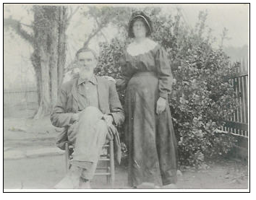

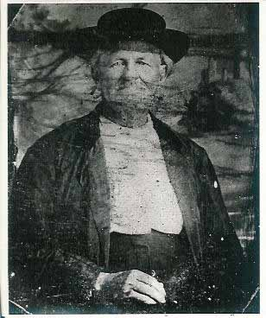Hogan Yerby

Doc, this is a house that Hogan built. It is on the Gravelly Plantation in Newtonville. Didn't
know if you had ever seen it or not.

Della
Della F A Yerby
DAY
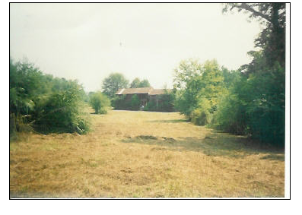
James Yerby
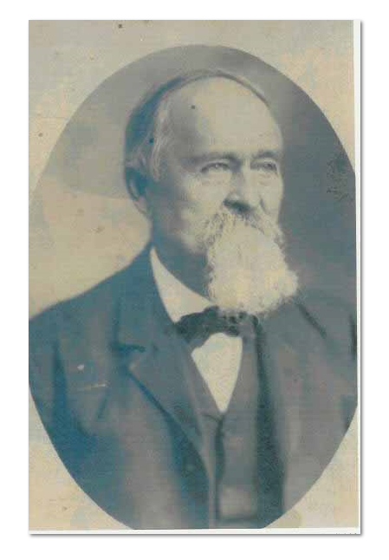

Dear Doc, here is a earlier picture of James C. Yerby (Hogan's son). I sent you the
one of him older with a beard.

Later, Della
Della F A Yerby
DAY
