Hi Doc, this is a letter that was in one of those Fayette Co., Books that I was telling you about.

It is from Lewellyn to Hogan.  It is very sad to know he never did get to see his dad again.

Della  
  
Della F A Yerby

DAYhttp://graphics.hotmail.com/emsmile.gif

C:\Users\Owner\AppData\Local\Microsoft\Windows\Temporary Internet Files\Content.Outlook\NIQJYOOO\Lewellyn's  CSA Letter.jpg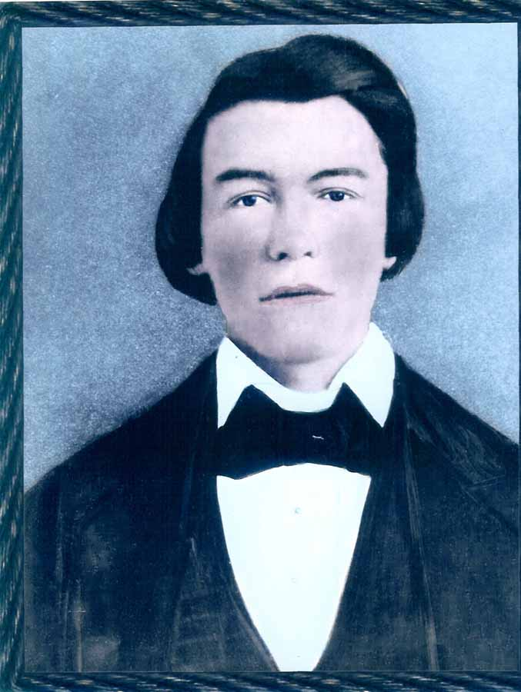

Doc, to answer a few of your questions.

Yes, Don and I both are disability retired.  And believe you me, SS is not the way to go, haha

I get sort of irritated at our President sending billions of dollars to these other countries to

build them back, when the people in the USA can't hardly make it on SS.  I wish he would invest

some of it to us, haha

As to all the FREE stuff, pictures etc.  I am the same way.  I print pictures and never ask anyone

for a dime.  I do it our of love for them.

You did go to school a long time!!  Well, I guess Carl does have a chance at getting a career, huh?

If you were 44, and he is 40!.  Thanks for the compliment on Mike.  He evidently didn't want his

picture made that day, he sure didn't smile.  I will have to send you a picture of my great grandbaby.

She is really a little doll.

You did a good job at taking Tolbert's wife off of the picture.  Thanks.  It looks natural.

I am going to send you the land record that I mentioned that has Cornelius Holliman land, Warren's

land and Charles Holliman's land.  Hope it comes through ok.

Talk to you later,  Della  
  
Della F A Yerby

DAYhttp://graphics.hotmail.com/emsmile.gif

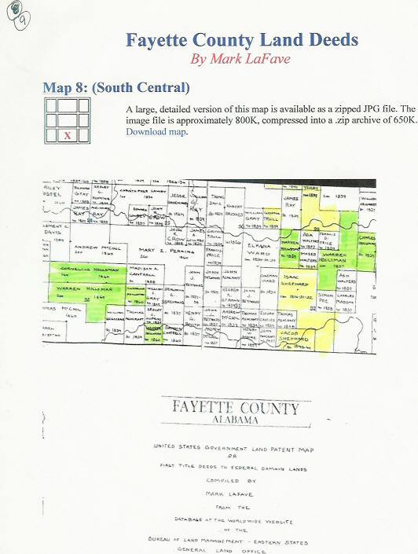Hi Doc, this is my oldest son, Mike.  He is the computer tech. for La-Z-Boy Chair Co.  He does all the net-working

for them.  He is the dad of my 2 grandchildren.

Carl married this girl that already had a 5 year old son.  So he was our grandchild too.  He had a bicycle accident,

while at his dad's, without a helmet.  He died that night, at 10 years of age.  He was such a precious child, just

as sweet as he could be.  We really miss him, but know that he is much better off than we are.  His mother and

dad were always having arguments concerning him, and one day he told DeeAnn's (Carl's wife) mother that he

wish he could just go live with Jesus.  About 2 weeks later, he did just that, he went home to Jesus.  He had

accepted Jesus as his Saviour already.  Thank the Lord.

How is your friend that lost his daughter in the wreck.  I have been praying for them that God would ease the

pain for them.  It has to be really hard to lose a child.

You and Phyllis be very careful with all that ice on the ground.  Don't need any more accidents, huh?

Those pictures of Newfoundland were really something else.  I love snow, but that is a bit much.  Were you

ever there, or were these sent to you?  Boy, talk about a snowman, you could really have a hugh one there, haha.

Take care, and God Bless you both,

Della

Della F A Yerby

DAYhttp://graphics.hotmail.com/emsmile.gif

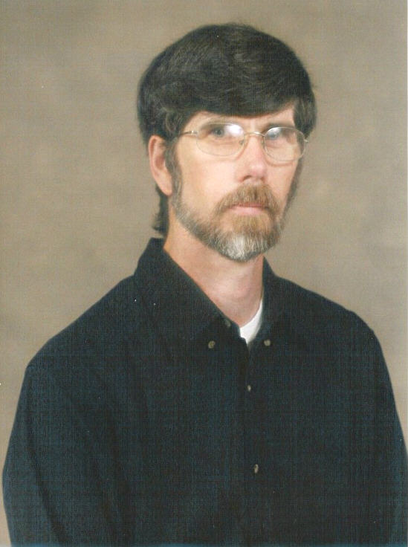

Hi Doc, here is a picture of me and Don.  Although it was made a few years (about 8), it still is pretty

much like us.  I have a little more gray now, and so does he.  This is at my son's wedding (on my mother's

front porch, she was 91 and they wanted her to see them get married). He is my baby boy, 40, and going

to college to be a computer programmer.  My other son is Mike, age 43.  I have 2 grandchildren, and 1 great

granddaughter, age 4 mos.  She is a little doll too, can't tell I am proud, huh?

I know what you mean about abuse, whether physical, mental or both.  It isn't worth it.  There are more

good mates in this world than that.  So we each had bad marriages.   Don is 4 years younger than me,

so I tell him he is supposed to respect his elders, haha   He is a great guy though.

Here is the tintype that I was telling you about.  It is my great grandmother holding my grandmother when she

was a baby.  The little girl standing is my grandmother's sister.  Sure hope you can do something with it.  I

was so scared to let go of it, because of it being the only one of its kind.  I appreciate it a lot.

Take care in all that ice.  Don't venture outside.

Blessings to y'all, Della  
  
Della F A Yerby

DAYhttp://graphics.hotmail.com/emsmile.gif

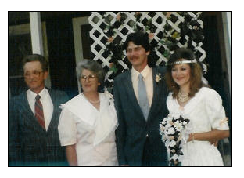

Doc, this is a picture of James thurston Yerby, son of Lewellyn (Lewellyn is Hogan's son-died CSA)

This is the way I received the picture, from Don's cousin in Louisiana.

Della  
  
Della F A Yerby

DAYhttp://graphics.hotmail.com/emsmile.gif

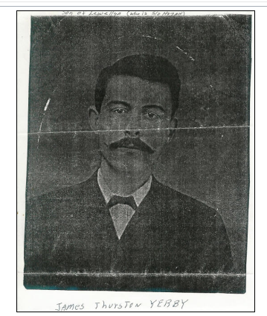This is the tintype that I was telling you about.

Thanks again for doing this for me.

Della  
  
Della F A Yerby

DAYhttp://graphics.hotmail.com/emsmile.gif

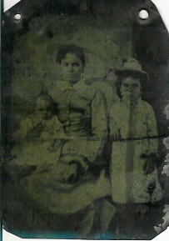

Hi Doc, this is a picture of James C. Yerby's (that I have already sent) wife.  
  
Della F A Yerby

DAYhttp://graphics.hotmail.com/emsmile.gif

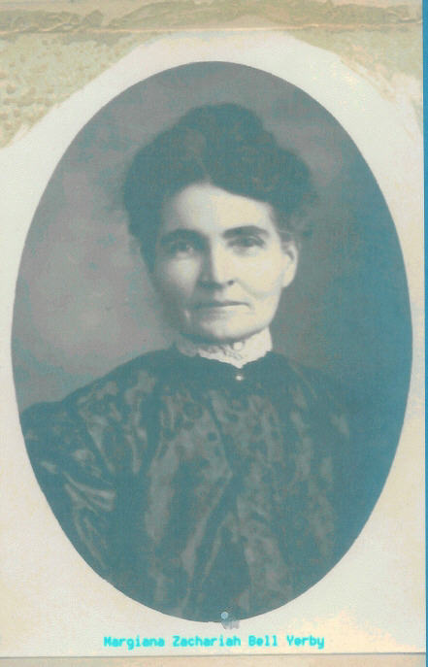This is the grave of William J. Yerby, Don's Great, Great Grandfather.  He is buried

in Camp Chase.  A cousin of Don's went and made these photos.  
  
Della F A Yerby

DAYhttp://graphics.hotmail.com/emsmile.gif

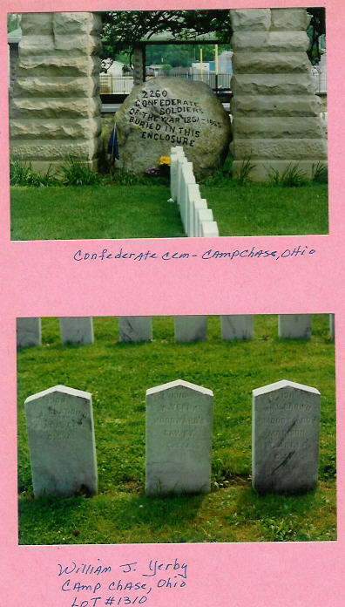

This one is of my grandpa.  He was in the Civil War (AL) and was in Camp Douglas.

His brother died there, but he made it home.  He joined in AL where he lived.

Later, he moved to MS. and married.  His name is John Gray Little.  So again,

thank you so much.

Della  
  
Della F A Yerby

DAYhttp://graphics.hotmail.com/emsmile.gif

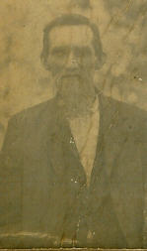

Doc, this is my great grandpa.  The only picture I have of him too.

You don't know what this means to me.  I hope I can help you one

day.  I certainly will try to.

Della  
  
Della F A Yerby

DAYhttp://graphics.hotmail.com/emsmile.gif

